IAM & SECURITY ENGINEERING
Day 3 Security Validation
Storage Account Configuration & RBAC Validation Report
Storage account | securedoceast01
Resource group | rg-secure-document-platform
Subscription | Azure subscription 1
Validation date | August 31st 2026
Engineer | IAM & Security Engineer 2
Document status | Validation Report — Findings Under Review

Table of Contents
Table of Contents 2
1. Security Validation Summary 3
2. Public Access Validation 3
Blob Anonymous Access 3
3. Secure Traffic Validation 3
Secure Transfer 3
Minimum TLS 3
4. Network Security Validation 4
Private Endpoint 4
Public Network Access 4
5. RBAC Least-Privilege Validation 4
Checks Performed 4
Findings 5
6. Approved Security Issues 5
7. Final Security Assessment 5

1. Security Validation Summary
Security Check | Expected | Actual | Status
Blob anonymous access | Disabled | Disabled | PASS
Secure transfer | Enabled | Enabled | PASS
Minimum TLS | TLS 1.2 or higher | TLS 1.2 | PASS
Public network access | Restricted per approved design | Enabled from all networks; restrictions not effective | REVIEW
Private endpoint | Required if approved by architecture | Configured (pe-securedoceast01-blob) | PASS
RBAC least privilege | Only required roles/scopes | Under review | REVIEW
Storage Blob Data Owner | Restricted to justified users | Under review | REVIEW

2. Public Access Validation

Blob Anonymous Access
Expected: Disabled
Observed: Blob anonymous access is disabled.
Status: PASS
Configuration meets the required control.

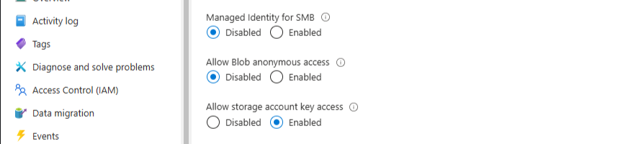

3. Secure Traffic Validation

Secure Transfer
Expected: Enabled
Observed: Secure transfer for REST API operations is enabled.
Status: PASS
Configuration meets the required control.

Minimum TLS
Expected: TLS 1.2 or higher
Observed: Minimum TLS version is TLS 1.2.
Status: PASS
Configuration meets the required control.

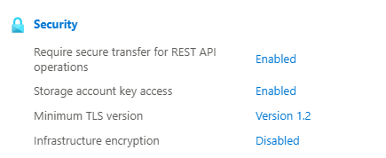

4. Network Security Validation

Private Endpoint
Expected: Private endpoint configured for Blob access where required.
Observed: Private endpoint pe-securedoceast01-blob is configured.
- Connected to VNet vn-secure-document-platform.
- Subnet: Private-Endpoint-Subnet.
- Target sub-resource: blob.
- Connection status: Approved.
Status: PASS
Configuration meets the required control.

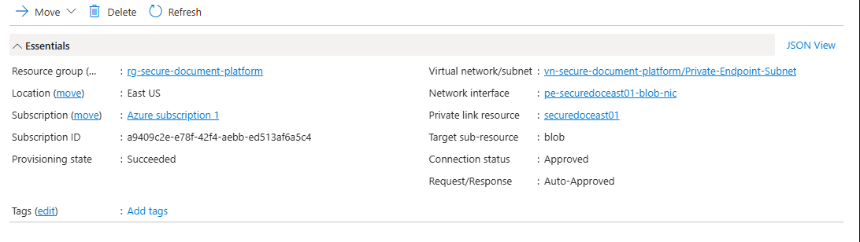

Public Network Access
Expected: Public access should be restricted according to the approved security architecture.
Observed: Public network access is enabled from all networks.
- No network security perimeter is associated.
- Virtual network/IP resource restrictions are not currently effective.
Status: REVIEW
Requires confirmation against the approved architecture before sign-off.
Action: Confirm with the Networking & Monitoring Engineer and project lead whether restricted network access is required, and why existing network restrictions are not effective despite the private endpoint being configured.

5. RBAC Least-Privilege Validation
The current RBAC configuration was compared against the approved RBAC plan.

Checks Performed
- Subscription-level privileged roles
- Storage Account Contributor assignments
- Storage Blob Data Owner assignments
- Reader assignments
- Network Contributor assignments
- Assignment scope
- Duplicate / overlapping permissions

Findings
- Subscription-level Owner access should remain restricted to authorized administrators.
- Storage Account Contributor should only be assigned to users who require storage-account administration.
- Storage Blob Data Owner should be restricted and replaced with Storage Blob Data Contributor where full ownership is unnecessary.
- Resource Group-level permissions should be reduced to narrower scopes where practical.
- Application access should use a Managed Identity with only the required Blob Data permissions.

Status: REVIEW / PENDING IMPLEMENTATION VERIFICATION
Findings are consistent with the approved least-privilege RBAC plan but require confirmation that the assignments have actually been implemented in Azure.

6. Approved Security Issues
Issue | Required Action | Verification | Status
Excessive RBAC | Apply approved least-privilege assignments | IAM role assignments | PENDING
Public network access | Restrict if required by approved architecture | Storage Networking | PENDING
Blob anonymous access | Disable | Storage Configuration | PASS
Insecure storage traffic | Require secure transfer | Storage Configuration | PASS
Weak TLS | Require TLS 1.2+ | Storage Configuration | PASS

7. Final Security Assessment
The storage account currently satisfies the checks for:
- Disabled anonymous blob access
- Secure transfer
- TLS 1.2
- Private endpoint configuration for Blob access
Public network access remains enabled from all networks despite the private endpoint being configured, and existing network restrictions are not currently effective. RBAC assignments still require verification against the final approved architecture and implemented assignments.
Validation Principle
No security control should be marked PASS solely because it is planned. The final status must reflect the configuration actually observed in Azure.

