Method and Results
Out-of-Sample Prediction, Forecast Mismatch, and Spatial Diffusion of Armed Conflict Across Nigerian States
Method
Predicting the Most Recent Year and Quantifying Forecast Mismatch
To assess how far current conflict can be anticipated from prior information, and where it departs from expectation, we predicted each state's 2025 political-violence fatalities (log-transformed; N = 37 states) using only pre-2025 predictors. Four nested linear models were compared: (M1) a persistence model using the prior year's (2024) fatalities; (M2) adding a spatial spillover term, the row-standardised queen-contiguity spatial lag of neighbours' 2024 fatalities; (M3) replacing the single lag with a three-year (2022–2024) violence history plus the spillover term; and (M4) adding static structural covariates (multidimensional poverty, population, and a northern-region indicator). Predictive skill was evaluated by exact leave-one-out cross-validation (LOOCV) using the PRESS statistic, which yields genuine out-of-sample R² rather than in-sample fit. The forecast mismatch for each state was defined as its standardised residual from the full model (observed minus predicted log fatalities): positive residuals denote states with more 2025 violence than their trajectory and neighbourhood implied (emergent hotspots), and negative residuals denote states that de-escalated below expectation. Residuals on very low base counts were interpreted as noise.
Characterising the Direction of Diffusion
Two methods described the spatial flow of conflict over 2010–2025. First, the fatality-weighted mean centre of violence—the fatality-weighted average of state centroids—was computed for each year and connected to trace the movement of the conflict's centre of gravity, summarised by the net displacement and bearing between the first and last years. Second, a directed neighbour lead–lag network was estimated: for every pair of contiguous states A and B, we regressed B's log fatalities in year t on B's own value in year t − 1 and A's value in year t − 1 (a space–time Granger-type test), retaining A → B as a directed diffusion edge where the coefficient on A's lag was positive and significant at p < .10 net of B's own persistence. Because this involves many pairwise tests on annual data, the network is interpreted as exploratory. Analyses used Python 3.13.
Results
Out-of-Sample Prediction of 2025 Conflict
Conflict in 2025 was substantially predictable from pre-2025 information. The prior year's fatalities alone correlated r = .80 with 2025 fatalities and explained a majority of out-of-sample variance (Table 1). Predictive skill increased as spatial spillover and a longer violence history were added, peaking for the model combining three-year history with neighbours' prior violence, LOOCV R² = .778. Adding static structural covariates did not improve out-of-sample performance (LOOCV R² = .765), indicating that predictability derived from the dynamics of conflict—its persistence and spatial diffusion—rather than from stable structural conditions.
Table 1
Out-of-Sample Predictive Performance for 2025 Conflict (Leave-One-Out Cross-Validation)
Model | In-sample R² | LOOCV R²
M1 Persistence (prior-year violence) | .646 | .591
M2 + spatial spillover | .739 | .672
M3 + 3-year history | .813 | .778
M4 + structural covariates | .844 | .765
Note. N = 37 states. Outcome = log(1 + 2025 fatalities). LOOCV computed via the PRESS statistic; negative values indicate no out-of-sample skill.

Forecast Mismatch: Emergent Hotspots and De-escalations
The forecast residuals isolated states whose 2025 outcomes broke from trajectory (Table 2). The largest positive residual was Kwara, which recorded 489 fatalities against a predicted ≈ 66 (residual = 2.00), a previously quiet North-Central state in which banditry broke out—an emergent hotspot invisible to its own history. Sokoto and Zamfara similarly escalated beyond expectation. Conversely, the largest negative residual was Kaduna, a major theatre that fell to 322 fatalities against a predicted ≈ 1355 (residual = -1.43), marking a sharp de-escalation. Substantively, positive residuals flag where the conflict system advanced into new territory faster than contagion alone predicts, whereas negative residuals flag interruptions of persistence (e.g., operations, displacement, or local accommodation); both locate the discrete shocks that structural and historical data cannot encode. Residuals on small base counts (e.g., Ekiti) were treated as statistical noise.
Table 2
States With the Largest Forecast Residuals for 2025
State / group | 2024 | 2025 | Predicted | Residual (log)
Under-predicted (emergent hotspots)
Kwara | 22 | 489 | 66 | 2.00
Ondo | 17 | 64 | 27 | .84
Abia | 83 | 94 | 53 | .56
Over-predicted (de-escalating)
Kaduna | 819 | 322 | 1355 | -1.43
FCT | 129 | 61 | 178 | -1.06
Ekiti | 16 | 2 | 6 | -.92
Note. Residuals from the full model (three-year history + spatial spillover + structural covariates). Predicted values rounded.

Direction of Spatial Diffusion
The fatality-weighted mean centre of violence migrated approximately 208 km over 2010–2025, tracing an arc rather than a straight path: it moved north-east toward the North-East theatre during the 2014–2015 Boko Haram peak, then reversed and migrated west and south-west into the North-West–North-Central banditry belt, settling near the Niger–Kwara–Kaduna frontier by 2024–2025. The directed lead–lag network returned 41 diffusion edges at p < .10. The substantively meaningful edges fed into the North-Central corridor—Kebbi → Niger (b = .73, p = .019) and Kaduna → Niger (b = .77, p = .047)—consistent with the Kwara breakout identified in the forecast residuals; a separate cluster of edges in the South-West and South-East reflected co-moving communal and separatist violence (Table 3). These directional findings are exploratory: lead–lag co-movement may reflect common shocks or unobserved armed-actor mobility; edges on low base counts are volatile; and the annual, state-level resolution cannot capture sub-state routes. Event-level (point-coordinate) data would permit a confirmatory space–time point-process model.
Figure 1
Spatial Flow of Armed Conflict in Nigeria, 2010–2025
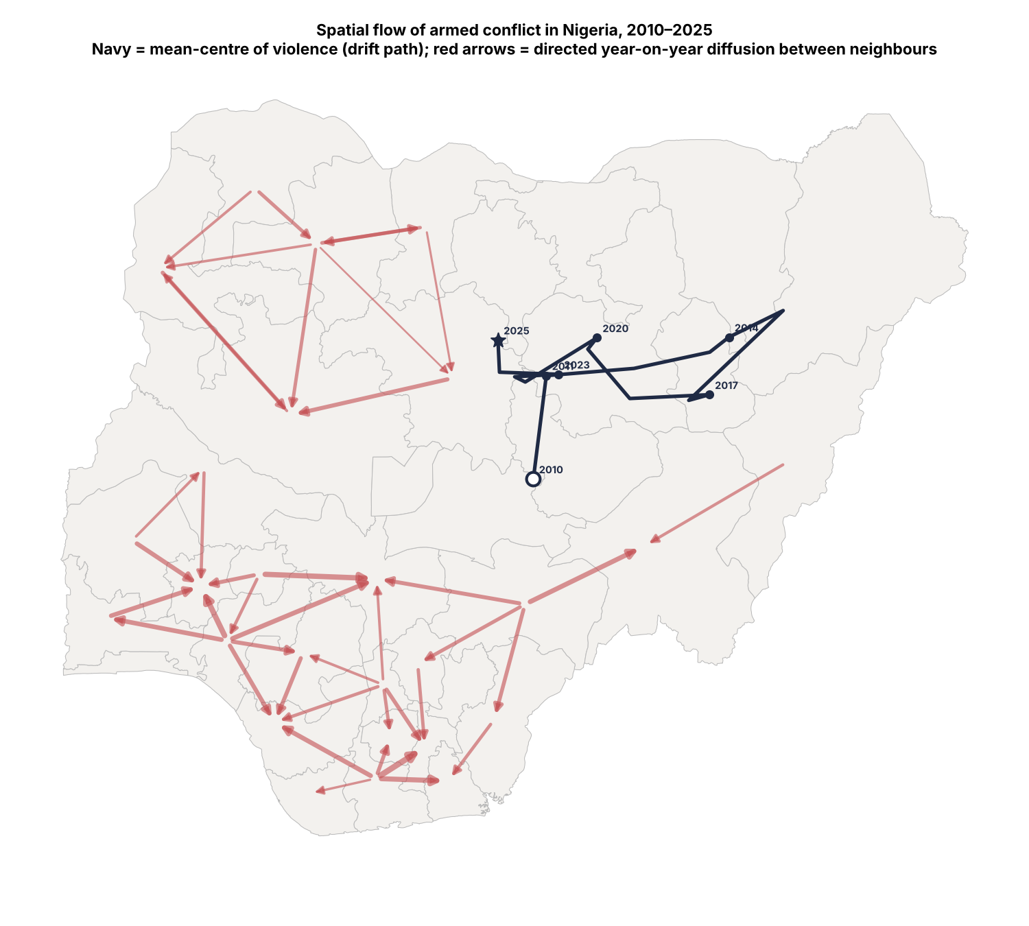
Note. The navy path traces the fatality-weighted mean centre of violence by year (open circle = 2010; star = 2025). Red arrows are directed year-on-year diffusion edges between neighbouring states (p < .10); arrow width is proportional to the lead–lag coefficient. Directional results are exploratory.

Table 3
Strongest Directed Diffusion Edges Between Neighbouring States
From → To | b | p
Rivers → Abia | 1.16 | .001
Ondo → Osun | 1.07 | .004
Ekiti → Kogi | 1.04 | .002
Rivers → Akwa Ibom | .98 | .000
Benue → Taraba | .92 | .003
Ondo → Kogi | .89 | .029
Rivers → Delta | .88 | .000
Ondo → Ogun | .87 | .016
Note. Edge A → B: coefficient on A's prior-year log fatalities predicting B's current log fatalities, controlling for B's own lag. Exploratory; see text.

Summary
Armed conflict in 2025 was largely predictable from prior violence and neighbouring violence (LOOCV R² = .778), with static structure adding nothing out-of-sample. The forecast mismatch nonetheless pinpointed genuine regime changes—Kwara's emergence and Kaduna's de-escalation—that lie in the residuals. Directionally, the violence centre has shifted from the North-East to the North-West–North-Central, and diffusion into the North-Central corridor foreshadowed the new hotspot. Together these results support a conflict-trap and contagion account of Nigerian insecurity.

