Forecasting and Projection
A continuation of the Method and Results, extending the predictive model to 2026 and 2027
Method
Forecasting Approach
Having established that conflict is driven by persistence and spatial diffusion, we generated genuine forecasts. A pooled one-step-ahead model was estimated on all state-year transitions 2015–2025, regressing log(1 + fatalities)ₜ on the state's own prior-year level and the row-standardised spatial lag of neighbours' prior-year level (own-lag β = 0.75, spillover β = 0.04; in-sample R² = 0.63). Full-year 2026 was forecast from 2025 values, with point estimates from Duan's smearing estimator (correcting log-retransformation bias) and 80%/95% prediction intervals from empirical residual quantiles. Because the ACLED series extended through October 2026, the 2026 forecast was validated against the 10 months of observed data, annualised (× 12/10). The 2027 projection was multi-step and therefore generated by Monte-Carlo recursive simulation (5,000 draws): the 2026 state vector was anchored on the annualised observed data with added uncertainty for the unobserved months, the model was applied one step, and a residual was resampled per draw, compounding input and process uncertainty.
Election-Year Scenario Analysis
Nigeria's general elections fall in early 2027, a plausible driver the autoregressive model cannot encode. We therefore first tested whether past election years elevated national violence. Comparing each election year with the year before yielded ratios of 0.98 (2015), 0.97 (2019), and 0.80 (2023)—mean 0.92—indicating no aggregate election-year uplift, because insurgency and banditry dominate national totals and electoral violence is comparatively localised. Accordingly, election effects were represented not as an estimated coefficient but as illustrative multiplicative sensitivity scenarios (+20% moderate, +40% severe) applied to the 2027 baseline distribution.
Results
Forecast for 2026 and Out-of-Sample Validation
The model forecast a 2026 national total of approximately 15,385 fatalities, essentially unchanged from 2025 (15,771). This was corroborated by the observed data: the first ten months recorded a total that annualised to approximately 16,017. At the state level the forecast tracked the realised data closely, Pearson r = 0.90 (log scale), Spearman ρ = 0.86, with 84% of states' annualised actuals falling within the 80% prediction interval (Table 4). The North-West and North-Central states remained the forecast epicentre.
Table 4
Forecast of 2026 Conflict Fatalities for the 10 Highest States, With Validation
State | 2025 | Forecast 2026 | 80% PI | Actual (ann.)
Borno | 3,864 | 2,608 | [483, 4,918] | 4,951
Zamfara | 2,747 | 2,204 | [408, 4,158] | 2,051
Katsina | 1,862 | 1,567 | [290, 2,956] | 1,482
Niger | 1,526 | 1,369 | [253, 2,582] | 1,235
Sokoto | 914 | 970 | [179, 1,830] | 1,031
Benue | 879 | 854 | [158, 1,611] | 580
Plateau | 663 | 703 | [130, 1,327] | 948
Kwara | 489 | 540 | [99, 1,020] | 276
Kebbi | 328 | 457 | [84, 863] | 551
Kaduna | 322 | 424 | [78, 801] | 617
Note. Actual (ann.) = Jan–Oct 2026 annualised (×12/10). Validation across all 37 states: Pearson r = 0.90, Spearman ρ = 0.86.

Projection for 2027 and Election Scenarios
The 2027 baseline projection placed national fatalities at a median of 13,462 and a mean of 15,451 (80% interval [9,383, 22,259]); the mean is the more appropriate central estimate given the right-skewed distribution. The projected medians for individual high-conflict states fall below their 2026 pace—a statistical mean-reversion artefact of autoregression with persistence below unity, not a substantive prediction of de-escalation; the upper interval is the realistic read for currently escalating states such as Borno. Under the illustrative election scenarios, the national mean rose to approximately 18,541 (+20%) and 21,632 (+40%) (Table 5). Figures 2 and 3 display the baseline fan and the scenario branches.
Table 5
National Conflict Projections for 2027 Under Baseline and Election-Year Scenarios
Scenario | Median | Mean | 80% PI
Baseline (no election effect) | 13,462 | 15,451 | [9,383, 22,259]
Moderate election uplift (+20%) | 16,154 | 18,541 | [11,260, 26,711]
Severe election uplift (+40%) | 18,847 | 21,632 | [13,136, 31,163]
Note. Election uplifts are assumed sensitivity values, not estimated effects; the historical national election-year record shows no uplift (mean ratio 0.92).

Figure 2
National Armed-Conflict Fatalities: Actuals and 2027 Baseline Projection (Fan)
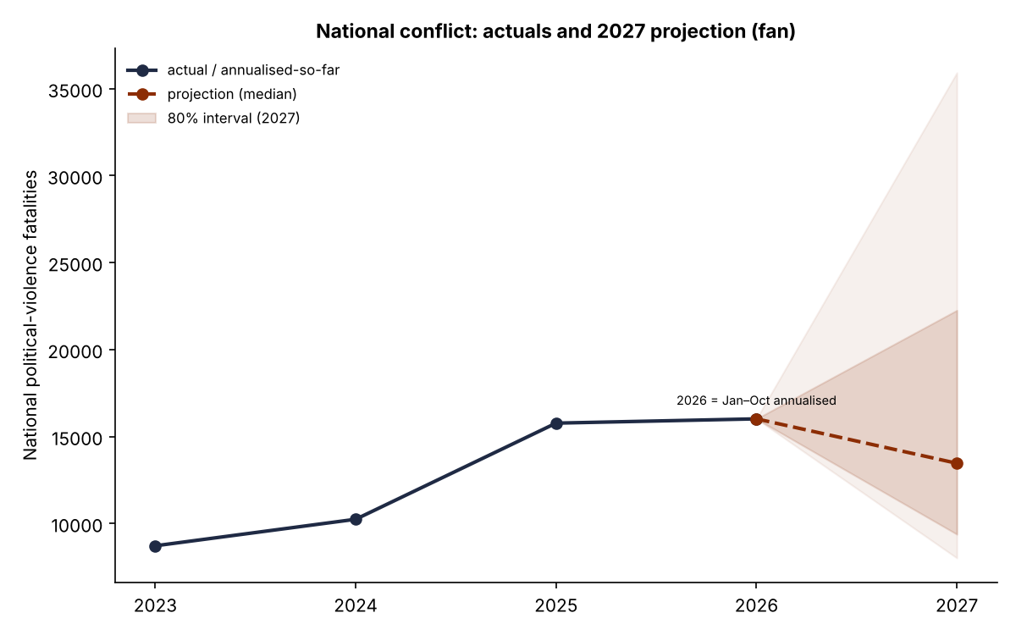
Note. Solid navy = observed (2023–2025) and annualised Jan–Oct 2026; dashed red = baseline median projection; shaded bands = 80% and 95% prediction intervals.

Figure 3
2027 National Projection Under Baseline Versus Illustrative Election-Year Scenarios
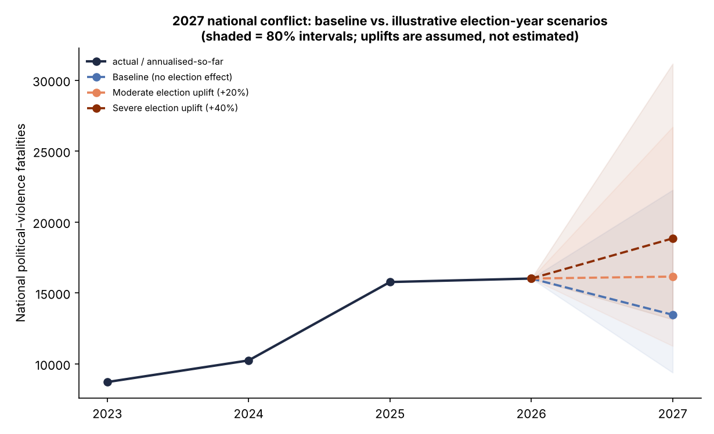
Note. Scenario uplifts (+20%, +40%) are assumed, not estimated; shaded bands = 80% intervals.

Caveats
Forecast skill degrades sharply with horizon. The 2026 forecast is validated (r = .90) and can be reported as a forecast; the 2027 figures are a conditional baseline (“if current dynamics persist”) with wide, compounding uncertainty and no possible validation, and are best presented as a scenario. Both are autoregressive and cannot anticipate structural breaks—new armed actors, major security operations, or election-related shocks—which is precisely where the 2025 forecast residuals (e.g., Kwara) located genuine surprises. The 2026 ACLED data are preliminary and subject to revision.

