Results
Descriptive Epidemiology
Between epidemiological week 6 of 2020 and week 34 of 2026, the Nigeria Centre for Disease Control recorded 7,006 laboratory-confirmed Lassa fever cases and 1,128 associated deaths across the 37 states, an overall case-fatality rate of 16.10%. The burden was highly concentrated: the five most affected states (Ondo, Edo, Bauchi, Taraba, and Ebonyi) together accounted for 86.3% of all confirmed cases, whereas 9 states reported fewer than 5 confirmed cases over the entire period and 1 state (Osun) reported none. Confirmed case counts were strongly right-skewed (M = 189.35, SD = 496.87, Mdn = 13.00, range 0–2,372), as were state incidence rates (M = 4.39, SD = 13.35, Mdn = 0.31 per 100,000, range 0–70.66). Descriptive statistics for the outcome and candidate predictors are presented in Table 1.
Spatial Dependence in Disease Burden
Global spatial autocorrelation was assessed with Moran's I using a row-standardized queen-contiguity spatial weights matrix (mean = 4.70 neighbors; no islands). Log-transformed confirmed case counts were significantly positively autocorrelated, I = .25, z = 2.65, p = .007, indicating that high- and low-burden states were spatially clustered rather than randomly distributed. The clustering persisted, with attenuation, for log incidence, I = .19, z = 2.16, p = .029, and for logit-transformed test positivity, I = .18, z = 2.01, p = .031.
Local indicators of spatial association (local Moran's I, 9,999 permutations) identified a single statistically significant high–high cluster (p < .05) comprising a contiguous central–southern belt: Edo, Taraba, Benue, Plateau, Nasarawa, and Delta. No significant low–low cluster was detected. The choropleth of confirmed cases and the LISA cluster map are shown in Figure 1.
Bivariate Associations
At the bivariate level, state incidence (log scale) was weakly and negatively correlated with latitude (r = −.20), population density (r = −.21), and multidimensional poverty (r = −.09). These simple associations were attenuated by the strongly right-skewed outcome, which was dominated by two low-latitude southern outliers (Ondo and Edo). The predictors were themselves intercorrelated—most strongly latitude with poverty (r = .89), reflecting Nigeria's north–south socioeconomic gradient, and latitude with health-facility density (r = −.57)—so their independent contributions are better assessed in the multivariable models below. These bivariate patterns are displayed in Figure 2. The number of georeferenced Mastomys natalensis occurrences (the primary reservoir) was uncorrelated with incidence (r = −.06); because occurrence records reflect trapping effort rather than abundance (the highest-incidence state, Ondo, had zero records), this variable was retained only as a sensitivity covariate.
Climate Covariates and the Dimensionality of the Risk Gradient
State-level climate normals (WorldClim 2.1, 5-arc-minute zonal means) mirrored the latitudinal gradient closely: annual rainfall ranged from 488 mm in the arid northeast (Yobe) to 3,115 mm on the southern coast (Bayelsa), and the southern high-incidence states (Ondo, Edo, Ebonyi) received 1,659–1,880 mm. Climate was, however, almost perfectly collinear with the other gradient predictors. Centroid latitude was correlated r = −.92 with annual rainfall, r = .95 with rainfall seasonality, r = .97 with temperature seasonality, and r = .89 with multidimensional poverty. Variance inflation factors in a combined model were accordingly extreme (temperature seasonality = 56.0, rainfall seasonality = 41.4, latitude = 34.8, annual rainfall = 9.3, poverty = 7.0), whereas population density was effectively orthogonal (VIF = 1.3). A principal-components analysis of the five gradient variables confirmed their redundancy: the first component alone accounted for 91.3% of their variance. Latitude, climate, and poverty therefore represent a single latent north–south axis and cannot be identified separately at this spatial scale.
A low-collinearity model retaining one mechanistic gradient proxy (rainfall seasonality) together with the orthogonal density term reproduced the pattern cleanly and stably: incidence fell with rainfall seasonality, IRR = 0.31, 95% CI [0.17, 0.57], p < .001, and with population density, IRR = 0.23, 95% CI [0.11, 0.49], p < .001, while reservoir occurrence remained null, IRR = 1.02, 95% CI [0.56, 1.85], p = .944 (Table 3). The instability of the poverty coefficient across specifications (positive when conditioned on rainfall, negative when conditioned on dry-season moisture) further indicates that it carries no risk signal independent of the gradient.
Negative Binomial Regression of Incidence
Given the overdispersed count outcome, state incidence was modeled with negative binomial regression using population as the exposure (equivalent to a log-population offset); the dispersion parameter (α) was freely estimated. Continuous predictors were z-standardized, so incidence-rate ratios (IRRs) express the multiplicative change in incidence per 1 SD increase. Two models are reported in Table 2. Model 1 (ecological–socioeconomic) included the hypothesized structural determinants; Model 2 additionally adjusted for surveillance effort (log suspected cases), proximity to a diagnostic laboratory, and health-facility density.
In Model 1 (α = 2.70), incidence was independently and strongly associated with latitude, IRR = 0.09, 95% CI [0.02, 0.43], z = −3.02, p = .003, and with population density, IRR = 0.30, 95% CI [0.12, 0.78], z = −2.46, p = .014: each standard-deviation increase in latitude or in log population density corresponded to a roughly 91% and 70% lower incidence, respectively. Multidimensional poverty showed a positive but non-significant association once the north–south gradient was accounted for, IRR = 2.51, 95% CI [0.68, 9.18], z = 1.39, p = .166, and reservoir occurrence was null, IRR = 1.03, 95% CI [0.61, 1.76], p = .909.
In Model 2 (α = 0.19), surveillance effort dominated: log suspected cases was by far the strongest correlate of confirmed incidence, IRR = 8.14, 95% CI [6.36, 10.41], z = 16.69, p < .001. Two further detection-related covariates were significant—distance to the nearest diagnostic laboratory, IRR = 1.60, 95% CI [1.19, 2.16], p = .002, and health-facility density, IRR = 1.43, 95% CI [1.11, 1.84], p = .005—whereas latitude (p = .111), population density (p = .069), poverty (p = .631), and reservoir occurrence (p = .228) were no longer statistically significant. Model 2 provided a substantially better fit than Model 1 (AIC = 297.2 vs. 395.2; McFadden R² = .30 vs. .05), consistent with detected cases being governed heavily by where and how intensively surveillance was conducted.
Model Adequacy and Residual Spatial Structure
To confirm that the covariates captured the observed spatial clustering, an ordinary least squares model of log incidence on the full predictor set was examined for residual autocorrelation. The model explained most of the variance, R² = .88, adjusted R² = .85, F(7, 29) = 31.17, p < .001, and its residuals exhibited no remaining spatial dependence (residual Moran's I = −.02, z = 0.82, p = .41). Lagrange multiplier tests were non-significant for both a spatial lag (p = .095; robust p = .060) and a spatial error process (p = .85; robust p = .38). Spatial lag and spatial error maximum-likelihood models yielded small, negatively signed autoregressive parameters (ρ = −.28; λ = −.07) and did not materially improve fit over the non-spatial specification (lag AIC = 43.6, error AIC = 45.2, OLS AIC = 45.3). A non-spatial negative binomial model was therefore retained as adequate at this spatial scale. The relationship between confirmed and suspected cases that underlies Model 2 is illustrated in Figure 3.
Table 1
Descriptive Statistics for Lassa Fever Burden and Candidate State-Level Predictors (N = 37 States)
Variable | M | SD | Mdn | Min | Max
Confirmed cases (cumulative) | 189.35 | 496.87 | 13.00 | 0 | 2,372
Incidence (per 100,000) | 4.39 | 13.35 | 0.31 | 0.00 | 70.66
Test positivity (%) | 9.22 | 7.29 | 8.92 | 0.00 | 35.31
Deaths | 30.49 | 66.67 | 3.00 | 0 | 294
Case-fatality rate (%) | 23.15 | 21.95 | 18.61 | 0.00 | 100.00
Population (millions) | 5.86 | 3.11 | 5.08 | 1.08 | 17.62
Population density (per km²) | 408.24 | 466.03 | 244.00 | 84.50 | 2,676.00
Multidimensional Poverty Index | 0.16 | 0.15 | 0.09 | 0.00 | 0.44
Poverty headcount (%) | 31.22 | 24.88 | 19.95 | 1.11 | 75.36
Health facilities (per 100,000) | 24.70 | 11.83 | 22.80 | 8.90 | 72.90
M. natalensis occurrences (GBIF) | 3.73 | 6.45 | 0.00 | 0 | 24
Centroid latitude (°N) | 8.47 | 2.52 | 8.03 | 4.77 | 13.03
Annual mean temperature (°C) | 26.50 | 0.72 | 26.40 | 24.70 | 28.20
Annual precipitation (mm) | 1,434.10 | 656.60 | 1,326.70 | 488.40 | 3,114.80
Precipitation seasonality (CV) | 92.50 | 27.30 | 82.60 | 63.10 | 148.30
Temperature seasonality (SD ×100) | 173.70 | 72.30 | 151.50 | 88.80 | 320.90
Note. Burden figures are cumulative over epidemiological week 6 of 2020 to week 34 of 2026 (Nigeria Centre for Disease Control weekly situation reports). Population and density from WorldPop bottom-up estimates (v2.0); poverty from the Oxford Poverty and Human Development Initiative subnational Multidimensional Poverty Index (MICS 2021); health facilities from the Humanitarian Data Exchange national registry; reservoir occurrences from the Global Biodiversity Information Facility; climate from WorldClim 2.1 (1970–2000 normals, 5-arc-minute zonal means). The case-fatality rate row summarizes state-level ratios; the population-weighted national rate was 16.10%.
Table 2
Negative Binomial Regression of State Lassa Fever Incidence (N = 37)
Predictor (per 1 SD) | Model 1: Ecological | Model 2: Surveillance-adjusted
Multidimensional Poverty Index | 2.51 [0.68, 9.18] | 1.11 [0.73, 1.69]
Population density (log) | 0.30 [0.12, 0.78]* | 0.80 [0.63, 1.02]
M. natalensis occurrences | 1.03 [0.61, 1.76] | 0.90 [0.76, 1.07]
Centroid latitude | 0.09 [0.02, 0.43]** | 0.71 [0.46, 1.08]
Health facilities (per 100,000) | — | 1.43 [1.11, 1.84]**
Distance to nearest laboratory | — | 1.60 [1.19, 2.16]**
Suspected cases (log) | — | 8.14 [6.36, 10.41]***
Dispersion (α) | 2.70 | 0.19
McFadden R² | .05 | .30
AIC | 395.2 | 297.2
Note. IRR = incidence-rate ratio per one standard-deviation increase in the predictor; models use population as the exposure. Model 2 adds surveillance/detection covariates. Em dashes indicate predictors not entered in Model 1.
*p < .05. **p < .01. ***p < .001.
Table 3
Parsimonious Low-Collinearity Negative Binomial Model of State Lassa Fever Incidence (N = 37)
Predictor (per 1 SD) | IRR | 95% CI | p
Precipitation seasonality (CV) | 0.31 | [0.17, 0.57] | < .001
Population density (log) | 0.23 | [0.11, 0.49] | < .001
M. natalensis occurrences | 1.02 | [0.56, 1.85] | .944
Note. IRR = incidence-rate ratio per one standard-deviation increase; exposure = population; dispersion estimated (α = 2.82). Rainfall seasonality is retained as a single, mechanistic proxy for the collinear north–south gradient (latitude, rainfall, temperature seasonality, and poverty; PCA first component = 91.3% of variance). All variance inflation factors < 1.4.
Figure 1
Spatial Distribution and Local Clustering of Confirmed Lassa Fever Cases Across Nigerian States, 2020–2026
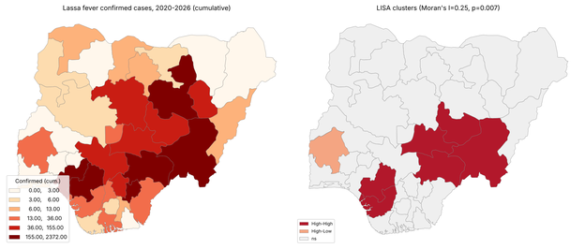
Note. Left: cumulative confirmed cases (quantile classes). Right: local Moran's I (LISA) clusters; the shaded high–high belt (Edo, Taraba, Benue, Plateau, Nasarawa, Delta) was statistically significant at p < .05 (global Moran's I = .25, p = .007).
Figure 2
Bivariate Relationships Between State Lassa Fever Incidence and Its Principal Determinants
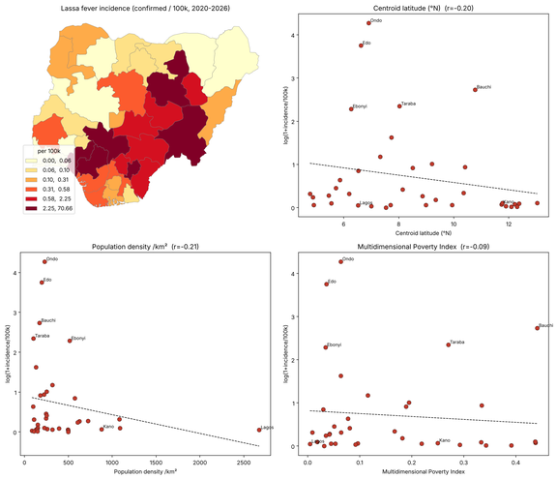
Note. Incidence (log scale, per 100,000) plotted against centroid latitude, population density, and the Multidimensional Poverty Index, with ordinary least squares fit lines and Pearson correlations.
Figure 3
Confirmed Cases as a Function of Surveillance Effort
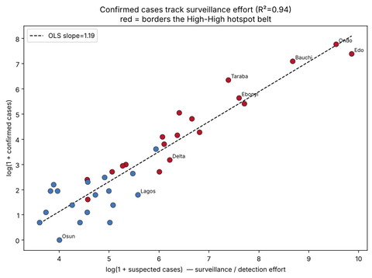
Note. Log-transformed confirmed versus suspected cases by state; states bordering the high–high cluster are highlighted. The near-linear relationship (OLS R² = .94) illustrates the dependence of detected burden on surveillance intensity.

