SANGGUNIANG PANLUNGSOD NG MAYNILA
Human Resource Information System

Human Resource
Information System
HR ADMINISTRATOR — USER ACCEPTANCE TESTING

Product Name: | Human Resource Information System (HRIS_WEB01)
Version: | 1.0
Prepared By: | Complete Digital Solutions, Inc.
Prepared For: | Sangguniang Panlungsod ng Maynila — Human Resource Division
Document Type: | User Acceptance Testing (UAT) Document — HR Administrator
Date: | May 2026
Status: | For UAT Review and Sign-Off

Document Version History

Version | Date | Prepared By | Description
1.0 | May 2026 | Complete Digital Solutions, Inc. | Initial UAT document for HRIS_WEB01 system with annotated screenshots.

1 Objective and Scope

1.1 Objective

The purpose of this User Acceptance Testing (UAT) document is to verify that the Human Resource Information System (HRIS_WEB01) meets all functional requirements agreed upon by the Sangguniang Panlungsod ng Maynila and Complete Digital Solutions, Inc.

This document guides HR staff and designated testers through structured test scenarios for each system module. Each test case includes clear steps, expected results, and a pass/fail outcome to be recorded by the tester. Annotated screenshots are included to show the exact screen the tester should see.

1.2 Scope

The following modules are covered in this UAT:

Module Group | Modules Covered
Core | Login and Authentication, Dashboard, Change Password, User Management
Employee Management | Employee List & Profile, Appointments, Clearance, 201 Files/Documents, Personal Data Sheet (PDS), Service Records, Educational Background, Eligibility, Family Background, Government IDs, Learning and Development, Other Information, References, Voluntary Work/Work Experience
System Settings | Academic Honors, Degree Courses, Degree Levels, Districts, Divisions, Document Type, Eligibility, Employee Status, Learning Type, Position Title, Professions, Salary Grades, Scholarship, Schools, Service Record Signatory, Clearance Approvers

2 Out of Scope

The following items are NOT included in this UAT:

# | Item | Reason
1 | Reports Module | This module is currently hidden and not operational. It will be tested in a future UAT cycle.
2 | Performance / Load Testing | Not in scope for UAT. Covered under a separate technical testing phase.
3 | Infrastructure and Network Testing | Out of scope. Managed by the IT infrastructure team.
4 | Database Administration Tasks | Direct database changes are not tested through the UI in this UAT.
5 | Integration with External Government Systems | HRIS_WEB01 does not integrate with external systems in this version.

3 UAT Environment

All UAT testing must be done in the UAT environment only. Do not test on the production (live) system.

3.1 System Access

UAT System URL: | [To be provided by the system administrator]
Environment: | UAT / Staging Server
Browser Required: | Google Chrome, Microsoft Edge, or Mozilla Firefox (latest version)
Network Access: | Internal office network or designated VPN connection
Test Credentials: | Provided separately by the HR Administrator before UAT begins

3.2 Software Requirements

Programming Language: | Java (Version 1.8 or higher)
Framework: | Spring Boot (Version 2.x or higher)
Database: | MySQL (Version 5.7 or higher)
Web Server: | Apache Tomcat (embedded in Spring Boot)
Operating System: | Windows, Linux, or macOS

3.3 Hardware Requirements

Environment | Minimum Requirement | Recommended
UAT Server | 4 GB RAM, Dual Core CPU, 20 GB storage | 8 GB RAM, Quad Core CPU, 50 GB storage
Tester's Computer | 2 GB RAM, Web Browser | 4 GB RAM, latest Chrome / Edge / Firefox

TIP: If the system is slow to load, check your internet connection first. Close other browser tabs to free up memory.

4 User Roles and Participants

Two user roles exist in HRIS_WEB01. Each role has different access levels and permissions.

4.1 System User Roles

Role | Access Level | Who Uses This Role
Administrator | Full access: Employee Management, System Settings, Clearance approval, PDS editing, 201 file uploads, Service Record management, User credentials management. | HR Officers, HR Administrators
Member | Limited access: View own PDS, file own Clearance request, view own Service Record, view own 201 files, Change Password. | Regular employees and staff

4.2 UAT Participants

Role in UAT | Name | Office / Division
UAT Coordinator
HR Administrator (Tester)
HR Staff Member (Tester)
HR Staff Member (Tester)
System Developer / Support | Complete Digital Solutions, Inc.

5 Entry and Exit Criteria

5.1 Entry Criteria — Before UAT Begins

UAT may only begin when ALL of the following conditions are met:

# | Condition
1 | The HRIS_WEB01 system is deployed and accessible in the UAT environment.
2 | Test user accounts (at least one Administrator and one Member) have been created and credentials distributed.
3 | Sample test data (employee records, settings entries) has been loaded into the UAT environment.
4 | All testers have received this UAT document and a short briefing on how to record results.
5 | All core modules (Login, Dashboard, Employee Management, System Settings) are ready for testing.
6 | The Reports module has been confirmed as hidden/disabled and will NOT be tested.

5.2 Exit Criteria — When UAT Is Complete

UAT is considered complete when ALL of the following are true:

# | Condition
1 | All test cases in this document have been executed and recorded.
2 | At least 95% of test cases have a PASS result.
3 | All Critical and High severity issues have been resolved and re-tested.
4 | The UAT Sign-Off section (Section 9) has been signed by all required participants.

6 Test Data Guidelines

Use the test data below when running the UAT. Do not use real personal data unless specifically required for testing.

6.1 Sample Test Accounts

Account Type | Username | Password | Notes
Administrator | admin_uat | [Provided separately] | Full access to all modules
Member | member_uat | [Provided separately] | Limited access — own records only

6.2 Sample Employee Data

Full Name: | Juan dela Cruz
Position Title: | Administrative Aide IV
Office/Division: | Secretariat Division
Employee Status: | Permanent
Date of Birth: | January 15, 1985
Civil Status: | Married
Eligibility: | Career Service Professional
Educational Attainment: | Bachelor of Science in Political Science

6.3 General Guidelines for Testers

# | Guideline
1 | Always use the UAT environment. Never test on the production (live) system.
2 | Record the Actual Result exactly as you see it on the screen — even if it is wrong.
3 | If a step fails, mark it FAIL, write what happened in the Actual Result column, and log it in the Issues Log (Section 8).
4 | Take a screenshot of any error message or unexpected result. Attach it to the Issues Log.
5 | If you are unsure what a field means, refer to the HRIS Users Manual or ask your UAT Coordinator.
6 | Do not close the browser during a test. Complete each test case fully before taking a break.

TIP: Tip for new testers: Read the full test case — all steps and expected results — BEFORE you start clicking. This helps you understand what to look for.

7 UAT Test Cases

This section contains all UAT test cases grouped by module. Each test case includes an annotated screenshot of the screen for reference.

Column | What to Write
Step / Action | This tells you exactly what to do on screen.
Expected Result | This is what SHOULD happen. Compare this to what you actually see.
Actual Result | Write exactly what happened on your screen — even if it is wrong or different.
Status | Circle or write PASS if the actual result matches the expected result. Write FAIL if it does not.

TIP: Important: Do not skip any test case. Even if a feature looks fine, you must still complete every step and record the result.

7.1 Core Modules

7.1.1 Login and Authentication
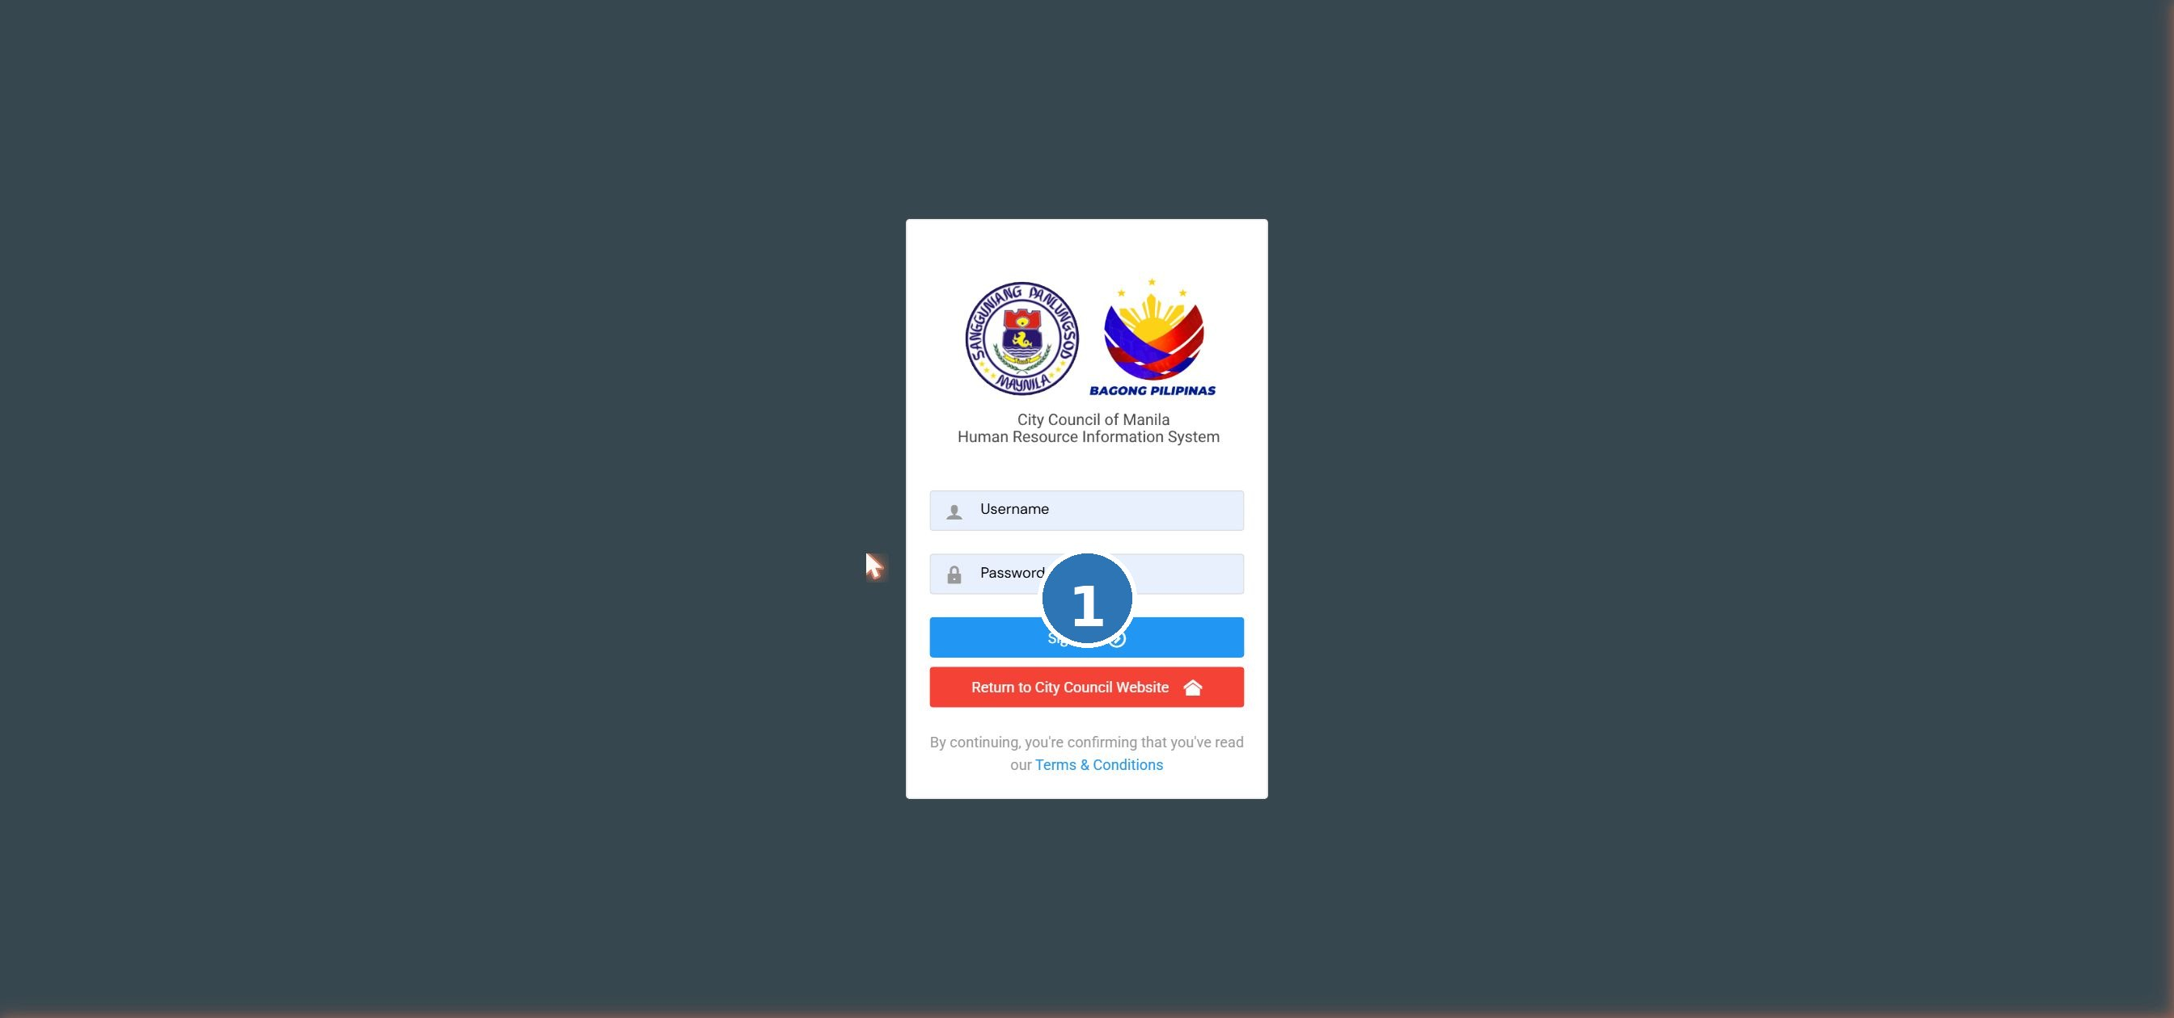
Screenshot: LOG-01 login page

TC-LOG-001 Successful login with valid credentials
Prerequisites / Test Data |  | A valid account exists. The tester knows the correct username and password.
# | Step / Action | Expected Result | Actual Result | Status
1 | Open the HRIS system URL in a web browser (Chrome, Edge, or Firefox). | The Login screen appears with Username and Password fields and a Sign In button. |  | Pass / Fail
2 | Type a valid username in the Username field. | The username is entered correctly in the field. |  | Pass / Fail
3 | Type the correct password in the Password field. | The password is hidden (shown as dots or asterisks). |  | Pass / Fail
4 | Click the Sign In button. | Login is successful. The system redirects to the user's Dashboard page. |  | Pass / Fail

TC-LOG-002 Login fails with an incorrect password
Prerequisites / Test Data |  | A valid account exists. The tester intentionally types the wrong password.
# | Step / Action | Expected Result | Actual Result | Status
1 | Open the Login screen. | The Login screen is displayed. |  | Pass / Fail
2 | Enter a valid username. | The username is entered in the field. |  | Pass / Fail
3 | Enter a wrong or incorrect password. | The password field is filled (masked). |  | Pass / Fail
4 | Click the Sign In button. | An error message appears on screen. The user is NOT redirected. The Login page remains open. |  | Pass / Fail

TC-LOG-003 Login fails when fields are left blank
Prerequisites / Test Data |  | No pre-conditions required.
# | Step / Action | Expected Result | Actual Result | Status
1 | Open the Login screen. | The Login screen is displayed. |  | Pass / Fail
2 | Leave both the Username and Password fields empty. | Both fields remain blank. |  | Pass / Fail
3 | Click the Sign In button. | A validation message appears (e.g., 'This field is required'). The system does not log in. |  | Pass / Fail

TC-LOG-004 User logs out successfully
Prerequisites / Test Data |  | The user is already logged in to the system.
# | Step / Action | Expected Result | Actual Result | Status
1 | From any page, click the Logout option in the navigation menu. | The system ends the current session. |  | Pass / Fail
2 | Observe the screen after clicking Logout. | The user is taken back to the Login screen. The session has ended. |  | Pass / Fail
3 | Try to navigate back to the Dashboard by clicking the browser's Back button. | The system does NOT allow access. The Login screen is shown again. |  | Pass / Fail

TIP: Tip: If you cannot see the Login screen, check that you typed the URL correctly in the browser address bar.

7.1.2 Dashboard
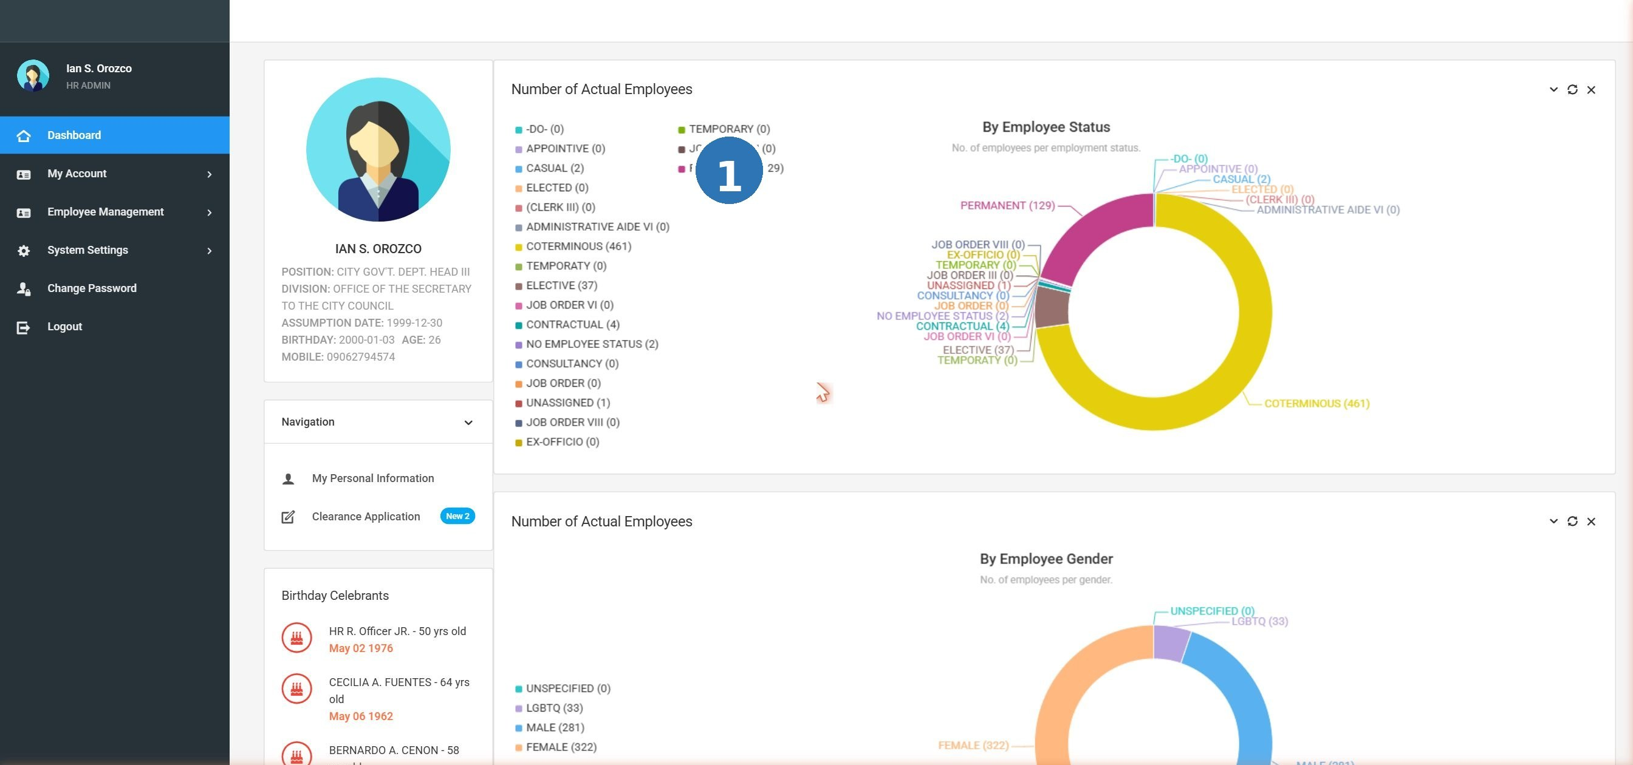
Screenshot: DSH-01 admin dashboard

TC-DSH-001 Member dashboard shows the employee's own summary
Prerequisites / Test Data |  | A Member account is available. Log in with the Member account.
# | Step / Action | Expected Result | Actual Result | Status
1 | Log in using a Member (non-admin) account. | Login is successful. |  | Pass / Fail
2 | Look at the Dashboard/Home page that appears. | The Dashboard shows a summary of the logged-in employee's information. |  | Pass / Fail
3 | Check the left navigation menu. | The menu shows: Dashboard, My Personal Data Sheet, My Clearance, My Service Record, My 201 Files, Change Password, Logout. |  | Pass / Fail

TC-DSH-002 Member cannot access Employee Management or System Settings
Prerequisites / Test Data |  | A Member account is logged in.
# | Step / Action | Expected Result | Actual Result | Status
1 | Look at the left navigation menu on the Member Dashboard. | Employee Management and System Settings are NOT visible in the menu. |  | Pass / Fail
2 | Try to access the Employee Management URL directly in the browser address bar. | The system blocks access. A message or redirect occurs — the Member cannot view other employee records. |  | Pass / Fail

TC-DSH-003 Admin dashboard shows employee analytics and birthday celebrants
Prerequisites / Test Data |  | An Administrator account is available. Log in with the Admin account.
# | Step / Action | Expected Result | Actual Result | Status
1 | Log in using an Administrator account. | Login is successful. |  | Pass / Fail
2 | Look at the Admin Dashboard. | The Dashboard shows employee counts grouped by Employee Status and by Gender. |  | Pass / Fail
3 | Check the Birthday Celebrants section. | A list of employees with birthdays in the current month is displayed. |  | Pass / Fail

TC-DSH-004 Admin dashboard shows all navigation menu items
Prerequisites / Test Data |  | An Administrator account is logged in.
# | Step / Action | Expected Result | Actual Result | Status
1 | Look at the left navigation menu after logging in as Administrator. | The menu includes: Dashboard, My Account section, Employee Management, System Settings, Change Password, Logout. |  | Pass / Fail
2 | Click Employee Management in the menu. | The Employee Management section opens, showing the employee list. |  | Pass / Fail
3 | Click System Settings in the menu. | The System Settings section opens with a list of configuration modules. |  | Pass / Fail

7.1.3 Change Password
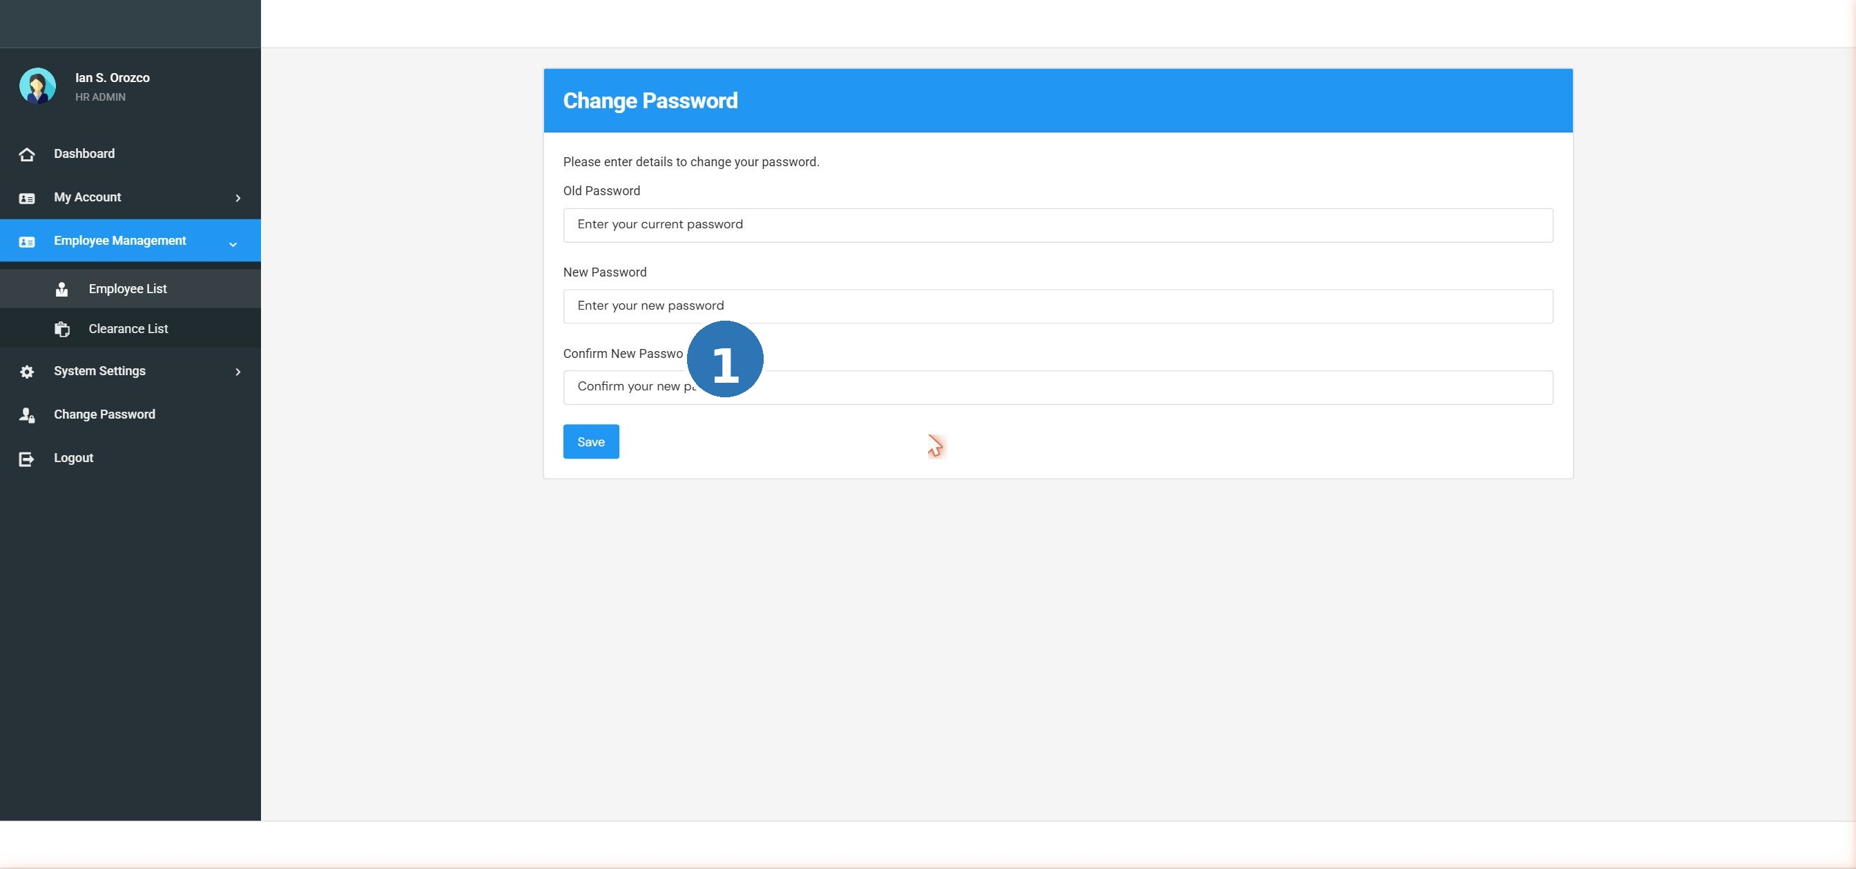
Screenshot: CPW-01 change password

TC-PWD-001 Successfully change password with valid inputs
Prerequisites / Test Data |  | The user is logged in. The current password is known.
# | Step / Action | Expected Result | Actual Result | Status
1 | Click Change Password in the navigation menu. | The Change Password form opens with three fields. |  | Pass / Fail
2 | Enter the current (old) password in the 'Enter Old Password' field. | The field is filled (password is masked). |  | Pass / Fail
3 | Enter a new password in the 'Enter New Password' field. | The new password is entered (masked). |  | Pass / Fail
4 | Re-enter the same new password in the 'Confirm New Password' field. | The confirmation field is filled. |  | Pass / Fail
5 | Click the Save button. | The new password is saved. A success message appears. The user may need to log in again with the new password. |  | Pass / Fail

TC-PWD-002 Wrong old password is rejected
Prerequisites / Test Data |  | The user is logged in.
# | Step / Action | Expected Result | Actual Result | Status
1 | Open the Change Password form. | The form with three password fields is displayed. |  | Pass / Fail
2 | Enter an INCORRECT old password in the 'Enter Old Password' field. | The field is filled. |  | Pass / Fail
3 | Enter any new password and confirm it. | Fields are filled. |  | Pass / Fail
4 | Click Save. | An error message appears (e.g., 'Old password is incorrect'). The password is NOT changed. |  | Pass / Fail

TC-PWD-003 New password and Confirm password do not match
Prerequisites / Test Data |  | The user is logged in.
# | Step / Action | Expected Result | Actual Result | Status
1 | Open the Change Password form. | The form is displayed. |  | Pass / Fail
2 | Enter the correct old password. | Field is filled correctly. |  | Pass / Fail
3 | Enter a new password (e.g., 'NewPass123'). | Field is filled. |  | Pass / Fail
4 | Enter a different value in Confirm New Password (e.g., 'NewPass456'). | Field is filled. |  | Pass / Fail
5 | Click Save. | An error message appears (e.g., 'Passwords do not match'). The password is NOT changed. |  | Pass / Fail

TC-PWD-004 Change Password fields cannot be left blank
Prerequisites / Test Data |  | The user is logged in.
# | Step / Action | Expected Result | Actual Result | Status
1 | Open the Change Password form. | The form is displayed. |  | Pass / Fail
2 | Leave all three password fields empty. | Fields remain blank. |  | Pass / Fail
3 | Click Save. | Validation errors appear on all required fields. The form is not submitted. |  | Pass / Fail

TIP: Tip: Your password is hidden as you type — you will see dots or asterisks. This is normal and keeps your password private.

7.1.4 User Management (System Users)
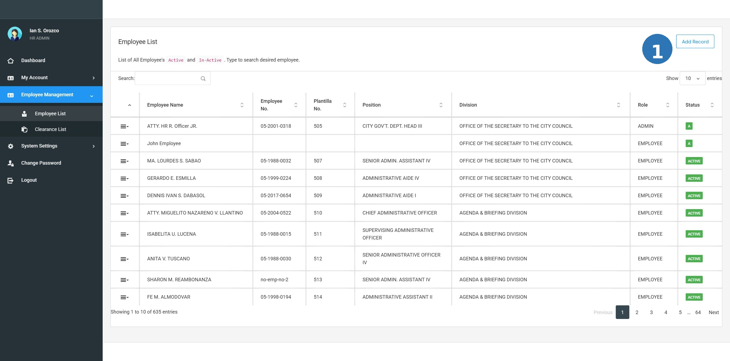
Screenshot: USR-01 user management

The User Management function is accessed through Employee Management. An Administrator sets the role, username, and password for each employee's system account.

TC-USR-001 Admin views the Update Employee Credentials page
Prerequisites / Test Data |  | Admin is logged in. At least one employee record exists in the system.
# | Step / Action | Expected Result | Actual Result | Status
1 | Go to Employee Management and open any employee record. | The employee profile page opens. |  | Pass / Fail
2 | Look for the 'Update Employee Credentials' option or button. | The Update Employee Credentials option is visible and accessible to the Admin. |  | Pass / Fail
3 | Click Update Employee Credentials. | A form appears showing fields for User Role, Username, and Password. |  | Pass / Fail

TC-USR-002 Admin assigns Administrator role to an employee
Prerequisites / Test Data |  | Admin is on the Update Employee Credentials form for a selected employee.
# | Step / Action | Expected Result | Actual Result | Status
1 | Open the Role dropdown. | Two options appear: Administrator and Member. |  | Pass / Fail
2 | Select 'Administrator' from the dropdown. | Administrator is selected. |  | Pass / Fail
3 | Enter a username and set a password. | Fields are filled correctly. |  | Pass / Fail
4 | Click Save. | The employee is saved as an Administrator. They can now log in with full admin access. |  | Pass / Fail

TC-USR-003 Admin assigns Member role to an employee
Prerequisites / Test Data |  | Admin is on the Update Employee Credentials form for a selected employee.
# | Step / Action | Expected Result | Actual Result | Status
1 | Open the Role dropdown. | Two options appear: Administrator and Member. |  | Pass / Fail
2 | Select 'Member' from the dropdown. | Member is selected. |  | Pass / Fail
3 | Enter a username and set a password. | Fields are filled correctly. |  | Pass / Fail
4 | Click Save. | The employee is saved as a Member. They can log in with limited (member-only) access. |  | Pass / Fail

TC-USR-004 Admin updates an existing employee's login credentials
Prerequisites / Test Data |  | An employee account already has a username and password assigned.
# | Step / Action | Expected Result | Actual Result | Status
1 | Open the Update Employee Credentials page for that employee. | The form shows the current username and role. |  | Pass / Fail
2 | Change the username to a new value. | The username field is updated. |  | Pass / Fail
3 | Enter a new password and confirm it. | Password fields are filled. |  | Pass / Fail
4 | Click Save. | The credentials are updated. The employee must use the new username and password at next login. |  | Pass / Fail

7.2 Employee Management

7.2.1 Employee List and Profile

Screenshot: EMP-01 employee list

TC-EMP-001 View the complete list of employees
Prerequisites / Test Data |  | Admin is logged in.
# | Step / Action | Expected Result | Actual Result | Status
1 | Click Employee Management in the navigation menu. | The Employee Management section opens. |  | Pass / Fail
2 | Look at the employee list that appears. | A list of all employees (active and inactive) is displayed with their names and basic details. |  | Pass / Fail
3 | Scroll down to see all records. | All employee records are listed. The list is readable and organized. |  | Pass / Fail

TC-EMP-002 Search for an employee using the Search box
Prerequisites / Test Data |  | Admin is logged in. The employee list is open. At least 2 employees exist.
# | Step / Action | Expected Result | Actual Result | Status
1 | Locate the Search box at the top of the employee list. | A Search box is visible. |  | Pass / Fail
2 | Type a portion of an employee's last name (e.g., 'dela Cruz') in the Search box. | As you type, the list filters to show only matching employees. |  | Pass / Fail
3 | Check the filtered results. | Only employees whose names match the search term are shown. |  | Pass / Fail
4 | Clear the Search box. | The full employee list returns. |  | Pass / Fail

TC-EMP-003 Add a new employee record
Prerequisites / Test Data |  | Admin is logged in. Sample employee data is ready (see Section 6).
# | Step / Action | Expected Result | Actual Result | Status
1 | Click the Add button (or Add Employee) on the Employee Management page. | A form for entering a new employee's information opens. |  | Pass / Fail
2 | Fill in the required fields: full name, position title, division, and employee status. | All fields accept the input correctly. |  | Pass / Fail
3 | Fill in optional fields as available (date of birth, civil status, etc.). | Optional fields also accept input. |  | Pass / Fail
4 | Click Save. | The new employee record is saved. The employee appears in the list. |  | Pass / Fail

TC-EMP-004 Edit an existing employee profile
Prerequisites / Test Data |  | Admin is logged in. At least one employee record exists.
# | Step / Action | Expected Result | Actual Result | Status
1 | Find an employee in the list and click View Record (or the Edit / pencil icon). | The employee's profile form opens with their current information. |  | Pass / Fail
2 | Change one field (e.g., update the division name). | The field can be edited. |  | Pass / Fail
3 | Click Save. | The updated information is saved. The employee list reflects the change. |  | Pass / Fail

TC-EMP-005 Upload an employee profile photo
Prerequisites / Test Data |  | Admin is logged in. An employee record is open. A photo file (JPG or PNG) is ready.
# | Step / Action | Expected Result | Actual Result | Status
1 | Open an employee's profile record. | The employee profile form is displayed. |  | Pass / Fail
2 | Find the profile photo upload area and click it or the Upload button. | A file browser or upload dialog opens. |  | Pass / Fail
3 | Select a valid photo file (JPG or PNG format). | The selected file is queued for upload. |  | Pass / Fail
4 | Save the record. | The photo is uploaded and displayed in the employee's profile. |  | Pass / Fail

TIP: Tip: Use the Search box at the top of the employee list to find a name quickly. Type just the last name — you do not need to type the full name.

7.2.2 Appointments
The Appointments module records each employee's official appointment history — position title, salary grade, signing date, entrance date, nature of appointment, and related details. Administrators add and manage these records; employees can view their own.

Step 1 — Select employee from Appointments List:
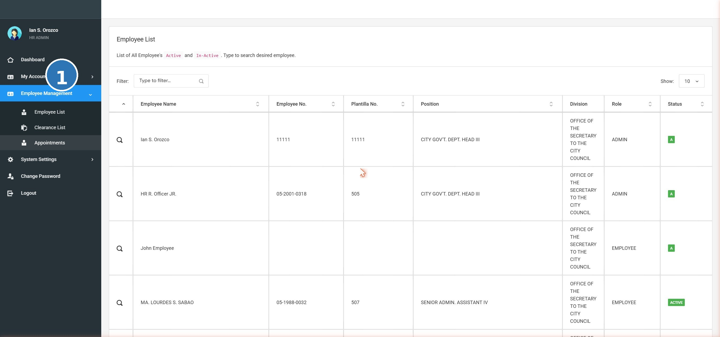
Screenshot: APT-LIST appointments list
Step 2 — Appointment Records page (with Add Record button):
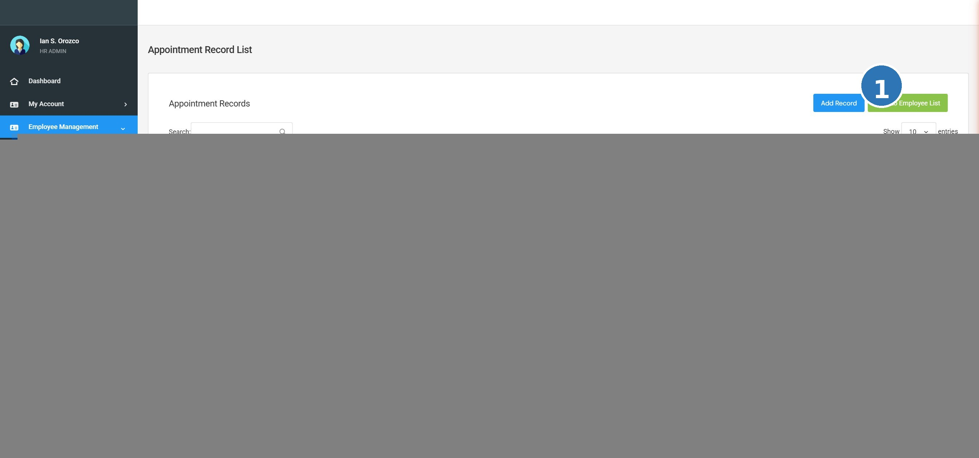
Screenshot: APT-01 appointments

TC-APT-001 View appointment records for an employee
Prerequisites / Test Data |  | Admin is logged in. An employee record with at least one appointment exists.
# | Step / Action | Expected Result | Actual Result | Status
1 | Open an employee's record in Employee Management. | The employee's profile page opens. |  | Pass / Fail
2 | Navigate to the Appointments section or tab. | The Appointments section is displayed. |  | Pass / Fail
3 | Check the list of appointments shown. | Appointment records are listed with relevant details (position, date, status, etc.). |  | Pass / Fail

TC-APT-002 Add a new appointment record
Prerequisites / Test Data |  | Admin is logged in. An employee record is open.
# | Step / Action | Expected Result | Actual Result | Status
1 | Go to the Appointments section of the employee record. | The Appointments section opens. |  | Pass / Fail
2 | Click Add to enter a new appointment. | An appointment form or input row appears. |  | Pass / Fail
3 | Fill in the required appointment fields (e.g., position, effective date, nature of appointment). | All fields accept the input. |  | Pass / Fail
4 | Click Save. | The new appointment record is saved and appears in the list. |  | Pass / Fail

TC-APT-003 Edit an existing appointment record
Prerequisites / Test Data |  | Admin is logged in. At least one appointment record exists for the employee.
# | Step / Action | Expected Result | Actual Result | Status
1 | Open an employee's Appointments section. | Appointment records are listed. |  | Pass / Fail
2 | Click the Edit button for any appointment record. | The edit form opens with current values. |  | Pass / Fail
3 | Update one or more fields. | Fields can be changed. |  | Pass / Fail
4 | Click Save. | Changes are saved. The updated record appears in the list. |  | Pass / Fail

7.2.3 Clearance
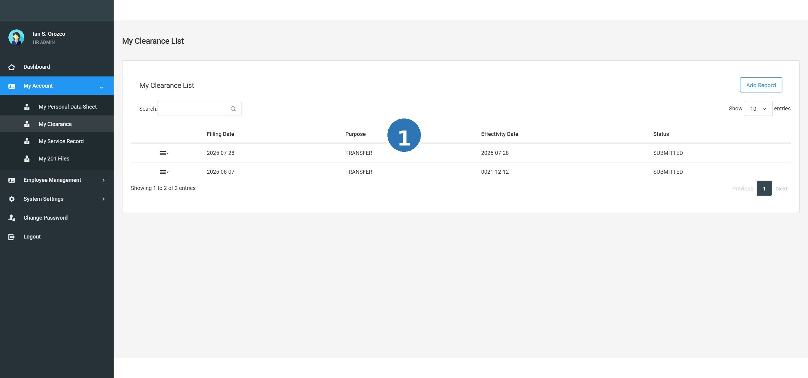
Screenshot: CLR-01 my clearance

The Clearance module has two sides: the Member files a clearance request; the Administrator approves or disapproves it.

TC-CLR-001 Member files a clearance request
Prerequisites / Test Data |  | A Member account is logged in. The employee does not have an existing pending clearance request.
# | Step / Action | Expected Result | Actual Result | Status
1 | Log in as a Member and go to My Clearance in the navigation menu. | The My Clearance page opens. |  | Pass / Fail
2 | Click the 'File Request' button. | A clearance request form or dialog opens. |  | Pass / Fail
3 | Fill in any required fields and click Submit. | The clearance request is submitted successfully. |  | Pass / Fail

TC-CLR-002 Filed clearance request shows as New (Pending)
Prerequisites / Test Data |  | A Member has just filed a clearance request (see TC-CLR-001).
# | Step / Action | Expected Result | Actual Result | Status
1 | Stay on the My Clearance page after submitting. | The page refreshes or updates. |  | Pass / Fail
2 | Look at the status of the newly filed request. | The request appears with the status 'New' or 'Pending'. It is waiting for Admin action. |  | Pass / Fail

TC-CLR-003 Admin views clearance requests in the Clearance List
Prerequisites / Test Data |  | Admin is logged in. At least one clearance request has been filed by a Member.
# | Step / Action | Expected Result | Actual Result | Status
1 | Go to Employee Management and click Clearance List. | The Clearance List page opens. |  | Pass / Fail
2 | Check the three tabs: New, Approved, Disapproved. | Three tabs are visible. The New tab shows pending requests. The other tabs show processed requests. |  | Pass / Fail
3 | Click the New tab. | All pending (unprocessed) clearance requests are listed. |  | Pass / Fail

Admin Clearance List View:
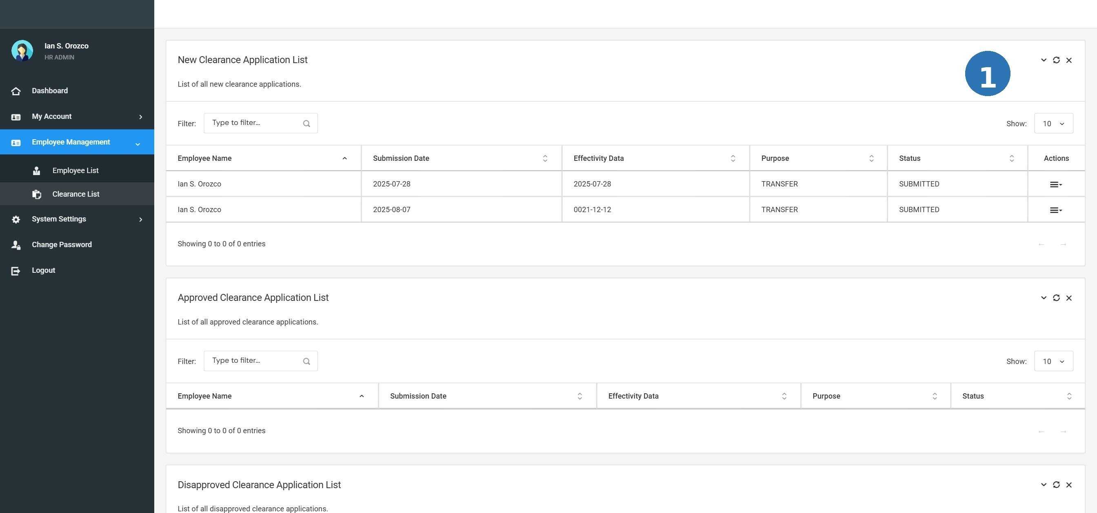
Screenshot: CLR-02 clearance list
TC-CLR-004 Admin approves a clearance request
Prerequisites / Test Data |  | Admin is logged in. At least one New clearance request exists in the Clearance List.
# | Step / Action | Expected Result | Actual Result | Status
1 | Open the Clearance List and go to the New tab. | Pending requests are shown. |  | Pass / Fail
2 | Find a clearance request and click the Approve button. | A confirmation dialog may appear. Proceed to approve. |  | Pass / Fail
3 | Confirm the approval. | The request status changes to 'Approved'. It moves to the Approved tab. |  | Pass / Fail
4 | Log in as the Member who filed the request and check My Clearance. | The member can see their clearance is now marked as Approved. |  | Pass / Fail

TC-CLR-005 Admin disapproves a clearance request
Prerequisites / Test Data |  | Admin is logged in. At least one New clearance request exists.
# | Step / Action | Expected Result | Actual Result | Status
1 | Open the Clearance List and go to the New tab. | Pending requests are listed. |  | Pass / Fail
2 | Find a request and click the Disapprove button. | A confirmation or reason dialog may appear. |  | Pass / Fail
3 | Confirm the disapproval. | The request status changes to 'Disapproved'. It moves to the Disapproved tab. The Member is notified. |  | Pass / Fail

7.2.4 201 Files / Documents
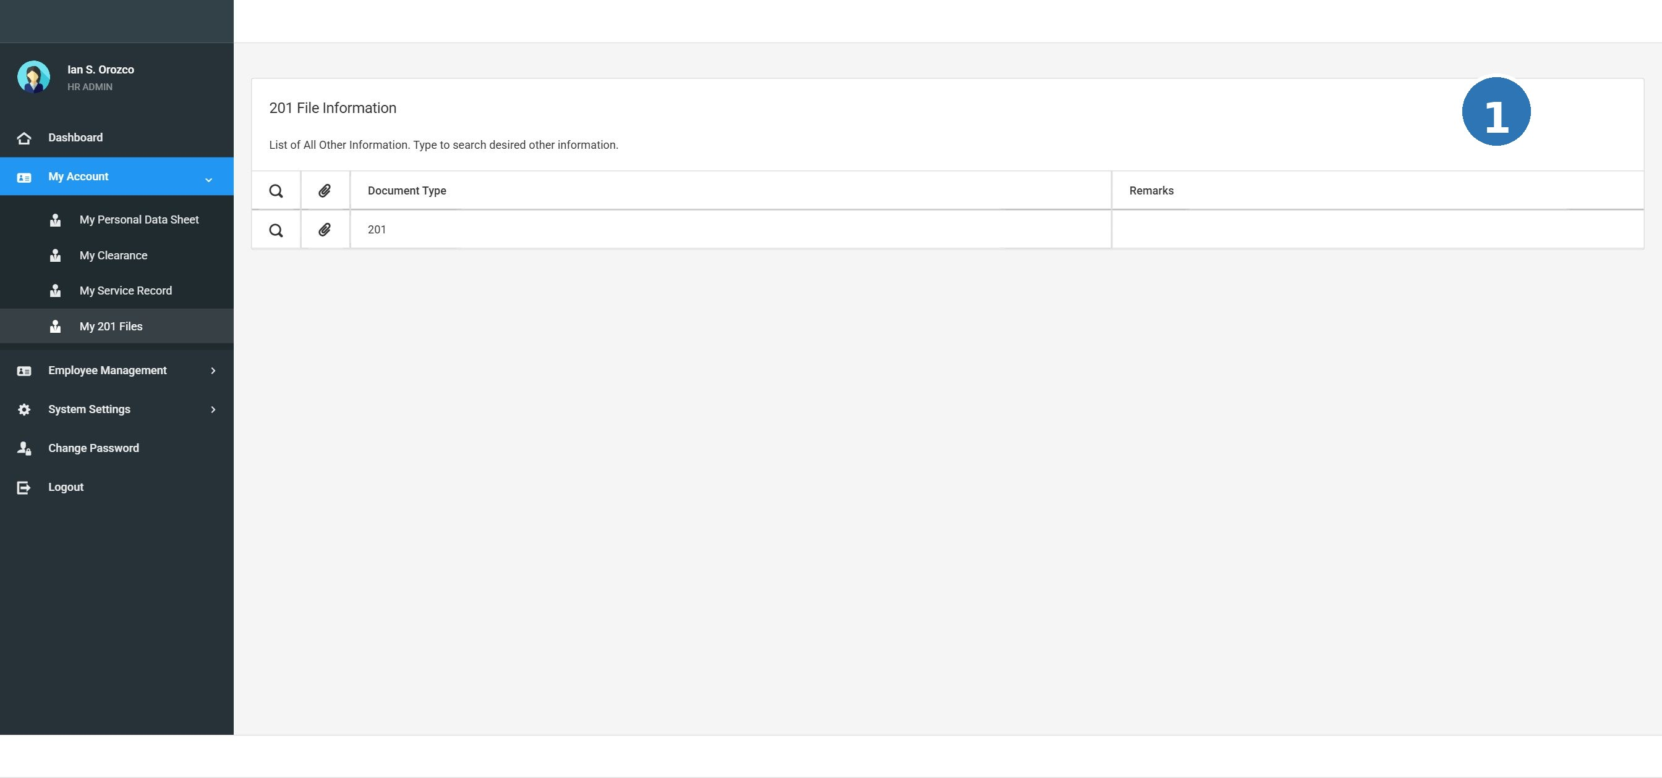
Screenshot: F201-01 201 files

201 Files are official employment documents attached to an employee's record by the HR Administrator. Regular Members can only view and download — they cannot upload files.

TC-F201-001 Admin views 201 files for an employee
Prerequisites / Test Data |  | Admin is logged in. An employee record with at least one 201 document exists.
# | Step / Action | Expected Result | Actual Result | Status
1 | Open an employee's profile in Employee Management. | Employee profile opens. |  | Pass / Fail
2 | Click the '201 Documents' option. | The 201 files section opens. |  | Pass / Fail
3 | Check the list of documents shown. | Documents are listed with: Document Type, Date Uploaded, Notes, and a View/Download button. |  | Pass / Fail

TC-F201-002 Admin uploads a new 201 document
Prerequisites / Test Data |  | Admin is logged in. An employee record is open. A sample file (PDF or image) is ready to upload.
# | Step / Action | Expected Result | Actual Result | Status
1 | Go to the 201 Documents section of the employee. | The 201 files list is shown. |  | Pass / Fail
2 | Click Attach or Upload. | An upload form or dialog opens. |  | Pass / Fail
3 | Select the Document Type from the dropdown (e.g., 'NBI Clearance'). | The document type is selected. |  | Pass / Fail
4 | Enter the Upload Date and any optional Notes. | Fields are filled correctly. |  | Pass / Fail
5 | Browse and select the file to attach. | The file is selected. |  | Pass / Fail
6 | Click Save or Upload. | The document is uploaded. It appears in the 201 files list. |  | Pass / Fail

TC-F201-003 Member views and downloads their own 201 files
Prerequisites / Test Data |  | Member is logged in. The member's 201 files have at least one document uploaded by the Admin.
# | Step / Action | Expected Result | Actual Result | Status
1 | Log in as a Member and go to My 201 Files in the navigation menu. | The My 201 Files page opens. |  | Pass / Fail
2 | Check the list of files shown. | The member can see a list of 201 documents with Document Type, Date Uploaded, and Notes. |  | Pass / Fail
3 | Click View/Download on any document. | The file opens or downloads for viewing. |  | Pass / Fail

TC-F201-004 Uploading a file of the same document type replaces the previous file
Prerequisites / Test Data |  | Admin is logged in. An employee already has a 201 document of type 'NBI Clearance'.
# | Step / Action | Expected Result | Actual Result | Status
1 | Go to the employee's 201 Documents section. | Existing documents are listed. |  | Pass / Fail
2 | Upload a NEW file and select the SAME Document Type (e.g., 'NBI Clearance'). | The upload form accepts the new file. |  | Pass / Fail
3 | Save the upload. | The new file replaces the old one. Only the new 'NBI Clearance' file remains in the list. |  | Pass / Fail

7.2.5 Personal Data Sheet (PDS)
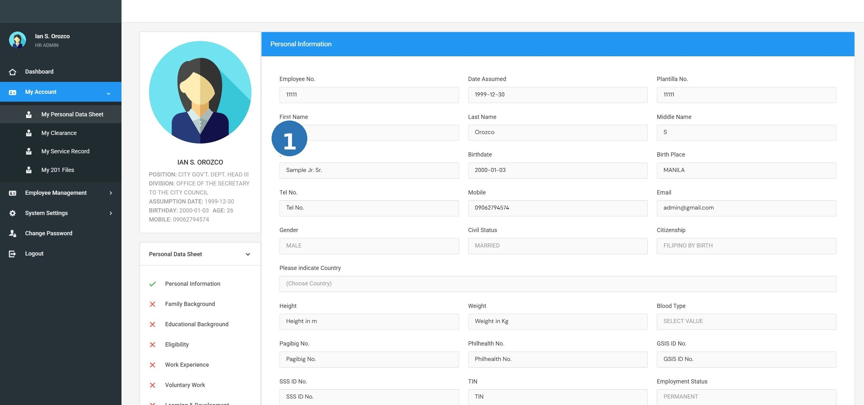
Screenshot: PDS-01 personal info

The PDS is the CS Form No. 212. It contains comprehensive information about each employee. Members can view their own PDS but cannot edit it. Only Administrators can edit PDS data.

TC-PDS-001 Member views their own Personal Data Sheet
Prerequisites / Test Data |  | Member is logged in.
# | Step / Action | Expected Result | Actual Result | Status
1 | Click My Personal Data Sheet in the navigation menu. | The PDS page opens. |  | Pass / Fail
2 | Check that the PDS sections are visible. | All sections appear: Personal Information, Family Background, Educational Background, Civil Service Eligibility, Work Experience, Voluntary Work, Learning & Development, Other Information. |  | Pass / Fail

TC-PDS-002 All PDS sections display correct information
Prerequisites / Test Data |  | Member is logged in. Sample employee data has been entered.
# | Step / Action | Expected Result | Actual Result | Status
1 | Open My Personal Data Sheet. | PDS page is displayed. |  | Pass / Fail
2 | Check the Personal Information section. | Name, birth date, place of birth, civil status, citizenship, and other personal details are shown correctly. |  | Pass / Fail
3 | Check the Family Background section. | Spouse, parents, and children information is shown. |  | Pass / Fail
4 | Check the Educational Background section. | Schools attended, degrees earned, honors, and scholarships are displayed. |  | Pass / Fail
5 | Check remaining sections (Eligibility, Work Experience, etc.). | All sections display the correct data that was entered. |  | Pass / Fail

TC-PDS-003 Member can view and print the PDS
Prerequisites / Test Data |  | Member is logged in. PDS data is filled in.
# | Step / Action | Expected Result | Actual Result | Status
1 | Open My Personal Data Sheet. | PDS page opens. |  | Pass / Fail
2 | Click the 'View Personal Data Sheet' or Print button. | A print-ready CS Form No. 212 PDF opens in the browser or a new tab. |  | Pass / Fail
3 | Check that the PDF shows all information correctly. | The PDF is formatted as CS Form No. 212 and shows the employee's data. |  | Pass / Fail

TC-PDS-004 Admin edits PDS information for an employee
Prerequisites / Test Data |  | Admin is logged in. An employee record is selected.
# | Step / Action | Expected Result | Actual Result | Status
1 | Open the employee record in Employee Management. | Employee profile opens. |  | Pass / Fail
2 | Go to the PDS section (View Record) and locate a field to update. | PDS fields are editable for the Admin. |  | Pass / Fail
3 | Update a field (e.g., change the civil status). | The field accepts the new value. |  | Pass / Fail
4 | Click Save. | The change is saved. The PDS now shows the updated value. |  | Pass / Fail

TC-PDS-005 Member cannot edit PDS fields
Prerequisites / Test Data |  | Member is logged in.
# | Step / Action | Expected Result | Actual Result | Status
1 | Log in as a Member and open My Personal Data Sheet. | The PDS page opens. |  | Pass / Fail
2 | Try to click on any field to edit the data. | Fields are read-only and cannot be edited. No Save button is visible for the Member. |  | Pass / Fail

7.2.6 Service Records
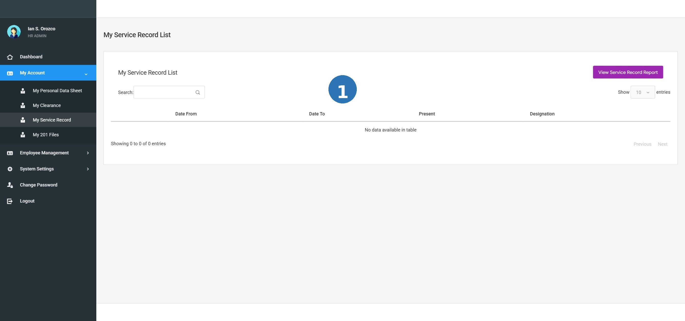
Screenshot: SVC-01 service record

Service Records show a chronological history of an employee's government service. Administrators can add and edit entries. Members can view and print their own record.

TC-SRV-001 View a service record for an employee
Prerequisites / Test Data |  | Admin is logged in. An employee has at least one service record entry.
# | Step / Action | Expected Result | Actual Result | Status
1 | Open an employee's profile in Employee Management. | Employee profile opens. |  | Pass / Fail
2 | Click View Service Record. | The service record list opens. |  | Pass / Fail
3 | Check the columns shown. | Columns shown: Inclusive Dates, Position Title, Office/Division, Monthly Salary, Status, Government Service. |  | Pass / Fail

TC-SRV-002 Admin adds a new service record entry
Prerequisites / Test Data |  | Admin is logged in. An employee record is open.
# | Step / Action | Expected Result | Actual Result | Status
1 | Open the employee's Service Record section. | The service record list is shown. |  | Pass / Fail
2 | Click Add. | A form or input row appears for a new service entry. |  | Pass / Fail
3 | Fill in required fields: inclusive dates (start and end), position title, office/division, monthly salary, and appointment status. | All fields accept the input. |  | Pass / Fail
4 | Click Save. | The new entry is saved and appears in the service record list. |  | Pass / Fail

TC-SRV-003 Admin edits an existing service record entry
Prerequisites / Test Data |  | Admin is logged in. At least one service record entry exists for the employee.
# | Step / Action | Expected Result | Actual Result | Status
1 | Open the employee's Service Record section. | Service record entries are listed. |  | Pass / Fail
2 | Click Edit on any entry. | The edit form opens with the current values. |  | Pass / Fail
3 | Change one value (e.g., update the monthly salary). | The field accepts the new value. |  | Pass / Fail
4 | Click Save. | The changes are saved. The updated entry appears in the list. |  | Pass / Fail

TC-SRV-004 Print / generate the Service Record Report
Prerequisites / Test Data |  | An employee has at least one service record entry.
# | Step / Action | Expected Result | Actual Result | Status
1 | Open the employee's Service Record section. | Service records are listed. |  | Pass / Fail
2 | Click the Print button in the upper right of the screen. | A printable Service Record Report PDF is generated and opens in the browser. |  | Pass / Fail
3 | Check that the report shows all entries and includes the authorized signatory name. | The PDF is correctly formatted and shows all service history entries. |  | Pass / Fail

TIP: Tip: Members can also print their own service record. Go to My Service Record, then click the Print button at the top-right corner.

7.2.7 Educational Background
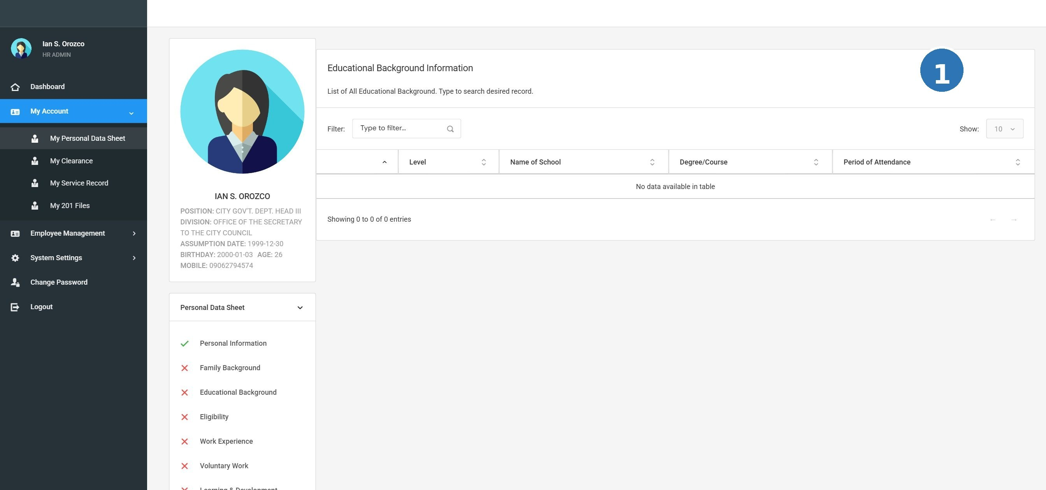
Screenshot: PDS-03 educational background

TC-EDU-001 View the Educational Background section
Prerequisites / Test Data |  | Admin is logged in. An employee record is open.
# | Step / Action | Expected Result | Actual Result | Status
1 | Open an employee's PDS record. | The PDS/profile page opens. |  | Pass / Fail
2 | Navigate to the Educational Background section. | The Educational Background section is visible with any existing entries. |  | Pass / Fail
3 | Check the data displayed. | Records show: school name, degree level, degree course, academic honors, scholarships, and year graduated. |  | Pass / Fail

TC-EDU-002 Add an educational background record
Prerequisites / Test Data |  | Admin is logged in. An employee record is open.
# | Step / Action | Expected Result | Actual Result | Status
1 | Go to the Educational Background section of the employee. | The section opens. |  | Pass / Fail
2 | Click Add. | An entry form appears. |  | Pass / Fail
3 | Select or fill in: Degree Level, Degree Course, School Name, and Year Graduated. | All fields accept the input. Dropdowns show the correct list of options. |  | Pass / Fail
4 | Optionally fill in Academic Honors and Scholarship. Click Save. | The educational record is saved and appears in the list. |  | Pass / Fail

TC-EDU-003 Required fields are validated in Educational Background
Prerequisites / Test Data |  | Admin is logged in. An employee record is open.
# | Step / Action | Expected Result | Actual Result | Status
1 | Open the Add form for Educational Background. | The entry form appears. |  | Pass / Fail
2 | Leave all required fields blank and click Save. | Validation error messages appear on all required fields. The record is NOT saved. |  | Pass / Fail
3 | Fill in only the required fields and click Save. | The record is saved successfully. |  | Pass / Fail

7.2.8 Eligibility
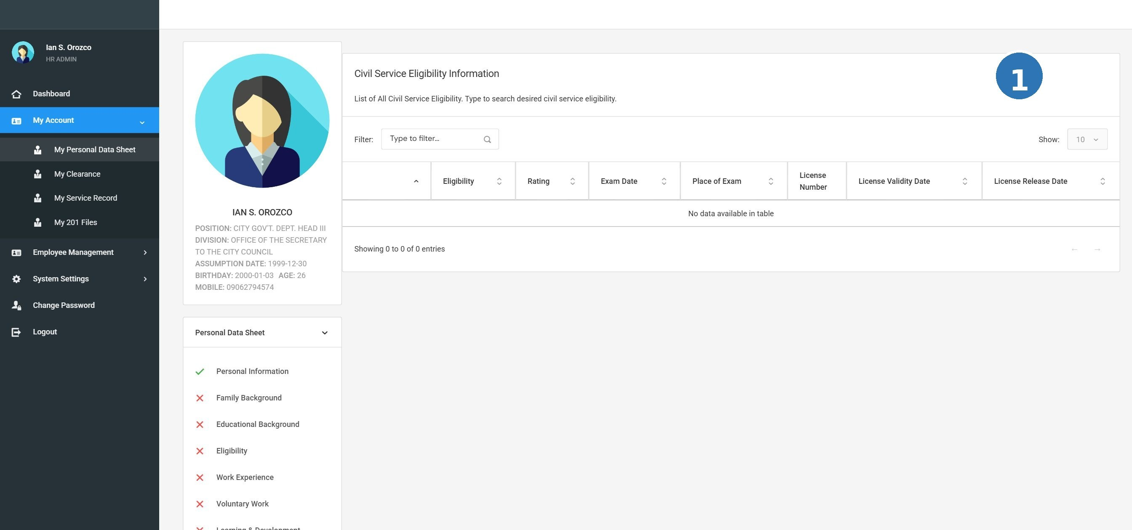
Screenshot: PDS-04 eligibility

TC-ELG-001 View Civil Service Eligibility records
Prerequisites / Test Data |  | Admin is logged in. An employee record with at least one eligibility entry exists.
# | Step / Action | Expected Result | Actual Result | Status
1 | Open an employee's PDS record and navigate to the Civil Service Eligibility section. | Eligibility records are displayed with: Eligibility Type, Rating, Date, Place, License Number. |  | Pass / Fail

TC-ELG-002 Add an eligibility record
Prerequisites / Test Data |  | Admin is logged in. An employee record is open.
# | Step / Action | Expected Result | Actual Result | Status
1 | Go to the Civil Service Eligibility section and click Add. | An entry form appears. |  | Pass / Fail
2 | Select the Eligibility Type from the dropdown (e.g., 'Career Service Professional'). | The dropdown shows the available eligibility types from System Settings. |  | Pass / Fail
3 | Fill in Rating, Date of Examination, Place, and License Number (if applicable). | Fields accept the input. |  | Pass / Fail
4 | Click Save. | The eligibility record is saved and appears in the list. |  | Pass / Fail

TC-ELG-003 Edit an eligibility record
Prerequisites / Test Data |  | Admin is logged in. At least one eligibility entry exists.
# | Step / Action | Expected Result | Actual Result | Status
1 | Open the Civil Service Eligibility section and click Edit on a record. | The edit form opens with current values. |  | Pass / Fail
2 | Update a field (e.g., change the rating). | The field can be updated. |  | Pass / Fail
3 | Click Save. | Changes are saved. The updated record appears in the list. |  | Pass / Fail

7.2.9 Family Background
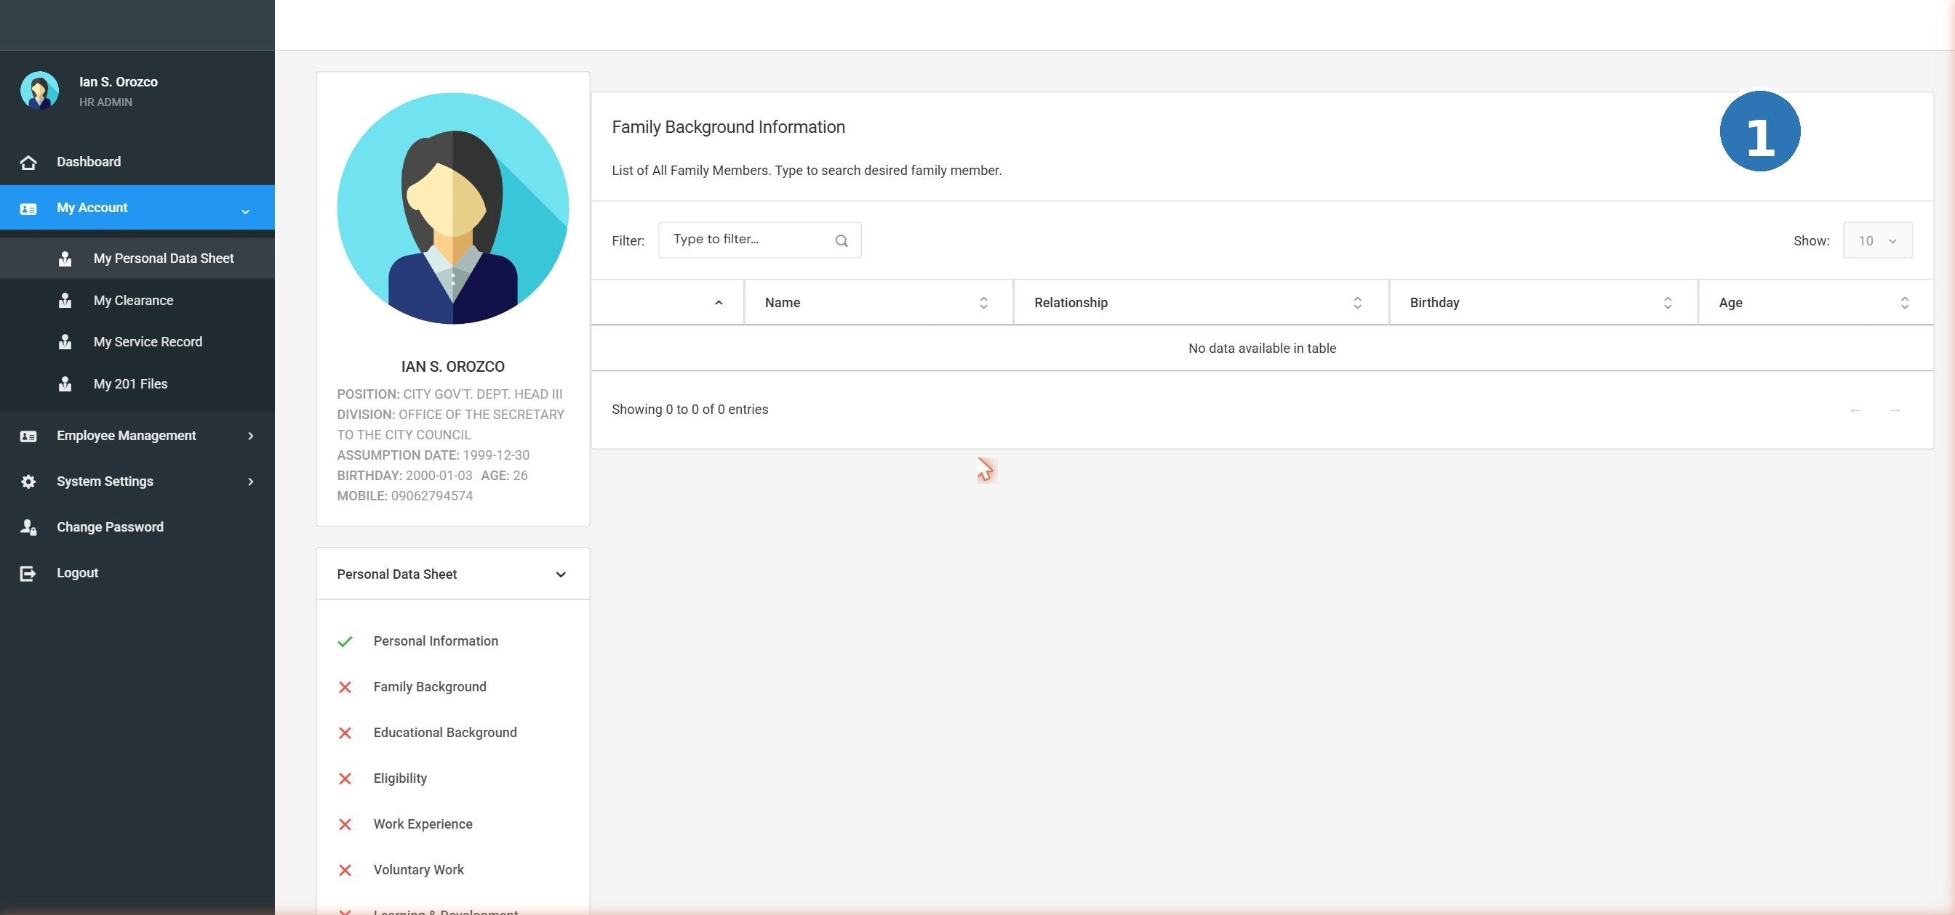
Screenshot: PDS-02 family background

TC-FAM-001 View the Family Background section
Prerequisites / Test Data |  | Admin is logged in. An employee record is open.
# | Step / Action | Expected Result | Actual Result | Status
1 | Open an employee's PDS and navigate to Family Background. | The Family Background section is displayed. |  | Pass / Fail
2 | Check the information shown. | Spouse, parents, and children details are visible. |  | Pass / Fail

TC-FAM-002 Add or edit family member information
Prerequisites / Test Data |  | Admin is logged in. An employee record is open.
# | Step / Action | Expected Result | Actual Result | Status
1 | Go to the Family Background section. | The section opens. |  | Pass / Fail
2 | Fill in or update spouse information (name, occupation, employer). | Fields accept the input. |  | Pass / Fail
3 | Add at least one child's name and date of birth. | Child entry is accepted. |  | Pass / Fail
4 | Click Save. | Family background information is saved. |  | Pass / Fail

TC-FAM-003 Edit existing family background information
Prerequisites / Test Data |  | Admin is logged in. Family background data exists for an employee.
# | Step / Action | Expected Result | Actual Result | Status
1 | Open Family Background and click Edit on an existing entry. | The edit form opens. |  | Pass / Fail
2 | Change one value. | Field is editable. |  | Pass / Fail
3 | Click Save. | Updated family information is saved. |  | Pass / Fail

7.2.10 Government IDs
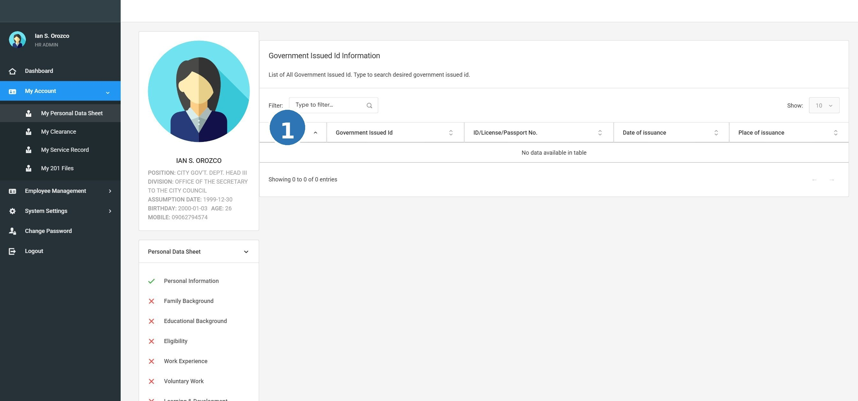
Screenshot: PDS-10 government id

TC-GID-001 View government ID records
Prerequisites / Test Data |  | Admin is logged in. An employee record with government ID entries exists.
# | Step / Action | Expected Result | Actual Result | Status
1 | Open an employee's PDS and navigate to the Government IDs section. | Government ID records are shown. |  | Pass / Fail
2 | Check the data displayed. | Government IDs are listed with ID type, ID number, date of issue, and place of issue. |  | Pass / Fail

TC-GID-002 Add a new government ID
Prerequisites / Test Data |  | Admin is logged in. An employee record is open.
# | Step / Action | Expected Result | Actual Result | Status
1 | Go to the Government IDs section and click Add. | An entry form appears. |  | Pass / Fail
2 | Fill in the ID type, ID number, date of issue, and place of issue. | Fields accept the input. |  | Pass / Fail
3 | Click Save. | The government ID is saved and appears in the list. |  | Pass / Fail

TC-GID-003 Edit a government ID record
Prerequisites / Test Data |  | Admin is logged in. At least one government ID exists for the employee.
# | Step / Action | Expected Result | Actual Result | Status
1 | Go to Government IDs and click Edit on a record. | Edit form opens. |  | Pass / Fail
2 | Update a field. | Field accepts new value. |  | Pass / Fail
3 | Click Save. | Changes are saved. |  | Pass / Fail

7.2.11 Learning and Development
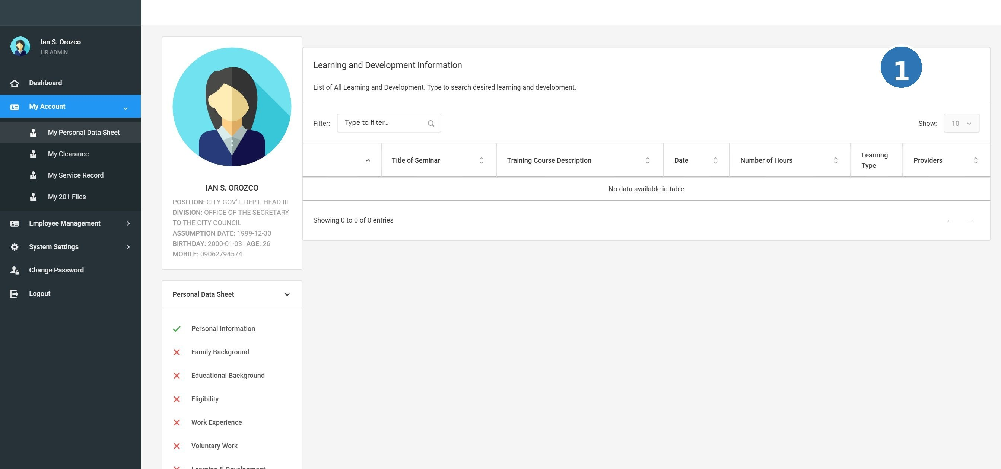
Screenshot: PDS-07 learning development

TC-LND-001 View Learning and Development records
Prerequisites / Test Data |  | Admin is logged in. An employee record with L&D entries exists.
# | Step / Action | Expected Result | Actual Result | Status
1 | Open an employee's PDS and go to the Learning & Development section. | L&D records are displayed. |  | Pass / Fail
2 | Check the information shown. | Training programs and seminars are listed with: title, duration, dates, conducted by, type, and venue. |  | Pass / Fail

TC-LND-002 Add a training or seminar record
Prerequisites / Test Data |  | Admin is logged in. An employee record is open.
# | Step / Action | Expected Result | Actual Result | Status
1 | Go to the Learning & Development section and click Add. | An entry form appears. |  | Pass / Fail
2 | Fill in: Training Title, Duration (hours), Inclusive Dates, Conducted By, Learning Type, and Venue. | Fields accept the input. Learning Type dropdown shows options from System Settings. |  | Pass / Fail
3 | Click Save. | The L&D record is saved and appears in the list. |  | Pass / Fail

TC-LND-003 Edit an existing L&D entry
Prerequisites / Test Data |  | Admin is logged in. At least one L&D entry exists.
# | Step / Action | Expected Result | Actual Result | Status
1 | Click Edit on any L&D record. | The edit form opens. |  | Pass / Fail
2 | Update one field (e.g., the training title). | Field can be changed. |  | Pass / Fail
3 | Click Save. | The updated record is saved. |  | Pass / Fail

7.2.12 Other Information
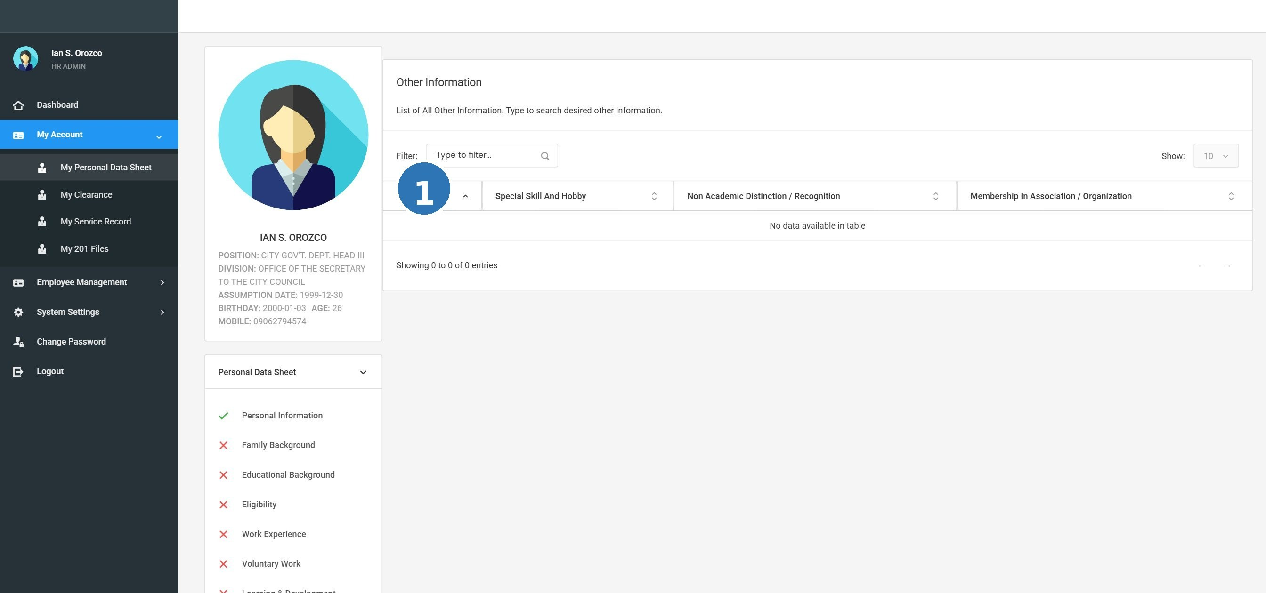
Screenshot: PDS-08 other info

TC-OTH-001 View the Other Information section
Prerequisites / Test Data |  | Admin is logged in. An employee record is open.
# | Step / Action | Expected Result | Actual Result | Status
1 | Open an employee's PDS and navigate to Other Information. | The Other Information section is displayed. |  | Pass / Fail
2 | Check the data shown. | Special skills, recognitions, associations, and references are listed. |  | Pass / Fail

TC-OTH-002 Add or edit Other Information records
Prerequisites / Test Data |  | Admin is logged in. An employee record is open.
# | Step / Action | Expected Result | Actual Result | Status
1 | Go to the Other Information section. | The section opens. |  | Pass / Fail
2 | Add a special skill (e.g., 'Proficient in Microsoft Excel'). | The entry is accepted. |  | Pass / Fail
3 | Add a recognition or award. | The entry is accepted. |  | Pass / Fail
4 | Click Save. | All other information entries are saved. |  | Pass / Fail

7.2.13 References
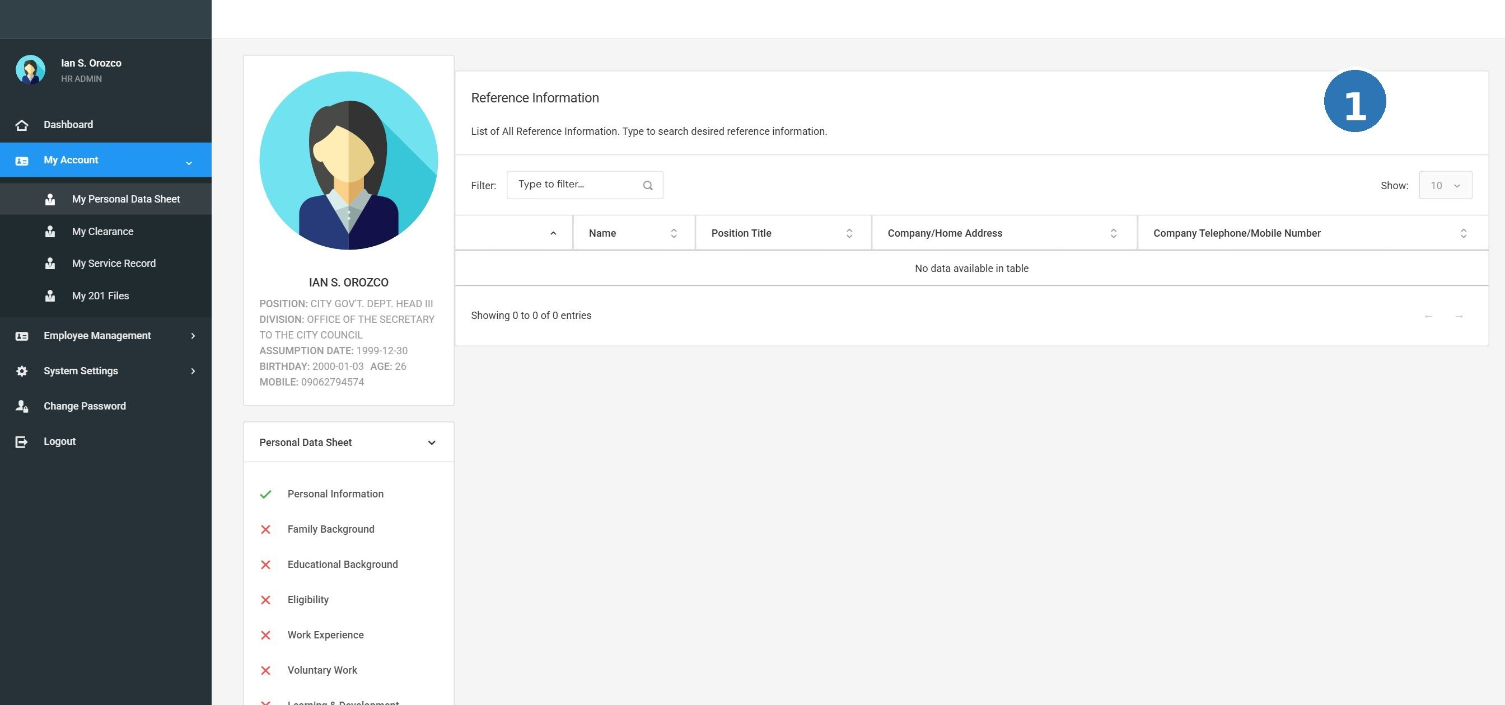
Screenshot: PDS-09 references

TC-REF-001 View character references
Prerequisites / Test Data |  | Admin is logged in. An employee record with references exists.
# | Step / Action | Expected Result | Actual Result | Status
1 | Open an employee's PDS and navigate to the References section. | The References section is displayed. |  | Pass / Fail
2 | Check the data shown. | References are listed with: Full Name, Position/Title, Address, and Contact Number. |  | Pass / Fail

TC-REF-002 Add a new character reference
Prerequisites / Test Data |  | Admin is logged in. An employee record is open.
# | Step / Action | Expected Result | Actual Result | Status
1 | Go to the References section and click Add. | An entry form appears. |  | Pass / Fail
2 | Fill in: Full Name, Position/Title, Address, and Contact Number. | All fields accept the input. |  | Pass / Fail
3 | Click Save. | The reference is saved and appears in the list. |  | Pass / Fail

TC-REF-003 Edit an existing reference
Prerequisites / Test Data |  | Admin is logged in. At least one reference exists.
# | Step / Action | Expected Result | Actual Result | Status
1 | Click Edit on an existing reference. | The edit form opens. |  | Pass / Fail
2 | Update one field (e.g., the contact number). | Field accepts the new value. |  | Pass / Fail
3 | Click Save. | Updated reference is saved. |  | Pass / Fail

7.2.14 Voluntary Work / Work Experience
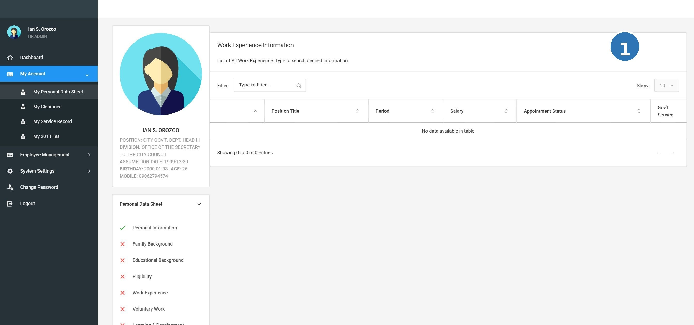
Screenshot: PDS-05 work experience

TC-VWK-001 View voluntary work and work experience entries
Prerequisites / Test Data |  | Admin is logged in. An employee record with work experience entries exists.
# | Step / Action | Expected Result | Actual Result | Status
1 | Open an employee's PDS and navigate to the Work Experience or Voluntary Work section. | Work experience entries are displayed. |  | Pass / Fail
2 | Check the data shown. | Entries show: Organization/Employer, Inclusive Dates, Position, Salary Grade (if applicable), and type (government or private). |  | Pass / Fail

TC-VWK-002 Add a new work experience entry
Prerequisites / Test Data |  | Admin is logged in. An employee record is open.
# | Step / Action | Expected Result | Actual Result | Status
1 | Go to the Work Experience / Voluntary Work section and click Add. | An entry form appears. |  | Pass / Fail
2 | Fill in: Organization/Employer, Inclusive Dates (from-to), Position Title, Monthly Salary, and whether it is Government Service. | All fields accept the input. |  | Pass / Fail
3 | Click Save. | The work entry is saved and appears in the list. |  | Pass / Fail

TC-VWK-003 Edit an existing work experience entry
Prerequisites / Test Data |  | Admin is logged in. At least one work experience entry exists.
# | Step / Action | Expected Result | Actual Result | Status
1 | Click Edit on a work experience entry. | The edit form opens with current values. |  | Pass / Fail
2 | Update one field. | Field accepts the new value. |  | Pass / Fail
3 | Click Save. | The update is saved. |  | Pass / Fail

7.3 System Settings

System Settings contain all the reference/lookup data used throughout HRIS_WEB01. Only HR Administrators can access and manage these settings. Each module below follows the same pattern: View the list, Add a new record, and Edit an existing record.

TIP: Tip: When you add a new item in System Settings, it will appear as an option in the dropdown menus throughout the system (e.g., in the PDS, Service Record, 201 Files).

7.3.1 Academic Honors
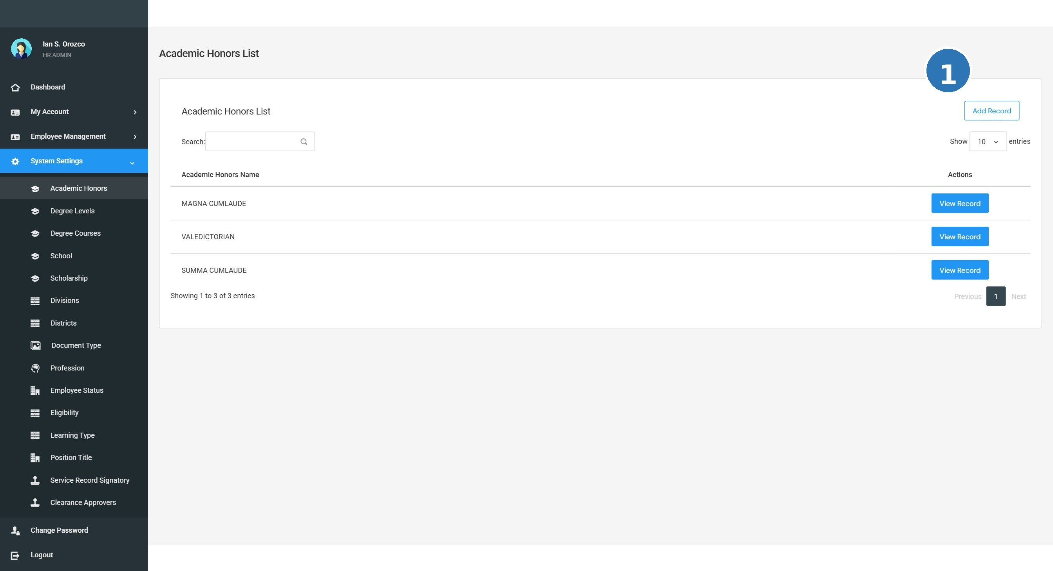
Screenshot: SS-01 academic honors

TC-SS-AH-001 View the list of Academic Honors
Prerequisites / Test Data |  | Admin is logged in. System Settings is accessible in the navigation menu.
# | Step / Action | Expected Result | Actual Result | Status
1 | Click System Settings in the left navigation menu. | The System Settings section opens with a list of modules. |  | Pass / Fail
2 | Click Academic Honors from the list. | A list of existing academic honors records is displayed in a table. |  | Pass / Fail
3 | Check that the records are readable and correctly displayed. | All records are visible. The table is clear and well-organized. |  | Pass / Fail

TC-SS-AH-002 Add a new Academic Honors record
Prerequisites / Test Data |  | Admin is logged in. The Academic Honors list page is open.
# | Step / Action | Expected Result | Actual Result | Status
1 | Click the Add button on the Academic Honors page. | A form or input dialog opens for entering a new academic honors record. |  | Pass / Fail
2 | Fill in the required field(s): Honor Name. | The field(s) accept the input correctly. |  | Pass / Fail
3 | Click Save (or Submit). | The new academic honors record is saved successfully. A confirmation message appears. |  | Pass / Fail
4 | Check the list for the newly added record. | The new academic honors record appears in the list with correct information. |  | Pass / Fail

TC-SS-AH-003 Edit an existing Academic Honors record
Prerequisites / Test Data |  | Admin is logged in. At least one academic honors record exists in the list.
# | Step / Action | Expected Result | Actual Result | Status
1 | On the Academic Honors list, click the Edit button (pencil icon) next to any record. | The edit form opens and shows the current values of that record. |  | Pass / Fail
2 | Change the value in one or more fields. | The fields can be edited and updated. |  | Pass / Fail
3 | Click Save. | The changes are saved. The updated record appears correctly in the list. |  | Pass / Fail

7.3.2 Degree Courses
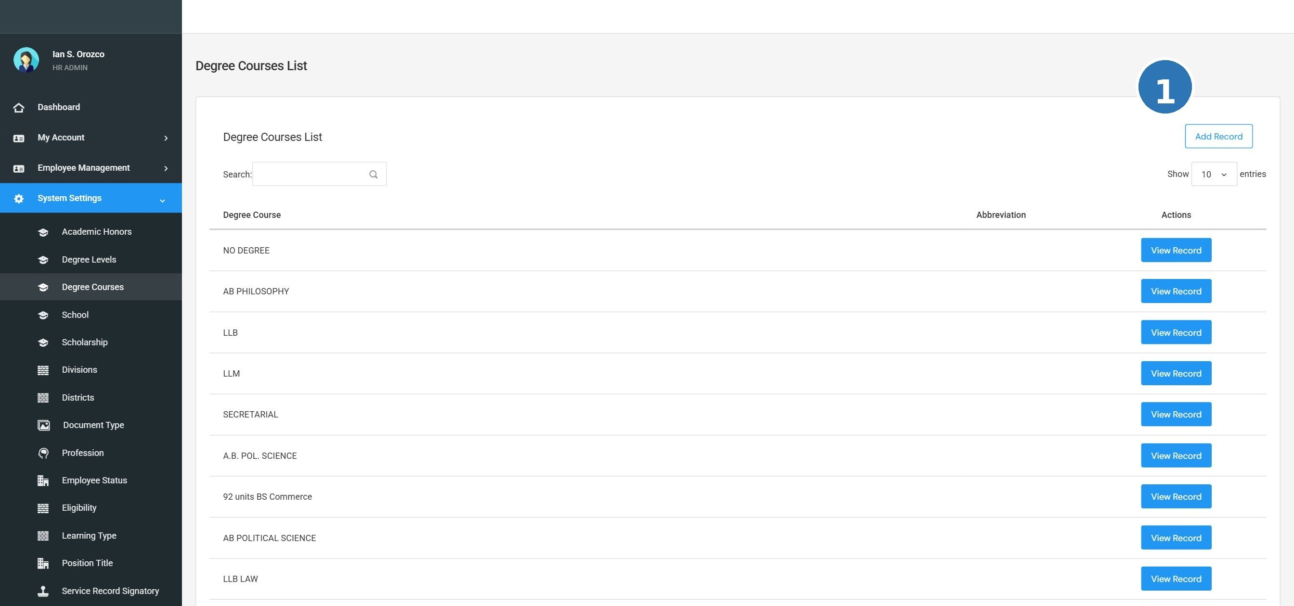
Screenshot: SS-03 degree courses

TC-SS-DC-001 View the list of Degree Courses
Prerequisites / Test Data |  | Admin is logged in. System Settings is accessible in the navigation menu.
# | Step / Action | Expected Result | Actual Result | Status
1 | Click System Settings in the left navigation menu. | The System Settings section opens with a list of modules. |  | Pass / Fail
2 | Click Degree Courses from the list. | A list of existing degree courses records is displayed in a table. |  | Pass / Fail
3 | Check that the records are readable and correctly displayed. | All records are visible. The table is clear and well-organized. |  | Pass / Fail

TC-SS-DC-002 Add a new Degree Courses record
Prerequisites / Test Data |  | Admin is logged in. The Degree Courses list page is open.
# | Step / Action | Expected Result | Actual Result | Status
1 | Click the Add button on the Degree Courses page. | A form or input dialog opens for entering a new degree courses record. |  | Pass / Fail
2 | Fill in the required field(s): Course Name. | The field(s) accept the input correctly. |  | Pass / Fail
3 | Click Save (or Submit). | The new degree courses record is saved successfully. A confirmation message appears. |  | Pass / Fail
4 | Check the list for the newly added record. | The new degree courses record appears in the list with correct information. |  | Pass / Fail

TC-SS-DC-003 Edit an existing Degree Courses record
Prerequisites / Test Data |  | Admin is logged in. At least one degree courses record exists in the list.
# | Step / Action | Expected Result | Actual Result | Status
1 | On the Degree Courses list, click the Edit button (pencil icon) next to any record. | The edit form opens and shows the current values of that record. |  | Pass / Fail
2 | Change the value in one or more fields. | The fields can be edited and updated. |  | Pass / Fail
3 | Click Save. | The changes are saved. The updated record appears correctly in the list. |  | Pass / Fail

7.3.3 Degree Levels
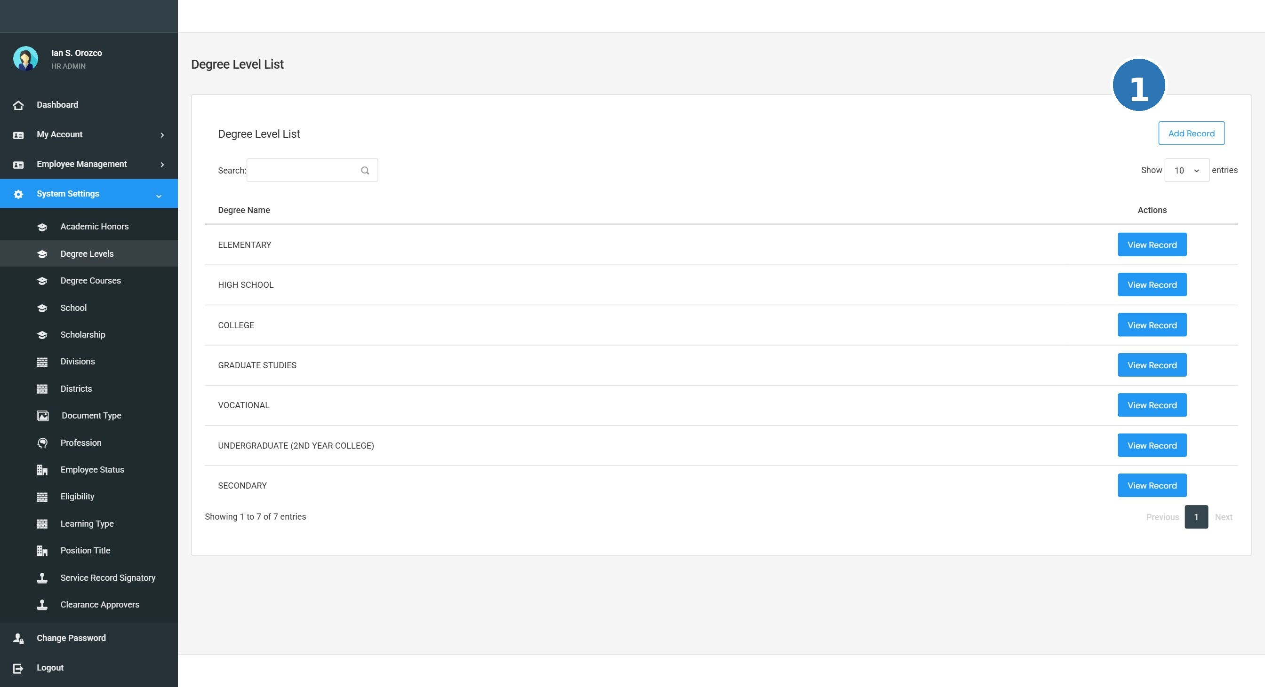
Screenshot: SS-02 degree levels

TC-SS-DL-001 View the list of Degree Levels
Prerequisites / Test Data |  | Admin is logged in. System Settings is accessible in the navigation menu.
# | Step / Action | Expected Result | Actual Result | Status
1 | Click System Settings in the left navigation menu. | The System Settings section opens with a list of modules. |  | Pass / Fail
2 | Click Degree Levels from the list. | A list of existing degree levels records is displayed in a table. |  | Pass / Fail
3 | Check that the records are readable and correctly displayed. | All records are visible. The table is clear and well-organized. |  | Pass / Fail

TC-SS-DL-002 Add a new Degree Levels record
Prerequisites / Test Data |  | Admin is logged in. The Degree Levels list page is open.
# | Step / Action | Expected Result | Actual Result | Status
1 | Click the Add button on the Degree Levels page. | A form or input dialog opens for entering a new degree levels record. |  | Pass / Fail
2 | Fill in the required field(s): Level Name. | The field(s) accept the input correctly. |  | Pass / Fail
3 | Click Save (or Submit). | The new degree levels record is saved successfully. A confirmation message appears. |  | Pass / Fail
4 | Check the list for the newly added record. | The new degree levels record appears in the list with correct information. |  | Pass / Fail

TC-SS-DL-003 Edit an existing Degree Levels record
Prerequisites / Test Data |  | Admin is logged in. At least one degree levels record exists in the list.
# | Step / Action | Expected Result | Actual Result | Status
1 | On the Degree Levels list, click the Edit button (pencil icon) next to any record. | The edit form opens and shows the current values of that record. |  | Pass / Fail
2 | Change the value in one or more fields. | The fields can be edited and updated. |  | Pass / Fail
3 | Click Save. | The changes are saved. The updated record appears correctly in the list. |  | Pass / Fail

7.3.4 Districts
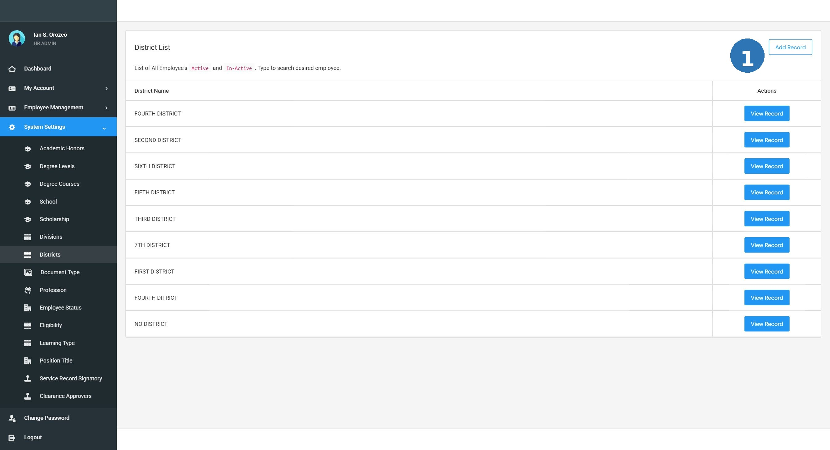
Screenshot: SS-07 districts

TC-SS-DI-001 View the list of Districts
Prerequisites / Test Data |  | Admin is logged in. System Settings is accessible in the navigation menu.
# | Step / Action | Expected Result | Actual Result | Status
1 | Click System Settings in the left navigation menu. | The System Settings section opens with a list of modules. |  | Pass / Fail
2 | Click Districts from the list. | A list of existing districts records is displayed in a table. |  | Pass / Fail
3 | Check that the records are readable and correctly displayed. | All records are visible. The table is clear and well-organized. |  | Pass / Fail

TC-SS-DI-002 Add a new Districts record
Prerequisites / Test Data |  | Admin is logged in. The Districts list page is open.
# | Step / Action | Expected Result | Actual Result | Status
1 | Click the Add button on the Districts page. | A form or input dialog opens for entering a new districts record. |  | Pass / Fail
2 | Fill in the required field(s): District Name. | The field(s) accept the input correctly. |  | Pass / Fail
3 | Click Save (or Submit). | The new districts record is saved successfully. A confirmation message appears. |  | Pass / Fail
4 | Check the list for the newly added record. | The new districts record appears in the list with correct information. |  | Pass / Fail

TC-SS-DI-003 Edit an existing Districts record
Prerequisites / Test Data |  | Admin is logged in. At least one districts record exists in the list.
# | Step / Action | Expected Result | Actual Result | Status
1 | On the Districts list, click the Edit button (pencil icon) next to any record. | The edit form opens and shows the current values of that record. |  | Pass / Fail
2 | Change the value in one or more fields. | The fields can be edited and updated. |  | Pass / Fail
3 | Click Save. | The changes are saved. The updated record appears correctly in the list. |  | Pass / Fail

7.3.5 Divisions
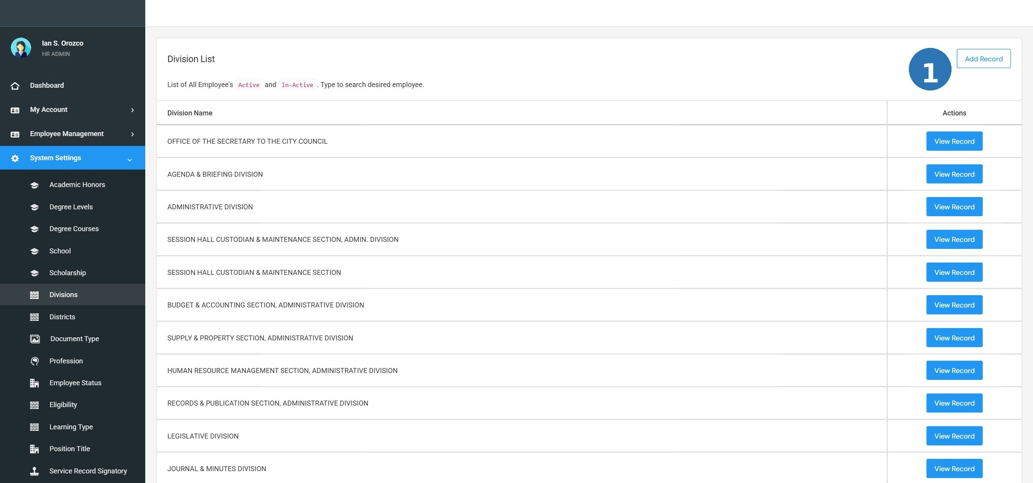
Screenshot: SS-06 divisions

TC-SS-DV-001 View the list of Divisions
Prerequisites / Test Data |  | Admin is logged in. System Settings is accessible in the navigation menu.
# | Step / Action | Expected Result | Actual Result | Status
1 | Click System Settings in the left navigation menu. | The System Settings section opens with a list of modules. |  | Pass / Fail
2 | Click Divisions from the list. | A list of existing divisions records is displayed in a table. |  | Pass / Fail
3 | Check that the records are readable and correctly displayed. | All records are visible. The table is clear and well-organized. |  | Pass / Fail

TC-SS-DV-002 Add a new Divisions record
Prerequisites / Test Data |  | Admin is logged in. The Divisions list page is open.
# | Step / Action | Expected Result | Actual Result | Status
1 | Click the Add button on the Divisions page. | A form or input dialog opens for entering a new divisions record. |  | Pass / Fail
2 | Fill in the required field(s): Division Name. | The field(s) accept the input correctly. |  | Pass / Fail
3 | Click Save (or Submit). | The new divisions record is saved successfully. A confirmation message appears. |  | Pass / Fail
4 | Check the list for the newly added record. | The new divisions record appears in the list with correct information. |  | Pass / Fail

TC-SS-DV-003 Edit an existing Divisions record
Prerequisites / Test Data |  | Admin is logged in. At least one divisions record exists in the list.
# | Step / Action | Expected Result | Actual Result | Status
1 | On the Divisions list, click the Edit button (pencil icon) next to any record. | The edit form opens and shows the current values of that record. |  | Pass / Fail
2 | Change the value in one or more fields. | The fields can be edited and updated. |  | Pass / Fail
3 | Click Save. | The changes are saved. The updated record appears correctly in the list. |  | Pass / Fail

7.3.6 Document Type
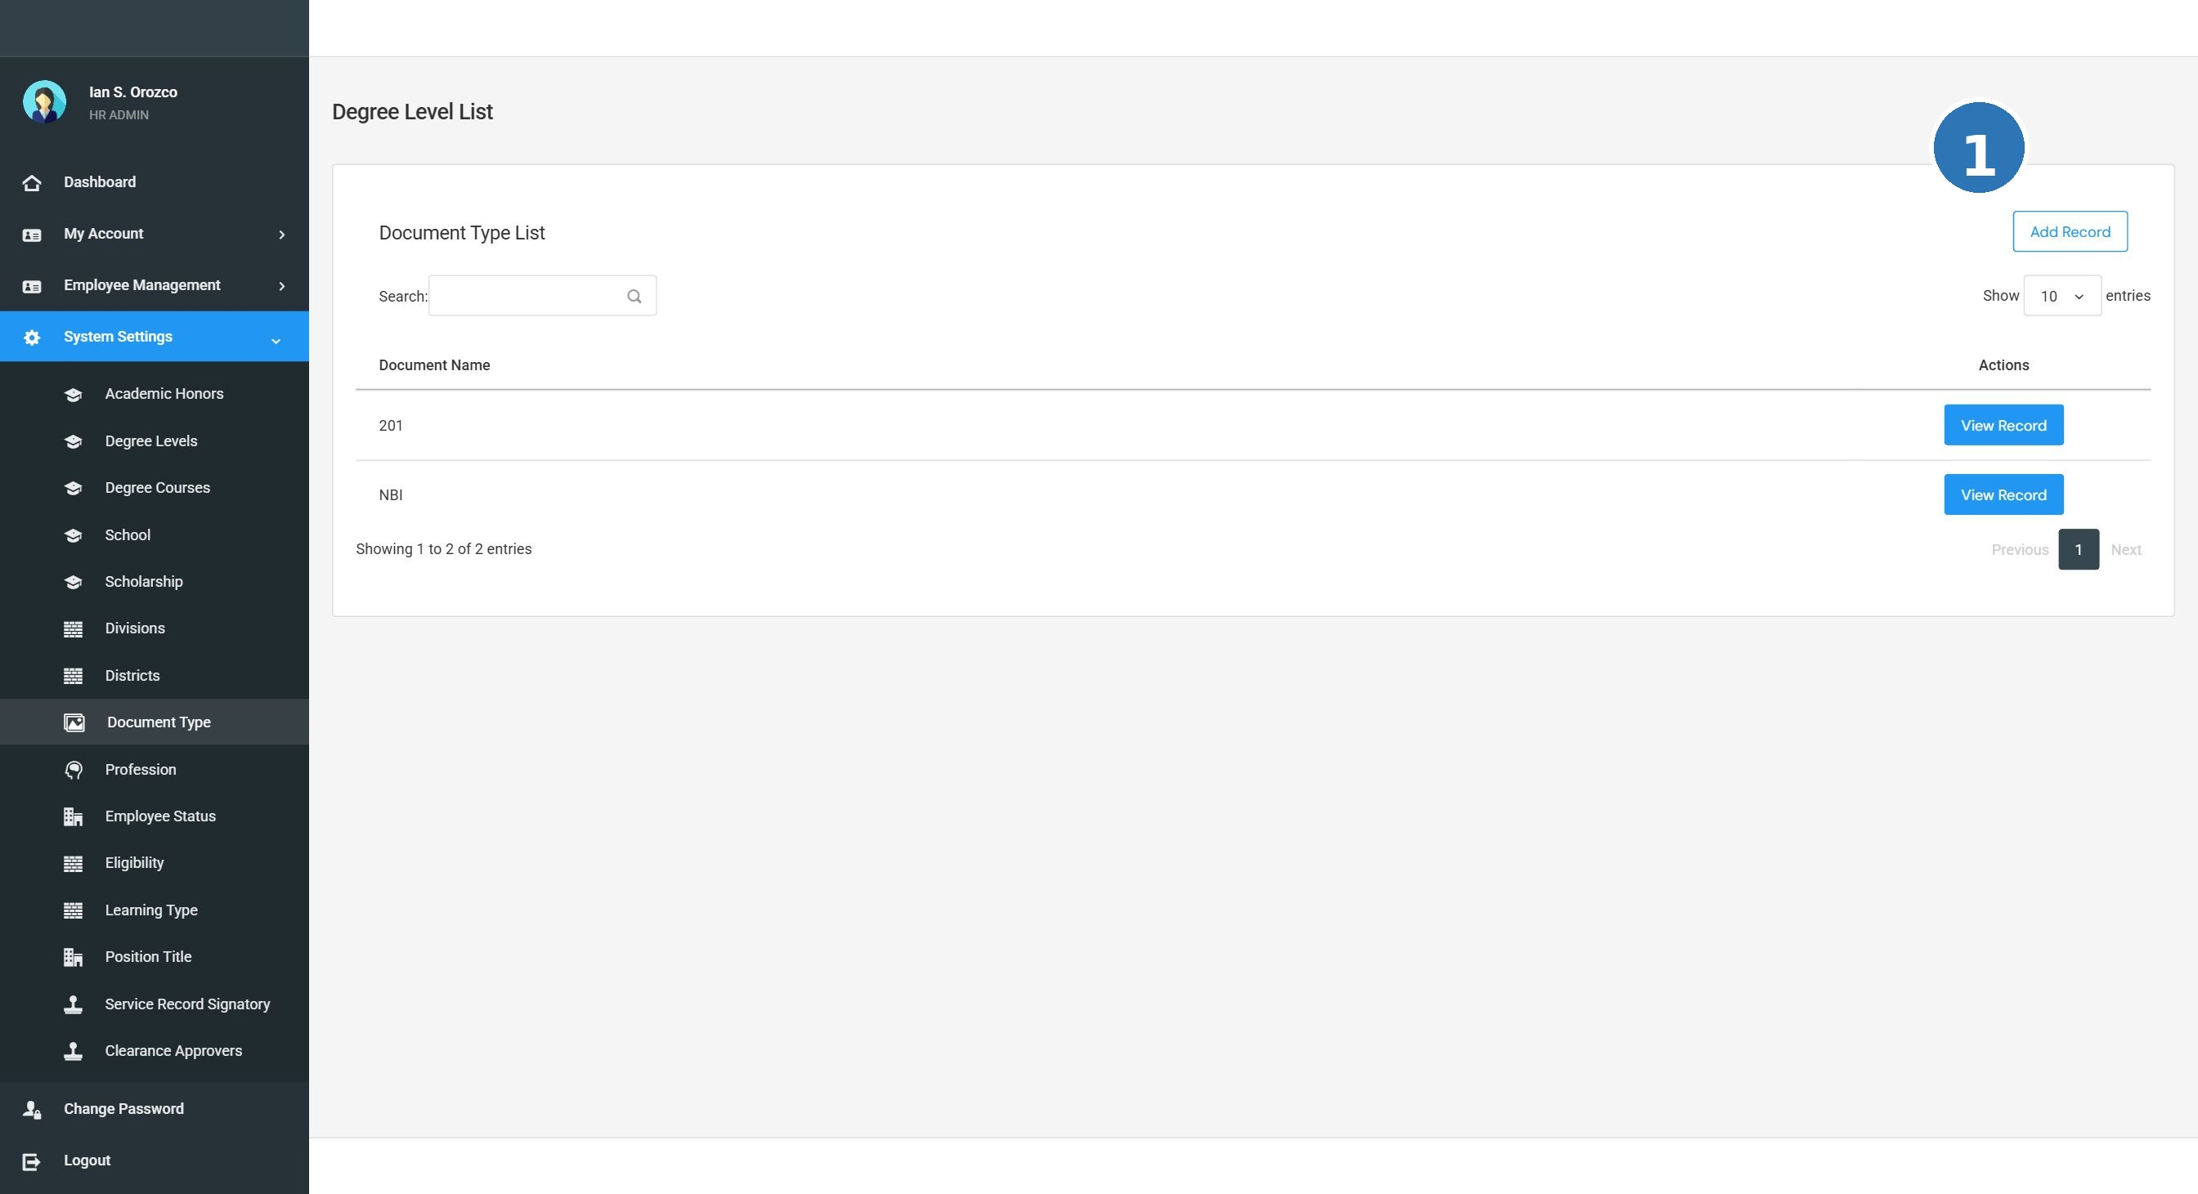
Screenshot: SS-08 document types

TC-SS-DT-001 View the list of Document Type
Prerequisites / Test Data |  | Admin is logged in. System Settings is accessible in the navigation menu.
# | Step / Action | Expected Result | Actual Result | Status
1 | Click System Settings in the left navigation menu. | The System Settings section opens with a list of modules. |  | Pass / Fail
2 | Click Document Type from the list. | A list of existing document type records is displayed in a table. |  | Pass / Fail
3 | Check that the records are readable and correctly displayed. | All records are visible. The table is clear and well-organized. |  | Pass / Fail

TC-SS-DT-002 Add a new Document Type record
Prerequisites / Test Data |  | Admin is logged in. The Document Type list page is open.
# | Step / Action | Expected Result | Actual Result | Status
1 | Click the Add button on the Document Type page. | A form or input dialog opens for entering a new document type record. |  | Pass / Fail
2 | Fill in the required field(s): Document Type Name. | The field(s) accept the input correctly. |  | Pass / Fail
3 | Click Save (or Submit). | The new document type record is saved successfully. A confirmation message appears. |  | Pass / Fail
4 | Check the list for the newly added record. | The new document type record appears in the list with correct information. |  | Pass / Fail

TC-SS-DT-003 Edit an existing Document Type record
Prerequisites / Test Data |  | Admin is logged in. At least one document type record exists in the list.
# | Step / Action | Expected Result | Actual Result | Status
1 | On the Document Type list, click the Edit button (pencil icon) next to any record. | The edit form opens and shows the current values of that record. |  | Pass / Fail
2 | Change the value in one or more fields. | The fields can be edited and updated. |  | Pass / Fail
3 | Click Save. | The changes are saved. The updated record appears correctly in the list. |  | Pass / Fail

7.3.7 Eligibility
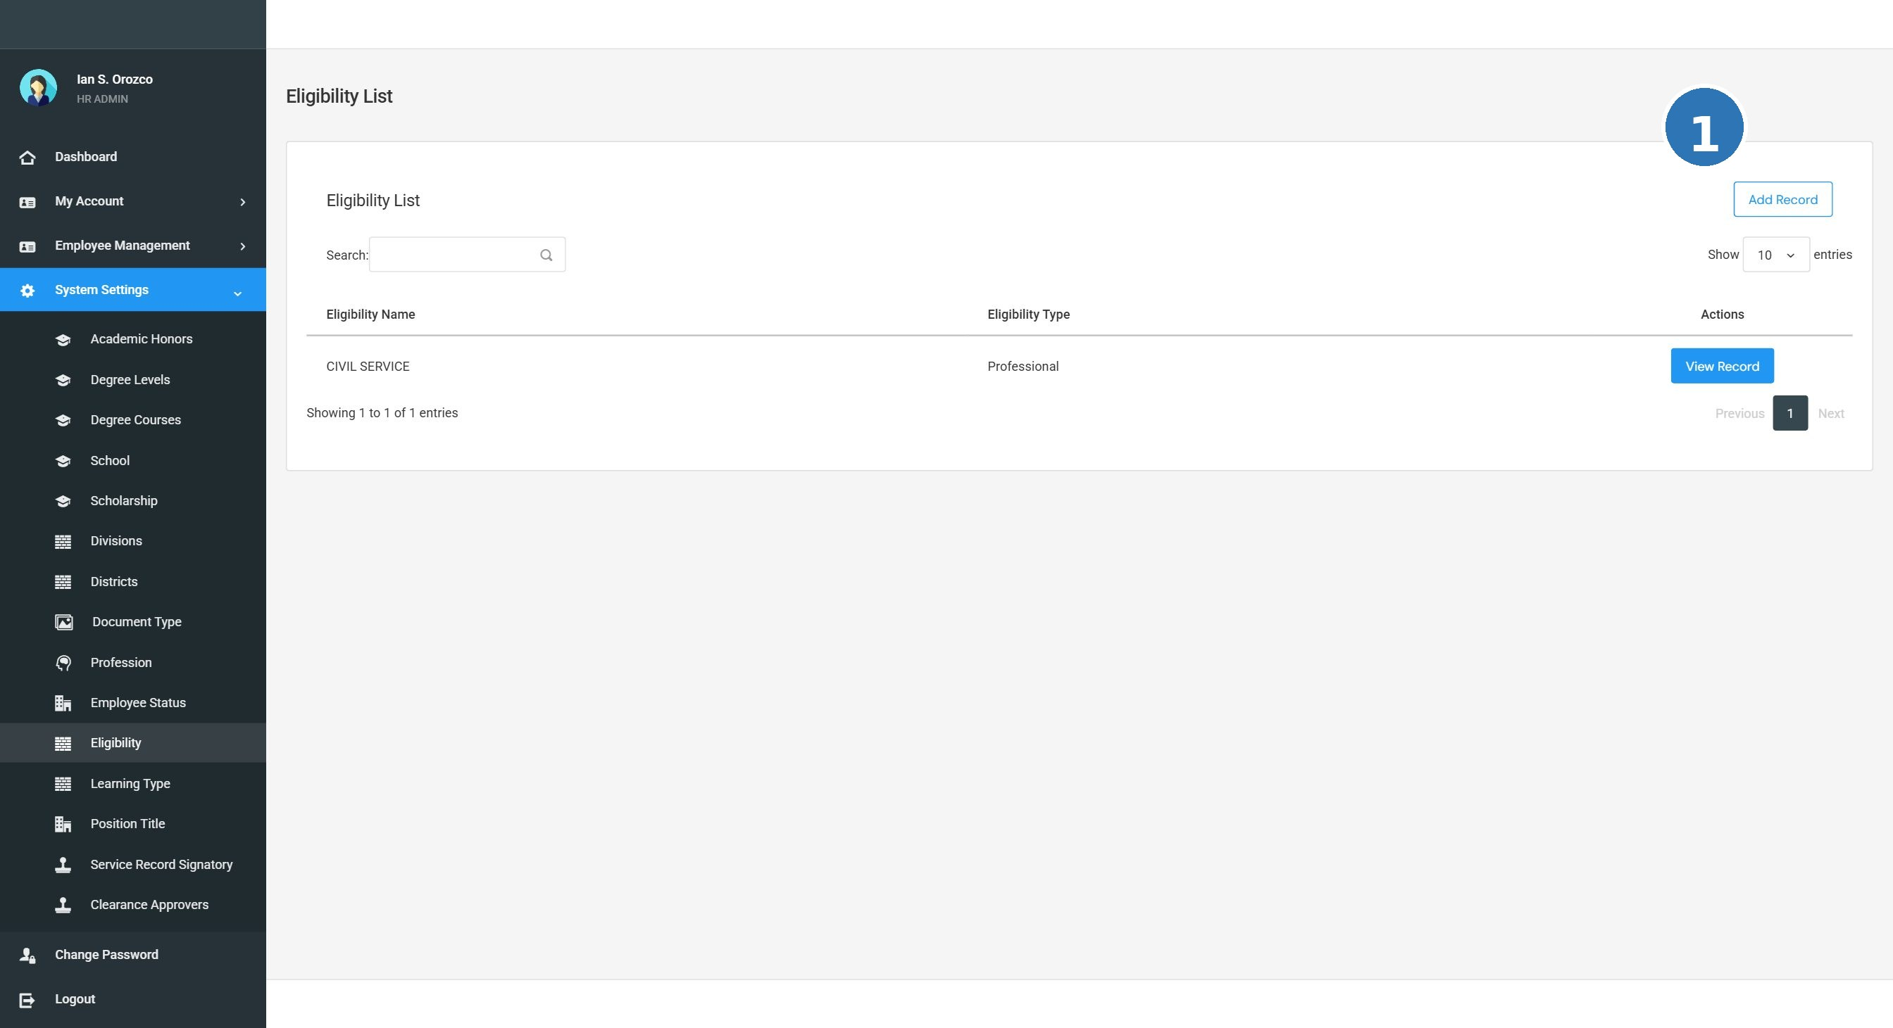
Screenshot: SS-11 eligibility types

TC-SS-EL-001 View the list of Eligibility
Prerequisites / Test Data |  | Admin is logged in. System Settings is accessible in the navigation menu.
# | Step / Action | Expected Result | Actual Result | Status
1 | Click System Settings in the left navigation menu. | The System Settings section opens with a list of modules. |  | Pass / Fail
2 | Click Eligibility from the list. | A list of existing eligibility records is displayed in a table. |  | Pass / Fail
3 | Check that the records are readable and correctly displayed. | All records are visible. The table is clear and well-organized. |  | Pass / Fail

TC-SS-EL-002 Add a new Eligibility record
Prerequisites / Test Data |  | Admin is logged in. The Eligibility list page is open.
# | Step / Action | Expected Result | Actual Result | Status
1 | Click the Add button on the Eligibility page. | A form or input dialog opens for entering a new eligibility record. |  | Pass / Fail
2 | Fill in the required field(s): Eligibility Name. | The field(s) accept the input correctly. |  | Pass / Fail
3 | Click Save (or Submit). | The new eligibility record is saved successfully. A confirmation message appears. |  | Pass / Fail
4 | Check the list for the newly added record. | The new eligibility record appears in the list with correct information. |  | Pass / Fail

TC-SS-EL-003 Edit an existing Eligibility record
Prerequisites / Test Data |  | Admin is logged in. At least one eligibility record exists in the list.
# | Step / Action | Expected Result | Actual Result | Status
1 | On the Eligibility list, click the Edit button (pencil icon) next to any record. | The edit form opens and shows the current values of that record. |  | Pass / Fail
2 | Change the value in one or more fields. | The fields can be edited and updated. |  | Pass / Fail
3 | Click Save. | The changes are saved. The updated record appears correctly in the list. |  | Pass / Fail

7.3.8 Employee Status
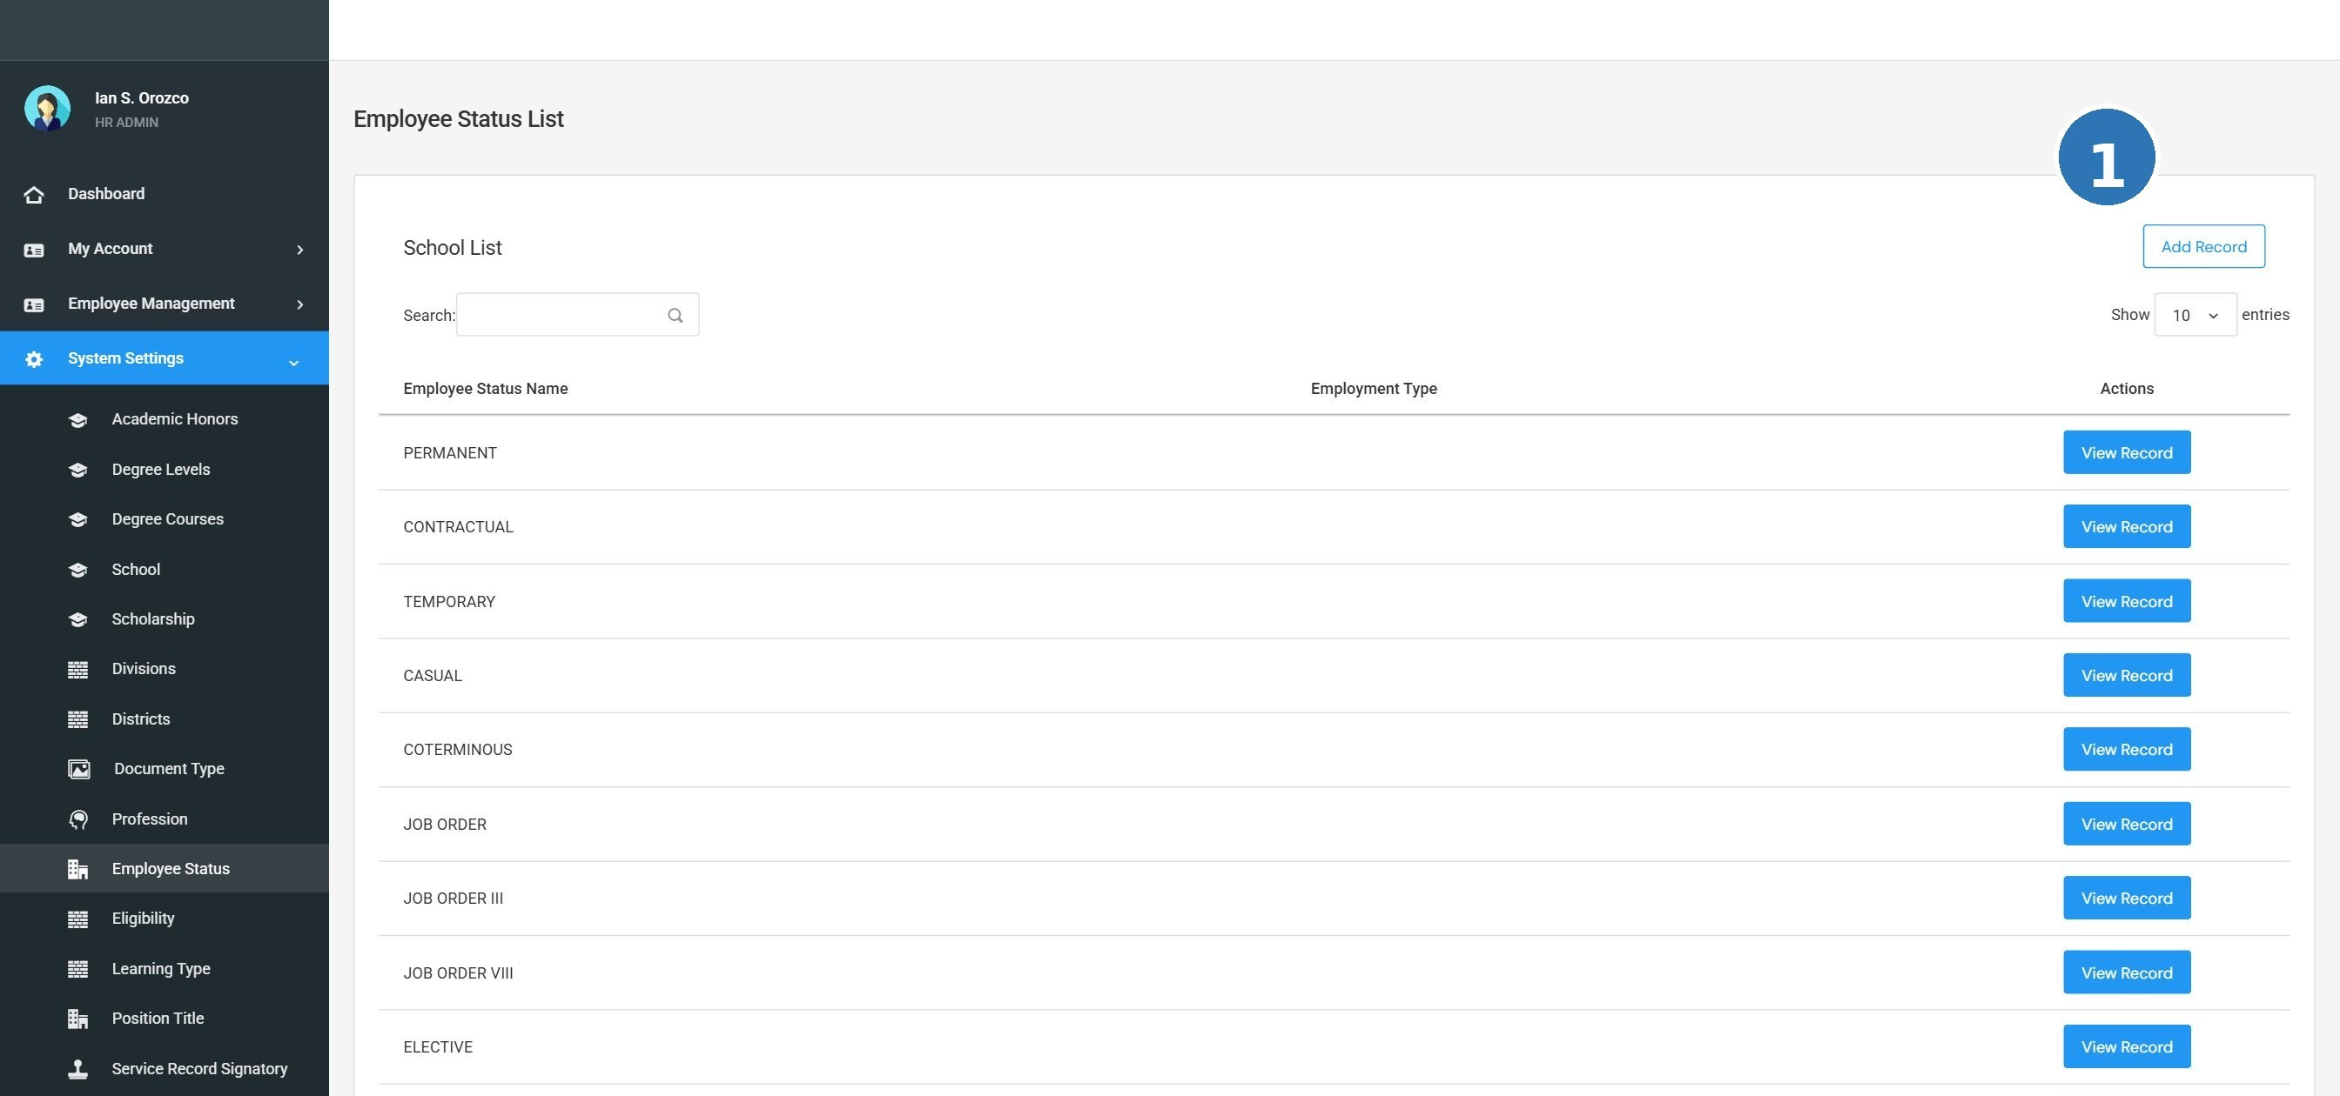
Screenshot: SS-10 employee status

TC-SS-ES-001 View the list of Employee Status
Prerequisites / Test Data |  | Admin is logged in. System Settings is accessible in the navigation menu.
# | Step / Action | Expected Result | Actual Result | Status
1 | Click System Settings in the left navigation menu. | The System Settings section opens with a list of modules. |  | Pass / Fail
2 | Click Employee Status from the list. | A list of existing employee status records is displayed in a table. |  | Pass / Fail
3 | Check that the records are readable and correctly displayed. | All records are visible. The table is clear and well-organized. |  | Pass / Fail

TC-SS-ES-002 Add a new Employee Status record
Prerequisites / Test Data |  | Admin is logged in. The Employee Status list page is open.
# | Step / Action | Expected Result | Actual Result | Status
1 | Click the Add button on the Employee Status page. | A form or input dialog opens for entering a new employee status record. |  | Pass / Fail
2 | Fill in the required field(s): Status Name. | The field(s) accept the input correctly. |  | Pass / Fail
3 | Click Save (or Submit). | The new employee status record is saved successfully. A confirmation message appears. |  | Pass / Fail
4 | Check the list for the newly added record. | The new employee status record appears in the list with correct information. |  | Pass / Fail

TC-SS-ES-003 Edit an existing Employee Status record
Prerequisites / Test Data |  | Admin is logged in. At least one employee status record exists in the list.
# | Step / Action | Expected Result | Actual Result | Status
1 | On the Employee Status list, click the Edit button (pencil icon) next to any record. | The edit form opens and shows the current values of that record. |  | Pass / Fail
2 | Change the value in one or more fields. | The fields can be edited and updated. |  | Pass / Fail
3 | Click Save. | The changes are saved. The updated record appears correctly in the list. |  | Pass / Fail

7.3.9 Learning Type
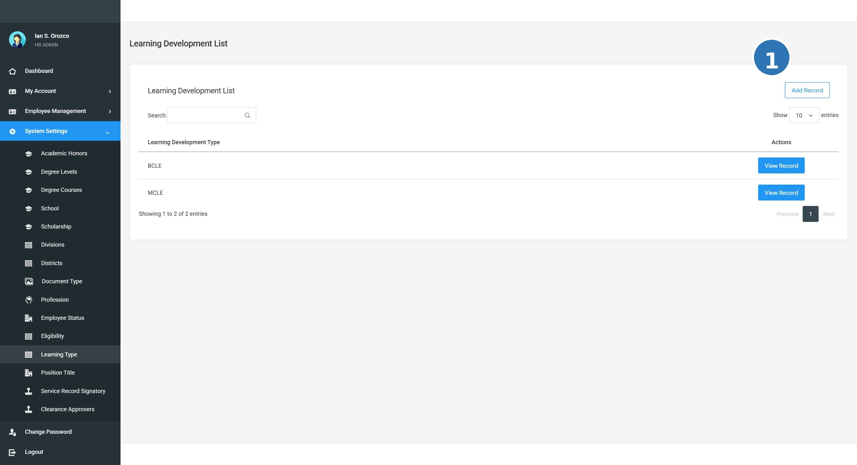
Screenshot: SS-12 learning type

TC-SS-LT-001 View the list of Learning Type
Prerequisites / Test Data |  | Admin is logged in. System Settings is accessible in the navigation menu.
# | Step / Action | Expected Result | Actual Result | Status
1 | Click System Settings in the left navigation menu. | The System Settings section opens with a list of modules. |  | Pass / Fail
2 | Click Learning Type from the list. | A list of existing learning type records is displayed in a table. |  | Pass / Fail
3 | Check that the records are readable and correctly displayed. | All records are visible. The table is clear and well-organized. |  | Pass / Fail

TC-SS-LT-002 Add a new Learning Type record
Prerequisites / Test Data |  | Admin is logged in. The Learning Type list page is open.
# | Step / Action | Expected Result | Actual Result | Status
1 | Click the Add button on the Learning Type page. | A form or input dialog opens for entering a new learning type record. |  | Pass / Fail
2 | Fill in the required field(s): Learning Type Name. | The field(s) accept the input correctly. |  | Pass / Fail
3 | Click Save (or Submit). | The new learning type record is saved successfully. A confirmation message appears. |  | Pass / Fail
4 | Check the list for the newly added record. | The new learning type record appears in the list with correct information. |  | Pass / Fail

TC-SS-LT-003 Edit an existing Learning Type record
Prerequisites / Test Data |  | Admin is logged in. At least one learning type record exists in the list.
# | Step / Action | Expected Result | Actual Result | Status
1 | On the Learning Type list, click the Edit button (pencil icon) next to any record. | The edit form opens and shows the current values of that record. |  | Pass / Fail
2 | Change the value in one or more fields. | The fields can be edited and updated. |  | Pass / Fail
3 | Click Save. | The changes are saved. The updated record appears correctly in the list. |  | Pass / Fail

7.3.10 Position Title
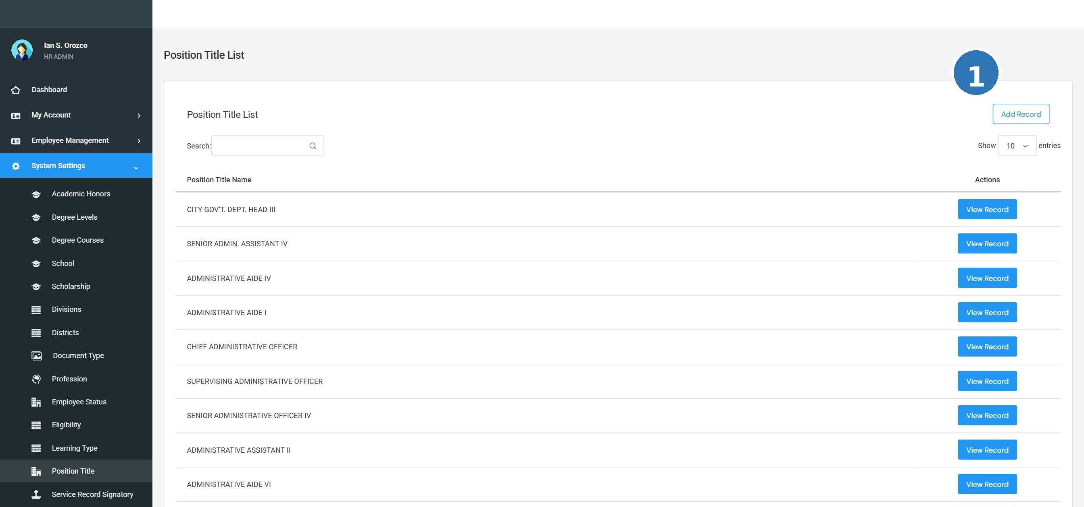
Screenshot: SS-13 position titles

TC-SS-PT-001 View the list of Position Title
Prerequisites / Test Data |  | Admin is logged in. System Settings is accessible in the navigation menu.
# | Step / Action | Expected Result | Actual Result | Status
1 | Click System Settings in the left navigation menu. | The System Settings section opens with a list of modules. |  | Pass / Fail
2 | Click Position Title from the list. | A list of existing position title records is displayed in a table. |  | Pass / Fail
3 | Check that the records are readable and correctly displayed. | All records are visible. The table is clear and well-organized. |  | Pass / Fail

TC-SS-PT-002 Add a new Position Title record
Prerequisites / Test Data |  | Admin is logged in. The Position Title list page is open.
# | Step / Action | Expected Result | Actual Result | Status
1 | Click the Add button on the Position Title page. | A form or input dialog opens for entering a new position title record. |  | Pass / Fail
2 | Fill in the required field(s): Position Title. | The field(s) accept the input correctly. |  | Pass / Fail
3 | Click Save (or Submit). | The new position title record is saved successfully. A confirmation message appears. |  | Pass / Fail
4 | Check the list for the newly added record. | The new position title record appears in the list with correct information. |  | Pass / Fail

TC-SS-PT-003 Edit an existing Position Title record
Prerequisites / Test Data |  | Admin is logged in. At least one position title record exists in the list.
# | Step / Action | Expected Result | Actual Result | Status
1 | On the Position Title list, click the Edit button (pencil icon) next to any record. | The edit form opens and shows the current values of that record. |  | Pass / Fail
2 | Change the value in one or more fields. | The fields can be edited and updated. |  | Pass / Fail
3 | Click Save. | The changes are saved. The updated record appears correctly in the list. |  | Pass / Fail

7.3.11 Professions
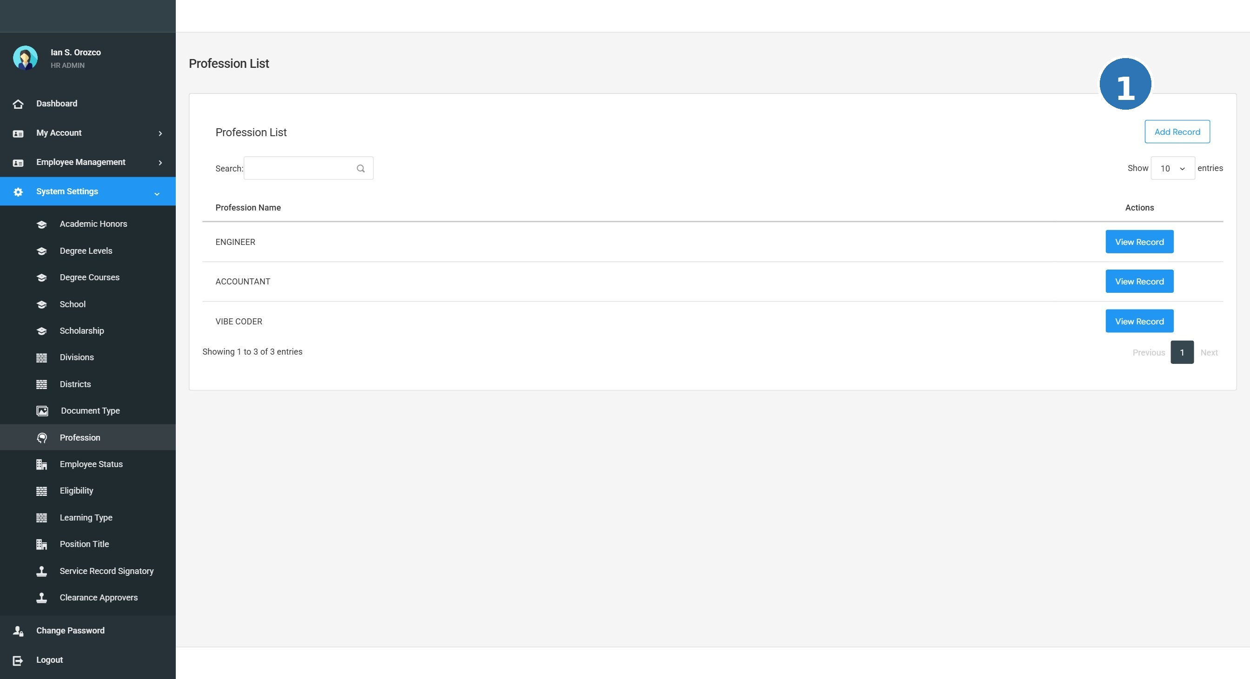
Screenshot: SS-09 professions

TC-SS-PR-001 View the list of Professions
Prerequisites / Test Data |  | Admin is logged in. System Settings is accessible in the navigation menu.
# | Step / Action | Expected Result | Actual Result | Status
1 | Click System Settings in the left navigation menu. | The System Settings section opens with a list of modules. |  | Pass / Fail
2 | Click Professions from the list. | A list of existing professions records is displayed in a table. |  | Pass / Fail
3 | Check that the records are readable and correctly displayed. | All records are visible. The table is clear and well-organized. |  | Pass / Fail

TC-SS-PR-002 Add a new Professions record
Prerequisites / Test Data |  | Admin is logged in. The Professions list page is open.
# | Step / Action | Expected Result | Actual Result | Status
1 | Click the Add button on the Professions page. | A form or input dialog opens for entering a new professions record. |  | Pass / Fail
2 | Fill in the required field(s): Profession Name. | The field(s) accept the input correctly. |  | Pass / Fail
3 | Click Save (or Submit). | The new professions record is saved successfully. A confirmation message appears. |  | Pass / Fail
4 | Check the list for the newly added record. | The new professions record appears in the list with correct information. |  | Pass / Fail

TC-SS-PR-003 Edit an existing Professions record
Prerequisites / Test Data |  | Admin is logged in. At least one professions record exists in the list.
# | Step / Action | Expected Result | Actual Result | Status
1 | On the Professions list, click the Edit button (pencil icon) next to any record. | The edit form opens and shows the current values of that record. |  | Pass / Fail
2 | Change the value in one or more fields. | The fields can be edited and updated. |  | Pass / Fail
3 | Click Save. | The changes are saved. The updated record appears correctly in the list. |  | Pass / Fail

7.3.12 Salary Grades
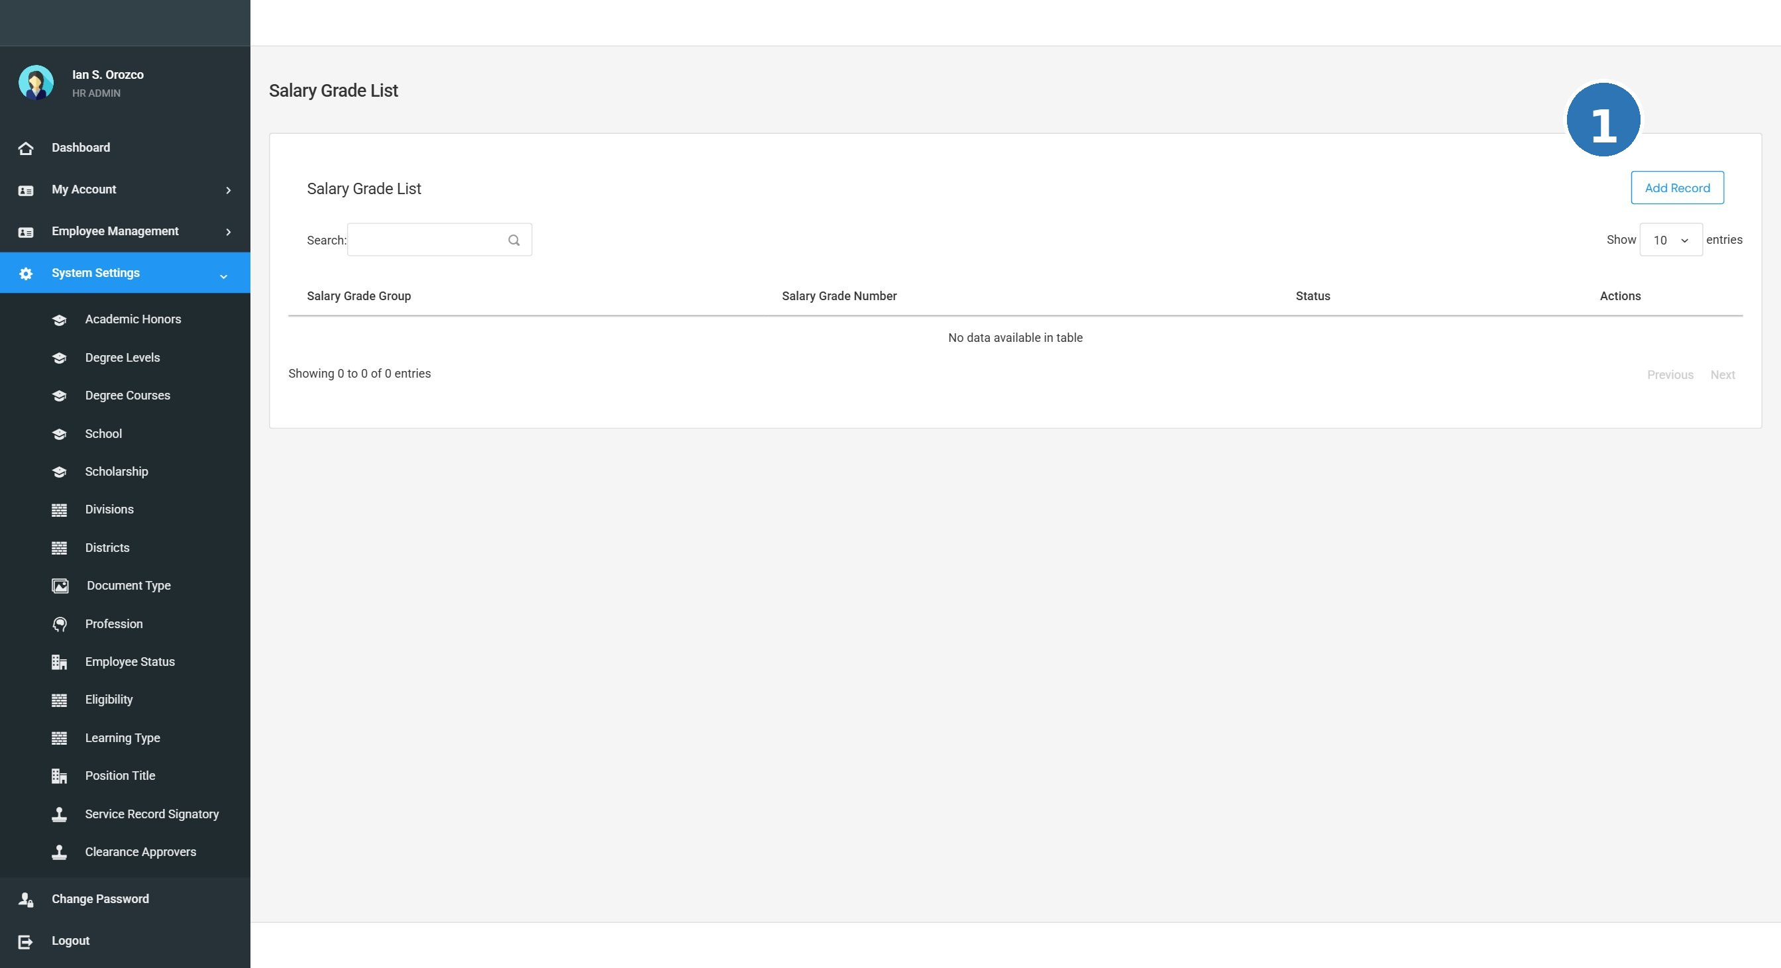
Screenshot: SS-17 salary grades

TC-SS-SG-001 View the list of Salary Grades
Prerequisites / Test Data |  | Admin is logged in. System Settings is accessible in the navigation menu.
# | Step / Action | Expected Result | Actual Result | Status
1 | Click System Settings in the left navigation menu. | The System Settings section opens with a list of modules. |  | Pass / Fail
2 | Click Salary Grades from the list. | A list of existing salary grades records is displayed in a table. |  | Pass / Fail
3 | Check that the records are readable and correctly displayed. | All records are visible. The table is clear and well-organized. |  | Pass / Fail

TC-SS-SG-002 Add a new Salary Grades record
Prerequisites / Test Data |  | Admin is logged in. The Salary Grades list page is open.
# | Step / Action | Expected Result | Actual Result | Status
1 | Click the Add button on the Salary Grades page. | A form or input dialog opens for entering a new salary grades record. |  | Pass / Fail
2 | Fill in the required field(s): Salary Grade Number / Name. | The field(s) accept the input correctly. |  | Pass / Fail
3 | Click Save (or Submit). | The new salary grades record is saved successfully. A confirmation message appears. |  | Pass / Fail
4 | Check the list for the newly added record. | The new salary grades record appears in the list with correct information. |  | Pass / Fail

TC-SS-SG-003 Edit an existing Salary Grades record
Prerequisites / Test Data |  | Admin is logged in. At least one salary grades record exists in the list.
# | Step / Action | Expected Result | Actual Result | Status
1 | On the Salary Grades list, click the Edit button (pencil icon) next to any record. | The edit form opens and shows the current values of that record. |  | Pass / Fail
2 | Change the value in one or more fields. | The fields can be edited and updated. |  | Pass / Fail
3 | Click Save. | The changes are saved. The updated record appears correctly in the list. |  | Pass / Fail

7.3.13 Scholarship
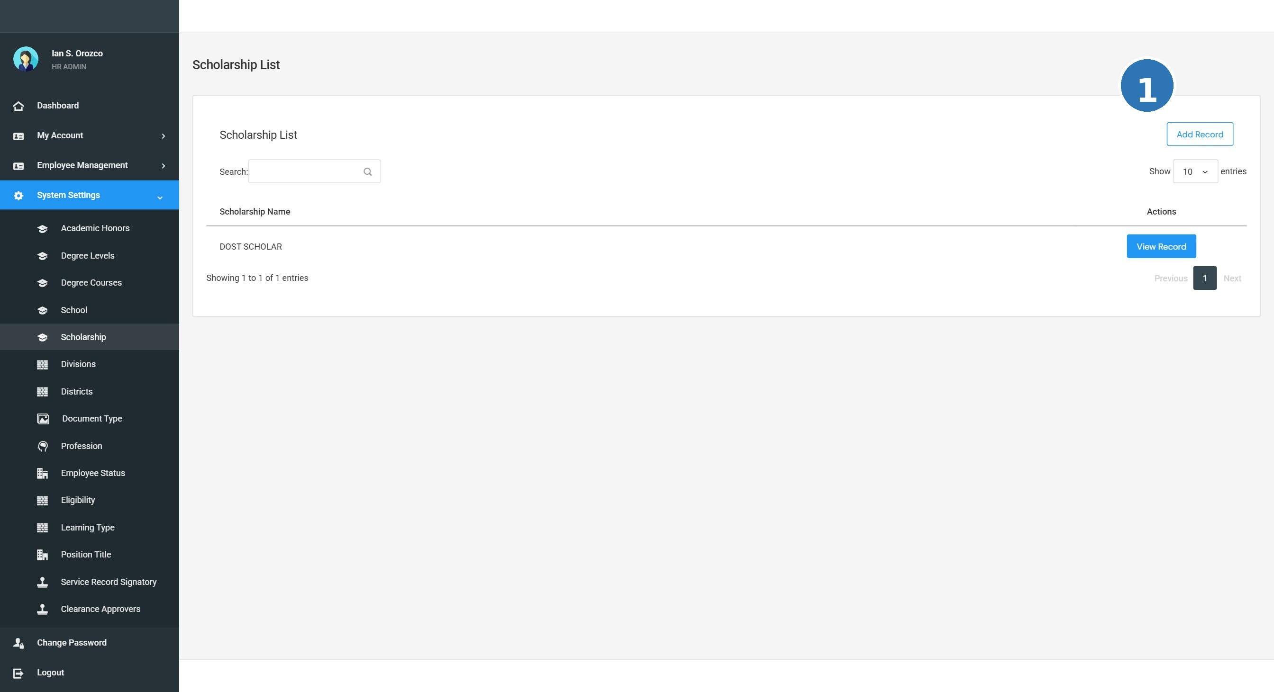
Screenshot: SS-05 scholarships

TC-SS-SC-001 View the list of Scholarship
Prerequisites / Test Data |  | Admin is logged in. System Settings is accessible in the navigation menu.
# | Step / Action | Expected Result | Actual Result | Status
1 | Click System Settings in the left navigation menu. | The System Settings section opens with a list of modules. |  | Pass / Fail
2 | Click Scholarship from the list. | A list of existing scholarship records is displayed in a table. |  | Pass / Fail
3 | Check that the records are readable and correctly displayed. | All records are visible. The table is clear and well-organized. |  | Pass / Fail

TC-SS-SC-002 Add a new Scholarship record
Prerequisites / Test Data |  | Admin is logged in. The Scholarship list page is open.
# | Step / Action | Expected Result | Actual Result | Status
1 | Click the Add button on the Scholarship page. | A form or input dialog opens for entering a new scholarship record. |  | Pass / Fail
2 | Fill in the required field(s): Scholarship Name. | The field(s) accept the input correctly. |  | Pass / Fail
3 | Click Save (or Submit). | The new scholarship record is saved successfully. A confirmation message appears. |  | Pass / Fail
4 | Check the list for the newly added record. | The new scholarship record appears in the list with correct information. |  | Pass / Fail

TC-SS-SC-003 Edit an existing Scholarship record
Prerequisites / Test Data |  | Admin is logged in. At least one scholarship record exists in the list.
# | Step / Action | Expected Result | Actual Result | Status
1 | On the Scholarship list, click the Edit button (pencil icon) next to any record. | The edit form opens and shows the current values of that record. |  | Pass / Fail
2 | Change the value in one or more fields. | The fields can be edited and updated. |  | Pass / Fail
3 | Click Save. | The changes are saved. The updated record appears correctly in the list. |  | Pass / Fail

7.3.14 Schools
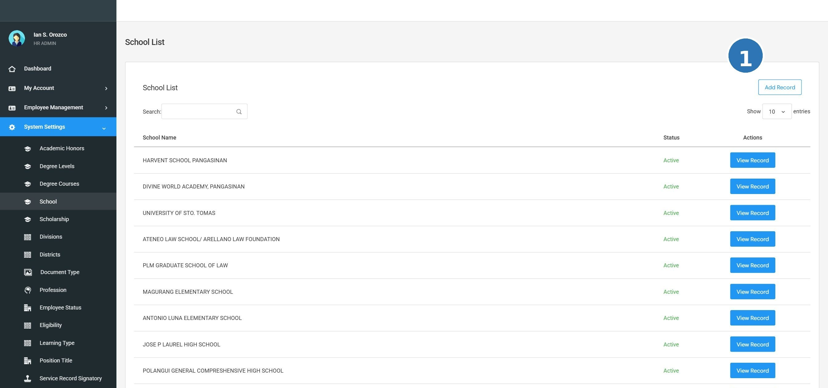
Screenshot: SS-04 schools

TC-SS-SH-001 View the list of Schools
Prerequisites / Test Data |  | Admin is logged in. System Settings is accessible in the navigation menu.
# | Step / Action | Expected Result | Actual Result | Status
1 | Click System Settings in the left navigation menu. | The System Settings section opens with a list of modules. |  | Pass / Fail
2 | Click Schools from the list. | A list of existing schools records is displayed in a table. |  | Pass / Fail
3 | Check that the records are readable and correctly displayed. | All records are visible. The table is clear and well-organized. |  | Pass / Fail

TC-SS-SH-002 Add a new Schools record
Prerequisites / Test Data |  | Admin is logged in. The Schools list page is open.
# | Step / Action | Expected Result | Actual Result | Status
1 | Click the Add button on the Schools page. | A form or input dialog opens for entering a new schools record. |  | Pass / Fail
2 | Fill in the required field(s): School Name. | The field(s) accept the input correctly. |  | Pass / Fail
3 | Click Save (or Submit). | The new schools record is saved successfully. A confirmation message appears. |  | Pass / Fail
4 | Check the list for the newly added record. | The new schools record appears in the list with correct information. |  | Pass / Fail

TC-SS-SH-003 Edit an existing Schools record
Prerequisites / Test Data |  | Admin is logged in. At least one schools record exists in the list.
# | Step / Action | Expected Result | Actual Result | Status
1 | On the Schools list, click the Edit button (pencil icon) next to any record. | The edit form opens and shows the current values of that record. |  | Pass / Fail
2 | Change the value in one or more fields. | The fields can be edited and updated. |  | Pass / Fail
3 | Click Save. | The changes are saved. The updated record appears correctly in the list. |  | Pass / Fail

7.3.15 Service Record Signatory
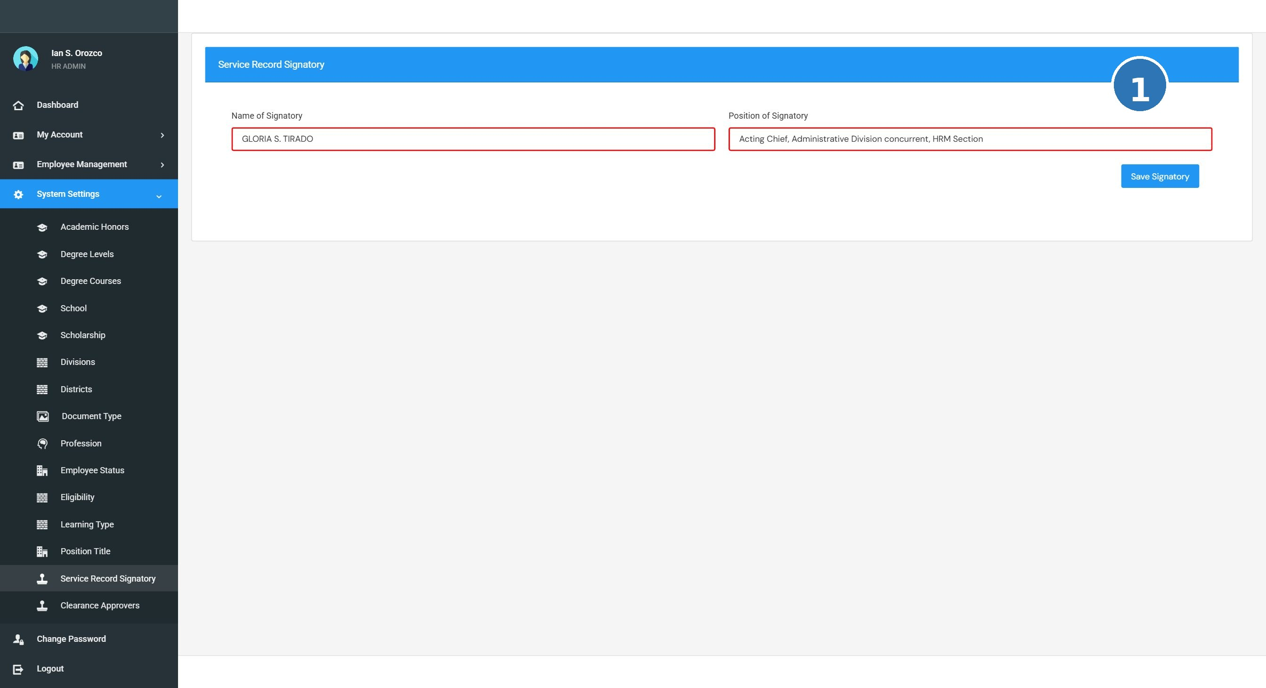
Screenshot: SS-14 service record signatory

TC-SS-SR-001 View the list of Service Record Signatory
Prerequisites / Test Data |  | Admin is logged in. System Settings is accessible in the navigation menu.
# | Step / Action | Expected Result | Actual Result | Status
1 | Click System Settings in the left navigation menu. | The System Settings section opens with a list of modules. |  | Pass / Fail
2 | Click Service Record Signatory from the list. | A list of existing service record signatory records is displayed in a table. |  | Pass / Fail
3 | Check that the records are readable and correctly displayed. | All records are visible. The table is clear and well-organized. |  | Pass / Fail

TC-SS-SR-002 Add a new Service Record Signatory record
Prerequisites / Test Data |  | Admin is logged in. The Service Record Signatory list page is open.
# | Step / Action | Expected Result | Actual Result | Status
1 | Click the Add button on the Service Record Signatory page. | A form or input dialog opens for entering a new service record signatory record. |  | Pass / Fail
2 | Fill in the required field(s): Signatory Name, Designation. | The field(s) accept the input correctly. |  | Pass / Fail
3 | Click Save (or Submit). | The new service record signatory record is saved successfully. A confirmation message appears. |  | Pass / Fail
4 | Check the list for the newly added record. | The new service record signatory record appears in the list with correct information. |  | Pass / Fail

TC-SS-SR-003 Edit an existing Service Record Signatory record
Prerequisites / Test Data |  | Admin is logged in. At least one service record signatory record exists in the list.
# | Step / Action | Expected Result | Actual Result | Status
1 | On the Service Record Signatory list, click the Edit button (pencil icon) next to any record. | The edit form opens and shows the current values of that record. |  | Pass / Fail
2 | Change the value in one or more fields. | The fields can be edited and updated. |  | Pass / Fail
3 | Click Save. | The changes are saved. The updated record appears correctly in the list. |  | Pass / Fail

7.3.16 Clearance Approvers
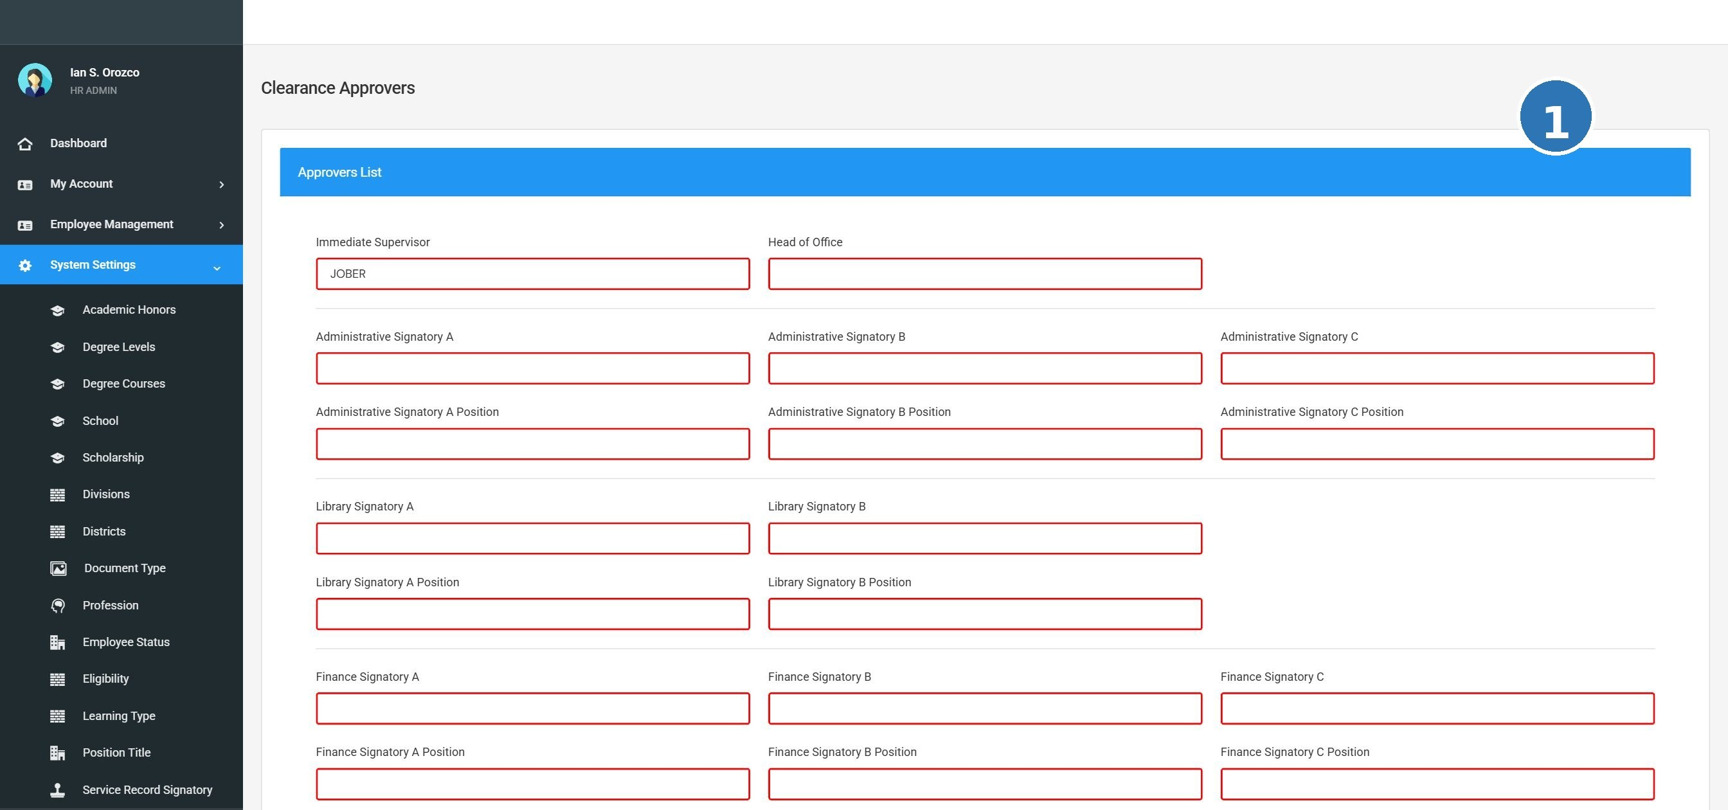
Screenshot: SS-15 clearance approvers

TC-SS-CA-001 View the list of Clearance Approvers
Prerequisites / Test Data |  | Admin is logged in. System Settings is accessible in the navigation menu.
# | Step / Action | Expected Result | Actual Result | Status
1 | Click System Settings in the left navigation menu. | The System Settings section opens with a list of modules. |  | Pass / Fail
2 | Click Clearance Approvers from the list. | A list of existing clearance approvers records is displayed in a table. |  | Pass / Fail
3 | Check that the records are readable and correctly displayed. | All records are visible. The table is clear and well-organized. |  | Pass / Fail

TC-SS-CA-002 Add a new Clearance Approvers record
Prerequisites / Test Data |  | Admin is logged in. The Clearance Approvers list page is open.
# | Step / Action | Expected Result | Actual Result | Status
1 | Click the Add button on the Clearance Approvers page. | A form or input dialog opens for entering a new clearance approvers record. |  | Pass / Fail
2 | Fill in the required field(s): Approver Name, Designation. | The field(s) accept the input correctly. |  | Pass / Fail
3 | Click Save (or Submit). | The new clearance approvers record is saved successfully. A confirmation message appears. |  | Pass / Fail
4 | Check the list for the newly added record. | The new clearance approvers record appears in the list with correct information. |  | Pass / Fail

TC-SS-CA-003 Edit an existing Clearance Approvers record
Prerequisites / Test Data |  | Admin is logged in. At least one clearance approvers record exists in the list.
# | Step / Action | Expected Result | Actual Result | Status
1 | On the Clearance Approvers list, click the Edit button (pencil icon) next to any record. | The edit form opens and shows the current values of that record. |  | Pass / Fail
2 | Change the value in one or more fields. | The fields can be edited and updated. |  | Pass / Fail
3 | Click Save. | The changes are saved. The updated record appears correctly in the list. |  | Pass / Fail

8 Issues Log Template

Use this log to record any problem, error, or unexpected behavior found during UAT testing. Fill in one row per issue.

TIP: Tip: Take a screenshot of every issue and attach it to this document or submit it to the UAT Coordinator.

Issue # | Date Found | Module | Description of Problem | Severity | Found By | Status | Resolution / Notes
1
2
3
4
5
6
7
8
9
10

8.1 Severity Definitions

Severity | Definition
Critical | The system crashes, data is lost, or a core function is completely broken and cannot be used at all.
High | A key function does not work correctly, and there is no workaround. UAT cannot proceed for this module.
Medium | A function works partially or incorrectly, but there is a workaround. Work can continue.
Low | A minor issue such as a spelling error, display problem, or cosmetic issue that does not affect function.

9 UAT Sign-Off

By signing below, the participants confirm that User Acceptance Testing has been completed for the HRIS_WEB01 system. The sign-off indicates that all agreed test cases have been executed and the system is accepted for deployment — or that outstanding issues have been clearly documented and agreed upon.

This sign-off does not cover the Reports module, which is currently excluded from UAT scope (see Section 2).

9.1 UAT Outcome Summary

Total Test Cases Executed:
Total PASS:
Total FAIL:
Total Issues Logged:
Critical/High Issues Resolved:
UAT Overall Result: | [ ] ACCEPTED [ ] ACCEPTED WITH CONDITIONS [ ] REJECTED

9.2 Participant Sign-Off

All UAT participants listed in Section 4 must sign below to confirm completion of testing.

Name and Position | Role in UAT | Signature | Date Signed
 | UAT Coordinator
 | HR Administrator (Tester)
 | HR Staff Member (Tester)
 | HR Staff Member (Tester)
Complete Digital Solutions, Inc. | System Developer / Technical Support

9.3 Conditions / Remarks

If the UAT result is 'Accepted with Conditions', describe the conditions below. If 'Rejected', describe what must be fixed before re-testing.

Remarks:

