SANGGUNIANG PANLUNGSOD NG MAYNILA
Human Resource Information System

Human Resource
Information System
EMPLOYEE — USER ACCEPTANCE TESTING

Product Name: | Human Resource Information System (HRIS_WEB01)
Version: | 1.0
Prepared By: | Complete Digital Solutions, Inc.
Prepared For: | Sangguniang Panlungsod ng Maynila — Human Resource Division
Document Type: | User Acceptance Testing (UAT) Document — Employee
Date: | May 2026
Status: | For UAT Review and Sign-Off

Version History

Version | Date | Author | Change Description
1.0 | May 2026 | Complete Digital Solutions, Inc. | Initial UAT document — Employee version

1 Purpose

This document is the Employee User Acceptance Testing (UAT) guide for the HRIS_WEB01 system. It is designed for regular employees (Members) of the Sangguniang Panlungsod ng Maynila who will be testing the system from their own accounts.

As an employee tester, you will verify that the features available to you work correctly and that you can use them comfortably. You do not need any technical knowledge. Simply follow the steps in each test case, write down what you see, and mark each test as PASS or FAIL.

TIP: This guide covers only the features visible to a regular Employee account. For Administrator features, refer to the separate HR Administrator UAT document.

2 Scope

This Employee UAT covers the following features that are accessible to a regular employee (Member) account:

No. | Feature | What the Employee Can Do
1 | Login | Sign in using your username and password
2 | Change Password | Update your own login password
3 | My Personal Data Sheet (PDS) | View your CS Form No. 212 and print it
4 | My Appointments | View your appointment history
5 | My Clearance | File a clearance request and check its status
6 | My 201 Files | View and download your 201 documents uploaded by HR
7 | My Service Record | View and print your Service Record

The following features are NOT part of this Employee UAT:

- Reports module (excluded from UAT scope)
- Administrator functions (User Management, System Settings, editing PDS, uploading 201 files, etc.)

3 Testing Objectives

The goal of this Employee UAT is to confirm:

- You can log in and log out of the system using your own account.
- You can view and print your Personal Data Sheet (PDS / CS Form No. 212).
- You can view your Appointment records.
- You can file a Clearance Request and see its approval status.
- You can view and download your 201 Files (official documents).
- You can view and print your Service Record.
- All information shown is accurate — it matches what the HR Division has on file.
- The system is easy to understand and navigate without any technical assistance.

TIP: If any information shown in the system is incorrect (for example, a wrong name or wrong date), report it immediately to the UAT Coordinator. This is important feedback.

4 Test Team

The following people are involved in this Employee UAT:

Name | Department / Position | Role in UAT
 |  | UAT Coordinator — coordinates and collects test results
 |  | Employee Tester — tests employee-facing features
 |  | Employee Tester — tests employee-facing features
Complete Digital Solutions, Inc. | System Developer | Technical support during testing

5 Test Environment

System Name: | HRIS_WEB01 — Human Resource Information System
Environment: | User Acceptance Testing (UAT)
Browser: | Google Chrome (latest version recommended)
Application URL: | To be provided by the UAT Coordinator
Employee Login: | Your assigned username and password
Test Data: | Your actual employee record and sample data prepared by HR

TIP: Use Google Chrome for best results. If you encounter display issues in another browser, switch to Chrome before reporting a problem.

6 How to Use This Document

Follow these steps when testing each feature:

Step | What to Do
1 | Read the Pre-Condition before starting. Make sure it is true before you begin.
2 | Follow each Step / Action exactly as written.
3 | In the Actual Result column — write what actually happened on your screen.
4 | In the P / F column — write PASS if the actual result matches the expected result. Write FAIL if it does not.
5 | If you see an error or something unexpected — take a screenshot and report it to the UAT Coordinator.

TIP: Do not skip any step. Every test case must be completed, even if the feature looks correct.

7 UAT Test Cases

This section contains all the test cases for the Employee UAT. Each test case has a screenshot showing the screen you will be testing, followed by a table of steps to follow.

Column | What to Write
Step / Action | This tells you exactly what to do on screen.
Expected Result | This is what SHOULD happen. Compare this to what you actually see.
Actual Result | Write exactly what happened on your screen — even if it is wrong or different.
P / F | Write PASS if the actual result matches the expected result. Write FAIL if it does not.

TIP: Important: Do not skip any test case. Even if a feature looks fine, you must still complete every step and record the result.

Overview — Employee Dashboard
After logging in, you will see your employee profile dashboard. The left sidebar shows all the features available to you as a regular employee.

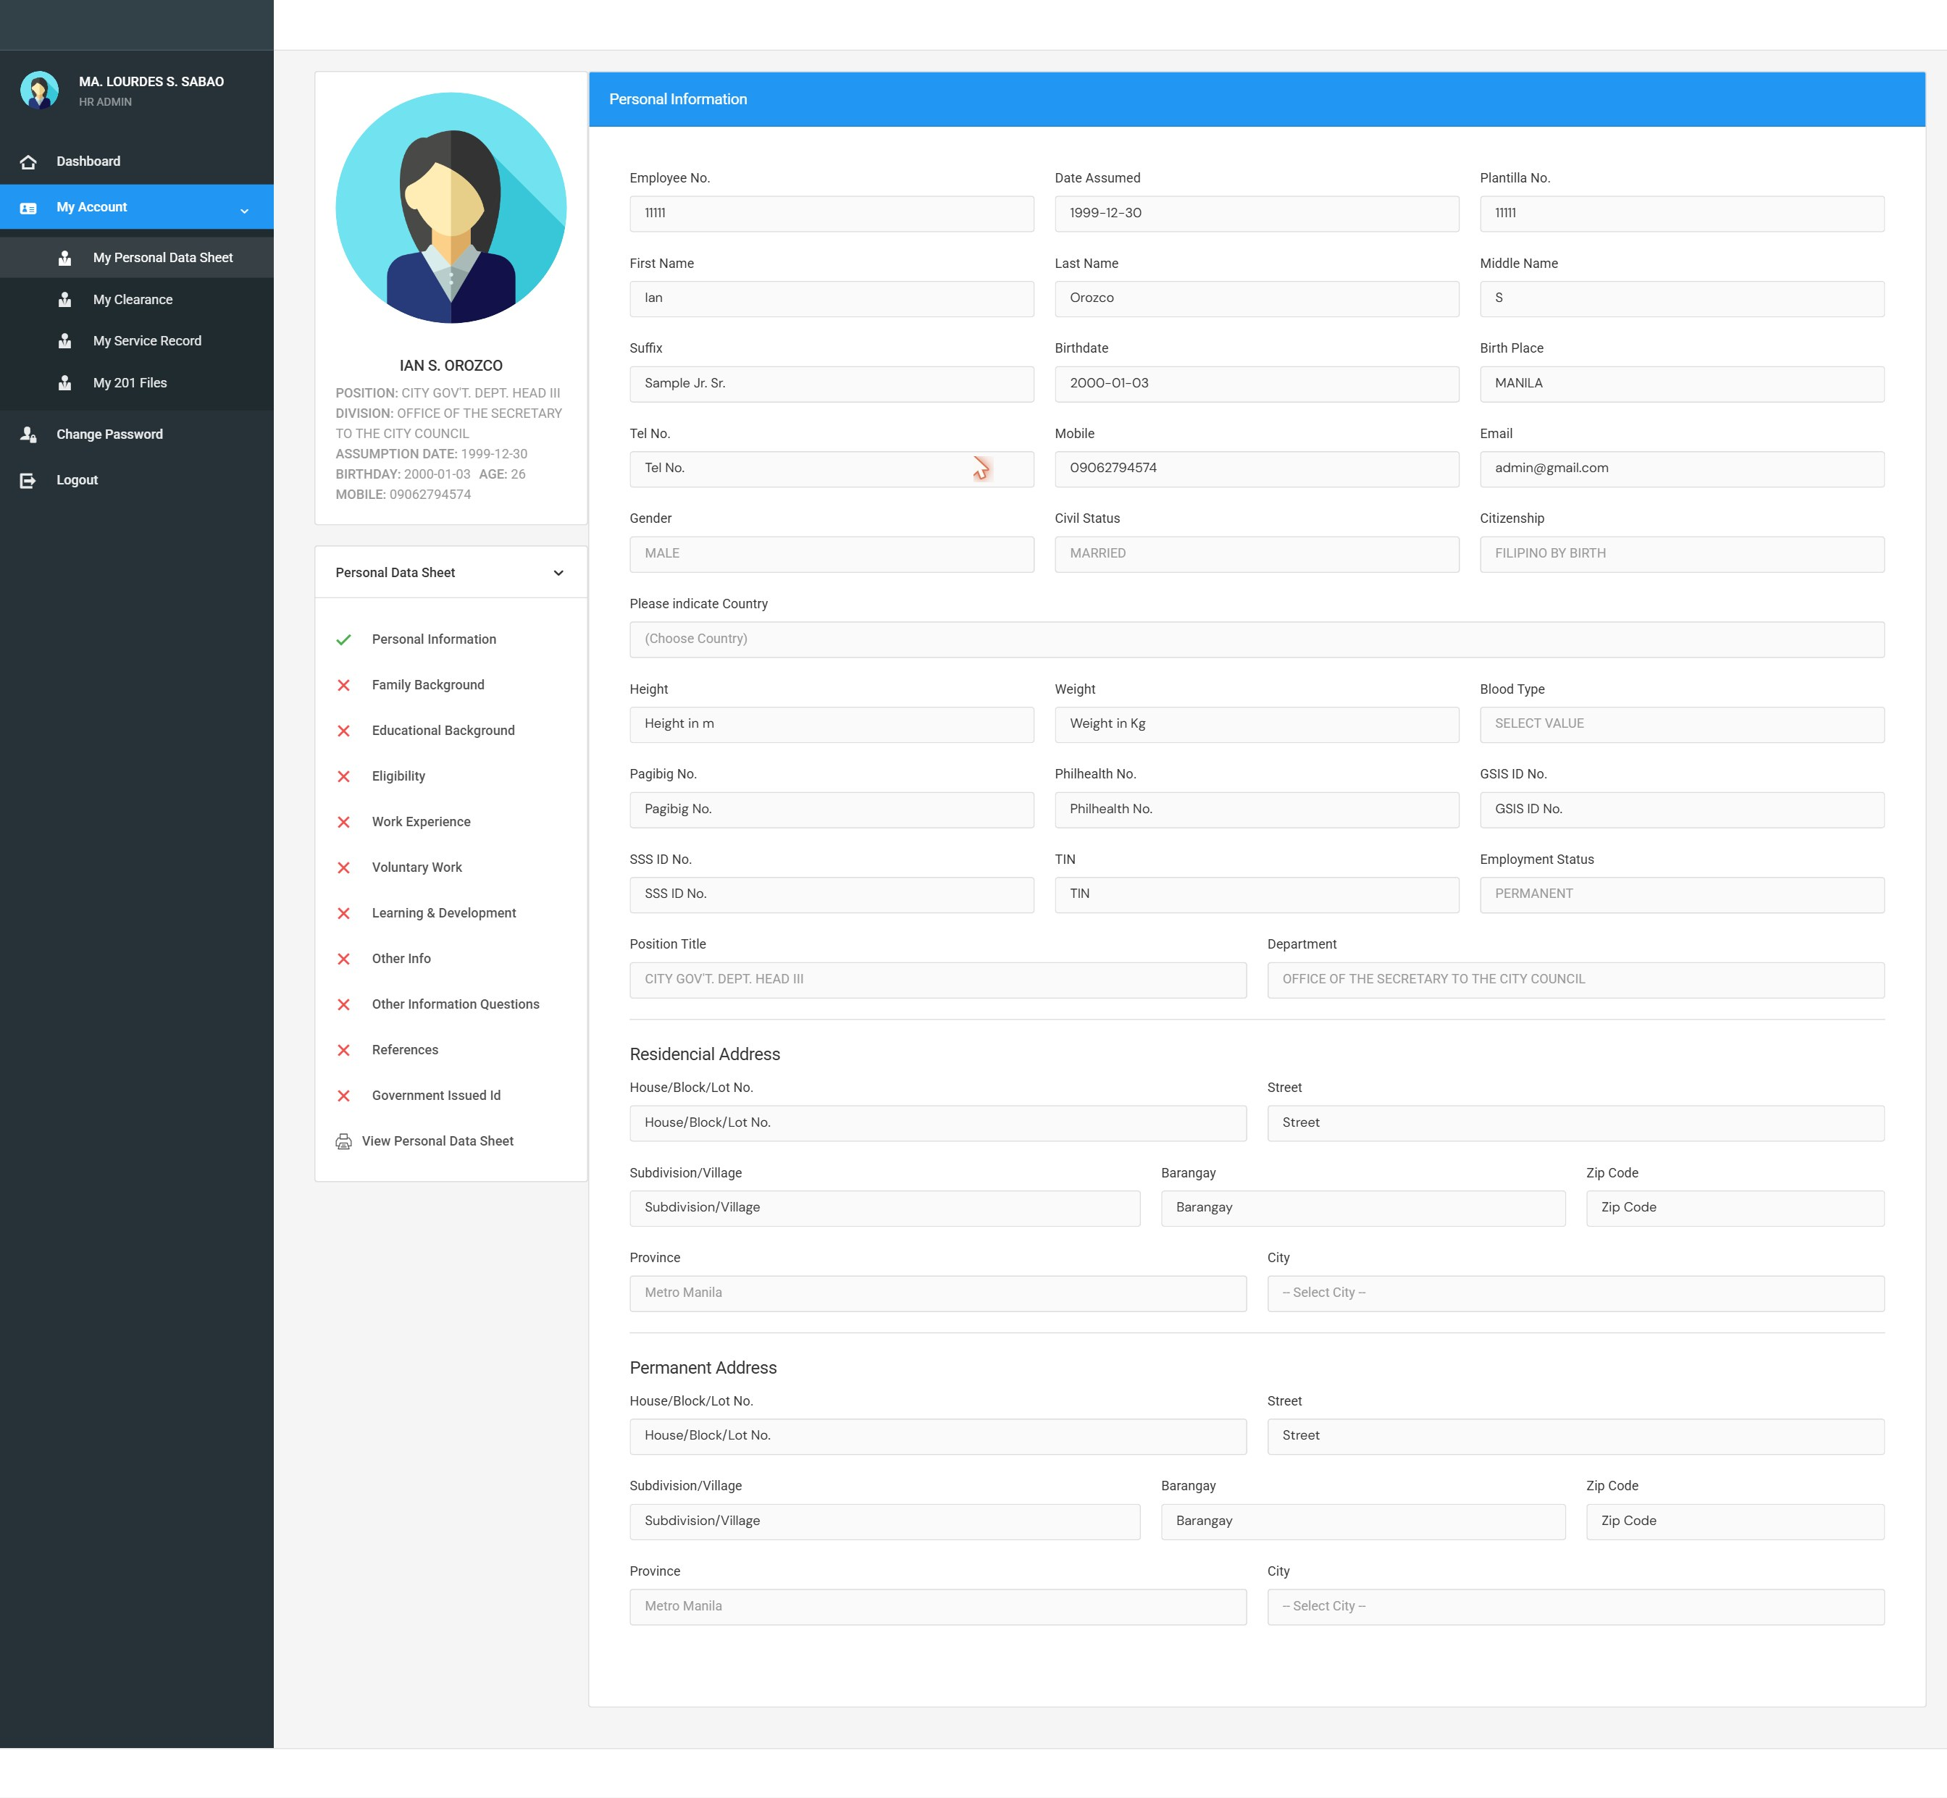
Screenshot: DSH-EMP employee dashboard

7.1 Login
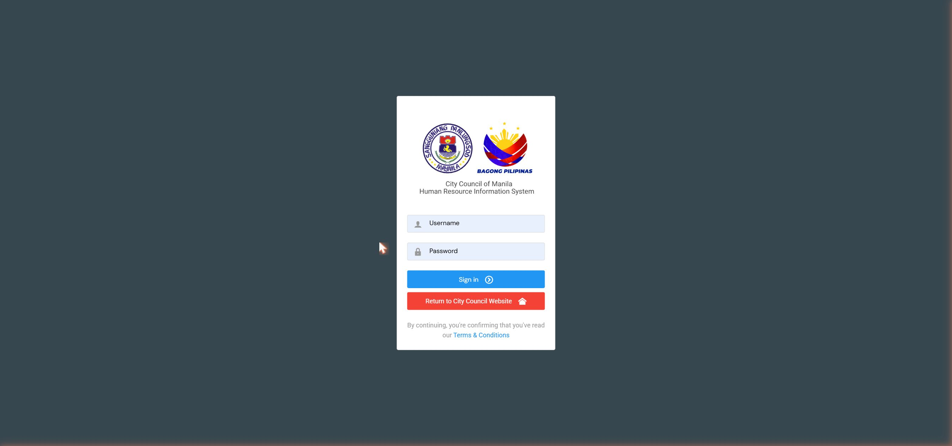
Screenshot: LOG-01 login page

Test Case ID: TC-EMP-LOG-001 |  | Expected Result | Actual Result | Status
Scenario: | Employee logs in with correct username and password
Pre-Condition: | You have been given your username and password by the HR Division.
Step # | Step / Action | Expected Result | Actual Result | P / F
1 | Open the HRIS system in Google Chrome using the URL provided. | The Login page appears with a username and password field.
2 | Type your username in the Username field. | The text you type appears in the field.
3 | Type your password in the Password field. | The password is hidden (shown as dots or asterisks).
4 | Click the Sign In button. | You are taken to the Dashboard. Your name or account is shown in the top right corner.

Test Case ID: TC-EMP-LOG-002 |  | Expected Result | Actual Result | Status
Scenario: | Login fails with wrong password
Pre-Condition: | You are on the Login page.
Step # | Step / Action | Expected Result | Actual Result | P / F
1 | Type your correct username. | Username is entered.
2 | Type a wrong password (e.g., type 'wrongpass'). | Wrong text is entered.
3 | Click Sign In. | An error message appears. The system does NOT log you in. You stay on the Login page.

7.2 Change Password
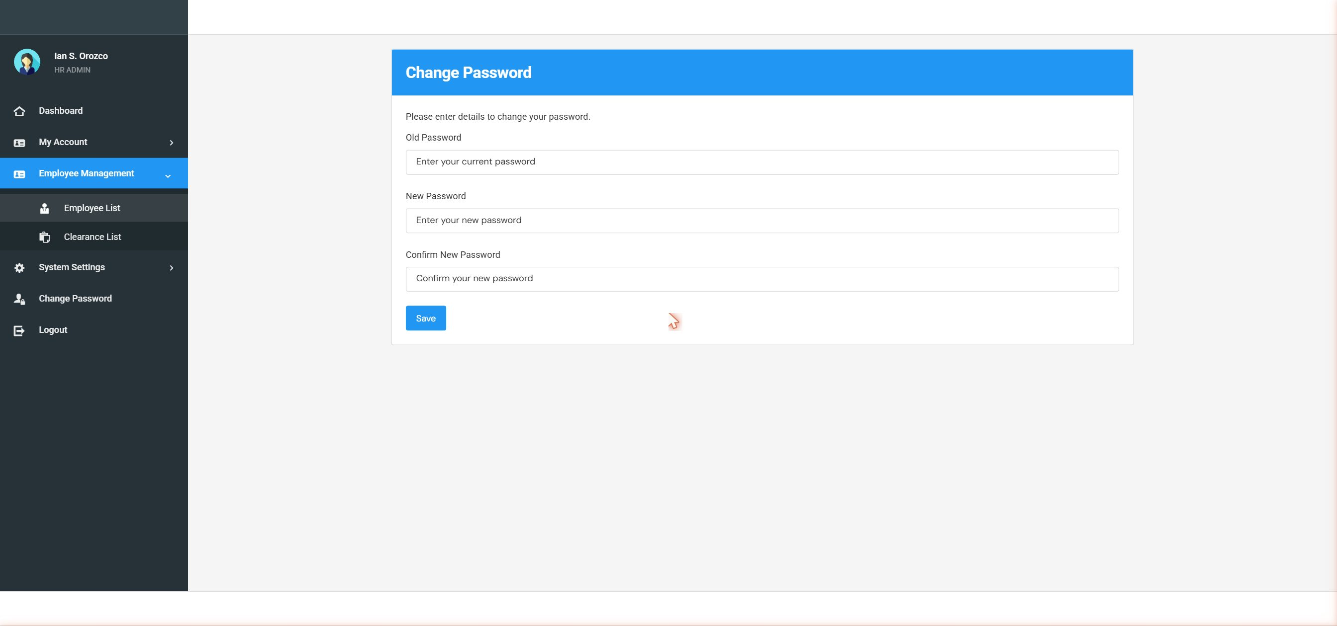
Screenshot: CPW-01 change password

Test Case ID: TC-EMP-PWD-001 |  | Expected Result | Actual Result | Status
Scenario: | Employee changes their password
Pre-Condition: | You are logged in. You know your current password.
Step # | Step / Action | Expected Result | Actual Result | P / F
1 | Click your name or the profile icon at the top right of the page. | A dropdown menu appears with options including Change Password.
2 | Click Change Password. | The Change Password page opens with three fields: Current Password, New Password, and Confirm New Password.
3 | Type your current password in the Current Password field. | Text appears (hidden as dots).
4 | Type a new password in the New Password field. Make it at least 6 characters. | Text appears (hidden as dots).
5 | Type the same new password again in the Confirm New Password field. | Text appears (hidden as dots).
6 | Click Save or Submit. | A success message appears. Your password has been changed.
7 | Log out and log back in using the new password. | You are successfully logged back in with the new password.

Test Case ID: TC-EMP-PWD-002 |  | Expected Result | Actual Result | Status
Scenario: | Change password fails when new passwords do not match
Pre-Condition: | You are on the Change Password page.
Step # | Step / Action | Expected Result | Actual Result | P / F
1 | Type your current password. | Current password entered.
2 | Type a new password in the New Password field. | New password entered.
3 | Type a DIFFERENT value in Confirm New Password. | A different value entered.
4 | Click Save. | An error message appears saying the passwords do not match. The password is NOT changed.

7.3 My Personal Data Sheet (PDS)
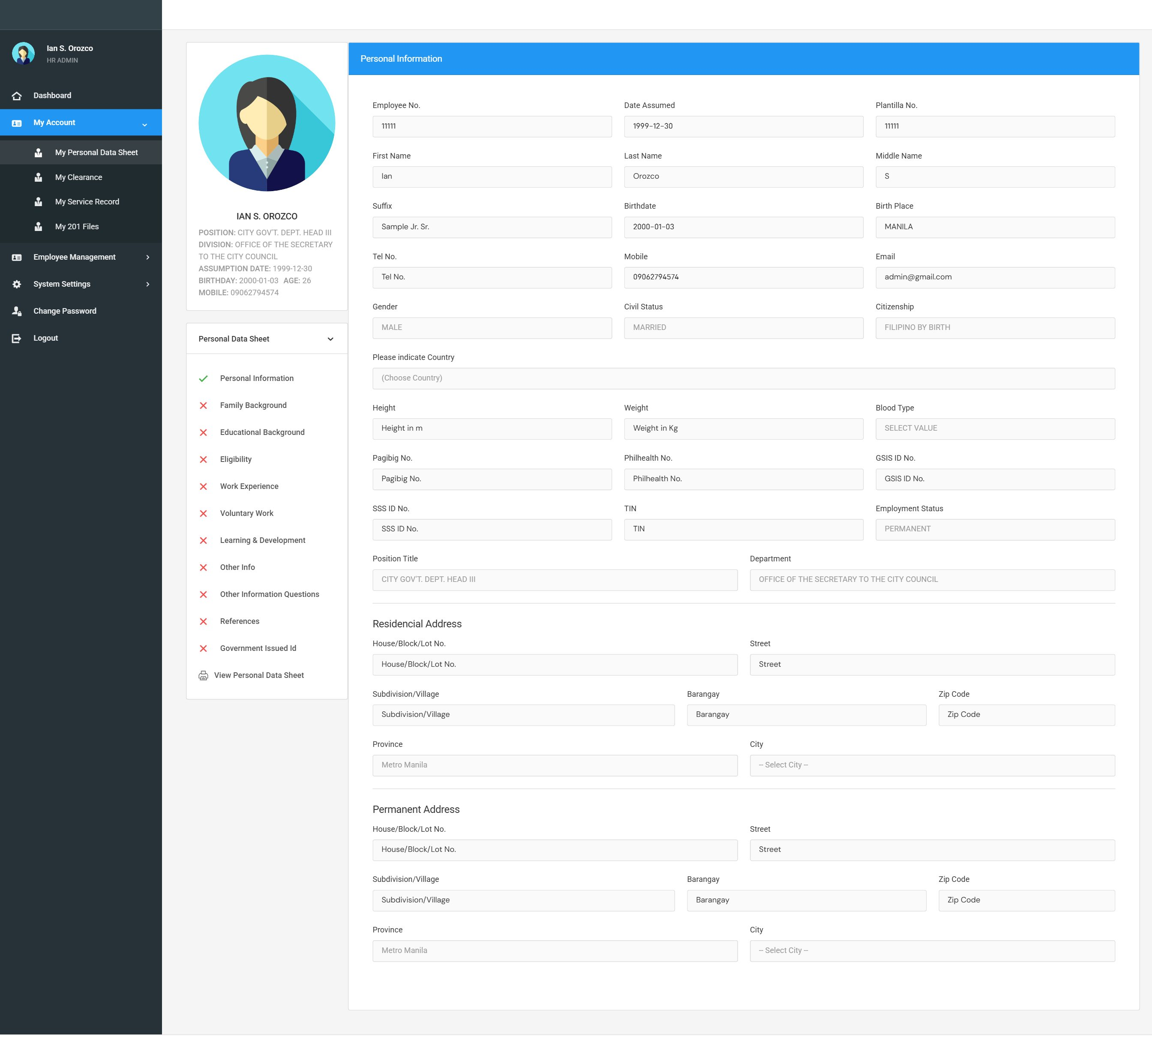
Screenshot: PDS-01 personal info

Your Personal Data Sheet (PDS) is CS Form No. 212. It contains your complete employee information. As a regular employee, you can view and print your PDS but you cannot edit it — only the HR Administrator can make changes.

Test Case ID: TC-EMP-PDS-001 |  | Expected Result | Actual Result | Status
Scenario: | View My Personal Data Sheet
Pre-Condition: | You are logged in with your employee account.
Step # | Step / Action | Expected Result | Actual Result | P / F
1 | Look at the left sidebar menu and click 'My Personal Data Sheet' or 'My Profile'. | Your Personal Data Sheet page opens.
2 | Check the Personal Information section. | Your full name, date of birth, place of birth, civil status, and other personal details are shown.
3 | Check the Family Background section. | Spouse, parents, and children's information is shown.
4 | Check the Educational Background section. | Your schools, degrees, and honors are listed.
5 | Scroll through the remaining sections (Eligibility, Work Experience, Voluntary Work, Learning & Development, Other Information, References, Government ID). | All sections are visible and show your correct information.

PDS Sub-Sections — Visual Reference

Family Background
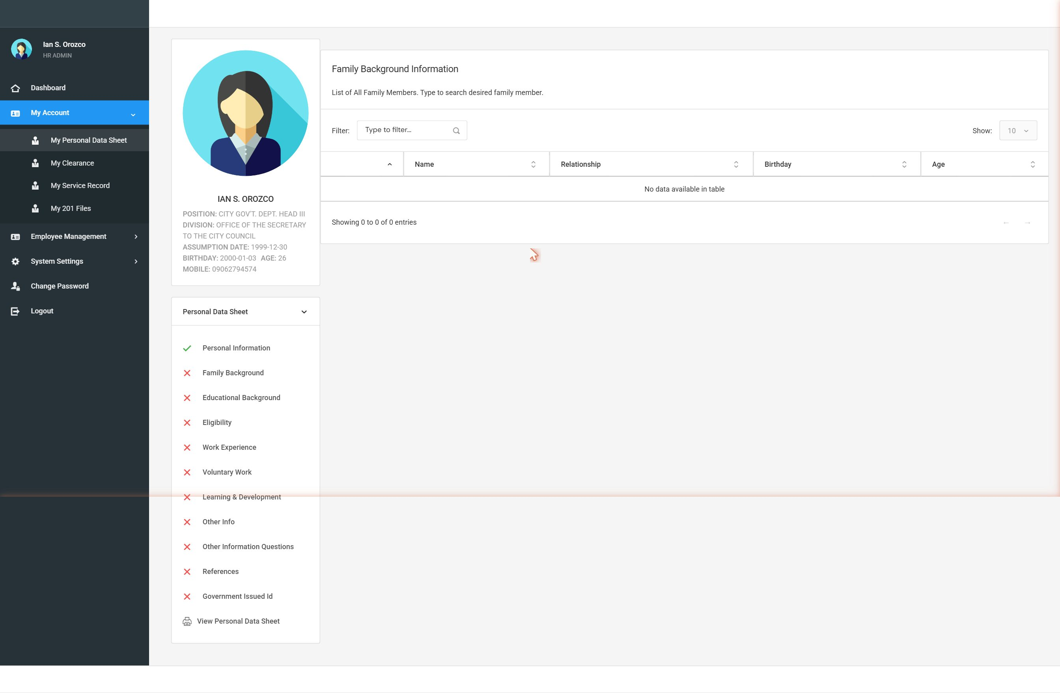
Screenshot: PDS-02 family background
Educational Background
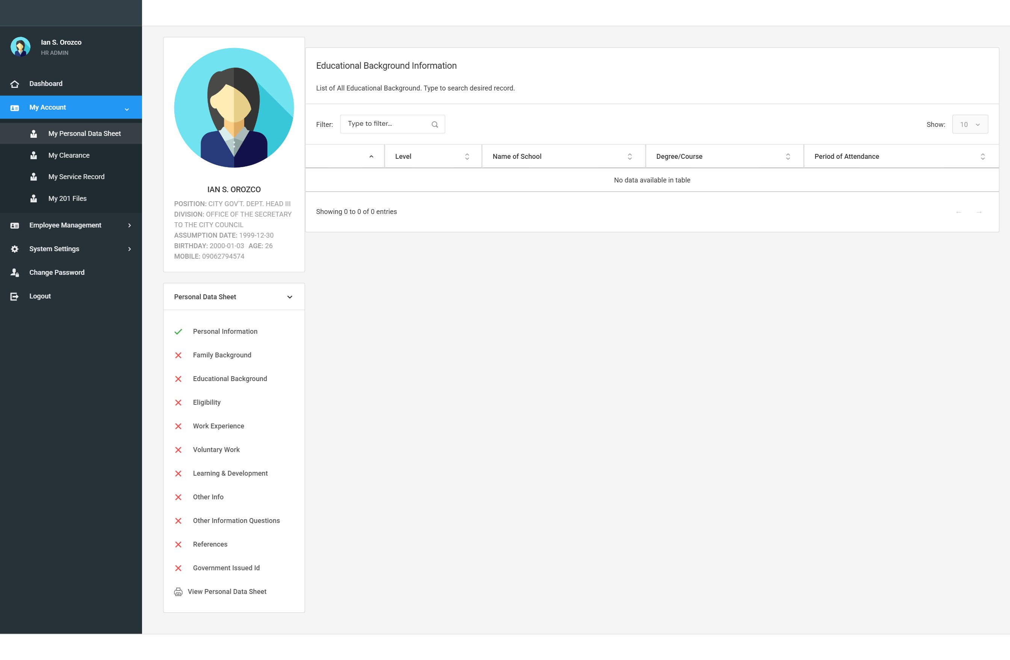
Screenshot: PDS-03 educational background
Eligibility
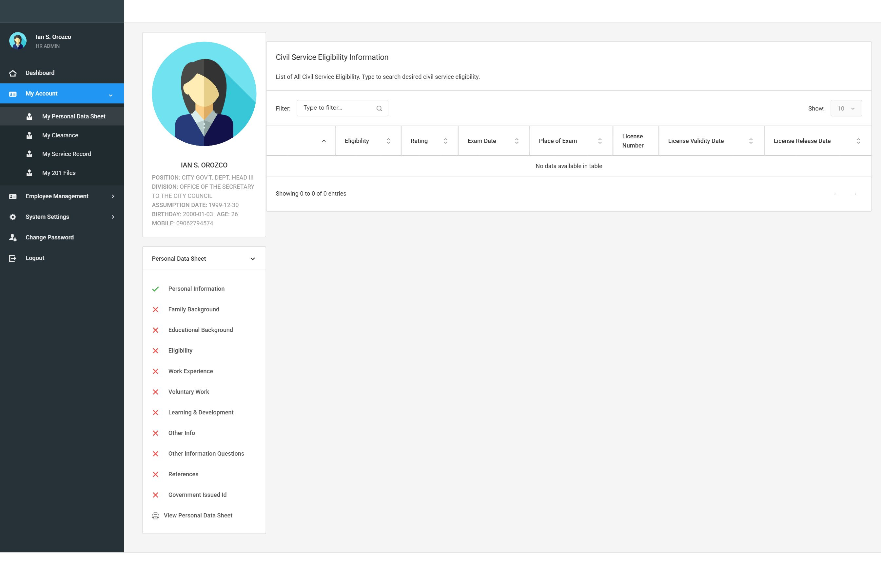
Screenshot: PDS-04 eligibility
Work Experience
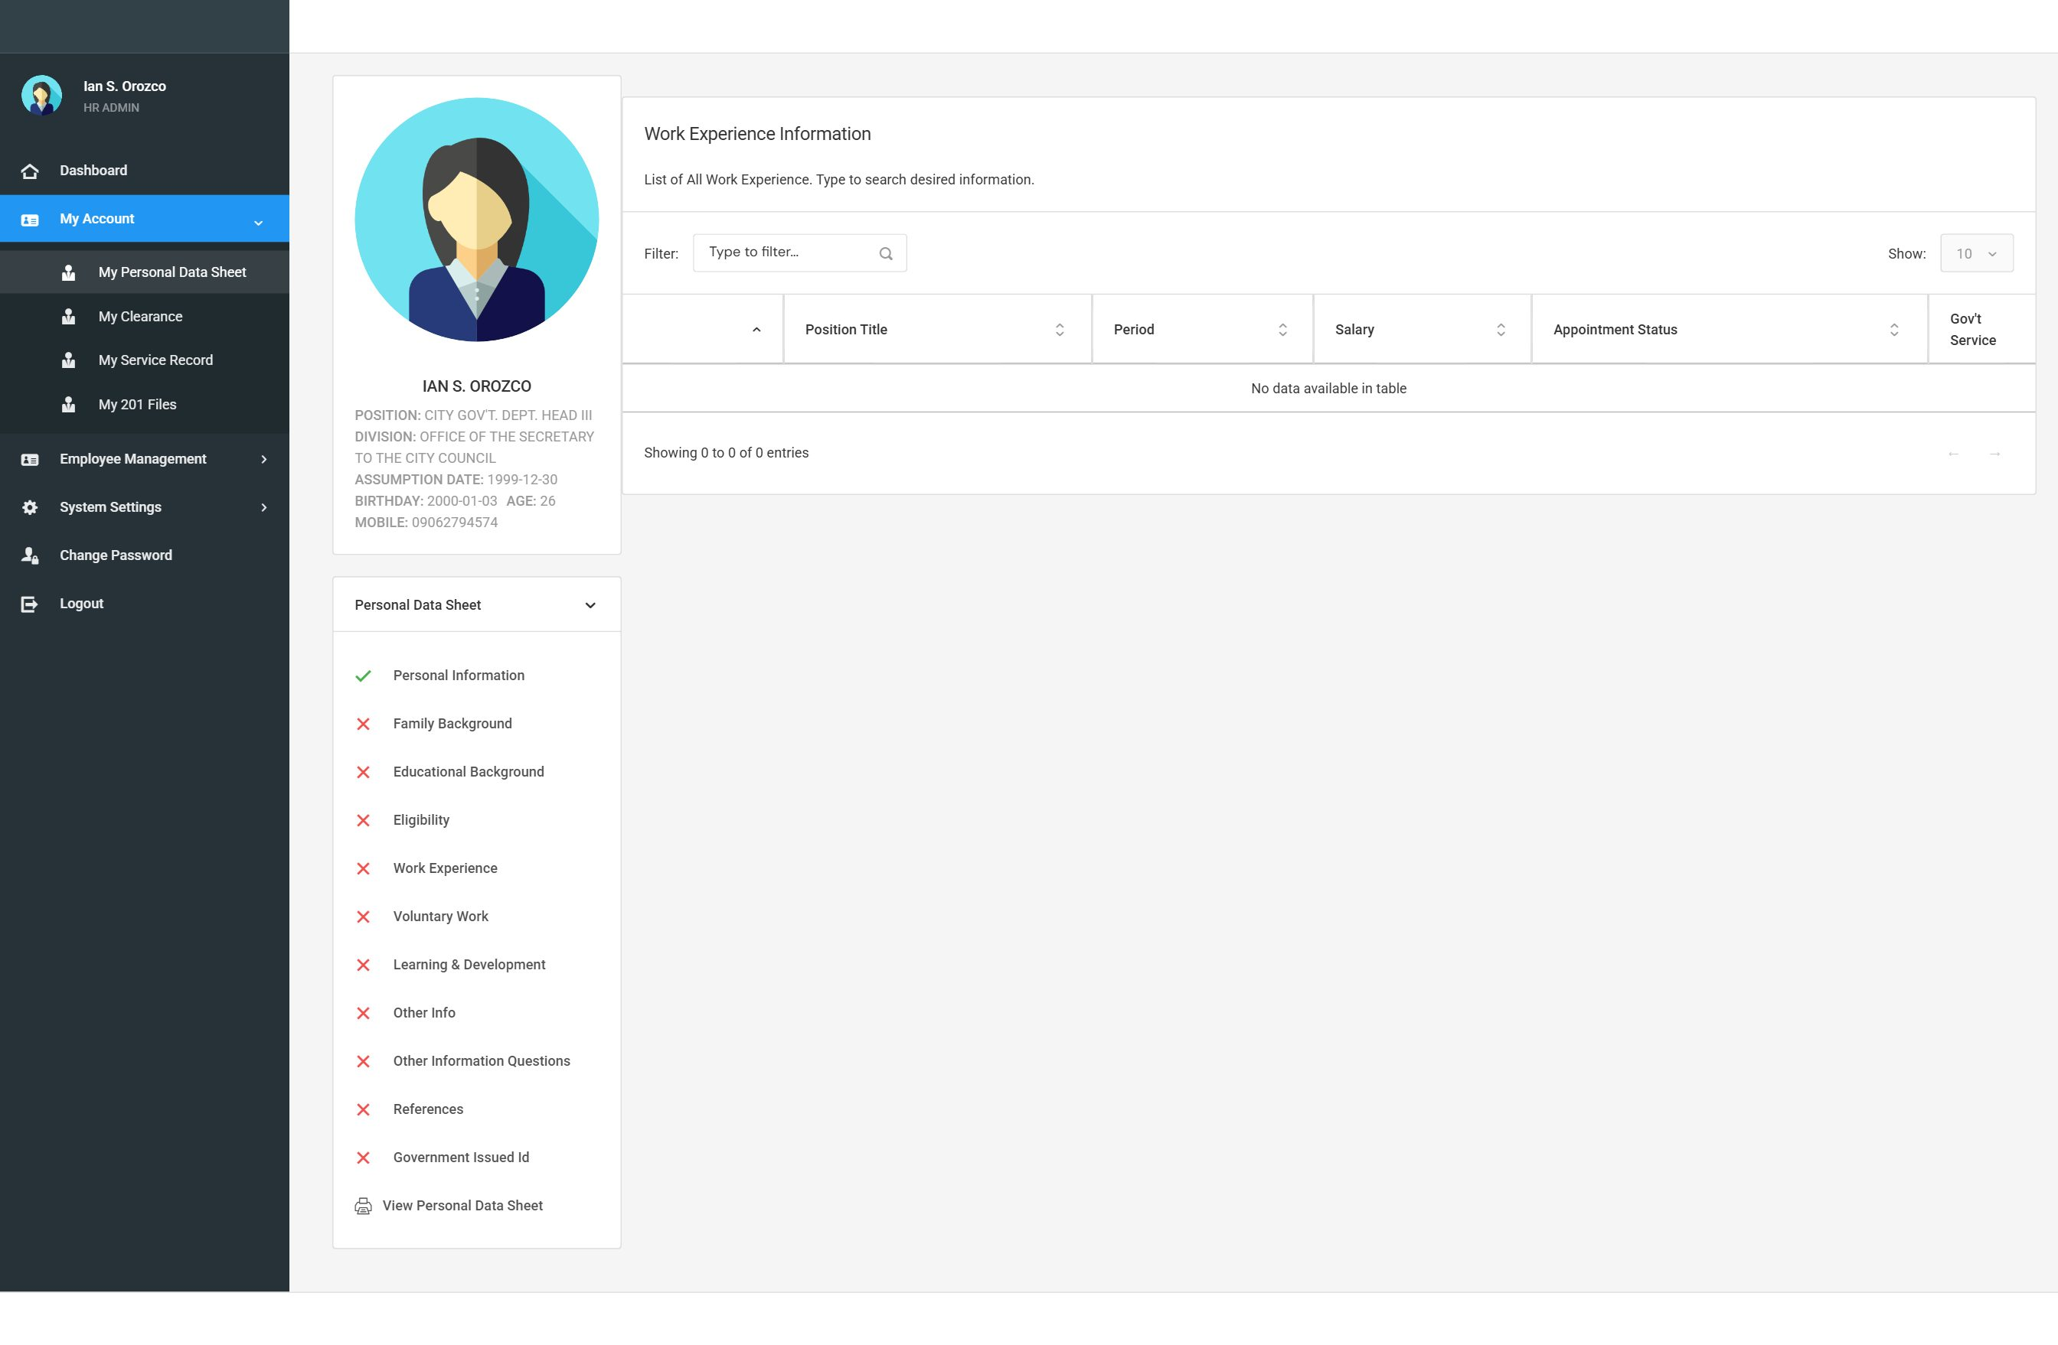
Screenshot: PDS-05 work experience
Voluntary Work
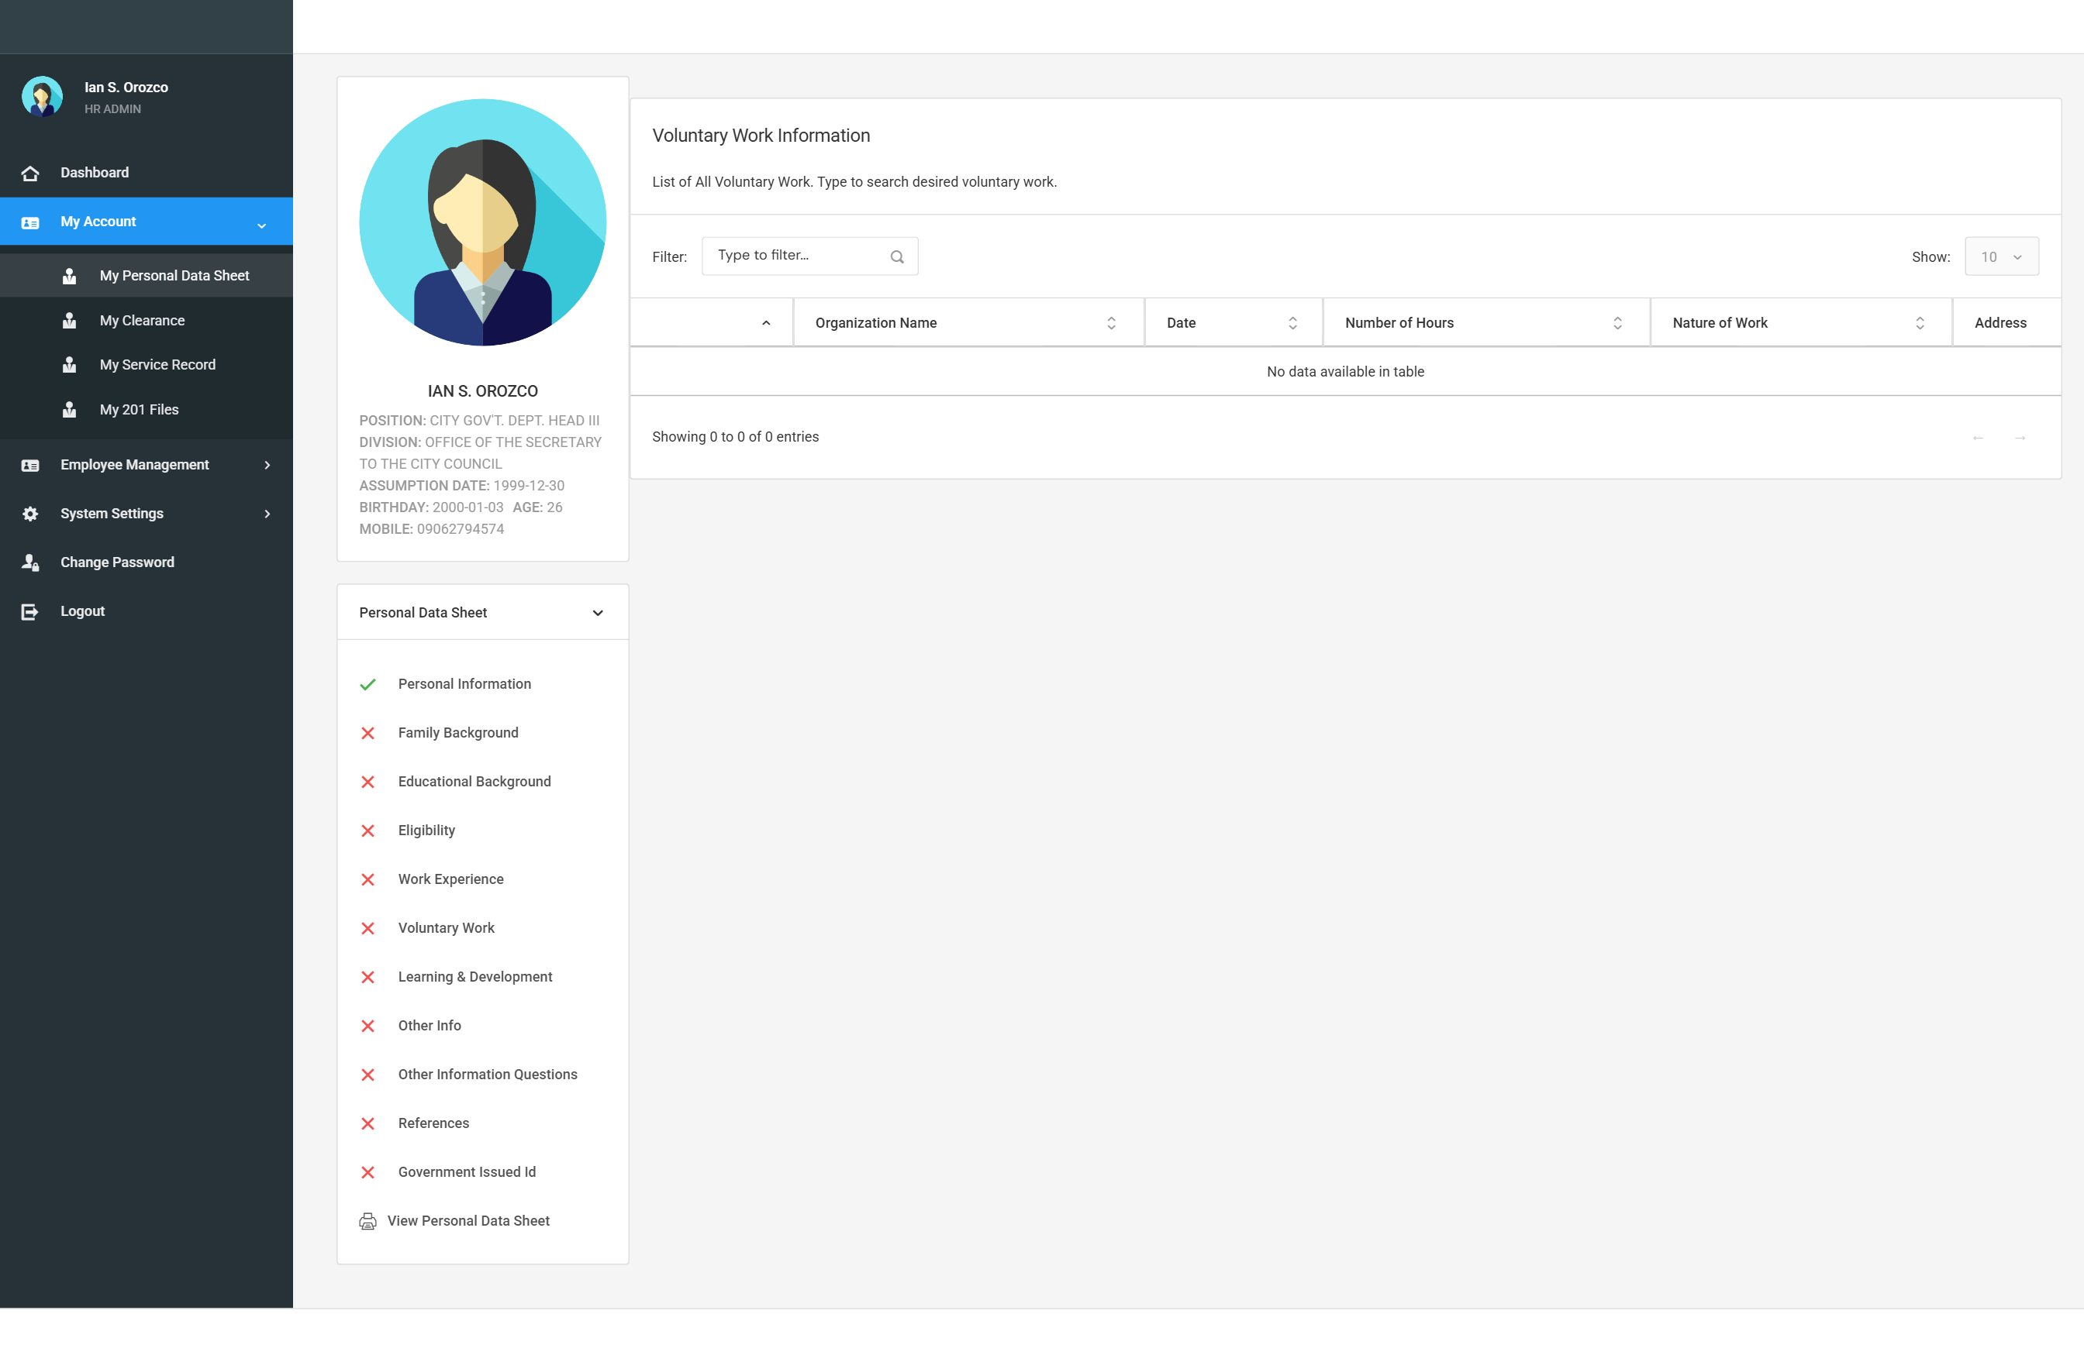
Screenshot: PDS-06 voluntary work
Learning & Development
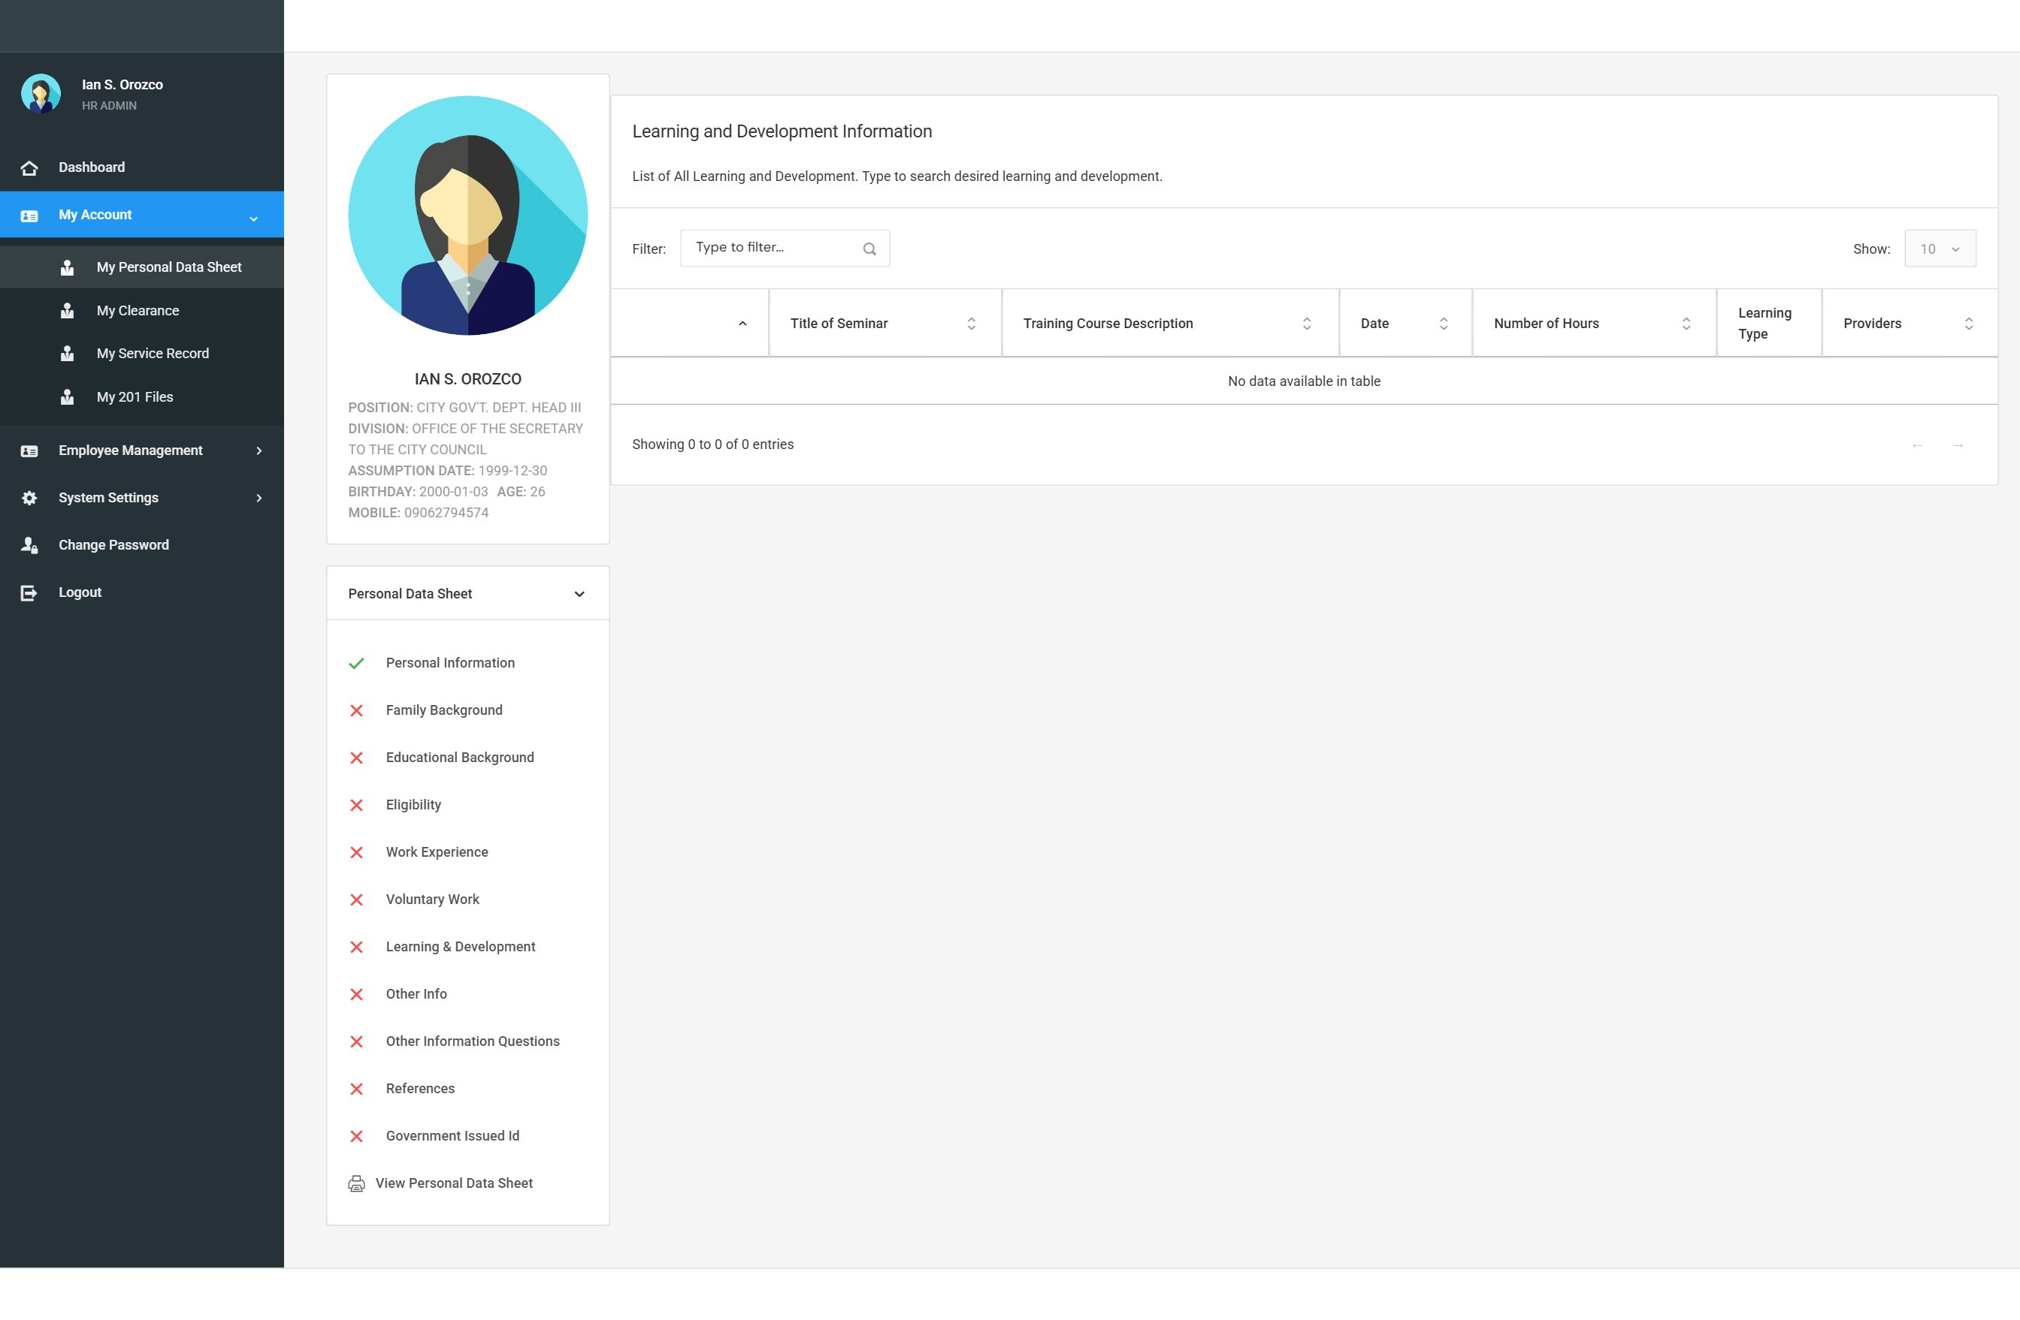
Screenshot: PDS-07 learning development
Other Information
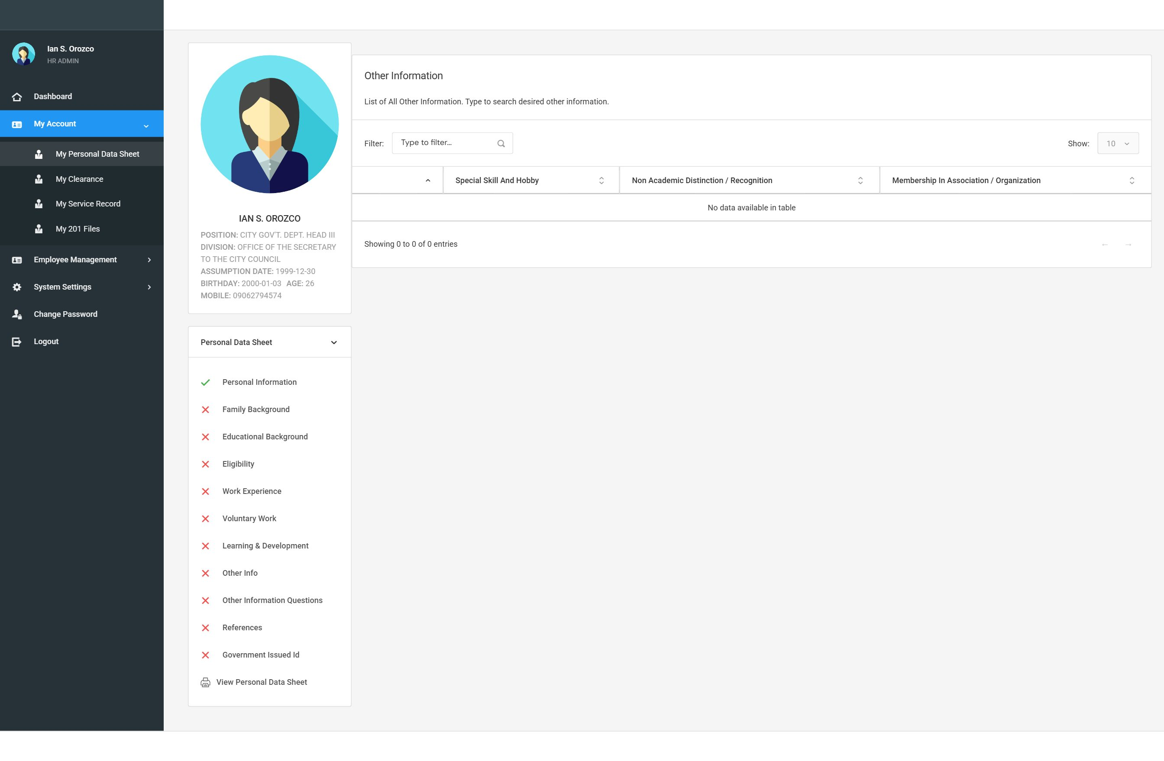
Screenshot: PDS-08 other info
References
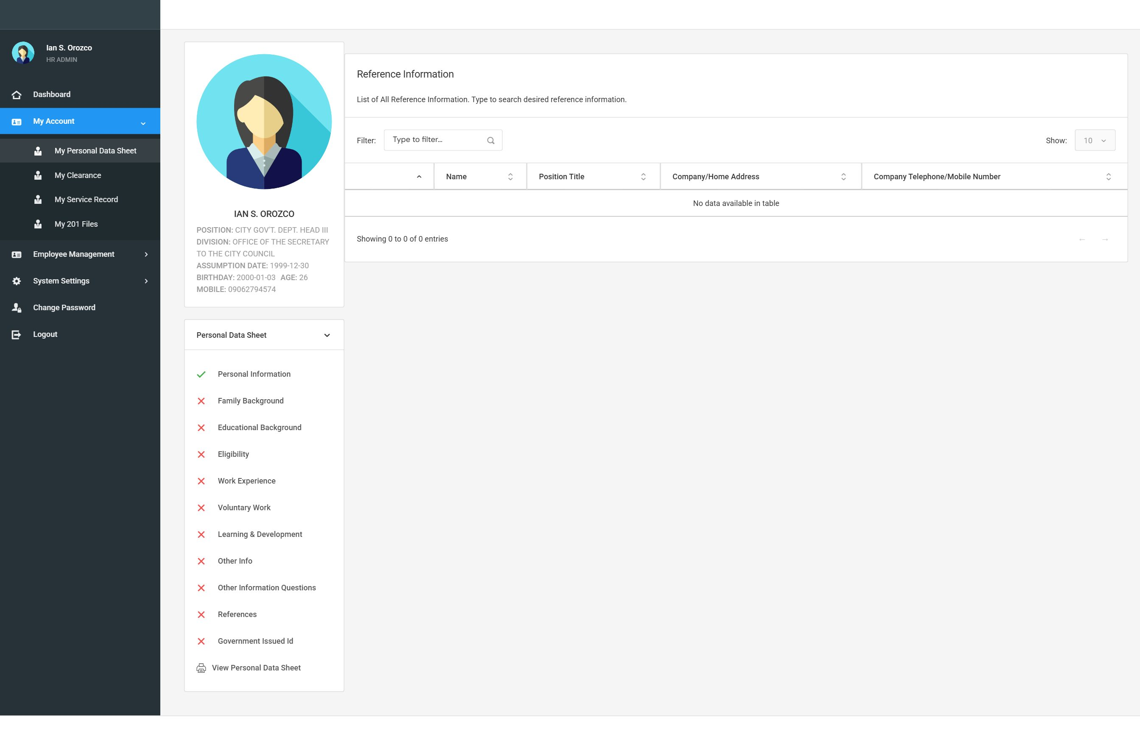
Screenshot: PDS-09 references
Government ID
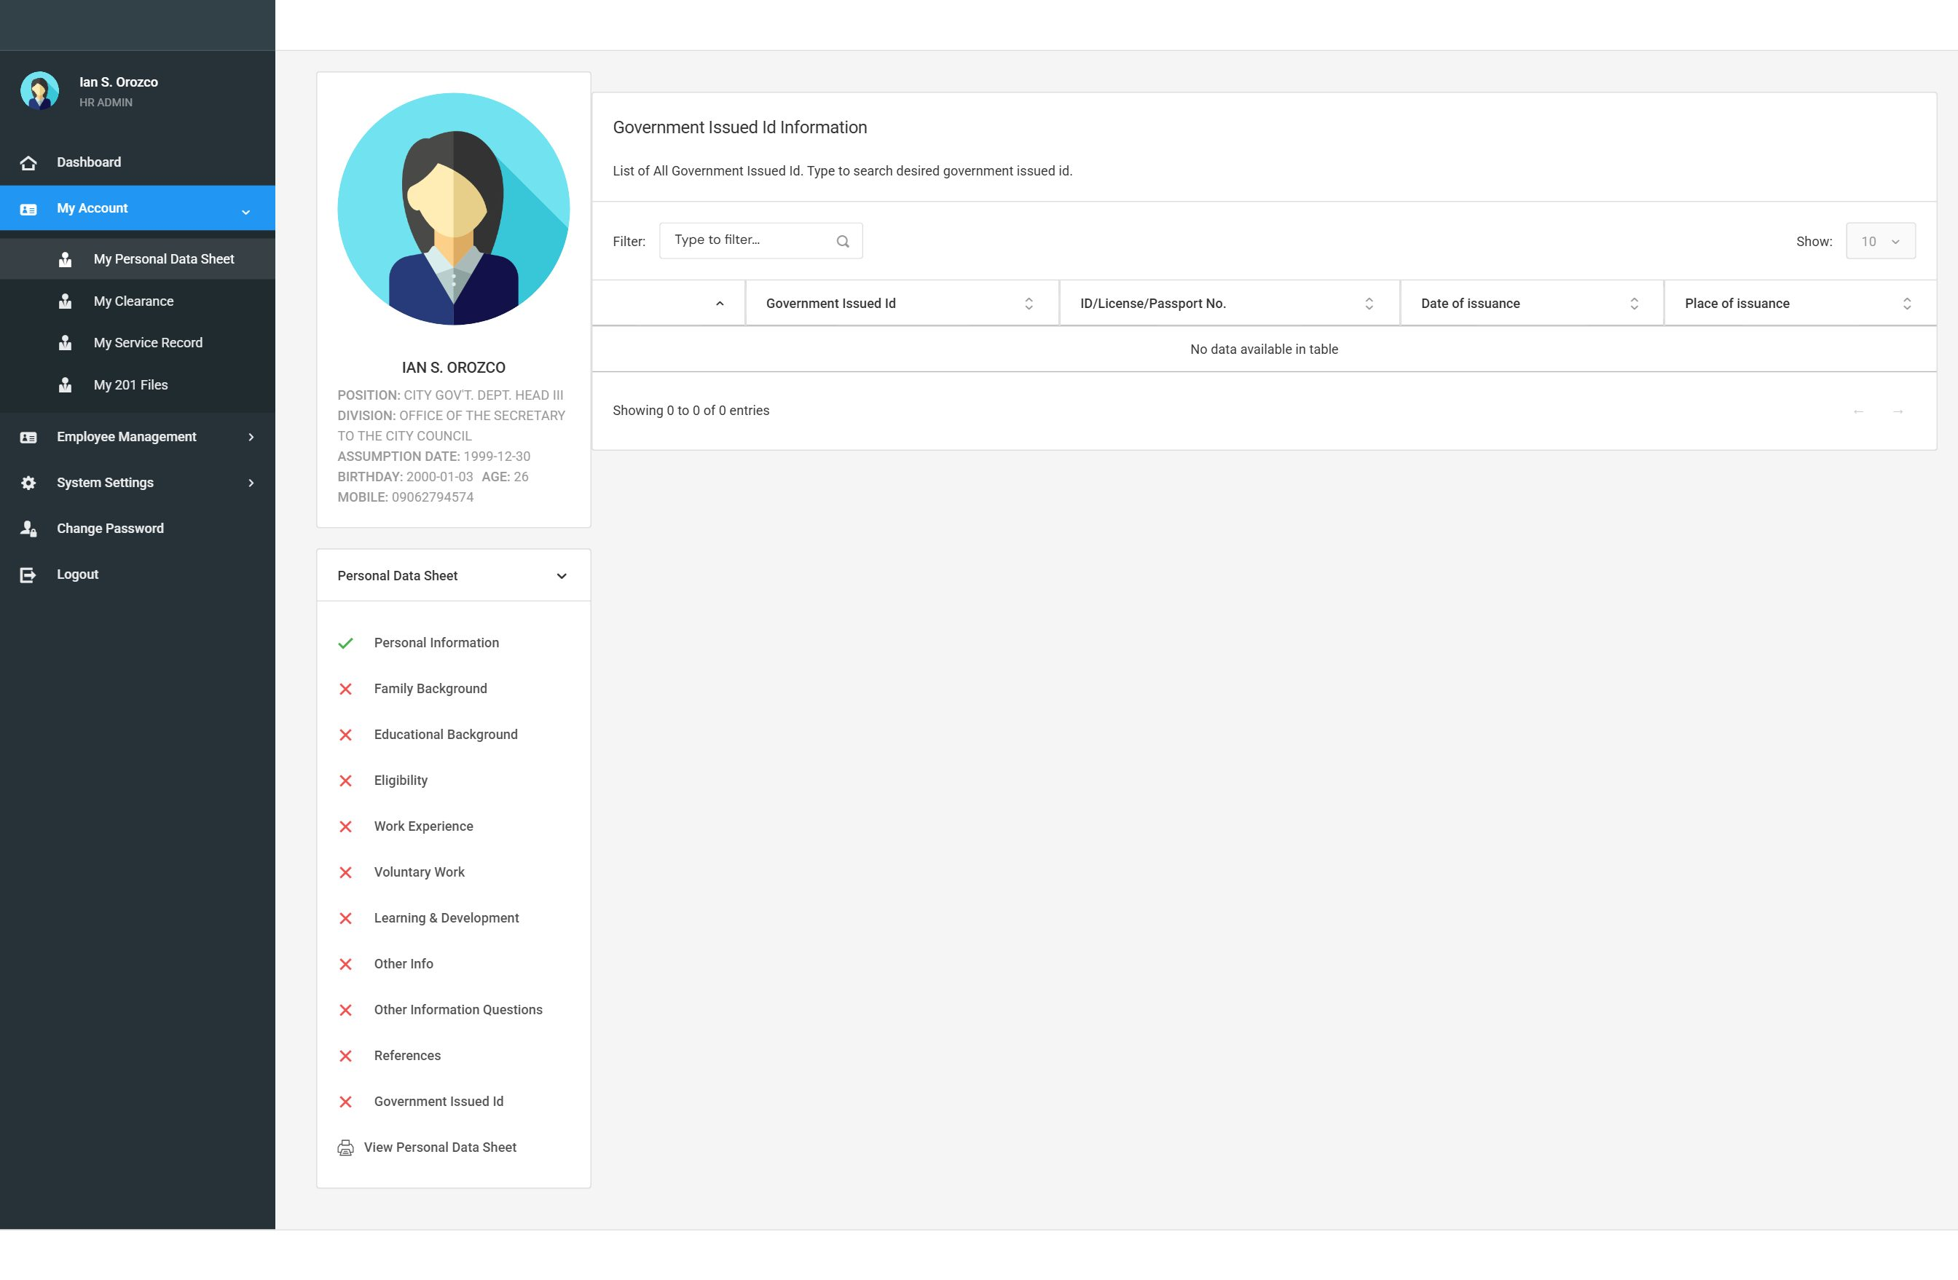
Screenshot: PDS-10 government id

Test Case ID: TC-EMP-PDS-002 |  | Expected Result | Actual Result | Status
Scenario: | Employee cannot edit PDS fields
Pre-Condition: | You are on your Personal Data Sheet page.
Step # | Step / Action | Expected Result | Actual Result | P / F
1 | Try clicking on your name, date of birth, or any other field to change it. | The fields cannot be clicked or edited. There is no Edit button or Save button visible to you.

Test Case ID: TC-EMP-PDS-003 |  | Expected Result | Actual Result | Status
Scenario: | Print the Personal Data Sheet
Pre-Condition: | Your PDS has data filled in.
Step # | Step / Action | Expected Result | Actual Result | P / F
1 | Open My Personal Data Sheet. | PDS page is shown.
2 | Click the 'View Personal Data Sheet' or Print button. | A PDF version of CS Form No. 212 opens in a new tab or window.
3 | Check that the PDF shows your correct information. | The PDF is formatted as CS Form No. 212 and shows your data correctly.

7.4 My Appointments
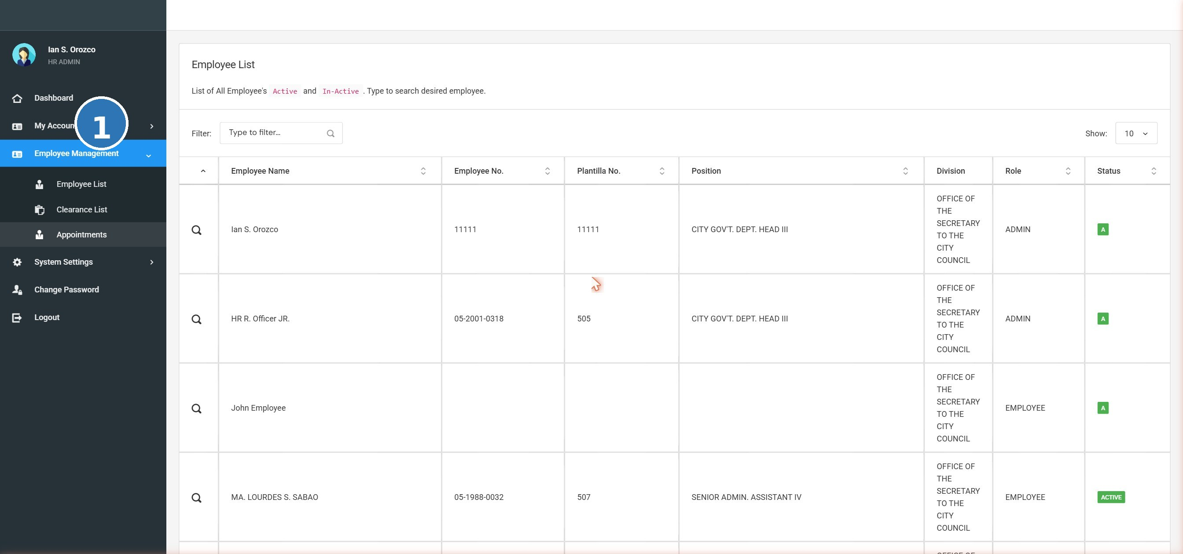
Screenshot: APT-LIST appointments list
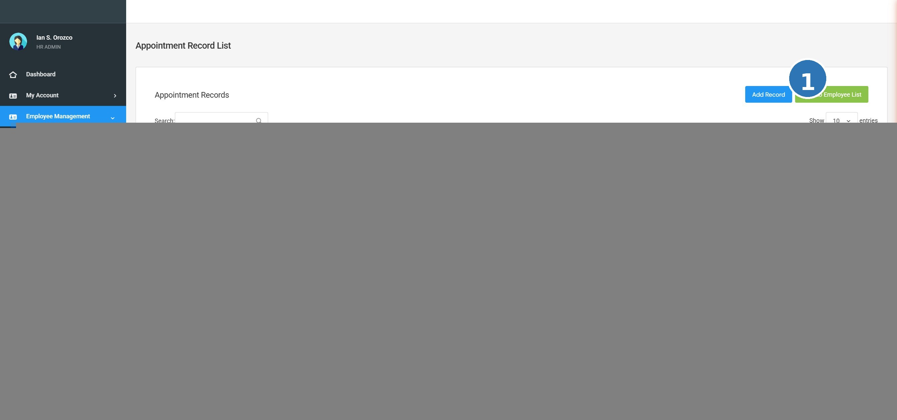
Screenshot: APT-01 appointments

The Appointments section shows your official appointment history — the positions you have held, salary grades, nature of appointment, and effective dates. You can view these records but cannot change them.

Test Case ID: TC-EMP-APT-001 |  | Expected Result | Actual Result | Status
Scenario: | View my appointment records
Pre-Condition: | You are logged in. Your appointment records have been entered by the HR Administrator.
Step # | Step / Action | Expected Result | Actual Result | P / F
1 | Click 'My Appointments' in the navigation menu. | Your appointment records page opens.
2 | Check the table of appointments shown. | A list of your appointment records is displayed showing: Position Title, Status of Appointment, Salary, Salary Grade, Signing Date, and Entrance Date.
3 | Check that the appointment details shown are correct. | The information matches your actual appointment records.

Test Case ID: TC-EMP-APT-002 |  | Expected Result | Actual Result | Status
Scenario: | Appointment records are read-only for employees
Pre-Condition: | You are on the My Appointments page.
Step # | Step / Action | Expected Result | Actual Result | P / F
1 | Try to click on any appointment record to edit it. | You cannot edit any record. There is no Edit or Delete button available to you. Only the HR Administrator can add or change appointment records.

7.5 My Clearance
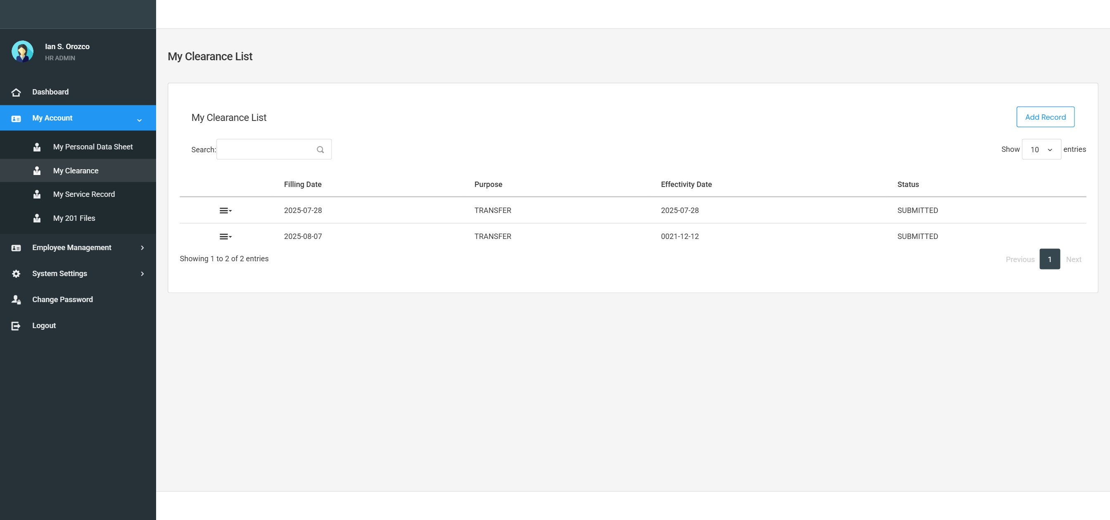
Screenshot: CLR-01 my clearance
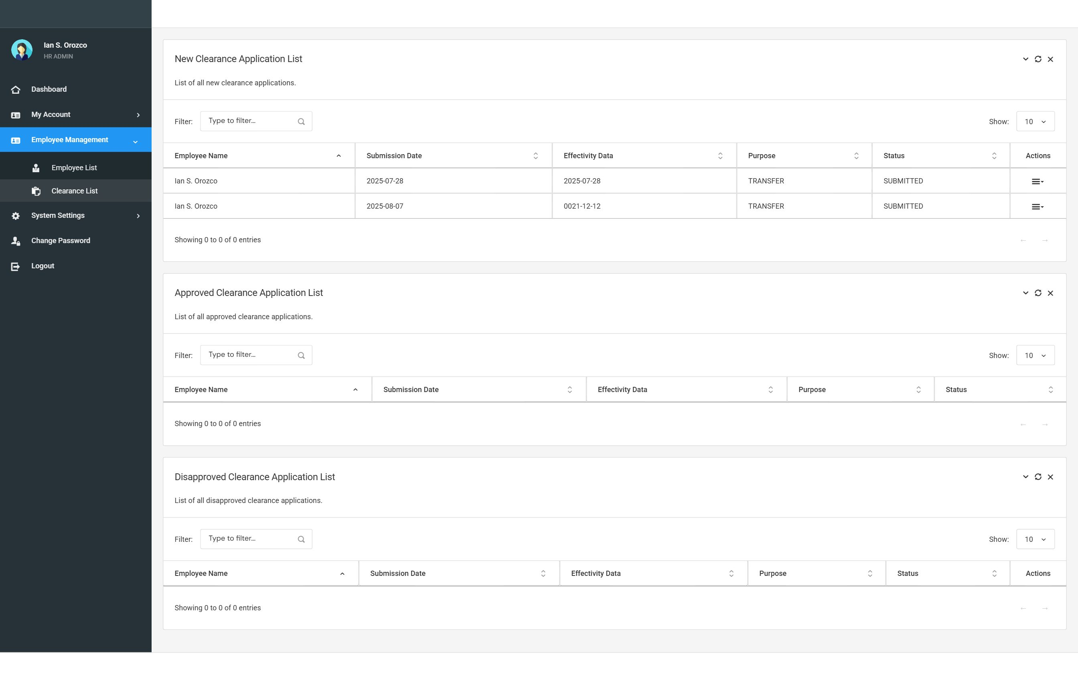
Screenshot: CLR-02 clearance list

The Clearance module allows you to file a clearance request online. After you file it, the HR Administrator will review and either approve or disapprove your request. You can check the status of your request at any time.

Test Case ID: TC-EMP-CLR-001 |  | Expected Result | Actual Result | Status
Scenario: | File a clearance request
Pre-Condition: | You are logged in. You do not have an existing pending clearance request.
Step # | Step / Action | Expected Result | Actual Result | P / F
1 | Click 'My Clearance' in the navigation menu. | The My Clearance page opens. If no request has been filed yet, the page shows an empty list or a message.
2 | Click the 'File Request' button. | A form or dialog appears for you to fill in your clearance request details.
3 | Fill in the required fields and click Submit. | Your clearance request is submitted. A success message appears.
4 | Check the clearance list on the same page. | Your new request appears in the list with a status of 'New' or 'Pending'.

Test Case ID: TC-EMP-CLR-002 |  | Expected Result | Actual Result | Status
Scenario: | Check the status of a filed clearance request
Pre-Condition: | You have already filed a clearance request (see TC-EMP-CLR-001).
Step # | Step / Action | Expected Result | Actual Result | P / F
1 | Go to My Clearance. | The My Clearance page shows your filed request.
2 | Look at the Status column of your request. | The status is shown (e.g., New, Approved, or Disapproved).
3 | If the HR Admin has already acted on the request — check whether it shows Approved or Disapproved. | The updated status is visible without needing to contact HR.

7.6 My 201 Files
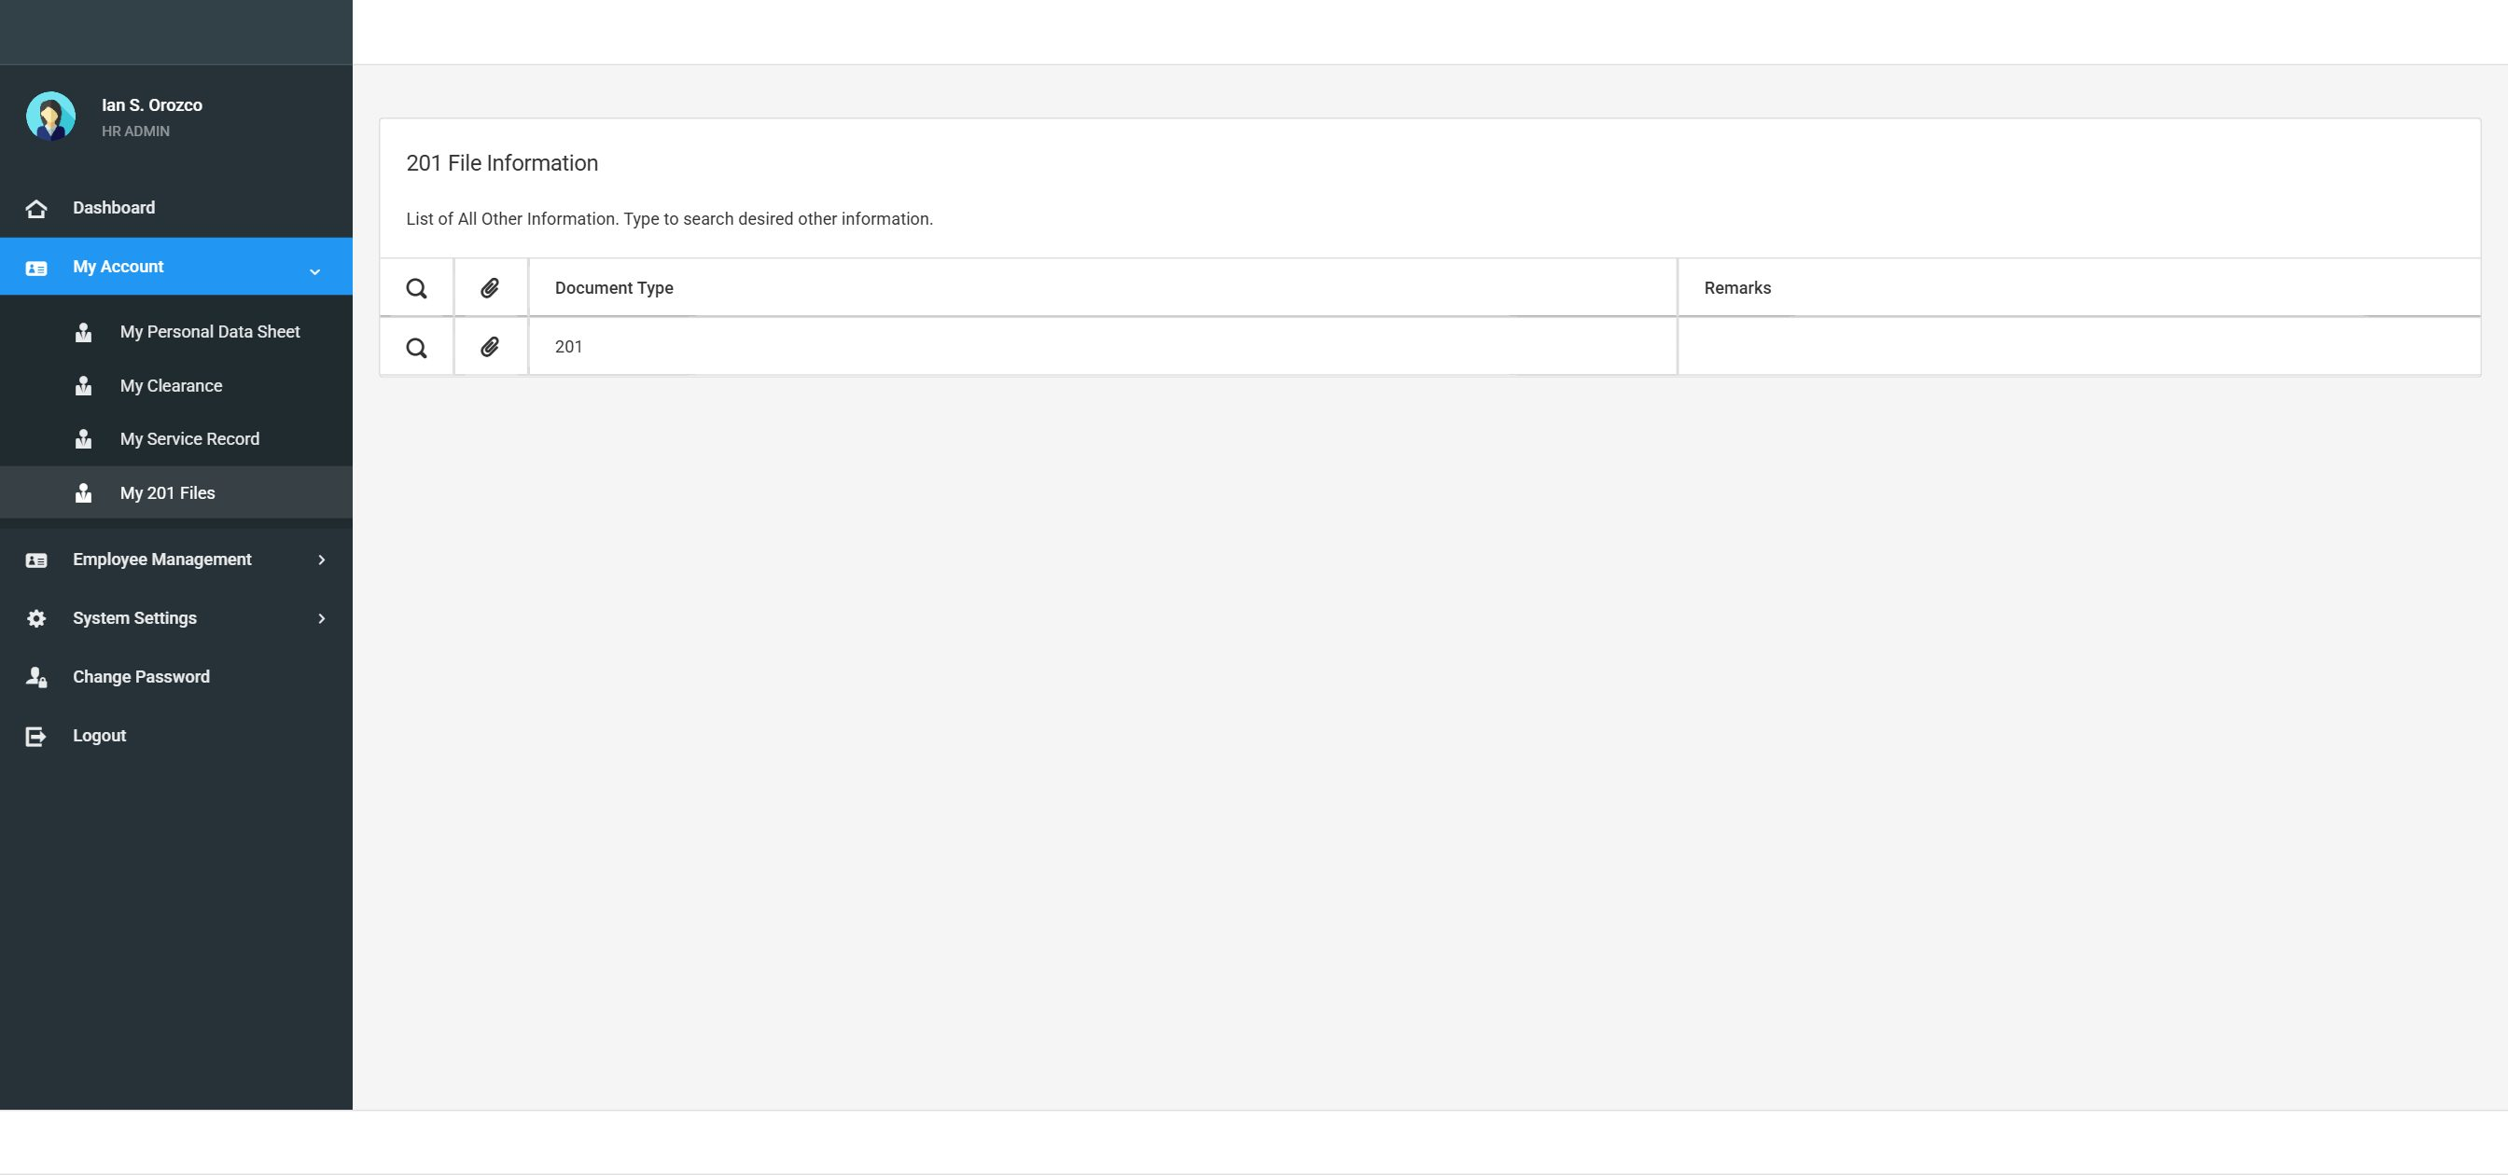
Screenshot: F201-01 201 files

Your 201 Files are your official employment documents uploaded to the system by the HR Administrator (e.g., NBI Clearance, Medical Certificate, Birth Certificate). As an employee, you can view and download your own documents but you cannot upload new files.

Test Case ID: TC-EMP-201-001 |  | Expected Result | Actual Result | Status
Scenario: | View my 201 files
Pre-Condition: | You are logged in. The HR Administrator has already uploaded at least one document for your account.
Step # | Step / Action | Expected Result | Actual Result | P / F
1 | Click 'My 201 Files' or 'My Documents' in the navigation menu. | The 201 Files page opens showing a list of your documents.
2 | Check the columns shown in the list. | The list shows Document Type, Date Uploaded, and Notes for each file.
3 | Check that the documents listed belong to you. | Only your own 201 documents are shown.

Test Case ID: TC-EMP-201-002 |  | Expected Result | Actual Result | Status
Scenario: | Download / view a 201 document
Pre-Condition: | You are on the My 201 Files page and at least one document is listed.
Step # | Step / Action | Expected Result | Actual Result | P / F
1 | Click the View or Download button next to any document. | The document opens in a new tab (for PDF files) or downloads to your computer.
2 | Check that the document is readable and correct. | The file opens without errors and shows the correct document.

Test Case ID: TC-EMP-201-003 |  | Expected Result | Actual Result | Status
Scenario: | Employee cannot upload 201 files
Pre-Condition: | You are on the My 201 Files page.
Step # | Step / Action | Expected Result | Actual Result | P / F
1 | Look for an Upload or Attach button on the page. | There is no Upload button visible to you. Only the HR Administrator can upload 201 documents.

7.7 My Service Record
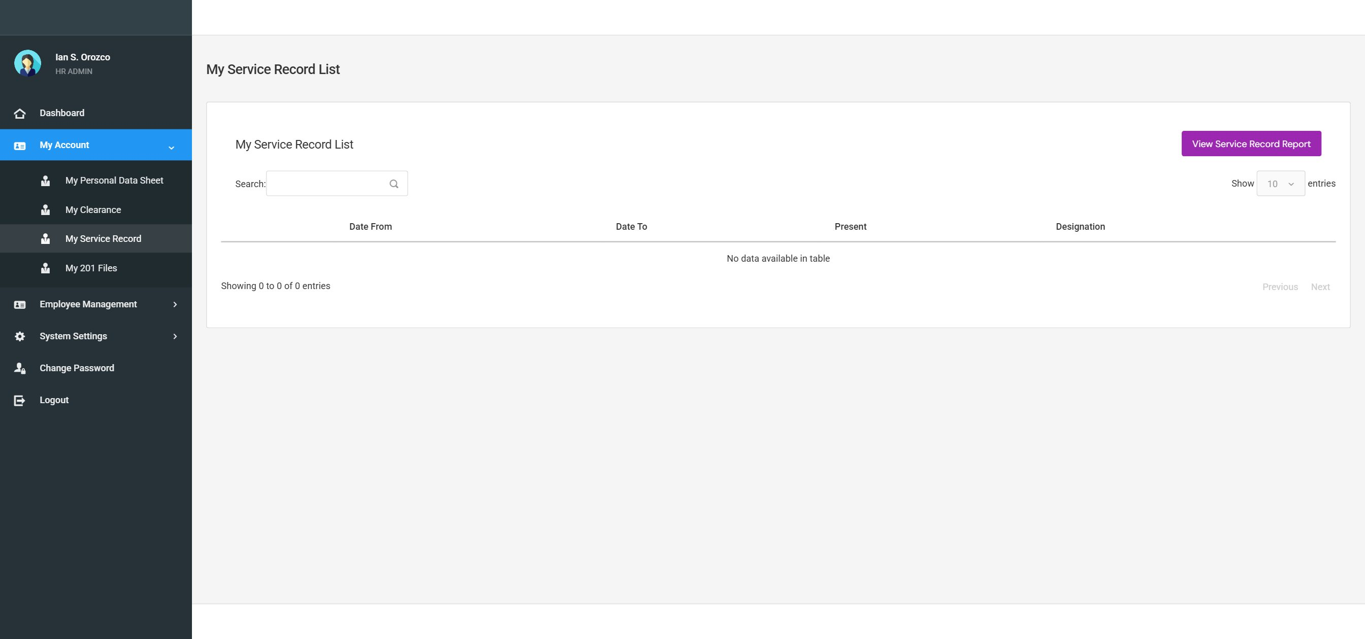
Screenshot: SVC-01 service record

The Service Record shows your complete history of government service — including all positions held, dates, salary, and appointment status. You can view and print your service record. Only the HR Administrator can add or edit entries.

Test Case ID: TC-EMP-SVC-001 |  | Expected Result | Actual Result | Status
Scenario: | View my service record
Pre-Condition: | You are logged in. At least one service record entry has been entered by the HR Administrator.
Step # | Step / Action | Expected Result | Actual Result | P / F
1 | Click 'My Service Record' in the navigation menu. | Your service record page opens.
2 | Check the list of service entries shown. | A table shows entries with: Inclusive Dates (From / To), Position Title, Office/Division, Monthly Salary, and Appointment Status.
3 | Verify that the entries shown are your actual service history. | The records match what the HR Division has on file for you.

Test Case ID: TC-EMP-SVC-002 |  | Expected Result | Actual Result | Status
Scenario: | Print my service record
Pre-Condition: | You are on the My Service Record page and entries are present.
Step # | Step / Action | Expected Result | Actual Result | P / F
1 | Click the 'View Service Record Report' button at the top of the page. | A dialog or form appears asking for the Print Date and Notes.
2 | Enter today's date in the Print Date field. | The date is entered.
3 | Leave the Notes as they are (default text is already filled in) or make any changes. | Notes are ready.
4 | Click Submit. | A printable PDF of your Service Record opens in a new browser tab.
5 | Check that the PDF shows your complete service history. | The PDF is correctly formatted and shows all your entries.

TIP: You can use the browser's Print function (Ctrl+P or Cmd+P) to print the Service Record PDF directly from the browser.

8 Issues Log

Use this log to record any problem or unexpected behavior you find during testing. Fill in one row per issue found.

TIP: Tip: Take a screenshot of every issue and attach it to this document or give it to the UAT Coordinator.

Issue # | Date Found | Feature | Description of Problem | Severity | Your Name
1
2
3
4
5
6
7
8

8.1 Severity Guide

Severity | Definition
Critical | The system crashes or I cannot use the feature at all.
High | The feature does not work correctly and I cannot find a way around it.
Medium | The feature works but something seems wrong. I can continue testing.
Low | A small display or spelling issue that does not affect how I use the feature.

9 UAT Sign-Off

By signing below, the employee testers confirm that they have completed all test cases in this Employee UAT document and that their findings have been recorded.

9.1 UAT Outcome Summary

Total Test Cases Executed:
Total PASS:
Total FAIL:
Total Issues Reported:
Overall Result: | [ ] ACCEPTED [ ] ACCEPTED WITH CONDITIONS [ ] REJECTED

9.2 Employee Tester Sign-Off

Name and Position | Department | Signature | Date

9.3 UAT Coordinator Acknowledgement

I confirm that the Employee UAT has been conducted and the results recorded in this document.

UAT Coordinator Name | Signature | Date

