NGINX on the AWS Cloud

Quick Start Reference Deployment

Olsi Birbo

Overview

Architecture

Deploying these templates builds the following environment on the AWS Cloud.
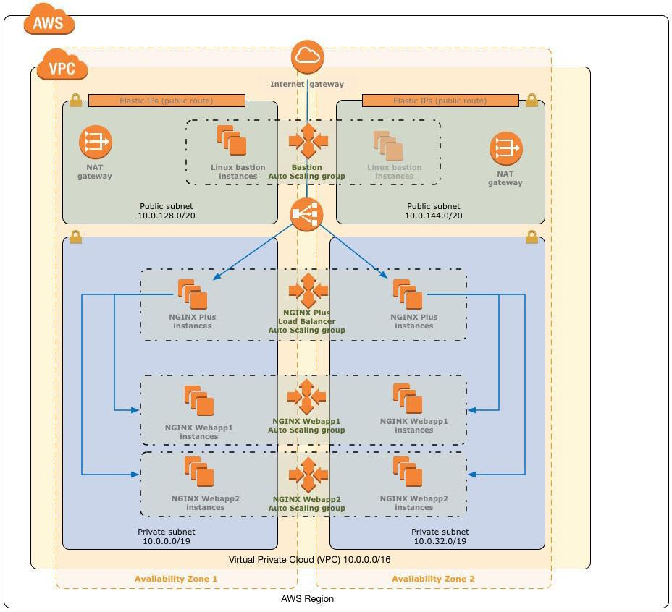

CloudFormation Template list:

- s3-bucket.TEMPLATE
- Postgresql.TEMPLATE
- NGINX-Centlog.TEMPLATE
- waf.TEMPLATE
- waf_assoc.TEMPLATE

Keypair name: fc-keypair.pem

The NGINX-Centlog.TEMPLATE deploys the following services and components:

- Two EC2 instances in different subnets for high availability. The two instances will serve a fronted/proxy to Postgres database and Elasticsearch Service.
The instances are accessible only from the Load Balancer and via ssh.
Both instances are running an NGINX instance. Nginx is built from source with ngx_postgres module so it can access data directly from Postgres RDS.
There’s a script that runs on INIT phase and creates self-signed certs for NGINX for ssl connectivity.
There’s another script that runs on INIT phase and populates Postgres DB with values that will be retrieved from Frontend.
AWSLogs agent is installed in both instances to forward logs to CloudWatch. The agent will publish Nginx logs in Cloudwatch.
The instances are attached with Instance Profile that has permissions to publish to Cloudwatch.
- Elastic IP. These are associated with public interfaces of EC2 instances to provide a fixed IP for whitelisting ingress to Elasticsearch Service. The latter can’t be accessed directly from Internet.
- ElasticSearch Service, this is configured to be accessed only from the EC2 Instances and via the Loadbalancer. It will be accessed via secure username/password.
- Lambda Function to forward from Cloudwatch to ElastiSearch Service. Logs published from EC2 instances in Cloudwatch will be streamed automatically to ElasticSearch
- One Application Load Balancer that provides inbound access to Nginx instances over ports 80/443.

Postgresql.TEMPLATE deploys the following services and components:

- One Postgres RDS instance, encrypted storage and accessible only from within the private subnet only. ( RDS is not deployed with multiple replicas in different AZ)

WAF Template will deploys the following services and components:
- WAF instance, to provide protection against 10 most importants web attacks.

WAF Assoc Template will deploy the following services and components:
- Associate WAF with Application Load Balancer

Deployment Steps

Step 1. Prepare an AWS Account

Create a key pair in your preferred region.

Step 2. Deploy s3 bucket for Load Balancer Logging

On the Select Template page, chose “s3-bucket.TEMPLATE”. keep the default setting for the template URL, and then choose Next.

Step 3. Deploy Postgres RDS Database

On the Select Template page, chose “Postgresql.TEMPLATE”. keep the default setting for the template URL, and then choose Next.
On the Specify Details page, review the parameters for the template. Enter values for the parameters that require your input. For all other parameters, you can customize the default settings provided by the template.

Parameters Configuration:

 | Parameter label (name) | Default | Description
 | DBAllocatedStorage | 5 | How much storage to allocate for DB
 | DBClass | db2.t2.mirco | Database instance class
 | DBName | postgres | Database name
 | DBPassword | Requires input | Database admin password

DBUsername | postgres | Database admin account username

Note: The free tier database does not support encrypted storage.

Step 4. Deploy NGINX Frontend, and centralized logging solution

On the Select Template page, chose “NGINX-centlog.TEMPLATE”. keep the default setting for the template URL, and then choose Next.

On the Specify Details page, review the parameters for the template. Enter values for the parameters that require your input. For all other parameters, you can customize the default settings provided by the template.

Proxy Configuration:

 | Parameter label (name) | Default | Description
 | User Name | Requires input | User Name used to authenticate to Kibana/ES
 | Password | Requires input | Password to authenticate to Kibana/ES
 | Access CIDR block | 0.0.0.0/0 | CIDR block to access Application Load Balancer from and EC2 Instances
 | SSH Key | Requires input | SSH Key to access Intstances.

Amazon ES Domain Configuration:

 | Parameter label (name) | Default | Description
 | Domain Name | centralizedlog | ES Default domain name
 | Cluster Size | small | ES Cluster size

Network Settings:

 | Parameter label (name) | Default | Description
 | VPC ID | Vpc-d3347db6 | VPC where resources will be created
 | 1st Subnet Network | subnet-21c29a56 | First subnet where one of Ec2 isntances will be created
 | 2nd Subnet Netwok | Subnet-298ebe4c | Second subnet where one of Ec2 isntances will be created

Other Parameters:

 | Parameter label (name) | Default | Description
 | Database | t2.micro | Postgres Database Name
 | DBHost | Requires input | Postgres hostnaame
 | DBPassword | Requires input | Postgres DB Password
 | DBUsername | Requires input | Postgres Username

FormInputVersion |  | 0.12 |  | NGINX FormInput Module version
NginxVersion |  | 1.4.2 |  | NGINX version
 | NgxDevelVersion |  | 0.3.0 |  | Nginx-devel-kit version
 | NgxPostgresVersion |  | 0.9 |  | Ngx_postgres module version

RDSJsonVersion | 0.15 | RDSJson module version
S3LogginBucket | Fc-bucket | Bucket name where ALB Logs will be sent

Step 5. Deploy WAF

On the Select Template page, chose “waf.TEMPLATE”. keep the default setting for the template URL, and then choose Next.

Step 6. Associate WAF with Load Balancer

On the Select Template page, chose “waf_assoc.TEMPLATE”. keep the default setting for the template URL, and then choose Next.

Testing the solution

Copy the DNS value for ApplicationLoadBalancer from the Outputs tab. This is the public DNS name that you can use to test that NGINX load balancing instances are up and running and serving content.

Useful files

The nginx configuration file:

$ cat /opt/nginx/conf/nginx.conf

events {
worker_connections 1024;
}
http {
upstream database {
postgres_server pp110ij6zsotbuy.cdwrv8bbea8h.eu-west-1.rds.amazonaws.com dbname=postgres
user=postgres password=Fundingcircledevenv;
}
server {
listen 80;
listen 443 ssl;
server_name localhost;
ssl_certificate /opt/nginx/ssl/cert/nginx.crt;
ssl_certificate_key /opt/nginx/ssl/private/nginx.key;
ssl_session_timeout 5m;
ssl_protocols SSLv2 SSLv3 TLSv1;
ssl_ciphers HIGH:!aNULL:!MD5;
ssl_prefer_server_ciphers on;
location / {
auth_basic 'Restricted';
auth_basic_user_file /opt/nginx/conf/kibana.htpasswd;
proxy_pass_request_headers off;
proxy_set_header Host $host;
proxy_set_header X-Forwarded-For $proxy_add_x_forwarded_for;
proxy_pass https://localhost:443;
}
location /nginx_status {
stub_status on;
allow 127.0.0.1;
allow 172.31.0.0/16;
deny all;
}
location /entries/ {
postgres_pass database;
rds_json on;
postgres_query HEAD GET 'SELECT * FROM fcnames ORDER BY random() LIMIT 1';
postgres_rewrite HEAD GET no_rows 403;
allow 127.0.0.1;
allow 0.0.0.0/0;
deny all;
}
}
}

Security considerations.

There are 2 layers of security in Frontend
- WAF implements protection against most common attack via detection such as csrf, sql script injection etc.
- NGINX whitelists the IPs that are allowed to access the website

Database is allowing connectivity only from within the VPC.

High availability considerations.
EC2 Instances run in different availability zones.
Postgres should be running replicas in different availability zones, and regions.

