

GreenNet: AI-Driven Routing Simulator for Sustainable Internet Energy Optimization

An Honors Society Project

Olta Zagraxha

Advisor:
Blerta Prevalla-Etemi
Second Readers:
Valon Raca & Muzafer Shala

Abstract
GreenNet is a simulation-based framework for studying whether energy-aware link-state control can reduce network energy use without causing unacceptable degradation in Quality of Service (QoS). The project combines a graph-based network simulator, configurable traffic scenarios, an All-On controller, a heuristic controller, and a PPO-based hybrid controller within one benchmarkable environment.
Each GreenNet run records delivered traffic, dropped traffic, average delay, path latency, estimated energy use, carbon-related output, and controller actions, then stores those artifacts for later comparison. The framework also exposes results through an API and web interface so that evaluation is inspectable rather than dependent on ad hoc screenshots or isolated logs.
The final thesis contribution is therefore methodological as much as algorithmic. GreenNet shows that sustainable-networking claims can be tested in a reproducible way: the heuristic controller remains the strongest overall policy in the final benchmark, while the PPO-based hybrid controller is the strongest AI-based policy and shows only modest gains under selected conditions rather than a decisive routing breakthrough.

Keywords: Green networking, energy-aware routing, artificial intelligence, reinforcement learning, network simulation, Quality of Service, sustainable computing, traffic optimization.

Introduction
Network traffic, cloud workloads, and continuously available digital services have increased the operational importance of communication networks while also increasing the electricity demand associated with routers, switches, links, and supporting infrastructure (Gupta & Singh, 2003; IEA, 2022). In that setting, energy efficiency is not a peripheral optimization problem. It directly affects the cost, sustainability, and operational footprint of digital infrastructure.
Conventional link-state routing was not designed around that objective. Protocols such as OSPF optimize forwarding around reachability, shortest-path cost, and convergence behavior rather than the possibility of placing underutilized links or devices into lower-power states (Moy, 1998). As green-networking research has repeatedly shown, that leaves substantial inefficiency during calm or uneven demand periods because the network often remains provisioned as if peak conditions were permanent (Bianzino et al., 2012; Gupta & Singh, 2003).
GreenNet addresses this problem at the controller level. Instead of attempting to replace routing with a black-box learner, the project keeps a static shortest-path or OSPF-like forwarding baseline and studies whether link-state control can reduce energy use while preserving service quality. The implemented comparison centers on three policies: an All-On controller that leaves all links active, a heuristic controller that deactivates links conservatively, and a PPO-based hybrid controller whose learned proposals are filtered by explicit safety logic.
That framing matters academically. The thesis is not claiming that AI has already solved sustainable routing; it is asking whether a carefully instrumented simulator can reveal when adaptive control helps, when it does not, and how those outcomes should be judged against QoS constraints and explicit acceptance thresholds. This keeps the sustainability question tied to measurable networking behavior rather than to broad claims about AI capability (Bianzino et al., 2012; IEA, 2022).
The remainder of the thesis documents GreenNet as both a software system and an evaluation method. It explains how topologies, traffic, policies, metrics, persistence, and reporting were implemented, and then uses that structure to interpret a conservative final result: the project succeeds most clearly as a reproducible comparative framework for sustainable-networking experiments.

Objectives
The main objective of this thesis is to design, implement, and evaluate GreenNet as a reproducible framework for energy-aware network control. Rather than proposing a single algorithm in isolation, the project investigates whether configurable simulation, disciplined benchmarking, and explicit QoS constraints can support credible comparison between a conventional All-On controller, a heuristic controller, and a PPO-based hybrid controller.
The specific objectives of the project are as follows:
- To develop a configurable network simulation environment capable of modeling different topologies, traffic scenarios, and routing behaviors.
- To implement and compare multiple control strategies, including an All-On controller, a heuristic controller, and a PPO-based hybrid controller that combines learned action proposals with rule-based safety constraints.
- To evaluate network behavior using both sustainability-related and performance-related metrics, including energy consumption, delivered traffic, dropped traffic, average delay, path latency, carbon-related output, and QoS compliance.
- To create a reproducible experimental workflow that supports consistent benchmarking across scenarios, seeds, locked evaluation settings, and stored result artifacts.
- To provide a clear visualization and reporting layer through a web-based interface and structured result summaries, making the analysis of policy trade-offs easier to understand.
- To examine whether AI-assisted decision-making can offer a practical and responsible approach to greener network management without causing unacceptable performance degradation.
Taken together, these objectives position GreenNet as a thesis-specific research platform: it is intended to show not only whether limited energy savings are possible, but also how such claims can be defended, repeated, and interpreted responsibly.

Research Questions and Hypothesis
This thesis is guided by the broader problem of how network operation can become more energy-aware without crossing unacceptable QoS boundaries. The project therefore asks questions about both controller performance and evaluation method.
Research Question 1:
How can intelligent routing and control strategies reduce network energy consumption while maintaining acceptable Quality of Service (QoS)?
This question is operationalized in GreenNet through explicit comparison of energy use, delivered traffic, dropped traffic, delay, path latency, and QoS threshold compliance. It asks whether link-state control can save energy without simply shifting cost into packet loss or delay.
Research Question 2:
How do AI-based approaches compare with the All-On controller and the heuristic controller under different traffic and topology conditions?
In GreenNet, this comparison is not between abstract algorithm labels but between concrete implementations executed under the same simulator, traffic scenarios, and reporting pipeline. The question therefore tests whether the PPO-based hybrid controller produces a better trade-off than the All-On and heuristic controllers, not whether reinforcement learning is generically promising in principle.
Research Question 3:
Can a simulation-driven framework provide a practical and reproducible way to evaluate sustainable routing strategies?
This question addresses the thesis contribution beyond raw benchmark numbers. A useful result in GreenNet must be repeatable from stored configurations, comparable across policies and scenarios, and interpretable through fixed acceptance logic rather than selective screenshot-level evidence.
Hypothesis:
The working hypothesis of this thesis is that the PPO-based hybrid controller can achieve modest energy savings relative to the All-On controller while remaining within explicit QoS limits, but that those gains may not surpass the heuristic controller across the full benchmark.
In GreenNet, this expectation is deliberately narrower than a claim that reinforcement learning will outperform every non-AI baseline. The hypothesis is designed to test whether adaptive control can produce a defensible energy-QoS trade-off under controlled conditions, even if the effect is modest and scenario-dependent.

Literature Review
Research on sustainable networking converges on a clear starting point: network infrastructure has historically been optimized for connectivity and performance, while energy use was treated as a secondary concern. Green networking emerged to address that gap by asking how routing, topology management, and equipment states can be adjusted to reduce power consumption without destabilizing service quality (Bianzino et al., 2012; Gupta & Singh, 2003). That framing is directly relevant to GreenNet, whose central problem is not generic AI optimization but energy-aware control under networking constraints.
Classical routing protocols explain why this gap exists. OSPF, for example, is a link-state protocol that computes forwarding from link costs and topology advertisements; it does not include native objectives for sleeping links, reducing device power, or reasoning about carbon impact (Moy, 1998). GreenNet therefore treats traditional routing as an operational baseline: forwarding remains shortest-path based, while energy-aware behavior is introduced at the controller layer rather than by redefining the control plane itself.
Green-networking studies show that traffic consolidation and selective deactivation of underutilized resources can reduce power consumption, particularly in backbone-style settings where parts of the network are overprovisioned for peak demand (Chiaraviglio et al., 2009; Gupta & Singh, 2003). At the same time, survey work emphasizes that these gains are only meaningful when they are balanced against packet delivery, latency, and resilience requirements (Bianzino et al., 2012). GreenNet adopts exactly that trade-off perspective: turning links off is useful only when the resulting QoS cost stays within a defensible bound.
Machine learning adds a different research strand. Work such as Valadarsky et al. (2017) shows that learned approaches can be used to search for strong routing configurations, while reinforcement learning provides the general decision-making framework for balancing long-term reward against immediate penalties (Sutton & Barto, 2018). GreenNet uses that literature selectively. The project does not attempt end-to-end learned path computation; instead, it applies reinforcement learning to link-state control over a fixed routing baseline, which is a narrower and more defensible problem formulation for a capstone-scale system.
Simulation methodology is equally important. Network simulators are valuable because they allow repeated experiments under controlled conditions, but the right level of fidelity depends on the research question. For GreenNet, the priority is not full protocol emulation; it is transparent comparison among controllers, fast iteration over seeds and scenarios, and direct integration with Python-based evaluation code. That is why the project uses a lightweight graph-based simulator rather than a heavier discrete-event platform, while still following the networking-research principle that simulation assumptions should be explicit and experiments repeatable (Henderson et al., 2008).
The sustainability context keeps these technical choices from becoming purely local optimizations. The IEA (2022) notes that data centres and data transmission networks are material contributors to digital-sector electricity use, which means even modest efficiency gains matter when they can be justified and reproduced. In GreenNet, sustainability is therefore treated as an engineering objective that must coexist with reliability and QoS, not as a rhetorical add-on to a generic AI project.
A practical gap remains between the literature and accessible research tooling. Many publications present optimization results, but fewer provide an integrated environment in which topologies, scenarios, controller outputs, evaluation thresholds, stored artifacts, and reviewer-facing visualizations are all connected. GreenNet is designed to fill that methodological gap by combining controller comparison, reproducible storage, and reporting into one thesis-scale system.
The literature therefore informs GreenNet in three concrete ways: it motivates energy-aware control as a legitimate networking problem, it justifies comparing learned and non-learned controllers, and it supports the thesis decision to judge success through controlled benchmarking instead of isolated favorable runs.

Methodology
This thesis uses a design-and-evaluation methodology in which GreenNet itself is the primary research instrument. The work proceeds by implementing the simulator and controller stack, defining controlled comparison rules, executing repeated experiments, and interpreting outcomes against explicit hypothesis thresholds rather than against narrative preference, in line with simulation-centered networking research practice (Henderson et al., 2008).
At the methodological core is a configurable Python-based environment that separates topology generation, traffic generation, routing baseline selection, controller logic, and metric collection. Simulation is used because it allows the same policies to be replayed across multiple seeds and scenarios with stable assumptions about capacity, latency, power, and carbon intensity. For this thesis, that level of control is more useful than attempting direct deployment on live infrastructure (Henderson et al., 2008).
Controller comparison is then performed over the same simulator. The All-On controller keeps every controllable link active, the heuristic controller applies conservative link-state rules, and the policy labeled PPO in the benchmark represents a PPO-based hybrid controller whose learned action proposals are filtered by masking, cooldowns, and recovery logic. This distinction is important because the thesis evaluates the implemented GreenNet controller stack, not an abstract pure-PPO baseline detached from the codebase.
Experiment execution is organized around reproducible artifacts. Runs emit per-step metrics, summaries, environment configurations, metadata, and aggregated reports, and the project also persists structured outputs through SQLite-backed storage. This means that the thesis can discuss not just what result was obtained, but which scenario, seed, and controller settings produced it.
Interpretation is governed by an explicit acceptance gate. In the final evaluation logic, success requires a substantial energy reduction together with bounded QoS degradation: delivered-traffic loss must remain within 2%, dropped-traffic increase within 5%, delay and path-latency increase within 10%, and QoS-violation-rate increase within 0.02. That threshold-based methodology prevents modest energy gains from being overstated as full hypothesis confirmation.
Finally, the methodology includes reviewer-facing reporting. GreenNet aggregates run data into comparison tables, stored summaries, and interface views so that policy trade-offs can be inspected from the same evidence used in the written analysis. The method is therefore both computational and documentary: it is designed to produce results and to make those results auditable.

System Architecture
GreenNet is organized as a modular research stack whose components map directly to the tasks of simulation, control, evaluation, storage, and reporting. The architecture is deliberately layered so that a change in controller logic does not require rewriting the simulator, and a change in reporting does not alter the underlying benchmark rules.
The simulation core is responsible for the network state itself. It maintains a graph of nodes and links, tracks active and inactive edges, computes path allocations under the configured routing baseline, enforces capacity constraints, estimates delay from utilization and base latency, and converts active-state decisions into energy and carbon-related metrics. This is the component that turns controller actions into measurable networking outcomes.
Control logic sits above that network state. GreenNet keeps forwarding behavior on a static shortest-path or OSPF-like baseline and varies only the controller responsible for link-state decisions. That separation is architecturally important because it lets the thesis compare the All-On controller, the heuristic controller, and the PPO-based hybrid controller without implying that path computation itself is being reinvented by the AI layer.
Control logic sits above that network state. GreenNet keeps forwarding behavior on a static shortest-path or OSPF-like baseline and varies only the controller responsible for link-state decisions. That separation is architecturally important because it lets the thesis compare All-On, heuristic, and PPO-based control without implying that path computation itself is being reinvented by the AI layer.
The evaluation layer transforms raw step data into thesis-level evidence. It aggregates totals and means for energy, delivery, drops, delay, path latency, QoS violation rate, and carbon-related output, then feeds those summaries into benchmark tables and acceptance-threshold checks. Without this layer, the simulator would only produce logs; with it, GreenNet produces interpretable comparisons.
Reproducibility depends on the persistence layer. GreenNet stores run metadata, environment configuration, summaries, and per-step measurements so that a benchmark can be revisited after the fact. That storage is not incidental bookkeeping. It is what allows the thesis to distinguish official benchmark artifacts from exploratory runs and to defend why some figures remain in the main body while others are moved to the appendix.
A backend API layer connects the stored and computed results to the interface. In practice, this service exposes run lists, summaries, aggregate comparisons, and simulator-facing metadata so that the reporting surface is driven by the same data used in the written analysis.
The visualization layer is the final architectural component. GreenNet uses a web interface to inspect topology state, controller comparisons, and result summaries, which makes the framework useful for thesis defense and review as well as for internal experimentation. The interface is therefore part of the research workflow: it helps translate benchmark artifacts into inspectable evidence.
Architecturally, GreenNet is best understood as a comparative experimentation platform. Its value comes from the way the simulator, controllers, metrics, storage, and interface reinforce one another to support reproducible claims about energy-aware networking.

Implementation
GreenNet was implemented as a working software system rather than as a paper design. The completed project includes the simulator, controller stack, experiment runners, persistence layer, backend API, and user-facing visualization needed to execute and interpret comparative benchmarks.
Controller implementation is intentionally separated from forwarding. The All-On controller leaves the topology fully active, the heuristic controller uses explicit rules to toggle edges conservatively, and the benchmark policy labeled PPO combines learned PPO proposals with masks, cooldowns, and safety overrides. That implementation detail matters to the thesis because the final AI result should be interpreted as constrained hybrid control, not as unconstrained end-to-end learned routing.
GreenNet also implements an experiment pipeline around those controllers. Command-line runners execute individual scenarios, matrix-style evaluations, and final aggregation steps; results are written as structured CSV and JSON artifacts and can be reloaded later for comparison or reporting. This pipeline is what makes the thesis benchmark reproducible rather than a one-off demonstration.
Metric collection and persistence are built into execution rather than added afterward. Per-step and aggregated values for energy, carbon, delivered traffic, dropped traffic, average delay, path latency, and controller activity are stored so that summaries, acceptance checks, and figures all derive from the same evidence trail.
The implementation also includes the reporting stack. FastAPI-based endpoints expose runs and summary data, while the frontend presents topology playback, policy comparisons, and result views. This is important for GreenNet because the project is intended to be reviewed as a complete comparative framework, not merely as backend code that produces opaque files.
Several auxiliary capabilities were added carefully rather than overclaimed. The environment includes lightweight online forecasting options such as EMA, Holt-style trend estimation, and adaptive EMA ensembles, and the codebase contains an exploratory impact-predictor path. In the final thesis framing, however, these features support the controller environment; they are not treated as separately validated headline contributions.
Implementation therefore serves the central thesis purpose directly: it turns the question of energy-aware control into a benchmarkable system with reproducible artifacts, comparable controller outputs, and explicit QoS-constrained interpretation.

Simulator Playback and Inspection
Figure 4 is retained because it shows the simulator in the form most useful to this thesis: an inspectable topology playback rather than a marketing-style dashboard. The figure makes the controller’s operating context visible by showing active links, packet flow, and state changes during execution.
Retaining one implementation figure is sufficient for the thesis because the main argument is comparative evaluation, not interface breadth.
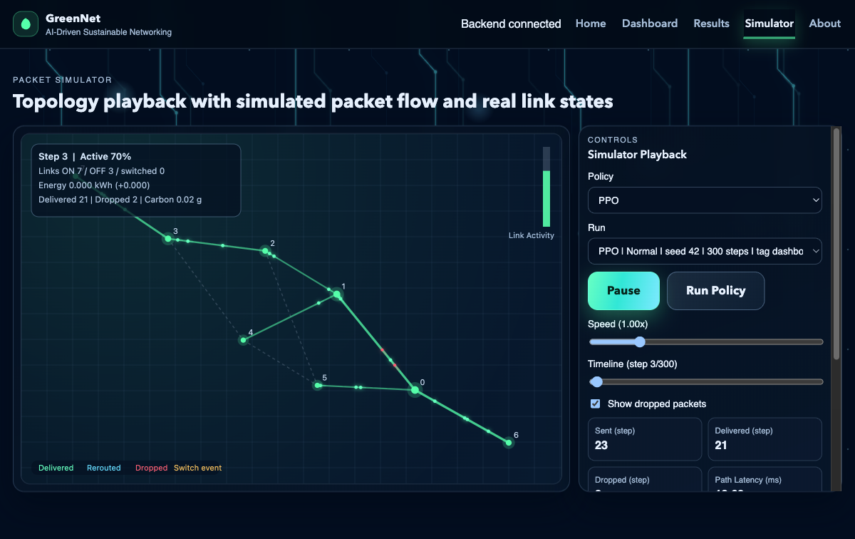
Figure 4. Simulator topology playback with packet-flow and link-state visualization during an active run.
As shown in Figure 4, GreenNet includes an execution view through which policy behavior can be observed step by step. That visibility helps connect the abstract benchmark tables to a concrete system implementation without interrupting the core results chapter with multiple UI screenshots.
More crowded dashboard and validation views remain useful as supporting evidence, but they belong in appendix-level material rather than in the main argumentative flow of the thesis.

Technologies and Tools Used
The GreenNet implementation relies on a small set of technologies chosen for transparency and interoperability rather than novelty. The thesis is strongest when each tool is tied to a clear role in the final system.
Python is the project’s primary implementation language because it supports the simulator, evaluation scripts, storage utilities, and API layer within one environment. That decision keeps the benchmark logic, controller logic, and reporting pipeline close enough to be inspected together instead of being scattered across unrelated stacks.
NetworkX is used for graph construction and path-oriented topology operations, while the simulator builds project-specific behavior on top of those graph primitives. This is a good fit for GreenNet because the project needs explicit control over link state, utilization, capacity, and path selection rather than a black-box networking engine.
NumPy and pandas support the numerical side of the project: repeated metric calculations, aggregation across seeds and scenarios, and production of report-ready summary tables. Gymnasium provides the environment interface that allows the PPO training and evaluation code to interact cleanly with the simulator.
The AI stack is intentionally narrow. Stable-Baselines3 provides the PPO implementation used for the learned controller, while PyTorch supports auxiliary ML code in the repository. Scikit-learn appears in exploratory support paths, but the thesis does not depend on presenting a broad machine-learning pipeline; its main AI claim rests on the implemented PPO-based hybrid controller.
FastAPI and Uvicorn power the backend service that exposes run metadata, summaries, and aggregate results to the interface. Their role is practical: they allow the same stored experiment outputs used in the thesis to be surfaced consistently in the web view.
On the frontend side, GreenNet uses a React-based interface built with Vite for the main dashboard, results, and simulator views. This is more accurate to the final project than a generic claim about a modern frontend: the interface is specifically used to inspect controller comparisons and replay stored results.
SQLite is the concrete persistence technology used for structured run storage inside the project, while PostgreSQL remains an optional future-facing extension rather than a core part of the thesis evaluation path. Using lightweight local persistence is consistent with the project’s emphasis on reproducible research artifacts.
Supporting tools such as Git, repository-managed configuration files, and Node-based frontend tooling matter because GreenNet is assembled from several interacting layers. They are not cited as innovations, but they are necessary for keeping the simulator, evaluation scripts, API, and frontend synchronized during iterative experimentation.
The technologies section therefore mirrors the actual project architecture: Python and its scientific libraries support simulation and evaluation, Stable-Baselines3 supports the learned controller, FastAPI and Uvicorn expose results, SQLite stores benchmark artifacts, and the React/Vite frontend makes those artifacts inspectable.
This stack is appropriate for a thesis whose central requirement is not maximum production scale, but defensible experimentation and clear reporting.

Challenges and Limitations
Developing GreenNet required balancing networking realism, ML integration, and capstone-scale feasibility. Many of the thesis decisions that make the project manageable also define the limits within which its results should be interpreted.
The first limitation is the simulator itself. GreenNet models forwarding and link-state control over a graph abstraction; it does not emulate a full routing control plane, device firmware behavior, or operational maintenance workflows. That is why the thesis treats the routing baseline as shortest-path or OSPF-like forwarding behavior rather than as a complete implementation of OSPF in production conditions.
The AI layer introduces an additional honesty constraint. In the final evaluation path, the policy labeled PPO is not a pure unconstrained learner; it operates inside a safety-oriented wrapper that uses masks, cooldowns, and fallback logic. This makes the controller more practical for the benchmark, but it also means that any observed gain cannot be attributed to raw PPO alone.
Training depth is another limitation. Reinforcement learning typically benefits from long tuning cycles and broad scenario exposure, yet GreenNet was developed within academic time bounds. The final PPO-based hybrid controller should therefore be read as a time-bounded thesis implementation, not as an upper bound on what reinforcement learning could achieve in a larger study.
Traffic modeling was another limitation in the project. GreenNet supports scenario-based experimentation through synthetic or controlled traffic patterns, which is useful for reproducibility and structured comparison. However, synthetic traffic can only approximate the complexity of real network demand. Real traffic often contains irregular bursts, long-range temporal dependencies, application-specific behavior, and patterns driven by human activity or infrastructure events that are difficult to capture fully in a simplified simulator. Because of this, GreenNet can demonstrate how routing policies behave under representative conditions, but it cannot claim to replicate the full unpredictability of operational Internet-scale environments.
Topology realism presents a similar issue. The project is able to model different network structures and compare policy behavior across them, but these topologies are still simplified representations. Real backbone, ISP, enterprise, or data-center networks often include additional constraints such as routing policy rules, heterogeneous hardware capacities, resilience requirements, maintenance windows, and operational restrictions. A research project at this scale cannot fully replicate all such conditions. This means that the architectural and policy insights produced by GreenNet are valuable for analysis and experimentation, but they should not be interpreted as complete substitutes for real network engineering validation.
From a software-engineering perspective, integration was itself a challenge. The simulator, controller logic, benchmark scripts, storage layer, API, and frontend all share assumptions about metric names, policy labels, and run metadata. Keeping those layers aligned was necessary for reproducibility, but it also required disciplined refactoring and careful artifact management throughout the project.
Project scope imposed a final boundary. GreenNet prioritizes simulation-based comparison, locked evaluation artifacts, and reviewer-facing reporting over production deployment concerns such as distributed orchestration or direct control of physical routers. That trade-off is deliberate and appropriate for the thesis question.
These limitations do not weaken the thesis contribution; they define it. GreenNet is valuable precisely because it states its assumptions, keeps its benchmark claims conservative, and makes clear where future work would be needed before any result could be generalized beyond the simulated environment.

Evaluation Strategy
The evaluation strategy of GreenNet is built around one question: under the same simulated conditions, which controller produces the most acceptable trade-off between energy reduction and service quality? Every part of the benchmark design follows from that question, and that trade-off framing is consistent with the green-networking literature on balancing efficiency against service quality (Bianzino et al., 2012; Chiaraviglio et al., 2009).
Controlled comparison is the first principle. The All-On controller, the heuristic controller, and the PPO-based hybrid controller are executed under the same topology assumptions, traffic scenarios, step limits, and metric definitions so that differences in outcome can be traced back to controller behavior rather than to changing experimental conditions.
Scenario diversity is the second principle. GreenNet does not evaluate a controller on a single happy-path workload; it uses at least normal, burst, and hotspot conditions to expose how each policy behaves under calm demand, fluctuating demand, and more stressed traffic. That matters because a controller that appears efficient in one regime may fail or become too conservative in another.
The strategy is also explicitly multi-metric. Energy reduction is recorded alongside delivered traffic, dropped traffic, average delay, path latency, QoS violation rate, and carbon-related output. This prevents a controller from being judged successful merely because it turns more links off.
Reproducibility is treated as part of evaluation rather than as an afterthought. GreenNet stores environment configurations, run metadata, summaries, and supporting artifacts so that benchmark claims can be revisited later. In a project with stochastic traffic and a learned controller, that storage discipline is essential.
Aggregation is the fourth principle. The thesis does not rely on a single illustrative run; it summarizes outcomes across policies, scenarios, and repeated executions, then derives final comparisons from those aggregates. This is what allows the project to distinguish a broadly stable trend from an isolated favorable example.
Most importantly, GreenNet uses threshold-based interpretation. The final hypothesis gate requires strong energy improvement together with bounded QoS change, so a controller can remain 'acceptable' in QoS terms and still fail to achieve the thesis hypothesis. That stricter standard is why the final benchmark is interpreted conservatively rather than advertised as a success on the basis of a small energy gain.
This evaluation strategy answers the research questions directly. It tests whether adaptive control can save energy, whether the AI-based controller improves on non-AI baselines in a meaningful way, and whether the framework itself can support repeatable sustainable-networking research.
In short, GreenNet evaluates policies by the quality of their trade-offs and by the reproducibility of the evidence behind those trade-offs.

Results and Discussion
This chapter presents the benchmark evidence that is most important to the final thesis argument. The main text keeps the official comparison among the All-On controller, the heuristic controller, and the PPO-labeled results, one selected positive AI case study, and the acceptance-threshold figure used to interpret those outcomes. In the discussion below, the label PPO refers to GreenNet’s implemented PPO-based hybrid controller, which is the strongest AI-based policy in the final benchmark but not the strongest overall policy.
Figure 1 is the central benchmark figure because it places the three evaluated policies in one controlled comparison bundle. Its role is not to showcase the best-looking individual run, but to show how the controllers compare when the same benchmark logic is applied across the final selected evaluation set.
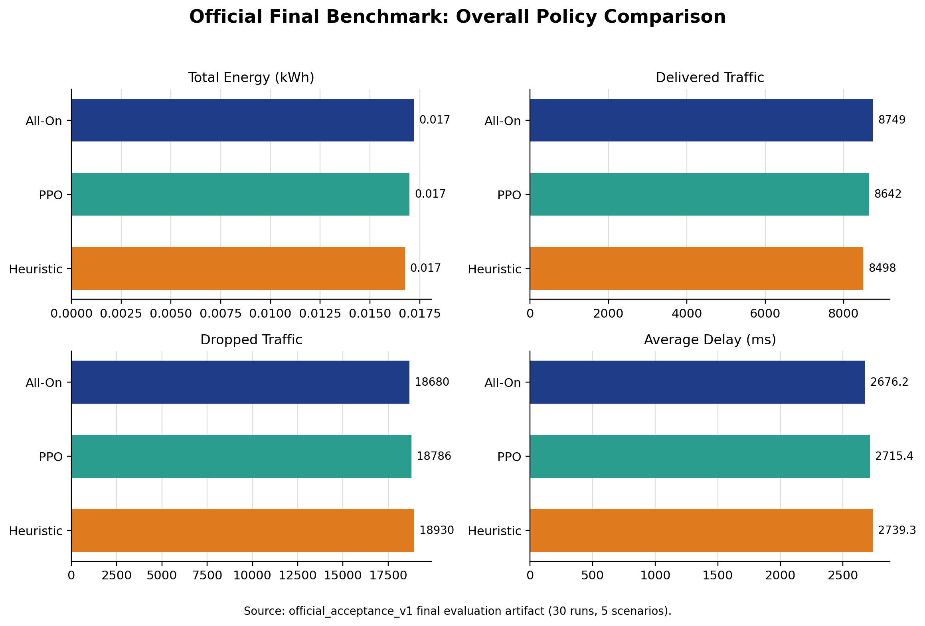
Figure 1. Official final benchmark comparison of the All-On controller, the heuristic controller, and the PPO-based hybrid controller across total energy, delivered traffic, dropped traffic, and average delay.
The main conclusion from Figure 1 is conservative. The final benchmark does not confirm the thesis hypothesis, because the observed energy gains are modest relative to the acceptance target and the heuristic controller remains the strongest overall policy in aggregate reporting. At the same time, the policy labeled PPO remains QoS-acceptable and performs as the strongest AI-based controller, which means the benchmark supports cautious promise rather than a headline breakthrough.
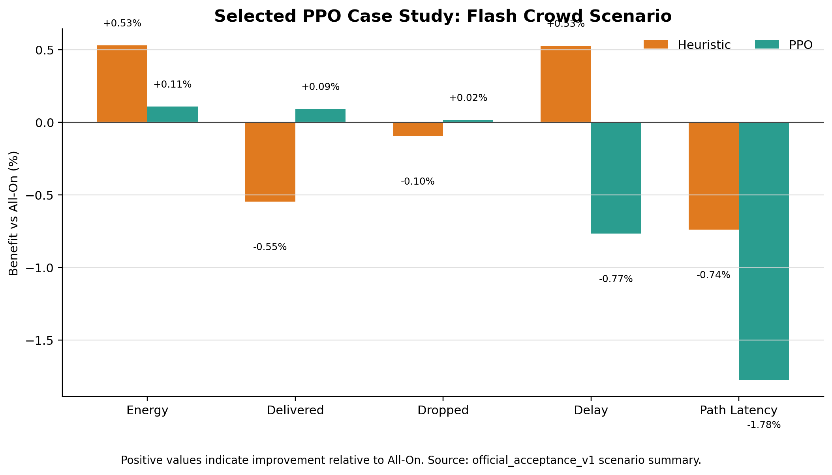
Figure 2. Flash-crowd case study showing policy benefit relative to All-On for energy, delivered traffic, dropped traffic, delay, and path latency.
The flash-crowd case is analytically useful because it shows the AI controller at its most defensible. In that scenario, the PPO-based hybrid controller slightly improves traffic-handling behavior while still pursuing energy-aware control, but the gain remains small enough that it cannot replace the aggregate benchmark as the main thesis conclusion.
Taken together, Figures 1 and 2 support a precise interpretation. The aggregate benchmark says that GreenNet’s heuristic controller is still the strongest overall policy and that the hypothesis is not achieved. The case study shows that the AI-based controller is not empty or decorative; it can produce beneficial trade-offs under selected conditions. The correct academic conclusion is therefore mixed: GreenNet demonstrates a real but limited AI signal inside a stronger comparative framework.

Reproducibility and Validation
Reproducibility and validation are included in the results chapter because GreenNet’s argument depends on how the benchmark is judged, not only on the raw plotted values. The project needs to show that negative or partial outcomes were produced by fixed rules rather than by post hoc narrative framing.
Figure 3 serves that purpose by making the acceptance logic explicit. It ties the final benchmark to predefined thresholds instead of allowing the thesis to call a small energy reduction a success simply because it is directionally positive.
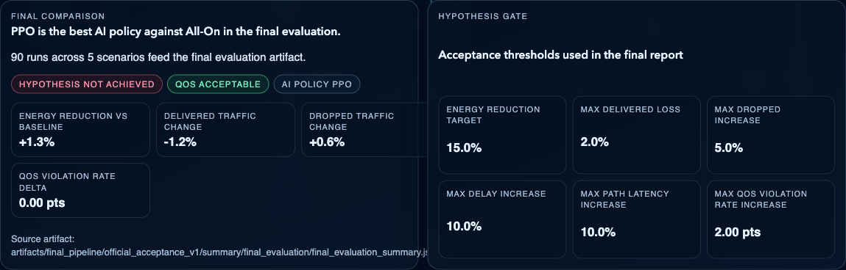
Figure 3. Official benchmark summary and acceptance thresholds used to judge hypothesis success in GreenNet.
This figure is methodologically important because it documents why the benchmark conclusion is conservative. The PPO-based hybrid controller can remain QoS-acceptable and still fail the hypothesis when the energy improvement is too small or when the full threshold set is not met. That interpretation strengthens, rather than weakens, the credibility of the thesis.

Conclusion
This thesis presented GreenNet as a reproducible framework for studying energy-aware network control under explicit QoS constraints. The project combined a graph-based simulator, controller comparison, artifact-backed evaluation, persistent storage, and interface-level reporting into one coherent system for sustainable-networking experiments.

What Was Achieved
From a research perspective, the strongest conclusion is not that AI won, but that the comparison is now defensible. The heuristic controller remains the best overall policy in the final benchmark, while the PPO-based hybrid controller is the strongest AI-based policy and shows limited but genuine promise in selected conditions such as the flash-crowd case study. That is a useful outcome because it identifies both the current ceiling of the implementation and the conditions under which adaptive control may become more worthwhile.

Several factors explain that result. The simulator uses a deliberately simplified but explicit power model; the PPO-based hybrid controller is constrained by masks and safety logic; reward shaping penalizes QoS degradation strongly; and the benchmark topologies remain modest in size. Together, these design choices encourage conservative behavior, which is useful for stability and honesty but limits the magnitude of achievable energy savings.
Seen in that light, the negative result is informative rather than disappointing. It shows that under GreenNet’s current assumptions, small AI-driven improvements are possible, but strong claims of sustainable-routing optimization would be premature.

An important strength of the thesis is that it reports the benchmark on its own terms. The acceptance logic is capable of rejecting an attractive narrative, and in this case it does: the final result is partial, not triumphant. That is exactly the kind of discipline a comparative systems thesis should demonstrate.
This matters especially in AI-oriented networking work, where it is easy to highlight a single favorable run or to blur the distinction between a pure learned controller and a safety-constrained hybrid system. GreenNet avoids that by keeping policy labels, benchmark thresholds, and supporting artifacts visible throughout the analysis.

Future Work
Future work should extend GreenNet in directions that are directly suggested by the benchmark. The most immediate step is deeper controller training and clearer ablation between the learned PPO component and the surrounding safety logic so that future gains can be attributed more precisely.
A second step is evaluation on larger and more heterogeneous topologies with more realistic demand traces. If energy-aware control is to matter beyond the capstone scale, it must be tested in settings where path diversity, redundancy, and load variation create more room for meaningful savings.
Further work could also strengthen the project’s auxiliary components without overstating them. Forecasting and impact-prediction paths should be evaluated separately if they are to be claimed as substantive contributions, and benchmark documentation should continue to prioritize artifact lineage and threshold-based interpretation.

Closing Remarks
GreenNet’s central contribution is therefore methodological and practical: it provides a principled environment in which sustainable-networking ideas can be tested, compared, and reported honestly. The final benchmark is intentionally modest, but the framework itself is strong enough to support more ambitious future studies without requiring the thesis to exaggerate what has already been achieved.

References
Bianzino, A. P., Chaudet, C., Rossi, D., & Rougier, J.-L. (2012). A survey of green networking research. IEEE Communications Surveys & Tutorials, 14(1), 3-20. https://doi.org/10.1109/SURV.2011.113010.00106
Chiaraviglio, L., Mellia, M., & Neri, F. (2009). Reducing power consumption in backbone networks. In 2009 IEEE International Conference on Communications (pp. 1-6). IEEE. https://doi.org/10.1109/ICC.2009.5199404
Gupta, M., & Singh, S. (2003). Greening of the Internet. ACM SIGCOMM Computer Communication Review, 33(4), 19-26. https://doi.org/10.1145/863955.863959
Henderson, T. R., Roy, S., Floyd, S., & Riley, G. F. (2008). ns-3 project goals. In Proceedings of the 2008 Workshop on ns-2: The IP Network Simulator (p. 13). ACM.
International Energy Agency. (2022). Data centres and data transmission networks. https://www.iea.org/reports/data-centres-and-data-transmission-networks
Moy, J. (1998). OSPF Version 2 (RFC 2328). IETF. https://www.rfc-editor.org/rfc/rfc2328
Sutton, R. S., & Barto, A. G. (2018). Reinforcement learning: An introduction (2nd ed.). MIT Press.
Valadarsky, A., Schapira, M., Shahaf, D., & Tamar, A. (2017). A machine learning approach to routing. arXiv. https://arxiv.org/abs/1708.03074

Appendix: Supporting Figures
The appendix retains real but non-central evidence that supports reproducibility, traceability, and broader interpretation without overloading the main thesis narrative.
Appendix Figure A1 documents the locked validation bundles used to store scenario-specific acceptance results under fixed constraints.
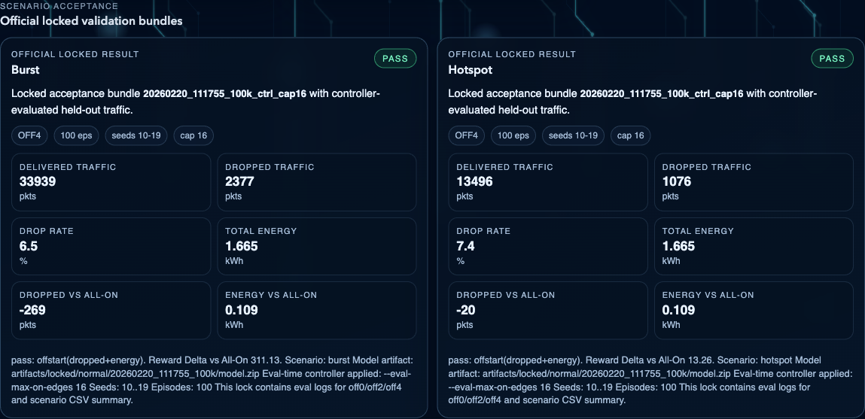
Appendix Figure A1. Official locked validation bundles used to document scenario-specific acceptance results and reproducibility settings.
Appendix Figure A1 is useful because it preserves the chain of evidence behind GreenNet's evaluation workflow. It shows that important held-out validations were stored as traceable bundles with explicit seeds, episode counts, and controller settings. However, because these bundles reflect a narrower validation context than the final benchmark, they are treated as supporting evidence rather than as central thesis results.
Appendix Figure A2 provides a compact scenario-by-scenario view of how the PPO-based hybrid controller changes energy use and delivered traffic relative to the All-On controller in the official final benchmark.
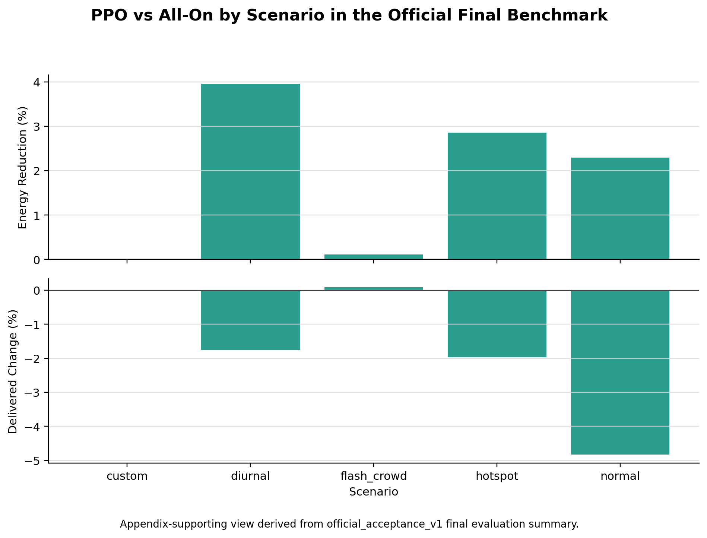
Appendix Figure A2. Scenario-by-scenario PPO-based hybrid controller trade-off relative to the All-On controller in the official final benchmark.
Appendix Figure A2 is intentionally placed outside the main body because it is analytically useful but more detailed than necessary for the primary thesis narrative. It helps the reader see that the PPO-based hybrid controller's strongest scenario-level case is flash-crowd, that diurnal and hotspot are better interpreted as compromise-policy cases, and that the normal scenario remains a negative result.

