

GreenNet: AI-Driven Routing Simulator for Sustainable Internet Energy Optimization

An Honors Society Project

Olta Zagraxha

Advisor:
Blerta Prevalla-Etemi
Second Readers:
Valon Raca & Muzafer Shala

Abstract
GreenNet is a framework to investigate the possibility of using energy-conscious link-state control to decrease the energy consumption of a network without inducing unacceptable Quality of Service (QoS) degradation. The project integrates a graph-based network simulator, scenarios of configurable traffic, an All-On controller, a heuristic controller, and a PPO-based hybrid controller in a single benchmarkable environment.
GreenNet runs record traffic, dropped traffic, average delay, path latency, estimated energy consumption, carbon-related output, and controller actions, which are stored to be used in subsequent comparisons. The structure also presents findings via an API and web interface in such a way that assessment is observable as opposed to relying on ad hoc screen shots or individual logs.
The last thesis contribution is thus methodological rather than algorithmic. GreenNet demonstrates that the claims of sustainable-networking can be experimented in a reproducible manner: the heuristic controller turns out to be the best overall policy in the last benchmark, and the PPO-based hybrid controller is the best AI-based policy and does not provide a routing breakthrough but only modest improvements under a set of conditions.

Keywords: Green networking, energy-aware routing, artificial intelligence, reinforcement learning, network simulation, Quality of Service, sustainable computing, traffic optimization.

Introduction
The operational significance of communication networks has been augmented by network traffic and cloud workloads as well as heightened electricity consumption of routers, switches, links, and supporting infrastructure (Gupta and Singh, 2003; IEA, 2022). That environment does not perceive energy efficiency as an ancillary optimization issue. It has a direct impact on the cost, sustainability and operating footprint of digital infrastructure.
The traditional link-state routing was never meant to be based on that goal. The protocols like OSPF focus on forwarding based on reachability, minimum-cost paths, and convergence characteristics in place of the possibility of placing underused links or devices to low-power state (Moy, 1998). That, as the numerous studies on green-networking have demonstrated, introduces high inefficiency in selective times of calm or uneven demand since the network is persistently supplied as though they were at peak levels (Bianzino et al., 2012; Gupta and Singh, 2003).
GreenNet takes care of this issue on the controller level. The project maintains a fixed shortest-path or OSPF-like forwarding baseline and experiments with whether link-state control can achieve lower energy consumption and maintain service quality rather than trying to replace routing with a black-box learner. The comparison that has been implemented focuses on three policies; an All-On controller, which leaves all links active, a heuristic controller, which deactivates links in a conservative manner, and a PPO-based hybrid controller, the proposals of which are constrained by explicit safety logic.
The fact that framing is important in academia. The thesis is not that AI has already found a solution to sustainable routing; it is whether a well-instrumented simulator can tell when adaptive control is useful, when not, and how one can evaluate those results against QoS requirements and clear acceptance criteria. This maintains the sustainability issue as a question of quantifiable networking behavior, as opposed to general assertions about AI capacity (Bianzino et al., 2012; IEA, 2022).
The rest of the thesis records GreenNet as a software and an evaluation system. It describes the implementation of topologies, traffic, policies, metrics, persistence, and reporting, and then applies such a structure to understand a conservative final outcome: the project succeeds best as an reproducible comparative framework of sustainable-networking experiments.

Objectives
The main objective of this thesis is to design, implement, and evaluate GreenNet as a reproducible framework for energy-aware network control. Rather than proposing a single algorithm in isolation, the project investigates whether configurable simulation, disciplined benchmarking, and explicit QoS constraints can support credible comparison between a conventional All-On controller, a heuristic controller, and a PPO-based hybrid controller.
The specific objectives of the project are as follows:
- To develop a configurable network simulation environment capable of modeling different topologies, traffic scenarios, and routing behaviors.
- To implement and compare multiple control strategies, including an All-On controller, a heuristic controller, and a PPO-based hybrid controller that combines learned action proposals with rule-based safety constraints.
- To evaluate network behavior using both sustainability-related and performance-related metrics, including energy consumption, delivered traffic, dropped traffic, average delay, path latency, carbon-related output, and QoS compliance.
- To create a reproducible experimental workflow that supports consistent benchmarking across scenarios, seeds, locked evaluation settings, and stored result artifacts.
- To provide a clear visualization and reporting layer through a web-based interface and structured result summaries, making the analysis of policy trade-offs easier to understand.
- To examine whether AI-assisted decision-making can offer a practical and responsible approach to greener network management without causing unacceptable performance degradation.
Taken together, these objectives position GreenNet as a thesis-specific research platform: it is intended to show not only whether limited energy savings are possible, but also how such claims can be defended, repeated, and interpreted responsibly.

Research Questions and Hypothesis
This thesis is guided by the broader problem of how network operation can become more energy-aware without crossing unacceptable QoS boundaries. The project therefore asks questions about both controller performance and evaluation method.
Research Question 1:
How can intelligent routing and control strategies reduce network energy consumption while maintaining acceptable Quality of Service (QoS)?
This question is operationalized in GreenNet through explicit comparison of energy use, delivered traffic, dropped traffic, delay, path latency, and QoS threshold compliance. It asks whether link-state control can save energy without simply shifting cost into packet loss or delay.
Research Question 2:
How do AI-based approaches compare with the All-On controller and the heuristic controller under different traffic and topology conditions?
In GreenNet, this comparison is not between abstract algorithm labels but between concrete implementations executed under the same simulator, traffic scenarios, and reporting pipeline. The question therefore tests whether the PPO-based hybrid controller produces a better trade-off than the All-On and heuristic controllers, not whether reinforcement learning is generically promising in principle.
Research Question 3:
Can a simulation-driven framework provide a practical and reproducible way to evaluate sustainable routing strategies?
This question addresses the thesis contribution beyond raw benchmark numbers. A useful result in GreenNet must be repeatable from stored configurations, comparable across policies and scenarios, and interpretable through fixed acceptance logic rather than selective screenshot-level evidence.
Hypothesis:
In GreenNet, this expectation is deliberately narrower than a claim that reinforcement learning will outperform every non-AI baseline. The working hypothesis is that adaptive control, especially in the PPO-based hybrid controller, may achieve modest but defensible savings under some operating conditions while remaining within explicit QoS limits.
In GreenNet, this expectation is deliberately narrower than a claim that reinforcement learning will outperform every non-AI baseline. The working hypothesis is that adaptive control, especially in the PPO-based controller, may achieve modest but defensible savings under some operating conditions while remaining within explicit QoS limits.

Literature Review
The literature on sustainable networking is united around a definite point of departure: It has long been assumed that network infrastructure is optimized based on connectivity and performance, with energy consumption being a second issue. Green networking came to fill the above gap with the question of how routing, topology management and equipment states can be tuned to minimize power consumption without disrupting service quality (Bianzino et al., 2012; Gupta and Singh, 2003). The relevance of that framing to GreenNet, the problem that is at the core of this company, is that it is not generic AI optimization but rather energy-aware control with networking constraints.
Classical routing protocols can be used to explain the existence of this gap. An example is OSPF which is a link-state protocol that calculates forwarding based on link costs and topology advertisements, it does not have native goals of sleeping links, saving device power, or carbon-impact rationality (Moy, 1998). GreenNet takes the traditional routing as a functional baseline: It retains the shortest-path-based forwarding, but makes the controller layer energy-aware instead of defining the control plane itself.
Green-networking research indicates that power consumption can be minimized by consolidating traffic and selectively shutting down unused resources, especially in backbone-type environments where some network segments are over-provisioned to handle peak demand (Chiaraviglio et al., 2009; Gupta and Singh, 2003). Simultaneously, survey work puts an accent that these gains can only be significant when they are balanced with the requirements of the packet delivery, latency, and resilience (Bianzino et al., 2012). GreenNet explicitly assumes that trade-off point of view: switching off links is only helpful when the cost of the resultant QoS remains within a defensible limit.
Machine learning is an additional line of research. Research like Valadarsky et al. (2017) demonstrates that learned strategies could be utilized to seek robust routing plans, whereas reinforcement learning could offer the broad decision-making paradigm to trade off long-term payoff with instant punishments (Sutton and Barto, 2018). GreenNet selectively uses that literature. The project does not do end-to-end learned path computation, but uses reinforcement learning to bridge link-state control to a fixed routing baseline, a more defensible problem formulation on a capstone scale system.
Simulation approach is also significant. The utility of network simulators is that repeated experiments with controlled conditions can be done, and the appropriate level of fidelity is dictated by research question. In the case of GreenNet, full protocol emulation is not of interest; transparent comparison between controllers, rapid iteration by seed and scenario, and direct interface to Python-based evaluation code are valued. This is the reason why the project relies on a lightweight graph-based simulator instead of a heavier discrete-event platform, and adheres to the networking-research principle that assumptions of simulation should be made explicit and experiments should be reproducible (Henderson et al., 2008).
These technical options remain local optimizations rather than global optimizations due to the sustainability context. According to the IEA (2022), data centres and data transmission networks are tangible consumers of electricity in the digital sector, and this fact implies that even small efficiency improvements are worthwhile when they are justifiable and can be replicated. Within GreenNet, sustainability is consequently considered as an engineering goal that should not be in conflict with reliability and QoS, but rather a rhetorical appendix to otherwise generic AI project.
An effective gap exists between the literature and available research tooling. There are numerous publications that report optimization results, yet fewer that provide such a unified environment where topology, scenarios, controller outputs, evaluation thresholds, and artifacts that are presented to reviewers are all interrelated. GreenNet is intended to bridge that methodological gap by integrating controller comparison, reproducible storage and reporting into a single thesis-scale system.
There are three concrete ways in which the literature informs GreenNet: it encourages energy-conscious control as a valid networking concern, it justifies the comparison of learned and non-learned controllers, and it supports the thesis choice to measure success by controlled benchmarking rather than by isolated successful runs.

Methodology
This thesis involves a design-and-evaluation approach where GreenNet as a research tool is the main tool. The work continues with applying the simulator and controller stack, specifying controlled comparison rules, conducting repeated experiments, and interpreting results as comparing to specific hypothesis thresholds as opposed to narrative preference as per simulation-based networking research practice (Henderson et al., 2008).
At the methodological heart is a programmable Python-based platform that splits the generation of topology, generation of traffic, routing baseline selection, controller logic, and collection of metrics. This is done using simulation as it enables the same policies to be re-experienced on a variety of seeds and scenarios with consistent assumptions on capacity, latency, power, and carbon intensity. In this thesis, such control will be more helpful than trying to implement it directly on live infrastructure (Henderson et al., 2008).
The comparison of controllers is then carried out on the same simulator. The All-On controller maintains all of the controllable links active, the heuristic controller implements more conservative link-state rules, and the PPO policy in the benchmark is a PPO-based hybrid controller whose proposals of actions are masked, cooldowns, and recovery logic. This difference matters since in the thesis, the implemented GreenNet controller stack is being evaluated, not an abstract pure-PPO baseline that is not tied to the codebase.
Then comparison of the controllers is made over the same simulator. The All-On controller maintains all controllable links active, heuristic controller uses conservative link-state rules, and the policy named PPO in the benchmark is a PPO-based hybrid controller, the resultant action proposals are masked, cooldowns and recovery logic are applied. This is noteworthy since this thesis assesses the deployed GreenNet controller stack, as opposed to a hypothetical pure-PPO baseline that is entirely disconnected from the codebase.
The execution of experiments is structured in a way that is based on reproducible artifacts. Runs generate per-step metrics, summaries, environment settings, metadata and aggregated reports and the project also retains structured output in SQLite-backed storage. This implies that one can not only talk about what the result was, but in what scenario, which seed, and which controller settings produced the result.
The interpretation is controlled by a clear acceptance gate. The final evaluation logic is that to be successful, there must be a significant energy reduction in addition to a limited degree of QoS degradation: loss of delivered-traffic should be less than 2% and an increase of dropped-traffic should be less than 5% and an increase in delay and path-latency should be less than 10% and an increase in the QoS-violation-rate should be less than 0 The threshold-based methodology does not exaggerate small gains of energy as complete confirmation of the hypothesis.
Lastly, the methodology involves reporting to the reviewers. GreenNet aggregations convert data into comparison tables, summaries stored in form and interface views to enable policy trade-offs to be inspected of the same evidence as in the written analysis. It is a computational and documentary approach: it is developed to generate results and to render its results auditable.

System Architecture
GreenNet is structured as a modular research stack the items of which are directly correlated to the activities of simulation, control, evaluation, storage and reporting. The architecture is designed to be stratified in such a way that changes in controller logic do not need re-implementation of the simulator, and changes in reporting do not need re-implementation of the underlying benchmark rules.
The network state in itself is the responsibility of the simulation core. It keeps a graph of nodes and links, traces active and inactive edges, calculates allocations of paths to paths on the basis of the routing root set as configured, implements capacity constraints, approximates delay due to utilization and base latency, and translates active-state decisions into metrics of energy and carbon. This is the element that transforms controller actions to quantifiable networking results.
There is control logic on top of that network state. GreenNet continues to forward behavior on a static shortest-path or OSPF-like basis and only changes the controller making link-state decisions. The architecturally significance of that separation is that it allows the thesis to compare the All-On controller with the heuristic controller and the PPO-based hybrid controller without suggesting that path computation is itself being rediscovered by the AI layer.
There is control logic on top of that network state. The greenNet maintains forwarding behavior at a fixed shortest-path or OSPF-like base, and only the controller is changed, making decisions based on link-state. This separation is architecturally significant as it allows the thesis to make comparisons between All-On, heuristic and PPO-based control without suggesting that path computation per se is undergoing reinvention by the AI layer.
The layer of evaluation will convert raw step data into thesis-level evidence. It sums up totals and means of energy, delivery, drops, delay, path latency, QoS violation rate and carbon-related output, and feeds those to benchmark tables and acceptance-threshold checks. In its absence the simulator would just generate logs when it is in place GreenNet generates readable comparisons.
Persistence layer is crucial to reproducibility. GreenNet stores contain metadata, environment configuration, summaries and measurements per step in such a way that a benchmark can be revisited post factum. Storage is no incidental bookkeeping. It is what enables the thesis to differentiate between official benchmark artifacts and exploratory runs as well as why certain figures should be kept in the main body and others transferred to the appendix.
An interface is linked to the results which are stored and calculated by a backend API layer. In practice, run lists, summaries, aggregate comparisons, and simulator-facing metadata are exposed to this service in such a way that the reporting surface is motivated by the same data as in the written analysis.
The last architectural component is the visualization layer. GreenNet provides an interface based on the web to check the topology state, comparison of controllers and summaries of the results and this is why the framework is both handy during thesis defense and review and during internal experimentation. The interface is thus a component of the research process: it assists in turning benchmark artifacts into evidence that can be inspected.
GreenNet can be conceptualized as an experimental platform as far as architecture is concerned. It derives its value in that the simulator, controllers, metrics, storage and interface reinforce each other to enable reproducible claims on energy-aware networking.

Implementation
GreenNet was a working software system and not paper designed. The finished work comprises the simulator, controller stack, experiment runners, persistence layer, backend API and visualization to users required to run and interpret comparative benchmarks.
Implementation The implementation of controllers is decoupled with forwarding. The All-On controller leaves the topology active, the heuristic controller switches edges conservatively with explicit rules, and the benchmark policy named PPO is a mixture of learned PPO proposals and masks, cooldowns, and safety overrides. The thesis is impacted by that implementation detail since the ultimate AI outcome must be understood as constrained hybrid control, rather than unconstrained end-to-end learned routing.
Implementation The implementation of controllers is decoupled with forwarding. The All-On controller leaves the topology in its active state, the heuristic controller operates based on explicit rules to toggle the edges in a conservative manner, and the benchmark policy denoted by PPO is a combination of the learned PPO proposals, masks, cooldowns, and safety overrides. The thesis is concerned with that implementation detail since the end result of the AI implementation must be understood as constrained hybrid control, in contrast to unconstrained end-to-end learned routing.
A pipeline of experiment is also practiced at GreenNet in the same controllers. Command-line runners run single scenarios, matrix-style checks and end-game consolidations; the output is stored as structured CSV and JSON objects and can be re-read in the future to compare or report. It is this pipeline that makes the thesis benchmark reproducible, not an instance demonstration.
Execution includes metric collection and persistence as opposed to being added later. The aggregated and per-step energy, carbon, delivered traffic, dropped traffic, average delay, path latency, and controller activity are kept in a way that all summaries, acceptance checks, and figures are based on the same evidence trail.
The implementation also includes the reporting stack. Endpoints based on FastAPI are used to provide access to runs and summary data, whereas the frontend includes topology playback, policy comparisons, and result views. It matters to the GreenNet project since the project is supposed to be evaluated as a wholesome comparative structure, rather than as a back-end code that gives out black box files.
Some of the auxiliary capabilities were graded in and not exaggerated. Lightweight online forecasting includes EMA, Holt-style trend estimation, adaptive EMA ensembles and the codebase includes an exploratory impact-predictor path. In the last thesis frame, though, the features are in favor of the controller environment; they are not considered as distinctly validated headline contributions.
Implementation is thus used to the direct end: it transforms the question of energy-conscious control into something that can be benchmarked, has reproducible artifacts, and can be interpreted with a QoS constraint explicitly.

Simulator Playback and Inspection
Figure 4 is retained because it shows the simulator in the form most useful to this thesis: an inspectable topology playback rather than a marketing-style dashboard. The figure makes the controller’s operating context visible by showing active links, packet flow, and state changes during execution.
Retaining one implementation figure is sufficient for the thesis because the main argument is comparative evaluation, not interface breadth.
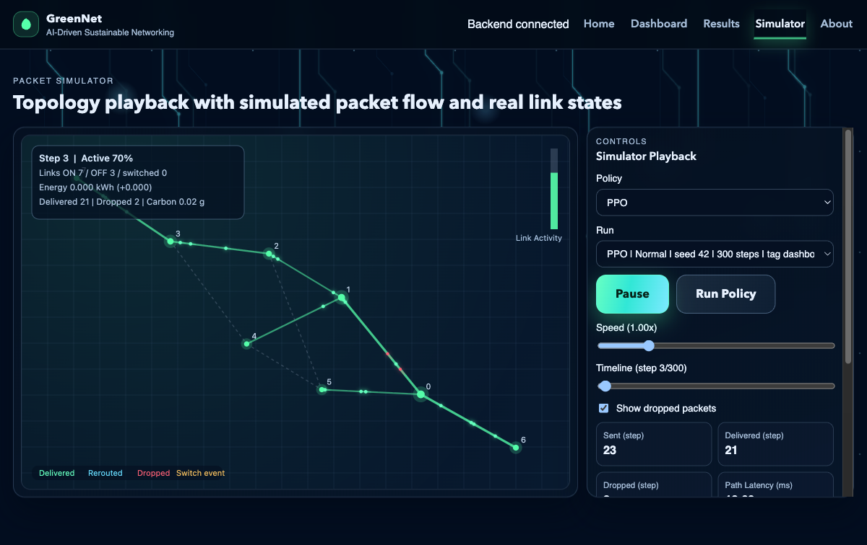
Figure 4. Simulator topology playback with packet-flow and link-state visualization during an active run.
As shown in Figure 4, GreenNet includes an execution view through which policy behavior can be observed step by step. That visibility helps connect the abstract benchmark tables to a concrete system implementation without interrupting the core results chapter with multiple UI screenshots.
More crowded dashboard and validation views remain useful as supporting evidence, but they belong in appendix-level material rather than in the main argumentative flow of the thesis.

Technologies and Tools Used
The implementation of GreenNet is based on the limited number of technologies that are selected according to their transparency and interoperability instead of being innovative. The thesis is most robust when every tool is associated with a definite purpose in the system at the end.
The main programming language used in the project is Python, as this language has the simulator, evaluation scripts, storage utilities, and API layer. That choice maintains benchmark logic, controller logic and reporting pipeline sufficiently close to be inspected as a unit rather than being dispersed over unrelated stacks.
Graph construction and path-based topology operations are done on NetworkX, and project-specific behavior is constructed on top of graph primitives via the simulator. This suits GreenNet well since the project must explicitly regulate the state of links, their usage, capacity and paths instead of a black-box networking engine.
NumPy and pandas help with the numerical component of the project: recurrent metric computations, summary between seeds and scenarios, and generation of report-friendly summary tables. Gymnasium is the interface to the environment that enables the PPO training and evaluation code to interface with the simulator.
The AI stack is deliberately thin. The PPO implementation applied to the learned controller is offered in the Stable-Baseline3, but the auxiliary ML code is supported by PyTorch that is included in the repository. Scikit-learn features in exploratory support directions, but its thesis does not hinge on showing a wide machine-learning pipeline; its primary AI assertion is on the PPO-based hybrid controller as implemented.
The backend service (exposing run metadata, summaries, and aggregate results to the interface) is powered by FastAPI and Uvicorn. They serve a practical purpose, in that they enable the same stored experiment outputs that were used in the thesis to be surfaced to the web view on a regular basis.
GreenNet runs a React-based interface, created with Vite, on the frontend, including the main dashboard, results, and simulator views. This holds more to the final project than a generic assertion regarding a modern frontend: the interface is used to view controller comparisons and to replay stored results.
The persistence technology is SQLite, which is structured run storage, and PostgreSQL is an optional extension to the thesis evaluation path which is future-facing and not a core component. The emphasis of the project on reproducible research artifacts is in line with using lightweight local persistence.
The support tools like Git, configuration files maintained in repositories, and tools built around the Node are important since GreenNet is composed of various interacting layers. They are not mentioned as innovations, but they are required to keep the simulator, evaluation scripts, API and frontend in step with iterative experimentation.
The technologies section thus reflects the implemented project structure: Python and its scientific libraries are used to simulate and evaluate, Stable-Baseline3 is used to learn the controller, FastAPI and Uvicorn are used to present results, SQLite is used to store benchmark artifacts, and React/Vite is used to inspect these artifacts.
This stack is suitable to a thesis where the key requirement is not scale of production, but a defense of experimentation and reporting.

Challenges and Limitations
The development of GreenNet meant a trade off between network reality, integration of ML and scale of capstone feasibility. The limits with which the results of the project should be understood are also determined by many of the thesis decisions which render the project manageable.
The initial constraint is the simulator. GreenNet is a representation of forwarding and link-state control on a graph abstraction; it is not a simulation of a complete routing control plane, device firmware behaviour or operational maintenance processes. This is the reason the thesis uses routing baseline as shortest-path or OSPF-like forwarding behavior instead of an actual implementation of OSPF in a production environment.
Another honesty constraint is added by the AI layer. The policy named PPO in the last evaluation path is not a pure unconstrained learner; it runs within a safety-oriented envelope involving the use of masks, cooldowns and fallback logic. This renders the controller more realistic to the benchmark, but it also implies that any gain observed cannot solely be credited to raw PPO.
Another honesty constraint is introduced by the AI layer. The policy named PPO in the last evaluation path is not an unconstrained learner, but a policy that is running within a safety-oriented envelope of applying masks, cooldowns, and fallback logic. This is more practical to the controller in the benchmark, but it also implies that any gain that is observed can not be traced to the effect of raw PPO itself.
Training depth is another limitation. Long tuning cycles and extensive exposure to scenarios are usually an advantage of reinforcement learning, but GreenNet was created on an academic time scale. The last PPO-based controller then should be interpreted as a time-constrained thesis execution, rather than an upper limit to what reinforcement learning might accomplish in a more substantial study.
Another constraint of the project was traffic modeling. Experimentation Greenet allows scenario-based experimentation with synthetic or controlled traffic patterns, to facilitate reproducibility and organised comparison. But artificial traffic can at best be a rough approximation of real network demand. Real traffic is frequently full of bursts, temporal dependencies across long distances, application-specific process, and human activity- or infrastructure-induced patterns that cannot be entirely modeled in a simplified simulator. Due to this fact, GreenNet is able to show the routing policies behaviour in representative conditions, but cannot say that it recreates the entire unpredictability of functional Internet-scale environments.
The same is the case with topology realism. The project can simulate various network structures, and analyze policy behavior across them, but these topologies are simplistic representations. Real backbone, ISP, enterprise or data-center networks frequently have other constraints like routing policy rules, heterogeneous hardware capacities, resilience requirements, maintenance windows, and operational constraints. All such conditions cannot be completely replicated in a research project of this size. This implies that the architectural and policy lessons which are generated by GreenNet can be useful in analysis and experimentation, although they cannot be construed as wholesale alternatives to real network engineering validation.
Software-engineering wise, integration too was a challenge. Assumptions regarding metric names, policy labels, and run metadata are common to the simulator, controller logic, benchmark scripts, storage layer, API, and frontend. The reproducibility of those layers needed keeping in line, but it demanded disciplined refactoring and attentive handling of artifacts during the project.
The scope of the project provided a limit. GreenNet emphasizes comparison by simulation, locked evaluation artifacts and presentation to reviewers, rather than concerns of production deployment like distributed orchestration or direct control of physical routers. The given trade-off is intentional and suitable to the thesis question.
These restrictions do not undermine the contribution of the thesis; they characterize it. The fact that GreenNet is worthwhile is that it does declare its assumptions, makes its benchmark claims modest, and it makes clear where further work would be required before any result can be extended outside the simulated environment.

Evaluation Strategy
The GreenNet evaluation strategy is constructed on the basis of a single question: in the same simulated conditions, what controller yields the most acceptable trade off of energy reduction and service quality? Each aspect of benchmark design is the result of that question, and this trade-off presentation is similar to the green-networking literature on trade-offs between efficiency and service quality (Bianzino et al., 2012; Chiaraviglio et al., 2009).
Controlled comparison is the first principle. The All-On controller, the heuristic controller and the PPO based hybrid controller are run on the same topology assumptions, traffic conditions, step limits as well as the metric definitions in such a way that variations in outcome can be attributed to controller behavior instead of the changing experimental conditions.
Scenario diversity is the second principle. GreenNet does not test a controller using one happy-path workload, but requires at least normal, burst, and hot spot conditions to reveal the behavior of each policy when handling calm demand, a variable demand, and more stressful traffic. That is important since a controller that seems to be efficient in a given regime might not work or may be too conservative in a different regime.
The strategy is also specifically multi-metric. The energy saved is registered with delivered traffic, dropped traffic, mean delay, path latency, QoS violation rate, and output related to carbon. This eliminates the possibility of a controller being deemed successful simply due to turning off more links.
Reproducibility is not considered as an afterthought but as a part of evaluation. GreenNet archives environment settings, executions, summaries and supporting artifacts in a manner that allows revisiting of benchmark claims in the future. That storage discipline is crucial in a project that has stochastic traffic and a trained controller.
The fourth principle is that of aggregation. The thesis is not based on one illustrative run; it generalizes the results of the policies, scenarios, and repeated executions and then generalizes the final comparisons with the results of these aggregations. This is what enables the project to keep a fairly stable trend and a single positive example separate.
Above all, GreenNet employs threshold-based interpretation. The last hypothesis gate involves a strong energy improvement and bounded QoS change, implying that a controller can be considered to be acceptable in QoS terms and at the same time fail to meet the thesis hypothesis. It is that higher criterion which leads to the interpretation of the final benchmark conservatively instead of being promoted as a victory based on a small energy saving.
This assessment plan will respond to the research questions. It can answer the question of whether adaptive control can save energy, whether the AI-based controller is significantly better than non-AI baselines, and whether the framework can enable repeatable sustainable-networking research.
In brief, GreenNet judges policies based on the quality of trade-offs and based on how reproducible is the evidence underlying the trade-offs.

Results and Discussion
This chapter presents the benchmark evidence that is most important to the final thesis argument. The main text keeps the official comparison among the All-On controller, the heuristic controller, and the PPO-labeled results, one selected positive AI case study, and the acceptance-threshold figure used to interpret those outcomes. In the discussion below, the label PPO refers to GreenNet’s implemented PPO-based hybrid controller, which is the strongest AI-based policy in the final benchmark but not the strongest overall policy.
Figure 1 is the central benchmark figure because it places the three evaluated policies in one controlled comparison bundle. Its role is not to showcase the best-looking individual run, but to show how the controllers compare when the same benchmark logic is applied across the final selected evaluation set.
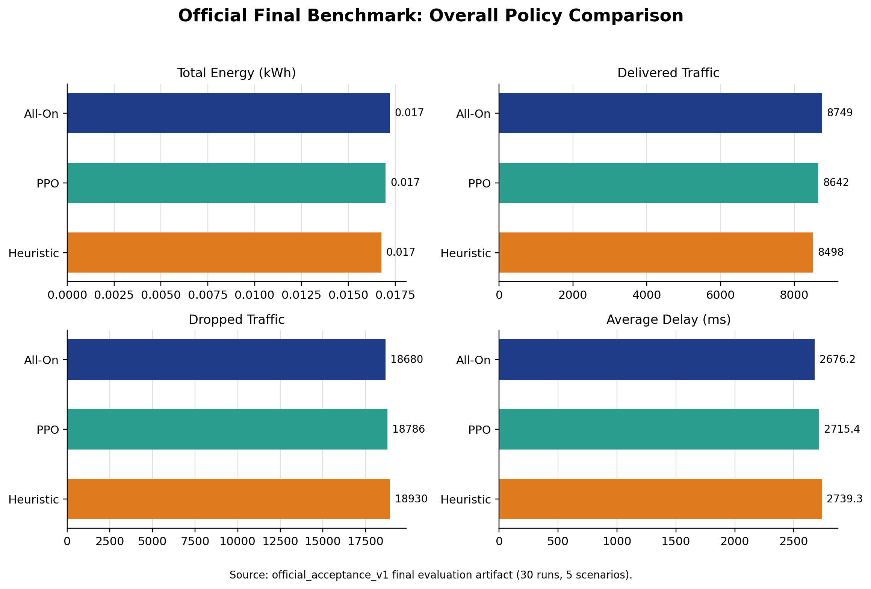
Figure 1. Official final benchmark comparison of the All-On controller, the heuristic controller, and the PPO-based hybrid controller across total energy, delivered traffic, dropped traffic, and average delay.
The main conclusion from Figure 1 is conservative. The final benchmark does not confirm the thesis hypothesis, because the observed energy gains are modest relative to the acceptance target and the heuristic controller remains the strongest overall policy in aggregate reporting. At the same time, the policy labeled PPO remains QoS-acceptable and performs as the strongest AI-based controller, which means the benchmark supports cautious promise rather than a headline breakthrough.
The main conclusion from Figure 1 is conservative. The final benchmark does not confirm the thesis hypothesis, because the observed energy gains are modest relative to the acceptance target and the heuristic controller remains the strongest overall policy in aggregate reporting. At the same time, the policy labeled PPO remains QoS-acceptable and performs as the strongest AI-based controller, which means the benchmark supports cautious promise rather than a headline breakthrough.
Figure 2 narrows the discussion to one selected PPO-positive case study. It is retained because the thesis should show not only the aggregate limitation of the AI result, but also the specific operating condition in which the PPO-based controller demonstrates a real positive trade-off.
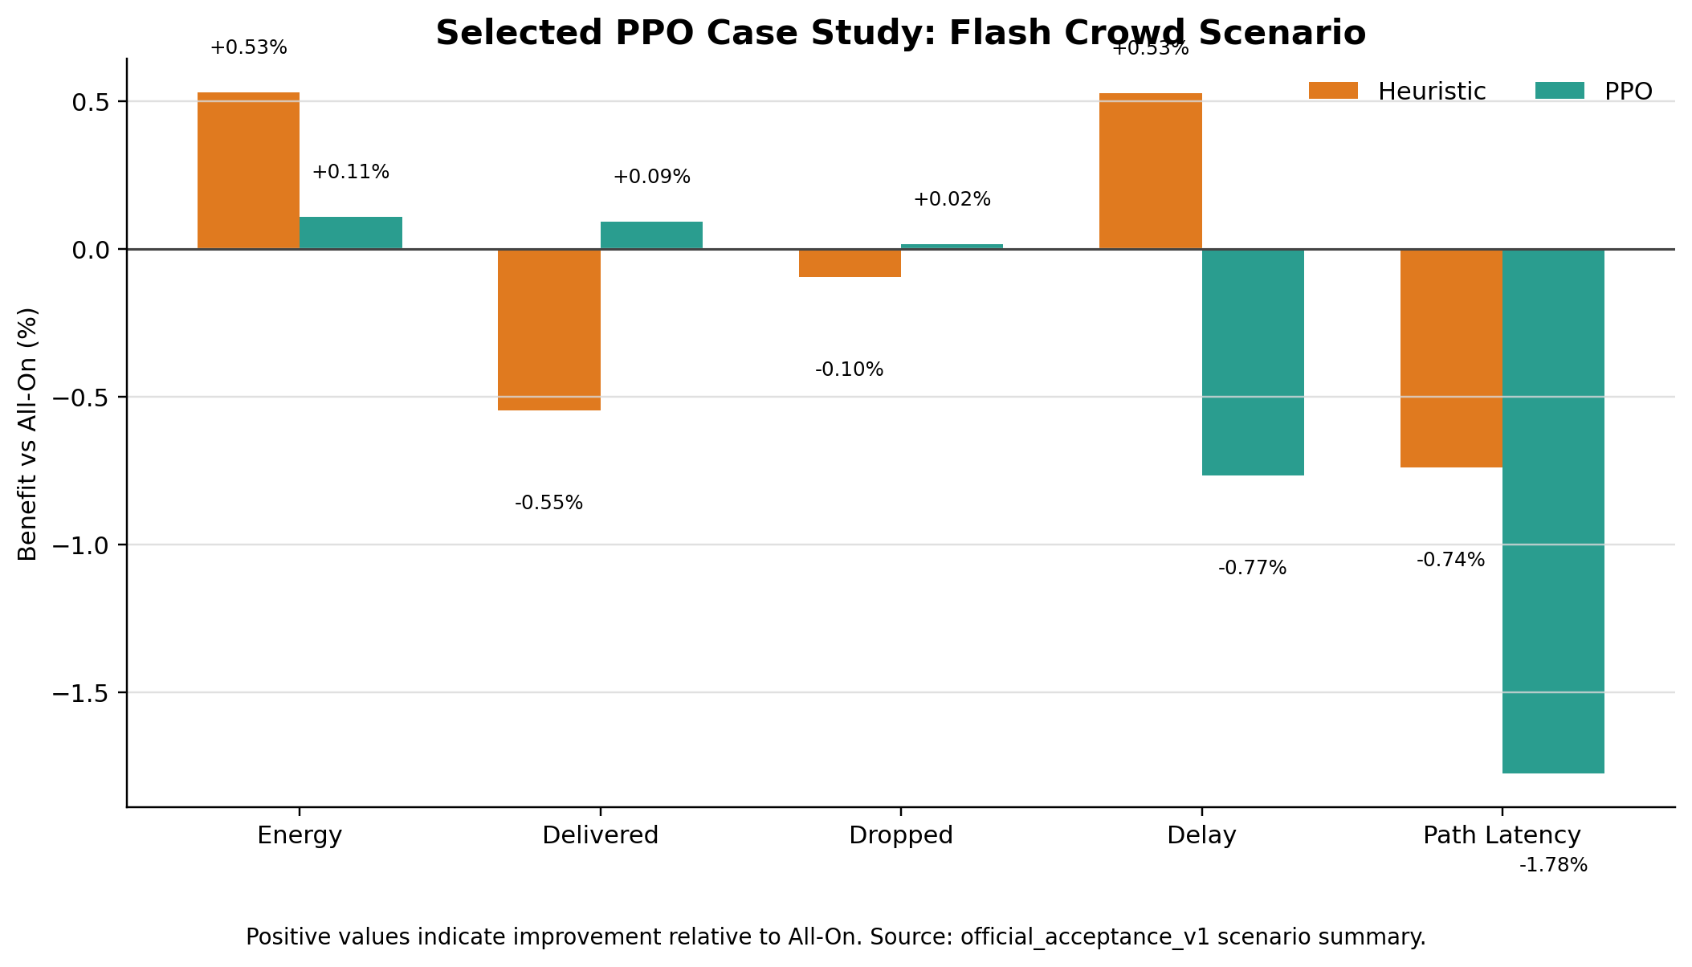
Figure 2. Flash-crowd case study showing policy benefit relative to All-On for energy, delivered traffic, dropped traffic, delay, and path latency.
The flash-crowd case is analytically useful because it shows the AI controller at its most defensible. In that scenario, the PPO-based controller slightly improves traffic-handling behavior while still pursuing energy-aware control, but the gain remains small enough that it cannot replace the aggregate benchmark as the main thesis conclusion.
Taken together, Figures 1 and 2 support a precise interpretation. The aggregate benchmark says that GreenNet’s heuristic controller is still the strongest overall policy and that the hypothesis is not achieved. The case study shows that the AI-based controller is not empty or decorative; it can produce beneficial trade-offs under selected conditions. The correct academic conclusion is therefore mixed: GreenNet demonstrates a real but limited AI signal inside a stronger comparative framework.

Reproducibility and Validation
Reproducibility and validation are included in the results chapter because GreenNet’s argument depends on how the benchmark is judged, not only on the raw plotted values. The project needs to show that negative or partial outcomes were produced by fixed rules rather than by post hoc narrative framing.
Figure 3 serves that purpose by making the acceptance logic explicit. It ties the final benchmark to predefined thresholds instead of allowing the thesis to call a small energy reduction a success simply because it is directionally positive.
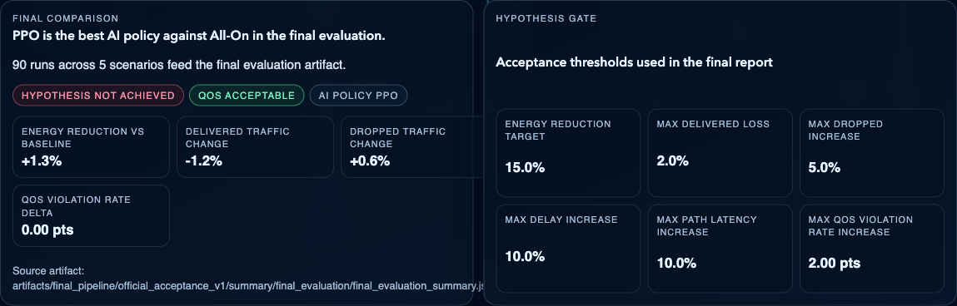
Figure 3. Official benchmark summary and acceptance thresholds used to judge hypothesis success in GreenNet.
This figure is methodologically important because it documents why the benchmark conclusion is conservative. The PPO-based controller can remain QoS-acceptable and still fail the hypothesis when the energy improvement is too small or when the full threshold set is not met. That interpretation strengthens, rather than weakens, the credibility of the thesis.

Conclusion
This thesis presented GreenNet as a reproducible framework for studying energy-aware network control under explicit QoS constraints. The project combined a graph-based simulator, controller comparison, artifact-backed evaluation, persistent storage, and interface-level reporting into one coherent system for sustainable-networking experiments.

What Was Achieved
From a research perspective, the strongest conclusion is not that AI won, but that the comparison is now defensible. The heuristic controller remains the best overall policy in the final benchmark, while the PPO-based hybrid controller is the strongest AI-based policy and shows limited but genuine promise in selected conditions such as the flash-crowd case study. That is a useful outcome because it identifies both the current ceiling of the implementation and the conditions under which adaptive control may become more worthwhile.
From a research perspective, the strongest conclusion is not that AI won, but that the comparison is now defensible. The heuristic controller remains the best overall policy in the final benchmark, while the PPO-based controller is the strongest AI-based policy and shows limited but genuine promise in selected conditions such as the flash-crowd case study. That is a useful outcome because it identifies both the current ceiling of the implementation and the conditions under which adaptive control may become more worthwhile.

Why the Hypothesis Was Not Fully Met
Several factors explain that result. The simulator uses a deliberately simplified but explicit power model; the PPO-based hybrid controller is constrained by masks and safety logic; reward shaping penalizes QoS degradation strongly; and the benchmark topologies remain modest in size. Together, these design choices encourage conservative behavior, which is useful for stability and honesty but limits the magnitude of achievable energy savings.
Several factors explain that result. The simulator uses a deliberately simplified but explicit power model; the PPO-based controller is constrained by masks and safety logic; reward shaping penalizes QoS degradation strongly; and the benchmark topologies remain modest in size. Together, these design choices encourage conservative behavior, which is useful for stability and honesty but limits the magnitude of achievable energy savings.
Seen in that light, the negative result is informative rather than disappointing. It shows that under GreenNet’s current assumptions, small AI-driven improvements are possible, but strong claims of sustainable-routing optimization would be premature.

On the Importance of Honest Research Reporting
An important strength of the thesis is that it reports the benchmark on its own terms. The acceptance logic is capable of rejecting an attractive narrative, and in this case it does: the final result is partial, not triumphant. That is exactly the kind of discipline a comparative systems thesis should demonstrate.
This matters especially in AI-oriented networking work, where it is easy to highlight a single favorable run or to blur the distinction between a pure learned controller and a safety-constrained hybrid system. GreenNet avoids that by keeping policy labels, benchmark thresholds, and supporting artifacts visible throughout the analysis.

Future Work
Future work should extend GreenNet in directions that are directly suggested by the benchmark. The most immediate step is deeper controller training and clearer ablation between the learned PPO component and the surrounding safety logic so that future gains can be attributed more precisely.
A second step is evaluation on larger and more heterogeneous topologies with more realistic demand traces. If energy-aware control is to matter beyond the capstone scale, it must be tested in settings where path diversity, redundancy, and load variation create more room for meaningful savings.
Further work could also strengthen the project’s auxiliary components without overstating them. Forecasting and impact-prediction paths should be evaluated separately if they are to be claimed as substantive contributions, and benchmark documentation should continue to prioritize artifact lineage and threshold-based interpretation.

Closing Remarks
GreenNet’s central contribution is therefore methodological and practical: it provides a principled environment in which sustainable-networking ideas can be tested, compared, and reported honestly. The final benchmark is intentionally modest, but the framework itself is strong enough to support more ambitious future studies without requiring the thesis to exaggerate what has already been achieved.

References
Bianzino, A. P., Chaudet, C., Rossi, D., & Rougier, J.-L. (2012). A survey of green networking research. IEEE Communications Surveys & Tutorials, 14(1), 3-20. https://doi.org/10.1109/SURV.2011.113010.00106
Chiaraviglio, L., Mellia, M., & Neri, F. (2009). Reducing power consumption in backbone networks. In 2009 IEEE International Conference on Communications (pp. 1-6). IEEE. https://doi.org/10.1109/ICC.2009.5199404
Gupta, M., & Singh, S. (2003). Greening of the Internet. ACM SIGCOMM Computer Communication Review, 33(4), 19-26. https://doi.org/10.1145/863955.863959
Henderson, T. R., Roy, S., Floyd, S., & Riley, G. F. (2008). ns-3 project goals. In Proceedings of the 2008 Workshop on ns-2: The IP Network Simulator (p. 13). ACM.
International Energy Agency. (2022). Data centres and data transmission networks. https://www.iea.org/reports/data-centres-and-data-transmission-networks
Moy, J. (1998). OSPF Version 2 (RFC 2328). IETF. https://www.rfc-editor.org/rfc/rfc2328
Sutton, R. S., & Barto, A. G. (2018). Reinforcement learning: An introduction (2nd ed.). MIT Press.
Valadarsky, A., Schapira, M., Shahaf, D., & Tamar, A. (2017). A machine learning approach to routing. arXiv. https://arxiv.org/abs/1708.03074

Appendix: Supporting Figures
The appendix retains real but non-central evidence that supports reproducibility, traceability, and broader interpretation without overloading the main thesis narrative.
Appendix Figure A1 documents the locked validation bundles used to store scenario-specific acceptance results under fixed constraints.
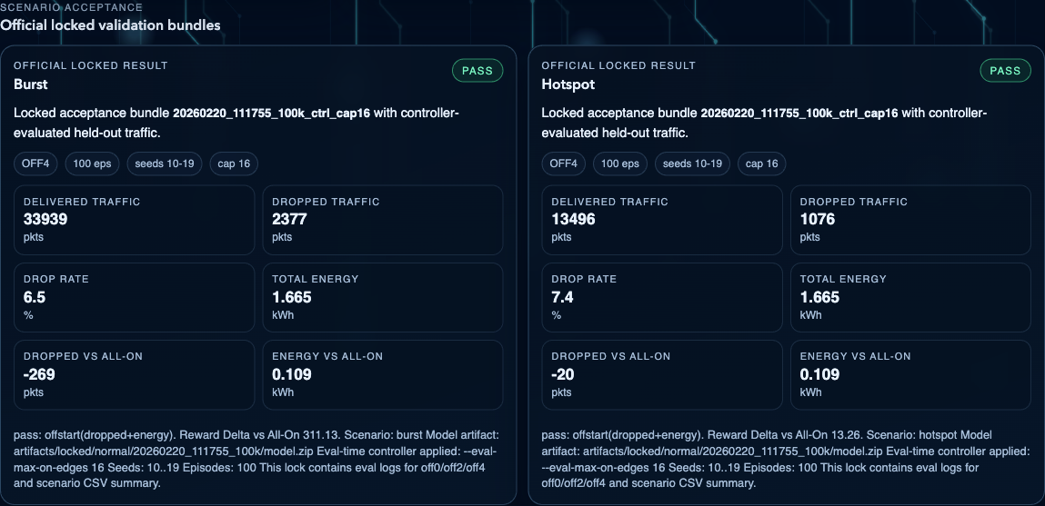
Appendix Figure A1. Official locked validation bundles used to document scenario-specific acceptance results and reproducibility settings.
Appendix Figure A1 is useful because it preserves the chain of evidence behind GreenNet's evaluation workflow. It shows that important held-out validations were stored as traceable bundles with explicit seeds, episode counts, and controller settings. However, because these bundles reflect a narrower validation context than the final benchmark, they are treated as supporting evidence rather than as central thesis results.

Appendix Figure A2 provides a compact scenario-by-scenario view of how the PPO-based hybrid controller changes energy use and delivered traffic relative to the All-On controller in the official final benchmark.
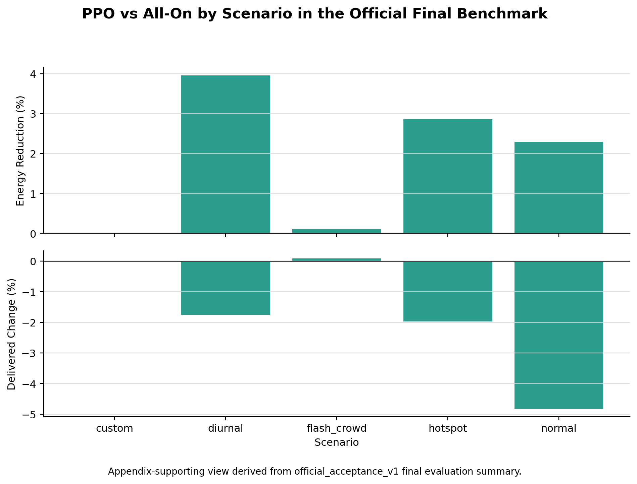
Appendix Figure A2. Scenario-by-scenario PPO-based hybrid controller trade-off relative to the All-On controller in the official final benchmark.
Appendix Figure A2 is intentionally placed outside the main body because it is analytically useful but more detailed than necessary for the primary thesis narrative. It helps the reader see that the PPO-based hybrid controller's strongest scenario-level case is flash-crowd, that diurnal and hotspot are better interpreted as compromise-policy cases, and that the normal scenario remains a negative result.

