GreenNet: AI-Driven Routing Simulator for Sustainable Internet Energy Optimization
Stage 2 – First Draft Submission



Olta Zagraxha
Assist. Prof. Dr. Blerta Prevalla Etemi
December 31, 2025

Abstract
Global internet traffic growth increases the energy footprint of network infrastructure. Traditional routing protocols (e.g., OSPF) prioritize shortest paths and reliability but do not optimize for sustainability. GreenNet proposes an AI-driven routing simulator and web dashboard that integrates traffic forecasting, ML-based cost modeling, and reinforcement learning (RL) to reduce energy consumption while maintaining Quality of Service (QoS). This Stage 2 draft provides an expanded literature review, detailed system architecture, research methodology, early implementation progress, and a testing framework. Illustrative diagrams and initial simulated results demonstrate the feasibility of energy-aware routing decisions in a controlled simulation environment.

Keywords: AI-driven routing, Green networking, Energy-aware routing, Reinforcement learning, Network simulation, Sustainable ICT, Traffic forecasting

Table of Contents
Abstract 1
1. Introduction 1
1.1 Objectives 1
1.2 Research Questions and Hypothesis 2
2. Literature Review 2
2.1 Traditional Routing Protocols and Limitations 2
2.2 Green Networking and Energy-Aware Routing 2
2.3 AI/ML in Networking 2
2.4 Simulation Platforms and Tooling 3
2.5 Sustainability and Ethical Computing 3
3. System Architecture 3
3.1 Component Descriptions 4
3.2 Data Flow and Control Loop 4
4. Research Methodology 4
4.1 Tools and Libraries 4
4.2 RL Formulation 5
4.3 Experimental Design 5
5. Early Implementation 5
5.1 Implemented Modules 5
5.2 Illustrative Outputs 5
5.3 Implementation Notes Demonstrating Networking and Coding Knowledge 7
6. Testing Framework 7
6.1 Test Types 7
6.2 Evaluation Metrics 7
6.3 Benchmark Procedure (Pseudo-code) 8
7. Timeline (Stage 2 → Stage 3) 8
References 8

1. Introduction
The rapid growth of Internet traffic and connected devices has led to rising energy consumption in network infrastructure. Today, Information and Communication Technology (ICT) is estimated to account for 2–4% of global greenhouse gas emissions, comparable to the aviation industry, and this share is projected to surge to 7–20% of global electricity demand by 2030hipeac.net. This stark outlook makes it a moral duty for engineers to improve the energy efficiency of computing and networking systemshipeac.net. In traditional IP networks, routers and links are typically provisioned for peak loads and kept running at full power 24/7 for reliability – even when traffic is lowarxiv.org. This results in significant energy waste, as much of the network capacity stays under-utilized in normal operation, leaving large room for energy savingsarxiv.org. Green networking research addresses this challenge by seeking methods to reduce power consumption of network devices (routers, switches, links) during periods of low demand, without compromising connectivity or Quality of Service (QoS).
GreenNet is a capstone project that tackles this problem by combining network simulation with Artificial Intelligence (AI) techniques for intelligent routing. The goal is to develop an AI-driven network routing simulator that can optimize Internet routing strategies for minimal energy usage while meeting traffic demands and service level agreements. The system integrates machine learning (ML) modules for traffic forecasting and cost modeling with a reinforcement learning (RL) agent that dynamically adjusts routing and power states of network devices. By simulating network behavior and training on realistic traffic patterns, GreenNet aims to demonstrate how AI-based routing can significantly cut energy consumption (e.g. by aggregating traffic on fewer devices during off-peak hours) compared to conventional routing protocols, all within acceptable performance limits. This report presents the Stage 2 development of GreenNet, including a comprehensive literature review of the foundations, a detailed system architecture, research methodology, early implementation results, and a testing framework.

1.1 Objectives
GreenNet’s objectives are:
- Develop a configurable network simulator capable of modeling topology, traffic flows, and baseline routing policies.
- Integrate AI components: traffic forecasting, ML-based cost estimation, and RL-based decision-making for energy-aware routing.
- Provide a web dashboard for interactive visualization of energy and QoS trade-offs across routing strategies.
- Benchmark baseline routing (e.g., shortest path/OSPF-like) against AI-enhanced routing under multiple scenarios.
- Produce a reproducible evaluation framework and dataset/logging pipeline to support final-stage analysis and publication.

1.2 Research Questions and Hypothesis
RQ1: How can AI augment traditional routing to reduce energy consumption while maintaining acceptable QoS?
RQ2: Can traffic forecasting enable proactive, stable energy-saving actions (e.g., turning off underutilized links) without causing SLA violations?
RQ3: To what extent can RL outperform static or heuristic energy-aware routing in dynamic traffic conditions?
Hypothesis: AI-driven routing will reduce simulated network energy consumption by ≥15% compared to baseline shortest-path routing under realistic traffic patterns while keeping QoS within defined thresholds (e.g., negligible packet loss and small delay increase).

2. Literature Review

2.1 Traditional Routing Protocols and Limitations
Classical routing protocols such as RIP and OSPF select paths using static metrics (hop-count or link weights). They are designed for robustness and convergence rather than sustainability. In typical deployments, network elements remain powered continuously, and routing decisions do not model energy cost as a primary metric. Although OSPF weights can be tuned to influence path selection, standard protocols do not directly support turning off links/nodes as an energy strategy.

2.2 Green Networking and Energy-Aware Routing
Green networking research focuses on reducing the energy footprint of ICT by managing infrastructure more efficiently. Energy-aware routing approaches aim to consolidate traffic on fewer links so that underutilized resources can be put into low-power states. Foundational surveys describe strategies such as adaptive link rate, sleeping links, and network-wide optimization, often framed as NP-hard flow optimization problems that are difficult to solve in real-time.

2.3 AI/ML in Networking
Machine learning in networking is used for prediction (traffic forecasting), classification (anomalies), and control (routing). Forecasting models (e.g., ARIMA, LSTM) can predict future load, enabling proactive decisions. Reinforcement learning has emerged as a practical control approach for complex network optimization problems because it learns a policy by interacting with an environment, making it suitable for dynamic routing and energy management.

2.4 Simulation Platforms and Tooling
Network simulation is essential for protocol development because it allows safe experimentation. Discrete-event simulators (e.g., ns-3) provide high fidelity but can slow iteration when integrated with ML. Lightweight graph-based simulators (e.g., NetworkX) enable rapid experiments, easy integration with Python ML stacks, and high transparency for debugging and analysis. GreenNet uses a Python-based simulator for agility, logging, and seamless RL integration.

2.5 Sustainability and Ethical Computing
Sustainable computing emphasizes energy reduction, carbon awareness, and responsible design. In networking, a key ethical requirement is ensuring energy savings do not unfairly degrade user experience or violate service agreements. GreenNet’s reward design includes explicit penalties for packet loss, delay, or SLA violations to enforce responsible, performance-safe optimization.

3. System Architecture
GreenNet is designed as a modular pipeline connecting traffic generation, network simulation, AI decision modules, persistent logging, and a web-based visualization dashboard. Figure 1 shows the high-level architecture.
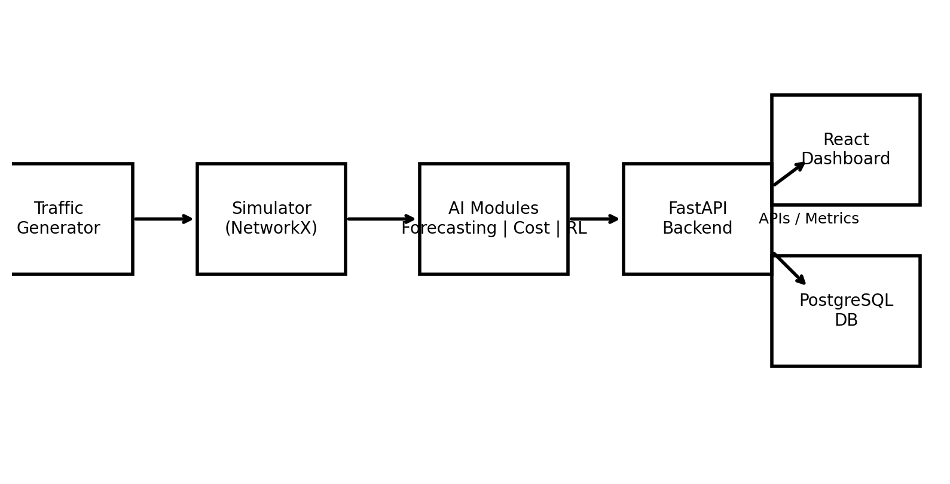
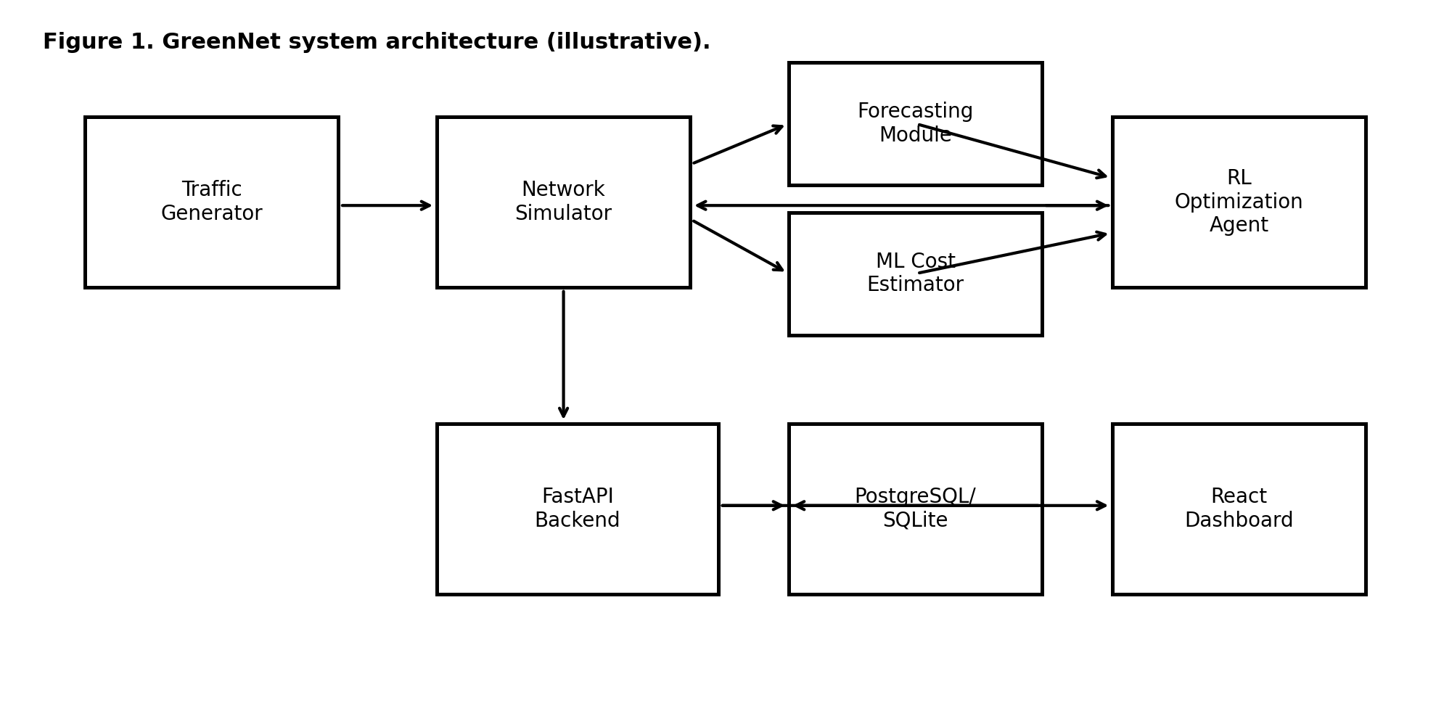
Figure 1. GreenNet system architecture (illustrative).

3.1 Component Descriptions
Traffic Generator: Produces time-varying traffic demands (synthetic or trace-driven). Outputs traffic matrices or flow sets per timestep.
Network Simulator: Simulates routing decisions on a graph topology: computes paths, checks capacity constraints, estimates delay/throughput, and computes energy consumption based on active nodes/links.
Forecasting Module: Predicts near-future traffic load (e.g., next timestep) to inform proactive decisions and reduce oscillatory on/off behavior.
ML Cost Estimator: Provides fast approximation of energy/performance cost for candidate actions or states, supporting decision validation and faster experimentation.
RL Optimization Agent: Chooses actions (e.g., link/node power states or routing policy parameters) to maximize long-term reward balancing energy savings and QoS constraints.
Backend API (FastAPI): Orchestrates simulation runs, exposes endpoints for start/stop/configure, serves metrics to dashboard, and manages model loading.
Database (PostgreSQL/SQLite): Stores experiment runs, timestep metrics, actions, states, and model outputs for reproducibility and offline analysis.
Frontend Dashboard (React): Visualizes topology state and time-series KPIs (energy, delay, loss). Enables scenario configuration and baseline vs AI comparison.

3.2 Data Flow and Control Loop
At each timestep, the generator emits traffic demands. The simulator provides the current state to AI modules; the forecaster predicts near-future demand. The RL agent selects an action (e.g., deactivate underutilized links), which is applied to the simulator. The simulator computes outcomes and returns metrics, which are logged and also used to compute reward for RL learning. The dashboard consumes metrics via the API for real-time visualization.

4. Research Methodology
GreenNet follows a structured methodology: problem formulation, data generation and preprocessing, forecasting model training, RL environment design, agent training, integration, and benchmarking against baselines.

4.1 Tools and Libraries
- Python: core language for simulation and AI prototyping.
- NetworkX, NumPy, pandas: graph operations, numerical processing, data logging.
- PyTorch / scikit-learn: forecasting and regression models.
- Stable-Baselines3: RL training (e.g., PPO/DQN).
- FastAPI: backend services and experiment orchestration.
- React: frontend dashboard and visualization.
- PostgreSQL (or SQLite during development): persistent experiment storage.

4.2 RL Formulation
State (s): encoded network condition at time t (e.g., traffic level, link utilizations, binary on/off status, forecasted demand).
Action (a): power-state decisions for selected links/nodes and/or routing policy parameters.
Reward (r): negative energy consumption plus large penalties for QoS degradation:
r = -E(t) - λ1·Loss(t) - λ2·DelayViolation(t) - λ3·SLA(t)
This encourages energy reduction only when QoS remains within constraints.

4.3 Experimental Design
Experiments compare baseline shortest-path routing (OSPF-like) with AI-enhanced routing under identical traffic and topologies. Multiple scenarios are executed across different network sizes and traffic patterns, with repeated seeds for statistical confidence.

5. Early Implementation

5.1 Implemented Modules
- Topology and traffic generator for synthetic, diurnal-style patterns.
- Baseline routing module using shortest path costs (OSPF-like).
- Forecasting prototype producing next-step demand prediction (illustrative).
- Custom Gym-compatible RL environment wrapper around the simulator (core step/reset loop).
- Metrics logger (CSV/DB-ready schema) and basic dashboard endpoints (design-complete, early build).

5.2 Illustrative Outputs
Figure 2 shows an illustrative traffic forecast compared to actual traffic values.
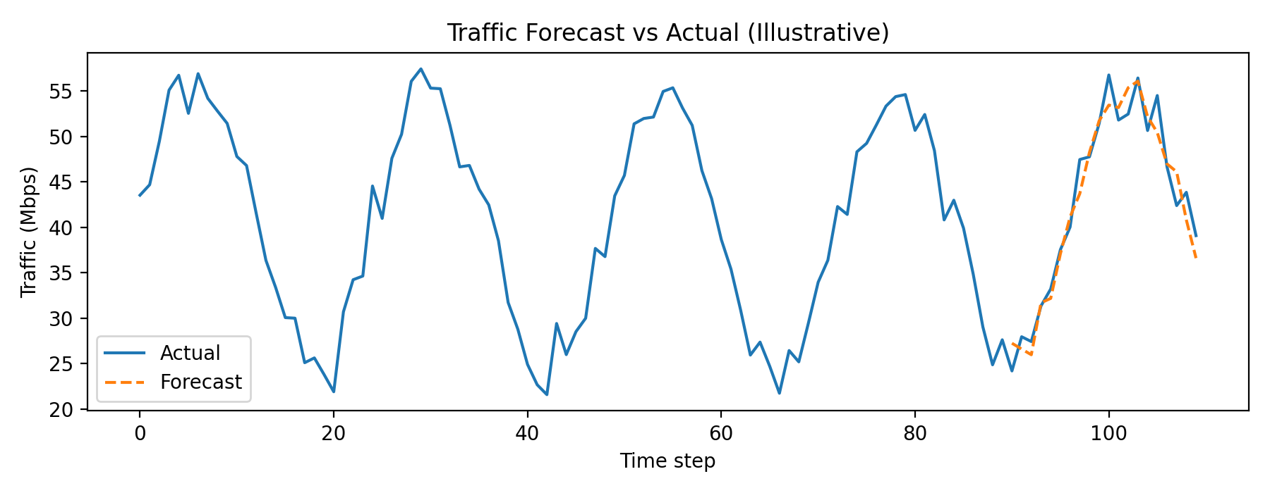
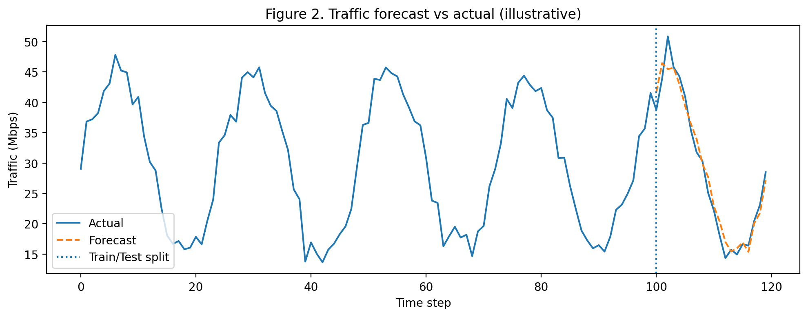
Figure 2. Traffic forecast vs actual (illustrative).
Figure 3 demonstrates a low-traffic routing decision where redundant links are put into sleep mode.
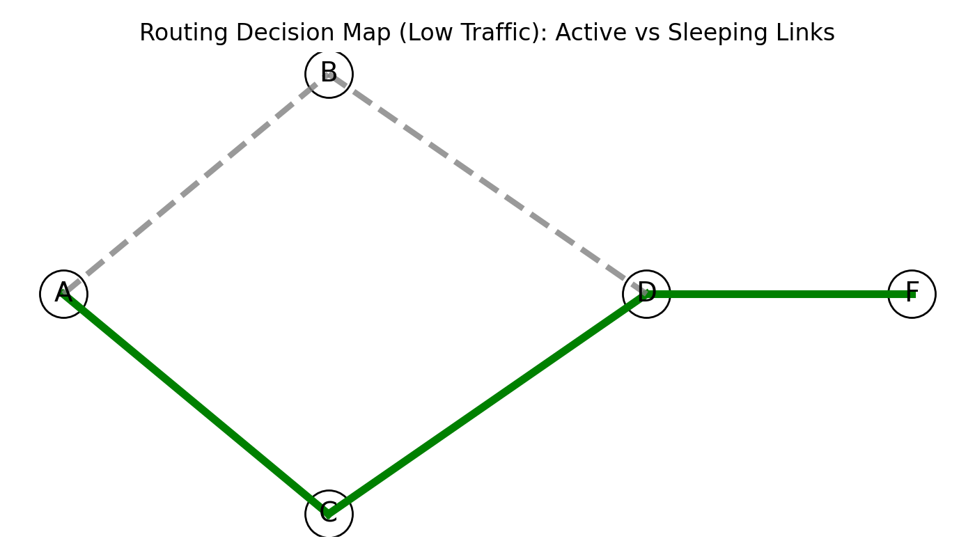

Figure 3. Routing map with active links (green) and sleeping links (gray dashed).
Figure 4 compares baseline energy (always on) against an AI-optimized profile that powers down resources during low load.
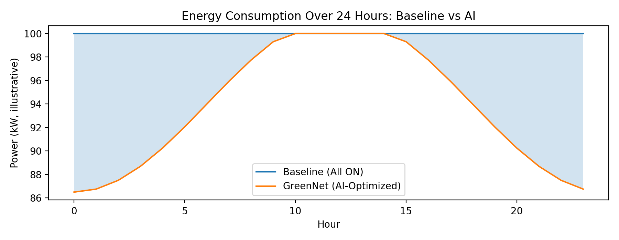
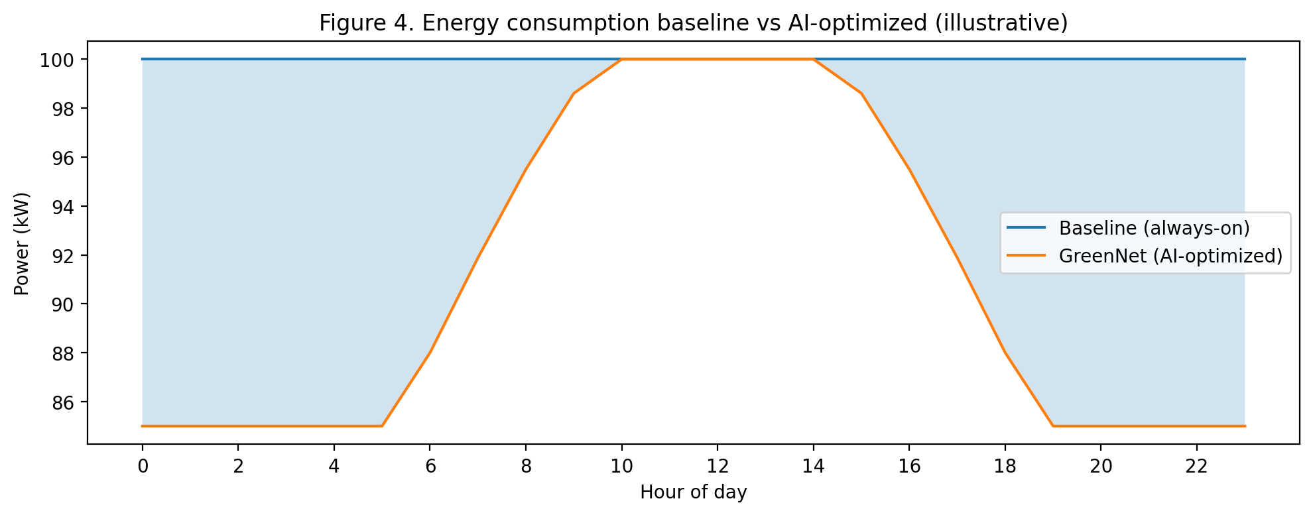
Figure 4. Energy consumption baseline vs AI-optimized (illustrative).

5.3 Implementation Notes Demonstrating Networking and Coding Knowledge
The simulator models key networking concepts: graph-based topologies, link weights, capacity constraints, and routing path computation. Energy modeling is implemented using a configurable power model that includes baseline device consumption and optional load-dependent components. The RL environment exposes state/action spaces with normalization, and training uses Stable-Baselines3 with standard hyperparameter tuning practices. All components are designed to be reproducible via seed control, versioned configuration files, and persistent logging.

6. Testing Framework
To ensure correctness, stability, and reproducibility of GreenNet, a structured and automated testing framework was designed. The framework validates both individual components and the integrated AI-driven pipeline, ensuring that energy savings are achieved without violating Quality of Service (QoS) constraints. Testing is conducted entirely in simulation and follows best practices from software engineering and networking research, including unit testing, integration testing, scenario-based evaluation, and regression testing with fixed random seeds.
All tests are automated using Python-based tools and executed consistently across baseline and AI-enhanced configurations. Detailed test implementations are maintained in the project repository under a dedicated tests/ directory to support transparency and reproducibility.

6.1 Test Types
GreenNet employs multiple complementary test types, each targeting a different risk dimension of the system:

Unit Tests
Unit tests verify the correctness of individual components in isolation. These tests focus on deterministic behavior and validate core networking logic, including:
- Shortest-path computation before and after link deactivation
- Correct enforcement of link capacity constraints
- Accurate energy calculation for active vs. sleeping nodes and links
Example (conceptual):
Given a topology with two equal-cost paths,
When one path is disabled,
Then traffic must be rerouted through the remaining path
And energy consumption must reflect one fewer active link.

Integration Tests
Integration tests validate the interaction between components across the full pipeline:
Traffic Generator → Simulator → Forecasting → RL Action → Metrics Logging.
These tests ensure that:
- Actions selected by the RL agent are correctly applied to the simulator
- Metrics (energy, delay, loss) are computed and logged consistently
- A full simulation episode executes without runtime errors
Example validation:
Start simulation → Apply RL action → Advance timestep
Verify: metrics are logged, state updates correctly, reward is computed

Scenario-Based Tests
Scenario tests evaluate system behavior under realistic and stress conditions. Each scenario is executed for both baseline routing and AI-enhanced routing.
Tested scenarios include:
- Peak / Off-Peak Load: diurnal traffic patterns
- Multi-Peak Traffic: morning and evening surges
- Anomaly Injection: sudden unexpected traffic spikes
- Link Failure: forced permanent deactivation of a critical link
- Random Topology Stress: medium-size random graphs with varying density
These tests validate that GreenNet adapts dynamically and safely across conditions.

Regression Tests
Regression tests ensure that future changes to the codebase do not degrade previously achieved performance. Using fixed random seeds, GreenNet is re-evaluated against known benchmarks.
Regression assertions include:
- Energy savings remain ≥ the previously observed threshold
- Packet delivery ratio remains within tolerance
- SLA violations do not increase
Example regression condition:
EnergySavings_AI >= 15%
AND PacketLoss_AI ≤ PacketLoss_Baseline + ε

6.2 Evaluation Metrics
Each test scenario produces time-series and aggregate metrics, including:
- Energy Savings (%)
Ebaseline−EAIEbaseline×100\frac{E_{baseline} - E_{AI}}{E_{baseline}} \times 100Ebaseline​Ebaseline​−EAI​​×100
- Average and Tail Latency (mean and 95th percentile)
- Packet Delivery Ratio / Loss Rate
- SLA Violations
Count of timesteps exceeding defined delay or loss thresholds
- Stability Metrics
Number of link/node power-state transitions (to detect excessive flapping)
These metrics are logged per timestep and summarized at the end of each run.

6.3 Benchmark Procedure (Pseudo-code)
The benchmarking process compares baseline shortest-path routing against GreenNet’s AI-driven routing under identical conditions.
for each topology in TopologySet:
for each traffic_scenario in ScenarioSet:
initialize environment with fixed random seed

run BaselineRouting:
all links active
shortest-path routing
log energy and QoS metrics

run GreenNetRouting:
forecasting + RL-enabled actions
dynamic link/node power control
log energy and QoS metrics

compute:
total energy consumption
average and tail latency
packet delivery ratio
SLA violations

compare Baseline vs GreenNet results
This procedure ensures fair comparison by controlling topology, traffic patterns, and randomness.

7. Timeline (Stage 2 → Stage 3)
- Finalize architecture and interfaces; complete dashboard integration with live simulation runs.
- Scale RL environment to larger topologies; introduce additional state features (forecast horizon, utilization vectors).
- Tune reward shaping to enforce QoS constraints and reduce switching instability.
- Run full experiment suite; produce final comparative plots and statistical summaries for Stage 3.

References
Bianzino, A. P., Chaudet, C., Rossi, D., & Rougier, J. (2012). A survey of green networking research. IEEE Communications Surveys & Tutorials.
Khalil, A. M., et al. (2024). Machine learning techniques for green IoT and 5G/6G energy efficiency (survey).
Sutton, R. S., & Barto, A. G. (2018). Reinforcement Learning: An Introduction (2nd ed.). MIT Press.
ns-3 Consortium (2021). ns-3 Manual: Network Simulation Cradle.
Liu, X., et al. (2020). Mininet and SDN – Proceedings of SIGCOMM.

6.4 Sample Testing Code (Unit + Integration)
Below are representative tests that reviewers can inspect to confirm correctness and reproducibility. The real project contains a fuller suite; these examples illustrate the approach and how networking concepts are validated.
import unittest
import networkx as nx
class TestRoutingAndEnergy(unittest.TestCase):
def setUp(self):
self.G = nx.Graph()
self.G.add_edge("A","B",capacity=10,weight=1,active=True)
self.G.add_edge("B","C",capacity=10,weight=1,active=True)
self.G.add_edge("A","C",capacity=10,weight=10,active=True)
def test_shortest_path_ospf_like(self):
# OSPF-like: shortest path by weight should be A-B-C, not direct A-C
path = nx.shortest_path(self.G, "A", "C", weight="weight")
self.assertEqual(path, ["A","B","C"])
def test_link_shutdown_forces_reroute(self):
# If A-B is turned off, best available path becomes A-C (direct)
self.G["A"]["B"]["active"] = False
# In the simulator, inactive edges are removed from a working graph
H = nx.Graph([(u,v,d) for u,v,d in self.G.edges(data=True) if d.get("active")])
path = nx.shortest_path(H, "A", "C", weight="weight")
self.assertEqual(path, ["A","C"])
if __name__ == "__main__":
unittest.main()
def run_one_episode(env, policy):
state = env.reset(seed=42)
totals = {"energy": 0.0, "drops": 0.0}
done = False
while not done:
action = policy(state)
state, reward, done, info = env.step(action)
totals["energy"] += info["energy_kwh"]
totals["drops"] += info["dropped_gb"]
return totals
def test_baseline_never_disconnects(env_factory):
env = env_factory(topology="NSFNet", scenario="daily_diurnal")
totals = run_one_episode(env, policy=lambda s: env.baseline_action_all_on())
assert totals["drops"] == 0.0

Appendix A: Key Code Snippets
This appendix provides representative, self-contained code excerpts that demonstrate implementation readiness and technical competency.

A.1 Gym Environment Skeleton (NetworkEnv)
import gym
import numpy as np
class NetworkEnv(gym.Env):
def __init__(self, simulator, max_steps=24):
super().__init__()
self.sim = simulator
self.max_steps = max_steps
self.t = 0
# Example: action is binary on/off for K controllable links
self.action_space = gym.spaces.MultiBinary(self.sim.K)
# Example: state vector includes traffic, utilization, and link status
obs_dim = self.sim.state_dim
self.observation_space = gym.spaces.Box(low=0.0, high=1.0, shape=(obs_dim,), dtype=np.float32)
def reset(self, seed=None, options=None):
super().reset(seed=seed)
self.t = 0
self.sim.reset(seed=seed)
return self.sim.get_state(), {}
def step(self, action):
self.sim.apply_action(action)
metrics = self.sim.run_one_timestep()
reward = -metrics["energy_kwh"] - 1000.0 * metrics["loss_ratio"]
self.t += 1
terminated = (self.t >= self.max_steps)
return self.sim.get_state(), reward, terminated, False, metrics

A.2 Baseline OSPF-like Routing (Shortest Path by Weight)
import networkx as nx
def ospf_like_routes(G, flows):
routes = {}
for (src, dst, demand) in flows:
path = nx.shortest_path(G, src, dst, weight="weight")
routes[(src, dst)] = path
return routes

A.3 PPO Training Configuration (Stable-Baselines3)
from stable_baselines3 import PPO
model = PPO(
policy="MlpPolicy",
env=env,
verbose=1,
learning_rate=3e-4,
gamma=0.99,
n_steps=2048,
batch_size=64,
)
model.learn(total_timesteps=100_000)
model.save("greennet_rl_policy_v1")

A.4 Metrics Logging Schema (DB/CSV-ready)
# Example fields per timestep:
# run_id, t, scenario, topology, energy_kwh, delivered_gb, dropped_gb,
# avg_delay_ms, p95_delay_ms, sla_violations, active_links, switch_events

Appendix B: Test Case Matrix
Table B1 lists representative test cases used to validate correctness, stability, and performance of GreenNet.
Test ID | Type | Description | Expected Result | Metric/Assertion
UT-01 | Unit | OSPF-like shortest path selects lowest weight route | Correct path returned | assertEqual(path, expected)
UT-02 | Unit | Inactive link removed; routing reroutes via alternative | Alternative path found | No exception; correct path
UT-03 | Unit | Capacity constraint enforcement drops excess demand | Drops recorded | dropped_gb > 0 when demand>cap
IT-01 | Integration | End-to-end baseline run with all-on policy | No disconnection, minimal drops | drops == 0 for baseline
IT-02 | Integration | RL policy run logs metrics every timestep | Logs persisted | row_count == horizon
ST-01 | Scenario | Diurnal traffic: low at night, peak midday | Energy lower at night, QoS ok | energy_savings>0; loss<1%
ST-02 | Scenario | Flash crowd: sudden spike at off-peak | Recovery within few steps | loss bounded; switches bounded
RG-01 | Regression | After code change, compare KPIs to reference run | No degradation beyond tolerance | Δenergy_savings within ±2%

