GreenNet: AI-Driven Routing Simulator for Sustainable Internet Energy Optimization

An Honors Society Project

Olta Zagraxha

Advisor:
Blerta Prevalla-Etemi
Second Readers:
Valon Raca & Muzafer Shala

Abstract
GreenNet is an AI-driven routing simulation and evaluation framework designed to explore how network infrastructures can reduce energy consumption while maintaining acceptable Quality of Service (QoS). As Internet traffic continues to grow, traditional routing approaches prioritize connectivity, shortest paths, and reliability, but they do not explicitly optimize for sustainability. This project addresses that gap by combining network simulation, energy-aware control policies, and intelligent decision-making methods within a unified experimental platform.

The system models network topologies, traffic scenarios, and routing behavior, and evaluates multiple policies, including traditional always-on routing, heuristic energy-aware control, and reinforcement learning-based optimization. GreenNet measures key performance indicators such as energy consumption, delivered and dropped traffic, delay, latency, carbon impact, and QoS compliance, enabling a structured comparison of routing strategies under realistic and dynamic conditions. In addition to the simulation core, the project includes reproducible evaluation workflows, persistent result storage, and a web-based interface for visualizing scenario outcomes and policy trade-offs.

The main contribution of GreenNet is a practical and academically grounded framework for studying sustainable networking through AI-assisted routing decisions. Rather than treating energy efficiency as an isolated objective, the project evaluates how energy savings can be achieved responsibly, without unacceptable degradation in service quality. The results demonstrate the value of combining classical networking principles with modern AI techniques to support greener and more transparent network management.

Keywords: Green networking, energy-aware routing, artificial intelligence, reinforcement learning, network simulation, Quality of Service, sustainable computing, traffic optimization.

Introduction
The rapid growth of Internet traffic, cloud services, and always-connected digital systems has made computer networks more important than ever. At the same time, this expansion has increased the energy consumption of networking infrastructure, including routers, switches, and communication links. Although modern networks are typically designed to maximize performance, reliability, and availability, they are often operated in ways that are not energy-efficient, especially during periods of low or fluctuating demand.
Traditional routing approaches prioritize metrics such as shortest path, link cost, and fast convergence, but they do not explicitly consider sustainability or energy usage as optimization goals. As a result, network components often remain active even when traffic conditions would allow more efficient configurations. This creates an important opportunity for research into smarter routing strategies that can reduce energy consumption without causing unacceptable degradation in Quality of Service (QoS).
GreenNet was developed in response to this challenge. The project presents an AI-driven routing simulation and evaluation framework that investigates how intelligent control policies can improve the energy efficiency of network operation. Instead of relying only on fixed traditional routing logic, GreenNet compares multiple approaches, including always-on routing, heuristic energy-aware control, and reinforcement learning-based decision-making, within a unified experimental platform. The system is designed to simulate realistic network topologies and traffic scenarios, measure both performance and sustainability-related metrics, and visualize the trade-offs between energy savings and service quality.
The broader motivation behind this work is the growing need for sustainable computing solutions. As digital infrastructure continues to expand globally, improving the efficiency of network operation is no longer only a technical issue, but also an environmental one. By combining networking principles with artificial intelligence techniques, GreenNet aims to demonstrate that network management can become both more adaptive and more responsible.
This thesis explores the design, implementation, and evaluation of GreenNet as a practical framework for sustainable routing research. It focuses on whether AI-assisted routing policies can reduce simulated network energy consumption while preserving acceptable performance, thereby contributing to the wider goal of greener and more efficient computing systems.

Objectives
The main objective of this thesis is to design, implement, and evaluate GreenNet as an AI-driven framework for energy-aware network routing. The project aims to investigate whether intelligent routing and control strategies can reduce network energy consumption while maintaining acceptable Quality of Service (QoS) under different traffic and topology conditions.
The specific objectives of the project are as follows:
- To develop a configurable network simulation environment capable of modeling different topologies, traffic scenarios, and routing behaviors.
- To implement and compare multiple routing and control strategies, including traditional always-on routing, heuristic energy-aware policies, and reinforcement learning-based approaches.
- To evaluate network behavior using both sustainability-related and performance-related metrics, including energy consumption, delivered traffic, dropped traffic, latency, delay, carbon impact, and QoS compliance.
- To create a reproducible experimental workflow that supports consistent benchmarking across scenarios, seeds, and policy configurations.
- To provide a clear visualization and reporting layer through a web-based interface and structured result summaries, making the analysis of policy trade-offs easier to understand.
- To examine whether AI-assisted decision-making can offer a practical and responsible approach to greener network management without causing unacceptable performance degradation.
Through these objectives, the thesis seeks to contribute to the study of sustainable computing by presenting a technically grounded and experimentally validated framework for energy-efficient routing research.

Research Questions and Hypothesis
This thesis is guided by the broader question of how network routing can be made more energy-efficient without compromising acceptable service quality. To address this problem, the study focuses on the following research questions:
Research Question 1:
How can intelligent routing and control strategies reduce network energy consumption while maintaining acceptable Quality of Service (QoS)?
This question examines whether energy-aware decision-making can improve the efficiency of network operation without introducing unacceptable levels of delay, packet loss, or instability.
Research Question 2:
How do AI-based approaches compare with traditional always-on and heuristic routing strategies under different traffic and topology conditions?
This question focuses on comparative evaluation. It investigates whether reinforcement learning-based or other intelligent policies can produce better overall trade-offs between sustainability and performance than conventional methods.
Research Question 3:
Can a simulation-driven framework provide a practical and reproducible way to evaluate sustainable routing strategies?
This question addresses the methodological contribution of the project. It explores whether GreenNet can serve not only as a technical prototype, but also as a structured platform for repeatable experimentation, analysis, and reporting.
Hypothesis:
AI-assisted routing and control strategies can reduce simulated network energy consumption compared to traditional always-on routing while maintaining acceptable QoS levels across different traffic scenarios and network topologies.
More specifically, the working expectation of this project is that intelligent decision-making methods, especially reinforcement learning-based approaches, can achieve meaningful energy savings by adapting network behavior to traffic conditions, while keeping performance degradation within acceptable limits.

Literature Review
The increasing energy demand of digital infrastructure has made sustainable networking an important research area in modern computing. As Internet usage, cloud services, and connected devices continue to expand, network infrastructures consume growing amounts of energy, creating both economic and environmental concerns. Traditional routing systems have historically been designed to optimize connectivity, reliability, and performance, but they have not treated energy efficiency as a primary design objective. This gap has encouraged the development of green networking approaches that attempt to reduce power consumption while maintaining acceptable service quality.
One major area of related work focuses on traditional routing protocols and their limitations. Classical protocols such as RIP and OSPF are designed around metrics like hop count, shortest path, and link cost. These protocols are highly effective in ensuring reachability and stable packet delivery, but they do not explicitly model energy usage in their routing decisions. As a result, routers, links, and other networking components often remain active regardless of actual traffic demand. This creates inefficiencies, especially during low-utilization periods, where some parts of the network could theoretically operate in lower-power states without significantly affecting performance.
A second major stream of research concerns green networking and energy-aware routing. Researchers in this area have explored strategies such as traffic consolidation, adaptive link activation, sleep modes for underutilized devices, and optimization-based routing decisions. The main idea behind these approaches is that energy can be saved by concentrating traffic on fewer active paths and temporarily reducing the activity of unused network elements. However, many of these methods are either static, highly simplified, or difficult to apply in real-time environments. In practice, energy-aware routing must balance efficiency with strict performance requirements, since overly aggressive power-saving decisions can increase delay, packet loss, or instability.
Artificial intelligence has emerged as a promising solution to this challenge. In networking, AI and machine learning have been applied to traffic prediction, anomaly detection, congestion control, and adaptive routing. Forecasting models can help estimate future traffic demand, allowing the system to make proactive decisions rather than reacting only after congestion or underutilization occurs. Reinforcement learning is particularly relevant because it enables an agent to learn control policies through repeated interaction with an environment. Instead of following fixed rules, an RL-based routing strategy can adapt to changing network states and optimize long-term trade-offs between energy savings and Quality of Service. This makes AI-based routing especially suitable for dynamic and uncertain traffic conditions.
Simulation platforms also play an important role in networking research. High-fidelity simulators such as ns-3 and OMNeT++ provide powerful environments for protocol analysis, but they can be more complex and slower to integrate with machine learning workflows. In contrast, lightweight graph-based simulation frameworks offer flexibility, transparency, and fast experimentation, making them attractive for research projects that combine networking with AI. For a project such as GreenNet, simulation is not only a technical implementation tool but also a research instrument that supports reproducible experimentation, comparative evaluation, and systematic testing across multiple scenarios.
Another important perspective in the literature is sustainability in computing. Sustainable computing emphasizes the reduction of environmental impact through efficient system design, responsible resource usage, and carbon-aware decision-making. Within this context, energy-efficient networking is not only a performance optimization problem, but also part of a broader ethical and environmental responsibility. Systems that reduce energy usage must still protect fairness, reliability, and service quality, especially when they affect critical digital infrastructure.
Despite the progress in these areas, there remains a gap between theoretical green networking strategies and practical, accessible frameworks for evaluating them. Many studies focus either on optimization models, isolated AI methods, or highly specialized environments. Fewer projects combine simulation, AI-driven control, structured evaluation, and user-facing visualization into one coherent platform. GreenNet addresses this gap by providing a unified framework for modeling network behavior, comparing routing policies, and studying the trade-offs between energy efficiency and service quality in a reproducible and understandable way.
Overall, the literature suggests that sustainable networking is both technically relevant and socially important. Traditional routing methods provide a strong operational foundation, but they are limited in terms of energy awareness. Green networking research introduces mechanisms for reducing power usage, while AI adds adaptability and decision-making intelligence. GreenNet builds on these foundations by integrating them into a single experimental framework aimed at exploring practical and responsible approaches to greener network management.

Methodology
This thesis follows a design-and-evaluation methodology centered on the development of a simulation-based framework for studying energy-aware network routing. The methodological approach combines system design, implementation, controlled experimentation, and comparative evaluation in order to investigate how intelligent routing policies affect both energy consumption and service quality.
At the core of the methodology is the development of GreenNet as a configurable network simulation and evaluation environment. The framework is designed to model network topologies, traffic conditions, routing strategies, and policy decisions in a controlled and reproducible way. Rather than testing routing approaches directly on real-world infrastructure, the project uses simulation to create a safe and flexible environment for experimentation. This makes it possible to compare multiple policies across different scenarios while maintaining consistency in topology, traffic demand, and performance metrics.
The first methodological step involves modeling the network environment. Different network topologies and traffic scenarios are defined to represent varied operating conditions, including normal traffic patterns, fluctuating demand, and more dynamic workloads. These scenarios provide the basis for evaluating how routing policies behave under different levels of utilization and stress. The system measures multiple output variables, including energy consumption, delivered traffic, dropped traffic, delay, latency, carbon-related impact, and Quality of Service (QoS) compliance.
The second step involves implementing and comparing different routing and control strategies. GreenNet includes a traditional always-on routing baseline, an energy-aware heuristic approach, and an AI-assisted strategy based on reinforcement learning. These policies are evaluated under the same simulated conditions to ensure fair comparison. The baseline provides a reference point for conventional network operation, while the heuristic and AI-based approaches are used to test whether more adaptive decision-making can improve sustainability outcomes.
The third methodological component focuses on data collection and experiment execution. For each run, GreenNet records structured metrics and summaries that describe both performance and energy-related behavior over time. These records support reproducibility and make it possible to aggregate results across multiple scenarios, policies, and random seeds. The use of consistent experiment workflows ensures that comparisons are based on repeatable procedures rather than isolated observations.
Another important part of the methodology is evaluation and interpretation. The project does not consider energy reduction alone as evidence of success. Instead, the evaluation framework emphasizes trade-offs between energy savings and service quality. A routing policy is considered useful only if it reduces energy usage without causing unacceptable degradation in network performance. For this reason, metrics such as delay, dropped traffic, and QoS violations are treated as essential evaluation criteria alongside energy and carbon-related measures.
Finally, the methodology includes a reporting and visualization layer. The results of the simulation and evaluation process are organized into structured summaries and presented through a web-based interface and reproducible output artifacts. This improves transparency and helps demonstrate the practical implications of the tested policies. By combining implementation, simulation, experimentation, and analysis, the methodology provides a coherent foundation for examining sustainable routing strategies in a rigorous and academically relevant way.

System Architecture
GreenNet is designed as a modular system architecture that combines network simulation, policy-driven control, experiment evaluation, persistent result storage, and visualization. The architecture is structured to support both experimentation and analysis, allowing different routing strategies to be tested under controlled conditions while keeping outputs reproducible and easy to interpret.
At the center of the system is the simulation core. This component models the network as a topology of interconnected nodes and links and executes traffic flows across that topology according to the selected routing and control policy. The simulator is responsible for processing the state of the network over time, applying policy decisions, and computing the resulting performance and energy metrics. Through this design, GreenNet can represent how different routing strategies affect both network behavior and resource usage under changing conditions.
The traffic generation layer provides the input workload for the simulator. It defines how demand enters the network over time and supports the creation of different traffic scenarios, such as stable demand, fluctuating load, or sudden changes in utilization. This layer is important because routing policies must be evaluated not only under ideal conditions, but also under more realistic and dynamic traffic patterns. By varying traffic scenarios, the system can test whether a policy remains effective and stable across multiple forms of demand.
Above the simulation layer is the policy control layer. This component determines how routing and energy-related decisions are made during each run. GreenNet supports multiple policy types, including a traditional always-on baseline, a heuristic energy-aware strategy, and an AI-assisted approach based on reinforcement learning. The policy layer interacts with the simulator by observing network conditions and selecting actions that influence how the network operates. This separation between simulation and policy logic makes the system easier to extend, compare, and evaluate.
Another major component of the architecture is the evaluation and metrics layer. This layer collects results from each simulation run and transforms them into structured performance indicators. These include energy consumption, delivered traffic, dropped traffic, delay, latency, carbon-related impact, and Quality of Service compliance. The evaluation layer supports both per-run analysis and aggregated comparison across multiple scenarios and policies. This is essential for the thesis, since the goal is not only to run simulations, but also to produce interpretable evidence about the trade-offs between sustainability and performance.
To support reproducibility and traceability, GreenNet also includes a persistence and logging layer. This part of the architecture stores experiment metadata, run summaries, and other structured outputs that describe how each simulation was executed and what results were obtained. Persistent storage ensures that results can be reviewed, compared, and reused later without relying only on temporary in-memory execution. It also supports the production of final summaries and report-ready artifacts.
The backend service layer acts as the bridge between the simulation system and the user-facing interface. It is responsible for exposing experiment data, summaries, and comparison results through a structured API. This makes it possible for external interfaces to request simulation outputs, load evaluation results, and present them in a clear way. The backend therefore plays a central role in connecting the computational part of the system with the presentation and reporting layer.
The final component is the visualization layer, implemented as a web-based interface for displaying results and comparisons. This layer allows users to inspect experiment outcomes, analyze trade-offs across policies, and understand the overall performance of the system. Rather than treating visualization as a separate add-on, GreenNet integrates it into the architecture as part of the overall research workflow. This makes the project not only a simulator, but also a complete evaluation framework that supports interpretation and communication of findings.
Overall, the system architecture of GreenNet is built around modularity, reproducibility, and comparative analysis. Each component has a distinct role, but all components work together to support the main purpose of the project: evaluating whether intelligent routing strategies can improve network energy efficiency while preserving acceptable service quality.

Implementation
The implementation of GreenNet focuses on building a practical and modular framework for simulating, evaluating, and visualizing energy-aware routing strategies. The system was developed as a combination of simulation logic, policy control mechanisms, experiment evaluation workflows, persistent result handling, and a web-based reporting interface. The goal of the implementation was not only to create a theoretical model, but also to produce a working platform that could support reproducible experimentation and meaningful comparison between routing approaches.
The core of the implementation is the network simulation environment. This component models network behavior over time by representing topologies, links, traffic demand, and policy-driven actions within a controlled execution loop. The simulator processes the current network state, applies routing or control decisions, and computes the resulting metrics for each run. This makes it possible to observe how different strategies influence both energy-related and performance-related outcomes under varying traffic conditions.
To support comparative analysis, multiple routing and control strategies were implemented within the system. These include a traditional always-on baseline, a heuristic energy-aware policy, and an AI-assisted approach based on reinforcement learning. The baseline serves as the reference model for conventional network operation, while the heuristic and AI-based policies are designed to explore more adaptive methods of improving energy efficiency. By keeping these strategies within the same simulation framework, the project ensures that comparisons are made under consistent and controlled conditions.
Another major part of the implementation is the experiment and evaluation pipeline. GreenNet includes structured workflows for running scenarios, collecting outputs, aggregating results, and producing final summaries. This layer allows the system to move beyond isolated simulation runs and toward a more rigorous evaluation process. Instead of observing one execution at a time, the project supports repeated runs across different scenarios, policies, and conditions, making the final analysis more reliable and reproducible.
The implementation also includes a metrics and persistence layer. During experiment execution, the system records important indicators related to both sustainability and service quality. These include energy consumption, delivered traffic, dropped traffic, delay, latency, carbon-related measures, and QoS-related status. These outputs are stored in a structured manner so that they can be reused for reporting, comparison, and later inspection. This persistence layer strengthens the scientific value of the project by improving traceability and reducing dependence on manual observation.
To make the results easier to understand and communicate, GreenNet also includes a backend and visualization layer. The backend exposes experiment outputs and summaries through a structured interface, while the frontend provides a web-based view of system behavior and policy comparison. This part of the implementation is important because it transforms raw simulation outputs into interpretable information. It enables users to explore results more easily and supports the presentation of the project in a clearer and more professional way.
From a software engineering perspective, the implementation emphasizes modularity and extensibility. Different parts of the project, such as simulation, policy logic, evaluation, storage, and visualization, are organized as connected but distinct components. This design allows the system to be improved incrementally and supports future extensions, such as new policies, additional traffic scenarios, richer metrics, or more advanced forecasting and optimization modules.
Overall, the implementation of GreenNet demonstrates that the project is not only conceptually motivated, but also technically realized as a working framework. By integrating simulation, intelligent decision-making, structured evaluation, and visualization into one system, the implementation provides the practical foundation needed to investigate sustainable and energy-aware network routing in a rigorous way.

Technologies and Tools Used
GreenNet was developed using a combination of technologies that support network simulation, AI-based decision-making, backend communication, data persistence, and visualization. Since the project is not only a theoretical study but also a working software system, the choice of tools was driven by practicality, integration, and suitability for experimentation.
The main programming language used in the project is Python. Python was selected because it provides a strong and mature ecosystem for scientific computing, simulation, machine learning, and API development. In GreenNet, Python serves as the foundation of the entire backend and simulation workflow. The core logic of the simulator, the experiment runners, the policy evaluation pipeline, data aggregation scripts, and the API layer are all built around Python. This made it possible to keep the analytical, algorithmic, and systems components within one coherent environment instead of splitting the project across unrelated technologies.
For the network representation itself, GreenNet relies on a graph-based modeling approach, where routers, switches, or network devices are represented as nodes and communication links are represented as edges. A key library used for this purpose is NetworkX, which is well suited for constructing and manipulating network topologies, computing routes, and testing path-related behavior. NetworkX made it easier to implement topology-aware routing experiments, shortest-path behavior, and other routing-related logic without needing to build graph operations from scratch. This was especially useful during the prototyping and evaluation phases, where transparency and fast iteration were more important than extremely low-level simulation detail.
To support numerical computation and structured data handling, the project uses NumPy and pandas. NumPy is useful for efficient array-based operations and repeated metric calculations inside simulation and evaluation workflows. pandas is used for organizing experiment results, aggregating outputs across multiple runs, and generating structured summaries suitable for later analysis. These libraries are particularly important in a project like GreenNet because the value of the system depends not only on running simulations, but also on comparing policies systematically across scenarios, seeds, and evaluation criteria.
The artificial intelligence part of GreenNet is implemented through a combination of machine learning and reinforcement learning tools. The project design explicitly includes scikit-learn, PyTorch, and Stable-Baselines3 as the main AI-related technologies. Scikit-learn is suitable for lightweight machine learning tasks and structured predictive components, especially when a simpler model is sufficient. PyTorch provides the flexibility needed for more advanced learning-based components and integrates naturally with reinforcement learning workflows. Stable-Baselines3 is particularly important in GreenNet because it offers an established framework for training and evaluating reinforcement learning agents such as PPO. Since one of the central goals of the project is to compare conventional routing behavior with AI-assisted adaptive control, these tools are essential to the technical identity of the system.
For the web service and system integration layer, GreenNet uses FastAPI. This technology is responsible for exposing simulation outputs, summaries, run metadata, and comparison data through backend endpoints that can be consumed by the user interface. FastAPI was an appropriate choice because it is lightweight, modern, and well suited for Python-based systems that need structured APIs with relatively low implementation overhead. In GreenNet, the backend is not just an optional addition; it is the component that connects the simulation and evaluation logic to the frontend visualization layer.
On the frontend side, the project includes a web-based dashboard built around a modern JavaScript framework approach, described in the project material as React/Next.js for the dashboard layer. In practical terms, this frontend is used to visualize key performance indicators such as energy consumption, traffic delivery, latency, and policy comparison results. The dashboard is important because GreenNet is meant to be demonstrable and interpretable, not just executable. Instead of leaving the system at the level of raw logs and CSV outputs, the frontend helps transform technical results into a clearer analytical presentation that is more suitable for reviewers, supervisors, and project evaluation.
For data persistence, GreenNet uses SQLite and also considers PostgreSQL as part of the broader system design. SQLite is especially useful during development and local experimentation because it requires minimal setup while still supporting structured storage of runs, summaries, and experiment-related records. PostgreSQL is relevant as a more scalable option if the system is extended further. The use of persistent storage is significant in this project because GreenNet is designed to support reproducibility. A routing experiment is only useful academically if its conditions and outputs can be stored, revisited, and compared later in a consistent way.
For running and serving the backend during development, the project also uses standard Python server tooling, particularly Uvicorn, which is commonly paired with FastAPI applications. This is part of the practical engineering layer of the project, enabling the API service to run locally and connect with the frontend during testing and demonstration. On the frontend side, standard Node.js-based tooling is used to run the interface in development mode and support a more interactive workflow.
From a development workflow perspective, Git and repository-based version control are also essential tools in the project. GreenNet evolved through multiple implementation and evaluation stages, and maintaining a structured codebase was necessary because the system includes several interacting layers: simulator logic, AI policies, evaluation scripts, persistence, backend APIs, and frontend reporting. Without version control, managing changes across these layers would have been error-prone and difficult to reproduce.
Overall, the technologies used in GreenNet reflect the interdisciplinary nature of the project. Python and its scientific ecosystem provide the computational backbone, NetworkX supports network modeling, NumPy and pandas handle data processing, PyTorch and Stable-Baselines3 enable AI-based control, FastAPI connects the backend services, SQLite/PostgreSQL support persistence, and the React-based frontend provides visualization. Together, these tools allow GreenNet to function as a complete research-oriented software system rather than only a conceptual model.

Challenges and Limitations
The development of GreenNet involved several technical and methodological challenges that influenced both the implementation process and the scope of the final system. Since the project combines networking, simulation, artificial intelligence, backend integration, and visualization within a single framework, one of the main difficulties was maintaining a balance between realism, complexity, and feasibility. The project was designed to be academically meaningful and technically functional, but like most research-oriented systems, it operates under a number of practical limitations.
One of the main challenges was the nature of the simulation environment itself. GreenNet is intended to study energy-aware routing decisions in a controlled and reproducible way, which makes simulation an appropriate methodology. However, a simulator is still an abstraction of real network behavior. In practice, real-world networks are affected by many additional factors, including protocol overheads, hardware-specific behavior, vendor-dependent energy characteristics, dynamic failures, background control traffic, and deployment constraints that are difficult to reproduce fully in a lightweight experimental platform. As a result, the conclusions drawn from GreenNet should be interpreted as simulation-based findings rather than direct claims about immediate production deployment.
A related limitation concerns the modeling of energy consumption. In order to make policy comparison possible, GreenNet uses an explicit energy model to estimate the effect of routing and power-state decisions on network resource usage. While this is necessary for evaluating sustainability-related outcomes, any such model inevitably simplifies reality. Real networking equipment does not always behave in a perfectly linear or easily predictable way with respect to utilization, sleep states, or transition costs. Some routers and links may consume a large share of their power even when under low load, while others may have different switching penalties or hardware constraints. Therefore, even though GreenNet provides a structured and technically defensible way to compare policies, its energy measurements remain model-based estimates rather than direct physical measurements from deployed infrastructure.
Another important challenge was maintaining the balance between energy savings and Quality of Service. It is relatively easy to reduce simulated energy consumption if a system aggressively disables links, concentrates traffic without sufficient safeguards, or ignores performance degradation. The real difficulty lies in reducing energy usage without causing unacceptable levels of packet drops, excessive delay, instability, or QoS violations. This trade-off is central to the project and also one of its biggest design challenges. Any energy-aware system can appear successful if it is judged only by lower consumption, but such an evaluation would be misleading. For this reason, GreenNet had to be designed around multi-metric comparison, where performance-related indicators remain just as important as sustainability-related ones.
The AI component, especially reinforcement learning, introduces its own limitations as well. Reinforcement learning is attractive because it can adapt decisions to changing network states, but it is also sensitive to reward design, scenario selection, and training stability. An RL policy may perform well in scenarios similar to those seen during training, yet behave less reliably under unfamiliar conditions. It may also learn strategies that optimize the defined reward mathematically without fully reflecting the practical intent of the system. This creates an important methodological challenge: the success of an AI-based routing policy depends not only on the algorithm itself, but also on the quality of the environment design, the state representation, the reward structure, and the diversity of training and evaluation scenarios. In other words, RL does not automatically produce an intelligent solution; it produces a policy that is only as meaningful as the experimental setup behind it.
Traffic modeling was another limitation in the project. GreenNet supports scenario-based experimentation through synthetic or controlled traffic patterns, which is useful for reproducibility and structured comparison. However, synthetic traffic can only approximate the complexity of real network demand. Real traffic often contains irregular bursts, long-range temporal dependencies, application-specific behavior, and patterns driven by human activity or infrastructure events that are difficult to capture fully in a simplified simulator. Because of this, GreenNet can demonstrate how routing policies behave under representative conditions, but it cannot claim to replicate the full unpredictability of operational Internet-scale environments.
Topology realism presents a similar issue. The project is able to model different network structures and compare policy behavior across them, but these topologies are still simplified representations. Real backbone, ISP, enterprise, or data-center networks often include additional constraints such as routing policy rules, heterogeneous hardware capacities, resilience requirements, maintenance windows, and operational restrictions. A research project at this scale cannot fully replicate all such conditions. This means that the architectural and policy insights produced by GreenNet are valuable for analysis and experimentation, but they should not be interpreted as complete substitutes for real network engineering validation.
From a software engineering perspective, another challenge was integrating multiple subsystems into one coherent platform. GreenNet includes simulation logic, policy control, evaluation workflows, persistence, backend APIs, and frontend visualization. Making these layers work together consistently required careful structuring of the codebase and output formats. A change in the simulation layer could affect evaluation summaries; changes in the data schema could affect API responses; and reporting changes could impact how results were interpreted in the dashboard. This kind of integration challenge is common in interdisciplinary software projects, and it influenced the pace and complexity of development.
There is also a practical limitation related to project scope. GreenNet aims to provide a complete research-oriented framework, but it is still developed within the time and scale constraints of an academic capstone project. For that reason, some aspects had to be prioritized over others. The project focuses more strongly on simulation-based evaluation, structured comparison, and reproducible experimentation than on production-grade deployment concerns such as distributed orchestration, hardware integration, real router control interfaces, or very large-scale operational benchmarking. This is not a flaw in the project design, but rather a deliberate scope decision that keeps the work focused and achievable.
Despite these limitations, the challenges faced during development also highlight the value of the project. GreenNet does not attempt to claim that sustainable routing is a solved problem, nor does it present AI as a perfect replacement for traditional network engineering. Instead, it provides a controlled and technically grounded framework for studying the problem in a rigorous way. The limitations of the system are therefore part of its academic honesty: they define the boundaries within which the results should be interpreted and help identify clear directions for future improvement.

Evaluation Strategy
The evaluation strategy of GreenNet is designed to determine whether energy-aware and AI-assisted routing policies can improve network sustainability without causing unacceptable degradation in Quality of Service (QoS). Since the project is centered on comparative analysis rather than only system implementation, evaluation plays a central role in the overall research design. The purpose of the evaluation is not simply to observe whether a policy reduces energy consumption, but to assess whether it does so in a technically responsible and reproducible manner.
The core principle of the evaluation strategy is controlled comparison. All routing and control policies are evaluated under the same simulated conditions so that differences in outcome can be attributed to policy behavior rather than inconsistent experimental setup. This means that topology conditions, traffic scenarios, and execution settings must remain comparable across runs. The traditional always-on baseline serves as the primary reference point, while heuristic energy-aware control and AI-based policies are evaluated against it in order to determine whether more adaptive approaches produce better trade-offs between sustainability and performance.
A second important element of the strategy is scenario diversity. A routing policy cannot be judged fairly on the basis of a single traffic pattern or one simplified network condition. For this reason, GreenNet is intended to be evaluated across multiple scenarios that reflect different forms of network demand, such as stable load, fluctuating traffic, and more dynamic or stress-oriented conditions. This allows the system to test whether a policy performs consistently or whether its apparent success depends too heavily on a narrow set of favorable circumstances. The use of varied scenarios is particularly important for AI-based approaches, which may perform well in familiar conditions but less reliably in unfamiliar or rapidly changing ones.
The evaluation also relies on multi-metric measurement. In GreenNet, success is not defined by energy savings alone. A policy that lowers energy consumption but significantly increases latency, packet drops, or QoS violations cannot be considered effective in a meaningful networking context. For this reason, the project evaluates several categories of metrics together. These include sustainability-related metrics such as total energy consumption and carbon-related impact, as well as performance-related metrics such as delivered traffic, dropped traffic, average delay, latency, and QoS compliance. Considering these metrics together makes it possible to identify whether a routing strategy achieves balanced improvement or whether it simply shifts cost from one dimension to another.
Another key part of the evaluation strategy is reproducibility. In academic software projects, one successful run is not enough to support a strong conclusion. GreenNet therefore uses a structured workflow in which experiment configurations, summaries, and outputs are stored in a consistent form. This makes it possible to repeat runs, compare policies under the same settings, and aggregate observations across multiple executions. Reproducibility is especially important when AI-based methods are involved, since learning-based policies may be influenced by randomness, initialization, or scenario ordering. A reproducible evaluation process helps reduce the risk of drawing conclusions from isolated or unstable outcomes.
The strategy also includes aggregation and comparative reporting. Instead of evaluating each run in isolation, GreenNet is designed to summarize results across policies, scenarios, and repeated executions. This allows broader patterns to be identified. For example, a policy may perform very well in low-load conditions but poorly under bursty traffic, or it may reduce energy effectively while introducing unacceptable instability. Aggregated comparison is therefore essential for moving from individual observations to more reliable research conclusions.
A further aspect of the evaluation strategy is the interpretation of trade-offs. Because GreenNet operates at the intersection of sustainability and network performance, the project is not based on the assumption that one policy will dominate every metric at once. In practice, some energy-saving strategies may slightly increase delay, while some performance-preserving strategies may consume more energy. The evaluation is therefore designed to identify whether the trade-offs remain acceptable, not whether every metric improves simultaneously. This is a more realistic and academically honest way to assess intelligent routing policies.
Finally, the evaluation strategy supports the broader research questions of the thesis. It is structured to determine whether AI-assisted routing provides measurable practical value beyond conventional routing approaches, whether such improvements remain stable across different operating conditions, and whether GreenNet can function as a reproducible framework for studying sustainable networking decisions. In this sense, the evaluation strategy is not only a way of testing the software, but also the main mechanism through which the thesis answers its research questions.
Overall, the evaluation strategy of GreenNet is built on controlled comparison, scenario diversity, multi-metric analysis, reproducibility, and careful interpretation of trade-offs. This approach ensures that the project is assessed in a rigorous and technically meaningful way, even before the final experimental results are fully completed.

Results and Discussion
This section presents the most defensible subset of GreenNet results. The main body keeps only the official final benchmark comparison, one selected PPO-positive case study, the acceptance-threshold evidence, and one implementation figure. More detailed validation and scenario-wide supporting evidence are moved to the appendix so that the central argument remains selective and academically coherent.
Figure 1 is the central final-results figure because it summarizes the official benchmark artifact across all three policies using the same locked evaluation bundle.
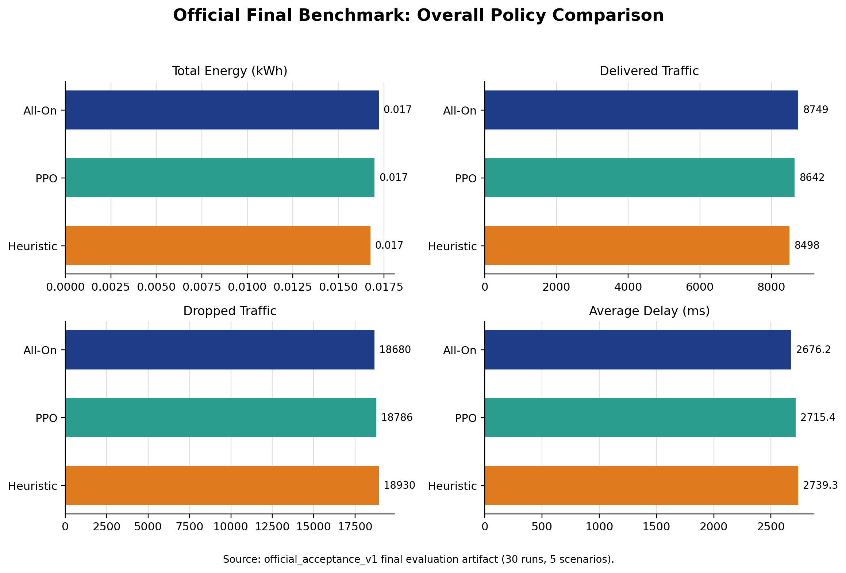
Figure 1. Official final benchmark comparison of All-On, PPO, and Heuristic policies across total energy, delivered traffic, dropped traffic, and average delay.
As shown in Figure 1, the final benchmark does not justify an exaggerated success claim. PPO is the strongest AI policy in the official comparison because it preserves acceptable QoS while reducing total energy by 1.33% relative to All-On, but it does not achieve the full thesis hypothesis. Delivered traffic is 1.22% lower than All-On, dropped traffic is 0.57% higher, and average delay is 1.47% higher. This figure therefore anchors the thesis in the real benchmark conclusion rather than in selected favorable examples.
Figure 2 focuses on the strongest real PPO-positive case from the official benchmark: the flash-crowd scenario.
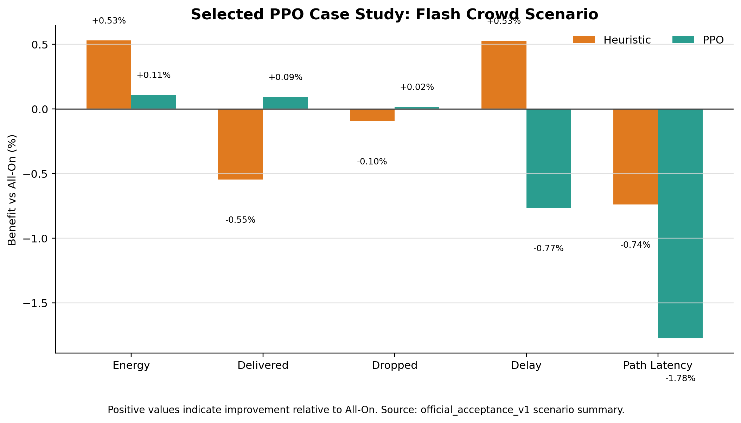
Figure 2. Flash-crowd case study showing policy benefit relative to All-On for energy, delivered traffic, dropped traffic, delay, and path latency.
Figure 2 is included because it is the cleanest scenario-level example in which PPO produces a genuine positive trade-off. In flash-crowd traffic, PPO slightly improves delivered traffic and slightly reduces dropped traffic relative to All-On while remaining within the same official evaluation framework. The effect is modest rather than dramatic, which makes it suitable as a disciplined case study rather than as a replacement for the final benchmark conclusion.
The relationship between Figures 1 and 2 is important for the thesis narrative. Figure 1 provides the official final result across the whole benchmark, while Figure 2 isolates one real scenario in which PPO demonstrates practical potential. This distinction keeps the argument honest: PPO shows selected strengths, but those strengths do not overturn the broader benchmark verdict.

Reproducibility and Validation
Alongside comparative results, GreenNet also needs to demonstrate that its evaluation workflow is traceable and criteria-driven. For this reason, the thesis retains the acceptance-threshold evidence in the main body and moves narrower validation artifacts to the appendix.
Figure 3 is retained in the methodology and validation narrative because it makes the acceptance logic explicit.
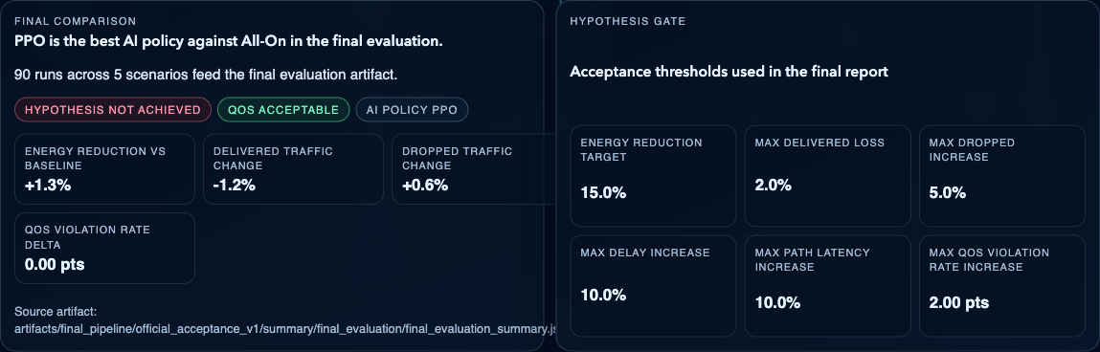
Figure 3. Official benchmark summary and acceptance thresholds used to judge hypothesis success in GreenNet.
This figure is academically important because it shows that GreenNet judges policies against predefined quantitative thresholds rather than by informal visual preference. It also makes the negative result visible: the final hypothesis is not achieved even though PPO remains QoS-acceptable. Keeping this threshold figure in the main body strengthens the rigor of the evaluation chapter and clarifies why a modest energy gain is not enough to claim full success.

Implementation
For the implementation chapter, only one visual figure is kept. The simulator topology playback is clearer and easier to defend than a crowded dashboard overview because it connects system design to observable execution without forcing the thesis to justify too many run-specific widgets at once.
Figure 4 is retained as the main implementation figure because it shows GreenNet in active operation rather than as a static interface view.
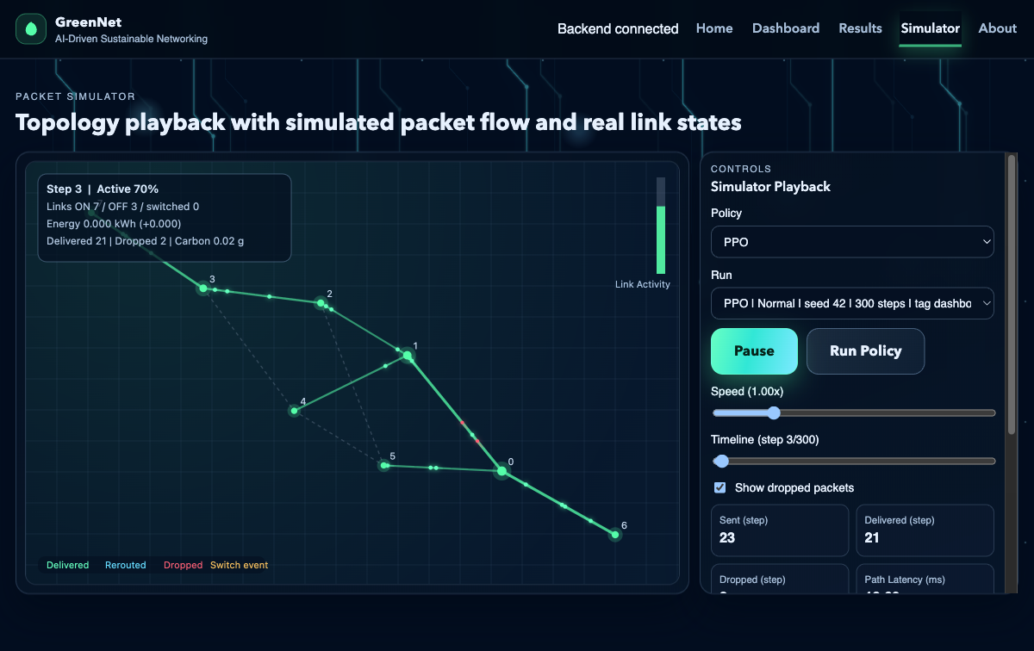
Figure 4. Simulator topology playback with packet-flow and link-state visualization during an active run.
As shown in Figure 4, the simulator makes packet flow, active links, and link-state changes visible during runtime. This strengthens the implementation chapter by demonstrating that GreenNet includes an inspectable execution layer through which policy behavior can be observed step by step. It is therefore more useful to the thesis than a crowded dashboard screenshot that would require heavier explanation to interpret correctly.
The denser dashboard overview, live comparison table, and historical validation screenshots are not used as central results figures. They remain useful as supporting evidence, but they are placed outside the main argumentative flow so that the thesis reads as a comparative research document rather than as a product-demo walkthrough.

Appendix: Supporting Figures
The appendix retains real but non-central evidence that supports reproducibility, traceability, and broader interpretation without overloading the main thesis narrative.
Appendix Figure A1 documents the locked validation bundles used to store scenario-specific acceptance results under fixed constraints.
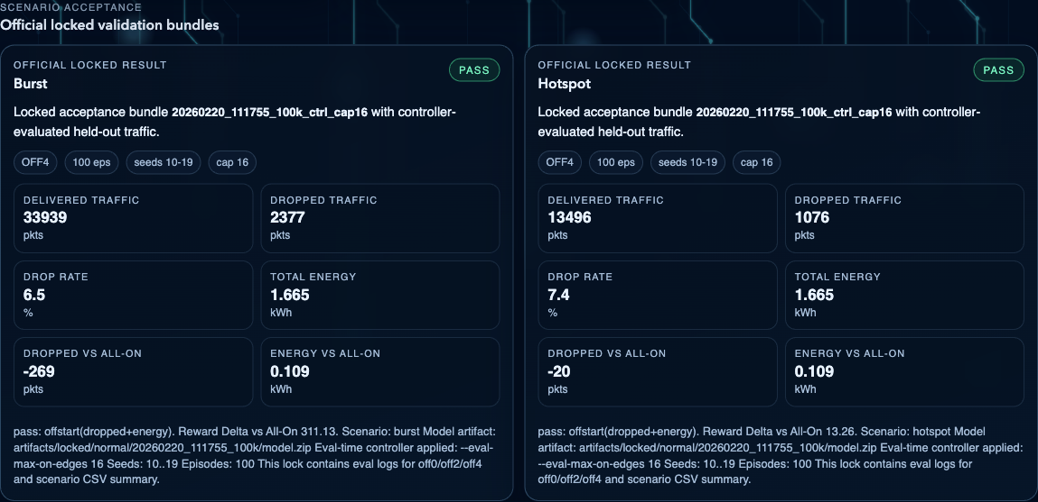
Appendix Figure A1. Official locked validation bundles used to document scenario-specific acceptance results and reproducibility settings.
Appendix Figure A1 is useful because it preserves the chain of evidence behind GreenNet's evaluation workflow. It shows that important held-out validations were stored as traceable bundles with explicit seeds, episode counts, and controller settings. However, because these bundles reflect a narrower validation context than the final benchmark, they are treated as supporting evidence rather than as central thesis results.
Appendix Figure A2 provides a compact scenario-by-scenario view of how PPO changes energy use and delivered traffic relative to All-On in the official final benchmark.
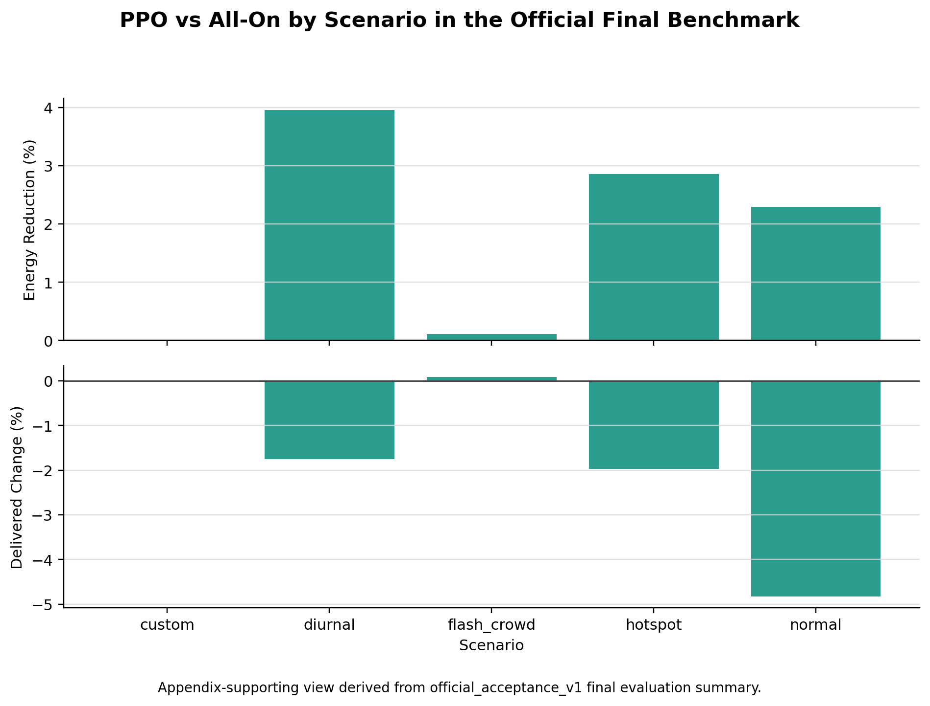
Appendix Figure A2. Scenario-by-scenario PPO trade-off relative to All-On in the official final benchmark.
Appendix Figure A2 is intentionally placed outside the main body because it is analytically useful but more detailed than necessary for the primary thesis narrative. It helps the reader see that PPO's strongest scenario-level case is flash-crowd, that diurnal and hotspot are better interpreted as compromise-policy cases, and that the normal scenario remains a negative result.

