**Nume: Oltean**

**Prenume**: David-Leon

**E-mail: Oltean.Io.David@student.utcluj.ro**

**Poza**:

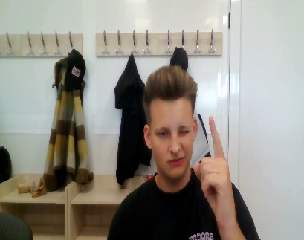

**Asteptari legate de educatie**:

* Sa se explice si pentru incepatori pentru a avea o sansa

**Discipline**: <https://etti.utcluj.ro/fise-discipline/articles/ea-ro.html>

|  |  |  |
| --- | --- | --- |
| Disciplina | An | Link |
| Informatica Aplicata | 1 | https://etti.utcluj.ro/files/Acasa/Site/FiseDisciplina/EaRo/06.pdf |
| Sport | 1 | https://etti.utcluj.ro/files/Acasa/Site/FiseDisciplina/EaRo/07.pdf |
| Tehnici cad | 2 | https://etti.utcluj.ro/files/Acasa/Site/FiseDisciplina/EaRo/28.pdf |
| Tehnologii web | 3 | https://etti.utcluj.ro/files/Acasa/Site/FiseDisciplina/EaRo/35.pdf |
| Televiziune | 4 | https://etti.utcluj.ro/files/Acasa/Site/FiseDisciplina/EaRo/45.pdf |

**Hobby-uri**:

* DJ-evenimente private/club NUNTI INMORMANTARI CUMETRII BOTEZURI MAJORATE DISCOTECI
* TEHNICIAN DE SCENA (MONTARE DEMONTARE ECHIPAMENTE PROFESIONALE (schele de lumini scene , sisteme de sunet
* Creeare muzica (mixmaster)

**Elemente HTML:**

**<h1><h2>…<h6>**



**<p>**

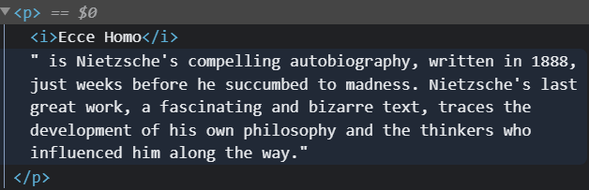

**<table>**

**<ul> sau <ol>**

**<img>**

**<div>**

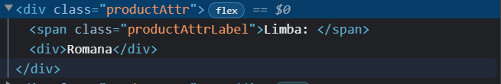

**<br>**



**Observatie**: imaginea utilizată în secțiunea ”Poza” a fost generată utilizând [https://generated.photos/humans/romanian-race#](https://generated.photos/humans/romanian-race) și nu aparține unei persoane reale.

**HTML Tutorial:** <https://www.w3schools.com/html/html_elements.asp>

**HTML Editor:** <https://www.w3schools.com/html/tryit.asp?filename=tryhtml_default>