Testfälle HotelExporter

Inhalt

Testfälle HotelExporter 1

Kurzverzeichnis der Beispiele 4

Beispiel 1: LAS-BELLAG-A1-RO 5

Gratisnacht 5

Antwort 7

Beispiel 2: MRU-LUXGAU-D2-HB 9

Gratisnächte und Early Bird Specials 9

Antwort 11

Beispiel 3: LAS-PARIS-A2-RO 12

Mehrere Specials mit Special Offers 12

Antwort 15

Beispiel 4: MCT-INTCON-A3-BB 18

Early Bird Ermässigung 18

Antwort 18

Beispiel 5: PRI-LEREPA-A2-BB 20

Gratisnächte mit Kinder gratis 20

Antwort 20

Beispiel 6: PRI-LEREPA-B2-BB 25

Gratisnächte mit Kinderpreisen 25

Antwort 25

Beispiel 7: KBV-LAYANA-B2-BB 28

Einmalige Zuschläge 28

Antwort 28

Beispiel 8: HKT-BANTRE-F3-BB 31

Special Offers und Early Booking Discount 31

Antwort 32

Beispiel 9: HKT-BANTRE-F2-BB 34

Special Offers und Early Booking Discount und Kinderfestpreise 34

Antwort 34

Beispiel 10: MLE-SIXLAA-B2-HB 37

Gratisnächte, EarlyBooking, Tageszuschläge, Einmalige Zuschläge, Kinderfestpreise 37

Antwort 38

|  |  |  |
| --- | --- | --- |
| Version | ModBy | Beschreibung |
| 1.5 | rb/mk | * Ergänzung aller Beispiele mit dem RevolvingGroup node in SpecialOffer XML Beispiele * Alle XMLs überprüft und auf 2016 geändert * Formatierung im Dokument angepasst um einheitlicher zu wirken |
| 1.5.1 | rb | * Zusätzliche SQL Formatierung * Überprüfung von Beispiel 10 SpecialOffer XML mit RevolvingGroup |

# Kurzverzeichnis der Beispiele

|  |  |  |  |
| --- | --- | --- | --- |
| Beispiel 1: LAS-BELLAG-A1-RO | 22JAN2016 | 5 Nächte | 1ADT  0 CHD |
| Beispiel 2: MRU-LUXGAU-D2-HB | 03OCT2016 | 9 Nächte | 2 ADT  0 CHD |
| Beispiel 3: LAS-PARIS-A2-RO | 13MAR2016 | 18 Nächte | 2 ADT  0 CHD |
| Beispiel 4: MCT-INTCON-A3-BB | 27AUG2016 | 7 Nächte | 3 ADT  0 CHD |
| Beispiel 5: PRI-LEREPA-A2-BB | 07JUL2016 | 10 Nächte | 2 ADT  2 CHD   1. '2011-04-25' 2. '2007-04-25' |
| Beispiel 6: PRI-LEREPA-B2-BB | 01JUL2016 | 5 Nächte | 2 ADT  1 CHD   1. '2011-04-25' |
| Beispiel 7: KBV-LAYANA-B2-BB | 26DEC2016 | 10 Nächte | 2 ADT  0 CHD |
| Beispiel 8: HKT-BANTRE-F3-BB | 05MAY2016 | 7 Nächte | 3 ADT  0 CHD |
| Beispiel 9: HKT-BANTRE-F2-BB | 13MAYJAN2016 | 8 Nächte | 2 ADT  1 CHD   1. '2011-04-25' |
| Beispiel 10: MLE-SIXLAA-B2-HB | 24JUN2016 | 8 Nächte | 2 ADT  2 CHD   1. '2007-04-25' 2. '2007-04-25' |

# Beispiel 1: LAS-BELLAG-A1-RO

RoomKey: TUIXYA213233

HotelKey: TUIXYZ11984

RoomCode: A1

MealCode: RO

## Gratisnacht

RoomKey: TUIXYA213233  
1x adult, 0x child  
PerDayPrices nur bis 31.03. verfügbar. Booking Periode kann nicht nach hinten geschoben werden!

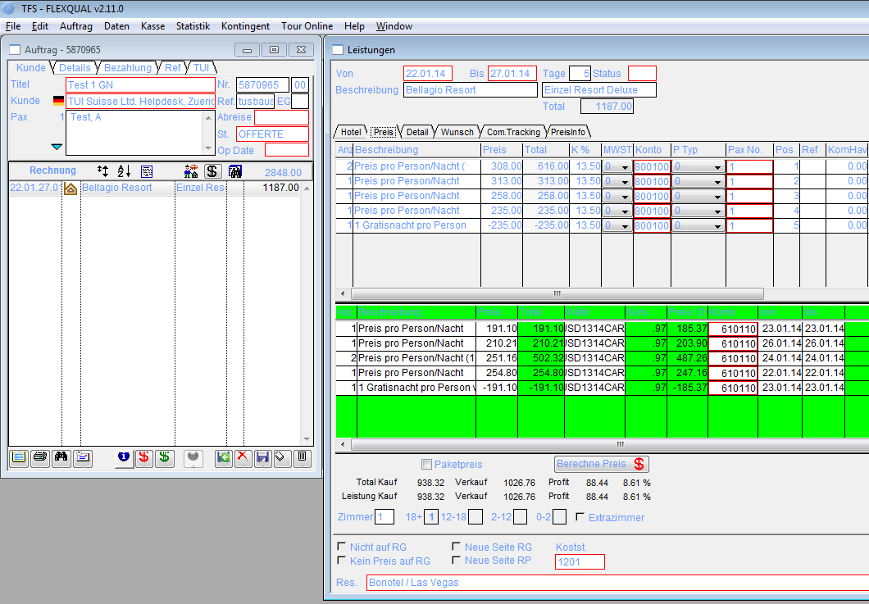

22.01 – 27.1, PerDayPrice + SpecialOffer 6/5

<PerDayPrice Day="2016-01-22"

Price="313.00"

DescId="1" />

<PerDayPrice Day="2016-01-23"

Price="235.00"

DescId="1" />

<PerDayPrice Day="2016-01-24"

Price="308.00"

DescId="1" />

<PerDayPrice Day="2016-01-25"

Price="308.00"

DescId="1" />

<PerDayPrice Day="2016-01-26"

Price="258.00"

DescId="1" />

<PerDayPrice Day="2016-01-27"

Price="258.00"

DescId="1" />

<SpecialOffers>

<SpecialOffer Baby="0"

Days="5"

Type="MinValue"

Child="0"

DateTo="2016-03-31"

DescId="2"

DateFrom="2016-01-10"

RuleType="Nr"

AddAmount="0.00"

DayString="5"

PayNights="4"

ToDayBase="5"

FromDayBase="5"

ChildAdultNr="0"

ChildChildNr="0"

RevolvingGroup="1"

EndDateRelevant="1"

LastSpOffEndDate="2016-03-31"

StartDateRelevant="0"

DaysBeforeDepartureTo="1"

DaysBeforeDepartureFrom="999" />

<SpecialOffer Baby="0"

Days="10"

Type="MinValue"

Child="0"

DateTo="2016-03-31"

DescId="2"

DateFrom="2016-01-10"

RuleType="Nr"

AddAmount="0.00"

DayString="5,5"

PayNights="4"

ToDayBase="5"

FromDayBase="5"

ChildAdultNr="0"

ChildChildNr="0"

RevolvingGroup="1"

EndDateRelevant="1"

LastSpOffEndDate="2016-03-31"

StartDateRelevant="0"

DaysBeforeDepartureTo="1"

DaysBeforeDepartureFrom="999" />

</SpecialOffers>

## Antwort

Zum ersten Beispiel: das XML exportiert nur Preise in Zukunft, nicht in der Vergangenheit, daher, wenn Roland die Beispiele erst am 23. Januar euch hat zukommen lassen, könnte dies das Fehlen der Daten erklären. Roland soll euch (aber dies habe ich Roland mehrfach auch explizit gesagt) Beispiele weit genug in Zukunft erstellen damit diese Art von Problem der fehlenden Daten nicht auftritt.

Bedenkt, Preise sind Übernachtungspreise, daher ist im ersten Beispiel vom 22. Januar bis zum 27 Januar folgende Preise gültig:

<PerDayPrice Day="2016-01-22"

Price="313.00"

DescId="1" />

<PerDayPrice Day="2016-01-23"

Price="235.00"

DescId="1" />

<PerDayPrice Day="2016-01-24"

Price="308.00"

DescId="1" />

<PerDayPrice Day="2016-01-25"

Price="308.00"

DescId="1" />

<PerDayPrice Day="2016-01-26"

Price="258.00"

DescId="1" />

Somit kommt man auf

1*313=313  
1*235=235  
2*308=616  
1*258=258

--------------------  
= 1422

Hier die SpecialOffers

<SpecialOffers>

<SpecialOffer Baby="0"

Days="5"

Type="MinValue"

Child="0"

DateTo="2016-03-31"

DescId="2"

DateFrom="2016-01-10"

RuleType="Nr"

AddAmount="0.00"

DayString="5"

PayNights="4"

ToDayBase="5"

FromDayBase="5"

ChildAdultNr="0"

ChildChildNr="0"

RevolvingGroup="1"

EndDateRelevant="1"

LastSpOffEndDate="2016-03-31"

StartDateRelevant="0"

DaysBeforeDepartureTo="1"

DaysBeforeDepartureFrom="999" />

<SpecialOffer Baby="0"

Days="10"

Type="MinValue"

Child="0"

DateTo="2016-03-31"

DescId="2"

DateFrom="2016-01-10"

RuleType="Nr"

AddAmount="0.00"

DayString="5,5"

PayNights="4"

ToDayBase="5"

FromDayBase="5"

ChildAdultNr="0"

ChildChildNr="0"

RevolvingGroup="1"

EndDateRelevant="1"

LastSpOffEndDate="2016-03-31"

StartDateRelevant="0"

DaysBeforeDepartureTo="1"

DaysBeforeDepartureFrom="999" />

</SpecialOffers>

MinValue = 235  
1422 - 235 = 1187

**Berechnung in der SP ist OK.**

Das Wichtigste habe ich oben markiert. Dieses Special ist ein Revolving Special, d.h. es gilt das gleiche Special für 5 Übernachtungen wie auch für 10 Übernachtungen. Damit Ihr es einfacher habt beim Filtern nehmen wir die Revolving Specials auseinander und liefern euch diese mehrfach für die jeweilige Anzahl „Days“ für dessen Periode dieses Special gültig ist. Die grösste Anzahl „Days“ welche in ein Buchungszeitraum passen sollten als Special genutzt werden. Da der Reisende hier nur 5 Nächte bleibt gilt die erste Regel. Wäre der Reisende 10 Nächte oder mehr geblieben, dann würde die zweite Regel gelten. Dies erlaubt es euch eine Liste der Specials zu machen, diese nach Days absteigend zu sortieren und die erste Regel zu nehmen die in das Buchungszeitraum passt ohne irgendwelche komplexen Regeln anzuwenden. Der „DayString“ erlaubt es euch bei einem Revolving Special die Tagespreise so zu gruppieren dass Ihr die korrekten Tage nehmen könnt die Special-Relevant sind. Im Beispiel oben, wenn der Reisende 10 Nächte bleiben würde, dann wäre der DayString="5,5" und Ihr müsstet die 10 Tage in zwei Gruppen @ 5 Nächte aufteilen und für die ersten 5 Nächte den richtigen Special-Tag nehmen und dann die nächten 5 Nächte nehmen und die richten Tage filtern die Special-Relevant sind.

Martin hat hier die Regeln für ein Special ziemlich detailliert dokumentiert, aber ich kann verstehen, dass dies auf den ersten Blick etwas überwältigend ist. Hoffentlich wird es mit den Beispielen klarer.

# Beispiel 2: MRU-LUXGAU-D2-HB

RoomKey: TUIXYA192344

HotelKey: TUIXYA43840

RoomCode: D2

MealCode: HB

## Gratisnächte und Early Bird Specials

RoomKey: TUIXYA192344  
2x adult, 0x child

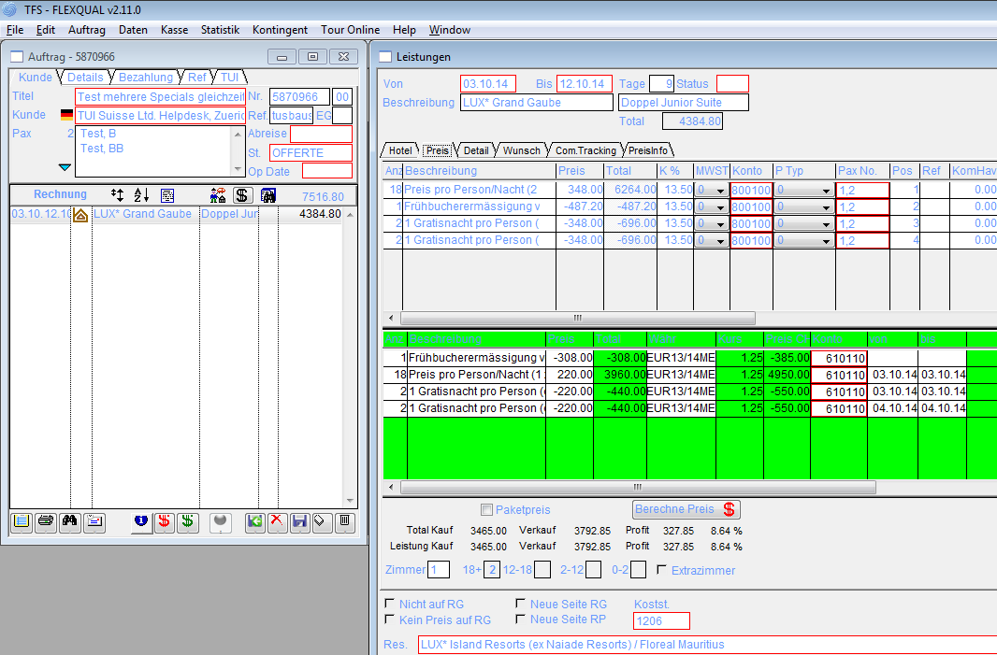

18*348 – (4 * 348) - 10% = 4384.80 OK

<EarlyBookings>

<EarlyBooking ToDay="0"

DateTo="2016-10-31"

DescId="5"

FromDay="0"

Percent="-10.00"

DateFrom="2016-10-01"

AddAmount="0.00"

EndDateRelevant="0"

StartDateRelevant="0"

DaysBeforeDepartureTo="1"

DaysBeforeDepartureFrom="999" />

</EarlyBookings>

<SpecialOffer Baby="0"

Days="7"

Type="MinValue"

Child="0"

DateTo="2016-10-31"

DescId="4"

DateFrom="2016-10-01"

RuleType="Always"

AddAmount="0.00"

DayString="7"

PayNights="5"

ToDayBase="7"

FromDayBase="7"

ChildAdultNr="0"

ChildChildNr="0"

RevolvingGroup="2"

EndDateRelevant="0"

LastSpOffEndDate="2016-10-31"

StartDateRelevant="0"

DaysBeforeDepartureTo="0"

DaysBeforeDepartureFrom="0" />

18*348 = 6264

<PerDayPrice Day="2016-10-03"

Price="348.00"

DescId="1" />

<PerDayPrice Day="2016-10-04"

Price="348.00"

DescId="1" />

<PerDayPrice Day="2016-10-05"

Price="348.00"

DescId="1" />

<PerDayPrice Day="2016-10-06"

Price="348.00"

DescId="1" />

<PerDayPrice Day="2016-10-07"

Price="348.00"

DescId="1" />

<PerDayPrice Day="2016-10-08"

Price="348.00"

DescId="1" />

<PerDayPrice Day="2016-10-09"

Price="348.00"

DescId="1" />

<PerDayPrice Day="2016-10-10"

Price="348.00"

DescId="1" />

<PerDayPrice Day="2016-10-11"

Price="348.00"

DescId="1" />

## ***Antwort***

Dies wäre der richtige Special Offer:

<SpecialOffer Baby="0"

Days="7"

Type="MinValue"

Child="0"

DateTo="2016-10-31"

DescId="4"

DateFrom="2016-10-01"

RuleType="Always"

AddAmount="0.00"

DayString="7"

PayNights="5"

ToDayBase="7"

FromDayBase="7"

ChildAdultNr="0"

ChildChildNr="0"

RevolvingGroup="2"

EndDateRelevant="0"

LastSpOffEndDate="2016-10-31"

StartDateRelevant="0"

DaysBeforeDepartureTo="0"

DaysBeforeDepartureFrom="0" />

Von 7 Nächten müssen nur 5 bezahlt werden => 2 Nächte gratis pro Person.  
18*348 – (4 * 348) = 4872  
EarlyBooking (-10%):  
4872 - 487.20 = 4384.80 (2192.40 pro Person)

**Berechnung in der SP ist OK.**

# Beispiel 3: LAS-PARIS-A2-RO

RoomKey: TUIXYA225404

HotelKey: TUIXYA46628

RoomCode: A2

MealCode: RO

## Mehrere Specials mit Special Offers

RoomKey: TUIXYA225404  
2x adult, 0x child  
PerDayPrices nur bis 31.03. verfügbar. Booking Periode kann nicht nach hinten geschoben werden!

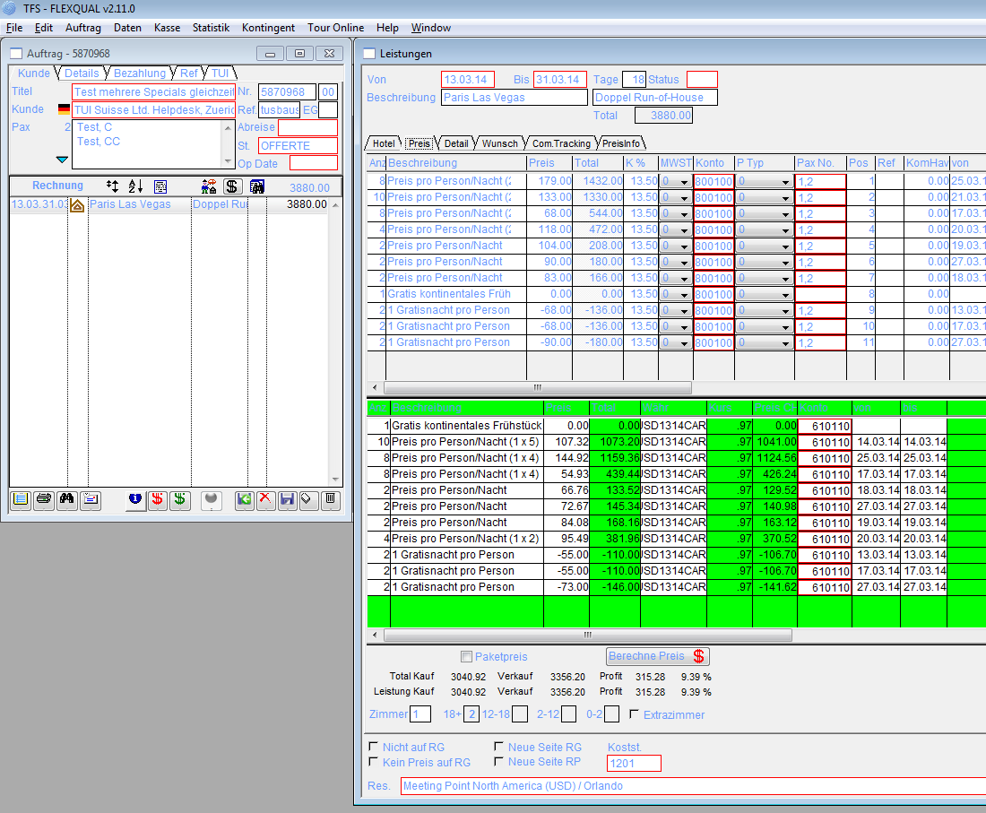

Original Bild siehe Erklärung zu falschem Preis!!!!

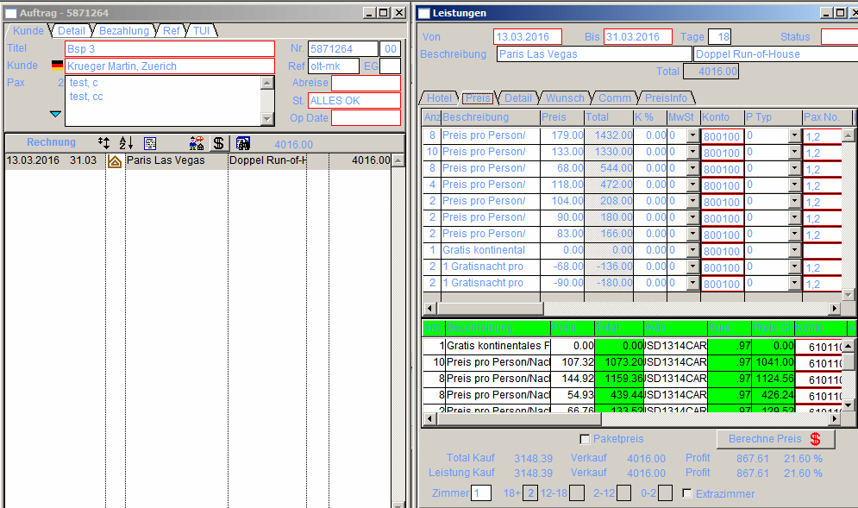

Habe das Bild nach der korrigierten Berechnung der SP neu angepasst!!!! Siehe erklärung unten zu original Bild

<PerDayPrice Day="2016-03-13"

Price="68.00"

DescId="1" />

<PerDayPrice Day="2016-03-14"

Price="133.00"

DescId="1" />

<PerDayPrice Day="2016-03-15"

Price="133.00"

DescId="1" />

<PerDayPrice Day="2016-03-16"

Price="68.00"

DescId="1" />

<PerDayPrice Day="2016-03-17"

Price="68.00"

DescId="1" />

<PerDayPrice Day="2016-03-18"

Price="83.00"

DescId="1" />

<PerDayPrice Day="2016-03-19"

Price="104.00"

DescId="1" />

<PerDayPrice Day="2016-03-20"

Price="118.00"

DescId="1" />

<PerDayPrice Day="2016-03-21"

Price="133.00"

DescId="1" />

<PerDayPrice Day="2016-03-22"

Price="179.00"

DescId="1" />

<PerDayPrice Day="2016-03-23"

Price="179.00"

DescId="1" />

<PerDayPrice Day="2016-03-24"

Price="179.00"

DescId="1" />

<PerDayPrice Day="2016-03-25"

Price="179.00"

DescId="1" />

<PerDayPrice Day="2016-03-26"

Price="118.00"

DescId="1" />

<PerDayPrice Day="2016-03-27"

Price="90.00"

DescId="1" />

<PerDayPrice Day="2016-03-28"

Price="133.00"

DescId="1" />

<PerDayPrice Day="2016-03-29"

Price="133.00"

DescId="1" />

<PerDayPrice Day="2016-03-30"

Price="68.00"

DescId="1" />

Grund preis : 4332 (2116 pro Person)

Abzuegl. Special ?? welche gilt hier ?  
Es gelten beide Specials mit Dauer von 12 Tage.

<SpecialOffer Baby="0"

Days="12"

Type="MinValue"

Child="0"

DateTo="2016-03-31"

DescId="2"

DateFrom="2016-03-26"

RuleType="Nr"

AddAmount="0.00"

DayString="4,4,4"

PayNights="3"

ToDayBase="4"

FromDayBase="4"

ChildAdultNr="0"

ChildChildNr="0"

RevolvingGroup="1"

EndDateRelevant="0"

LastSpOffEndDate="2016-03-31"

StartDateRelevant="0"

DaysBeforeDepartureTo="1"

DaysBeforeDepartureFrom="999" />

## Antwort

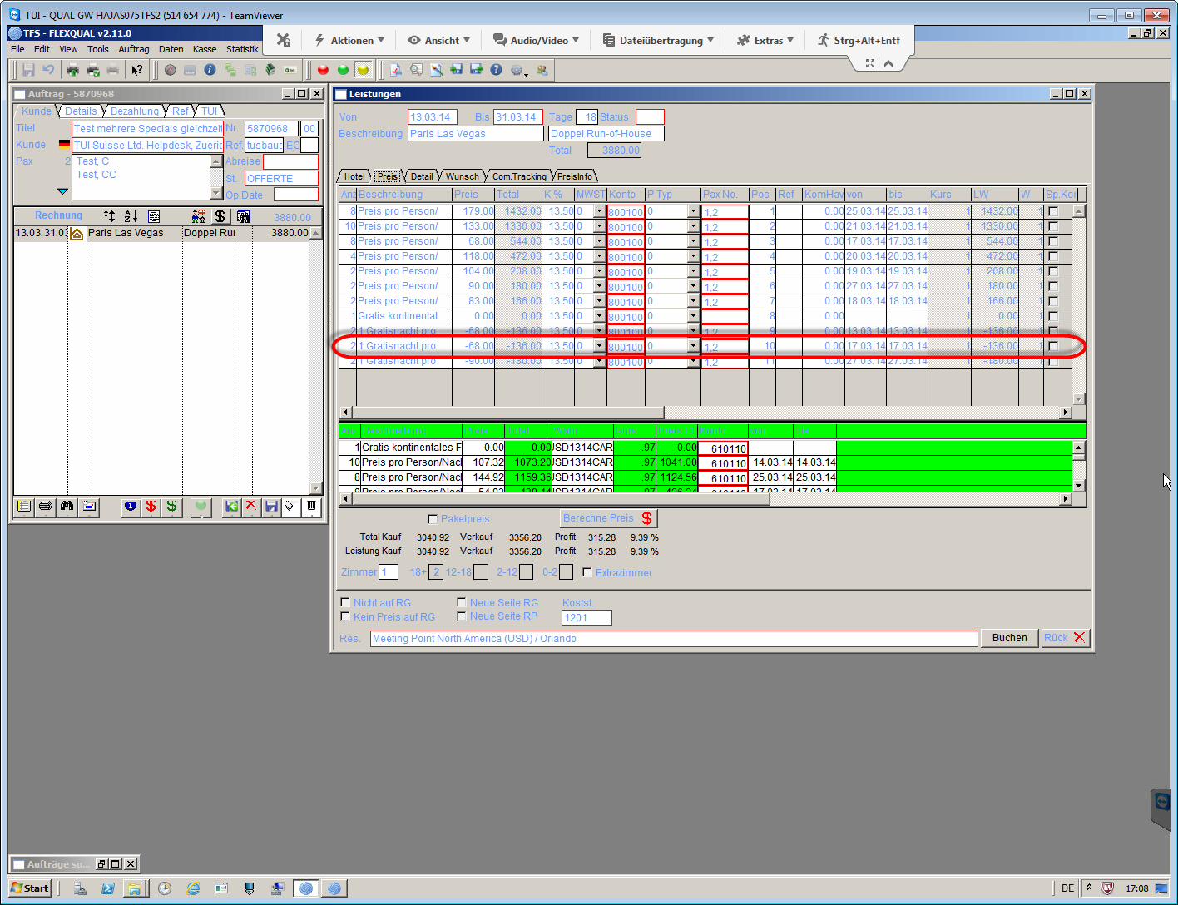

Die markierte Zeile wurde von uns falsch berechnet. Der Spezial Offer geht nur bis zum 18.3.

<SpecialOffer Baby="0"

Days="4"

Type="MinValue"

Child="0"

DateTo="2016-03-18"

DescId="2"

DateFrom="2016-03-07"

RuleType="Nr"

AddAmount="0.00"

DayString="4"

PayNights="3"

ToDayBase="4"

FromDayBase="4"

ChildAdultNr="0"

ChildChildNr="0"

RevolvingGroup="2"

EndDateRelevant="0"

LastSpOffEndDate="2016-03-18"

StartDateRelevant="0"

DaysBeforeDepartureTo="1"

DaysBeforeDepartureFrom="999" />

Das heisst wir haben einen SpecialOffer vom 13.03 bis 16.03

Einen weiteren haben wir vom 26.03 bis 31.03.

<SpecialOffer Baby="0"

Days="4"

Type="MinValue"

Child="0"

DateTo="2016-03-31"

DescId="2"

DateFrom="2016-03-26"

RuleType="Nr"

AddAmount="0.00"

DayString="4"

PayNights="3"

ToDayBase="4"

FromDayBase="4"

ChildAdultNr="0"

ChildChildNr="0"

RevolvingGroup="1"

EndDateRelevant="0"

LastSpOffEndDate="2016-03-31"

StartDateRelevant="0"

DaysBeforeDepartureTo="1"

DaysBeforeDepartureFrom="999" />

Grund preis : 4332 (2166 pro Person)

Abzügl. Zwei Gratisnächte: 2166 - 68 - 90 = 2008 pro Person (4016 gesamt)

-- calculte price of free nights  
db2 "select sum(minprice) as SpecialOffer from (select min(pp) as minprice, min(dd) as day from( \

select (dp.price) as pp, dp.day as dd, so.dateto as dt, so.datefrom df \

from tfsperdayprice dp, tfsspecialoffers so where (dp.day >= so.datefrom and dp.day <= so.dateto and \

date(dp.day + ((fromdaybase / 2) + (mod(fromdaybase,2))) DAY) between so.datefrom and so.dateto) \

and (dp.day between '2016-03-13' and '2016-03-31') and dp.roomkey = 'TUIXYA225404' and dp.roomkey = so.roomkey and so.days in \

(select min(days) as dd from tfsspecialoffers where days <= (select days('2016-03-31')-days('2016-03-13') from sysibm.sysdummy1) \

and roomkey = 'TUIXYA225404')) t group by dt, df) as t"

select **sum**(minprice) as SpecialOffer   
from   (select **min**(pp) as minprice,   
               **min**(dd) as day   
        from  (  select ( dp.price ) as pp,   
                       dp.day       as dd,   
                       so.dateto    as dt,   
                       so.datefrom  df    
               from   tfsperdayprice dp,   
                      tfsspecialoffers so   
               where  ( dp.day >= so.datefrom   
                        and dp.day <= so.dateto   
                        and   **date**(dp.day + ( ( fromdaybase / 2 ) + (   
                                             **mod**(fromdaybase, 2) ) )   
                                           day)   
                             between   
                             so.datefrom and so.dateto )    
                      and ( dp.day between '2016-03-13' and '2016-03-31' )   
                      and dp.roomkey = 'TUIXYA225404'   
                      and dp.roomkey = so.roomkey   
                      and so.days in   (select **min**(days) as dd   
                                       from   tfsspecialoffers   
                                       where  days <= (select **days**('2016-03-31')   
                                                              - **days**   
                                                              (   
                                                              '2016-03-13')   
                                                       from   sysibm.sysdummy1)    
                                              and roomkey = 'TUIXYA225404')) t   
        group  by dt,   
                  df) as t

SPECIALOFFER  
---------------------------------  
 158.00

**Obige Berechnung muss für die anderen Beispiele getestet werden und in SP eingebaut werden.**

# Beispiel 4: MCT-INTCON-A3-BB

RoomKey: TUIXYZ52136

HotelKey: TUIXYZ21604

RoomCode: A3

MealCode: BB

## Early Bird Ermässigung

RoomKey: TUIXYZ52136  
3x adult, 0x child

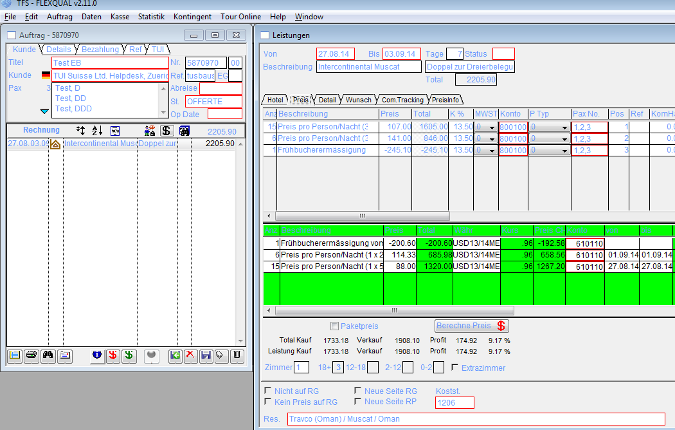

## Antwort

<PerDayPrice Day="2016-08-27"

Price="107.00"

DescId="1" />

<PerDayPrice Day="2016-08-28"

Price="107.00"

DescId="1" />

<PerDayPrice Day="2016-08-29"

Price="107.00"

DescId="1" />

<PerDayPrice Day="2016-08-30"

Price="107.00"

DescId="1" />

<PerDayPrice Day="2016-08-31"

Price="107.00"

DescId="1" />

<PerDayPrice Day="2016-09-01"

Price="141.00"

DescId="1" />

<PerDayPrice Day="2016-09-02"

Price="141.00"

DescId="1" />

15 x 107.—

6 x 141.—

= 2451 (817 pro Person)

<EarlyBookings>

<EarlyBooking ToDay="0"

DateTo="2016-10-31"

DescId="2"

FromDay="0"

Percent="-10.00"

DateFrom="2015-11-01"

AddAmount="0.00"

EndDateRelevant="0"

StartDateRelevant="0"

DaysBeforeDepartureTo="45"

DaysBeforeDepartureFrom="999" />

</EarlyBookings>

-10% von 2451.—

= 2205.90 (735.30 pro Person)

**Berechnung in der SP ist OK.**

# Beispiel 5: PRI-LEREPA-A2-BB

RoomKey: TUIXYA226264

HotelKey: TUIXYA45542

RoomCode: A2

MealCode: BB

## Gratisnächte mit Kinder gratis

RoomKey: TUIXYA226264  
2x adult, 2x child, birth-1: '2011-04-25', birth-2: '2007-04-25'

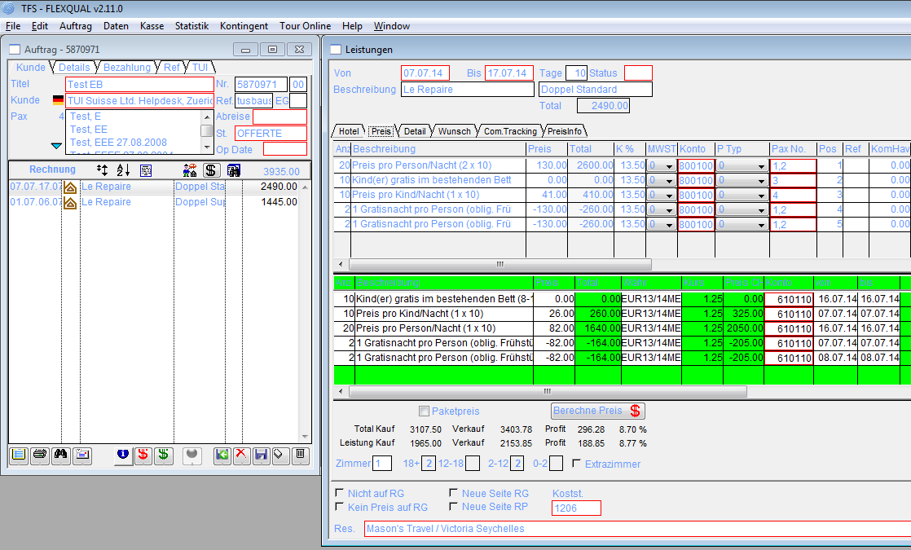

## Antwort

Fall 1 erstes Hotel:

<PerDayPrice Day="2016-07-07"

Price="130.00"

DescId="1" />

<PerDayPrice Day="2016-07-08"

Price="130.00"

DescId="1" />

<PerDayPrice Day="2016-07-09"

Price="130.00"

DescId="1" />

<PerDayPrice Day="2016-07-10"

Price="130.00"

DescId="1" />

<PerDayPrice Day="2016-07-11"

Price="130.00"

DescId="1" />

<PerDayPrice Day="2016-07-12"

Price="130.00"

DescId="1" />

<PerDayPrice Day="2016-07-13"

Price="130.00"

DescId="1" />

<PerDayPrice Day="2016-07-14"

Price="130.00"

DescId="1" />

<PerDayPrice Day="2016-07-15"

Price="130.00"

DescId="1" />

<PerDayPrice Day="2016-07-16"

Price="130.00"

DescId="1" />

Preis für Erwachsene: 2600 (1300 pro Person)

db2 "SELECT sum(price) as P from tfsperdayprice where roomkey = 'TUIXYA226264' and day >= '2016-07-07' \ and day < '2016-07-17' and childidxnr = 0 "

select **sum**(price) as P   
from   tfsperdayprice   
where  roomkey = 'TUIXYA226264'   
       and day >= '2016-07-07'    
       and day < '2016-07-17'   
       and childidxnr = 0

Erstes Kind 5 Jahre

<PerDayPrice Day="2016-07-07"

AgeTo="2"

Price="0.00"

DescId="2"

AgeFrom="0"

ChildIdxNr="1" />

<PerDayPrice Day="2016-07-07"

AgeTo="8"

Price="0.00"

DescId="4"

AgeFrom="3"

ChildIdxNr="1" />

<PerDayPrice Day="2016-07-08"

AgeTo="8"

Price="0.00"

DescId="4"

AgeFrom="3"

ChildIdxNr="1" />

<PerDayPrice Day="2016-07-09"

AgeTo="8"

Price="0.00"

DescId="4"

AgeFrom="3"

ChildIdxNr="1" />

<PerDayPrice Day="2016-07-10"

AgeTo="8"

Price="0.00"

DescId="4"

AgeFrom="3"

ChildIdxNr="1" />

<PerDayPrice Day="2016-07-11"

AgeTo="8"

Price="0.00"

DescId="4"

AgeFrom="3"

ChildIdxNr="1" />

<PerDayPrice Day="2016-07-12"

AgeTo="8"

Price="0.00"

DescId="4"

AgeFrom="3"

ChildIdxNr="1" />

<PerDayPrice Day="2016-07-13"

AgeTo="8"

Price="0.00"

DescId="4"

AgeFrom="3"

ChildIdxNr="1" />

<PerDayPrice Day="2016-07-14"

AgeTo="8"

Price="0.00"

DescId="4"

AgeFrom="3"

ChildIdxNr="1" />

<PerDayPrice Day="2016-07-15"

AgeTo="8"

Price="0.00"

DescId="4"

AgeFrom="3"

ChildIdxNr="1" />

<PerDayPrice Day="2016-07-16"

AgeTo="8"

Price="0.00"

DescId="4"

AgeFrom="3"

ChildIdxNr="1" />

Erstes Kind gratis (3-8 Jahre) 0.00

db2 "SELECT sum(price) as P from tfsperdayprice where roomkey = 'TUIXYA226264' and day >= '2016-07-07' \  
and day < '2016-07-17' and (select year('2016-03-31')-year('2011-04-25') as age from sysibm.sysdummy1) \  
between agefrom and ageto and childidxnr=1"

select **sum**(price) as P   
from   tfsperdayprice   
where  roomkey = 'TUIXYA226264'   
       and day >= '2016-07-07'    
       and day < '2016-07-17'   
       and (select **year**('2016-03-31') - **year**('2011-04-25') as age   
            from   sysibm.sysdummy1)   between agefrom and ageto   
       and childidxnr = 1

Zweites Kind 9 Jahre

<PerDayPrice Day="2016-07-08"

AgeTo="13"

Price="41.00"

DescId="5"

AgeFrom="8"

ChildIdxNr="2" />

<PerDayPrice Day="2016-07-09"

AgeTo="13"

Price="41.00"

DescId="5"

AgeFrom="8"

ChildIdxNr="2" />

<PerDayPrice Day="2016-07-10"

AgeTo="13"

Price="41.00"

DescId="5"

AgeFrom="8"

ChildIdxNr="2" />

<PerDayPrice Day="2016-07-11"

AgeTo="13"

Price="41.00"

DescId="5"

AgeFrom="8"

ChildIdxNr="2" />

<PerDayPrice Day="2016-07-12"

AgeTo="13"

Price="41.00"

DescId="5"

AgeFrom="8"

ChildIdxNr="2" />

<PerDayPrice Day="2016-07-13"

AgeTo="13"

Price="41.00"

DescId="5"

AgeFrom="8"

ChildIdxNr="2" />

<PerDayPrice Day="2016-07-14"

AgeTo="13"

Price="41.00"

DescId="5"

AgeFrom="8"

ChildIdxNr="2" />

<PerDayPrice Day="2016-07-15"

AgeTo="13"

Price="41.00"

DescId="5"

AgeFrom="8"

ChildIdxNr="2" />

<PerDayPrice Day="2016-07-16"

AgeTo="13"

Price="41.00"

DescId="5"

AgeFrom="8"

ChildIdxNr="2" />

Zweites Kind: 410

db2 "SELECT sum(price) as P from tfsperdayprice where roomkey = 'TUIXYA226264' and day >= '2016-07-07' \   
and day < '2016-07-17' and (select year('2016-03-31')-year('2007-04-25') as age from sysibm.sysdummy1) \  
between agefrom and ageto and childidxnr=2"

select **sum**(price) as P   
from   tfsperdayprice   
where  roomkey = 'TUIXYA226264'   
       and day >= '2016-07-07'    
       and day < '2016-07-17'   
       and (select **year**('2016-03-31') - **year**('2007-04-25') as age   
            from   sysibm.sysdummy1)   between agefrom and ageto   
       and childidxnr = 2

SpecialOffer

<SpecialOffer Baby="0"

Days="10"

Type="MinValue"

Child="0"

DateTo="2016-10-31"

DescId="6"

DateFrom="2015-11-01"

RuleType="Always"

AddAmount="0.00"

DayString="10"

PayNights="8"

ToDayBase="10"

FromDayBase="10"

ChildAdultNr="0"

ChildChildNr="0"

RevolvingGroup="2"

EndDateRelevant="0"

LastSpOffEndDate="2016-10-31"

StartDateRelevant="0"

DaysBeforeDepartureTo="0"

DaysBeforeDepartureFrom="0" />

Zwei Gratisnächte pro Person: 260 (520 gesamt)

Gesamtpreis: 2490

**Berechnung für Kinderpreise ist in SP eingebaut.**

**Berechnung in SP ist korrekt.**

# Beispiel 6: PRI-LEREPA-B2-BB

RoomKey: TUIXYA226278

HotelKey: TUIXYA45542

RoomCode: B2

MealCode: BB

## Gratisnächte mit Kinderpreisen

RoomKey: TUIXYA226278  
2x adult, 1x child, birth: '2011-04-25'

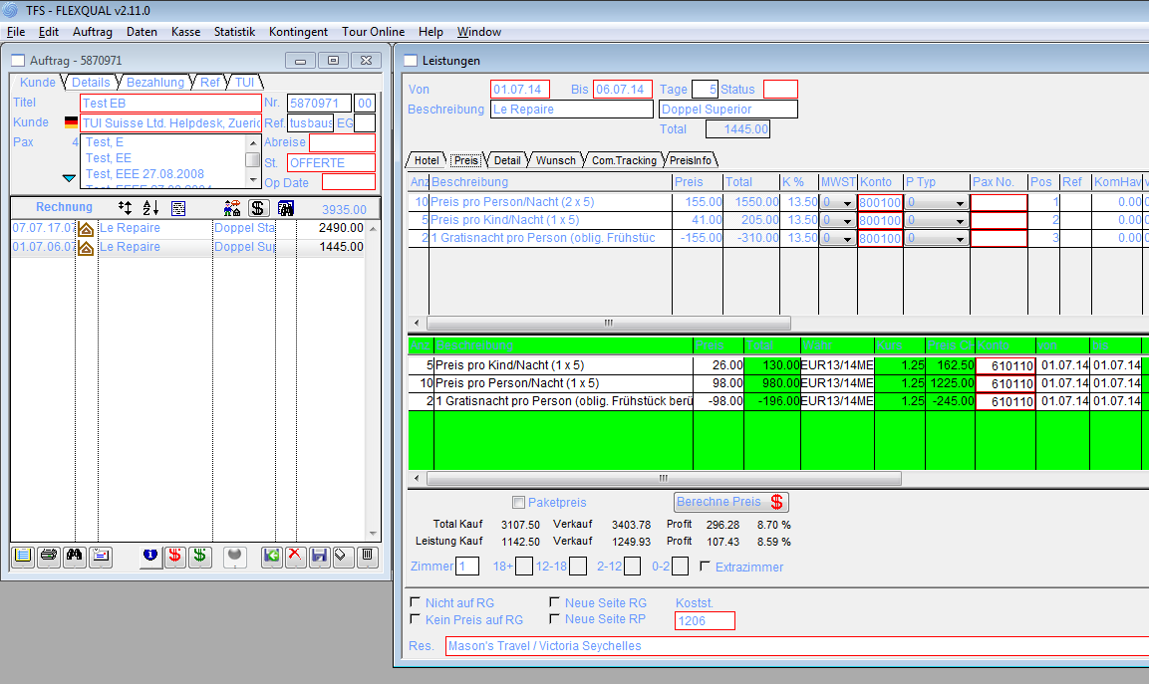

## Antwort

Fall 1 zweites Hotel:

<PerDayPrice Day="2016-07-01"

Price="155.00"

DescId="1" />

<PerDayPrice Day="2016-07-02"

Price="155.00"

DescId="1" />

<PerDayPrice Day="2016-07-03"

Price="155.00"

DescId="1" />

<PerDayPrice Day="2016-07-04"

Price="155.00"

DescId="1" />

<PerDayPrice Day="2016-07-05"

Price="155.00"

DescId="1" />

Übernachtungen: 1550 (775 pro Person)

Ein Kind 5 Jahre

<PerDayPrice Day="2016-07-01"

AgeTo="13"

Price="41.00"

DescId="4"

AgeFrom="3"

ChildIdxNr="1" />

<PerDayPrice Day="2016-07-02"

AgeTo="13"

Price="41.00"

DescId="4"

AgeFrom="3"

ChildIdxNr="1" />

<PerDayPrice Day="2016-07-03"

AgeTo="13"

Price="41.00"

DescId="4"

AgeFrom="3"

ChildIdxNr="1" />

<PerDayPrice Day="2016-07-04"

AgeTo="13"

Price="41.00"

DescId="4"

AgeFrom="3"

ChildIdxNr="1" />

<PerDayPrice Day="2016-07-05"

AgeTo="13"

Price="41.00"

DescId="4"

AgeFrom="3"

ChildIdxNr="1" />

Kind-Preis 205  
**Kinderpreis ist in SP eingebaut.**

Spezial Offer

<SpecialOffer Baby="0"

Days="5"

Type="MinValue"

Child="0"

DateTo="2016-10-31"

DescId="5"

DateFrom="2015-11-01"

RuleType="Always"

AddAmount="0.00"

DayString="5"

PayNights="4"

ToDayBase="5"

FromDayBase="5"

ChildAdultNr="0"

ChildChildNr="0"

RevolvingGroup="1"

EndDateRelevant="0"

LastSpOffEndDate="2016-10-31"

StartDateRelevant="0"

DaysBeforeDepartureTo="0"

DaysBeforeDepartureFrom="0" />

Abzügl. Gratisnacht 310 (155 pro Person)

Gesamt: 1445

SQL wie bei Beispiel 5.  
**Berechnung ist OK in SP**

# Beispiel 7: KBV-LAYANA-B2-BB

RoomKey: TUIXYA166116

HotelKey: TUIXYA40808

RoomCode: B2

MealCode: BB

## Einmalige Zuschläge

RoomKey: TUIXYA166116  
2x adult, 0x child

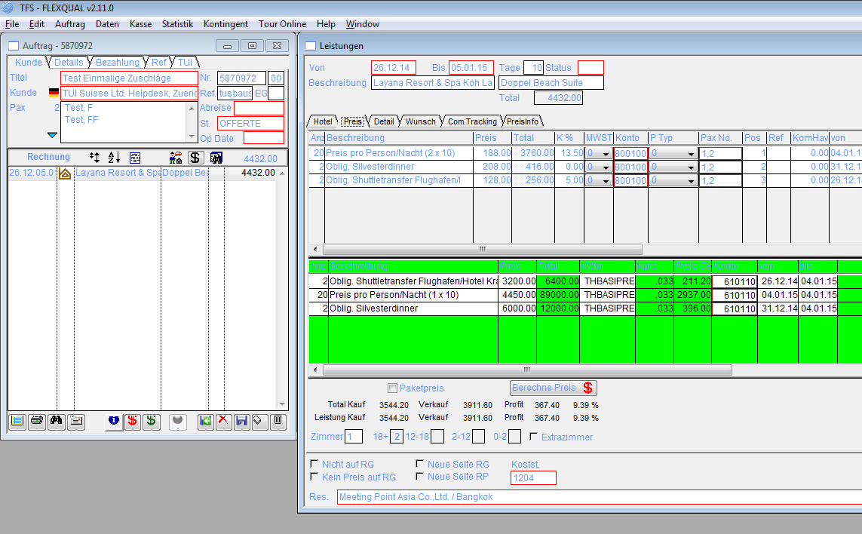

## Antwort

<PerDayPrice Day="2016-12-26"

Price="188.00"

DescId="1" />

<PerDayPrice Day="2016-12-27"

Price="188.00"

DescId="1" />

<PerDayPrice Day="2016-12-28"

Price="188.00"

DescId="1" />

<PerDayPrice Day="2016-12-29"

Price="188.00"

DescId="1" />

<PerDayPrice Day="2016-12-30"

Price="188.00"

DescId="1" />

<PerDayPrice Day="2016-12-31"

Price="188.00"

DescId="1" />

<PerDayPrice Day="2017-01-01"

Price="188.00"

DescId="1" />

<PerDayPrice Day="2017-01-02"

Price="188.00"

DescId="1" />

<PerDayPrice Day="2017-01-03"

Price="188.00"

DescId="1" />

<PerDayPrice Day="2017-01-04"

Price="188.00"

DescId="1" />

Preis 3760 (1880 pro Person)

OneTimes:

<Desc DescId="2">

<de>Oblig. Shuttletransfer Flughafen/Hotel Krabi zum Hotel Layana Resort (retour)</de>

<fr>Return transfer from/to Krabi Airport/Hotel to Layana resort</fr>

</Desc>

<Desc DescId="3">

<de>Oblig. Silvesterdinner</de>

<fr>Dîner de Sylvestre obligatoire</fr>

</Desc>

<OneTime Price="128.00"

DateTo="2017-03-31"

DescId="2"

DateFrom="2016-11-01"

AlwaysApply="0"

WeekdaysValid="1111111"

EndDateRelevant="0"

SpecialCommission="5.00"

StartDateRelevant="0"

NotSpecialRelevant="1" />

<OneTime Price="208.00"

DateTo="2016-12-31"

DescId="3"

DateFrom="2016-12-31"

AlwaysApply="0"

WeekdaysValid="1111111"

EndDateRelevant="0"

SpecialCommission="0.00"

StartDateRelevant="0"

NotSpecialRelevant="1" />

db2 "select sum(price) from tfsonetime where datefrom < '2016-12-26' and dateto >= '2017-01-15' or (datefrom between '2016-12-26' and '2017-01-15' and dateto between '2016-12-26' and '2017-01-15') and roomkey = 'TUIXYA166116' "

select **sum**(price)   
from   tfsonetime   
where  datefrom < '2016-12-26'   
       and dateto >= '2017-01-15'   
        or ( datefrom between '2016-12-26' and '2017-01-15'   
             and dateto between '2016-12-26' and '2017-01-15' )   
           and roomkey = 'TUIXYA166116'

**SQL für OneTimes wurde in SP übernommen.**

Onetimes: 336 pro Person (672 gesamt)  
Gesamtpreis: 3760 + 672 = 4432

**Berechnung in SP ist OK.**

# Beispiel 8: HKT-BANTRE-F3-BB

RoomKey: TUIXYA167810

HotelKey: TUIXYA41018

RoomCode: F3

MealCode: BB

## Special Offers und Early Booking Discount

RoomKey: TUIXYA194584  
3x adult, 0x child

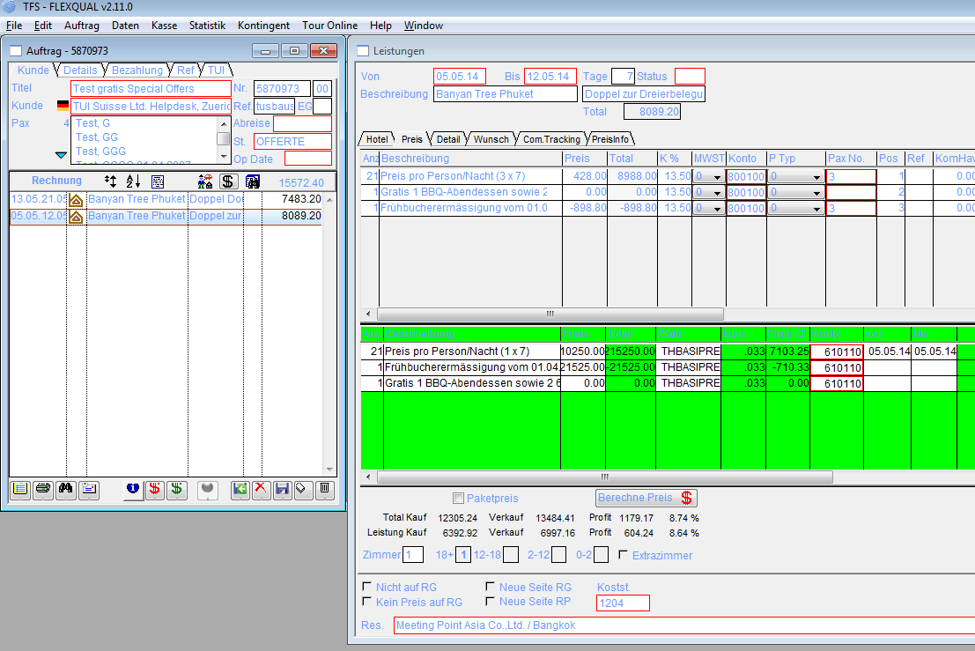

## Antwort

<PerDayPrice Day="2016-05-05"

Price="428.00"

DescId="1" />

<PerDayPrice Day="2016-05-06"

Price="428.00"

DescId="1" />

<PerDayPrice Day="2016-05-07"

Price="428.00"

DescId="1" />

<PerDayPrice Day="2016-05-08"

Price="428.00"

DescId="1" />

<PerDayPrice Day="2016-05-09"

Price="428.00"

DescId="1" />

<PerDayPrice Day="2016-05-10"

Price="428.00"

DescId="1" />

<PerDayPrice Day="2016-05-11"

Price="428.00"

DescId="1" />

EarlyBooking

<Desc DescId="3">

<de>Frühbucherermässigung vom 01.04.14-31.10.14 bei Buchung bis 30 Tage vor Anreise</de>

<fr>Réduction anticipée</fr>

</Desc>

<Desc DescId="4">

<de>

Gratis 1 BBQ-Abendessen sowie 2 60minütige Massagen in der Villa min. 4 Nächten

</de>

<fr>Free one time BBQ-Dinner and 2 sessions of 60 minutes massages in the villa</fr>

</Desc>

<EarlyBooking ToDay="99"

DateTo="2016-10-31"

DescId="3"

FromDay="1"

Percent="-10.00"

DateFrom="2016-04-01"

AddAmount="0.00"

EndDateRelevant="0"

StartDateRelevant="0"

DaysBeforeDepartureTo="30"

DaysBeforeDepartureFrom="999" />

<EarlyBooking ToDay="0"

DateTo="2016-10-31"

DescId="4"

FromDay="0"

DateFrom="2016-04-01"

AddAmount="0.00"

ForceDisplay="1"

EndDateRelevant="1"

StartDateRelevant="1"

DaysBeforeDepartureTo="1" />

**Bereits in der SP enthalten.**

**Berechnung in SP ist korrekt.**

# Beispiel 9: HKT-BANTRE-F2-BB

RoomKey: TUIXYA167760

HotelKey: TUIXYA41018

RoomCode: F2

MealCode: BB

## Special Offers und Early Booking Discount und Kinderfestpreise

RoomKey: TUIXYA167760  
2x adult, 1x child, birth: '2011-04-25'

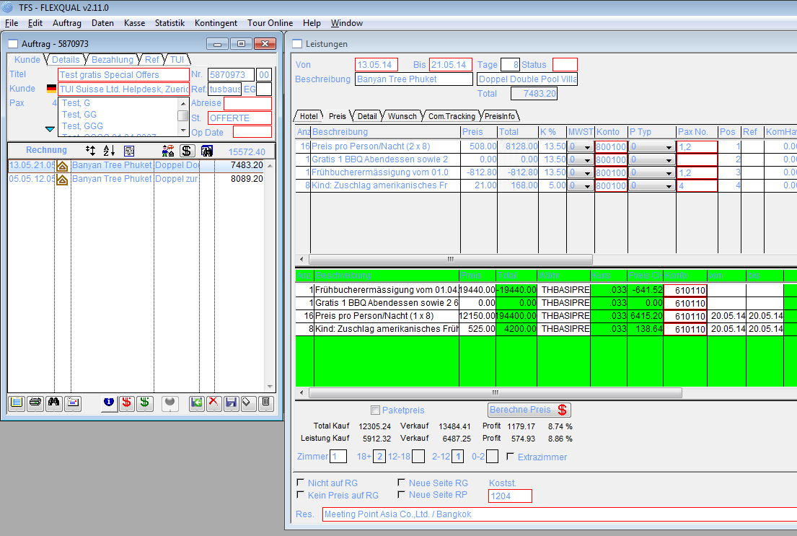

## Antwort

<PerDayPrice Day="2016-05-13"

Price="508.00"

DescId="1" />

<PerDayPrice Day="2016-05-14"

Price="508.00"

DescId="1" />

<PerDayPrice Day="2016-05-15"

Price="508.00"

DescId="1" />

<PerDayPrice Day="2016-05-16"

Price="508.00"

DescId="1" />

<PerDayPrice Day="2016-05-17"

Price="508.00"

DescId="1" />

<PerDayPrice Day="2016-05-18"

Price="508.00"

DescId="1" />

<PerDayPrice Day="2016-05-19"

Price="508.00"

DescId="1" />

<PerDayPrice Day="2016-05-20"

Price="508.00"

DescId="1" />

Erwachsene 8128 (4046 pro Person)

Kind

<PerDayPrice Day="2016-05-13"

Type="R"

AgeTo="12"

Price="21.00"

DescId="2"

AgeFrom="4"

ChildIdxNr="1"

SpecialCommission="5.00" />

<PerDayPrice Day="2016-05-14"

Type="R"

AgeTo="12"

Price="21.00"

DescId="2"

AgeFrom="4"

ChildIdxNr="1"

SpecialCommission="5.00" />

<PerDayPrice Day="2016-05-15"

Type="R"

AgeTo="12"

Price="21.00"

DescId="2"

AgeFrom="4"

ChildIdxNr="1"

SpecialCommission="5.00" />

<PerDayPrice Day="2016-05-16"

Type="R"

AgeTo="12"

Price="21.00"

DescId="2"

AgeFrom="4"

ChildIdxNr="1"

SpecialCommission="5.00" />

<PerDayPrice Day="2016-05-17"

Type="R"

AgeTo="12"

Price="21.00"

DescId="2"

AgeFrom="4"

ChildIdxNr="1"

SpecialCommission="5.00" />

<PerDayPrice Day="2016-05-18"

Type="R"

AgeTo="12"

Price="21.00"

DescId="2"

AgeFrom="4"

ChildIdxNr="1"

SpecialCommission="5.00" />

<PerDayPrice Day="2016-05-19"

Type="R"

AgeTo="12"

Price="21.00"

DescId="2"

AgeFrom="4"

ChildIdxNr="1"

SpecialCommission="5.00" />

<PerDayPrice Day="2016-05-20"

Type="R"

AgeTo="12"

Price="21.00"

DescId="2"

AgeFrom="4"

ChildIdxNr="1"

SpecialCommission="5.00" />

Kinderpreis 168 (21 * 8)

EarlyBooking

<Desc DescId="5">

<de>Frühbucherermässigung vom 01.04.14-31.10.14 bei Buchung bis 30 Tage vor Anreise</de>

<fr>Réduction anticipée</fr>

</Desc>

<Desc DescId="6">

<de>

Gratis 1 BBQ Abendessen sowie 2 60minütige Massagen in der Villa min. 4 Nächten

</de>

<fr>Free one time BBQ Dinner and 2 sessions of 60 minutes massages in the villa</fr>

</Desc>

<EarlyBookings>

<EarlyBooking ToDay="99"

DateTo="2016-10-31"

DescId="5"

FromDay="1"

Percent="-10.00"

DateFrom="2016-04-01"

AddAmount="0.00"

EndDateRelevant="0"

StartDateRelevant="0"

DaysBeforeDepartureTo="30"

DaysBeforeDepartureFrom="999" />

<EarlyBooking ToDay="0"

DateTo="2016-10-31"

DescId="6"

FromDay="0"

DateFrom="2016-04-01"

AddAmount="0.00"

ForceDisplay="1"

EndDateRelevant="1"

StartDateRelevant="1"

DaysBeforeDepartureTo="1"

DaysBeforeDepartureFrom="999" />

</EarlyBookings>

EarlyBooking bereits in SP enthalten.  
Kinderpreis in SP prüfen.  
Berechnung in SP ist OK.

# Beispiel 10: MLE-SIXLAA-B2-HB

RoomKey: TUIXYA193642

HotelKey: TUIXYA40766

RoomCode: B2

MealCode: HB

## Gratisnächte, EarlyBooking, Tageszuschläge, Einmalige Zuschläge, Kinderfestpreise

RoomKey: TUIXYA193642  
2x adult, 2x child, birth-1: '2007-04-25', birth-2: '2007-04-25'

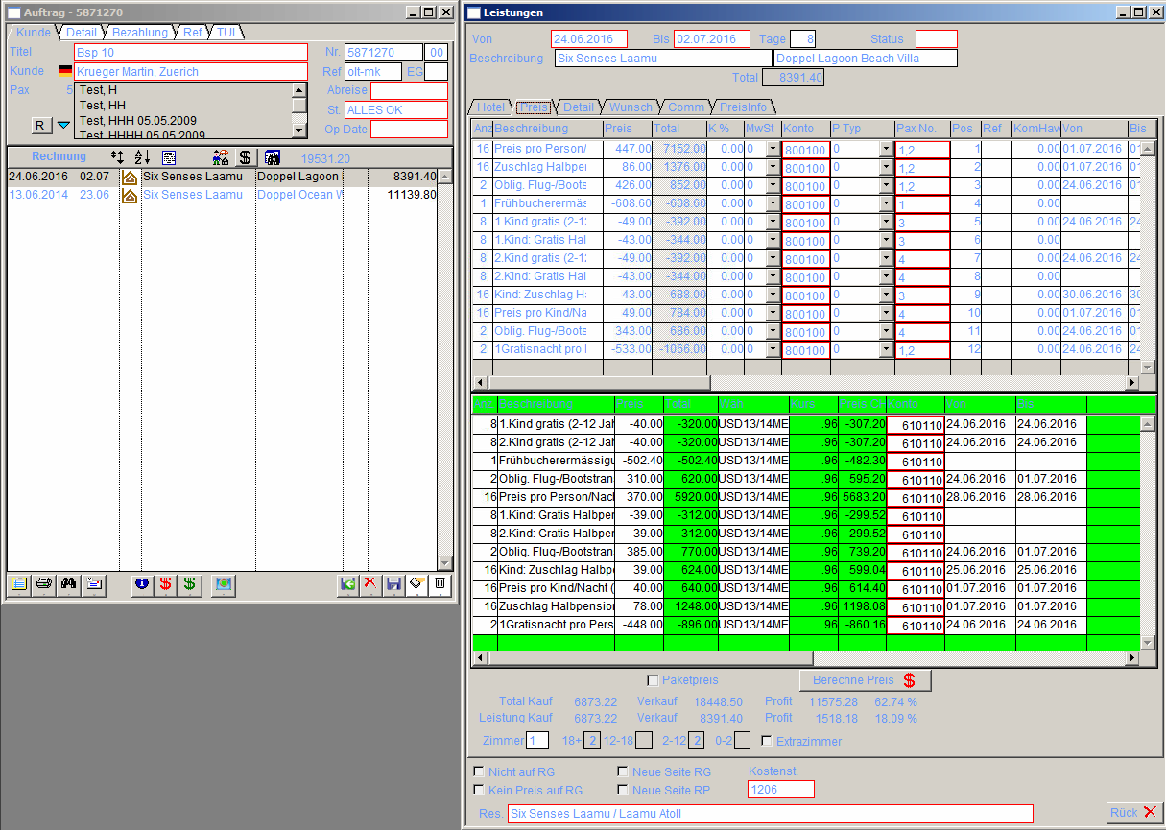

## Antwort

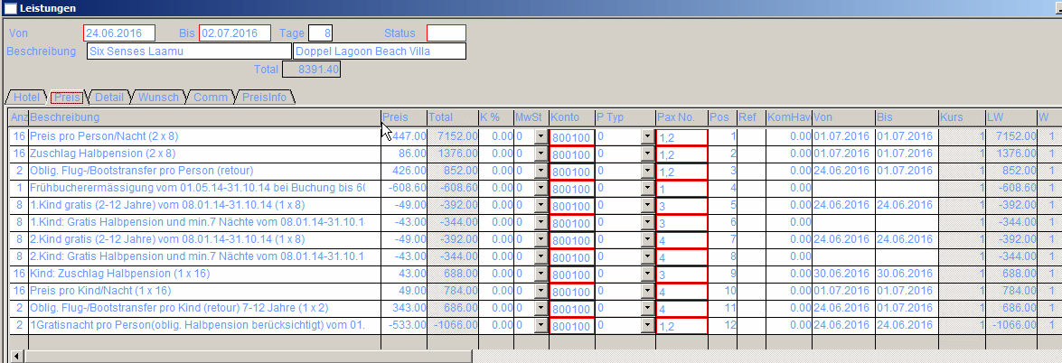

PerDayPrice adult: 7152 (3576 pro Person)

<PerDayPrice Day="2016-06-24"

Price="447.00"

DescId="1" />

<PerDayPrice Day="2016-06-25"

Price="447.00"

DescId="1" />

<PerDayPrice Day="2016-06-26"

Price="447.00"

DescId="1" />

<PerDayPrice Day="2016-06-27"

Price="447.00"

DescId="1" />

<PerDayPrice Day="2016-06-28"

Price="447.00"

DescId="1" />

<PerDayPrice Day="2016-06-29"

Price="447.00"

DescId="1" />

<PerDayPrice Day="2016-06-30"

Price="447.00"

DescId="1" />

<PerDayPrice Day="2016-07-01"

Price="447.00"

DescId="1" />

<PerDayPrice Day="2016-07-02"

Price="447.00"

DescId="1" />

<PerDayPrice Day="2016-07-03"

Price="447.00"

DescId="1" />

<PerDayPrice Day="2016-07-04"

Price="447.00"

DescId="1" />

<PerDayPrice Day="2016-07-05"

Price="447.00"

DescId="1" />

<PerDayPrice Day="2016-07-06"

Price="447.00"

DescId="1" />

<PerDayPrice Day="2016-07-07"

Price="447.00"

DescId="1" />

<PerDayPrice Day="2016-07-08"

Price="447.00"

DescId="1" />

<PerDayPrice Day="2016-07-09"

Price="447.00"

DescId="1" />

<PerDayPrice Day="2016-07-10"

Price="447.00"

DescId="1" />

<PerDayPrice Day="2016-07-11"

Price="447.00"

DescId="1" />

<PerDayPrice Day="2016-07-12"

Price="447.00"

DescId="1" />

<PerDayPrice Day="2016-07-13"

Price="447.00"

DescId="1" />

<PerDayPrice Day="2016-07-14"

Price="447.00"

DescId="1" />

<PerDayPrice Day="2016-07-15"

Price="447.00"

DescId="1" />

<PerDayPrice Day="2016-07-16"

Price="447.00"

DescId="1" />

<PerDayPrice Day="2016-07-17"

Price="447.00"

DescId="1" />

<PerDayPrice Day="2016-07-18"

Price="447.00"

DescId="1" />

<PerDayPrice Day="2016-07-19"

Price="447.00"

DescId="1" />

PerDayPrice Kind 1: 0.00

<PerDayPrice Day="2016-06-24"

AgeTo="2"

Price="0.00"

DescId="7"

AgeFrom="0"

**ChildIdxNr**="1" />

<PerDayPrice Day="2016-06-25"

AgeTo="2"

Price="0.00"

DescId="7"

AgeFrom="0"

ChildIdxNr="1" />

<PerDayPrice Day="2016-06-26"

AgeTo="2"

Price="0.00"

DescId="7"

AgeFrom="0"

ChildIdxNr="1" />

<PerDayPrice Day="2016-06-27"

AgeTo="2"

Price="0.00"

DescId="7"

AgeFrom="0"

ChildIdxNr="1" />

<PerDayPrice Day="2016-06-28"

AgeTo="2"

Price="0.00"

DescId="7"

AgeFrom="0"

ChildIdxNr="1" />

<PerDayPrice Day="2016-06-29"

AgeTo="2"

Price="0.00"

DescId="7"

AgeFrom="0"

ChildIdxNr="1" />

<PerDayPrice Day="2016-06-30"

AgeTo="2"

Price="0.00"

DescId="7"

AgeFrom="0"

ChildIdxNr="1" />

<PerDayPrice Day="2016-07-01"

AgeTo="2"

Price="0.00"

DescId="7"

AgeFrom="0"

ChildIdxNr="1" />

<PerDayPrice Day="2016-07-02"

AgeTo="2"

Price="0.00"

DescId="7"

AgeFrom="0"

ChildIdxNr="1" />

PerDayPrice Kind 2: 0.00

<PerDayPrice Day="2016-06-24"

AgeTo="2"

Price="0.00"

DescId="7"

AgeFrom="0"

**ChildIdxNr**="2" />

<PerDayPrice Day="2016-06-25"

AgeTo="2"

Price="0.00"

DescId="7"

AgeFrom="0"

ChildIdxNr="2" />

<PerDayPrice Day="2016-06-26"

AgeTo="2"

Price="0.00"

DescId="7"

AgeFrom="0"

ChildIdxNr="2" />

<PerDayPrice Day="2016-06-27"

AgeTo="2"

Price="0.00"

DescId="7"

AgeFrom="0"

ChildIdxNr="2" />

<PerDayPrice Day="2016-06-28"

AgeTo="2"

Price="0.00"

DescId="7"

AgeFrom="0"

ChildIdxNr="2" />

<PerDayPrice Day="2016-06-29"

AgeTo="2"

Price="0.00"

DescId="7"

AgeFrom="0"

ChildIdxNr="2" />

<PerDayPrice Day="2016-06-30"

AgeTo="2"

Price="0.00"

DescId="7"

AgeFrom="0"

ChildIdxNr="2" />

<PerDayPrice Day="2016-07-01"

AgeTo="2"

Price="0.00"

DescId="7"

AgeFrom="0"

ChildIdxNr="2" />

Kind 1 Ermässigung Halbpension: -344

<PerDayPrice Day="2016-06-24"

Type="R"

AgeTo="12"

Price="-43.00"

DescId="4"

AgeFrom="7"

**ChildIdxNr**="1" />

<PerDayPrice Day="2016-06-25"

Type="R"

AgeTo="12"

Price="-43.00"

DescId="4"

AgeFrom="7"

ChildIdxNr="1" />

<PerDayPrice Day="2016-06-26"

Type="R"

AgeTo="12"

Price="-43.00"

DescId="4"

AgeFrom="7"

ChildIdxNr="1" />

<PerDayPrice Day="2016-06-27"

Type="R"

AgeTo="12"

Price="-43.00"

DescId="4"

AgeFrom="7"

ChildIdxNr="1" />

<PerDayPrice Day="2016-06-28"

Type="R"

AgeTo="12"

Price="-43.00"

DescId="4"

AgeFrom="7"

ChildIdxNr="1" />

<PerDayPrice Day="2016-06-29"

Type="R"

AgeTo="12"

Price="-43.00"

DescId="4"

AgeFrom="7"

ChildIdxNr="1" />

<PerDayPrice Day="2016-06-30"

Type="R"

AgeTo="12"

Price="-43.00"

DescId="4"

AgeFrom="7"

ChildIdxNr="1" />

<PerDayPrice Day="2016-07-01"

Type="R"

AgeTo="12"

Price="-43.00"

DescId="4"

AgeFrom="7"

ChildIdxNr="1" />

<PerDayPrice Day="2016-07-02"

Type="R"

AgeTo="12"

Price="-43.00"

DescId="4"

AgeFrom="7"

ChildIdxNr="1" />

Kind 2 Ermässigung Halbpension: -344

<PerDayPrice Day="2016-06-24"

Type="R"

AgeTo="12"

Price="-43.00"

DescId="6"

AgeFrom="7"

**ChildIdxNr**="2" />

<PerDayPrice Day="2016-06-25"

Type="R"

AgeTo="12"

Price="-43.00"

DescId="6"

AgeFrom="7"

ChildIdxNr="2" />

<PerDayPrice Day="2016-06-26"

Type="R"

AgeTo="12"

Price="-43.00"

DescId="6"

AgeFrom="7"

ChildIdxNr="2" />

<PerDayPrice Day="2016-06-27"

Type="R"

AgeTo="12"

Price="-43.00"

DescId="6"

AgeFrom="7"

ChildIdxNr="2" />

<PerDayPrice Day="2016-06-28"

Type="R"

AgeTo="12"

Price="-43.00"

DescId="6"

AgeFrom="7"

ChildIdxNr="2" />

<PerDayPrice Day="2016-06-29"

Type="R"

AgeTo="12"

Price="-43.00"

DescId="6"

AgeFrom="7"

ChildIdxNr="2" />

<PerDayPrice Day="2016-06-30"

Type="R"

AgeTo="12"

Price="-43.00"

DescId="6"

AgeFrom="7"

ChildIdxNr="2" />

<PerDayPrice Day="2016-07-01"

Type="R"

AgeTo="12"

Price="-43.00"

DescId="6"

AgeFrom="7"

ChildIdxNr="2" />

<PerDayPrice Day="2016-07-02"

Type="R"

AgeTo="12"

Price="-43.00"

DescId="6"

AgeFrom="7"

ChildIdxNr="2" />

Kind 1 Aufschlag: 392

<PerDayPrice Day="2016-06-24"

AgeTo="12"

Price="49.00"

DescId="3"

AgeFrom="2"

**ChildIdxNr**="1" />

<PerDayPrice Day="2016-06-25"

AgeTo="12"

Price="49.00"

DescId="3"

AgeFrom="2"

ChildIdxNr="1" />

<PerDayPrice Day="2016-06-26"

AgeTo="12"

Price="49.00"

DescId="3"

AgeFrom="2"

ChildIdxNr="1" />

<PerDayPrice Day="2016-06-27"

AgeTo="12"

Price="49.00"

DescId="3"

AgeFrom="2"

ChildIdxNr="1" />

<PerDayPrice Day="2016-06-28"

AgeTo="12"

Price="49.00"

DescId="3"

AgeFrom="2"

ChildIdxNr="1" />

<PerDayPrice Day="2016-06-29"

AgeTo="12"

Price="49.00"

DescId="3"

AgeFrom="2"

ChildIdxNr="1" />

<PerDayPrice Day="2016-06-30"

AgeTo="12"

Price="49.00"

DescId="3"

AgeFrom="2"

ChildIdxNr="1" />

<PerDayPrice Day="2016-07-01"

AgeTo="12"

Price="49.00"

DescId="3"

AgeFrom="2"

ChildIdxNr="1" />

<PerDayPrice Day="2016-07-02"

AgeTo="12"

Price="49.00"

DescId="3"

AgeFrom="2"

ChildIdxNr="1" />

Kind 2 Aufschlag: 392

<PerDayPrice Day="2016-06-24"

AgeTo="12"

Price="49.00"

DescId="3"

AgeFrom="2"

ChildIdxNr="2" />

<PerDayPrice Day="2016-06-25"

AgeTo="12"

Price="49.00"

DescId="3"

AgeFrom="2"

ChildIdxNr="2" />

<PerDayPrice Day="2016-06-26"

AgeTo="12"

Price="49.00"

DescId="3"

AgeFrom="2"

ChildIdxNr="2" />

<PerDayPrice Day="2016-06-27"

AgeTo="12"

Price="49.00"

DescId="3"

AgeFrom="2"

ChildIdxNr="2" />

<PerDayPrice Day="2016-06-28"

AgeTo="12"

Price="49.00"

DescId="3"

AgeFrom="2"

ChildIdxNr="2" />

<PerDayPrice Day="2016-06-29"

AgeTo="12"

Price="49.00"

DescId="3"

AgeFrom="2"

ChildIdxNr="2" />

<PerDayPrice Day="2016-06-30"

AgeTo="12"

Price="49.00"

DescId="3"

AgeFrom="2"

ChildIdxNr="2" />

<PerDayPrice Day="2016-07-01"

AgeTo="12"

Price="49.00"

DescId="3"

AgeFrom="2"

ChildIdxNr="2" />

<PerDayPrice Day="2016-07-02"

AgeTo="12"

Price="49.00"

DescId="3"

AgeFrom="2"

ChildIdxNr="2" />

Add Price per day Erwachsene: 1376 (688 pro Person), Zuschlag Halbpension

<AddPerDayPrice Day="2016-06-24"

Price="86.00"

DescId="9"

SpecialCommission="5.00"

NotSpecialRelevant="1" />

<AddPerDayPrice Day="2016-06-25"

Price="86.00"

DescId="9"

SpecialCommission="5.00"

NotSpecialRelevant="1" />

<AddPerDayPrice Day="2016-06-26"

Price="86.00"

DescId="9"

SpecialCommission="5.00"

NotSpecialRelevant="1" />

<AddPerDayPrice Day="2016-06-27"

Price="86.00"

DescId="9"

SpecialCommission="5.00"

NotSpecialRelevant="1" />

<AddPerDayPrice Day="2016-06-28"

Price="86.00"

DescId="9"

SpecialCommission="5.00"

NotSpecialRelevant="1" />

<AddPerDayPrice Day="2016-06-29"

Price="86.00"

DescId="9"

SpecialCommission="5.00"

NotSpecialRelevant="1" />

<AddPerDayPrice Day="2016-06-30"

Price="86.00"

DescId="9"

SpecialCommission="5.00"

NotSpecialRelevant="1" />

<AddPerDayPrice Day="2016-07-01"

Price="86.00"

DescId="9"

SpecialCommission="5.00"

NotSpecialRelevant="1" />

<AddPerDayPrice Day="2016-07-02"

Price="86.00"

DescId="9"

SpecialCommission="5.00"

NotSpecialRelevant="1" />

<AddPerDayPrice Day="2016-07-03"

Price="86.00"

DescId="9"

SpecialCommission="5.00"

NotSpecialRelevant="1" />

<AddPerDayPrice Day="2016-07-04"

Price="86.00"

DescId="9"

SpecialCommission="5.00"

NotSpecialRelevant="1" />

<AddPerDayPrice Day="2016-07-05"

Price="86.00"

DescId="9"

SpecialCommission="5.00"

NotSpecialRelevant="1" />

<AddPerDayPrice Day="2016-07-06"

Price="86.00"

DescId="9"

SpecialCommission="5.00"

NotSpecialRelevant="1" />

<AddPerDayPrice Day="2016-07-07"

Price="86.00"

DescId="9"

SpecialCommission="5.00"

NotSpecialRelevant="1" />

<AddPerDayPrice Day="2016-07-08"

Price="86.00"

DescId="9"

SpecialCommission="5.00"

NotSpecialRelevant="1" />

<AddPerDayPrice Day="2016-07-09"

Price="86.00"

DescId="9"

SpecialCommission="5.00"

NotSpecialRelevant="1" />

<AddPerDayPrice Day="2016-07-10"

Price="86.00"

DescId="9"

SpecialCommission="5.00"

NotSpecialRelevant="1" />

<AddPerDayPrice Day="2016-07-11"

Price="86.00"

DescId="9"

SpecialCommission="5.00"

NotSpecialRelevant="1" />

<AddPerDayPrice Day="2016-07-12"

Price="86.00"

DescId="9"

SpecialCommission="5.00"

NotSpecialRelevant="1" />

<AddPerDayPrice Day="2016-07-13"

Price="86.00"

DescId="9"

SpecialCommission="5.00"

NotSpecialRelevant="1" />

<AddPerDayPrice Day="2016-07-14"

Price="86.00"

DescId="9"

SpecialCommission="5.00"

NotSpecialRelevant="1" />

<AddPerDayPrice Day="2016-07-15"

Price="86.00"

DescId="9"

SpecialCommission="5.00"

NotSpecialRelevant="1" />

<AddPerDayPrice Day="2016-07-16"

Price="86.00"

DescId="9"

SpecialCommission="5.00"

NotSpecialRelevant="1" />

<AddPerDayPrice Day="2016-07-17"

Price="86.00"

DescId="9"

SpecialCommission="5.00"

NotSpecialRelevant="1" />

<AddPerDayPrice Day="2016-07-18"

Price="86.00"

DescId="9"

SpecialCommission="5.00"

NotSpecialRelevant="1" />

<AddPerDayPrice Day="2016-07-19"

Price="86.00"

DescId="9"

SpecialCommission="5.00"

NotSpecialRelevant="1" />

Add Price per day Kind 2: 344

<AddPerDayPrice Day="2016-06-24"

AgeTo="12"

Price="43.00"

DescId="2"

AgeFrom="7"

ChildIdxNr="2"

SpecialCommission="5.00" />

<AddPerDayPrice Day="2016-06-25"

AgeTo="12"

Price="43.00"

DescId="2"

AgeFrom="7"

ChildIdxNr="2"

SpecialCommission="5.00" />

<AddPerDayPrice Day="2016-06-26"

AgeTo="12"

Price="43.00"

DescId="2"

AgeFrom="7"

ChildIdxNr="2"

SpecialCommission="5.00" />

<AddPerDayPrice Day="2016-06-27"

AgeTo="12"

Price="43.00"

DescId="2"

AgeFrom="7"

ChildIdxNr="2"

SpecialCommission="5.00" />

<AddPerDayPrice Day="2016-06-28"

AgeTo="12"

Price="43.00"

DescId="2"

AgeFrom="7"

ChildIdxNr="2"

SpecialCommission="5.00" />

<AddPerDayPrice Day="2016-06-29"

AgeTo="12"

Price="43.00"

DescId="2"

AgeFrom="7"

ChildIdxNr="2"

SpecialCommission="5.00" />

<AddPerDayPrice Day="2016-06-30"

AgeTo="12"

Price="43.00"

DescId="2"

AgeFrom="7"

ChildIdxNr="2"

SpecialCommission="5.00" />

<AddPerDayPrice Day="2016-07-01"

AgeTo="12"

Price="43.00"

DescId="2"

AgeFrom="7"

ChildIdxNr="2"

SpecialCommission="5.00" />

<AddPerDayPrice Day="2016-07-02"

AgeTo="12"

Price="43.00"

DescId="2"

AgeFrom="7"

ChildIdxNr="2"

SpecialCommission="5.00" />

Add Price per day Kind 1: 344

<AddPerDayPrice Day="2016-06-24"

AgeTo="12"

Price="43.00"

DescId="2"

AgeFrom="7"

ChildIdxNr="1"

SpecialCommission="5.00" />

<AddPerDayPrice Day="2016-06-25"

AgeTo="12"

Price="43.00"

DescId="2"

AgeFrom="7"

ChildIdxNr="1"

SpecialCommission="5.00" />

<AddPerDayPrice Day="2016-06-26"

AgeTo="12"

Price="43.00"

DescId="2"

AgeFrom="7"

ChildIdxNr="1"

SpecialCommission="5.00" />

<AddPerDayPrice Day="2016-06-27"

AgeTo="12"

Price="43.00"

DescId="2"

AgeFrom="7"

ChildIdxNr="1"

SpecialCommission="5.00" />

<AddPerDayPrice Day="2016-06-28"

AgeTo="12"

Price="43.00"

DescId="2"

AgeFrom="7"

ChildIdxNr="1"

SpecialCommission="5.00" />

<AddPerDayPrice Day="2016-06-29"

AgeTo="12"

Price="43.00"

DescId="2"

AgeFrom="7"

ChildIdxNr="1"

SpecialCommission="5.00" />

<AddPerDayPrice Day="2016-06-30"

AgeTo="12"

Price="43.00"

DescId="2"

AgeFrom="7"

ChildIdxNr="1"

SpecialCommission="5.00" />

<AddPerDayPrice Day="2016-07-01"

AgeTo="12"

Price="43.00"

DescId="2"

AgeFrom="7"

ChildIdxNr="1"

SpecialCommission="5.00" />

<AddPerDayPrice Day="2016-07-02"

AgeTo="12"

Price="43.00"

DescId="2"

AgeFrom="7"

ChildIdxNr="1" />

OneTime adults: 852 (426 pro person)

<OneTime Price="426.00"

DateTo="2016-10-31"

DescId="12"

DateFrom="2015-11-01"

AlwaysApply="0"

WeekdaysValid="1111111"

EndDateRelevant="0"

SpecialCommission="5.00"

StartDateRelevant="1"

NotSpecialRelevant="1" />

OneTime childs: 686 (343 pro child)

<OneTime Baby="0"

AgeTo="12"

Child="1"

Price="343.00"

DateTo="2016-10-31"

DescId="11"

AgeFrom="7"

DateFrom="2015-11-01"

AlwaysApply="0"

WeekdaysValid="1111111"

EndDateRelevant="0"

SpecialCommission="5.00"

StartDateRelevant="1"

NotSpecialRelevant="1" />

Early Booking: 10% Rabatt (90% des Originalpreises)

<EarlyBooking ToDay="0"

DateTo="2016-10-31"

DescId="16"

FromDay="0"

Percent="-10.00"

DateFrom="2016-05-01"

AddAmount="0.00"

EndDateRelevant="0"

StartDateRelevant="0"

DaysBeforeDepartureTo="1"

DaysBeforeDepartureFrom="999" />

Special Offer (Gratisnacht pro Person)

<SpecialOffer Baby="0"

Days="5"

Type="MinValue"

Child="0"

DateTo="2016-10-31"

DescId="14"

DateFrom="2016-05-01"

RuleType="Always"

AddAmount="86.00"

DayString="5"

PayNights="4"

ToDayBase="5"

FromDayBase="5"

ChildAdultNr="0"

ChildChildNr="0"

RevolvingGroup="1"

EndDateRelevant="0"

LastSpOffEndDate="2016-10-31"

StartDateRelevant="0"

DaysBeforeDepartureTo="0"

DaysBeforeDepartureFrom="0" />

Erklärung von Martin Krüger:

Gratisnacht pro Person:

* Preis pro Person = 447.—
* Anz Personen = 2
* Preis total = Preis pro Person + Anz Personen =894.—
* Spezial Offer AddAmound pro Person = 86.— (! Vorzeichen immer mitnehmen kann auch negativ sein)
* Da Anz Personen = 2 folgt: Spezial Offer total = Spezial Offer AddAmound x 2 = 172.—
* Gratisnacht Total = Preis total + Spezial Offer total = 894+172=1066.—
* Gratisnacht pro Person: Gratisnacht Total / Anz Personen = 1066/2 = 533.--.

db2 "select sum(minprice) as SpecialOffer from (select min(pp) + min(am) as minprice, min(dd) as day from(select (dp.price) as pp, \

dp.day as dd, so.dateto as dt, so.datefrom df, so.addamount as am from tfsperdayprice dp, tfsspecialoffers so where dp.childidxnr = 0 and \

(dp.day >= so.datefrom and dp.day <= so.dateto and date(dp.day + ((fromdaybase / 2) + (mod(fromdaybase,2))) DAY) \

between so.datefrom and so.dateto) and (dp.day between '2016-06-24' and '2016-07-02') and dp.roomkey = 'TUIXYA193642' \

and dp.roomkey = so.roomkey and (so.datebeforedepartureto >= '2016-07-02' or so.lastspoffenddate >= '2016-07-02') and so.days in (select min(days) as dd from tfsspecialoffers where days <= \

(select days('2016-07-02')-days('2016-06-24') from sysibm.sysdummy1) and roomkey = 'TUIXYA193642')) t group by dt, df) as t"

select **sum**(minprice) as SpecialOffer   
from   (select **min**(pp) + **min**(am) as minprice,   
               **min**(dd)           as day   
        from  (select ( dp.price ) as pp,   
                        dp.day      as dd,   
                      so.dateto    as dt,   
                      so.datefrom  df,   
                      so.addamount as am   
               from   tfsperdayprice dp,   
                      tfsspecialoffers so   
               where  dp.childidxnr = 0   
                      and   ( dp.day >= so.datefrom   
                             and dp.day <= so.dateto   
                             and **date**(dp.day + ( ( fromdaybase / 2 ) + ( **mod**(   
                                                 fromdaybase, 2) )   
                                               ) day)    
                                 between   
                                 so.datefrom and so.dateto )   
                      and ( dp.day between '2016-06-24' and '2016-07-02' )   
                      and dp.roomkey = 'TUIXYA193642'    
                      and dp.roomkey = so.roomkey   
                      and ( so.datebeforedepartureto >= '2016-07-02'   
                             or so.lastspoffenddate >= '2016-07-02' )   
                      and so.days in (select **min**(days) as dd   
                                      from   tfsspecialoffers   
                                      where  days <=   (select **days**('2016-07-02')   
                                                              - **days**   
                                                              (   
                                                              '2016-06-24')   
                                                       from   sysibm.sysdummy1)   
                                             and roomkey = 'TUIXYA193642')) t   
        group  by dt,   
                  df) as t

**Obige Berechnung muss für die anderen Beispiele getestet werden.**

Special Offer (Gratisnacht) in SP OK

Early Booking in SP OK

OneTime in SP ist OK

Kinderpreise in SP OK

AddPerDayPrice in SP OK