Original Manuscript ID: Access-2023-31917
05-12-2023
Original Article Title: “Electricity Theft Detection for Smart Homes: Harnessing the Power of Machine Learning with Real and Synthetic Attacks”

To: IEEE Access Editor
Re: Response to reviewers

Dear Editor,

Thank you for allowing a resubmission of our manuscript, with an opportunity to address the reviewers’ comments.
We are uploading (a) our point-by-point response to the comments (below) (response to reviewers, under “Author’s Response Files”), (b) an updated manuscript with yellow highlighting indicating changes (as “Highlighted PDF”), and (c) a clean updated manuscript without highlights (“Main Manuscript”).

Best regards,
Abraham et al.

Reviewer#1, Concern # 1 (please list here): This paper tackles electricity theft detection in smart homes by machine learning with real and synthetic attacks. Overall, this paper is well written. I recommend it for publication. Accept (minor edits)
Author response: We would like to express our sincere gratitude for your positive evaluation of our manuscript. Your acceptance of and suggestions for minor edits are greatly appreciated.
In response to your recommendations for minor edits, I have carefully reviewed the manuscript. During this review, we focused on the following areas to ensure further improvement and alignment with journal standards:
- Restructuring the paper to enhance consistency.
- Clarify the proposed framework model and feature selection process.
- Addressing discrepancies between confusion matrices and Receiver Operating Characteristic (ROC) curves.
- Expanding the comparative analysis of our model with the existing literature.
- We have corrected typographical errors, refined captions, labeled tables appropriately, and conducted comprehensive proofreading of the manuscript.
Although specific suggestions or areas of focus were not provided, we endeavored to proactively identify and address potential improvements. We remain open to any specific feedback you or the editorial team may have in the future and are committed to making the necessary adjustments to enhance our manuscript.
Thank you again for your valuable feedback and support.

Author action: We updated the manuscript by ….
Reviewer#2, Concern # 1 (please list here): The contribution is very weak as thousands of relevant works are doing exactly the same using machine learning in electricity theft detection and evaluated benign and malicious samples.
Author response: We appreciate your insights and the opportunity to further discuss the contribution of our work in the context of the existing literature on machine learning in electricity theft detection.
Our study pioneered the use of knowledge-based synthetic attack data in the field of machine learning for electricity theft detection. This innovative approach circumvents the substantial time and resource investments typically required to gather authentic attacks and normal consumption patterns in real-world conditions. Not only does our method save costs, it also facilitates the evaluation of synthetic attacks alongside real data, enhancing practical applicability.
In contrast to existing studies, such as Punmiya et al. (2019) [16], which primarily employ basic statistical models (e.g., random, mean, shift, and reverse) to create synthetic attack loads, our research introduces a unique set of attack scenarios. These scenarios, including Baseload, Weakload, Peakhour, Midnight, and Evil-Twin attacks, are specifically designed to more closely mimic complex and realistic electricity theft behaviors within a smart home environment.
Furthermore, while prior studies such as Dayaratne et al. (2021) [18] and Singh et al. (2017) [19] focus on protecting utility companies from electricity theft, our model empowers individual households to independently detect and prevent such theft. This aspect is particularly crucial in scenarios where electricity is illicitly diverted from one residence to another.
Our novel approach significantly enriches the field by more accurately simulating electricity theft patterns. It also validates the effectiveness of the trained synthetic binary classification models in identifying anomalies using actual attack data. A comparison of our approach with existing methodologies is detailed in the literature review section of the introduction in our manuscript, underscoring its unique contributions and advancements in this area of study.
To evaluate benign and malicious samples, this study employs the aggregate power consumption of home appliances extracted from the AMPds2 dataset. This dataset provides fine-grained time-series data within a smart home environment, a resource that is not widely available in the current smart-grid landscape.
I remain open to further elaboration on any of these points as required, and welcome additional suggestions to enhance the manuscript's contribution to the field.
Thank you once again for the opportunity to clarify these aspects of our study. I anticipate making a constructive contribution to the discourse in this research area.
Author action: We have updated the manuscript by rearranging the introduction and highlighting the contributions of our model to electricity theft detection in smart homes.

Reviewer#2, Concern # 2 (please list here): Are the references provided applicable and sufficient? No
Author response: We have checked and added references as we updated the manuscript
Author action: We updated the manuscript by ….
Reviewer#3, Concern # 1 (please list here): 1. The main motivation of the paper as well as a summary of the contribution should be stated in the abstract.

Author response: Thank you for taking the time to read and review the manuscript. We appreciate your valuable suggestions and have revised our manuscript accordingly. Below are the responses to your questions and concerns:
Abstract: Electricity theft detection (ETD) in smart homes is challenging as smart meter data aggregate legitimate and malicious usage patterns. Traditionally, theft detection was dependent on manual inspections and meter failures. However, with the advancement of machine learning (ML), it is now possible to automatically detect theft based on meter reading patterns. Our proposed framework utilizes ML knowledge-based synthetic attack data (KBSAD) to train an attack classifier. This data consists of benign and attack patterns, which serve as the foundation for generating synthetic and simulated attacks that closely mirror real-world scenarios. The framework was validated using the Almanac of Minutely Power dataset version 2 (AMPds2), which contains fine-grained time-series data from a smart home. We processed the data for binary classification to evaluate our synthetic attack model with real attack instances. The Extreme Gradient Boosting algorithm performed best with an average AUC score of 98.74% and 98.69% for detecting and classifying anomalies in real and simulated attacks, respectively. These methods outperformed legacy unsupervised methods (LUM). By integrating the KBSAD, our approach eliminates the need for extensive data collection for real attacks and seamlessly combine synthetic attacks with genuine consumption readings, representing a significant advancement in the field of smart-home electricity theft detection.

Author action: We have updated the manuscript by reformatting the abstract to include the main motivation of the paper as well as a summary of the contribution.
Reviewer#3, Concern # 2 (please list here): 2. It is better to divide the Introduction into the following sections.
a. The motivation for this study is as follows:
b. Literature Review:
c. Study gaps:
d. Contribution:
Author response: (a) Motivation: Our focus was on securing homes from the threat of electricity theft by external parties. In cases where an attacker steals electricity not directly from the power grid but from neighboring houses, the utility company may remain indifferent to such theft, leaving homeowners responsible for safeguarding their own resources.
(b) Literature Review
Reference | Method | Contributions | Limitations | Our Model's Resolution
Punmiya et al., 2019 [16] | Simple statistical models: random, mean, shift, reverse for synthetic attack loads | These models provided initial frameworks for synthetic load generation and attack simulation. | Limited complexity and lack of realism in attack scenarios. | Introduces a novel set of attack scenarios (Baseload, Weakload, Peakhour, Midnight, Evil-Twin) that simulate more realistic electricity theft patterns.
Abraham et al., 2023 [17] | Knowledge-based synthetic attack generation | Rooted in understanding the intentions behind various attacks. | Lack empirical validation with real attack data. | Validates the extended model with real attack data for binary classification and anomaly detection.
Dayaratne et al., 2021 [18]; Singh et al., 2017 [19]; Punmiya et al., 2019 [16] | Protection of utility companies from electricity theft | Focus on large-scale protection to prevent revenue loss from power stealing. | Issue of power theft between individual homes are not addressed. | Our model enables households to autonomously detect and protect against electricity theft, including scenarios where power is stolen from one home by another.

This table encapsulates the research landscape, showing how each piece of literature contributes to the field of Electricity Theft Detection (ETD) while also highlighting the gaps our proposed model aims to fill. Our model not only adopts more sophisticated attack simulations, but also extends validation methods to include real-world attack data, thereby enhancing the practical application of ETD systems in smart homes.
(c) Study Gaps.
- Limited Reduction Techniques: Prior research, such as the work by Jokar et al. (2015), focuses on random-, mean-, and reverse-time-based reduction methods to differentiate between benign and attack data in binary classification models.
- Need for Realism: There gap in simulating authentic electricity theft patterns that closely mimic real-world complexities.
- Validation with Real Attacks: Existing studies lack rigorous validation of synthetic binary classification models against actual attack data in order to identify anomalies or outliers.
- Complexity in Simulation: The current literature does not fully address the challenge of creating sophisticated simulations that accurately represent the multifaceted nature of electricity theft.
- Enhanced Anomaly Prediction: A opportunity exists to improve anomaly detection methods by validating models with genuine attack instances.
To address these gaps, the proposed research is as follows:
- Incorporates Complex Theft Patterns: Aims to integrate more intricate and realistic patterns of electricity theft into the training process.
- Validates with Real Data: Seeks to validate the effectiveness of trained models in predicting anomalies by testing them against verified real attack datasets.
- Advances Methodologies: More advanced methodologies that go beyond simple reduction techniques are introduced to provide a nuanced understanding of electricity theft.
- Contributes to Anomaly Detection: Enhances the body of knowledge in anomaly detection with potential applications in smart grid cybersecurity.

(d) Our Research Contributions are:
- Cost-efficiency: Training ETD models with synthetic attack data bypasses the need to gather real-life attack patterns and saves time and resources.
- Real-World Evaluation: Enables the testing of ETD models against synthetic attacks and real data, ensuring cost-effective and practical assessment.
- Simplified Calculation: Streamlines the process of incorporating attack scenarios into meter readings by adding synthetic data for legitimate usage.
- Previously Unattainable: Offers a solution to the challenge in computer network communications, where node behavior analysis depends on actual attack occurrences.
- Enhanced flexibility: The adaptability of synthetic data, informed by a wide knowledge base, can significantly improve ETD model training.
- Improved Training and Precision: Leverages the diversity of synthetic attacks to train more robust ETD models, leading to accurate attack detection and classification in smart homes
Author action: We updated the manuscript by creating Motivation, Literature review, study gaps, and contribution subsections under the Introduction.
Reviewer#3, Concern # 3 (please list here): 3. The structure of the paper as a whole is inconsistent with the overall review:

Author response: For consistency, we have restructured the paper according to the suggestions above.
Author action: We have updated the manuscript by rearranging each section in our manuscript for consistency.
Reviewer#4, Concern # 1 (please list here):
1) What is the rationale behind classifying the attacks to 5 categories shown in Fig. 1. In other words, given that the proposed framework in Fig. 3 is able to recognize the attack and also the class of the attack, what the importance of such a detection/classification will be for the operator?
Author response: Thank you for taking the time to read and review the manuscript. We appreciate your valuable suggestions and have revised our manuscript accordingly. Below are the responses to your questions and concerns:
Comparing the details of multiclass classification in Figure 1 with the preprocessing for binary classification in Figure 2, we discussed several points regarding their implications within the context of an anomaly detection framework such as the one shown in Figure 3.
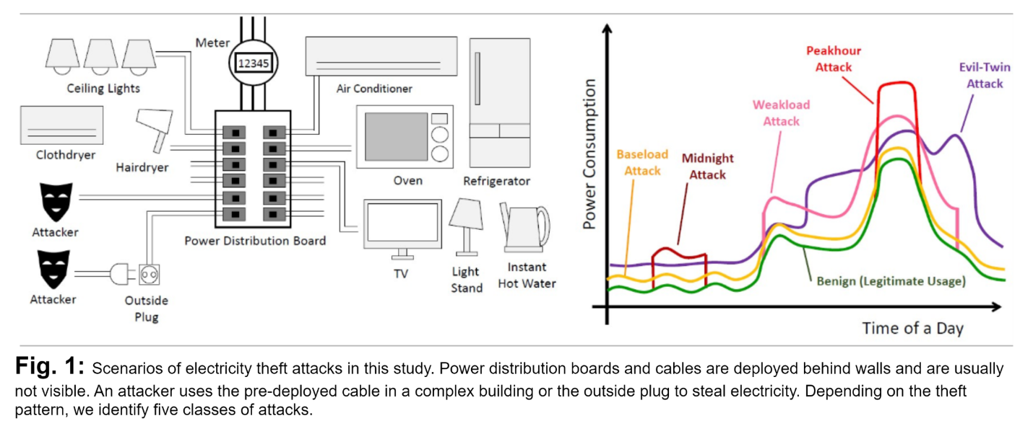
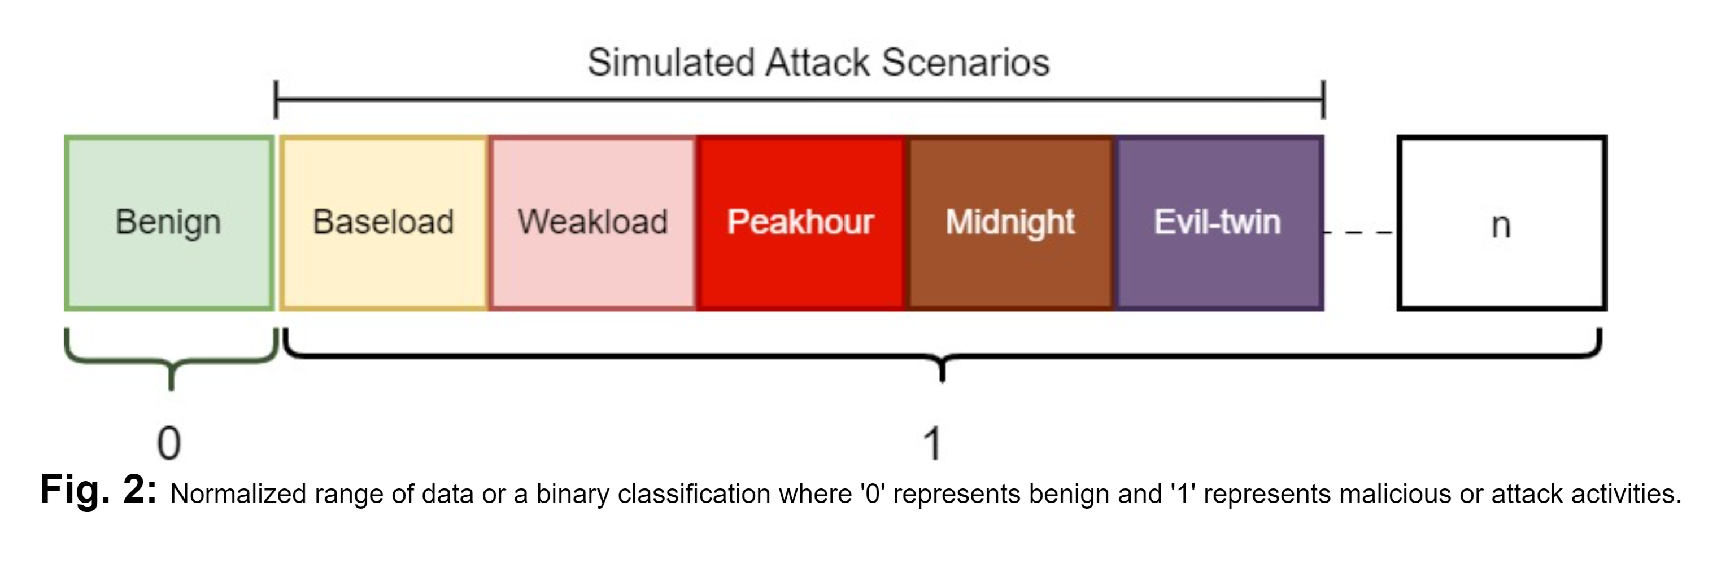
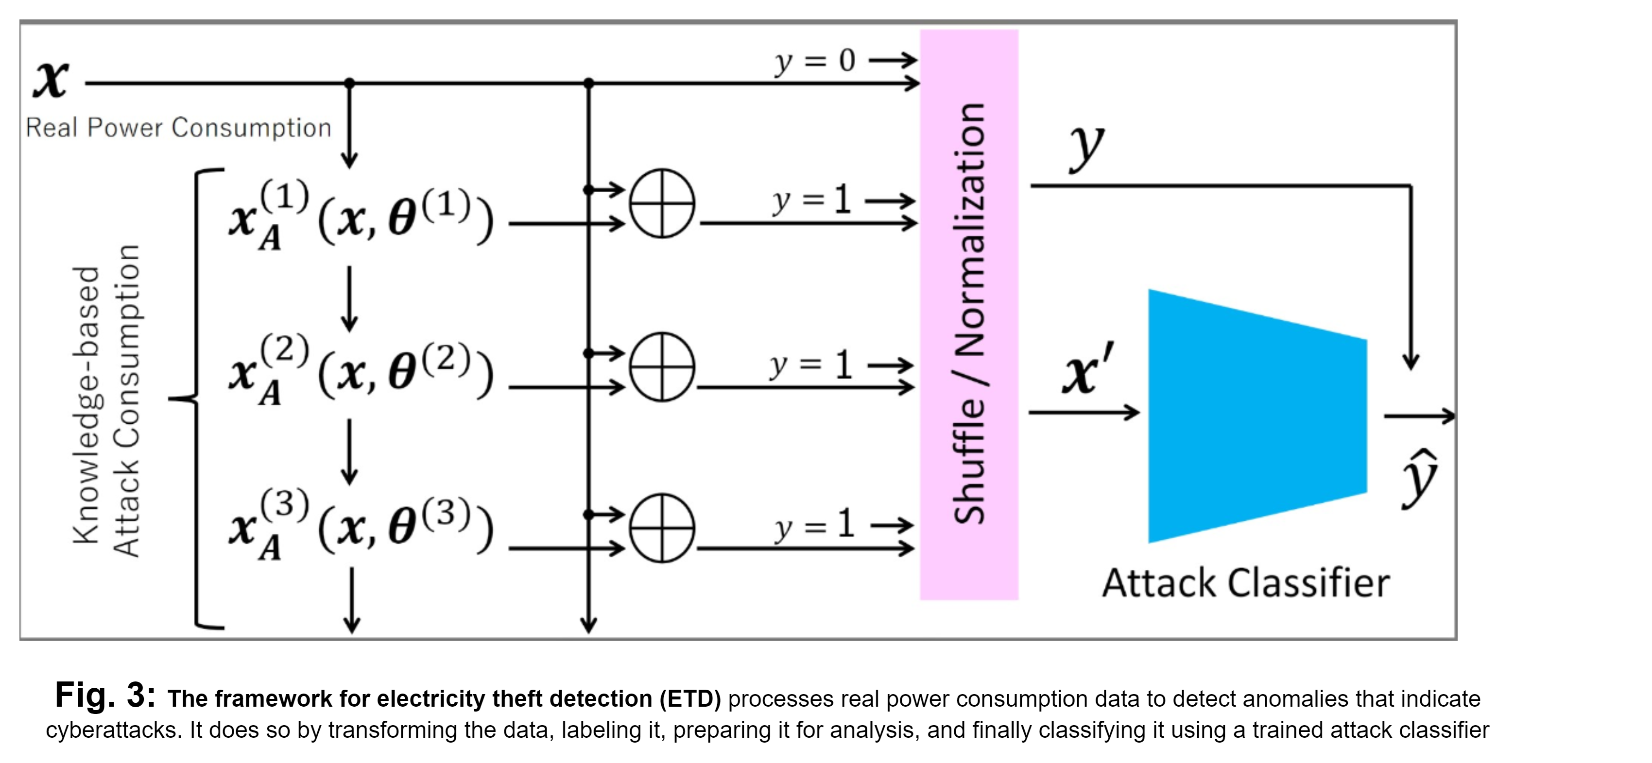
Explanation: The caption in Fig 3 has been incorrect and has been corrected. Unlike our previous paper [17], in which we categorized smart home attacks into five categories, this study expands the limitations of the models to detect attacks that are not classified; hence, we preprocessed our dataset to accommodate the five attack scenarios + unknown attacks, n, as ‘1’ and the benign or non-attack data as ‘0’ for our proposed ETD framework in Fig. 3 to detect known attacks and classify unknown as anomalies. The details of the comparison between multiclass classification (Fig. 1) and Binary Classification (Fig. 2) using different aspects such as Granularity, Complexity, Response Strategy are shown in the table below.
Aspect | Multiclass Classification (Fig. 1) | Binary Classification (Fig. 2)
Granularity | Identifies specific types of attacks. | Distinguishes between normal and abnormal behavior.
Complexity | Requires complex models and more data. | Simpler models and potentially less data needed.
Response Strategy | Allows for tailored responses to specific attacks. | General response to any detected anomaly.
Adaptability to Unknown Attacks | May not classify new attack types correctly. | Better at detecting new or unknown types of attacks.
System Overhead and False Positives | Higher system overhead and potential for more false positives. | Lower overhead and potentially fewer false positives.
Model Training and Evolution | Needs continuous updates for new attack types. | Easier to maintain and update.
Forensics and Reporting | Provides detailed information for in-depth analysis. | Limited information for detailed forensics.

The proposed framework in Figure 3 benefits from recognizing both specific attacks and unclassified anomalies, integrating the strengths of both approaches for a robust security posture.
The detection and classification of cyber threats by operators are vital for several reasons.
- Rapid Response: Binary classification facilitates immediate threat recognition, enabling swift action to mitigate potential cyber threats.
- In-depth Analysis & Prevention: Multiclass classification provides detailed insights into attack types, guiding resource allocation, and the development of prevention strategies.
- Strategic Planning & Resilience: Specific attack classifications aid in tailored incident response planning and enhance the overall system resilience.
- Compliance and Confidence: Adherence to regulatory standards through accurate detection and classification bolsters customer confidence in security measures.
- Operational Integrity: Efficient detection and classification are vital for maintaining operational continuity and minimizing disruptions from cyber incidents.
Precise and swift identification of various cyberattack types is critical for operators to safeguard the integrity, availability, and confidentiality of smart-home systems.
Author action: We updated the manuscript by correcting errors in Fig. 3 caption and also included the benefit of recognizing both specific attacks and unclassified anomalies.
Reviewer#4, Concern # 2 (please list here): 2) Please provide more insights on the model selection and feature selection for the proposed machine learning framework. I recommend including more information about maximum-likelihood parameter estimation while optimizing the objective function.
Author response: (a) Model Selection
XGBoost (SYN-XGB) demonstrated superior performance, with the highest AUC (98.69%) and ACC (95.54%) among the models. Ensemble learning with boosting makes it robust to anomalies and noise in the electricity-consumption dataset. Regularization of the objective function helps prevent overfitting, contributing to better generalization.
The Maximum Likelihood Parameter Estimation (MLE) in the context of our proposed (XGBoost) model selection, involves finding the values of hyperparameters, e.g, learning rate (eta), max-depth or number of trees(n_estimators) that maximize the likelihood of observing the actual data. After we performed a Grid Search with Cross-Validation, the objective function, which is a combination of a loss function and a regularization term (L1 and L2) with values of 0.01 and 1, respectively, was minimized during training, and selection was made based on the hyperparameter tuning of each model after the cross-validation.
XGBoost employs a gradient boosting framework, and during each iteration, fits a weak learner to the negative gradient of the loss function.
The regularization terms (L1 and L2 regularization) were included to prevent overfitting.
Table 7 has been updated with the MLE from grid search cross-validation to optimize the objective function in determining our model selection.
About the features of Appliance consumption Dataset
Feature Selection for the Proposed ML Framework
With reference to Section V of our previous study [17], we used AMPds2 (Almanac of Minutely Power Dataset version 2) [20] as a benchmark for the two-year power consumption of homes. AMPds2 consists of the minute-level measured power at the output of a power distribution board. The names of the appliances monitoring points are shown in Table I.
The main feature of our proposed machine learning framework is the aggregated power consumption data (power_base). Each entry in power_base[day][min] represents the aggregated power consumption for a specific category for a given day and minute. The data are structured in such a way that each day has 1440 min, and for each minute, there is aggregated power consumption information for different categories.
Features (Independent Variables)
- Aggregated Power Consumption Data (power_base).
  - Structure: The power_base dictionary contains aggregated electricity consumption data for different days and minutes.
  - Representation: Each entry in power_base[day][min] represents the aggregated power consumption for a specific category for a given day and min.
Proposed XGB machine-learning framework
Input Features (X)
- Shape: The input feature matrix (X) has dimensions of (730, 1440 * num_categories), where 730 is the number of days and num_categories (e.g., len(HPE)).
- Flattening: The nested structure of power_base is flattened to create a feature matrix, where each row represents a day and each column represents the aggregated power consumption for a specific category at a given minute.
Output Labels (y).
Labels: The output labels (y) correspond to specific conditions related to power consumption for the categories in target_names.
Feature Importance:
- XGBoost provides a feature importance score based on the contribution of each feature to the model predictions.
- Feature importance can be analyzed to understand the categories and times of day that are most influential in predicting the conditions related to power consumption.
Prediction:
- After training, our proposed model (XGBoost) was used to predict the new data.
The aggregated power consumption data (power_base) served as the primary feature of the proposed (XGBoost) machine-learning framework. The model was trained to predict specific conditions related to the power consumption of the target categories (target_names). Maximum-likelihood parameter estimation involves optimizing an objective function that combines a loss function and regularization terms. The hyperparameters were tuned to optimize the model performance, and the feature importance analysis provided insights into the influential factors in the predictions.
Author action: We have updated the manuscript by elaborating on the model and feature selection of our proposed ML framework with relevant references.
Reviewer#4, Concern # 3 (please list here): 3) Please fill the gap between confusion matrices and receiver operating characteristic curves. It is not clear how the curves represent a general view on the content of the confusion matrices. Please kindly explain.
Author response: We randomly selected three ROC curves and confusion matrices to explain our models from the 18 confusion matrices for all SYN models: XGB, RF, and MLP. However, the MLP in Figure 12 is not properly represented. We corrected this error in the revised manuscript, as shown in the figures below. In addition, the confusion matrices in our manuscript were normalized, and the unnormalized versions are explained below. We selected the Home A_sim ROC curve and confusion matrices for each model. The same principle applies to the other synthetic models.
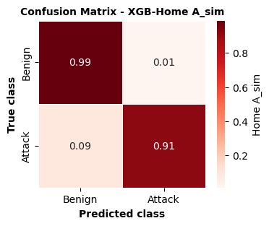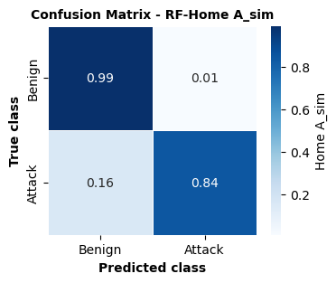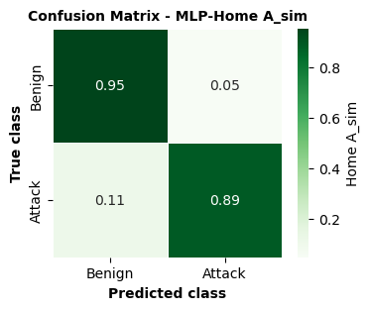

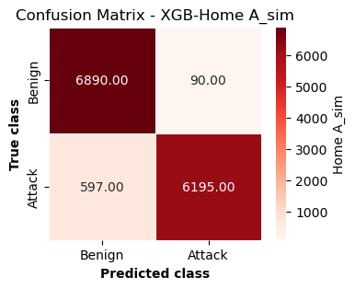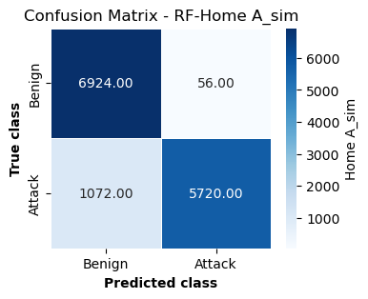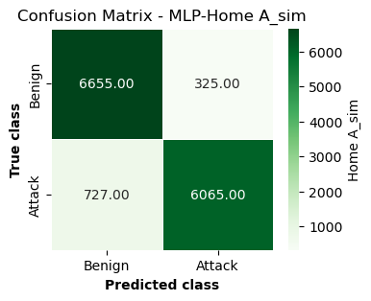
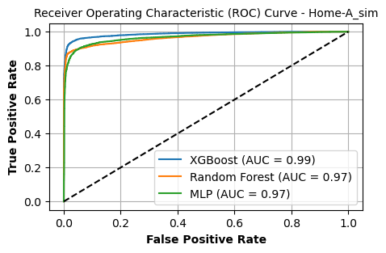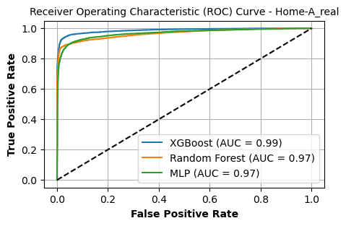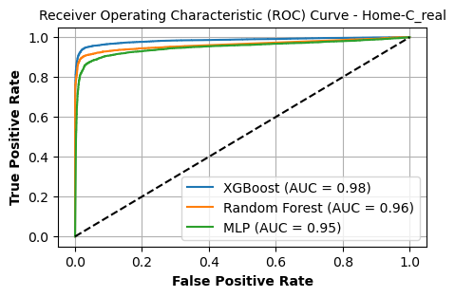
The ROC curve provides a general view of the model's performance across all thresholds, giving a sense of discrimination ability. In contrast, the confusion matrix provides detailed information about the performance of our model at a specific threshold level.
In the ROC curve, the AUC for each model (XGBoost, Random Forest, MLP) provides a single measure of performance across all possible classification thresholds, summarizing the trade-off between TPR and FPR.
The confusion matrices provide a more granular view. For instance:
- The MLP for Home A simulated (Home A_sim) confusion matrix indicates that the model correctly identifies 95% of benign cases (TN), the exact value is 6655, and 89% of attack cases (TP), 6065, at a specific threshold.
- The Random Forest confusion matrix showed a high TN rate of 99%, but a lower TP rate of 84%.
- The XGBoost confusion matrix shows a similarly high TN rate of 99% and a better TP rate of 91%.
The ROC curve does not show the actual values of TP, FP, TN, and FN; rather, it shows the rate at which these values change with the different thresholds. A high AUC reflects a model that has a high TPR and low FPR across different thresholds, which generally corresponds to high values of TP and TN and low values of FP and FN in the confusion matrices at a particular operating threshold.
LEGACY-UNSUPERVISED MODELS (LUM):
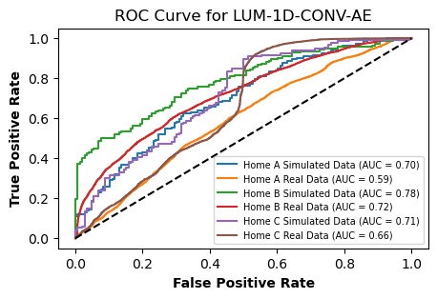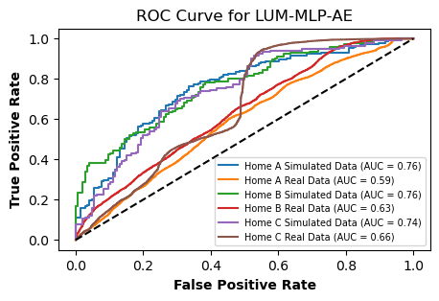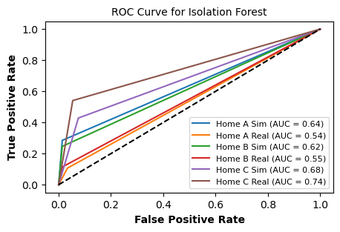

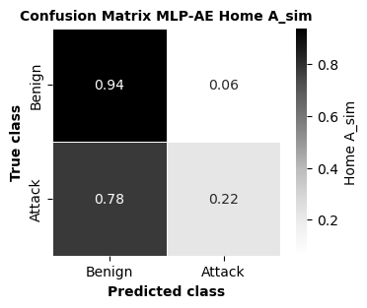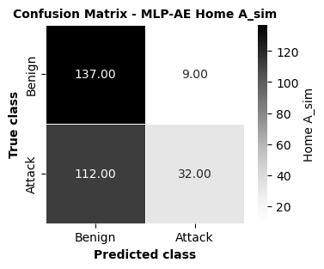
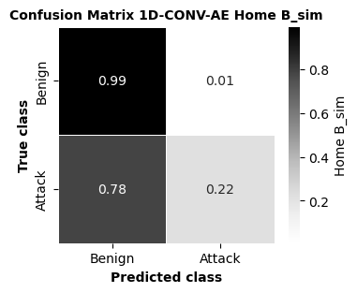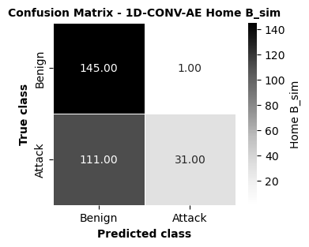
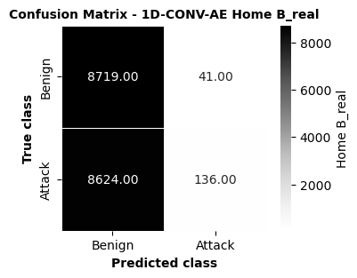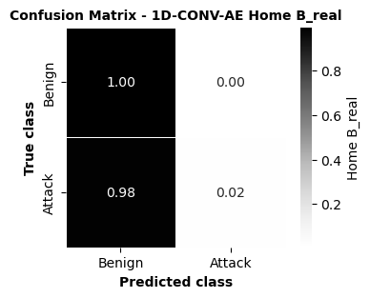
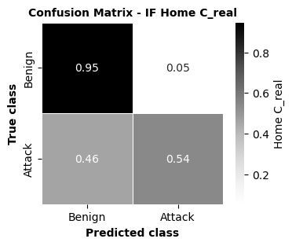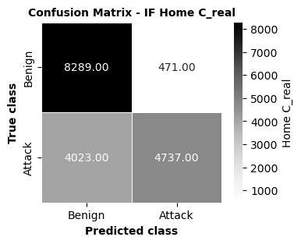

From the confusion matrix, we can calculate various performance metrics, such as precision, recall, specificity, and F1 score at a specific operating point (threshold).
In the ROC curve, each point on the ROC curve represents a different threshold applied to the classifier to decide between the positive and negative classes. Each of these points corresponds to a different confusion matrix with its own set of TP, TN, FP, and FN values.
For instance, consider the confusion matrices for the simulated and real data from Home B using the 1D-CONV-AE model:
- The AUC of 0.78 and 0.72 for simulated and real data respectively on the ROC curve suggests that the model's ability to distinguish between the classes is reasonably good for simulated data and less so for real data.
- For the corresponding confusion matrices, we see high TN rates (0.99 for simulated, 1.00; real) but varying TP rates (0.78 for simulated, 0.98 and real). This suggests that, while the model is quite good at identifying negative cases (benign), its performance on positive cases (attacks) is inconsistent between the simulated and real data.
- In the confusion matrices, we observe the specific number of instances that are correctly and incorrectly classified, which is reflected in the ROC curve by the closeness of the curve to the top left corner.
From the ROC curve for the isolated forest model,
- Home A Simulated has an AUC of 0.64, meaning that the model has a 64% chance of correctly distinguishing between a benign and an attack instance for the simulated environment of Home A.
- Home A Real had a lower AUC of 0.54, suggesting that the model is less effective in distinguishing between benign and attack instances in the real-world data of Home A.
Similarly, Home B Simulated and Home B Real have AUCs of 0.62 and 0.55, respectively, and Home C Simulated and Home C Real have AUCs of 0.68 and 0.74.
The higher the AUC, the better the model is at distinguishing between the positive (attacks) and negative (benign) classes. For example, the model performed best on real data for Home C, with an AUC of 0.74.
Confusion Matrix Details
From the confusion matrix for Home C real data,
- True Positive (TP): 4737–The model correctly identified 4737 instances of attack.
- True Negatives (TN): 8289–The model correctly identified 8289 instances as benign.
- False positive (FP): 471–The model incorrectly identified 471 benign instances as attacks.
- False Negatives (FN): 4023 - The model failed to identify 4023 attacks, mistakenly
Relating the Confusion Matrix to the ROC Curve
- The specific values in the confusion matrix correspond to a single point on the ROC curve for Home C’s real data. The point is determined by the sensitivity (TPR) and FPR.
These values would find a corresponding point on the ROC curve, but the exact point is not marked in the ROC curve. However, we know that point exists, and if the threshold is adjusted, this point moves along the curve, which also results in different values in the confusion matrix.
In summary, the ROC curve indicates how well the model can separate the two classes, and provides a holistic view of the model's performance across all thresholds. In contrast, the confusion matrix indicates exactly where the model makes mistakes at a specific threshold.
Author action: We updated the manuscript by adding more figures and table to validate reviewers’ comments
Reviewer#4, Concern # 4 (please list here): 4) Please report the training and testing errors of the proposed framework. How to guarantee a trade-off between these two errors?
Author response: (a) ML Supervised Learning
For classification tasks, errors are often reported as:
- Training Error: 1−accuracy on the training set
- Test Error: 1−accuracy on the test set
The accuracy of each set was calculated as the number of correct predictions divided by the total number of predictions.
This table presents the training and test errors for the XGBoost, Random Forest, and MLP models.
Metric | XGB (Proposed) | RF | MLP | SVM | LR
ACC | 0.9554 | 0.9275 | 0.9331 | 0.9035 | 0.8148
Recall | 0.9213 | 0.8581 | 0.9472 | 0.8432 | 0.7311
Precision | 0.9882 | 0.9916 | 0.9399 | 0.9471 | 0.8565
AUC | 0.9869 | 0.9676 | 0.9632 | 0.943 | 0.8748

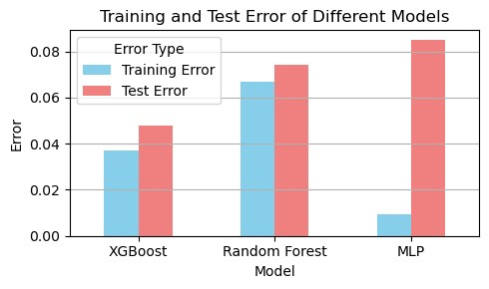
To guarantee a trade-off between training and test errors, we used GridSearchCV for hyperparameter tuning and included cross-validation(cv5) for all models and regularization parameters L1(reg_alpha) and L2(reg_lamda) for XGBoost. For Random Forest, the parameters min_samples_split and min_samples_leaf act as a form of regularization by preventing the tree from growing too deep or complex. For MLP, alpha is used as an L2 penalty term, and the max_iter parameter is set, which is combined with the default early_stopping= true setting.
The table presents the test AUC for the XGBoost, Random Forest, and MLP models. These results were obtained using hyperparameter tuning with GridSearchCV, cross-validation, and regularization as
specified for each model. ​​
Model | Test AUC
XGBoost | 0.984347
Random Forest | 0.966294
MLP | 0.954237

(b) Unsupervised Learning Proposed Framework
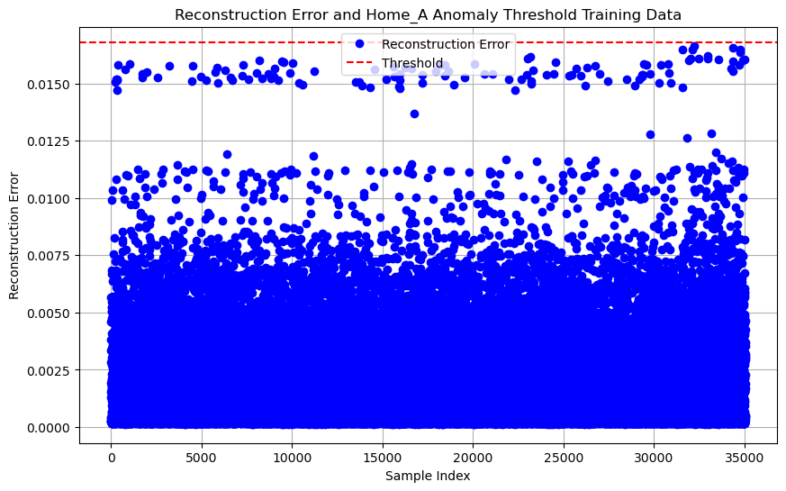
Training Error
The training error in an autoencoder is often measured as the reconstruction error, which is the difference between the input data and the reconstructed data output of the autoencoder. In the code, the training error was calculated as the mean squared error across all features for each data point.
train_predictions = autoencoder.predict(X_train_scaled)
reconstruction_error = np.mean(np.square(X_train_scaled - train_predictions), axis=1)
Test Error
The test error was calculated similarly for the test dataset, which the model did not observe during training.
test_predictions = autoencoder.predict(X_test_scaled)
test_reconstruction_error = np.mean(np.square(X_test_scaled - test_predictions), axis=1)
Reporting Training and Test Errors
Typically, we calculated and displayed the average or median reconstruction errors for the training and test datasets. The threshold for anomaly detection is then applied to classify whether a test sample is normal or an anomaly, and is used to calculate various performance metrics.
Visualizing Errors and Performance
The figures below show the plots for the visualization of the reconstruction errors for anomaly threshold determination. The reconstruction error plot shows the threshold line above which the data points were considered anomalies. The ROC curve provides insight into the trade-off between the true positive rate and false positive rate at various threshold settings, with the AUC score summarizing the model's overall capability in anomaly detection.
Fig. 1: Determine the threshold of our autoencoder using training data.
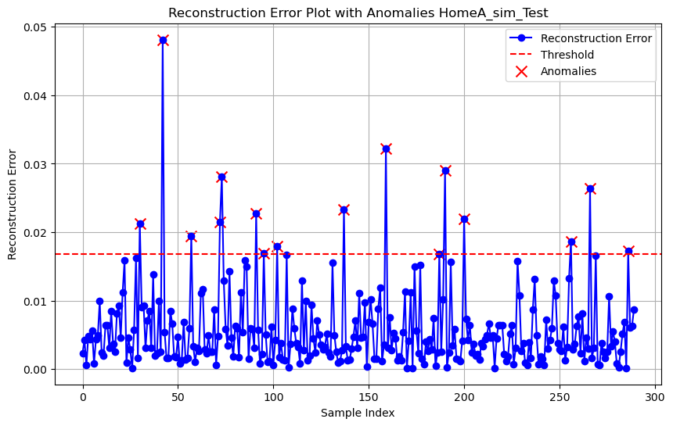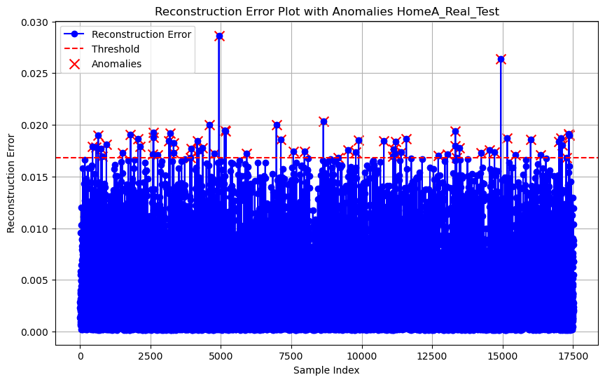
Trade-off Between Training and Test Errors
In machine learning, particularly in unsupervised anomaly detection with autoencoders, we aimed to minimize the reconstruction error on both the training and test datasets. However, a training error (overfitting) that is too low may result in poor generalization of the test data. The following methods help achieve a good trade-off.
- Early Stopping: The code uses an EarlyStopping callback to stop training once the validation loss stops improving, which helps to prevent overfitting.
- Validation Split: By setting aside a portion of the training data for validation (as in validation_split=0.1), the generalization capabilities of the model were monitored during training.
- Regularization: Although not explicitly used in the code, techniques such as L1 or L2 regularization can be applied to the autoencoder layers to penalize overly complex models.
- Hyperparameter Tuning: Adjusting the size of the encoding (32,64,) and hidden layers (16, 32) and the training hyperparameters (such as learning rate) helps us find a balance between underfitting and overfitting.
- Threshold Setting: The threshold for classifying an anomaly is set based on the training data reconstruction error with a multiplier of the median absolute deviation. Adjusting this threshold helps balance sensitivity and specificity.
Author action: We updated the manuscript by adding more figures and references.
Reviewer#4, Concern # 5 (please list here): 5) The performance of the proposed framework must be compared with other machine learning-based techniques (e.g., SVM) available in the existing literature. Please also report the limitations of the proposed framework.
Author response: In our previous paper [17], we evaluated our models using nine different classifiers, including SVM, as shown below:
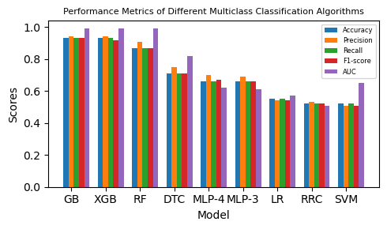
However, ensemble methods, such as GB and XGB, demonstrated the best overall performance for the multi-class ETD task, with high scores in all evaluated metrics. The precision-focused RF algorithm and more nuanced MLP-4 also show promising results. In contrast, traditional algorithms, such as SVM, LR, and RRC, appear to be less effective for this particular application.
We further carried out experiments with SVM and LR binary classifiers, our proposed XGB framework demonstrate the most balanced performance and are likely the most suitable model for ETD among the evaluated options, as shown below:
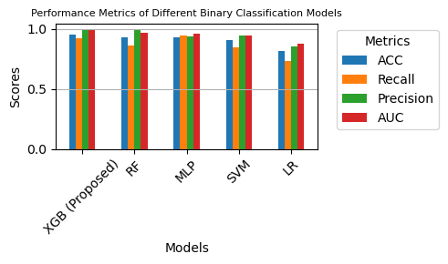
Our proposed XGB model had the highest ACC and AUC scores, as shown in the table below, indicating its superior overall performance among the evaluated models. The RF model shows remarkable precision, whereas the MLP has the highest recall, which makes it the most sensitive model for detecting the positive class. The SVM and LR models trail behind the others across most metrics, with LR having the lowest scores in all categories, as shown in the table below.
Metric | XGB (Proposed) | RF | MLP | SVM | LR
ACC | 0.9554 | 0.9275 | 0.9331 | 0.9035 | 0.8148
Recall | 0.9213 | 0.8581 | 0.9472 | 0.8432 | 0.7311
Precision | 0.9882 | 0.9916 | 0.9399 | 0.9471 | 0.8565
AUC | 0.9869 | 0.9676 | 0.9632 | 0.943 | 0.8748

Limitations of our proposed framework
- Reliance on Synthetic Data: The model primarily uses synthetic attack data, which may not fully capture the complexity and variability of real-world scenarios. There is an ongoing debate about the extent to which these synthetic data can accurately represent real-world conditions.
- Limited Real-World Attack Data: The model has been tested with real-world attack data, but the amount of this data is limited. Expanding the dataset to include a broader and more diverse range of real attack scenarios is necessary to enhance the applicability and reliability of the model in real-world contexts.
- Generalizability Concerns: The effectiveness of the model was evaluated in specific home environments (homes A, B, and C). However, smart homes vary widely in configuration, raising questions about the model's generalizability to different types of smart homes.
- Data Privacy Challenges: With increasing concerns about data privacy, it is essential to ensure that data collection methods, particularly those involving real-world attack data, adhere to privacy standards. Solutions such as federated learning or secure multiparty computation could help detect electricity theft in smart homes without compromising customer privacy.
Author action: We updated the manuscript by removing our model limitations from the Discussion and Future Work section and created a subsection for our model limitations.
Reviewer#4, Concern # 6 (please list here): 6) There are several typos throughout the draft (e.g., Table ??, etc.). Please do a second, more focused, proofreading before final decision can be made.
Author response: Thank you for your comments, we reviewed and revised our paper/manuscript thoroughly. We have proofread and corrected the typographical errors throughout the manuscript.
Author action: We updated the manuscript by checking with PaperPal Preflight to check for grammatical issues.
Reviewer#4, Concern # 7 (please list here): 7) Is the subject matter presented in a comprehensive manner? No. It is not.
Author response: We have updated all comments from the reviewers and have represented our manuscript according to the IEEE Access Journal guidelines.
Author action: We updated the manuscript by reviewing the reviewers’ comments and IEEE Access Journal guidelines.
Note: References suggested by reviewers should only be added if it is relevant to the article and makes it more complete. Excessive cases of recommending non-relevant articles should be reported to ieeeaccesseic@ieee.org

