Electricity Theft Attack Detection Dataset (ETA-DD)

for Abraham’s IEEE Access Journal Paper

This ETA-DD consists of
- two training sub-datasets and
- two testing sub-datasets
for homes A, B & C.

This ETA-DD is assumed for Binary Classification Problems (Benign or Attack). This is because it is intended for the application of unsupervised learning for attack detection, and the evaluation of detection accuracies with the real building data. The real building power consumption cannot be easily labeled for the predefined attack cases. These are the reasons why this study focuses on attack detection, rather than classification. Even though it is not intended for attack classification, the evaluation scope has drastically widened.

1. Structure of the Dataset

- For Supervised Training (Synthetic Attack Patterns are contained)
  - psa_journal_home_A_synthetic_train.csv
  - psa_journal_home_B_synthetic_train.csv
  - psa_journal_home_C_synthetic_train.csv

- For Unsupervised Training (Benign Patterns only)
  - psa_journal_home_A_unsupervised_train.csv
  - psa_journal_home_B_unsupervised_train.csv
  - psa_journal_home_C_unsupervised_train.csv

- With Simulated Testing (Synthetic Attack Patterns are contained)
  - psa_journal_home_A_sim_test.csv
  - psa_journal_home_B_sim_test.csv
  - psa_journal_home_C_sim_test.csv

- With Real Power Consumption-based Testing (Real Power Consumption is added)
  - psa_journal_home_A_real_test.csv
  - psa_journal_home_B_real_test.csv
  - psa_journal_home_C_real_test.csv

2. Feature Vector (X) and Label (Y)

Each file starts from a header row, then consumption records follow. Each consumption record is organized as this

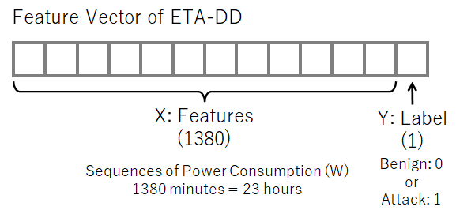

X: features consist of 1380 elements each corresponding to the power consumption of the minute of the day. However, 1380 minutes are 23 hours. This is because we have applied data augmentation as described in the following section.

Y: label that identifies the meaning of the X. Benign is defined as 0. Attack is defined as 1.

3. Data Augumentation

To increase the number of Benign records, we have applied data augmentation as follows.

In our daily life, the operation of home appliances may be changed for about one hour. Base on this idea, we have shifted the original data over time axis and extracted also as a benign record.

1. Training Dataset 1 (for Supervised Approach)

The following three files belong to this dataset:
- psa_journal_home_A_synthetic_train.csv
- psa_journal_home_B_synthetic_train.csv
- psa_journal_home_C_synthetic_train.csv

