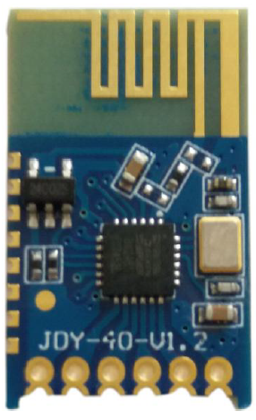
1kΩ
(24) B13
(26) B15
(25) B14
(15) B6
PIC32MX130
JDY40 connections to the PIC32MX130.
3.3V
3.3V
3.3V

