**HOW TO APPLY FOR TRANSCRIPT**















Specified Institution to receive Transcript

Candidates Institution

#### Overview

#### Things to Note

#### Delivery Options & Processing Period

#### Fees & Payment Mode

#### Enquiries

#### Overview

An academic record, also known as an academic transcript, is an official statement which displays all your final subject results achieved through your study at your institution. Every institution prepares, maintains, and permanently retains a record of each student’s academic work.

As the transcript contains personal and confidential information, it is issued by the institution to the person named in it or sent to another institution upon the request of the same person. Transcript(s) requested to be sent to another institution will be placed in a sealed envelope and mailed directly to the institution.

Order Transcript (***OTranscript***) is an automated online transcript ordering service developed by Risk Control Services for the convenience of the key stakeholders in transcript processing, viz;

* All alumni of Nigerian institutions who for any reason are not able to undertake the processing of the transcript by themselves,
* The academic institutions themselves who may be challenged by the cumbersome manual process in the transcript ordering and delivery process.
* The institutions where the Transcript is needed to make timely academic decisions.

However, it is the respective institutions that produce the transcripts because they are the custodians of the students’ academic records. Risk Control via the ***OTranscript*** medium will follow up with the institutions to ensure that the transcript processing is prioritized, and result sent to the address specified by the person requesting for the transcript.

A fee is payable when you request for your transcript. This covers the processing fee charged by the institution, courier cost and administrative fee by Risk Control.

These are the steps to complete your order through the Transcript portal

Step 1

* Register on this portal

Step 2

* After Registration Click on Order Transcripts from the RCVC Portal

Step 3

* Fill in Your Details

Step 4

* Print, Fill, Sign, Scan and upload the Transcript Request Form and Transcript Authorization Form.

Step 6

* Pay the specified non-refundable fee.

Step 7

* Look out for confirmation that your Order has been accepted for processing through a notification on the screen **‘’Order Accepted for Processing"**

Step 8

* Once a transcript is ordered online, and payment received, the sending and processing from the institutions begin. You can always check the status of your order through the Order No you will be given after your order has been accepted for processing.

#### Things to Note

Before you proceed with your order, please ensure you read the following carefully:

* Your institution may not process your transcript request if there is a restriction placed on your account for financial or other obligations to the university.
* Before Risk Control can process your order, it is mandatory that you fill and sign Letter of Authorization and Transcript Request Form. You can send the completed form by email to crm@riskcontrolnigeria.com.
* When your order is successful, you will see a screen with a title of **"Order Accepted for Processing"** This screen will state that your transcript order has been accepted and will provide you with an order number that you should retain in case you need to contact us about your order. If you do not see the "Order Accepted for Processing" screen, it may be due to incorrect information or your payment has not been confirmed. Please contact the Transcript Team if you have not received a response regarding the processing status of your transcript 3 working days after the application date. Please note that payments for successful applications are non-refundable.
* You can always check the status of your order on this portal from your account page.
* When your Transcript has been mailed you will receive a Completion email. We use renowned couriers for delivery of transcripts. Applicants can also track delivery status of their transcripts by entering the tracking code included in the request completion email they receive or from the applications status page.
* If you encounter any problem processing this order, please call Client relationship on +234 1 2954283 or send email to crm@riskcontrolnigeria.com. You are also free to use the chat online feature on this site.

#### Delivery Options & Processing Period

You may process your transcripts personally, or authorize a proxy to process on your behalf. In this case, Risk control is acting as your proxy to process your transcript.   
  
For this purpose, you are required to produce the following documents:

* 1. The ‘Transcript Authorization Form’ (please download here) **This must be completed and signed before the processing of your order can commence**.
  2. A photo ID e. g International Passport, National Identity Card or Drivers Licences

**Please note

* That your institution may not process your transcript request if there is a restriction placed on your account for financial or other obligations to the university.
* That most institutions will only send official transcripts directly to an institution specified by you.
* That once a transcript is ordered online, the printing and mailing process will begin. The payment made is non-refundable.
* That older records are often difficult for many institutions in Nigeria to retrieve because the records have not been stored properly. That many institutions in Nigeria do not have their records stored in digital format. This may sometimes delay the processing of your order by the institution because of additional resources and time needed by the institution.

Please allow up to 20 workings days for this document to be processed by your institution. This may be longer depending on how efficient your institution is with regards to record storage and retrieval.

Other factors that may cause delay include;

* Examination period
* Matriculation period
* Convocation period
* Electricity related challenges
* Industrial action
* School closure

Processing time excludes delivery time by post. An additional 3 working days is advised

#### Fees & Payment Mode

All-inclusive processing fees are charged as follows;

* Local (Within Nigeria) =N=25,000
* International (Outside Nigeria) =N= 45,000

This covers the processing fee charged by the institution, courier cost and administrative fee by Risk Control Services.

**Mode of Payment**

You may choose to pay by one of the following modes of payment:

1. Electronic Payment (e-Payment)

Payment made by means of debit/credit card or internet banking – *details will be provided via the OTranscript Online Transcript Application system*. All payment must be made in Nigerian currency.

1. Bank Deposit or Cheque

Cheque(s) must be drawn from a bank in Nigeria

Your request will only be processed if your cheque is successfully cleared by our bank.

#### Enquiries

For enquiries pertaining to all Transcripts and Degree Verification, please refer to crm@riskcontrolnigeria.com

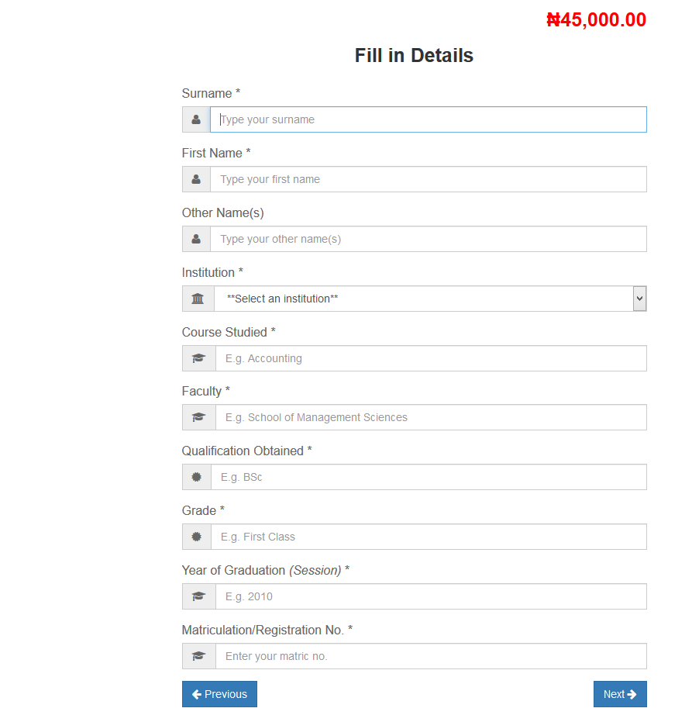

Wasiu

Please add these rows and content to the Form above before the **Next** button

**Delivery Option** (Please note that for now, the only delivery method is paper)

|  |  |
| --- | --- |
|  | Drop down to show delivery option ie Local =N= 30,000 or International =N=45,000 |

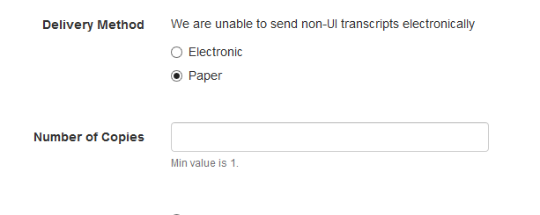

Transcript Delivery Address

|  |  |
| --- | --- |
|  |  |

At the end of the Form there should be a Declaration

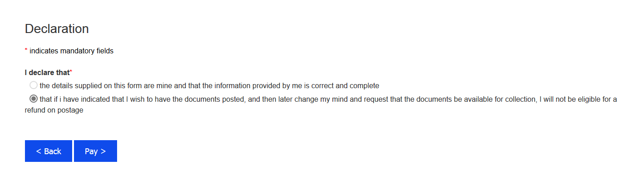

I declare that the details supplied on this form are mine and that the information provided by me is correct and complete. Also, if I have indicated that I wish to have the documents posted, and then later change my mind and request that the documents be available for collection, I will not be eligible for a refund on postage.

**Upload Authorization Form page**

Please change the content to **Upload Documents instead of Upload Authorization Form** because

The candidate will be expected to Upload the following documents

* Transcript Agent Authorization Form
* Passport photograph
* Photo ID

