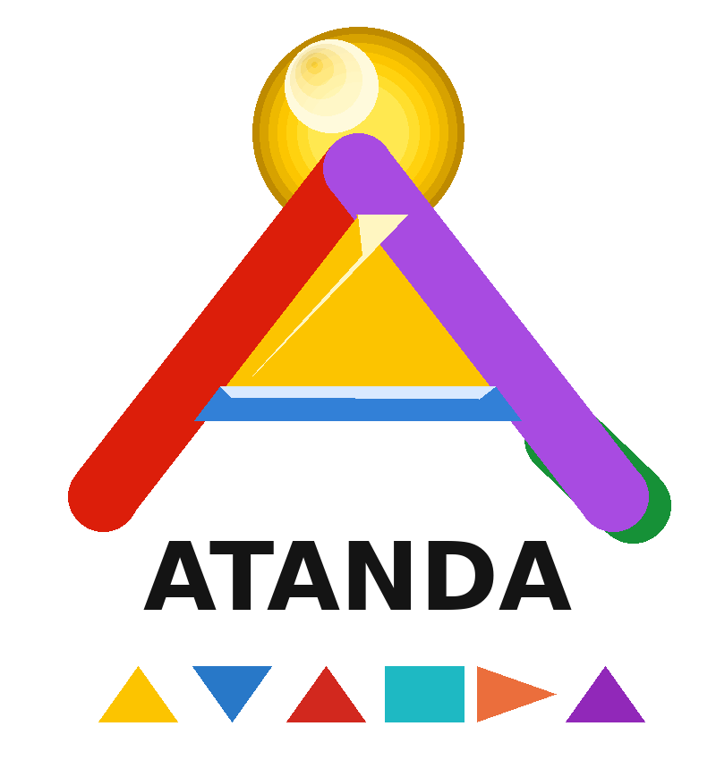
━━━━━━━━━━━━━━━━━━━━
Series 03 · ATANDA Whitepaper Library
CONTEXT CRAFT KCSE RANKINGS V4
Fourth Edition Quality Rankings with Updated Benchmark Data
─────────────────────────────
Practitioner Reference · March 2026 · ATANDA Training & Learning Systems
LET YOUR LIGHT SHINE

DOCUMENT INFORMATION

Title | Context Craft KCSE Rankings v4
Series | 03 of 17 · ATANDA Library
Version | 1.0 — 2025/2026
Classification | Practitioner Reference
Subject | Fourth Edition Quality Rankings with Updated Benchmark Data
Author | ATANDA Knowledge Systems
Review | Annual

TABLE OF CONTENTS

01 EXECUTIVE SUMMARY

Fourth edition KCSE Rankings incorporating benchmark data from over 1200 enterprise context deployments conducted in 2025, the most statistically robust quality rankings to date.

▶ | Rankings based on 1200+ enterprise deployments across 14 industry sectors.
▶ | New Reliability Score added alongside KCSE score to capture deployment consistency.
▶ | Domain-specific rankings introduced: Financial Services, Healthcare, Legal, Technology.
▶ | KCSE framework ensures only production-validated cards are included.
▶ | Context Craft practitioners outperform unstructured prompters by 40-60% on quality benchmarks.

02 CORE CONCEPTS

Foundational concepts practitioners must understand before applying Context Craft.

2.1 The Four Context Types

Every effective AI context combines Role (who the AI is), Task (what it must do), Knowledge (what it knows), and Evaluation (how quality is measured).

CORE INSIGHT
Most practitioners focus 80% of effort on Task context. The biggest quality improvements come from investing equally across all four types.

2.2 KCSE Scoring

KCSE scores measure Knowledge depth, Clarity, Specificity, and Evaluation measurability on a 10-point scale. Cards must score 7+ across all four dimensions for production use.

03 APPLICATION GUIDE

How to apply Context Craft in enterprise AI deployments.

3.1 Context Audit Process

Assess your three highest-value AI use cases. Score current Role, Task, Knowledge, and Evaluation context quality on 1-10. This baseline guides your improvement roadmap.

3.2 Card Selection Strategy

Begin with the four foundation cards: CC-R-001 Expert Role, CC-K-003 Domain Knowledge, CC-E-001 Quality Benchmark, CC-F-001 Context Frame. These four cards address 80% of context quality gaps.

- CC-R-001: Expert Role Framing
- CC-K-003: Domain Knowledge Briefing
- CC-E-001: Quality Benchmark Setting
- CC-F-001: Context Frame

References & Related Documents
- Context Craft Complete Card Inventory — ATANDA, 2025
- Context Craft Evolution — ATANDA, 2025
- BONSAI Promptware ONE — ATANDA, 2025


━━━━━━━━━━━━━━━
TRAINING · LEARNING SYSTEMS · DIGITAL PRODUCT DESIGN
LET YOUR LIGHT SHINE
© 2026 ATANDA Training & Learning Systems. All rights reserved.

