**NAME: Oluwaseun Akerele**

**COURSE: CST-250-500**

**ASSIGNMENT: Milestone 1: Console Application**

**DATE: 08/11/2024**

**Milestone 1: Console Application**

**Introduction**

This project requires the creation of a console application that simulates a game board using object-oriented programming. The application consists of three main classes: Cell, Board, and Program, which work together to handle game dynamics like cell status, board setup, and gameplay rules. The focus of the application is on modular design and encapsulation in software development.

**Design Overview**

The console application is created to establish and control a dynamic game board, shown as a grid of cells. Each cell on the board can be in one of two states: "live" or "not live," which affects the progress of the game. The Board class sets up this grid and adjusts the difficulty level, which determines how many "live" cells are present. Tasks include arranging live neighbors and determining active neighbors for each cell, which are crucial for following game rules and interactions. The Program class manages the overall flow, dealing with user inputs and showing the current state of the board, offering a simple yet engaging user experience that showcases fundamental concepts in object-oriented programming and system design.

**Computer Specification**

Device name DESKTOP-GJUO7TV

Processor Intel(R) Core(TM) i5-7300U CPU @ 2.60GHz 2.71 GHz

Installed RAM 16.0 GB (15.9 GB usable)

Device ID 118DCACA-ECC5-438F-AFB1-ADF4B3E5B638

Product ID 00330-50624-93673-AAOEM

System type 64-bit operating system, x64-based processor

Pen and touch Touch support with 10 touch points

**UML**

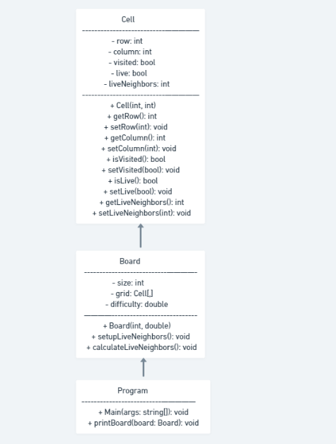

**OUTPUT**

**Board .cs**

**Cell.cs**

**Program.cs**

**What was challenging?**

The most challenging part was ensuring the accurate calculation of neighboring cells for each cell, particularly when dealing with cells at the edges of the grid to avoid exceeding array limits.

**What did you learn?**

I learned how to effectively work with and manipulate 2D arrays in C#. This project also deepened my understanding of object-oriented principles like encapsulation and modularity when designing classes and methods.

**How would you improve on the project?**

To enhance the project, I would add new features like different game modes and varying levels of difficulty. Additionally, refactoring the code to improve efficiency, especially in how neighbors are calculated and updated, would be advantageous.

**How can you use what you learned on the job?**

The skills I acquired in managing data structures and implementing logical solutions can be directly utilized in developing software solutions for intricate business applications. Understanding object-oriented design is essential for creating maintainable code, which facilitates the adaptation and expansion of software projects in a professional environment.