**Real-Time Chat Application Documentation**

**Table of Contents**

1. Introduction ---------------------------------------------------------------------------------2
2. Architecture ---------------------------------------------------------------------------------3
3. Features -------------------------------------------------------------------------------------- 6
4. Technologies Used ------------------------------------------------------------------------- 7
5. Getting Started ------------------------------------------------------------------------------8
6. Contributing --------------------------------------------------------------------------------11
7. Acknowledgements ----------------------------------------------------------------------12
8. UI Screenshots -----------------------------------------------------------------------------13

**introduction**

The Real-Time Chat App is a program that lets people talk to each other instantly over the internet. It's useful for many things, such as staying in touch with friends and family, working together on projects, or providing customer support.

Architecture

The app uses a special kind of architecture called "client-server." Here's a breakdown of the important parts:

* **Client-side (what you see):** This is the part that runs on your web browser or phone. It's built with React, a popular tool for making user interfaces. It also uses Firebase for things like logging in and keeping chat messages up-to-date.
* **Server-side (what you don't see):** This part runs on a server computer somewhere on the internet. It also uses Firebase to store chat messages and handle other things that happen behind the scenes.

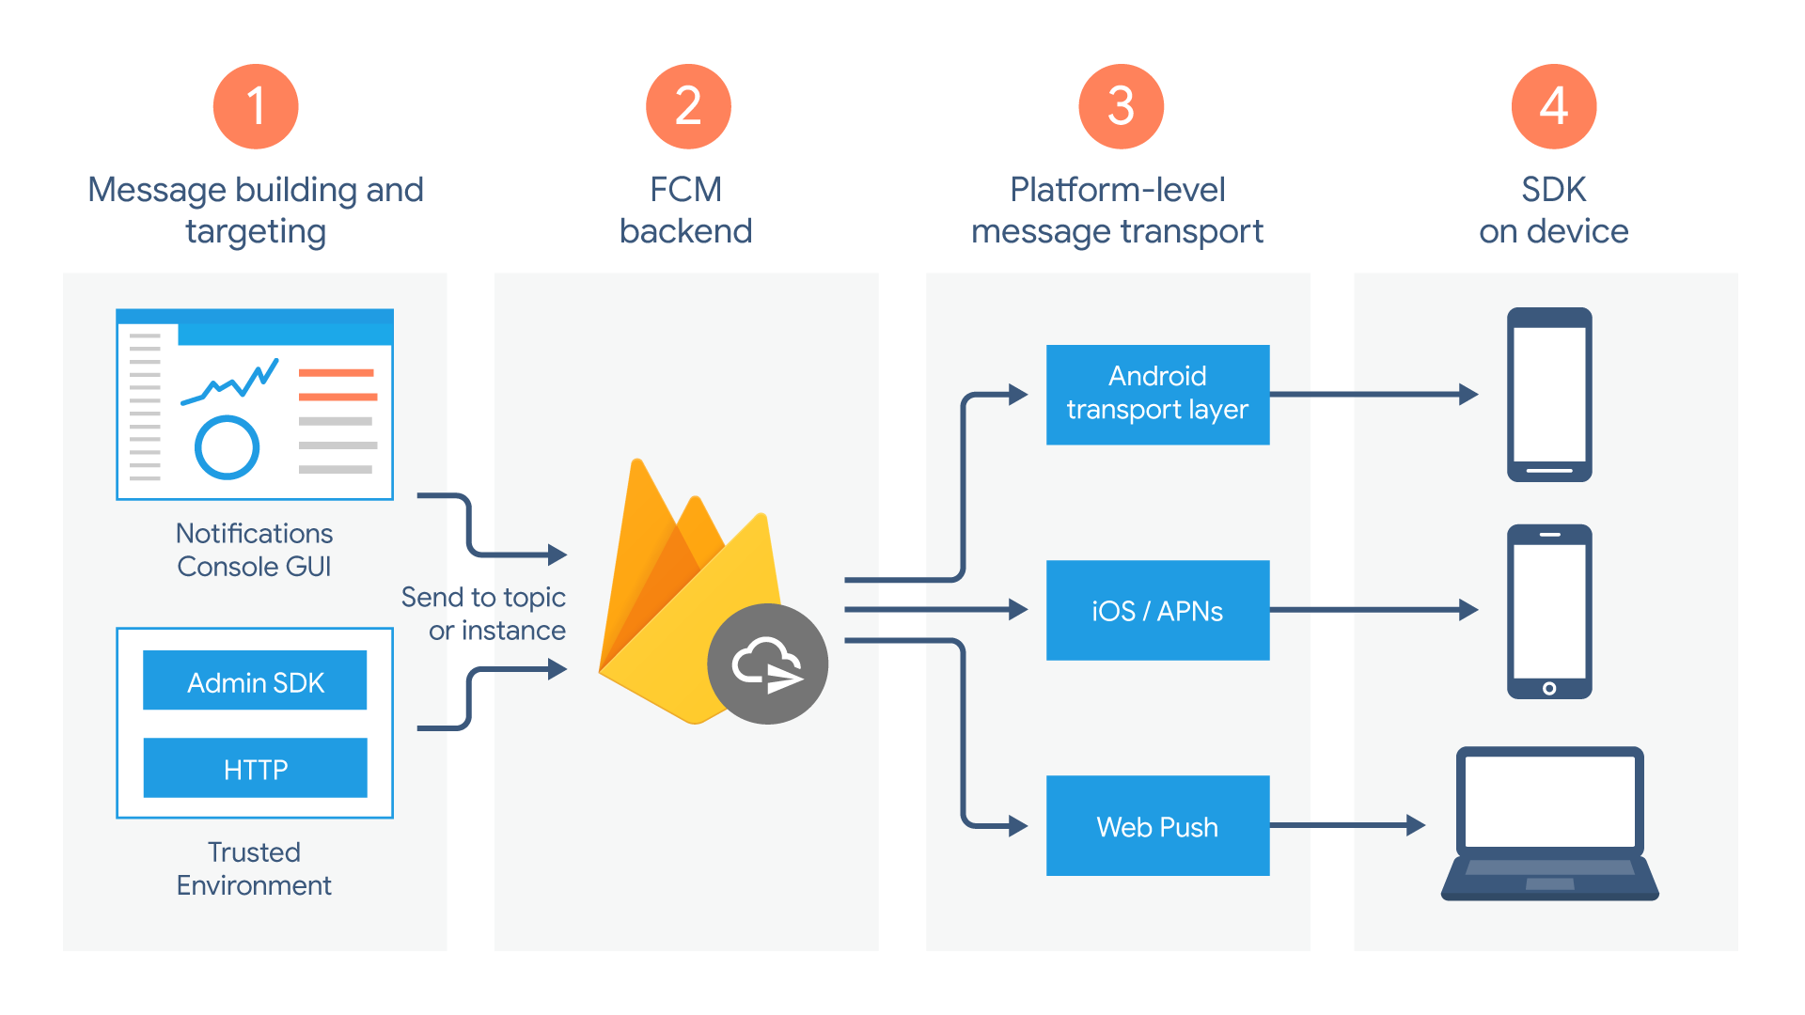

**Features**

* **Sign in:** Users can create accounts using their email and password.
* **Chat in real-time:** Messages appear for everyone using the app right away.
* **Easy to use:** The app is designed to be simple and clear so anyone can use it.

**What technology does it use?**

* React: This is what makes the user interface look nice and work smoothly.
* Firebase: This is a powerful toolkit from Google that helps build web and mobile apps. In this case, it's used for logging in, keeping messages up-to-date, and maybe even doing other things in the background.

**Getting started**

1. **Make sure you have the right things:** You'll need Node.js and npm installed on your computer, and you'll need a Firebase account.
2. **Set up the app:** Download the code for the app and then install any additional pieces it needs.
3. **Connect to Firebase:** Create a new project in Firebase and follow the instructions to set it up for the app.
4. **Run the app:** Start the app and open it in your web browser.
5. **Sign in and chat:** Log in with your email and password to start chatting with other people in real-time!

**Contribution**

**How can I contribute?**

If you find any problems with the app or have ideas to make it better, the creators welcome your help! You can let them know by following the instructions in the documentation.

**Acknowledgement**

**Thanks!**

The creators of the app would like to thank the Firebase documentation and various React tutorials for helping them build this app.

**What else is there?**

The document also includes screenshots of what the signup page, login page, and chat interface look like.

**Ui Screenshots**

* Signup page

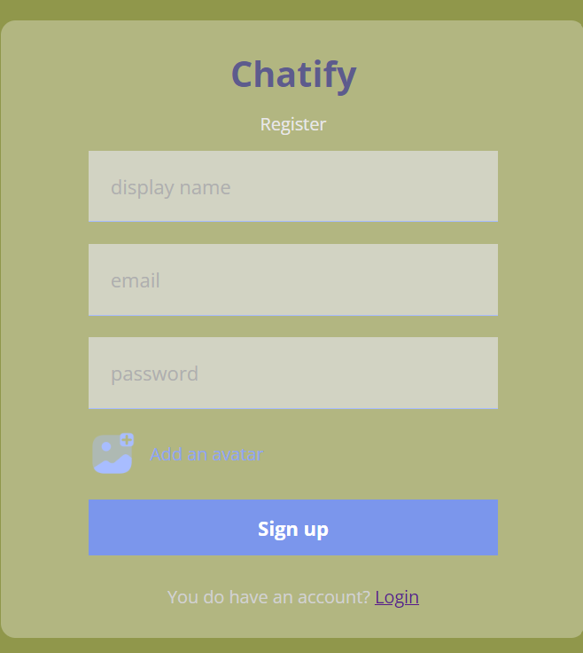

**Login Page**

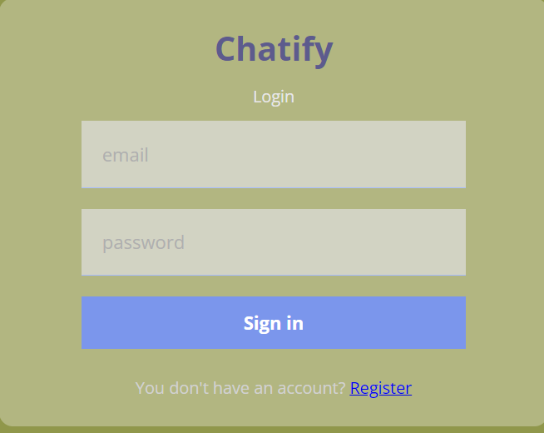

**Chat interface:**

