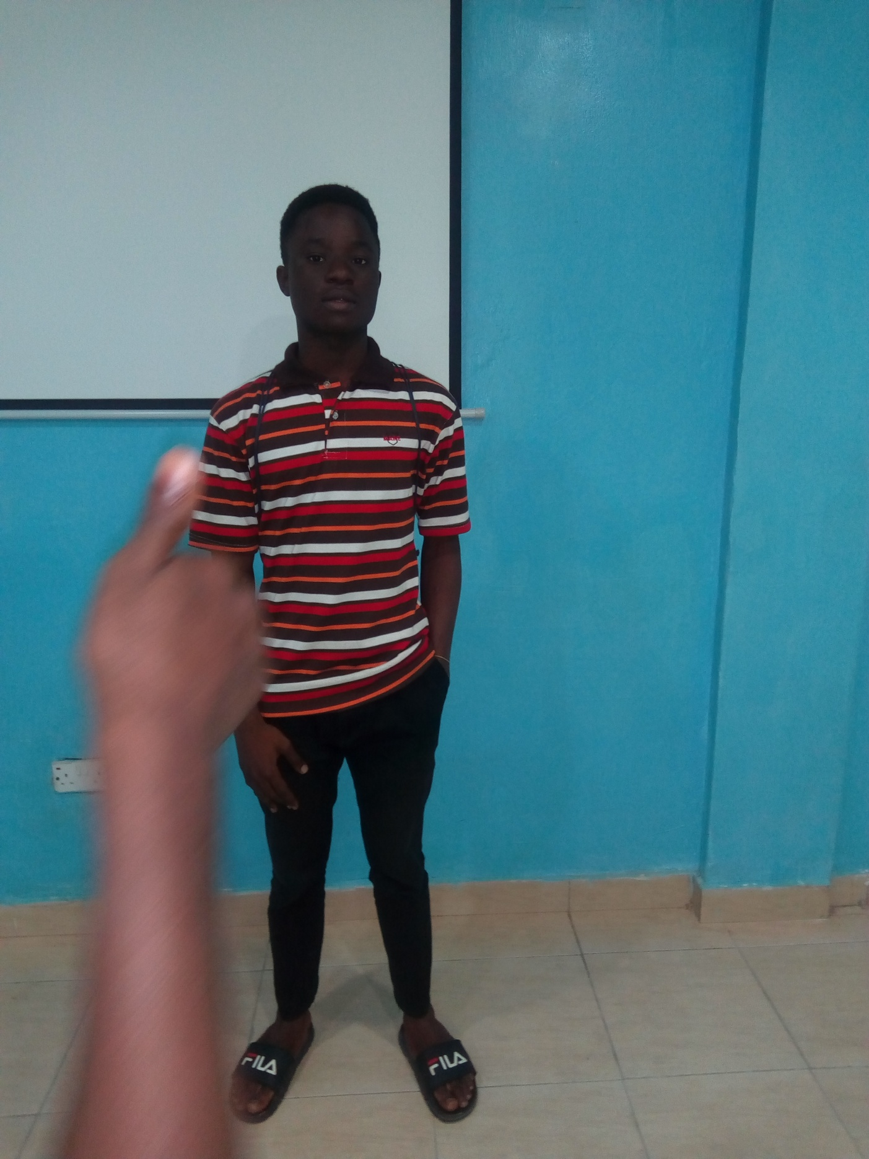**AKINTUNLESE OLUWATOBI**

**Mobile Developer**

Phone: 08140309671

Email: akintunlesetobi@gmail.com

*LinkedIn:*

<https://www.linkedin.com/in/akintunlese-oluwatobi/>

*Twitter:*

<https://twitter.com/AkintunleseTobi>

*GitHub:*

https://github.com/oluwatobi1/  
Facebook:

https://www.facebook.com/akintunlese.tobi

**EDUCATION**

|  |  |
| --- | --- |
| SCHOOL | University of Lagos |
| Faculty | Engineering |
| Department | Mechanical Engineering |
| Level | 300 |
| Best Course so far | Machine Drawing |