NETWORKWALKS
PENETRATION TESTING REPORT
MEDIROZA GENERAL HOSPITAL
Batch B083F | Week 4 | M4 Final Report
Black-box Web Application Penetration Test

Engagement Item | Details
Client | Mediroza General Hospital
Target | https://medirozahospital.com
Test Type | Black-box Penetration Testing & Vulnerability Assessment
Duration | 5 Days
Authorization | Written authorization granted by the training engagement
Tester | Oluwatobiloba A. Banjo
Program / Batch | NetworkWalks — Batch B083F
Assessment Status | Completed — M1, M2, M3 and M4

CONFIDENTIAL — AUTHORISED TRAINING PERSONNEL ONLY

1. Executive Summary
This report documents the Week 4 black-box penetration-testing engagement conducted against Mediroza General Hospital's authorized training target, https://medirozahospital.com. The engagement was performed within the defined scope and rules provided by NetworkWalks, including written authorization, target-domain restriction, and prohibitions on social engineering and denial-of-service activity.
The assessment progressed through reconnaissance, web enumeration, application-access testing, retrieval of three authorized patient-report PDFs, password-recovery testing of those files, and analysis of an exposed historical database backup. The assessment identified multiple security weaknesses that combined to create significant confidentiality risk.
The most significant result was successful unauthorized access to a restricted patient area through an application input/authentication weakness, followed by retrieval of three confidential PDF reports. All three reports were protected with PDF Standard Security Revision 3 (128-bit), but their passwords were successfully recovered using a dictionary-based password-recovery tool. Subsequent analysis also confirmed a publicly accessible SQL database backup under the /old/ directory containing staff and shareholder table structures and confidential record fields.
Because the evidence demonstrates unauthorized access to restricted information and exposure of confidential staff, ownership, and patient-related data within the authorized laboratory environment, the overall risk is assessed as HIGH, with individual findings rated according to their demonstrated impact.
ID | Finding | Risk | Status
F-01 | Web application authentication/input weakness enabling restricted-area access | Critical | Confirmed
F-02 | Public directory indexing exposing sensitive application paths | High | Confirmed
F-03 | Publicly accessible database backup containing confidential records | High | Confirmed
F-04 | Weak PDF passwords protecting confidential reports | High | Confirmed
OBS-01 | Exposed service/technology information and multiple externally reachable services | Low–Medium | Observed

2. Scope and Methodology

2.1 Scope
Item | Scope Definition
Target | https://medirozahospital.com
Assessment Type | Full black-box penetration test
Environment | Authorized NetworkWalks educational/controlled environment
Allowed | Reconnaissance, enumeration, authentication testing, controlled exploitation, evidence collection
Excluded | Social engineering, denial of service, and testing outside the target domain
Authorization | Written authorization was explicitly stated in the project brief

2.2 Methodology
The assessment followed a practical black-box workflow:
- Reconnaissance and target identification.
- DNS, HTTP, web-technology and service enumeration.
- Directory and application-path discovery.
- Authentication and input-behaviour assessment.
- Controlled exploitation to demonstrate impact within the authorized target.
- Collection of the three milestone-specified PDF reports.
- PDF encryption analysis and password-recovery testing.
- Local validation of recovered/decrypted files.
- Analysis of retrieved artifacts and publicly exposed server-side files.
- Risk assessment, remediation recommendations and evidence documentation.

2.3 Tools Used
Tool | Purpose
WHOIS | Domain registration and DNS infrastructure reconnaissance
NSLookup | DNS resolution and IP identification
cURL | HTTP response and header analysis
WhatWeb | Web technology fingerprinting
Nmap | Port and service discovery
Gobuster | Web directory and file enumeration
Browser / HTTP tools | Manual validation of discovered directories, files, login pages and application endpoints.
NetworkWalks Hash Calculator | Password/hash analysis and recovery testing against the retrieved encrypted PDF files.
NetworkWalks Password Cracker | Password recovery testing against the retrieved encrypted PDF files using supported cracking functionality.
pdf2john | Extraction of PDF password hashes for password-recovery testing with John the Ripper.
John the Ripper | Password-cracking attempt against the extracted PDF hashes.
pdfcrack | Authorized PDF password-recovery testing
qpdf | PDF decryption and encryption-state validation
pdfinfo | PDF metadata and encryption-state inspection
ExifTool | PDF metadata inspection
pdf-parser | PDF object and metadata analysis

2.4 Limitations
- The assessment was limited to the authorized target domain.
- No denial-of-service testing was performed.
- No social-engineering activity was performed.
- The report intentionally excludes patient records, session cookies, employee PII, salary values and shareholder identities.
- Service-version observations were treated as reconnaissance information unless a vulnerability was directly demonstrated.

3. Reconnaissance and Attack Surface
Initial reconnaissance identified the target's public-facing infrastructure and web application characteristics. The target resolved to 199.188.201.16. HTTP/HTTPS responses identified LiteSpeed and other proxy/service components. Nmap identified externally reachable services including FTP, SMTP, DNS, HTTP/HTTPS, POP3 and IMAP.
These observations established a broad attack surface. The assessment did not treat service banners or software-version information alone as vulnerabilities; they were used to guide subsequent authorized testing.
Observation | Result | Security Significance
DNS | medirozahospital.com → 199.188.201.16 | Identifies the public-facing service address
HTTP | HTTP redirects to HTTPS | Confirms web service and transport behaviour
Web server | LiteSpeed observed | Technology fingerprinting information
Open services | 21, 25, 26, 53, 80, 110, 143, 443, 465, 587, 993, 995 | Broad externally reachable service surface
robots.txt | Referenced /patient/, /staff/ and /old/ | Exposed application paths requiring review
Directory discovery | /patient/, /staff/, /old/ | Confirmed directory indexing/misconfiguration

4. Findings and Proof of Exploitation

F-01 — Authentication / Input Weakness Enabling Restricted-Area Access
Risk Rating: CRITICAL
Testing of the web application's authentication/input handling resulted in successful unauthorized access to a restricted patient area within the authorized environment. This provided access to the milestone-specified patient-report resources.

Evidence / Impact
- A restricted patient portal was identified during enumeration.
- Authentication/input behaviour was tested within the authorized scope.
- The assessment achieved access to the restricted area.
- Three confidential patient-report PDFs were retrieved as required by M1.
- The impact demonstrates that the application access control could be bypassed sufficiently to reach protected information.

Why this is Critical
The demonstrated impact goes beyond information disclosure or fingerprinting: an external tester was able to reach a restricted application area and retrieve confidential reports. In a real healthcare environment, this type of weakness could materially affect confidentiality and potentially expose regulated information.

Recommended Remediation
- Identify and remediate the vulnerable authentication/input-handling code path.
- Use parameterized queries/prepared statements for all database interaction.
- Apply strict server-side input validation and context-aware output encoding.
- Do not rely on client-side controls for authorization.
- Implement centralized authorization checks on every protected endpoint.
- Review authentication and authorization logs for indicators of abuse.
- Retest the complete authentication flow after remediation.

F-01 Evidence
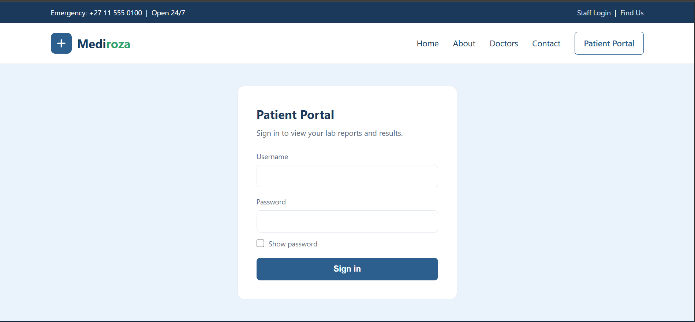
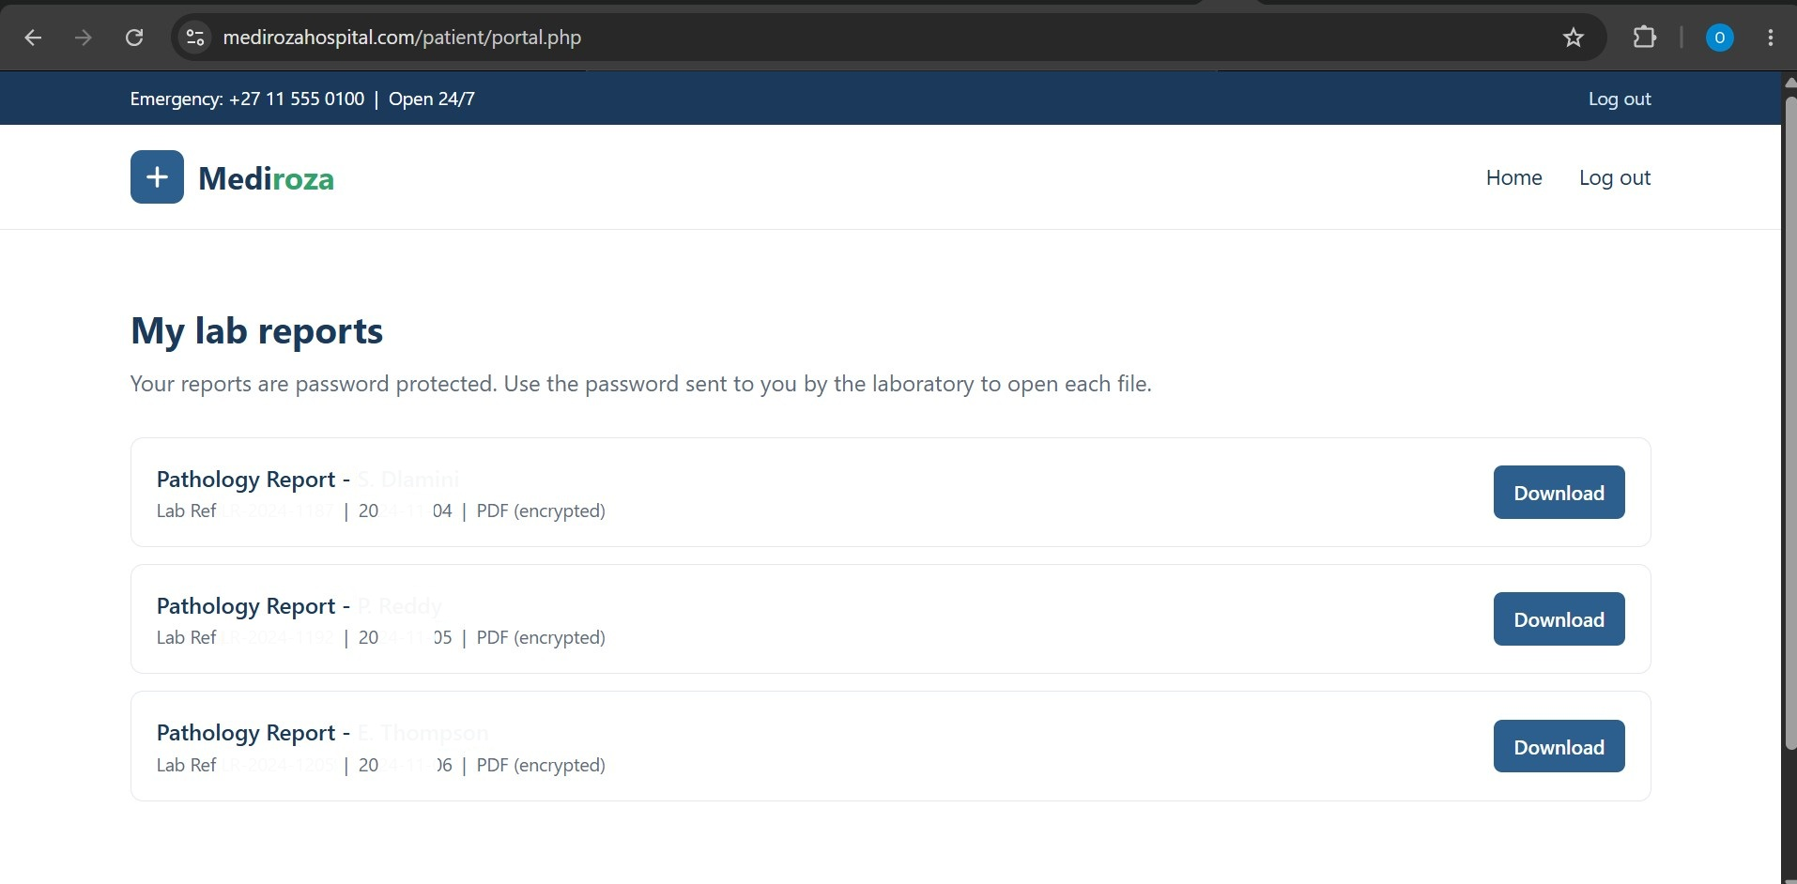

F-02 — Public Directory Indexing Exposing Sensitive Application Paths
Risk Rating: HIGH
Directory indexing was confirmed on multiple application paths. The /staff/, /patient/ and /old/ directories returned HTTP 200 responses containing directory listings. The listings exposed authentication endpoints, patient portal resources, an error log, and historical backup content.
Path | Confirmed Exposure | Impact
/staff/ | staff/login.php | Reveals restricted staff authentication entry point
/patient/ | login.php, portal.php, download.php, reports/, error_log | Reveals patient application structure and potentially sensitive log location
/old/ | mediroza_db_backup_2019.sql | Directly exposes historical database backup

Recommended Remediation
- Disable directory indexing/autoindexing on web-accessible directories.
- Remove sensitive files, logs and backups from the web document root.
- Return access-denied responses for directories that should not be public.
- Review all historical directories for forgotten application artifacts.
- Implement a deployment process that prevents backups and logs from entering public web roots.
F-02 Evidence 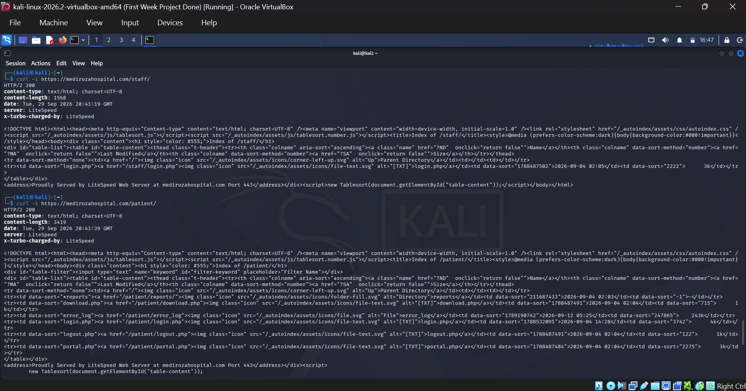
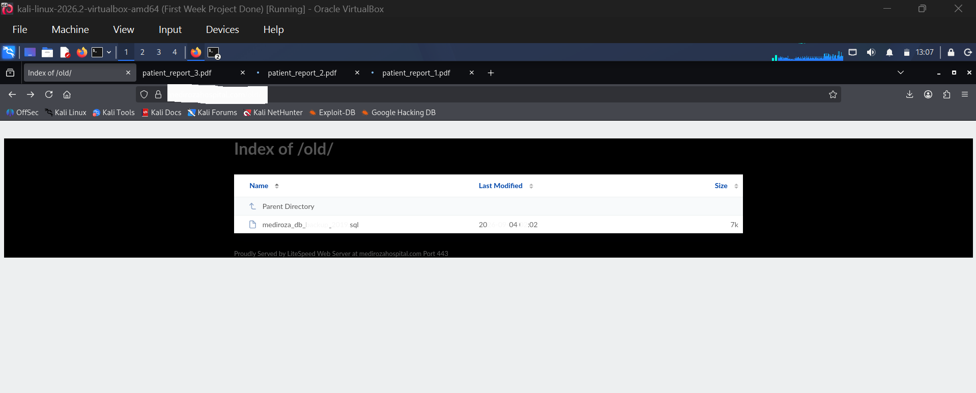

F-03 — Publicly Accessible Database Backup Containing Confidential Records
Risk Rating: HIGH
The historical SQL backup /old/mediroza_db_backup_2019.sql was directly retrievable without authentication. An HTTP HEAD request returned 200 OK and the file was downloaded locally for authorized analysis.
Structural analysis confirmed the presence of staff and shareholders tables. The staff schema included fields for employee identity/contact information, national identification information, monthly salary and employment date. The shareholders schema included shareholder identity and ownership-related fields.
Actual employee names, contact details, national IDs, salary values and shareholder records are intentionally excluded from this report to prevent unnecessary disclosure of confidential information.

Impact
- Confidential employee information could be exposed to an unauthenticated external party.
- Compensation information could be disclosed.
- Identity-related information could be exposed.
- Shareholder/ownership information could be disclosed.
- A database backup may contain additional historical data beyond the tables observed during this assessment.

Recommended Remediation
- Remove the SQL backup from the public web root immediately.
- Store backups outside the web-accessible document root.
- Disable directory indexing for historical/archive directories.
- Review the server for additional backups, database dumps, logs and temporary files.
- Rotate any credentials or secrets that may have been stored in historical backups.
- Restrict backup access using appropriate permissions and authenticated administrative storage.
- Implement backup-retention and secure-deletion procedures.
F-03 Evidence
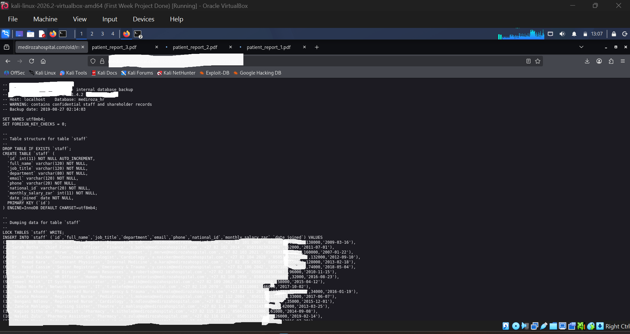
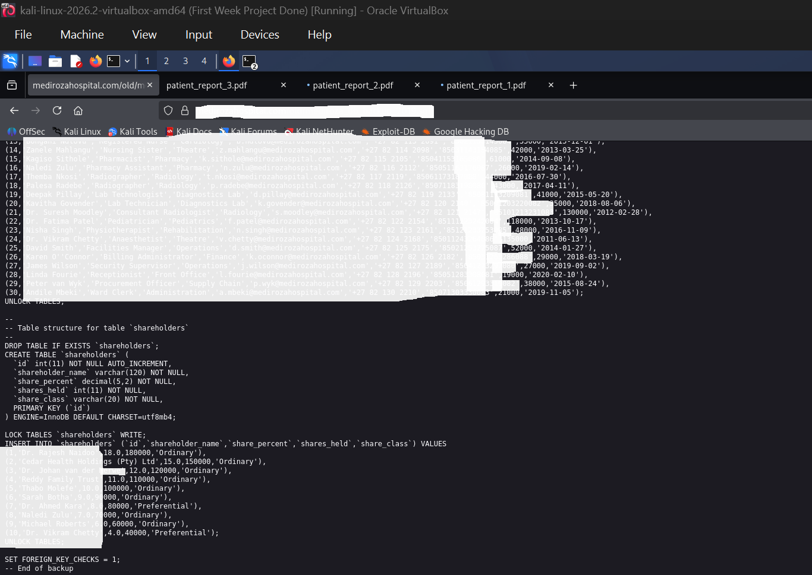

F-04 — Weak Passwords Protecting Confidential PDF Reports
Risk Rating: HIGH
All three retrieved PDFs were protected with the PDF Standard Security Handler using Revision 3 and 128-bit encryption. Dictionary-based password recovery using pdfcrack and the RockYou wordlist successfully recovered the user passwords for all three files.
Cross-tool validation: the NetworkWalks Hash Calculator and Password Cracker were also used during M2. The NetworkWalks tools successfully recovered the passwords for Patient Report 1 and Patient Report 2. Patient Report 3 was not successfully cracked using the NetworkWalks tools. It was subsequently recovered using pdfcrack with the authorized RockYou wordlist. This cross-tool result demonstrates that the recovery outcome for Reports 1 and 2 was reproducible across the training toolsets, while Report 3 required a different password-recovery approach.
The recovered passwords are intentionally not reproduced in this report. The successful recovery demonstrates that the encryption layer did not provide effective protection against a common-password/dictionary attack.
Report | Encryption | Password Recovery | Validation
Patient Report 1 | Standard V2.3 / 128-bit / R3 | Successful | qpdf confirmed decrypted PDF was not encrypted
Patient Report 2 | Standard V2.3 / 128-bit / R3 | Successful | qpdf confirmed decrypted PDF was not encrypted
Patient Report 3 | Standard V2.3 / 128-bit / R3 | Successful | qpdf confirmed decrypted PDF was not encrypted

Recommended Remediation
- Use strong, randomly generated passwords for sensitive exported documents.
- Avoid common words, predictable sequences and keyboard patterns.
- Use modern document-protection mechanisms where appropriate.
- Treat encryption and password strength as separate controls: strong encryption cannot compensate for weak passwords.
- Establish a secure process for distributing and storing patient reports.
F-04 Evidence 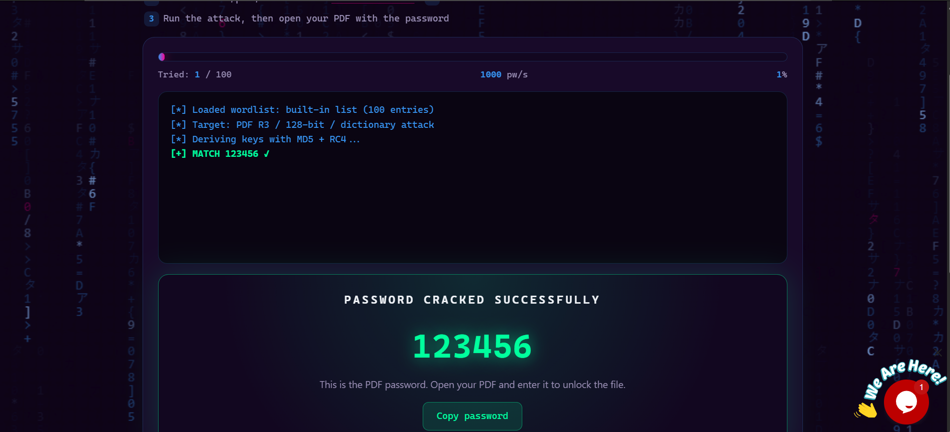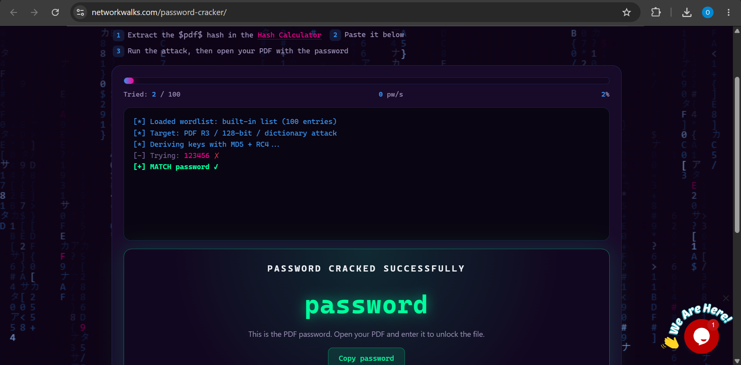
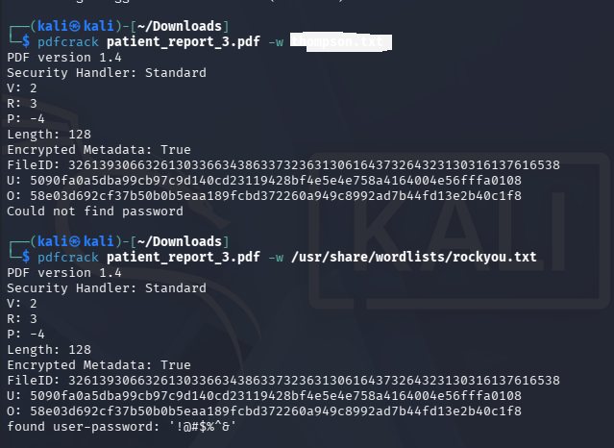

OBS-01 — Externally Reachable Services and Technology Information
Risk Rating: LOW–MEDIUM (Observation)
Nmap identified multiple externally reachable services including FTP, SMTP, DNS, HTTP/HTTPS, POP3 and IMAP. Service enumeration also identified technologies including Pure-FTPd, Exim, Dovecot, BIND and HAProxy/LiteSpeed-related components. These observations were not independently treated as exploitable vulnerabilities because no direct version-specific exploit was validated during the engagement.

Recommended Remediation
- Review whether every externally reachable service is required.
- Restrict administrative and legacy services where business need does not require public exposure.
- Keep all externally exposed services patched and monitored.
- Use network access controls and segmentation where appropriate.
- Minimize unnecessary service and version disclosure.

4.5 M2 Cross-Tool Password-Recovery Validation
M2 was performed using two password-recovery approaches required by the training workflow. The NetworkWalks Hash Calculator and Password Cracker were used first; they successfully recovered the passwords for Patient Report 1 and Patient Report 2, while Patient Report 3 was not recovered with those tools. A separate authorized recovery approach using pdfcrack and the RockYou wordlist successfully recovered the password for Patient Report 3. All three recovered passwords were then validated by decrypting the corresponding PDFs with qpdf. The recovered passwords themselves are intentionally excluded from this report.

5. Milestone Results
Milestone | Objective | Result | Status
M1 | Retrieve three confidential patient PDF lab reports | Three authorized PDFs were retrieved from the restricted area. | Completed
M2 | Crack encryption on all three PDFs | NetworkWalks Hash Tools recovered Reports 1 and 2; Report 3 required pdfcrack. All three PDFs were successfully decrypted and validated with qpdf. | Completed
M3 | Find staff salaries and shareholder details | Public SQL backup exposed staff and shareholder table structures and confidential record fields. | Completed
M4 | Produce professional penetration-testing report | This report documents scope, methodology, findings, risk ratings and remediation. | Completed

6. Evidence Handling and Confidentiality
Because the engagement involved healthcare-themed records and confidential organizational information, evidence has been handled on a need-to-know basis. Public project documentation should contain only sanitized evidence.
- Do not publish the three patient PDFs.
- Do not publish recovered PDF passwords.
- Do not publish complete PDF hashes or session cookies.
- Do not publish employee names, phone numbers, email addresses or national identification numbers.
- Do not publish individual salary amounts or shareholder identities/holdings.
- Use redacted screenshots for GitHub and LinkedIn evidence.
- Retain original evidence only in the authorized local training environment.

7. Recommendations and Remediation Plan
Priority | Action | Related Finding
Immediate | Remediate the authentication/input weakness and enforce server-side authorization on protected resources. | F-01
Immediate | Remove the publicly accessible SQL backup and other sensitive historical files from the web root. | F-03
Immediate | Disable directory indexing for /patient/, /staff/, /old/ and similar directories. | F-02/F-03
High | Review and secure all backup, log and temporary files accessible through the web server. | F-02/F-03
High | Replace weak PDF passwords with strong, unique credentials and secure document-distribution procedures. | F-04
High | Review authentication/session management and monitor for suspicious access attempts. | F-01
Medium | Review publicly exposed services and remove those not required. | OBS-01
Medium | Patch and continuously monitor externally exposed services. | OBS-01
Medium | Conduct a follow-up penetration test after remediation. | All

8. Conclusion
The Week 4 Mediroza General Hospital assessment demonstrated how weaknesses across application security, access control, file handling and password security can combine to create substantial confidentiality risk.
The engagement successfully completed all four milestones. M1 demonstrated access to the restricted patient-report area and retrieval of three authorized reports. M2 demonstrated that all three reports could be decrypted after dictionary-based password recovery. M3 identified a publicly accessible historical SQL backup containing confidential staff and shareholder information. M4 consolidates these results into a professional penetration-testing report.
The most important remediation themes are secure application input handling, robust authorization controls, removal of sensitive files from public web roots, disabling directory indexing, strong document passwords, and disciplined backup management.
All testing described in this report was performed within the authorized NetworkWalks educational scope. No denial-of-service or social-engineering activity was performed.

9. Appendix A — Sanitized Technical Evidence
Evidence | Sanitized Observation
DNS | medirozahospital.com resolved to 199.188.201.16
HTTP | HTTP redirected to HTTPS; HTTPS returned successful responses during testing
robots.txt | Referenced /patient/, /staff/ and /old/
Directory indexing | /patient/, /staff/ and /old/ returned directory listings
Patient portal | /patient/portal.php redirected unauthenticated requests to login.php
SQL backup | /old/mediroza_db_backup_2019.sql returned HTTP 200
PDF encryption | All three reports used Standard PDF security, Revision 3, 128-bit
Password recovery | All three authorized PDF passwords were recovered using pdfcrack
Decryption | qpdf validated all three decrypted PDFs as not encrypted
Database structure | staff and shareholders tables confirmed in the exposed SQL backup

10. Appendix B — Public Documentation Rules
For the GitHub repository and LinkedIn post, evidence should be sanitized before publication. The public version should demonstrate the technical work without exposing confidential client or patient information.
- Use redacted screenshots only.
- Reference findings by ID rather than publishing sensitive data.
- Describe schemas and data categories rather than actual records.
- Never include passwords, hashes, cookies or tokens.
- Keep original evidence files in the authorized local project environment.

— END OF REPORT —
Oluwatobiloba Banjo | NetworkWalks Batch B083 | Week 4

