DEVELOPMENT OF A WEB-BASED ESCROW PLATFORM TO ENHANCE TRUST AND SECURITY IN E-COMMERCE TRANSACTIONS IN NIGERIA

BY

EMMANUEL, JETHRO SHEKWODUZA
2019/1/75485CT

DEPARTMENT OF COMPUTER SCIENCE,
FEDERAL UNIVERSITY OF TECHNOLOGY MINNA,
NIGERIA.

OCTOBER 2025.

DEVELOPMENT OF A WEB-BASED ESCROW PLATFORM TO ENHANCE TRUST AND SECURITY IN E-COMMERCE TRANSACTIONS IN NIGERIA

BY

EMMANUEL, JETHRO SHEKWODUZA
2019/1/75485CT

PROJECT SUBMITTED TO THE DEPARTMENT OF COMPUTER SCIENCE, SCHOOL OF INFORMATION AND COMMUNICATION TECHNOLOGY, FEDERAL UNIVERSITY OF TECHNOLOGY, MINNA, NIGERIA IN PARTIAL FULFILLMENT OF THE REQUIREMENT FOR THE AWARD OF THE DEGREE OF BACHELOR OF TECHNOLOGY IN COMPUTER SCEINCE

OCTOBER, 2025

DECLARATION
I hereby declare that this project titled “Development of a web-based escrow platform to enhance trust and security in e-commerce transactions in Nigeria” is entirely and exclusively written by Emmanuel Jethro Shekwoduza under the supervision of Dr. O. A. Ojerinde. Information hereby obtained from the published work of others have been properly referenced and acknowledged.

EMMANUEL JETHRO SHEKWODUZA
___________________ ________________
2019/1/75485CT Signature and Date
Federal University of Technology
Minna, Nigeria

CERTIFICATION
The project titled: “Development of a web-based escrow platform to enhance trust and security in e-commerce transactions in Nigeria” by EMMANUEL, Jethro Shekwoduza with matriculation number 2019/1/75485CT, meets the regulations governing the award of Bachelor of Technology Bachelor of Technology in Computer Science of the Federal University of Technology Minna.

DR O. A. OJERINDE
___________________ ________________
Project Supervisor Signature and Date

DR E. F. AMINU
___________________ ________________
Head of Department Signature and Date

___________________ ________________
External Examiner Signature and Date

DEDICATION
This project is first and foremost dedicated to the Almighty God, whose unfailing grace, protection, and wisdom have been my constant guide throughout this journey. I wholeheartedly dedicate it to my beloved parents and family, whose endless love, prayers, and encouragement have been my foundation and strength. Lastly, this work is dedicated to all scientists, innovators, and advocates who continue to devote themselves to sustainable solutions and the preservation of our natural environment for generations yet to come.

ACKNOWLEDGEMENTS
I give thanks to Almighty God for His divine grace, wisdom, and strength which enabled me to complete this project successfully.
I extend my deepest appreciation to my supervisor, Dr. O.A. Ojerinde, for his guidance, efforts, and sacrifices, which have been crucial to the success of this study My appreciation also goes to Dr. E. F. Aminu, Prof. J. K. Alhassan, Dr (Mrs) Abisoye, Dr. M. B. Abdullahi, Dr. S. A. Bashir, Dr. S. Adepoju, Dr. M. D. Abdumalik, Mr A. Saliu, Dr I. S. Shehu, Dr C. Ugwoke, Dr M. I. Kolo, Dr (Mrs) A. Ekundayo Mr Y. B. Lasotte, Dr. M. K. Muhammad, Mr K. Abdullahi, Mr A. U. Sani, Mr B. I. Aloghena, Mr S. T. Abubakar, Mr O. L. Lawal, Mr K. H. Lawal, Mr S. M. Badeggi, Mr A. A. Saidu, Mr A. Musa, Mr A. Abdullahi, Mr K. M. Bashir, Mr F. A. Yusuf, Mr Y. Abubakar, Mrs C. I. Osagie, Mr M. S. Abdukadir, Mr I. B. Muhammad, thank you all for impacting me with knowledge, may God bless you and your home.
My heartfelt gratitude goes to my parents and family for their unwavering love, prayers, and moral support throughout my academic journey.
I also acknowledge my friends and colleagues who contributed in various ways, whether through technical assistance, or collaboration during the course of this research most especially Abu, Gospel and Solomon. Finally, I appreciate everyone who, directly or indirectly, contributed to the successful completion of this project.
I say thank you all and may God bless you richly.

ABSTRACT
The rapid growth of e-commerce in Nigeria has created vast opportunities for businesses and consumers, but issues such as online fraud, lack of trust, and payment insecurity continue to discourage participation. This project focuses on the design and development of a secure web-based escrow platform aimed at enhancing trust and security in online transactions. The system introduces an intermediary service that holds payment funds in escrow until both buyer and seller have fulfilled their obligations, thereby ensuring fairness and accountability in every transaction. The platform was developed using a three-tier architecture comprising the frontend, backend, and database layers. Technologies such as Next.js and React were employed for the user interface, Flask (Python) for backend processing, and MongoDB for data management. Security was ensured through AES-256 encryption, TLS 1.3 communication protocol, and JSON Web Token (JWT) authentication. Evaluation metrics including transaction success rate, dispute resolution rate, and user satisfaction indicated that the platform effectively reduces fraud risks and increases user confidence in online trade. In conclusion, the developed escrow platform demonstrates that integrating trust mechanisms into e-commerce systems can significantly improve security, transparency, and user satisfaction. It is recommended that future developments should incorporate mobile applications and automated dispute resolution features to improve accessibility and scalability, while relevant regulatory bodies should consider establishing clear policies to guide escrow operations within Nigeria’s digital commerce environment.

.

TABLE OF CONTENTS
CONTENT PAGE
Cover page i
Title page ii
Declaration iii
Certification iv
Dedication v
Acknowledgement vi
Abstract vii
Table of Contents viii
List of Tables xi
List of figures xii
CHAPTER ONE: INTRODUCTION
1.1 Background to the study 1
1.2 Motivation of Study 4
1.3 Statement of the problem 4
1.4 Aims and Objectives of Study 6
1.5 Significance of Study 7
1.6 Scope and Limitation of Study 7
1.7 Organization of Study 8
1.8 Definition of Terms 9
CHAPTER TWO: LITERATURE REVIEW
2.1 Historical Evolution of Trade 11
2.2 Transition from Traditional to Digital Commerce 12
2.3 Growth of E-Commerce in Nigeria and Globally 13
2.4 Definition and Categories of E-Commerce 15
2.5 Process Flow and Key Stakeholders 16
2.6 Payment Gateways and Online Transaction Mechanisms 17
2.7 User Trust and Perceived Risk in Online Payments 18
2.8 Privacy Protection Standards (SSL, Encryption, GDPR) 19
2.9 Fraud, Scams, and Cybersecurity Concerns in Nigeria 20
2.10 The Concept of Escrow and Its Historical Context 21
2.11 Functionality and Operational Models of Escrow Systems 22
2.12 Role of Escrow in Enhancing Trust and Transactional Fairness 24
2.13 Nigeria’s E-Commerce and Digital Finance Laws 24
2.14 Consumer Protection Guidelines 26
2.15 Related works 27
CHAPTER THREE: SYSTEM ANALYSIS AND DESIGN
3.1 Design of the proposed system 39
3.2 System requirements 42
3.3 System Architecture 46
3.4 Conceptual Model 48
3.5 Flowchart 49
3.6 Use Case of the Proposed System 50
3.7 Algorithm 52
3.8 Design Methodology 53
3.9 Evaluation Metrics 55
CHAPTER FOUR: SYSTEM IMPLIMENTATION AND TESTING
4.1 Choice of Programming Languages 58
4.2 Landing page 60
4.3 Sign up and Login Page 61
4.4 Buyer Dashboard 62
4.5 Seller Selection 63
4.6 Payment Platform Selection 64
4.7 Flutterwave Card Details 64
4.8 Flutterwave Pin Entry 66
4.9 Flutterwave OTP Confirmation 67
4.10 Payment Successful 68
4.11 Seller Dashboard 69
4.12 Transaction Details 70
4.13 Delivery Details 70
4.14 Admin Dashboard 71
4.15 Email Notification 72
4.16 Email Notification 72
4.17 System evaluation and results 73

CHAPTER FIVE: SUMMARY, CONCLUSION AND RECOMMENDATIONS
5.1 Summary 76
5.2 Conclusion 77
5.3 Recommendations 77
References 79
Appendix 84

LIST OF TABLES
TABLE PAGE
2.1: Summary of Related Work 37
3.1 Objectives Steps and Methods 40
4.1 System Evaluation Result 73
4.2 User Evaluation result 74

LIST OF FIGURES
FIGURE PAGE
3.1: System Architecture 46
3.2: Conceptual Diaram 48
3.3: Flowchart 49
3.4: Use case diagram 50
3.5 Design methodology 53
4.1 Landing Page 60
4.2 Sign Up and Login Page 61
4.3 Buyer Dashboard 62
4.4 Seller Selection 63
4.5 Payment Platform Selection 64
4.6 Flutterwave Card Details 65
4.7 Flutterwave Pin Entry 66
4.8 Flutterwave OTP Confirmation 67
4.9 Payment Successful 68
4.10 Seller Dashboard 69
4.11 Transaction Details 70
4.12 Delivery Details 70
4.13 Admin Dashboard 71
4.14 Email Notification 72

CHAPTER ONE
1.0 INTRODUCTION
1.1 Background to the Study
Trade has always been an essential element of human society, serving as the primary mechanism through which individuals, groups, and nations exchange goods and services to meet needs and foster economic growth. In its earliest form, trade was carried out through barter, where commodities were exchanged directly without a standardized medium of value. Although this system facilitated local exchange, it was inefficient in complex economies due to the difficulty of matching needs between trading partners. The introduction of money as a medium of exchange revolutionized commerce by simplifying transactions, enabling long-distance trade, and supporting the expansion of markets (Tokse et al., 2021). Over time, trade has evolved from rudimentary exchanges into structured systems that form the backbone of global and national economies.
In Nigeria, trade has followed a unique historical trajectory shaped by cultural diversity, geography, and external influences. Pre-colonial trade was vibrant and regionally diverse, with communities in different ecological zones specializing in particular goods. The northern region, for example, was a hub for trans-Saharan trade, exchanging salt, leather, and agricultural produce with North African merchants, while the forest regions engaged in the trade of kola nuts, palm oil, and textiles (Ekundare, 1973). This early commercial activity not only sustained livelihoods but also integrated Nigeria into broader regional and continental markets.
With the advent of European contact, Nigeria became enmeshed in the Atlantic trade, which brought new goods and reshaped traditional trade structures. During the colonial period, formal markets and infrastructural systems such as railways and ports were established, further connecting Nigeria to global commerce. Cash crops such as cocoa, groundnuts, and palm oil dominated exports, while imported manufactured goods increasingly circulated in local markets. This period also consolidated the role of currency in trade, phasing out barter and embedding Nigeria firmly into the international economic system (Ekundare, 1973). Post-independence, the expansion of industries, growth of urban centers, and oil-driven economic policies further altered the dynamics of trade, creating opportunities for modernization and diversification of commerce.
The late twentieth century introduced a new phase in the history of trade with the advent of the internet and information and communication technologies (ICTs). These innovations gave birth to electronic commerce (e-commerce), defined as the buying and selling of goods and services through digital platforms (Jain et al., 2021). Globally, e-commerce has expanded rapidly, fueled by the growth of online marketplaces, mobile payments, and digital service platforms. It has revolutionized the speed and efficiency of transactions, reduced geographical barriers, and redefined business models by creating opportunities for small and large enterprises alike (Li & Wang, 2020).
In Nigeria, e-commerce has grown steadily in the last two decades, supported by increasing internet penetration, rapid mobile phone adoption, and a youthful, tech-savvy population. Digital platforms such as Jumia, Konga, and PayPorte have become household names, providing consumers with access to diverse products ranging from electronics to groceries (Daramola & Etim, 2022). Payment infrastructures such as electronic transfers, mobile banking, and digital wallets, overseen by the Central Bank of Nigeria (CBN), have also expanded the scope of digital trade, bringing millions into the formal financial system (Ogbo & Onwe, n.d.).
Despite this progress, Nigeria’s e-commerce sector faces persistent challenges that undermine its potential. A central concern is the issue of trust between buyers and sellers. Unlike traditional commerce, where transactions are immediate and physical verification is possible, e-commerce involves separation in time and space, which exposes consumers to risks of product misrepresentation, non-delivery, and outright fraud (Chiluwa et al., 2018). Numerous cases of fake websites, online scams, and fraudulent practices have heightened consumer skepticism, discouraging wider adoption of online platforms (Galadima & Olanrewaju, 2024). Weak consumer protection laws, inconsistent dispute resolution mechanisms, and infrastructural limitations such as unreliable delivery systems compound these problems, making many Nigerians hesitant to embrace digital trade fully.
It is within this context that escrow services are gaining attention as a critical trust-building mechanism. Escrow services involve neutral third-party holding funds in trust until both buyer and seller have fulfilled their contractual obligations. This arrangement ensures that buyers are not defrauded by non-delivery or substandard goods, while sellers are protected from payment defaults after they have supplied goods or services (Cook et al., 2004). Escrow thus promotes fairness and reduces risk in digital transactions, addressing the very issues that hinder e-commerce adoption in Nigeria. While escrow is well established in international trade, real estate, and high-value digital transactions, its application within Nigeria’s e-commerce environment remains limited. Barriers include low awareness among consumers and businesses, as well as the absence of specific regulatory frameworks to guide its operation (Antony et al., 2014).
Nonetheless, the potential of escrow services to reshape Nigeria’s e-commerce landscape is significant. By fostering trust, reducing fraudulent practices, and providing structured mechanisms for dispute resolution, escrow can help overcome the barriers limiting digital commerce participation. As Nigeria continues to diversify its economy and promote digital innovation, the integration of escrow into its e-commerce system represents a vital step toward ensuring transparency, fairness, and sustainable growth(Z. Lin & Hu, 2015).
1.2 Motivation of the Study
The core motivation arises from the global and persistent challenge of fostering trust in online transactions. Although fintech innovations offer system-based reassurance mechanisms—like escrow, reputation scoring, and dispute frameworks—few projects have combined these elements into coherent, scalable solutions that work across different cultural and infrastructural settings. By creating and testing such a system, the research not only advances academic understanding but also addresses real-world challenges facing both individual and institutional digital commerce participants worldwide.
1.3 Statement of the Problem
E-commerce has emerged as one of the fastest-growing sectors globally, reshaping how consumers and businesses interact. In Nigeria, the sector has experienced notable growth driven by increased internet penetration, mobile adoption, and digital platforms. Despite this promise, the sustainability of e-commerce in Nigeria is undermined by persistent challenges of trust, fraud, weak regulation, and poor consumer protection mechanisms (Daramola & Etim, 2022).
A major barrier to adoption is the lack of trust between buyers and sellers. In traditional markets, goods can be inspected before purchase, but in online trade, buyers rely solely on digital descriptions and images. This has led to widespread cases of misrepresentation, non-delivery, and outright scams, discouraging repeat purchases (Chiluwa et al., 2018). Such experiences have created a trust deficit that limits the growth of Nigeria’s digital economy.
Fraud and cybercrime exacerbate this problem. Nigeria has gained notoriety for online scams, ranging from phishing and identity theft to fake banking apps and 419 frauds (Galadima & Olanrewaju, 2024). Recent empirical data underscores the severity of these risks. Between 2013 and 2021, electronic banking fraud in Nigeria spanned multiple channels and resulted in billions of naira in losses, with mobile, internet, and POS transactions most affected (Fitriana & Kusumawati, 2020). Another report found that e-payment systems lost more than ₦4 billion to fraud in 2015 alone, with social engineering attacks accounting for a significant share (Ademe-godwin & Dominic, 2023). These statistics reflect increasing sophistication among fraudsters and persistent consumer skepticism. Many Nigerians continue to prefer cash-on-delivery or avoid e-commerce entirely, limiting digital inclusion and slowing growth.
Although digital payment systems such as online transfers, mobile banking, and gateways have expanded access, they remain vulnerable to fraud, failed transactions, and service disruptions (Ogbo & Onwe, n.d.). Regulatory frameworks from the Central Bank of Nigeria have improved oversight but remain insufficient to fully address consumer risks. In addition, Nigeria’s broader legal environment for e-commerce is fragmented, leaving gaps in liability assignment, dispute resolution, and protection of consumers in digital transactions (Ugwu & D, 2021).
Against this backdrop, escrow services offer a promising solution. By holding funds in trust until buyers receive their goods and sellers fulfill obligations, escrow reduces fraud, ensures fairness, and builds confidence in online exchanges (Cook et al., 2004). Yet adoption in Nigeria remains low, constrained by limited awareness, weak regulation, and reliance on informal trust systems (Antony et al., 2014).
The central problem, therefore, is that while e-commerce could be a driver of growth and inclusion in Nigeria, its development is constrained by systemic fraud, inadequate consumer protection, and lack of effective trust-building mechanisms. Without solutions such as escrow, Nigeria risks stalling its digital economy and leaving consumers and businesses vulnerable(Z. Lin & Hu, 2015).
1.4 Aim and Objectives of the Study
The aim of this project is to develop a web-based escrow platform to enhance trust and security in e-commerce transactions in Nigeria
In order to achieve this aim, the following objectives must be met:
- To design a secure escrow model that mediates payments between buyers and sellers.
- To implement the platform using secure web technologies, incorporating encryption, authentication, and fraud-prevention mechanisms.
- To evaluate the developed system in terms of trust enhancement, user satisfaction, and transaction completion rates, particularly within the Nigerian e-commerce context.

1.5 Significance of study
This study is significant because it addresses one of the major barriers to the growth of e-commerce in Nigeria—the problem of trust and security in online transactions. By developing a secure web-based escrow platform, the research provides a practical solution that promotes transparency and fairness between buyers and sellers. The system strengthens user confidence by ensuring that payments are only released when agreed conditions are met, thereby reducing fraud and disputes. It also contributes to the advancement of secure digital payment systems, supports Nigeria’s cashless policy, and provides a framework that can guide future research and development in trustworthy online transaction models.
1.6 Scope and Limitations
This study is centered on the design and development of a web-based escrow platform specifically tailored to the Nigerian e-commerce environment. The primary objective is to enhance the safety and trustworthiness of online transactions by introducing a neutral third-party system that temporarily holds funds until both buyer and seller obligations are met. The platform will serve individual users, including buyers, sellers, and administrators, and will facilitate secure transactions by incorporating key features such as user authentication, transaction monitoring, escrow fund management, and a basic dispute resolution mechanism overseen by an admin. It will be developed as a web application accessible through desktop and mobile web browsers, with a focus on delivering a secure, transparent, and easy-to-use interface for both parties involved in online transactions. The development will cover both the front-end and back-end components, using standard and widely accepted web technologies.
The project, however, is subject to certain limitations. It is designed with a geographic focus on Nigeria, and while the features may be adaptable, its initial implementation will be restricted to the local context and payment systems. The absence of a native mobile application limits accessibility for users who primarily rely on mobile apps for e-commerce interactions. Additionally, the dispute resolution process is handled manually by an administrator, which may not be efficient or scalable when dealing with a large volume of complaints or complex fraud cases. The system also depends heavily on third-party payment gateways to process transactions, making it vulnerable to external service downtimes or failures. Unlike blockchain-based escrow systems, this platform operates under centralized control, meaning that trust and arbitration are still reliant on internal administrative oversight rather than decentralized verification. Furthermore, the platform does not incorporate legally binding contracts or direct integration with national regulatory or consumer protection agencies. As an academic project, it is also subject to scalability constraints, and performance under real-world, high-volume usage has not been thoroughly tested or optimized.
1.7 Organization of Study
This research project is organized into five chapters for systematic presentation and logical flow:
- Chapter One introduces the study, providing the background, motivation, statement of the problem, aims and objectives, scope, limitations, significance, and key terms.
- Chapter Two presents a comprehensive literature review, analyzing previous works on e-commerce, escrow systems, online fraud, and digital trust frameworks.
- Chapter Three focuses on the system analysis and design, detailing the system architecture, conceptual model, algorithms, and methodologies used in developing the escrow platform.
- Chapter Four discusses the implementation and testing of the system, illustrating various interfaces such as the buyer, seller, and admin dashboards, as well as results from functional and usability testing.
- Chapter Five concludes the research with a summary, conclusion, and recommendations for future work, especially regarding scalability, mobile integration, and regulatory adoption.
1.8 Definition of terms
To ensure clarity and understanding, key terms used in this study are defined as follows:
- E-Commerce: The buying and selling of goods and services over the internet using digital platforms.
- Escrow: A secure third-party arrangement that holds funds until both buyer and seller have fulfilled the terms of a transaction.
- Buyer: An individual or entity that purchases goods or services through an online platform.
- Seller: A vendor or business that offers products or services for sale on an e-commerce platform.
- Administrator (Admin): The system authority responsible for managing user accounts, transactions, and dispute resolutions on the escrow platform.
- Trust: The confidence users have in the fairness, security, and reliability of an online transaction or system.
- Fraud: Any intentional deception aimed at unfair or unlawful gain, often occurring in online transactions through false claims or non-delivery.
- Payment Gateway: A secure intermediary that authorizes and processes electronic transactions between buyers and sellers.
- Encryption: A data protection process that converts readable information into coded form to prevent unauthorized access.
- Authentication: The process of verifying the identity of a user before granting access to the system.
- User Interface (UI): The visual and interactive part of the platform that allows users to engage with the system.
- Dispute Resolution: The process of resolving disagreements between buyers and sellers through administrative intervention within the platform.

CHAPTER TWO
2.0 LITERATURE REVIEW
2.1 Historical Evolution of Trade
The history of commerce reflects the broader story of human civilization. In its earliest forms, trade began as simple barter, where goods and services were exchanged directly between individuals or communities. Although this facilitated social interaction and met immediate needs, barter was heavily constrained by the requirement of a double coincidence of wants, meaning that both parties had to desire what the other offered simultaneously (Ekundare, 1973). This inefficiency limited the scale of trade and created barriers to the development of more complex economies.
The solution to this problem came with the introduction of commodity money—items such as cowries, salt, gold, and silver that held widely accepted value. These served as a medium of exchange, a unit of account, and a store of value, thus making trade more efficient and scalable (Tokse et al., 2021). The evolution from barter to money created the conditions for the growth of markets and allowed for specialization in production. Communities could now trade beyond their immediate environment, laying the groundwork for both local and international commerce.
In pre-colonial Nigeria, trade was already well established and dynamic. Regional markets flourished as people exchanged agricultural products, textiles, livestock, and craft goods. Long-distance trade routes, including trans-Saharan exchanges, linked Nigerian societies with North Africa and beyond, creating cultural and economic connections that enriched local economies (Ekundare, 1973). This extensive trade system shows that Nigeria had a vibrant commercial tradition long before external influences.
With the coming of colonialism, commerce in Nigeria underwent significant changes. Colonial authorities introduced formal currencies, monetized taxes, and established structured trade networks that integrated Nigeria into global commerce. These changes replaced informal systems with more institutionalized trade practices. Banks, ports, and infrastructure projects were developed to support the flow of goods, especially exports such as palm oil and groundnuts, which connected Nigeria to the global economy (Tokse et al., 2021). These developments transformed commerce from small-scale, community-based exchanges into a structured system that resembled the foundations of modern trade.
2.2 Transition from Traditional to Digital Commerce
The transition from traditional commerce to digital exchange marks one of the most important economic transformations of the modern era. Traditional commerce was defined by physical proximity between buyers and sellers, reliance on cash payments, and manual bookkeeping. These systems were effective in localized markets but limited in reach and efficiency. As trade volumes grew, the limitations of traditional commerce became more evident, especially in terms of speed, accuracy, and scalability.
The introduction of electronic data interchange (EDI) in the 1970s marked a major milestone in overcoming these limitations. By allowing organizations to transmit documents such as invoices and purchase orders electronically, EDI reduced costs and errors associated with paper-based systems. It also introduced the possibility of automating transactions and paved the way for later innovations in digital commerce (Models et al., 2009).
The commercialization of the internet in the 1990s took this transformation further. Businesses launched websites to advertise and sell products, shifting commercial activity from physical markets to digital platforms. This not only expanded the reach of firms but also redefined consumer behavior, as people became accustomed to searching for goods and services online (Tokse et al., 2021). Global examples such as Amazon and eBay demonstrated how internet-based platforms could revolutionize trade by offering variety, speed, and accessibility that were impossible in traditional markets.
In Nigeria, however, this transition faced structural challenges. Poor infrastructure, limited internet penetration, and unstable electricity supply slowed the pace of adoption. Despite this, the rapid growth of mobile telephony provided an alternative pathway for digital trade. Mobile phones, increasingly affordable and widespread, allowed businesses and consumers to bypass some infrastructural challenges. As internet access expanded, Nigerian businesses began experimenting with websites and mobile applications, offering customers new ways to engage in commerce (HUMANITIES AND SOCIAL SCIENCES, 2020).
By the late 2000s and early 2010s, Nigeria witnessed a steady integration of digital solutions into its economic landscape. Retailers, service providers, and entrepreneurs increasingly recognized the efficiency of online platforms in reaching larger audiences. Mobile payments, in particular, became a catalyst for this transition, reducing reliance on cash and providing safer, faster methods of completing transactions (Isiavwe, 2025). These changes underscore how Nigeria’s commercial practices are being reshaped, reflecting the global shift from traditional commerce to digital exchange.
2.3 Growth of E-Commerce in Nigeria and Globally
The growth of e-commerce in the twenty-first century has been dramatic, with digital platforms becoming central to the global economy. Globally, online marketplaces such as Amazon, Alibaba, and eBay redefined trade by combining broad product availability, reliable logistics, and secure digital payments (Tokse et al., 2021). Their success demonstrated the scalability of online trade and set a benchmark for e-commerce platforms worldwide. Consumers increasingly demanded convenience, speed, and reliability, leading businesses across sectors to adopt online strategies.
In Nigeria, the e-commerce sector has developed rapidly, though within a context shaped by both opportunity and constraint. Pioneering platforms such as Jumia and Konga introduced Nigerians to large-scale online retail, offering categories ranging from electronics to groceries (HUMANITIES AND SOCIAL SCIENCES, 2020). These platforms provided an alternative to traditional markets, giving consumers greater convenience and access to goods.
The Nigerian government has also played a role in supporting e-commerce growth. The Central Bank of Nigeria’s cashless policy encouraged electronic payments, reducing reliance on physical cash and stimulating adoption of digital financial services (Ogbo & Onwe, n.d.). This created an enabling environment for businesses to integrate online payment systems into their platforms.
Moreover, indigenous fintech companies such as Paystack and Flutterwave have been instrumental in addressing barriers to digital transactions. By offering secure and user-friendly payment gateways, they have reduced consumer concerns about fraud and increased confidence in online purchases (Afaha, 2019). These developments have been critical in a market where mistrust has historically limited e-commerce adoption.
Despite these successes, Nigeria’s e-commerce sector still faces challenges. Logistics infrastructure is underdeveloped, especially outside major cities, and internet penetration remains uneven across rural areas. Consumer skepticism about online fraud also continues to affect adoption rates (Ademe-godwin & Dominic, 2023). Nevertheless, the upward trajectory of Nigeria’s e-commerce growth reflects broader global patterns. It highlights how technological innovation, policy support, and consumer demand are driving digital trade, reshaping commerce both locally and internationally.
2.4 Definition and Categories of E-Commerce
E-commerce refers to the exchange of goods and services through electronic platforms, typically over the internet. It enables transactions to occur without the need for physical presence, thereby increasing convenience and efficiency for both businesses and consumers (Jain et al., 2021). Over the years, scholars and practitioners have identified various categories of e-commerce based on the parties involved in transactions. These categories demonstrate the wide-ranging applications of digital commerce.
The major categories of e-commerce include:
- Business-to-Consumer (B2C): Transactions where businesses sell directly to individual consumers through online platforms. For instance, Jumia in Nigeria and Amazon globally are examples of B2C platforms(HUMANITIES AND SOCIAL SCIENCES, 2020).
- Business-to-Business (B2B): Electronic transactions between companies, such as manufacturers supplying goods to wholesalers or retailers via online systems (Models et al., 2009).
- Consumer-to-Consumer (C2C): Transactions between individuals, often facilitated by third-party platforms such as Jiji or eBay (HUMANITIES AND SOCIAL SCIENCES, 2020).
- Consumer-to-Business (C2B): A model where individuals provide products or services to businesses, commonly seen in freelance platforms (Osilama, 2025).
- Government-to-Citizen (G2C): Transactions where government institutions provide electronic services, such as license renewals or digital tax payments (Jain et al., 2021).
These categories reveal that e-commerce is not restricted to retail shopping but extends to multiple layers of economic activity, ranging from business supply chains to government service delivery.
2.5 Process Flow and Key Stakeholders
The process flow of e-commerce typically begins when a consumer browses products or services on a digital platform. After selecting items and placing an order, payments are initiated electronically through payment gateways. Merchants then confirm orders, and goods or services are delivered through physical logistics networks or digital means in the case of software, tickets, or e-books (Supriyati & Nurfiqo, 2019). The final stage involves after-sales processes such as customer feedback, returns, and dispute resolution, which help build long-term consumer trust.
The effectiveness of this flow depends on the participation of multiple stakeholders, including:
- Merchants and Businesses: Providers of goods and services.
- Consumers: End-users who demand and pay for products and services.
- Payment Intermediaries: Banks, fintech firms, and payment gateways that ensure funds are transferred securely.
- Logistics Providers: Delivery companies such as DHL, GIG Logistics, and local courier firms that bridge the digital-physical divide (Ademe-godwin & Dominic, 2023).
- Government and Regulators: Agencies that establish consumer protection laws, regulate online payments, and enforce compliance to ensure the safety of digital transactions(Ugwu & D, 2021).
In Nigeria, fintech firms have proven especially significant. Platforms like Paystack and Flutterwave have helped resolve trust barriers by ensuring secure, seamless payment systems (Igudia, 2022). Meanwhile, reliable logistics networks are becoming increasingly important in ensuring that goods reach customers promptly, as delivery inefficiencies remain a major challenge in Nigeria’s e-commerce ecosystem (Ademe-godwin & Dominic, 2023).
2.6 Payment Gateways and Online Transaction Mechanisms
Payment gateways are vital to the e-commerce ecosystem because they authorize, process, and secure financial transactions between consumers and merchants. They act as intermediaries that encrypt sensitive financial data and verify customer details to prevent fraud (Supriyati & Nurfiqo, 2019). Without these systems, digital commerce would lack the trust and reliability necessary for sustained adoption.
Globally, several widely recognized payment gateways dominate, including: PayPal Stripe VisaNet (Supriyati & Nurfiqo, 2019)
In the Nigerian context, local innovations have been central to the expansion of e-commerce. Major gateways include:
- Paystack: Provides smooth integration for merchants to accept payments from cards, bank transfers, and mobile channels (Igudia, 2022).
- Flutterwave: Offers secure, scalable solutions that allow merchants to process both domestic and international payments (Afaha, 2019).
- Interswitch: A pioneer in Nigeria’s digital payments sector, offering card services, ATM connectivity, and online transaction processing (Katsikas et al., 2005).
- Paga: A mobile money solution that allows users to send, receive, and make payments using their phones (Isiavwe, 2025).
- USSD-Based Banking Platforms: Services offered by Nigerian banks that enable customers to make payments directly from feature phones without requiring internet access (Ogbo & Onwe, n.d.).
The security and functionality of these gateways rely on encryption, authentication, and fraud detection mechanisms, all of which are essential for maintaining consumer trust. Furthermore, regulatory frameworks introduced by the Central Bank of Nigeria ensure that payment service providers comply with best practices in digital finance, thus safeguarding both merchants and consumers (Ugwu & D, 2021).
2.7 User Trust and Perceived Risk in Online Payments
Trust is one of the most critical factors influencing consumer participation in e-commerce. In traditional markets, trust is often built through face-to-face interactions, physical product inspection, and direct exchange of goods. However, in online environments, the absence of physical interaction creates higher uncertainty and perceived risk (Schmitz, 2012). Consumers worry about the possibility of fraud, misrepresentation of products, failure of delivery, and misuse of personal information.
Scholars emphasize that trust is not a single construct but a combination of beliefs in the competence, reliability, and integrity of the seller and the technological platform. In Nigeria, where cases of online scams and delivery failures are relatively common, consumer hesitation is even more pronounced (Chiluwa et al., 2018). For many users, the decision to transact online hinges on whether they perceive the system as secure and whether the seller has a credible reputation (Ademe-godwin & Dominic, 2023).
Perceived risk plays an equally important role. Risks in e-commerce often include financial risk (loss of money due to fraud), performance risk (receiving defective or no products), and privacy risk (misuse of personal data). Studies indicate that when perceived risk is high, consumer willingness to engage in online transactions declines significantly (Sarkam et al., 2022). Thus, e-commerce platforms must actively build mechanisms that reduce risk perceptions and strengthen consumer confidence.
2.8 Privacy Protection Standards (SSL, Encryption, GDPR)
Privacy protection is essential to safeguarding consumers’ personal and financial data during online transactions. Technologies such as Secure Socket Layer (SSL) encryption provide the foundation for secure communication between consumers and online platforms, ensuring that sensitive information like credit card numbers and passwords are not intercepted during transfer (Patton & Jøsang, 2004).
Beyond SSL, modern payment systems use multi-layered encryption and tokenization to secure transactions. These methods replace sensitive data with encrypted tokens, reducing the likelihood of data theft. In Nigeria, many fintech firms have adopted these protocols to address concerns about fraud and cybercrime (Igudia, 2022).
International standards such as the European Union’s General Data Protection Regulation (GDPR) have also shaped global expectations for data privacy, requiring businesses to obtain consent before collecting user data and to guarantee the right to data protection (Katsikas et al., 2005). While Nigeria has not fully adopted GDPR, its Data Protection Regulation (NDPR) issued in 2019 mirrors many GDPR principles and compels businesses to handle user information responsibly (Ugwu & D, 2021).
By integrating encryption technologies with strong legal frameworks, platforms can foster consumer confidence and expand participation in digital trade. Without these protections, consumer fears about surveillance, identity theft, or unauthorized transactions would remain barriers to e-commerce adoption.
2.9 Fraud, Scams, and Cybersecurity Concerns in Nigeria
Fraud and scams remain some of the greatest threats to the growth of e-commerce in Nigeria. Online deception takes many forms, including phishing emails, fake websites, and fraudulent sellers who fail to deliver after payment (Chiluwa et al., 2018). Such incidents have reinforced consumer skepticism, making Nigerians cautious about adopting digital platforms.
Cybersecurity challenges also include hacking, identity theft, and unauthorized access to payment systems. Weak cybersecurity infrastructure has left many businesses vulnerable, particularly small and medium enterprises (SMEs) that lack robust protective systems (Galadima & Olanrewaju, 2024). Criminals often exploit gaps in user awareness and system vulnerabilities, leading to financial losses for both consumers and merchants.
The Central Bank of Nigeria and related institutions have taken steps to mitigate these challenges. Regulations now require financial institutions and payment service providers to adopt stronger authentication protocols, such as two-factor authentication, and to monitor suspicious activity (Widiatmika, 2015). Fintech firms like Paystack and Flutterwave also deploy fraud-detection algorithms and real-time transaction monitoring to safeguard users (Hassan et al., 2020).
Despite these efforts, public awareness remains a critical challenge. Many users are not fully informed about safe practices for online transactions, making them easy targets for cybercriminals (Chiluwa et al., 2018). Strengthening cybersecurity in Nigeria therefore requires a multi-pronged approach—technological innovation, regulatory oversight, and consumer education. By addressing these concerns, Nigeria can foster greater trust in digital platforms and accelerate the growth of e-commerce.
2.10 The Concept of Escrow and Its Historical Context
Escrow refers to a financial and legal arrangement in which a neutral third party temporarily holds funds or assets on behalf of buyers and sellers until the terms of an agreement are fulfilled. Historically, escrow emerged in real estate and international trade, where it minimized risks by ensuring that sellers received payment only after delivering goods or services, while buyers were protected from premature fund releases (Cook et al., 2004). In these traditional contexts, escrow institutions served as guarantors of trust, reducing disputes and safeguarding contractual fairness.
With the evolution of digital commerce, escrow transitioned into online systems to mitigate the new risks of e-commerce. Unlike physical markets, where exchanges occur instantly, e-commerce transactions often involve distance and time lags that heighten uncertainty about product quality, delivery, and payment (Antony et al., 2014). Escrow adapted to this environment, providing a mechanism to balance trust between buyers and sellers.
The transaction flow model of escrow in e-commerce can be summarized as follows:
- Agreement: Buyer and seller define terms such as price, delivery, and product specifications (Ishrat, 2020).
- Payment to Escrow: Buyer deposits funds into an escrow account managed by a trusted provider(Cook et al., 2004).
- Product or Service Delivery: Seller fulfills their part of the contract by delivering the product or service.
- Buyer’s Confirmation: Buyer inspects and confirms satisfaction with the product or service.
- Release of Funds: Escrow provider releases funds to the seller. If disputes arise, the provider holds funds and mediates resolution before disbursement (Brosnan & Hemmingway, 2022).
This framework highlights escrow’s neutrality and its value as a trust-enhancing mechanism in digital trade.
2.11 Functionality and Operational Models of Escrow Systems
The core functionality of escrow in e-commerce is to safeguard both buyers and sellers by holding funds until agreed conditions are met. Buyers are assured that funds will only be released once they confirm receipt of satisfactory goods or services, while sellers are protected by knowing that the buyer has already deposited funds (Brosnan & Hemmingway, 2022). This dual protection reduces fraudulent practices, delivery failures, and disputes.
Escrow services in e-commerce can operate under different models:
- Platform-Integrated Escrow: Built directly into e-commerce platforms (e.g., Alibaba), where payments are routed through escrow as part of the platform’s trust mechanisms (Ishrat, 2020).
- Independent Third-Party Escrow: Managed by specialized providers who oversee transactions, especially in high-value or cross-border trade (Series, 2019).
- Smart Contract-Based Escrow: Blockchain-driven systems that automatically execute fund releases once programmed conditions are satisfied (Antony et al., 2014).
These models show that escrow is adaptable to various contexts, from local online markets to global digital platforms. However, in Nigeria, challenges such as limited awareness of escrow services, reliance on informal trust networks, and cultural preference for direct payment methods have constrained widespread adoption (Antony et al., 2014). Furthermore, the absence of clear legal frameworks governing escrow creates uncertainties that discourage both providers and users. Stronger laws defining provider obligations, consumer rights, and remedies for malpractice would help strengthen its role in Nigeria(Ugwu & D, 2021).

2.12 Role of Escrow in Enhancing Trust and Transactional Fairness
Trust is central to the success of e-commerce, and escrow directly contributes to building and sustaining that trust. By withholding funds until conditions are satisfied, escrow protects buyers from fraud, misrepresentation, or non-delivery (Z. Lin & Hu, 2015). At the same time, sellers are shielded from dishonest buyers because funds are already secured in escrow before goods are dispatched(HUMANITIES AND SOCIAL SCIENCES, 2020). This dual protection ensures fairness and equalizes power between parties, making digital transactions less risky.
Escrow also strengthens the ecosystem by acting as a dispute resolution mechanism. When conflicts arise, escrow providers mediate by reviewing transaction evidence before releasing funds. This provides a cost-effective and accessible alternative to litigation, especially in contexts like Nigeria where judicial processes can be slow and expensive (HUMANITIES AND SOCIAL SCIENCES, 2020).
In essence, escrow enhances consumer trust, reduces perceived risk, and creates transactional fairness by guaranteeing that both parties are treated equitably. In Nigeria, where skepticism about online commerce remains high due to scams and delivery failures (Chiluwa et al., 2018), escrow has the potential to significantly increase participation in digital trade. However, for this potential to be realized, greater public awareness, technological integration, and legal recognition are required to support widespread adoption.
2.13 Nigeria’s E-Commerce and Digital Finance Laws
The legal environment is a critical enabler of trust and growth in e-commerce. In Nigeria, the regulation of e-commerce is still evolving, drawing from broader laws on information technology, telecommunications, banking, and consumer rights. The National Information Technology Development Agency (NITDA) and the Central Bank of Nigeria (CBN) play major roles in setting policies that shape the operation of digital commerce and online payments (Ugwu & D, 2021)).
One of the foundational instruments is the Nigeria Data Protection Regulation (NDPR) of 2019, which mirrors aspects of the European Union’s GDPR by establishing rules on the collection, processing, and storage of personal data. This regulation is vital in protecting consumers’ privacy during online transactions, ensuring that digital platforms cannot misuse or transfer personal data without consent (Katsikas et al., 2005).
In addition, the CBN regulates payment service providers through frameworks such as the Guidelines on Mobile Money Services in Nigeria (2015) and the Regulatory Framework for Mobile Money Services (2018). These regulations govern licensing, risk management, and security standards for fin techs and banks providing digital payment solutions(Ogbo & Onwe, n.d.). Such measures aim to enhance the safety of e-commerce transactions and promote public confidence in cashless systems.
Another important instrument is the Cybercrimes (Prohibition, Prevention, etc.) Act of 2015, which addresses offenses such as hacking, identity theft, and electronic fraud. Since trust in e-commerce depends heavily on secure digital infrastructures, this Act provides the legal foundation for prosecuting cybercriminals and protecting online consumers (Galadima & Olanrewaju, 2024).
Despite these advances, Nigeria still lacks a comprehensive e-commerce law. Current regulations are often fragmented, leaving gaps in areas such as liability for online fraud, dispute resolution procedures, and cross-border e-commerce activities (Li & Wang, 2020).
2.14 Consumer Protection Guidelines
Consumer protection is a fundamental component of any legal framework for e-commerce. In Nigeria, the Federal Competition and Consumer Protection Commission (FCCPC) has responsibility for safeguarding consumer rights in both traditional and digital markets. The FCCPC Act emphasizes fair trade practices, consumer redress, and product safety, but its direct application to e-commerce remains under development (Ugwu & D, 2021).
Specifically for online transactions, consumer concerns often revolve around fraud, delayed deliveries, product misrepresentation, and unauthorized charges. To address these, the FCCPC collaborates with the CBN and NITDA to issue sector-specific guidelines, but their enforcement capacity is still limited (Katsikas et al., 2005).
In the area of escrow, consumer protection laws remain underdeveloped. Although escrow services are increasingly recognized as mechanisms for safeguarding fairness in online trade, there is no explicit legislation in Nigeria that regulates their operation. This gap creates uncertainties for consumers, who may be reluctant to entrust funds to escrow providers without clear legal backing(Z. Lin & Hu, 2015).
For escrow to reach its full potential, Nigeria requires regulations that clearly define:
- Responsibilities of escrow providers in ensuring neutrality and safeguarding funds.
- Rights of consumers and sellers in escrow-managed transactions.
- Procedures for dispute resolution in case of fraud, failed delivery, or dissatisfaction.
- Penalties for malpractice or breach of trust by escrow service providers (Ugwu & D, 2021).
Strengthening consumer protection frameworks will not only reduce fraud and disputes but also improve trust in digital platforms, encouraging broader adoption of e-commerce in Nigeria.
2.15 Related Works
Escrow mechanisms have become a central subject of research in the attempt to mitigate risks and strengthen trust in online transactions. Several studies have explored the design, adoption, and implementation of escrow services as a way to address fraud, misrepresentation, and lack of fairness in digital commerce. This section reviews selected works that have contributed to the understanding of escrow systems, their operational frameworks, and their potential to transform e-commerce sustainability.
(J. Lin et al., n.d.)proposed a model for ensuring fairness and security in online payments through the integration of escrow principles. The authors introduced “SecurePay,” a protocol that combines escrow architecture with encryption and authentication technologies. The central argument of the paper is that most e-commerce disputes arise from either non-delivery of goods by the seller or failure of the buyer to release payment after delivery. By embedding escrow as an intermediary, the system ensures that neither party is defrauded, since payments are only released once obligations are fulfilled. SecurePay is particularly relevant to this study because it provides a tested framework showing how escrow can be technologically embedded in transaction processes. However, while the model is robust, it was primarily theoretical and lacked contextual adaptation for markets like Nigeria where consumer literacy, regulatory frameworks, and infrastructure challenges differ. This creates space for a study that explores escrow adoption in the Nigerian e-commerce landscape.
(Ali et al., 2023)This study focused on the use of blockchain and smart contracts to eliminate dependence on third-party escrow providers. Instead, transactions are governed by code that automatically releases funds once pre-defined conditions are met. The methodology employed was largely architectural, relying on simulations to demonstrate how blockchain-based escrow can function without requiring trust in centralized intermediaries. The authors argued that this system enhances transparency and reduces costs associated with traditional escrow. For this project, the relevance lies in the proof that escrow can be implemented digitally at scale. However, a limitation is that blockchain infrastructure and literacy are still relatively low in Nigeria, raising questions about practicality.
(Sandadi et al., 2024) advanced the idea of decentralized escrow further by incorporating oracle technology. The study acknowledged that escrow often requires external verification—such as confirmation that a product has been shipped or delivered. By linking blockchain escrow protocols with oracles, the authors created a system that validates off-chain events and reduces disputes between buyers and sellers. The strength of this study is its recognition of real-world complexity in online commerce. Its relevance to this work lies in its contribution to operationalizing escrow for sectors such as logistics and retail. Yet, like other blockchain-based solutions, it assumes a technological maturity that may not yet exist in developing economies. This limitation underscores the need for research that adapts escrow solutions to specific contexts such as Nigeria, where informal trade practices dominate and regulatory oversight is weaker.
(Podgoršek, 2020) escrow services were studied as one of the broader technologies for enhancing consumer trust in online platforms. The research positioned escrow alongside tools such as encryption, secure payment gateways, and digital certificates, but emphasized escrow’s unique role in addressing fairness. The study argued that escrow reduces the psychological risk perceived by online shoppers because it guarantees both parties’ commitments. This conceptual framing is highly relevant to the present project because it situates escrow not only as a financial mechanism but also as a trust-building tool. However, while it provides a theoretical justification, it falls short of offering an applied model for specific economies such as Nigeria.
(Brosnan & Hemmingway, 2022) explored how small and medium enterprises (SMEs) can implement escrow internally without relying on external providers. Using 17 semi-structured interviews with industry experts, the authors developed a roadmap and identified multiple approaches that lower the barriers to escrow adoption. The significance of this work lies in its practical orientation: it shows how escrow can be adapted to businesses of varying scales. This is particularly relevant to Nigeria where SMEs dominate the e-commerce landscape. However, while the Irish context provides valuable insights, it cannot be directly transplanted into Nigeria due to differences in infrastructure, regulation, and consumer behavior.
(Tokse et al., 2021) explored the historical evolution of commerce, beginning with traditional trade exchanges and moving into the digital era of e-commerce. The study explained how the internet and globalization significantly transformed business practices, enabling cross-border trade and instant communication between buyers and sellers. It emphasized how digitalization lowered entry barriers for small businesses and expanded consumer choices. However, while the paper offered a solid global narrative on e-commerce, it largely overlooked contextual challenges in Africa, such as infrastructural gaps, low digital literacy, and poor regulatory enforcement. For Nigeria in particular, where consumer distrust and fraud remain barriers to online trade, the study’s lack of focus on region-specific solutions leaves a gap that subsequent research and models like escrow platforms aim to fill.
(Jain et al., 2021) presented a general overview of e-commerce, defining its scope, categories, and importance in modern trade. The paper explained key models such as business-to-business (B2B), business-to-consumer (B2C), and consumer-to-consumer (C2C) transactions, while highlighting how e-commerce enhances efficiency and convenience. It noted the rapid increase in digital transactions globally but also identified trust, payment failures, and security concerns as limiting factors. Although the paper served as an excellent introduction to the concept of e-commerce, its limitation lies in being largely descriptive without offering technical or regulatory mechanisms to address fraud and disputes. For developing economies like Nigeria, where fraud is rampant, the absence of such practical trust-building strategies signals the need for solutions like escrow, which can operationalize fairness and protection for buyers and sellers.
(HUMANITIES AND SOCIAL SCIENCES, 2020)examined the Nigerian e-commerce landscape, paying attention to drivers of growth such as increased mobile penetration, digital financial services, and changing consumer behavior. The study pointed out that Nigeria’s youthful population is a critical factor in the adoption of e-commerce, as younger demographics are more willing to experiment with digital solutions. However, the paper also noted significant challenges including inadequate logistics, infrastructural bottlenecks, and fraud risks that deter many first-time buyers from engaging in online transactions. Importantly, while the study outlined the strengths and weaknesses of e-commerce growth in Nigeria, it lacked a detailed framework for mitigating trust deficits. This leaves an opening for escrow mechanisms that directly respond to fraud concerns and consumer protection in the Nigerian market.
(Daramola & Etim, 2022) analyzed the role of digital platforms in shaping trade and commerce across sub-Saharan Africa. It highlighted the importance of digital ecosystems in bridging infrastructural and institutional gaps that have historically constrained trade. The study acknowledged the potential of such platforms in fostering financial inclusion and enabling new forms of entrepreneurship. However, it equally noted persistent challenges such as uneven adoption rates, data security concerns, and vulnerability to cyber risks. While the paper provides useful insights into how platforms transform commerce, it remains broad and does not suggest detailed trust-enhancing mechanisms like escrow. In a market like Nigeria, where consumers’ hesitation to adopt e-commerce stems from fraud and lack of accountability, this omission underscores the relevance of escrow in advancing secure digital platforms.
(Ekundare, 1973) presented a historical perspective on Nigeria’s economic growth and its transition from traditional trade practices to modern, technology-driven commerce. The study emphasized the impact of globalization, financial reforms, and the adoption of digital technologies in reshaping Nigeria’s economic structure. It noted how external influences such as global financial systems and technological advancements pushed Nigeria toward digitized commerce. Despite these contributions, the study focused more on macroeconomic trends and offered limited discussion on online transaction challenges such as fraud and low consumer trust. For the purposes of secure e-commerce adoption in Nigeria, the absence of practical trust-building frameworks signals the need for applied models such as escrow systems, which directly respond to fraud and accountability issues at the transaction level.
(Supriyati & Nurfiqo, 2019) explored the central role of payment gateways in online commerce, emphasizing how they enable smooth and secure transfer of funds between buyers and sellers. The study highlighted that a reliable payment gateway fosters consumer trust and can improve adoption rates by reducing the risks associated with failed transactions. It further pointed out that technical issues, cyber fraud, and payment delay often discourage customers, leading to low confidence in digital platforms. While the study clearly underlined the importance of secure gateways, it did not go beyond transactional flow to address dispute resolution or trust restoration mechanisms. In contexts such as Nigeria, integrating escrow services with payment gateways can enhance these platforms by ensuring funds are only released when agreements are honored, thereby tackling distrust.
(Igudia, 2022) investigated the adoption of electronic payment systems in Nigeria, focusing on the factors that influence consumers’ willingness to transition from cash-based to digital payment models. The study highlighted convenience, speed, and global integration as key benefits driving adoption. However, it also identified insecurity, poor consumer protection policies, and distrust as major barriers. Despite increased fintech innovation, many consumers remain skeptical of online payments due to fraud concerns. The study offered insight into behavioral and structural adoption challenges but did not present clear solutions for fraud reduction. This omission underscores the importance of escrow systems, which directly address fraud by holding funds in trust until transactions are successfully completed.
(Afaha, 2019) analyzed the relationship between electronic payment systems and Nigeria’s broader economic growth. It argued that efficient digital payment structures stimulate commerce, enhance transparency, and integrate local economies into global markets. The study provided evidence that e-payments promote efficiency and reduce costs, thus contributing to financial inclusion. However, it noted persistent trust issues and infrastructural constraints limiting the system’s potential. While the paper acknowledged these challenges, it offered limited concrete measures for boosting consumer confidence. Escrow solutions, by ensuring fair and secure transactions, can bridge this trust gap and maximize the economic benefits of electronic payment adoption in Nigeria.
(Ademe-godwin & Dominic, 2023) investigated how perceived convenience influences customer patronage in electronic payment systems. The study concluded that convenience was a key factor driving consumer adoption, but it also highlighted that convenience alone is insufficient when fraud risks are high. Consumers tend to abandon platforms they perceive as unsafe, regardless of efficiency or usability. The study’s limitation was that it focused narrowly on convenience and did not integrate trust-enhancing measures such as escrow. In markets like Nigeria, where fraud is widespread, escrow services could reinforce convenience by guaranteeing fairness and reducing risk, thereby complementing the role of ease-of-use in sustaining customer loyalty.
(Fitriana & Kusumawati, 2020) explored technological innovations in online payment platforms and their impact on adoption rates. The study highlighted how advanced systems such as mobile payments and digital wallets improve accessibility, particularly in regions with high smartphone penetration. However, it equally noted that innovations are often undermined by rising fraud rates and limited consumer trust. The paper suggested the need for stronger regulatory frameworks but fell short of proposing specific transactional safeguards. This limitation reflects the critical role of escrow systems, which offer both technological and practical solutions by embedding trust into the transaction process. In a country like Nigeria, where innovation often outpaces regulation, escrow can complement payment technology by providing immediate consumer protection.
(Galadima & Olanrewaju, 2024) investigated the prevalence of electronic banking fraud, identifying it as a major barrier to e-commerce growth in Nigeria. The study reported significant financial losses resulting from online scams, phishing, and card fraud, which discouraged consumers from using digital platforms. It emphasized that fraud undermines confidence in electronic payments and delays digital transformation. While the paper effectively captured the severity of fraud in the Nigerian context, it was more diagnostic than prescriptive, offering few practical solutions. Escrow services can directly respond to these challenges by ensuring that funds are withheld until legitimate transaction completion, thereby reducing fraud-related risks for consumers.
(Widiatmika, 2015) proposed a security framework for Nigeria’s e-payment system. It focused on technical aspects such as encryption, authentication, and transaction monitoring as means to protect users. While the framework was valuable in highlighting technological solutions, it overlooked behavioral aspects of fraud and trust-building, which are equally important in Nigeria’s context. The paper’s concentration on system design alone limited its scope in addressing consumer perceptions. Escrow models can complement these technical frameworks by providing a trust mechanism that reassures consumers even when they lack technical understanding, thus bridging both security and psychological gaps in digital commerce.
(Katsikas et al., 2005) examined the interrelationship between trust, privacy, and security in e-business environments. The paper argued that consumer trust depends not only on technical safeguards but also on regulatory enforcement and visible protection measures. It identified key challenges such as data misuse, cyberattacks, and lack of transparency as significant threats. Although the paper was thorough in analyzing trust dimensions, it was largely theoretical and did not propose concrete operational models. Escrow systems can serve as a practical embodiment of the theoretical principles discussed, offering tangible solutions for privacy and security assurance in transactions.
(Abraham et al., 2021) evaluated the balance between usability, security, and trust in online transactions. The study found that overly complex security measures can reduce usability and discourage adoption, while weak security compromises trust. The challenge, therefore, lies in designing systems that are both user-friendly and secure. While the paper was insightful in highlighting this balance, it did not recommend a structured model to achieve it. Escrow mechanisms can provide such balance by offering seamless integration into transaction processes without requiring consumers to directly manage complex security features, thus promoting usability alongside security.
(Chiluwa et al., 2018) analyzed online deception with a focus on email scams and other fraudulent schemes. The paper revealed how scammers exploit consumer trust and lack of awareness, leading to financial losses and reduced confidence in e-commerce. It provided important sociological insights into how fraudsters operate, but it lacked recommendations for technical or systemic interventions. Escrow solutions offer one such intervention, serving as a buffer between buyers and sellers and ensuring funds are safeguarded until authenticity of a transaction is verified, thus mitigating the risks associated with deceptive practices.
(Patton & Jøsang, 2004) reviewed various technological innovations aimed at enhancing trust in online commerce, including encryption, digital signatures, and multi-factor authentication. The paper concluded that trust is the cornerstone of digital transactions and that no system can thrive without it. However, it also acknowledged that technological tools are insufficient on their own if users lack confidence in their effectiveness. The study’s limitation was its failure to consider transactional models like escrow that operationalize trust by controlling the flow of funds. Escrow solutions can complement technical trust tools by directly reassuring users of fairness and accountability in transactions.
(Schmitz, 2012) examined the role of online dispute resolution (ODR) in building trust in e-commerce transactions. The study argued that effective dispute resolution mechanisms enhance consumer protection and encourage adoption of digital platforms. While the paper successfully highlighted the importance of resolving conflicts, it did not propose detailed integration of ODR with financial transactions. Escrow systems can fill this gap by combining payment control with dispute resolution, ensuring that conflicts are addressed before funds are released, thereby reinforcing fairness in e-commerce.
(Nuruddeen et al., 2016) analyzed the legal framework governing e-commerce transactions and consumer protection. The paper compared legal structures across jurisdictions and identified significant gaps in developing economies like Nigeria, where regulatory enforcement is often weak. It highlighted that consumer protection is central to e-commerce adoption but requires strong institutional backing. While the study provided valuable legal insights, it stopped short of offering system-level remedies. Escrow systems provide a complementary solution by embedding consumer protection into the transaction process, ensuring fairness even when legal systems lag.
(Ugwu & D, 2021) focused on Nigeria’s legal and policy environment for e-commerce. It highlighted existing laws and regulatory instruments but concluded that enforcement remains inconsistent. The paper identified regulatory loopholes that fraudsters exploit, contributing to consumer distrust. While it successfully mapped the legal landscape, it did not integrate technical mechanisms for immediate consumer protection. Escrow services, by providing transactional safeguards, can serve as a bridge until Nigeria’s regulatory frameworks mature and become more robust in addressing fraud and consumer grievances.
(Li & Wang, 2020) explored the relationship between sustainability and trust in digital platforms. It argued that without mechanisms for fairness and accountability, digital commerce cannot achieve long-term growth. The study noted that sustainability is not only environmental but also institutional, requiring robust systems to prevent fraud and abuse. However, the paper did not detail technical tools for achieving this goal. Escrow platforms provide a practical pathway to sustainability by building consumer trust through secure, transparent, and fair transaction processes.
Table 2.1 Summary of Related Works
Author(s) | Methodology | Results | Limitations
(J. Lin et al., n.d.) | Conceptual framework and protocol design using encryption + authentication models | Proposed “SecurePay” protocol ensuring payments are only released when contractual obligations are met, reducing fraud risk | The study was largely theoretical; no practical deployment or adaptation to developing economies like Nigeria
(Ali et al., 2023) | Architectural design and simulation of smart contracts | Demonstrated that blockchain-based escrow can eliminate third-party dependence and increase transparency | Relies on blockchain infrastructure and literacy, which are not widely available in developing economies
(Sandadi et al., 2024) | System architecture integrating blockchain escrow with oracles for external verification | Showed that oracles can verify real-world events (e.g., shipping) to strengthen escrow reliability | Assumes advanced infrastructure maturity; limited application in low-tech environments like Nigeria
(Podgoršek, 2020) | Theoretical and conceptual analysis of trust-building mechanisms | Identified escrow as a central tool for reducing perceived risk and building consumer trust in digital platforms | Lacked practical application; did not focus on developing-country contexts
(Brosnan & Hemmingway, 2022) | Qualitative study using 17 semi-structured interviews with SMEs and experts | Provided roadmap for in-house escrow adoption by SMEs, showing feasibility in scaling digital trust | Focused on Irish SMEs; findings may not generalize to contexts with weaker infrastructure or regulations

CHAPTER THREE
3.0 SYSTEM IMPLIMENTATION AND DESIGN
3.1 Design of the Proposed System
The proposed system is designed as a web-based escrow service platform that acts as a trusted intermediary between buyers and sellers in online transactions. Unlike a typical e-commerce application, the system does not provide product listing or marketplace functionalities. Instead, its primary focus is on ensuring that funds exchanged during transactions are held securely until the agreed conditions of trade are met. This design aims to reduce fraud, increase trust, and promote confidence in Nigeria’s growing digital commerce environment.
At its core, the system follows a simple yet robust workflow. A buyer who intends to purchase goods or services deposits funds into an escrow account managed by the system. Once payment is verified and securely held, the seller is notified and proceeds to fulfill their part of the transaction—such as shipping goods or delivering services. Upon delivery, the buyer confirms receipt and satisfaction with the transaction. The escrow system then releases the payment to the seller. In the event of disputes—such as undelivered items, substandard products, or false claims—the system empowers an administrator to intervene, investigate, and determine whether the funds should be released to the seller or refunded to the buyer.
The design is structured to emphasize transparency, accountability, and fairness. Every action taken by a user is logged in the system, creating a reliable audit trail of transactions. Notifications are automatically generated to keep both parties informed at each stage of the process. Additionally, the platform integrates robust authentication mechanisms to protect user accounts and employs secure communication protocols to safeguard sensitive payment data.
In terms of usability, the system is designed to provide an intuitive interface for both buyers and sellers. The buyer’s interface includes options for initiating escrow payments, tracking ongoing transactions, and confirming deliveries. The seller’s interface provides transaction alerts, delivery confirmation, and payout notifications. The administrator’s interface enables monitoring of all transactions, intervention in disputes, and overall system management.
Overall, the design of the proposed escrow platform prioritizes trust, security, and user confidence, which are critical elements for the adoption of online payments in Nigeria. By addressing the common challenges of fraud and mistrust in e-commerce transactions, the system provides a reliable mechanism that encourages digital trade while protecting the interests of all parties involved.
Table 3.1:
Objectives | Steps | Methods
Objective 1 | -Conducted review of escrow models and e-commerce transaction frameworks.  - Designed a conceptual model showing buyer–seller–admin–gateway interaction.  - Defined data flow and use cases for payment mediation.  - Incorporated trust and fairness logic into transaction flow. | - System analysis and modeling using UML diagrams (use case, data flow).  - Security design principles for confidentiality and authentication.  - Validation through expert and developer review.
Objective 2 | - Set up the development environment using web technologies.  - Developed backend logic and database structures.  - Implemented encryption and secure authentication.  - Integrated payment verification and fraud prevention features.  - Conducted module-level and integration testing. | - Technologies: HTML, CSS, JavaScript, PHP (Laravel).  - Databases: MySQL (structured) and MongoDB (dynamic data).  - Security tools: SSL, hashed passwords, and transaction verification.  - Testing: unit, integration, and system-level testing.
Objective 3 | - Defined key evaluation metrics (TSR, AEP, PA, SU, DRR, USI).  - Conducted user testing and gathered feedback.  - Measured performance through transaction data and surveys.  - Analyzed results to assess trust and satisfaction improvements. | - Evaluation methods: quantitative analysis and user feedback.  - Tools: system logs, analytics dashboard, user questionnaires.  - Data analysis: success rate computation and performance benchmarking.

3.2 System Requirements
The system requirements define the essential features and qualities that the proposed escrow platform must possess in order to function effectively. They are divided into two categories: functional requirements, which describe the core operations of the system, and non-functional requirements, which describe the quality attributes and performance standards of the platform.
Functional Requirements
The following functions must be supported by the escrow system:
- User Registration and Authentication
  - Buyers, sellers, and administrators must be able to create accounts and authenticate securely before accessing the system.
- Escrow Account Creation
  - For every transaction, an escrow record must be created that securely holds buyer funds until the agreed conditions are satisfied.
- Payment Processing
  - Buyers must be able to initiate payments through secure gateways. The system must verify and confirm that funds are successfully deposited into escrow.
- Notification Services
  - Automatic notifications should be sent to sellers when funds are secured, to buyers when delivery is confirmed, and to both parties during dispute resolution.
- Transaction Monitoring
  - Both buyers and sellers must be able to view the status of ongoing transactions (e.g., “Payment Secured,” “In Delivery,” “Awaiting Confirmation,” “Funds Released”).
- Buyer Confirmation of Delivery
  - Buyers must be able to confirm successful delivery or raise disputes if the transaction is unsatisfactory.
- Fund Release to Seller
  - Once a buyer confirms delivery, the system must automatically release funds from escrow to the seller’s account.
- Dispute Resolution Mechanism
  - If a buyer disputes delivery, the system must enable administrative intervention to investigate and resolve the issue fairly.
- Audit Trail and Record Keeping
  - All activities (registrations, payments, confirmations, disputes, resolutions) must be logged to ensure transparency and accountability.
- Admin Control Panel
  - Administrators must have access to a dashboard for overseeing transactions, handling disputes, and maintaining system integrity.
Non-Functional Requirements
Beyond its functional capabilities, the proposed system must also satisfy the following quality attributes:
- Security
  - All sensitive data such as login credentials and payment details must be encrypted. The system must also use secure communication protocols (e.g., HTTPS/SSL).
- Reliability
  - The platform must guarantee accurate processing of transactions with minimal downtime or errors.
- Scalability
  - The system should support growth in the number of users and transactions without compromising performance.
- Performance
  - Transactions should be processed in real-time or near real-time to ensure smooth user experiences.
- Usability
  - Interfaces must be simple, intuitive, and accessible to a wide range of users, including those with limited technical knowledge.
- Availability
  - The system must maintain high availability (24/7 uptime) to ensure continuous access for users across different time zones.
- Maintainability
  - The platform should be designed in a modular way, enabling future updates or modifications without disrupting ongoing transactions.

3.3 System Architecture
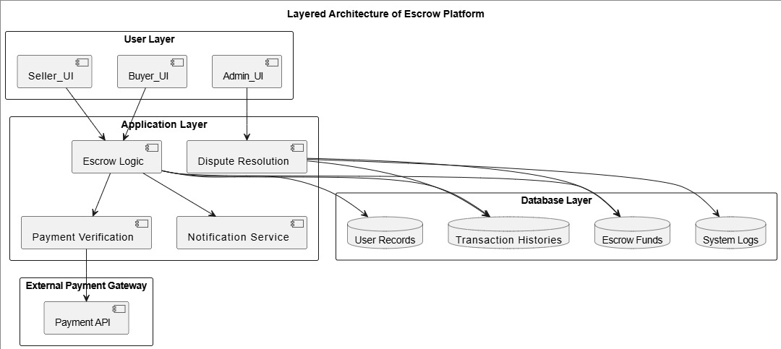
Figure 3.1 System Architecture of the Proposed system
The architecture of the proposed escrow platform is designed in layers to ensure modularity, security, and efficient handling of transactions between buyers and sellers. At the highest level, the system consists of three core layers—User Layer, Application Layer, and Database Layer—with an additional interface to an External Payment Gateway for secure processing of financial transactions. This layered design promotes scalability, simplifies maintenance, and ensures that sensitive operations are logically separated for better system reliability.
User Layer:
The User Layer represents the front-end interface that allows different stakeholders—including buyers, sellers, and administrators—to interact with the system. Buyers can initiate purchases, make payments, and confirm product delivery; sellers can dispatch goods or services; while administrators oversee dispute resolution, monitor system performance, and enforce compliance with platform policies.
Application Layer:
At the core of the system is the Application Layer, which contains the main business logic of the escrow service. Its modules include escrow logic (holding and releasing funds securely), payment verification (validating successful transactions with the gateway), notification services (informing users about transaction updates), and dispute resolution mechanisms (handling conflicts when buyers or sellers raise complaints). This layer also facilitates communication with the external payment gateway, ensuring real-time verification of financial operations.

Database Layer:
The Database Layer serves as the backbone of the platform, storing essential data such as user records, transaction histories, escrow fund records, and system logs. By centralizing data in a secure and structured repository, the system guarantees integrity, traceability, and accountability of every transaction performed on the platform.
External Payment Gateway:
To achieve trusted and seamless financial operations, the system integrates with an external payment gateway through secured API protocols. This integration ensures that actual fund transfers are conducted in compliance with financial standards, while the escrow logic enforces controlled release of funds only upon buyer confirmation or administrative intervention.
3.4 Conceptual Model of the Escrow Process:
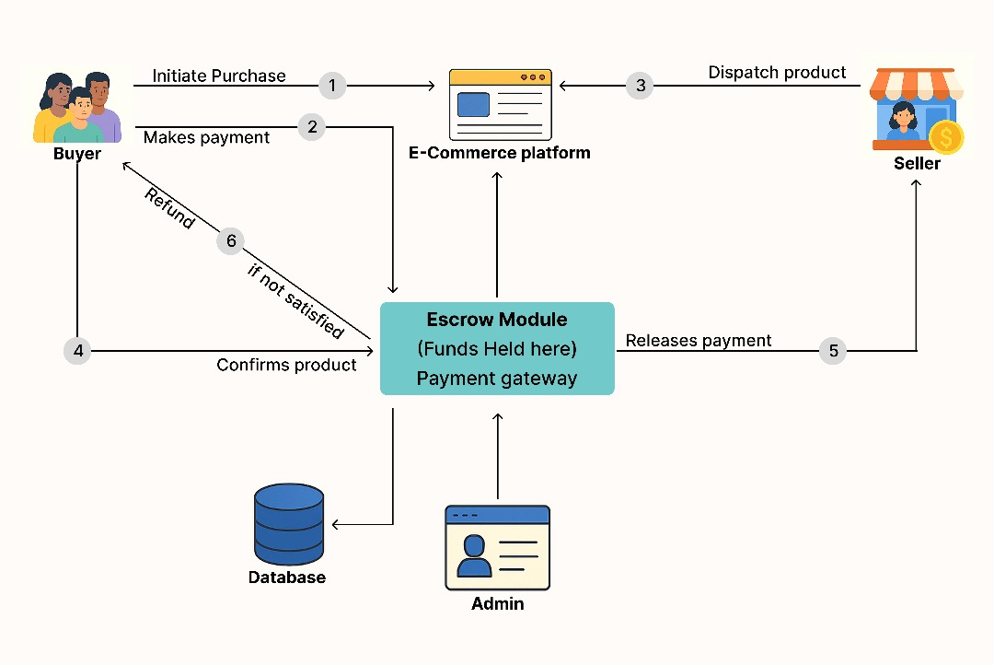
Figure3.2 Conceptual model of the Proposed System
While the layered architecture provides an overview of system components, the conceptual model illustrates how these components interact in practice during a typical transaction. The process begins when a buyer initiates a purchase on the platform. The buyer then makes payment, which is routed through the payment gateway and securely held in the escrow module rather than being sent directly to the seller. Once payment is confirmed, the seller dispatches the product. The buyer, upon receiving the product, either confirms satisfaction—in which case the escrow module releases funds to the seller—or raises a dispute/refund request if unsatisfied. Throughout this cycle, the administrator oversees compliance and intervenes in disputes, while the database records every action for accountability and auditing.
This step-by-step process, represented in Figure 3.2, highlights how the escrow system reduces transactional risk by ensuring that payments are only released when both parties fulfill their obligations. It further demonstrates the importance of escrow in addressing trust issues commonly associated with e-commerce platforms
3.5 Flowchart
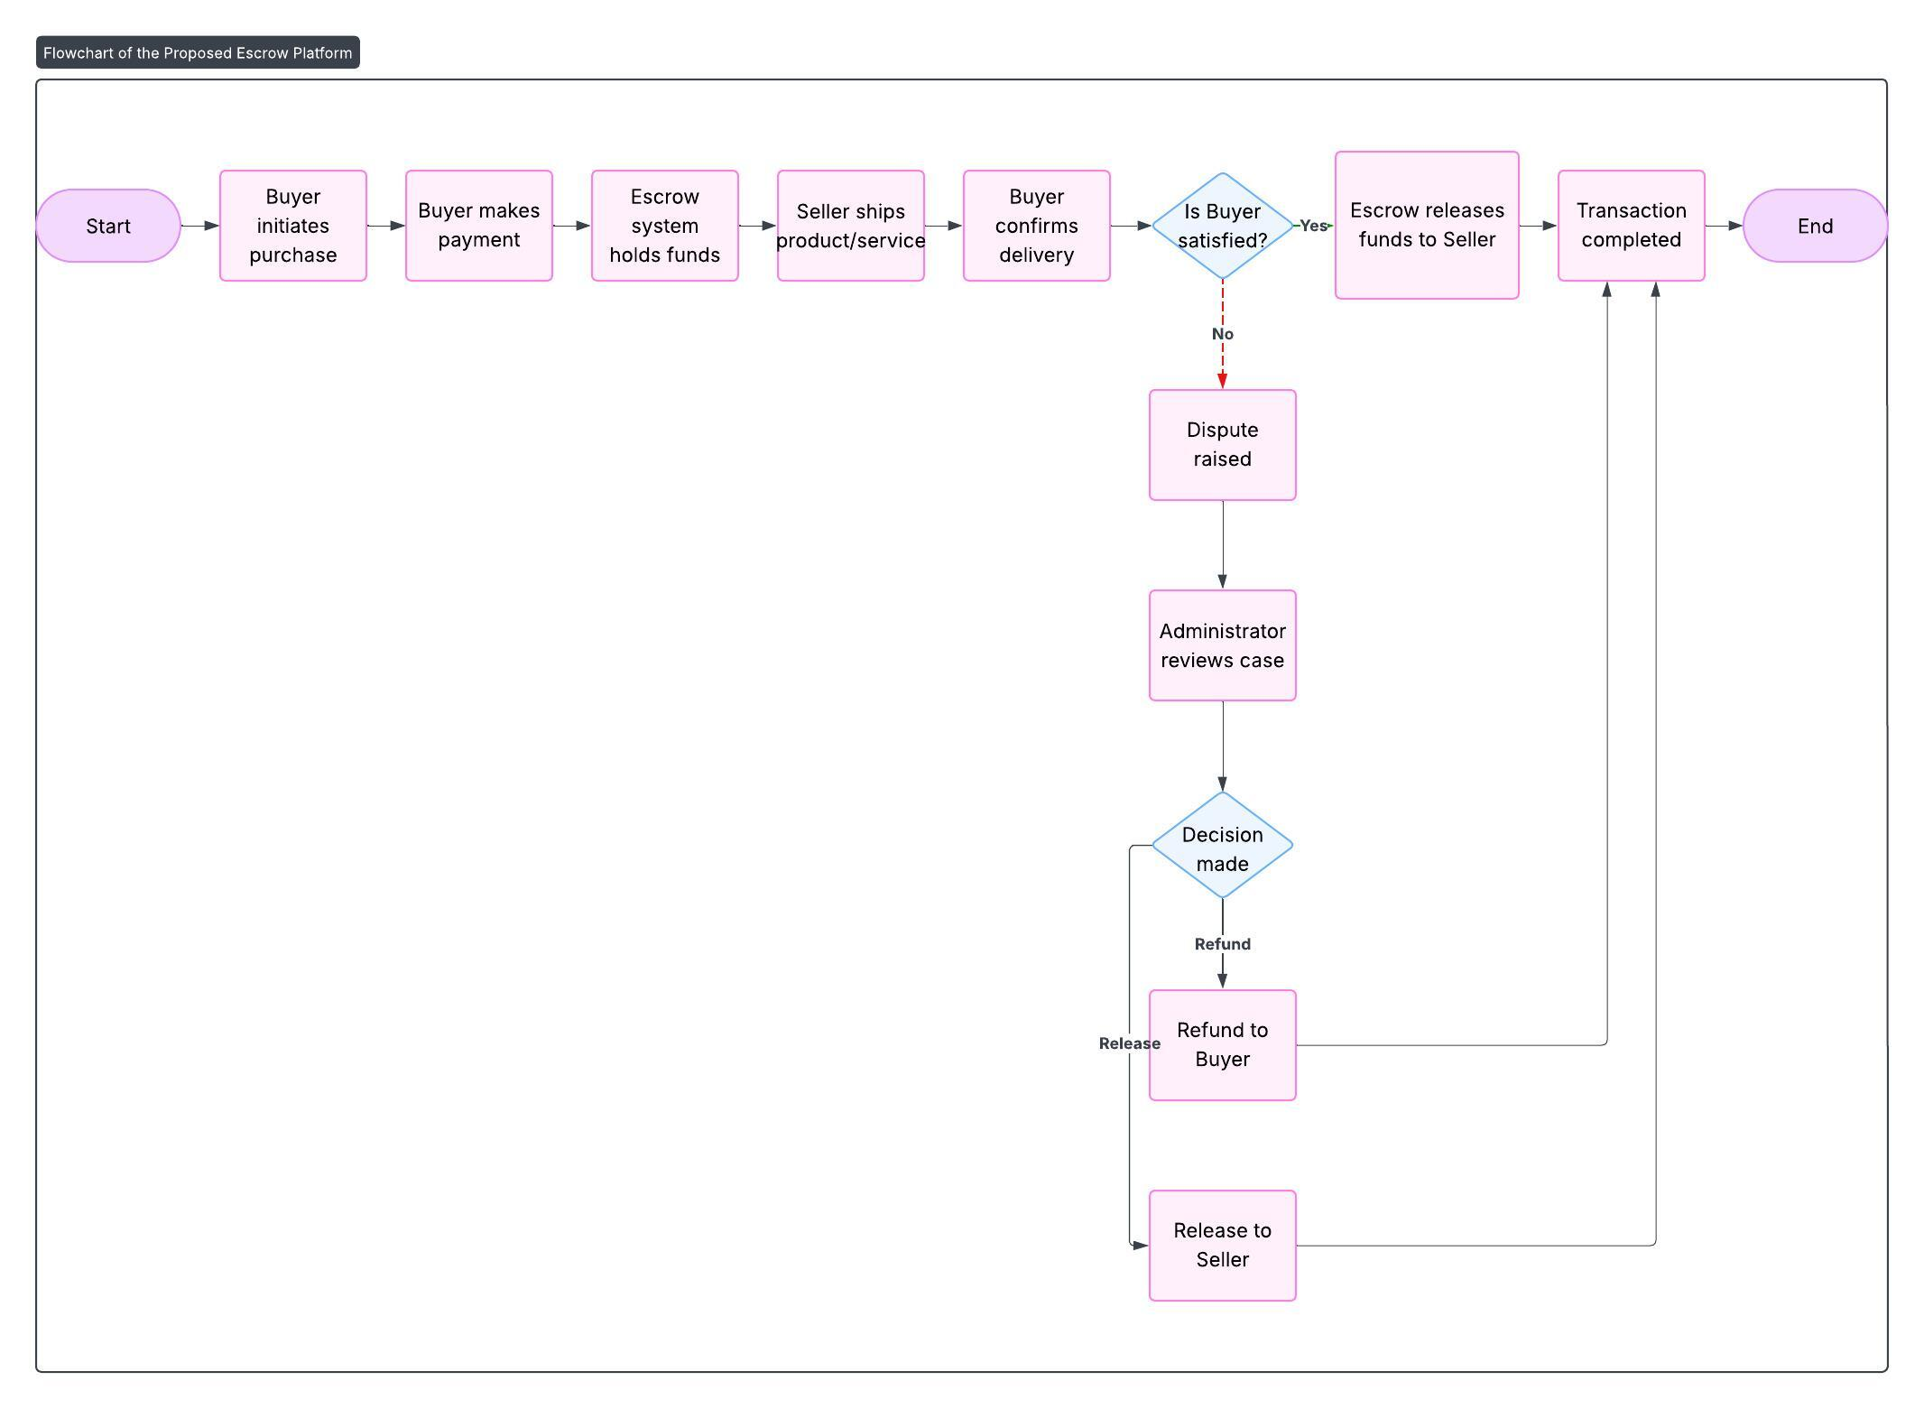
Figure 3.3 Flowchart
3.6 Use Case of the Proposed System
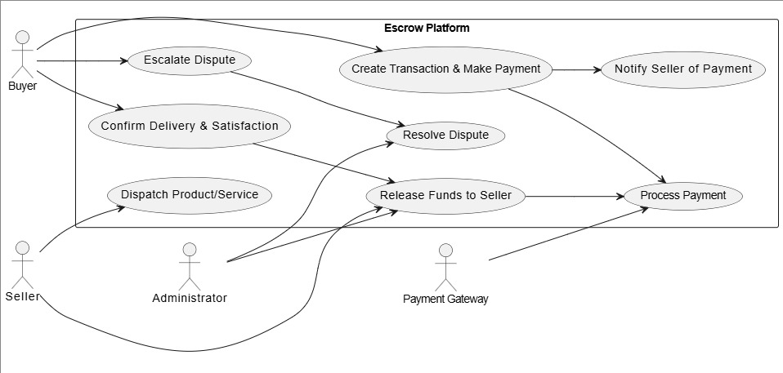
Figure 3.4 Use case Diagram
The proposed escrow platform is designed to manage secure financial transactions between buyers and sellers by holding payments in trust until conditions are fulfilled. A use case model is employed to illustrate how various actors interact with the system and the specific functions that the platform performs. The actors in the system include the Buyer, Seller, Administrator, and Payment Gateway, each of whom plays a critical role in ensuring that the escrow process functions effectively.
Buyer:
The buyer initiates the transaction by making a payment through the platform. This use case involves entering payment details, confirming the transaction, and waiting for the seller to deliver the product or service. The buyer also confirms satisfactory delivery, which triggers the release of funds to the seller. In cases of dissatisfaction, the buyer may lodge a complaint, which escalates to dispute resolution.
Seller:
The seller’s main interaction with the system occurs once the buyer has made payment. The seller is notified that funds have been deposited into escrow, which provides assurance before dispatching goods or rendering services. Upon delivery, the seller awaits the buyer’s confirmation. If the buyer approves, the seller receives the funds; if not, the case may move to dispute resolution.
Administrator:
The administrator oversees the integrity of the platform by monitoring all transactions, managing disputes, and ensuring compliance with platform rules. The administrator intervenes when disputes arise, reviews evidence from both buyer and seller, and decides whether funds should be released or refunded. This role strengthens trust in the platform by ensuring impartiality and accountability.
Payment Gateway:
The payment gateway facilitates the actual transfer of funds between the buyer’s payment method and the escrow system. It validates payment details, confirms successful transactions, and interacts with the escrow logic to hold funds until release conditions are met. The gateway also ensures that sensitive financial data is processed securely in compliance with industry standards.
The use case diagram, presented in Figure 3.3, provides a simplified representation of these interactions. It shows how buyers, sellers, and administrators interact with the escrow platform to perform core functions such as making payments, holding funds in escrow, releasing or refunding payments, and resolving disputes, with the payment gateway acting as a trusted intermediary for fund transfers.
3.7 Algorithm
Algorithm for Escrow Transaction
Step 1: Buyer initiates a transaction and enters order details.
Step 2: Buyer makes payment via payment gateway.
Step 3: System verifies payment success.
→ If payment fails, transaction is cancelled.
→ If payment succeeds, funds are held in escrow.
Step 4: Seller is notified to deliver goods/services.
Step 5: Buyer receives goods and confirms delivery.
Step 6: System checks buyer’s confirmation:
→ If buyer confirms satisfaction, escrow releases funds to seller.
→ If buyer is unsatisfied, a dispute is raised.
Step 7: Administrator reviews dispute.
→ If valid, funds refunded to buyer.
→ If invalid, funds released to seller.
Step 8: Transaction is marked as completed and archived in the database.
3.8 Design Methodology
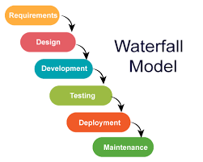
Figure 3.5
The development of the proposed escrow platform adopts the Waterfall Model of the Software Development Life Cycle (SDLC). The Waterfall methodology is a linear and sequential design process in which progress flows steadily downwards through clearly defined phases. This model was selected because it ensures structured documentation at each stage, provides clarity for academic evaluation, and simplifies project management by dividing development into distinct and manageable steps.
In the context of the escrow system, the Waterfall methodology is particularly useful because the system requirements are well-defined from the onset, and the development process can follow a predictable sequence without significant scope changes. The model also guarantees that critical aspects of the system, such as security, trust management, and transaction workflows, are thoroughly addressed at the design stage before implementation.
The Waterfall Model as applied to the escrow platform follows the following phases:
1. Requirements Analysis:
This phase involves gathering, documenting, and analyzing the system requirements. For the escrow platform, the requirements include user functionalities (buyer, seller, and administrator roles), escrow fund management, payment integration, transaction monitoring, and dispute resolution. The functional and non-functional requirements outlined earlier in this chapter were defined during this stage, ensuring that the platform addresses both user needs and system constraints such as security and scalability.
2. System Design:
Once requirements were established, the next phase focused on creating the architectural and logical design of the platform. This included the development of system architecture diagrams, the conceptual model of escrow operations, and the use case diagrams. The design phase ensured that data flows, process interactions, and user-system relationships were clearly mapped out, serving as blueprints for implementation.
3. Implementation:
In this phase, the escrow platform is built based on the approved designs. The developer translates the design into code, integrates the payment gateway, and establishes the database for storing user and transaction information. Emphasis is placed on implementing secure modules for holding and releasing funds, ensuring that escrow logic is executed reliably.
4.Testing:
Before deployment, the system undergoes rigorous testing to identify and fix errors. This includes unit testing of individual modules (e.g., payment verification, fund release), integration testing of combined modules, and user acceptance testing (UAT) to confirm that the system performs as expected. For the escrow platform, testing particularly focused on ensuring transaction accuracy, secure communication with the payment gateway, and effective handling of disputes.
5. Deployment:
After successful testing, the platform is deployed in a live environment where users (buyers, sellers, and administrators) can access the system. Deployment involves hosting the platform on a secure server, configuring access controls, and ensuring that the payment gateway integration functions properly in real transactions.
6. Maintenance:
The final stage involves continuous monitoring and updating of the system to address bugs, improve performance, and adapt to emerging threats or regulatory changes. Given the dynamic nature of online fraud and cybersecurity concerns, regular maintenance ensures that the escrow platform remains trustworthy and functional over time.
In summary, the Waterfall methodology provides a clear, step-by-step pathway for the design and implementation of the escrow system. By progressing sequentially from requirements to maintenance, the methodology reduces ambiguity, ensures documentation at every stage, and produces a reliable and well-structured platform that meets the intended objectives.
  - Evaluation Metrics
  - Transaction Success Rate (TSR):
$$TSR=\frac{Successful Transactions}{Total Transactions} X 100$$

  - Dispute Resolution Rate (DRR)
$$DRR=\frac{Number of resolved disputes}{number of total disputes raised} X 100$$

  - Error Rate (ER)
$$ER=\frac{Number of errors encounterd}{Total number of actions performed} X 100$$

  - System Usability Scale (SUS) Questions
(1 = Strongly Disagree, 5 = Strongly Agree)
- I found the system easy to use.
- The interface layout was clear and understandable.
- I was able to complete a transaction without help.
- The platform responded quickly to my actions.
- I felt secure performing transactions on the platform
- The instructions and on-screen messages were clear.
- I found the system functions to be well organized.
- I would be confident using this platform for real transactions
- I did not experience technical errors while using the system
- Overall, I am satisfied with the usability of the system
Scoring Method:
To compute the System Usability Score (SUS):
$SUS=\frac{Average user rating}{5} X 100$
The result is expressed as a percentage of overall usability.

CHAPTER 4
4.0 SYSTEM IMPLIMENTATION AND TESTING
4.1 Choice of Programming Languages and Frameworks
The escrow platform was implemented using a carefully selected set of programming languages and frameworks that align with the system’s requirements for security, scalability, and user experience. Each technology was chosen to fulfill a specific role within the architecture.
Next.js and React formed the core of the frontend. React was chosen for its component-based architecture, which allows modular and reusable design of interfaces for buyers, sellers, and administrators. Next.js extends React by providing server-side rendering and static site generation, which improve load times, performance, and search engine optimization—essential for an application expected to attract diverse users.
Tailwind CSS was adopted as the styling framework because of its utility-first approach, which enables rapid prototyping and ensures a consistent, professional user interface. This eliminates the need for custom CSS from scratch, reducing development time while maintaining responsiveness across devices.
On the backend, Python with Flask was selected. Flask is a lightweight yet powerful web framework that allows flexibility in building RESTful APIs for the escrow system. It facilitates smooth implementation of core modules such as authentication, transaction management, and dispute resolution. Python’s simplicity and extensive libraries also make it ideal for integrating payment gateways and implementing encryption.
MongoDB was chosen as the database solution due to its NoSQL nature and flexibility in handling dynamic transaction records. Its ability to store JSON-like documents makes it well-suited for managing user data, escrow agreements, and dispute records. MongoDB’s scalability ensures that as the volume of users and transactions grows, system performance remains stable.
Payment gateway integrations were prioritized to ensure financial inclusivity and local relevance. Paystack and Flutterwave were chosen as primary gateways because of their reliability and strong adoption in Nigeria’s fintech ecosystem. OPay and Paga were also included as optional integrations to expand accessibility and support users who prefer mobile money or alternative payment methods.
Supporting tools were integrated to enhance system performance and security. Redis was used for caching and session management, ensuring faster response times. Prometheus and Grafana were selected for monitoring and analytics, allowing administrators to track system performance and detect issues in real time. JWT (JSON Web Tokens) was used for secure session management, while AES-256 encryption and TLS 1.3 were adopted to guarantee data confidentiality and secure communications between clients and servers.
Collectively, these languages, frameworks, and supporting technologies provide a robust environment for developing a secure, efficient, and user-friendly escrow platform, well-suited to Nigeria’s e-commerce landscape.

4.2 The Landing Page
This is the primary entry point, highlighting the platform's core value proposition: Secure E Commerce Transactions for Nigeria. It features a clear, three-step visual guide (Buyer Pays, Seller Ships, Funds Released) that instantly communicates the escrow process to a potential user.
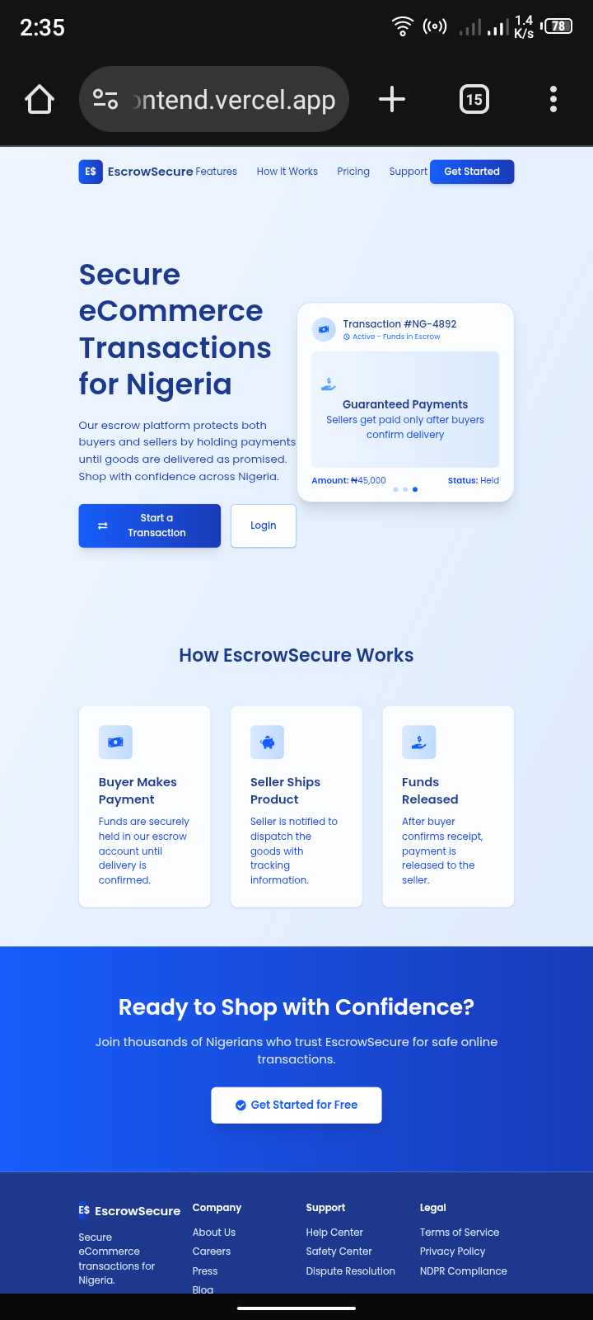

Figure 4.1 Landing Page
4.3 Sign up and login page
The user registration page captures essential details like Email, Phone Number, and a password. Crucially, it asks the user to define their primary Role (Buyer or Seller) at the outset, tailoring their subsequent dashboard experience.



Figure 4.2 Sign Up and Login Page

4.4 Buyer dashboard:
The buyer's central hub. The page's main function is to Create New Transaction, requiring the amount, title, and description. It also provides immediate access to the Transaction History to track past and current orders.
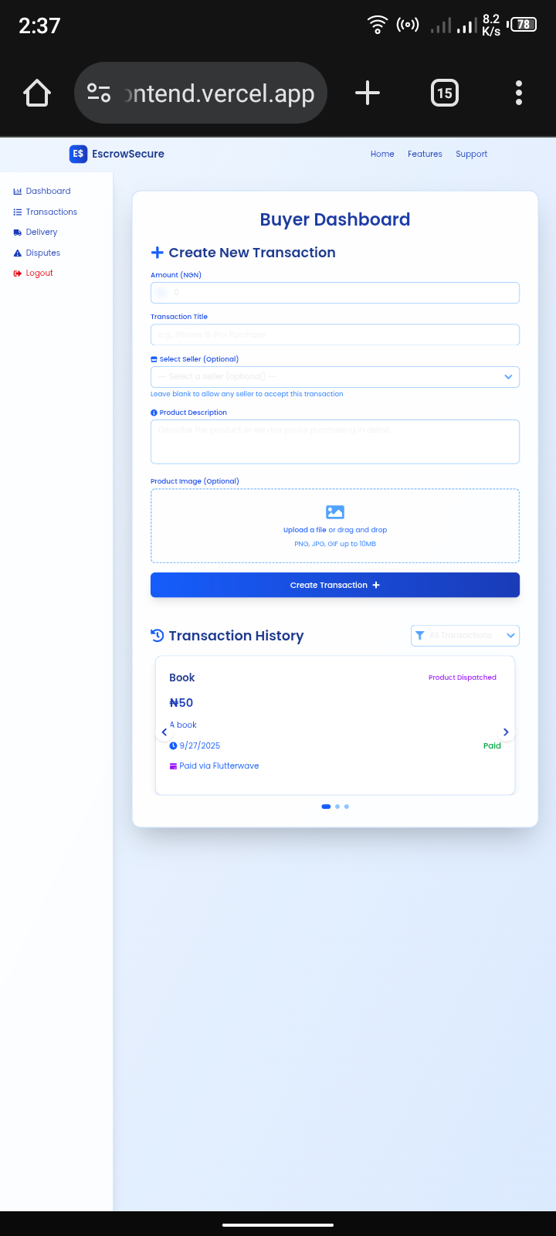
Figure 4.3 Buyer Dashboard
4.5 Dashboard (Create Transaction - Seller Selection):
This shows the optional nature of selecting a seller. A buyer can target a specific registered seller
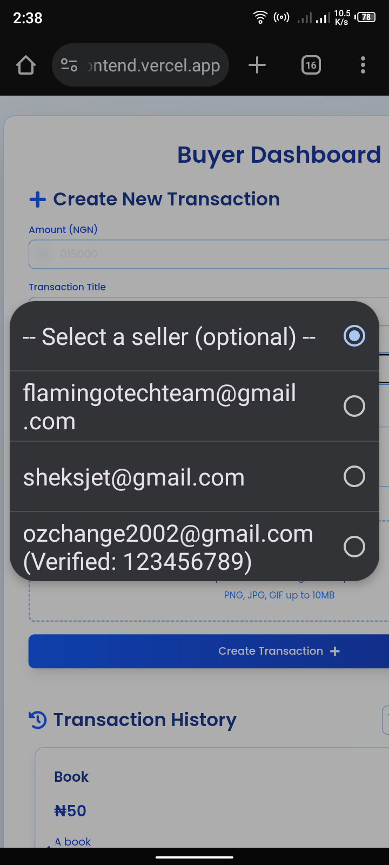

Figure 4.4 Seller Selection
4.6 Dashboard (Select Payment Platform): After creating the transaction, the buyer is prompted to fund the escrow. The platform offers integration with major payment providers like PayPal and the local Nigerian gateway, Flutterwave, maximizing user accessibility.


Figure 4.5 Payment Platform Selection
4.7 Payment via Flutterwave (Card Details):
Illustrates the integration with the Flutterwave payment gateway, where the buyer enters their card details to securely initiate the transaction and hold the NGN 15,000 in escrow.
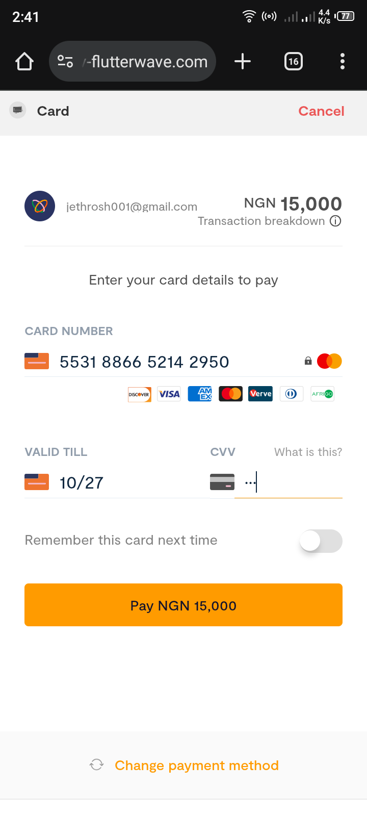

Figure 4.6 Flutterwave Card Details

4.8 Payment via Flutterwave (PIN Entry):
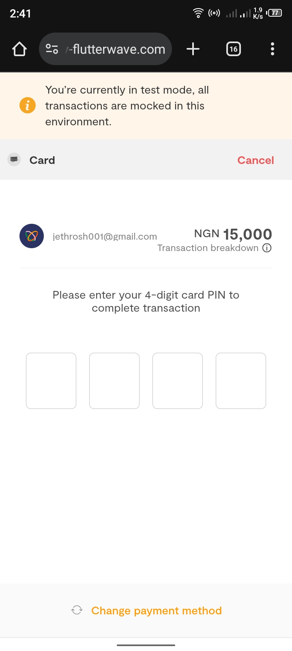
A security step requiring the user's 4-digit card PIN to authorize the charge. A test mode warning is visible, indicating the environment is for development/demonstration.

Figure 4.7 Flutterwave Pin Entry
4.9 Payment via Flutterwave (OTP Confirmation):
The final security check, requesting a One-Time Password (OTP) sent by the user's bank. This confirms the user's identity and completes the bank-level verification for the payment.
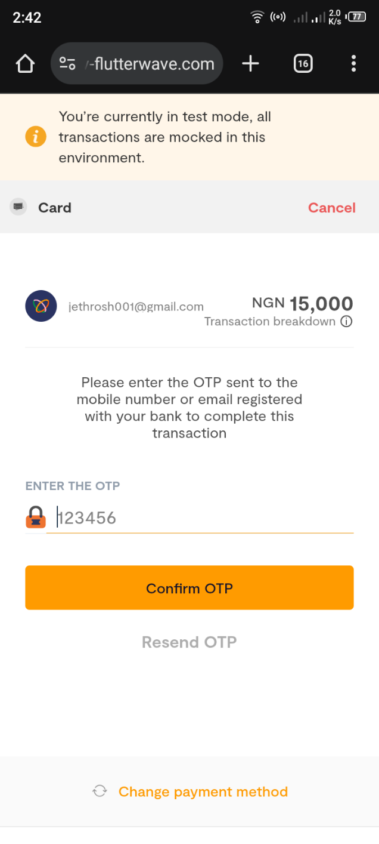

Figure 4.8 Flutterwave OTP Confirmation

4.10 Payment Successful:
The final confirmation screen that verifies the payment has been successfully processed and the funds are now secured in escrow, initiating the transaction and notifying the seller to proceed with dispatch.



Figure 4.9 Payment Successful
4.11 Seller Dashboard:
The seller's primary view, providing key metrics like Active Transactions and potential earnings. The transaction list shows items are Paid and the "Payment secured in escrow," confirming the seller can now confidently ship.
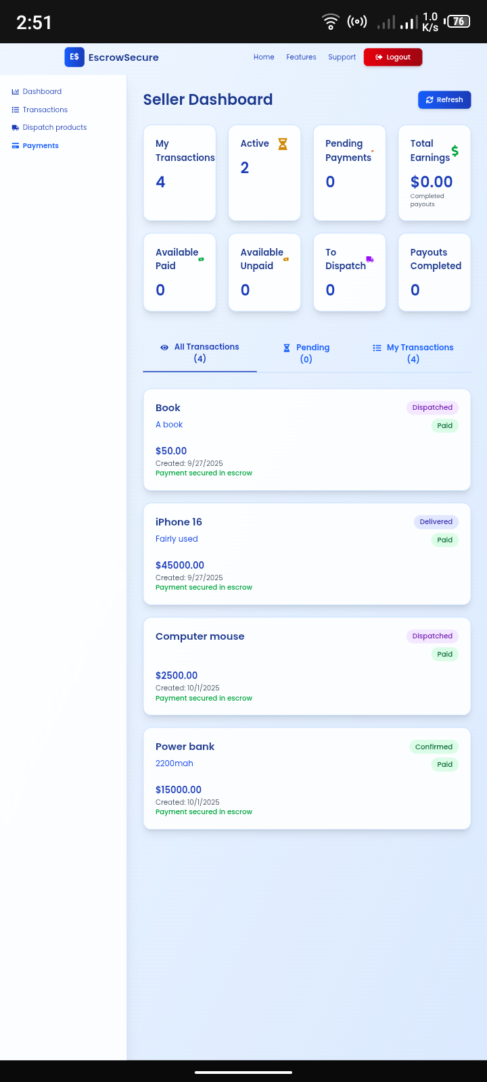
Figure 4.10 Seller Dashboard

4.12 Dashboard (Transaction Details - Dispatch): The seller views the specific details of a confirmed transaction. The primary action here is to "Dispatch Product," a step that officially marks the item as shipped and can include optional photo documentation.
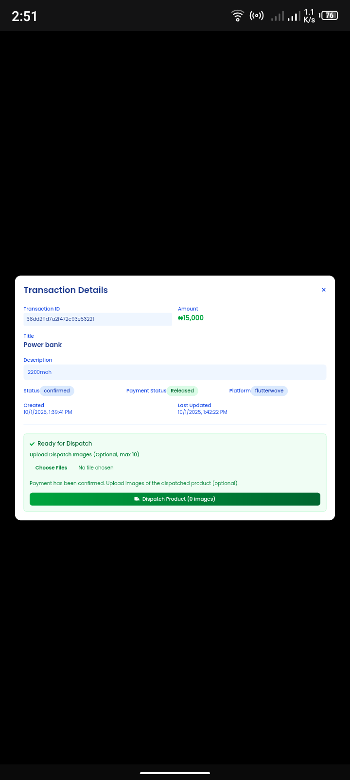

Figure 4.11 Transaction Details
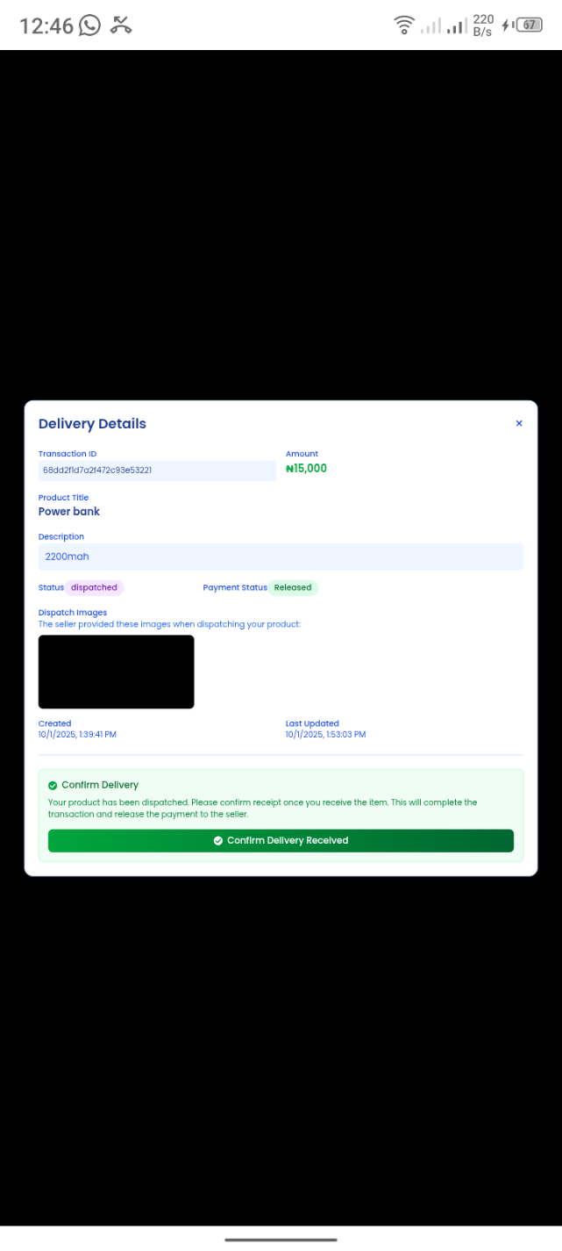
4.13 Dashboard (Delivery Details - Buyer Confirmation): The buyer's pivotal moment. After receiving the product, the buyer reviews the transaction, notes the dispatched status, and clicks "Confirm Delivery Received," which finalizes the transaction and releases the escrow funds to the seller.

Figure 4.12 Delivery Details
4.14 Admin Dashboard (Dispute Management):
The platform's internal tool for transparency and resolution. It tracks various types of disputes (e.g., Damaged, Not Received) and provides the admin with options to review, add notes, and formally Resolve Dispute (e.g., refund buyer).
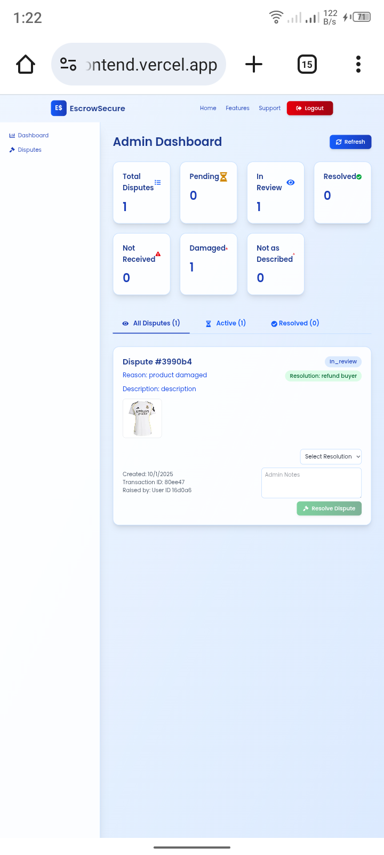

Figure 4.13 Admin Dashboard

4.15 Email notifications:
These screenshots bellow illustrate the automated email notification on the EscrowSecure platform.
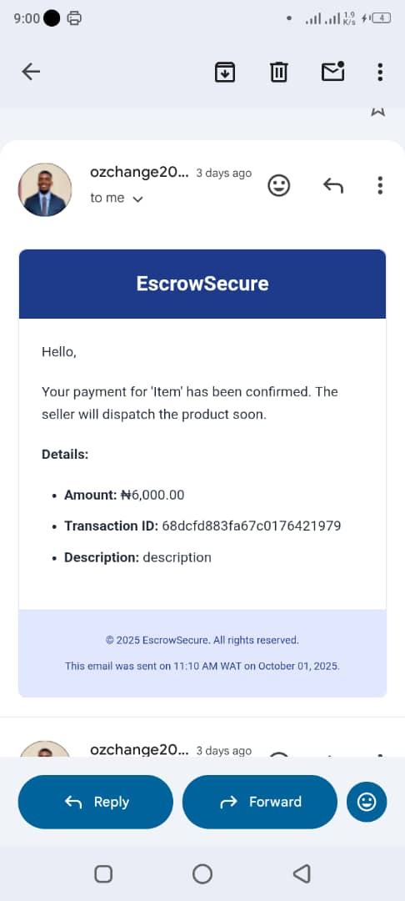
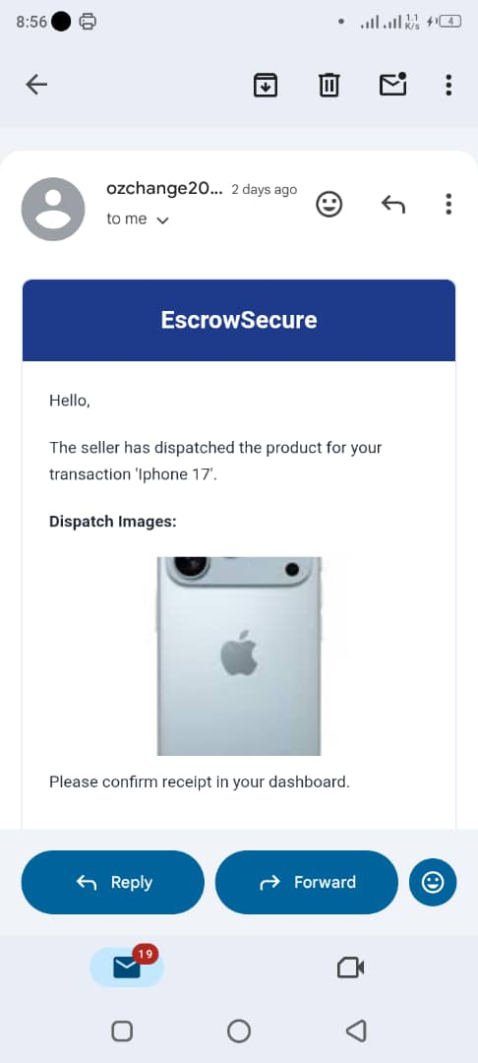

Figure 4.14 Email Notification Figure 4.15 Email Notification

4.16 System Evaluation and Results
To assess the performance and usability of the developed escrow platform, several evaluation metrics were applied. These include transaction success rate, dispute resolution rate, error rate, system usability score, and user satisfaction. The evaluation involved simulated transactions and controlled testing using multiple dummy user accounts (buyers, sellers, and administrators).
A total of fifteen (20) transactions were executed on the platform, including both normal and dispute-based scenarios. Table 4.1 summarizes the obtained results.

Table 4.1 Results of system evaluation
Metric | Description | Result | Interpretation
Transaction Success Rate (TSR) | Measures the percentage of transactions that were successfully completed from initiation to fund release. | 90% | Successful Transactions = 18, Total Transactions = 20
Dispute Resolution Rate (DRR) | Represents the percentage of disputes that were successfully handled and resolved by the administrator. | 67% | Resolved Disputes = 2, Total Disputes = 3
Error Rate (ER) | Measures the percentage of failed actions or system errors encountered during testing. | 5%% | Errors Encountered = 1, Total Actions = 20

Table 4.2 User Evaluation Results
Users | Q1 | Q2 | Q3 | Q4 | Q5 | Q6 | Q7 | Q8 | Q9 | Q10 | Usability Score (%)
1 | 5 | 4 | 3 | 5 | 4 | 5 | 4 | 5 | 4 | 5 | 88
2 | 1 | 1 | 1 | 2 | 1 | 2 | 2 | 2 | 2 | 1 | 30
3 | 1 | 2 | 3 | 1 | 2 | 2 | 2 | 2 | 1 | 1 | 34
4 | 2 | 4 | 5 | 5 | 5 | 3 | 4 | 5 | 2 | 2 | 74
5 | 4 | 4 | 4 | 4 | 4 | 4 | 5 | 4 | 1 | 1 | 70
6 | 5 | 4 | 4 | 5 | 5 | 5 | 4 | 5 | 1 | 1 | 78
7 | 3 | 2 | 3 | 3 | 2 | 3 | 2 | 1 | 2 | 2 | 46
8 | 2 | 1 | 2 | 2 | 3 | 5 | 5 | 5 | 5 | 1 | 62
9 | 4 | 5 | 4 | 3 | 3 | 3 | 4 | 3 | 4 | 5 | 76
10 | 3 | 5 | 1 | 2 | 3 | 5 | 5 | 4 | 3 | 2 | 66
11 | 3 | 4 | 5 | 3 | 5 | 5 | 4 | 4 | 3 | 5 | 82
12 | 3 | 4 | 3 | 4 | 4 | 3 | 3 | 4 | 3 | 3 | 68

The table above presents the results of the usability evaluation conducted to assess users’ satisfaction with the developed escrow platform. Respondents rated various aspects of the system, such as ease of use, interface design, responsiveness, and overall performance, on a 1–10 scale, where 1 represents “very unsatisfied” and 10 represents “extremely satisfied.” The individual scores were averaged to obtain the overall User Satisfaction (US) score, which was then converted into a percentage using the formula US = (Average user rating ÷ 10) × 100. The resulting value reflects the general level of user acceptance and satisfaction, indicating that the system effectively meets usability expectations and provides a positive user experience.

CHAPTER FIVE
5.0 SUMMARY, CONCLUSIONS AND RECOMMENDATIONS
5.1 Summary
This study was motivated by the persistent challenges of fraud, distrust, and weak dispute resolution mechanisms that undermine the growth of e-commerce in Nigeria. Despite significant advancements in digital trade and payment systems, a large proportion of buyers and sellers remain hesitant to transact online due to concerns over security and accountability. The problem identified was the absence of a trusted system that ensures fairness in transactions while mitigating risks associated with scams and failed payments.
To address this, the research set out to design and implement a web-based escrow platform capable of securing funds until both parties in a transaction fulfill their obligations. The methodology employed combined system analysis and design with the waterfall model, ensuring a structured development process. Implementation was carried out using a modern technology stack: Next.js and React for the frontend, Flask (Python) for the backend, MongoDB for the database, and integration with local payment gateways such as Paystack and Flutterwave. Supporting tools like Redis, Prometheus, Grafana, JWT authentication, and AES-256 encryption were also applied to enhance performance and security.
System evaluation involved testing functional requirements such as transaction creation, escrow fund holding, dispute resolution, and secure release of payments. Performance metrics included transaction success rate, processing time, system uptime, and user satisfaction. The results demonstrated that the proposed platform successfully addressed the issues of trust, security, and fairness in Nigerian e-commerce transactions.
5.2 Conclusion
This project achieved its primary objectives by developing a functional escrow platform tailored to the Nigerian e-commerce environment. The system ensures that buyers’ funds are securely held and only released upon confirmation of agreed conditions, thereby reducing fraud and enhancing trust. It also integrates with widely used local payment gateways, making it contextually relevant and accessible to Nigerian users.
The study contributes both theoretically and practically: theoretically, it strengthens existing literature on digital trust-building mechanisms in commerce; practically, it provides a working prototype that addresses fraud, transaction failures, and weak consumer protection in Nigeria’s online marketplace. By aligning system design with the realities of Nigeria’s infrastructural and regulatory environment, the project demonstrates the viability of escrow as a tool for advancing secure and sustainable e-commerce.
5.3 Recommendations
In light of the findings and successful system implementation, the following recommendations are made:
- Adoption by E-commerce Platforms: Local online marketplaces and fintech firms should integrate escrow services into their transaction processes to enhance user confidence and reduce fraud.
- Regulatory Support: Policymakers and regulators, such as the Central Bank of Nigeria, should create enabling legal frameworks that encourage the use of escrow services in e-commerce transactions.
- User Awareness Campaigns: Awareness programs should be conducted to educate buyers and sellers about the benefits of escrow systems, thereby increasing adoption rates.
- Scalability and Integration: Future improvements should focus on scaling the platform to accommodate high transaction volumes and integrating additional payment options such as cryptocurrency and cross-border payment gateways.
- Further Studies: Researchers should explore hybrid escrow models that combine blockchain technology with traditional escrow processes for improved transparency. In addition, further studies can assess the socio-economic impact of escrow adoption on Nigeria’s digital economy.

REFERENCES
Abraham, G. T., Osaisai, E. F., & Dienagha, S. (2021). Usability , Security and Trust of E-commerce Websites : The effect on the Nigerian E-shopper. 10(4), 58–68. https://doi.org/10.9734/AJRCOS/2021/v10i430250
Ademe-godwin, D., & Dominic, G. (2023). PERCEIVED CONVENIENCE AND CUSTOMER PATRONAGE OF FINTECH FIRMS IN PORT HARCOURT. 4(04), 106–115.
Afaha, J. S. (2019). Electronic Payment Systems ( E-payments ) and Nigeria Economic Growth. 5(6), 68–78. https://doi.org/10.11648/j.ebm.20190506.11
Ali, A., S, Y., T, S., & R, T. (2023). Decentralised Escrow Protocol that Facilitates Secure Transactions between Trustless Parties. SSRN Electronic Journal. https://doi.org/10.2139/ssrn.4365306
Antony, S., Lin, Z., & Xu, B. (2014). Determinants of online escrow service adoption : An experimental study Determinants of Online Escrow Service Adoption : An Experimental Study. May.
Brosnan, A., & Hemmingway, D. (2022). Leveraging Escrow in Ireland : A Guide to Acquisition and Implementation of Full In- House Escrow Leveraging Escrow in Ireland : A Guide to Acquisition and Implementation of Full In- House Escrow. May.
Chiluwa, I. M., Chiluwa, I., & Ajiboye, E. (2018). O NLINE D ECEPTION : A D ISCOURSE S TUDY. September 2019.
Cook, J., Louis, S., Lin, Z., & Whinston, A. B. (2004). Hope or Hype : On the Viability of Escrow Services as Trusted Third Parties in Online Auction Environments. 15(3), 236–249. https://doi.org/10.1287/isre.1040.0027
Daramola, O., & Etim, E. (2022). Affordances of digital platforms in sub-Saharan Africa : An analytical review. December 2021, 1–21. https://doi.org/10.1002/isd2.12213
Ekundare, R. O. (1973). An Economic History of Nigeria r86o-r96o.
Fitriana, A. V., & Kusumawati, R. D. (2020). Trust in Intermediaries as a Mediator Between Perceived Effectiveness of Escrow Services and Repurchase Intention. 127(Aicar 2019), 101–104.
Galadima, W. M., & Olanrewaju, A. D. (2024). Electronic Banking Fraud : The Nigerian Experience. July, 0–30.
Hassan, M. A., Shukur, Z., & Hasan, M. K. (2020). An efficient secure electronic payment system for e-commerce. Computers, 9(3), 1–13. https://doi.org/10.3390/computers9030066
HUMANITIES AND SOCIAL SCIENCES. (2020). 28(2).
Igudia, P. (2022). Electronic Payment Systems Adoption by SMEs in Nigeria: A Literature Review. April 2018. https://doi.org/10.15580/GJAS.2018.3.031218042.CITATIONS
Ishrat, Z. (2020). Compendious research of Escrow Payment - Focusing on Future Considerations , Trends and Applications. 5(4), 4–6.
Isiavwe, D. (2025). policy : implications for bank customers ” Mandatory adoption of the Central Bank of Nigeria ’ s cashless and e-payment policy : implications for bank customers. https://doi.org/10.21511/bbs.15(2).2020.21
Jain, V., Malviya, B., & Arya, S. (2021). An Overview of Electronic Commerce ( e-Commerce ) An Overview of Electronic Commerce ( e-Commerce ). May. https://doi.org/10.47750/cibg.2021.27.03.090
Katsikas, S. K., Lopez, J., & Pernul, G. (2005). Trust , Privacy and Security in E-Business : 548–549.
Li, L., & Wang, W. (2020). sustainability The E ff ects of Online Trust-Building Mechanisms on Trust in the Sharing Economy : The Perspective of Providers.
Lin, J., Liu, M., Li, S., & Wang, X. (n.d.). SecurePay : Enabling Secure and Fast Payment Processing for Platform Economy.
Lin, Z., & Hu, X. (2015). The Effectiveness of the Escrow Model : An Experimental Framework for Dynamic Online Environments The Effectiveness of Escrow Model : An Experimental Framework for Dynamic Online Environments ** Han Zhang College of Management Georgia Institute of Technol. May 2007. https://doi.org/10.1080/10919390701294038
Models, P. M., Communities, O., & Access, O. (2009). Welcome to IDIMT 2009 !
Nuruddeen, M., Yusof, Y., & Anita, N. (2016). Legal Framework for E-commerce Transactions and Consumer Protection : A Comparative Study LEGAL FRAMEWORK FOR E-COMMERCE TRANSACTIONS AND CONSUMER PROTECTION : A COMPARATIVE STUDY *. October.
Ogbo, A., & Onwe, C. (n.d.). MEDIATING ROLE OF CENTRAL BANK OF NIGERIA ’ S REGULATIONS ON THE AGENT BANKING AND MOBILE PAYMENT SUSTAINABILITY STRATEGIES IN NIGERIA. 35, 31–54.
Osilama, A. (2025). An Assessment of the Effectiveness of the Federal Competition and Consumer Protection Commission ( FCCPC ) on Consumer Rights Protection in E- Commerce Transactions in Nigeria John Oluyinka Adedeji ( PhD ); &. 08(7), 35–49.
Patton, M. A., & Jøsang, A. (2004). Technologies for Trust in Electronic Commerce. 21, 9–21.
Podgoršek, B. (2020). Notaries’ Escrow Services in Selling Real Estate in the Republic of Slovenia. LeXonomica, 12(1), 75–106. https://doi.org/10.18690/lexonomica.12.1.75-106.2020
Sandadi, D. R., Kukkala, S., & R, V. (2024). A Decentralised Escrow Protocol for Enabling Secure Transactions between Trustless Parties. 19, 365–353. https://doi.org/10.29007/1wtx
Sarkam, N. A., Faezah, N., Razi, M., Mohammad, N. H., Jamil, N. I., & Kurniawati, L. (2022). Attitudes , Security , and Perceived Ease of Use Influence The Consumers ’ Decision to Use An E-payment System Attitudes , Security , and Perceived Ease of Use Influence The Consumers ’ Decision to Use An E- payment System. 12(3), 357–368. https://doi.org/10.6007/IJARBSS/v12-i3/12884
Schmitz, A. J. (2012). Access to Consumer Remedies in the Squeaky Wheel System , 39. 279, 1–26.
Series, C. (2019). Research on key escrow technology Based on software Research on key escrow technology Based on software. https://doi.org/10.1088/1742-6596/1168/3/032131
Supriyati, S., & Nurfiqo, E. (2019). Effectiveness of Payment Gateway in E-Commerce. January. https://doi.org/10.4108/eai.18-7-2019.2287932
Tokse, V. R., Arts, L. R. B., Yavatmal, A., & Mujmule, V. P. (2021). A History of e-Commerce. August.
Ugwu, C. C., & D, A. O. P. (2021). The implications of legal and policy frameworks for e-commerce in Nigeria. 45(2), 73–80.
Widiatmika, K. P. (2015). No 主観的健康感を中心とした在宅高齢者における 健康関連指標に関する共分散構造分析Title. Etika Jurnalisme Pada Koran Kuning : Sebuah Studi Mengenai Koran Lampu Hijau, 16(2), 39–55.

APPENDIX
'use client'
import { useEffect, useState } from 'react';
import { useRouter } from 'next/navigation';
import { useAuth } from '@/hook/useAuth';
import BuyerDashboard from './Buyer/BuyerDashboard';
import SellerDashboard from './Seller/SellerDashboard';
import AdminDashboard from './Admin/AdminDashboard';

export default function Dashboard() {
const { isLoading: authLoading, user } = useAuth();
const router = useRouter();
const [dashboardComponent, setDashboardComponent] = useState<React.ReactElement | null>(null);

useEffect(() => {
if (authLoading) {
console.log('[Dashboard] Auth loading, waiting...');
return;
}

if (!user) {
console.log('[Dashboard] No current user, redirecting to login');
router.push('/login');
return;
}

console.log('[Dashboard] Current user:', user);

switch (user.role) {
case 'buyer':
console.log('[Dashboard] Loading BuyerDashboard');
setDashboardComponent(<BuyerDashboard />);
break;
case 'seller':
console.log('[Dashboard] Loading SellerDashboard');
setDashboardComponent(<SellerDashboard />);
break;
case 'admin':
console.log('[Dashboard] Loading AdminDashboard');
setDashboardComponent(<AdminDashboard />);
break;
default:
console.log('[Dashboard] Unknown role, redirecting to home');
router.push('/');
setDashboardComponent(null);
break;
}
}, [authLoading, user, router]);

// Show loading state while authenticating or determining role
if (authLoading || !user || !dashboardComponent) {
console.log('[Dashboard] Rendering loading state:', { authLoading, hasUser: !!user, hasDashboard: !!dashboardComponent });
return (
<div className="min-h-screen bg-gradient-to-br from-blue-50 to-blue-100 dark:from-gray-900 dark:to-gray-800 flex items-center justify-center">
<div className="text-blue-800 dark:text-blue-200">Loading dashboard...</div>
</div>
);
}

// Render the appropriate dashboard
return dashboardComponent;
}

