**Mission to Mars**

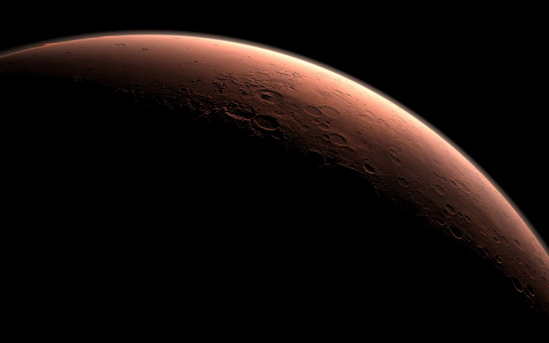

In this assignment, you will build a web application that scrapes various websites for data related to the Mission to Mars and displays the information in a single HTML page. The following outlines what you need to do.

**Step 1 - Scraping**

Complete your initial scraping using Jupyter Notebook, BeautifulSoup, Pandas, and Requests/Splinter.

* Create a Jupyter Notebook file called `mission_to_mars.ipynb` and use this to complete all of your scraping and analysis tasks. The following outlines what you need to scrape.

***NASA Mars News***

* Scrape the [NASA Mars News Site](https://mars.nasa.gov/news/) and collect the latest News Title and Paragragh Text. Assign the text to variables that you can reference later.

```python

# Example:

news_title = "NASA's Next Mars Mission to Investigate Interior of Red Planet"

news_p = "Preparation of NASA's next spacecraft to Mars, InSight, has ramped up this summer, on course for launch next May from Vandenberg Air Force Base in central California -- the first interplanetary launch in history from America's West Coast."

```

***JPL Mars Space Images - Featured Image***

* Visit the url for JPL's Featured Space Image [here](https://www.jpl.nasa.gov/spaceimages/?search=&category=Mars).

* Use splinter to navigate the site and find the image url for the current Featured Mars Image and assign the url string to a variable called `featured_image_url`.

* Make sure to find the image url to the full size `.jpg` image.

* Make sure to save a complete url string for this image.

```python

# Example:

featured_image_url = 'https://www.jpl.nasa.gov/spaceimages/images/largesize/PIA16225_hires.jpg'

```

***Mars Weather***

* Visit the Mars Weather twitter account [here](https://twitter.com/marswxreport?lang=en) and scrape the latest Mars weather tweet from the page. Save the tweet text for the weather report as a variable called `mars_weather`.

```python

# Example:

mars_weather = 'Sol 1801 (Aug 30, 2017), Sunny, high -21C/-5F, low -80C/-112F, pressure at 8.82 hPa, daylight 06:09-17:55'

```

***Mars Facts***

* Visit the Mars Facts webpage [here](http://space-facts.com/mars/) and use Pandas to scrape the table containing facts about the planet including Diameter, Mass, etc.

* Use Pandas to convert the data to a HTML table string.

***Mars Hemisperes***

* Visit the USGS Astrogeology site [here](https://astrogeology.usgs.gov/search/results?q=hemisphere+enhanced&k1=target&v1=Mars) to obtain high resolution images for each of Mar's hemispheres.

* You will need to click each of the links to the hemispheres in order to find the image url to the full resolution image.

* Save both the image url string for the full resolution hemipshere image, and the Hemisphere title containing the hemisphere name. Use a Python dictionary to store the data using the keys `img_url` and `title`.

* Append the dictionary with the image url string and the hemisphere title to a list. This list will contain one dictionary for each hemisphere.

```python

**Example**:

hemisphere_image_urls = [

{"title": "Valles Marineris Hemisphere", "img_url": "..."},

{"title": "Cerberus Hemisphere", "img_url": "..."},

{"title": "Schiaparelli Hemisphere", "img_url": "..."},

{"title": "Syrtis Major Hemisphere", "img_url": "..."},

]

```

**Step 2 - MongoDB and Flask Application**

Use MongoDB with Flask templating to create a new HTML page that displays all of the information that was scraped from the URLs above.

* Start by converting your Jupyter notebook into a Python script called `scrape_mars.py` with a function called `scrape` that will execute all of your scraping code from above and return one Python dictionary containing all of the scraped data.

* Next, create a route called `/scrape` that will import your `scrape_mars.py` script and call your `scrape` function.

* Store the return value in Mongo as a Python dictionary.

* Create a root route `/` that will query your Mongo database and pass the mars data into an HTML template to display the data.

* Create a template HTML file called `index.html` that will take the mars data dictionary and display all of the data in the appropriate HTML elements. Use the following as a guide for what the final product should look like, but feel free to create your own design.

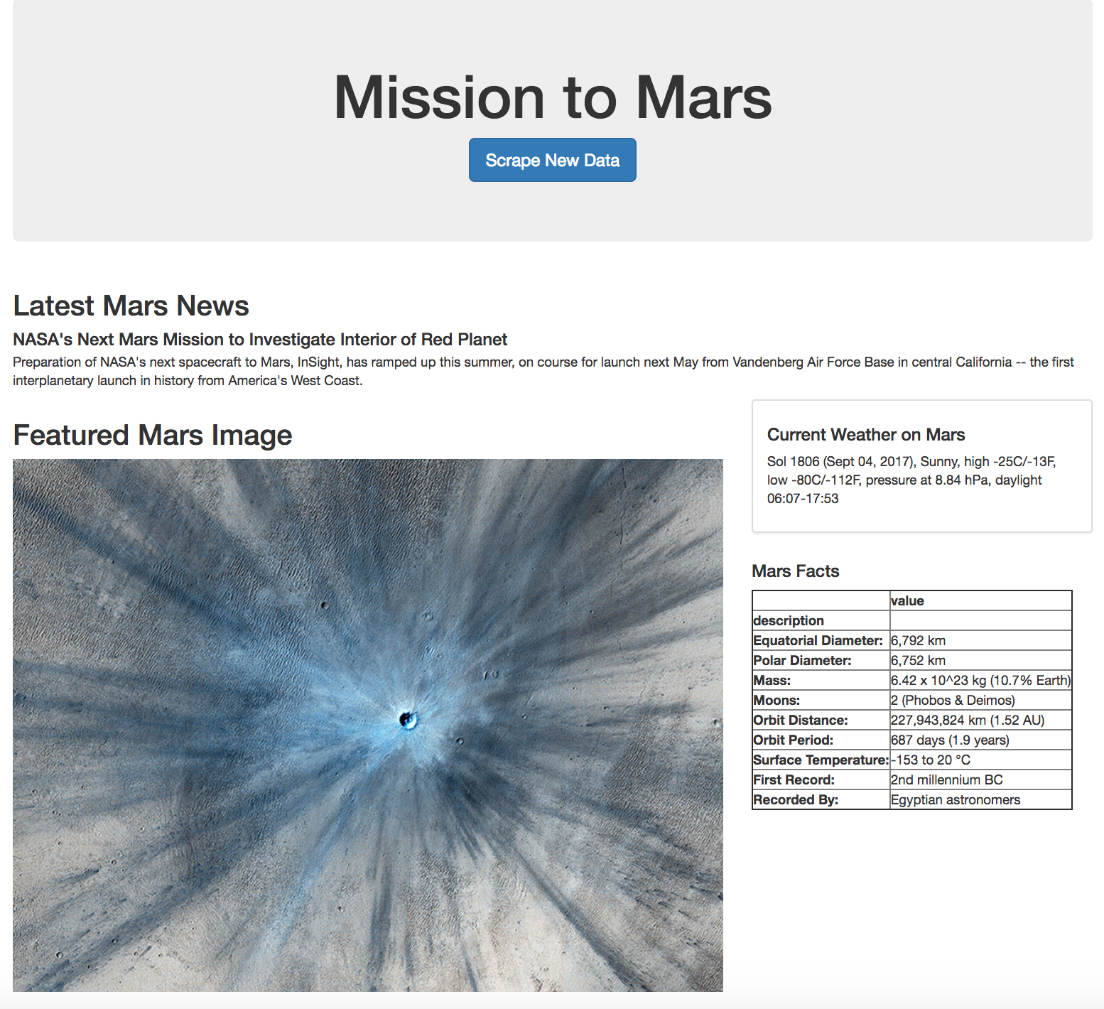

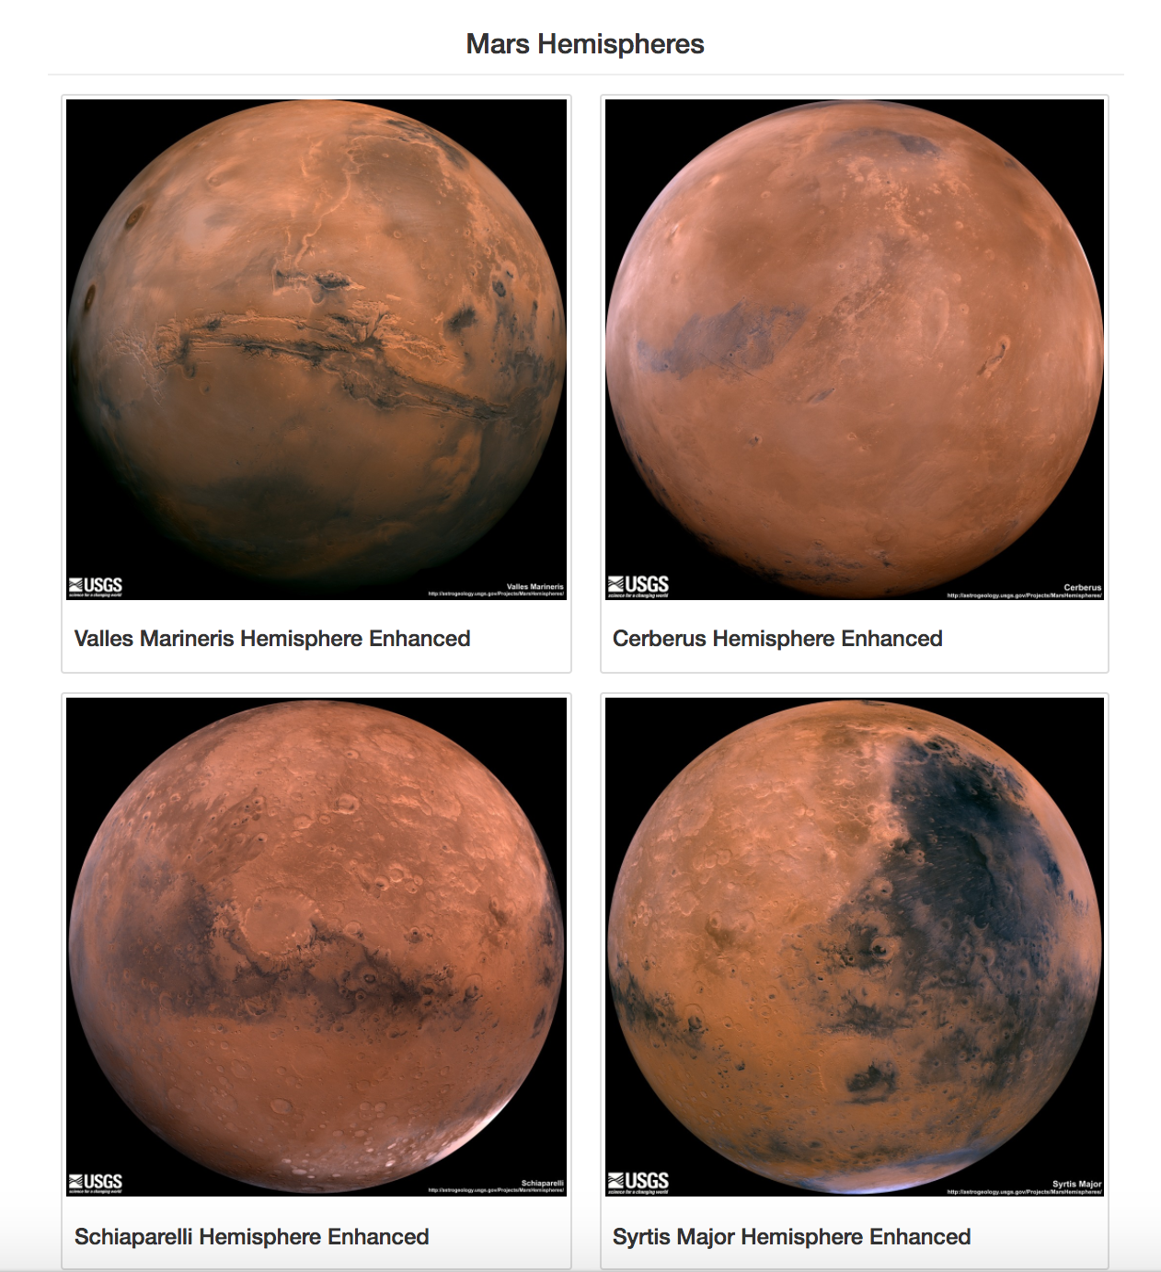

* Finally, deploy your Flask app to Heroku.

***Hints***

* Use splinter to navigate the sites when needed and BeautifulSoup to help find and parse out the necessary data.

* Use Pymongo for CRUD applications for your database. For this homework, you can simply overwrite the existing document each time the `/scrape` url is visited and new data is obtained.

* Use Bootstrap to structure your HTML template.