Installing foundation locally:

See <https://foundation.zurb.com/sites/docs/v/5.5.3/sass.html>

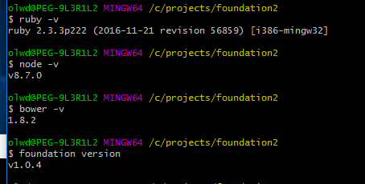

Verify as above that all the gems/ software versions are installed

Compass is installed

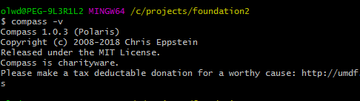

foundation new MY_PROJECT

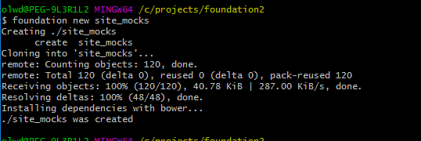

cd into olwd@PEG-9L3R1L2 MINGW64 /c/projects/foundation2/site_mocks

Run

gem install bundler

Then run bundle (only once per project)

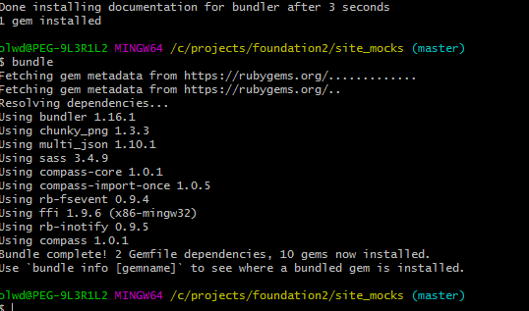

bundle exec compass watch CRITICAL!! This serves the site!!!

How to customise is here <https://foundation.zurb.com/sites/docs/v/5.5.3/sass-files.html>

root/scss/_settings.scss - modify Foundation variables here or switch default ones on and off.

root/scss/app.scss - deactivate or change imports of component partials

root/bower_components/foundation/scss/foundation --- put partials here