Instructor Dashboards In EdX

Saif Rayyan

MIT

Bldg. 8-310

77 Massachusetts Avenue

Cambridge, MA 02139 USA

srayyan@mit.edu

Daniel Seaton

Harvard University

125 Mt. Auburn Street 4th Floor

Cambridge, MA 02139 USA

dseaton@gmail.com

Colin Fredericks

Harvard University

125 Mt. Auburn Street 4th Floor

Cambridge, MA 02139 USA

Colin_Fredericks@harvard.edu

Glenn Lopez

Harvard University

125 Mt. Auburn Street 4th Floor

Cambridge, MA 02139 USA

Glenn_Lopez@harvard.edu

Victor Shnayder

EdX

141 Portland Street

Cambridge, MA 02139 USA

victor@edx.org

Permission to make digital or hard copies of part or all of this work for personal or classroom use is granted without fee provided that copies are not made or distributed for profit or commercial advantage, and that copies bear this notice and the full citation on the first page. Copyrights for third-party components of this work must be honored. For all other uses, contact the owner/author(s). Copyright is held by the author/owner(s).

L@S 2016, April 25–26, 2016, Edinburgh, UK.

ACM 978-1-4503-3726-7/16/04.

<http://dx.doi.org/10.1145/2876034.2893405>

# Abstract

Staff from edX, MIT, and Harvard will present two instructor dashboards for edX MOOCs. Current workflows will be described, from parsing and displaying data to using dashboards for course revision. A major focus will be lessons learned in the first two years of deployment.

# Author Keywords

mooc; dashboard; edx; analytics; instructor

# Introduction

Course dashboards in edX provide aggregated student data and simple research results to instructional teams. This demonstration walks through the process of designing, deploying, and using dashboards, from the viewpoints of programmers, data scientists, course authors, and institutional researchers.

# Dashboards

Two different dashboards are available for use with edX: the [Insights](https://edx.readthedocs.org/projects/edx-installing-configuring-and-running/en/latest/analytics/install_analytics.html) dashboard, available to all users of the edX and Open edX platforms, which is accessible from within the platforms, and an MIT/Harvard collaboration called [XAnalytics](https://github.com/mitodl/xanalytics), which is available to course teams and institutional researchers at each institution, and is being adopted by other institutions as well. Both dashboards are open-source.

**Good Utilization of this Space Sample, as Side Bar**

**Preparation**: Do not change the text box size or position.

**Materials:** This can not appear higher or lower on the page because of pagination and specific headers added during the indexing and pagination process.

**Process:** A 0.75 inch rule is beneficial to break this apart from the body text. The text in this text box should remain the same size as the Body Text: 8.5 Verdana or Arial (with use of **bold** and *italics* to highlight points)

**Images & Figures:** If you have any images in color, it is always good practice to print your paper out in black and white to ensure that the tones and screens used in your figures reproduce well in black and white, but your images will appear in full color in the electronic proceedings and in the ACM digital library. Images in your document should be at least 300 or 600 dpi for quality reproduction.

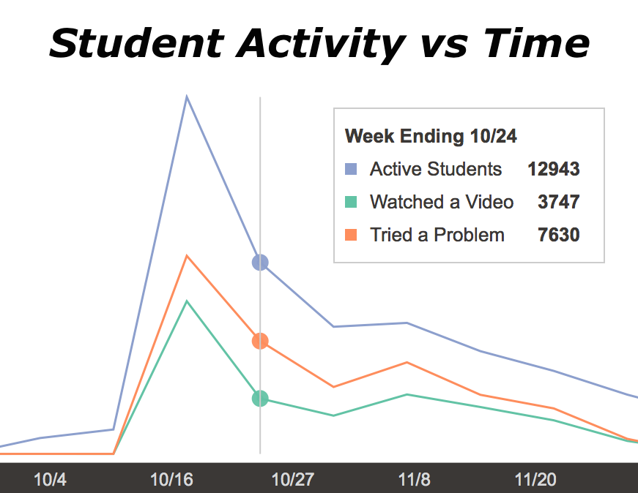Three major groups use these dashboards: course leads, professors, and administrators. The choice of what data to display and how to display it was made in close consultation with these users.

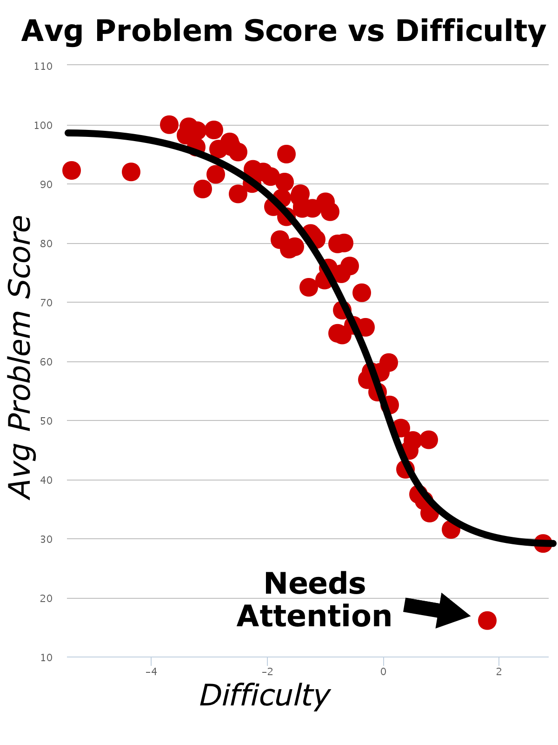Within a particular constituency, there can be substantial differences in user requirements. Discussion at the demonstration will include how these differences are handled in the two systems. For example, the needs of MOOC teachers differ greatly from the needs of on-campus teachers. In a face-to-face course where online materials are used to provide homework or additional resources, advising and assessing individual students is a major priority. Consequently, there is a greater need for up-to-the-minute information. Figure 1, from the Insights dashboard, shows how dashboard data can identify which components of the course are most engaging to the students. Conversely, MOOC instructors do not have the time or ability to address thousands of students individually. Dashboard data is instead used to guide iterative course development in a months-long cycle. Figure 2, from XAnalytics, shows how graphs of IRT-derived data can point out individual assessment items that need attention.

Fig. 2: Using dashboard data to identify assessments that need revision.

Fig. 1: Using dashboard data to identify which components are engaging students.

Many MOOC instructors also find demographic and geographical breakdowns to be very motivating. Both XAnalytics and Insights provide this information in aggregate form.

# Future Developments

The future evolution of these dashboards will be a major focus of our discussion at our demonstration. We encourage L@S attendees to join in the conversation about how to handle novel and difficult sources of data.

In particular, both XAnalytics and Insights plan to group student data by demographics, performance, and other factors. We expect that these reports will be very valuable in reaching traditionally under-served groups of students. The XAnalytics team hopes to add the ability to handle custom survey questions (from sources such as Qualtrics), while the Insights team is considering how to handle the filtering of engaged and disengaged students.

Discussion forum data is also an acknowledged blind spot for both dashboards, and a complex task for computer-driven analytics. Both teams are considering how best to approach these difficult items, and we welcome input.

# Demonstration

Both the Insights and XAnalytics dashboards will be demonstrated using real, anonymized student data from live courses. Both the instructor-facing side and the data chain will be shown.

# Acknowledgements

The close collaboration between researchers at Harvard and MIT has been a boon for the development of the XAnalytics dashboards. Likewise, the deep involvement both institutions have with edX has helped to shape and drive the Insights dashboards. We are thankful for the community of research that has been created in Cambridge and Boston around online learning, and for the generosity of the individuals and institutions who help us improve education for the world.