# User's guide for using Search Crawler

The program can be used in two modes: search using simple BFS algorithm or have an Adaptive Search

that uses Gittins index.

Step-by-step:

1. When you run the program you will see following window:

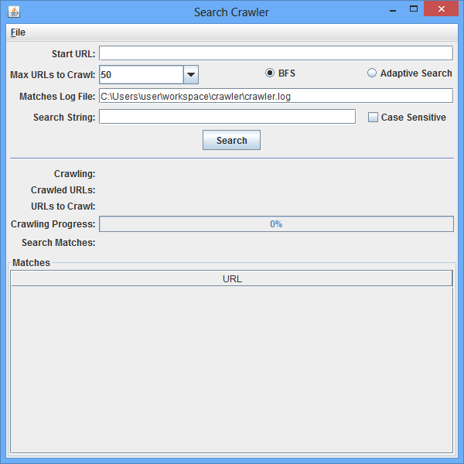

1. Now we have to enter parameters of our search
   1. In field “Start URL” enter the source that you want to scan, e.g. <http://something.com>. If the URL is incorrect you will see this “Error” window after pressing the “Search” button.

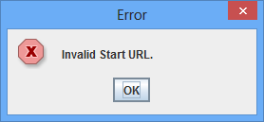

* 1. In field “Max URL” enter the number of pages that you want this search to scan. Standard values are 50, 100, 200, 500, 1000, 10 000.
  2. To choose what algorithm to use press the appropriate button “BFS” or “Adaptive Search”.
  3. “Match Log File” – please enter the pass to file where you want to store results of conducted search. The program will create the file automatically.
  4. “Search String” is a string that you want to search for in all web pages.
  5. Tick the “Case Sensitive” box if you want the search to be case sensitive.

1. After entering all search criteria and configurations, you can press the “Search” button. This is an example of program’s running.

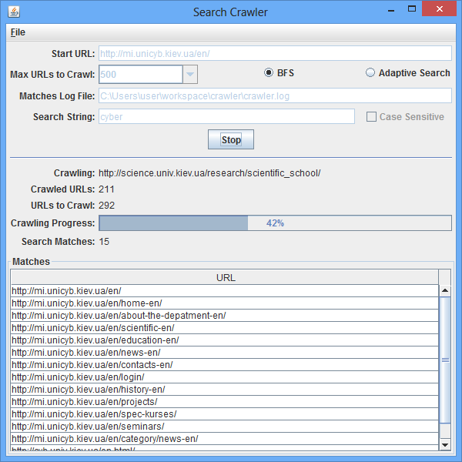

1. If search did not have any results you will see next window.

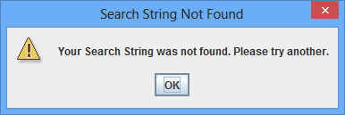

1. The results of the search should look like this:

