COMP3123 – Assignment 02
Olympia Santaguida-Antunes
Student# 101469745

Containers Running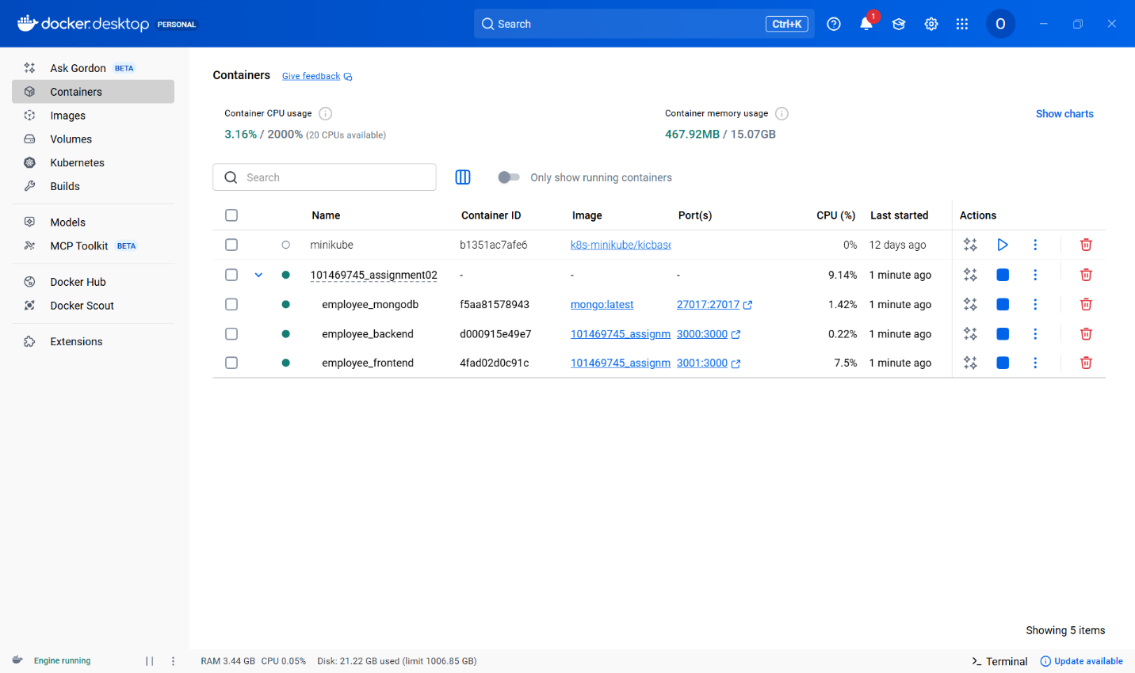
Frontend: SignUp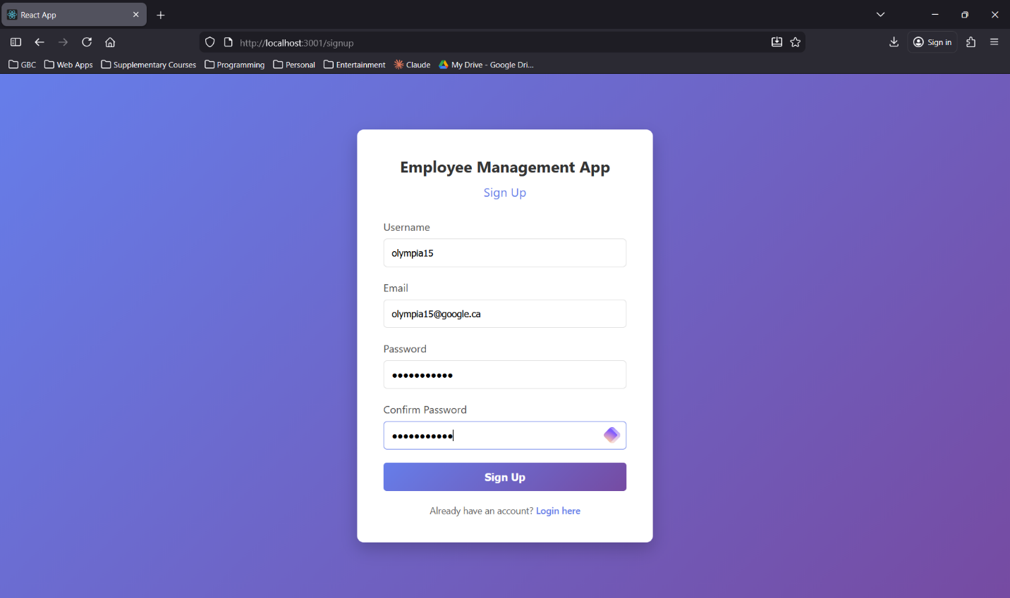
Frontend: SignUp Success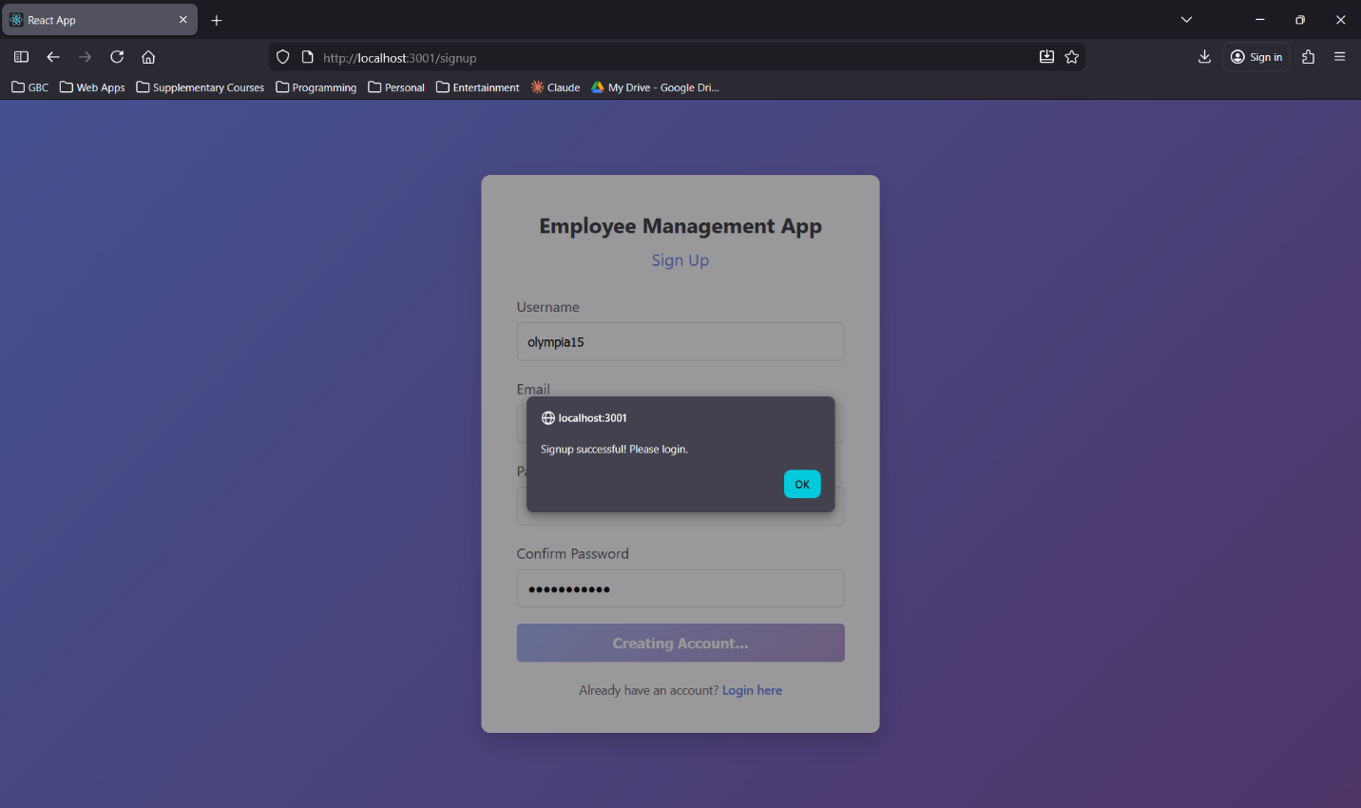
Frontend: Login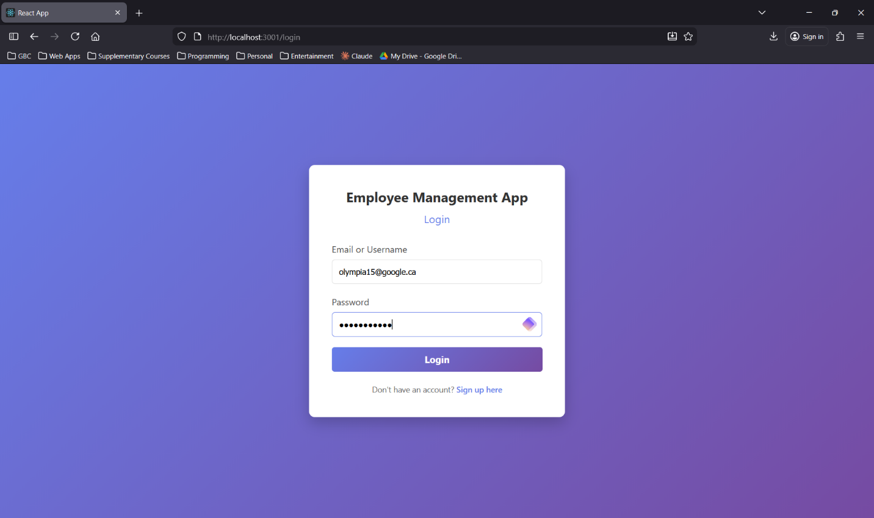
Frontend: Search Screen with All Employees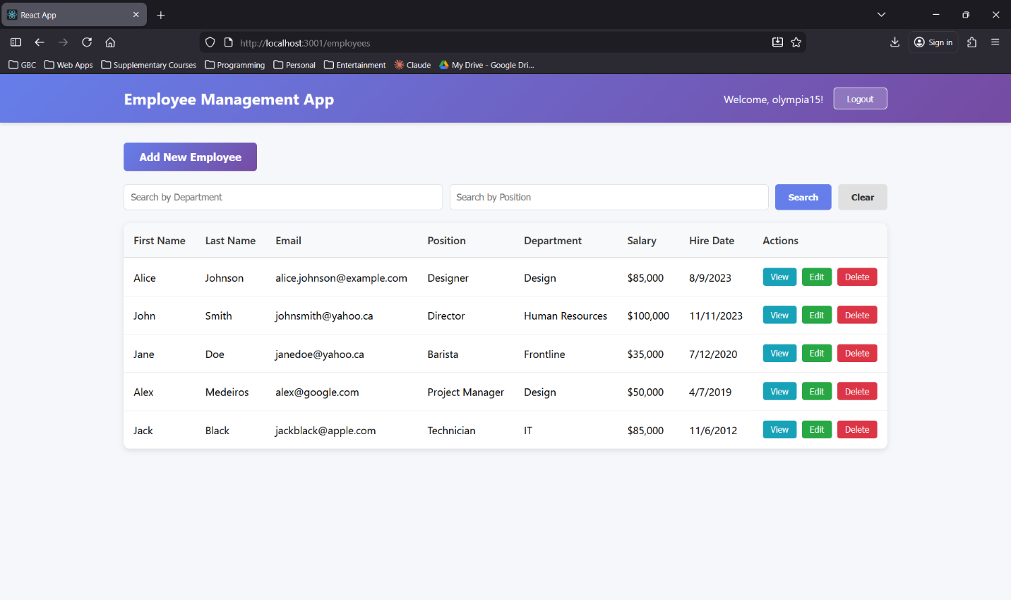
Frontend: Add Employee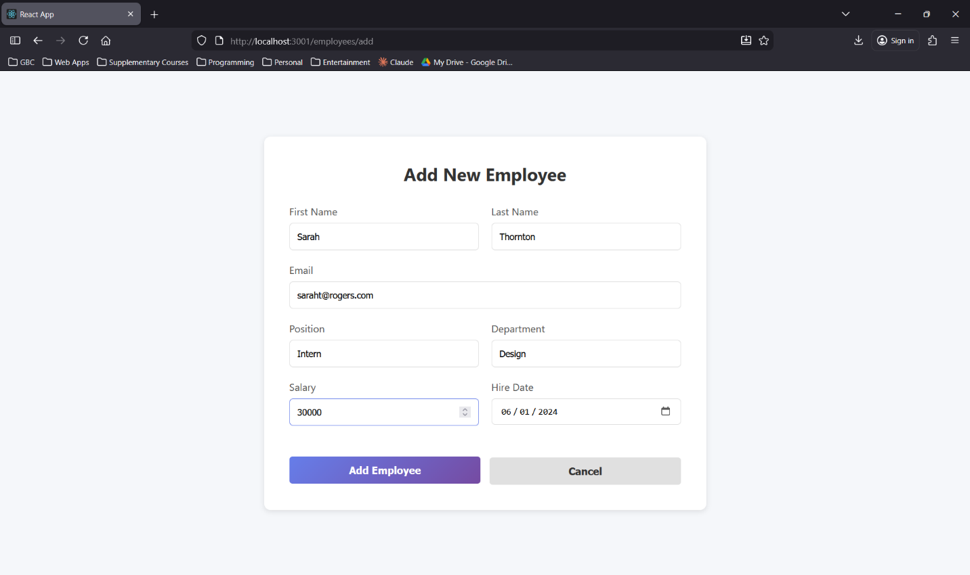
Frontend: Add Success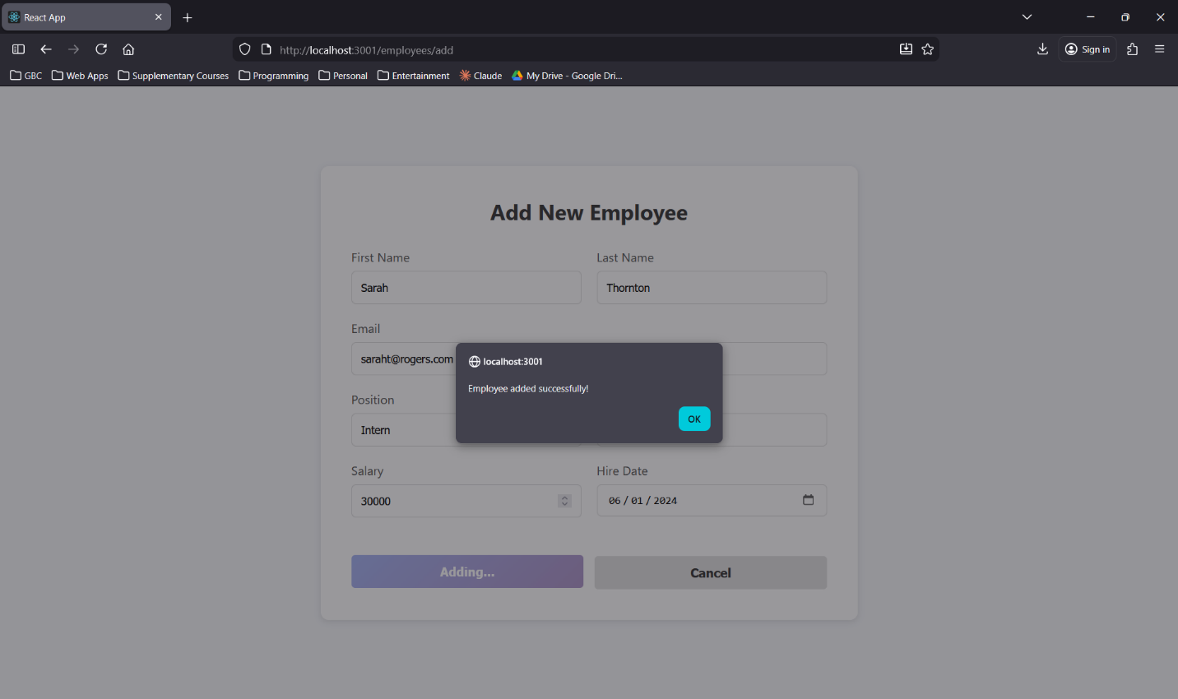
Frontend: Search Screen with Newly Added Employee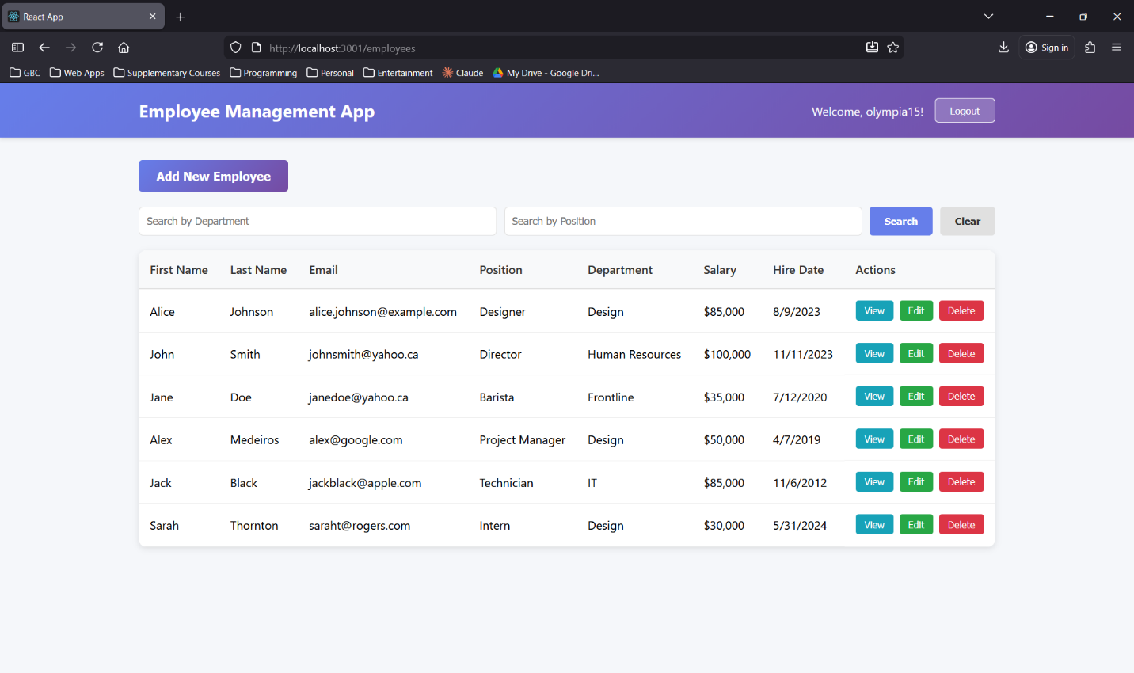
Frontend: Search by Department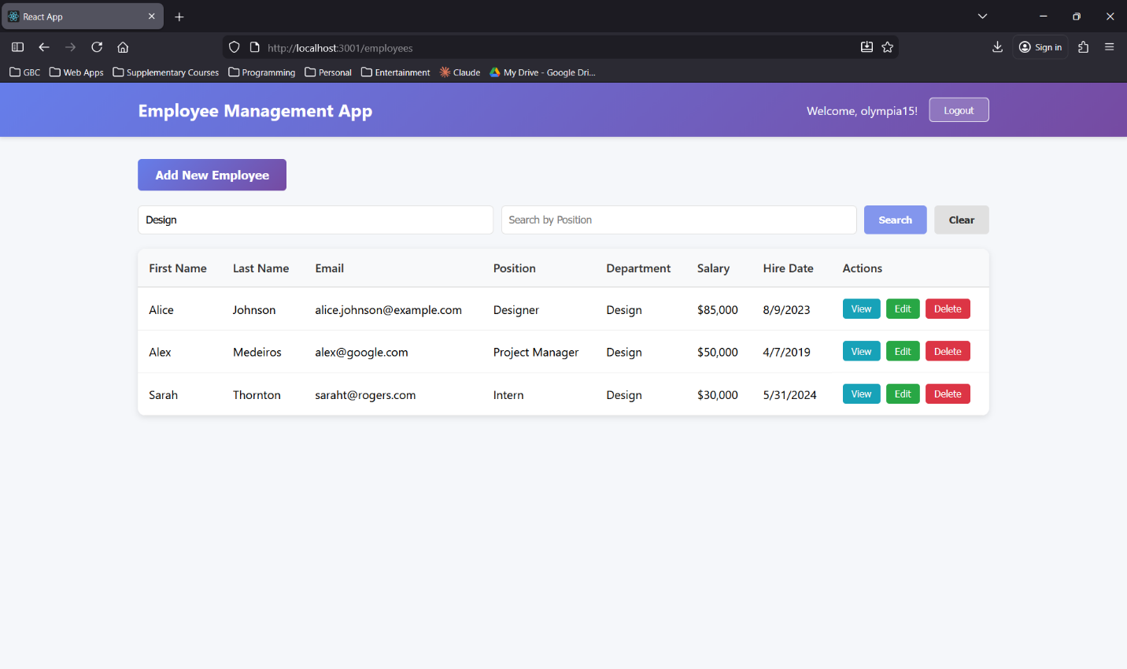
Frontend: Search by Department and Position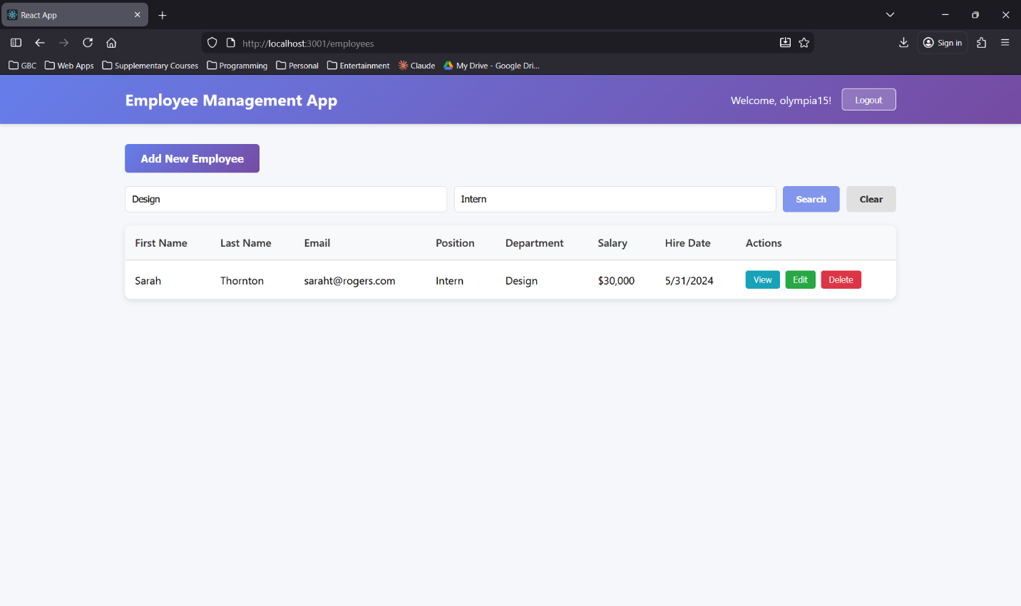
Frontend: View Employee Details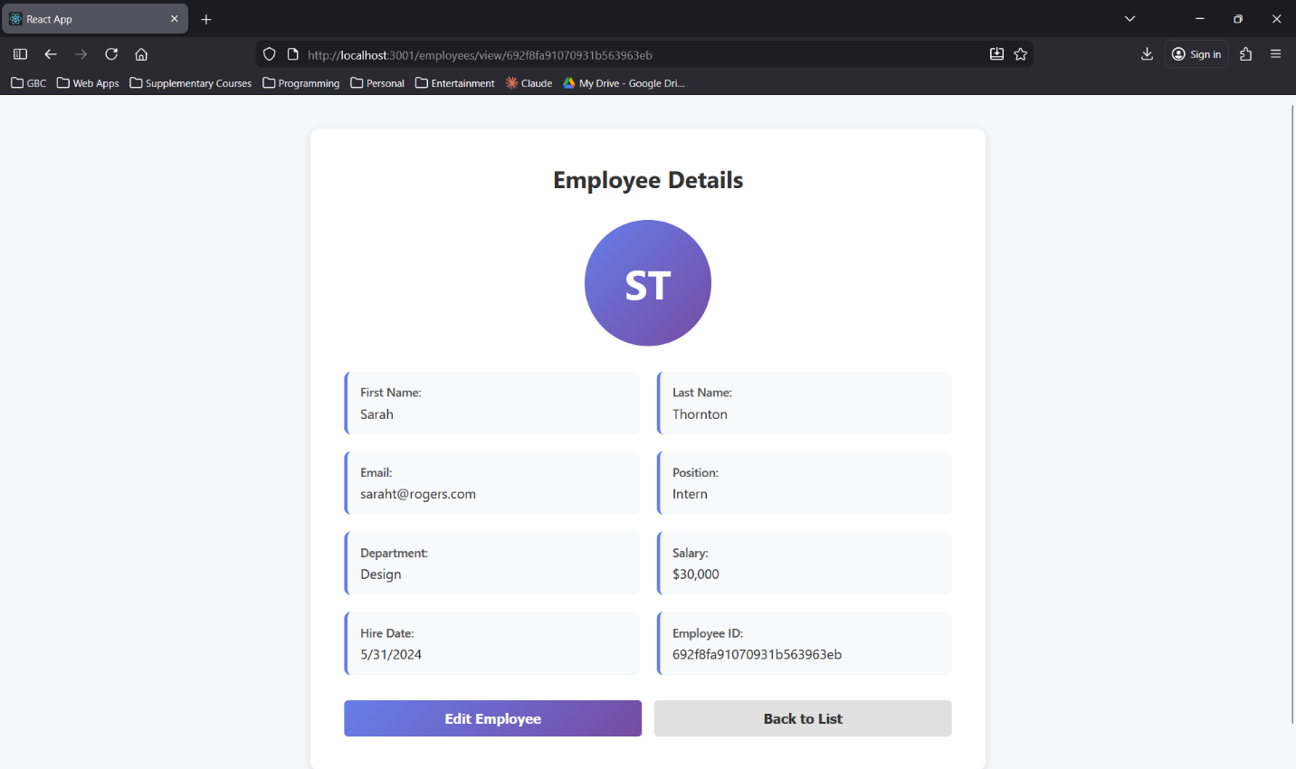
Frontend: Edit Employee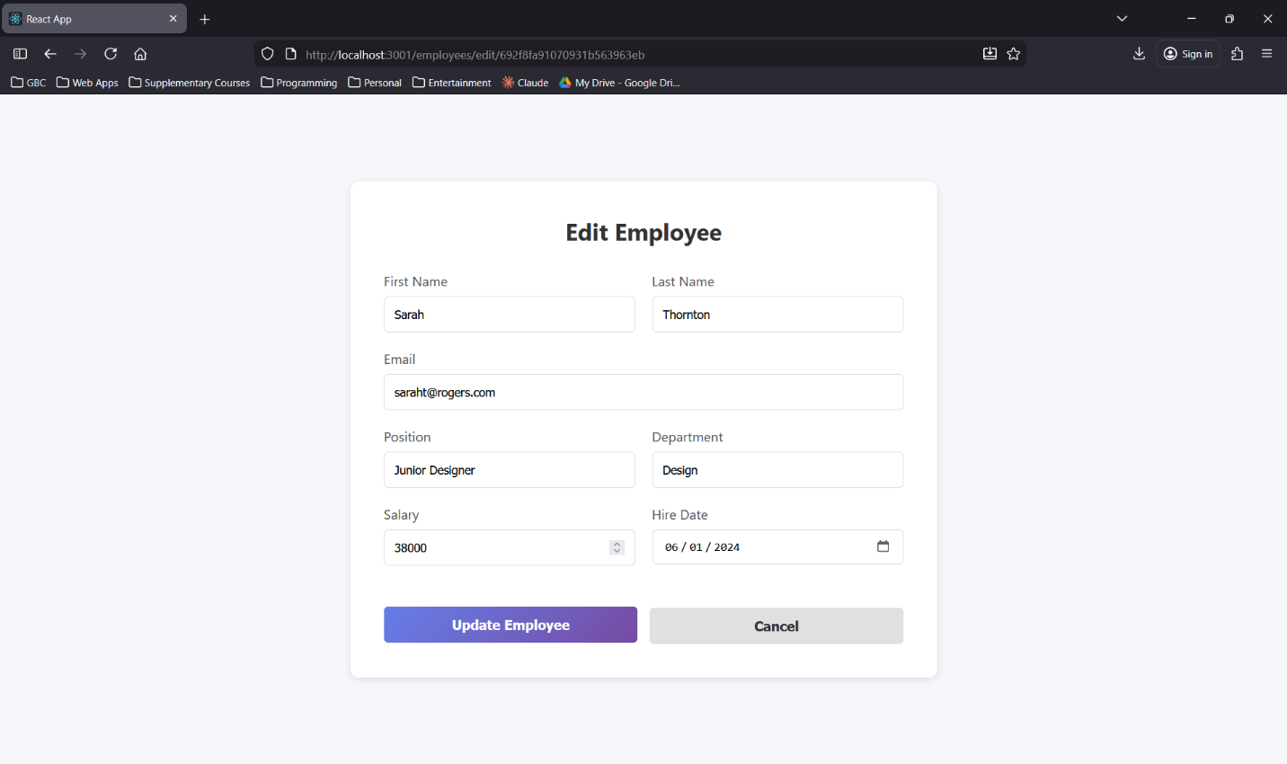
Frontend: Edit Success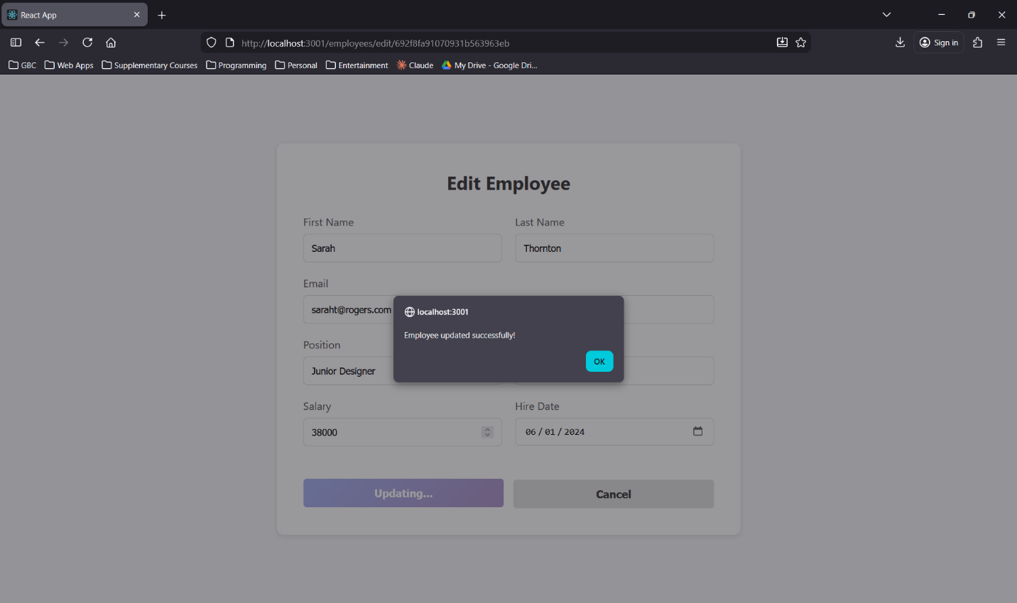
Frontend: Search by Position (with Updated Employee)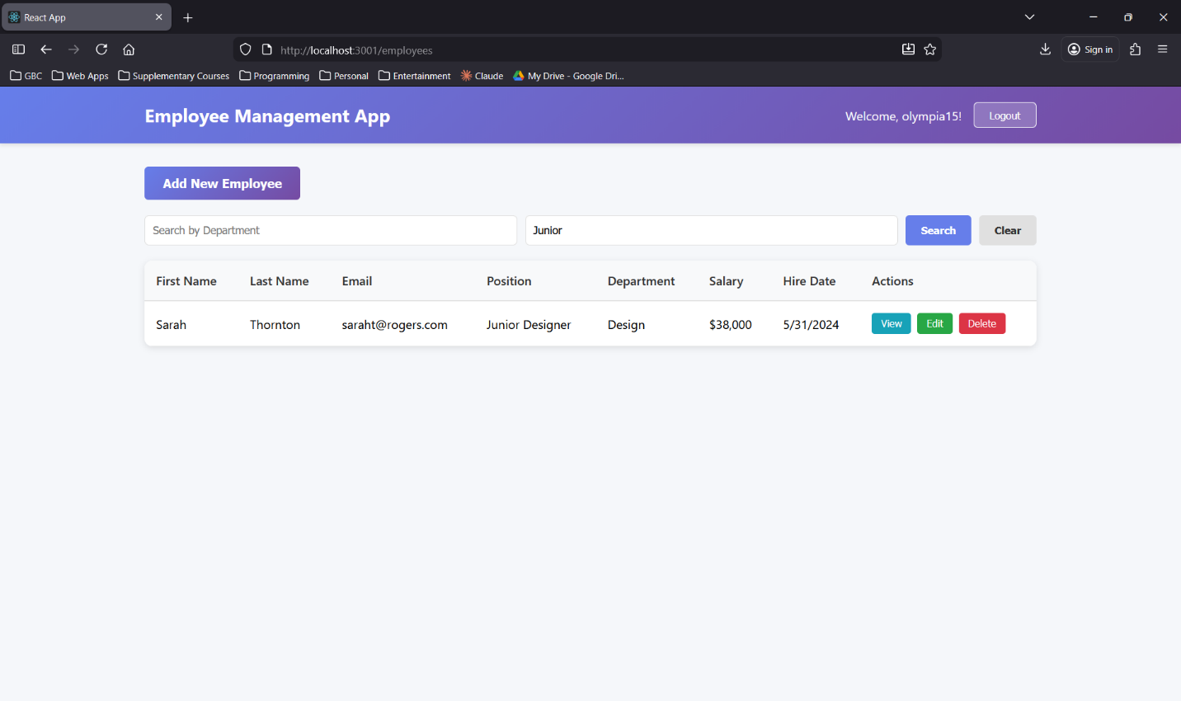
Frontend: Delete Employee Confirm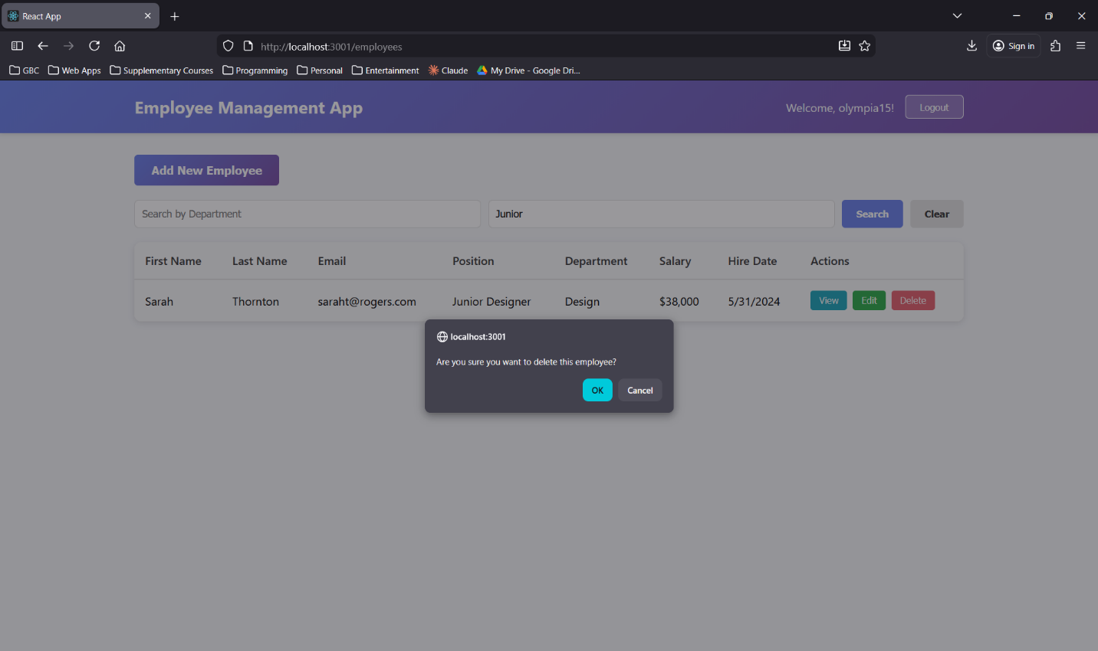
Frontend: Search Screen (After Employee Deleted)
Backend: SignUp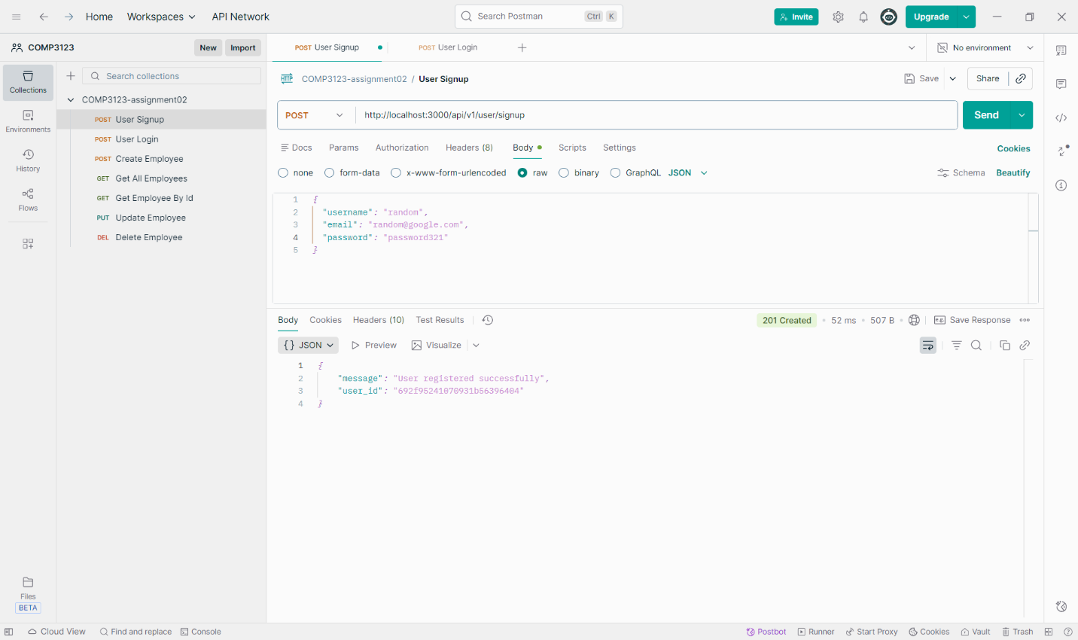
Backend: Login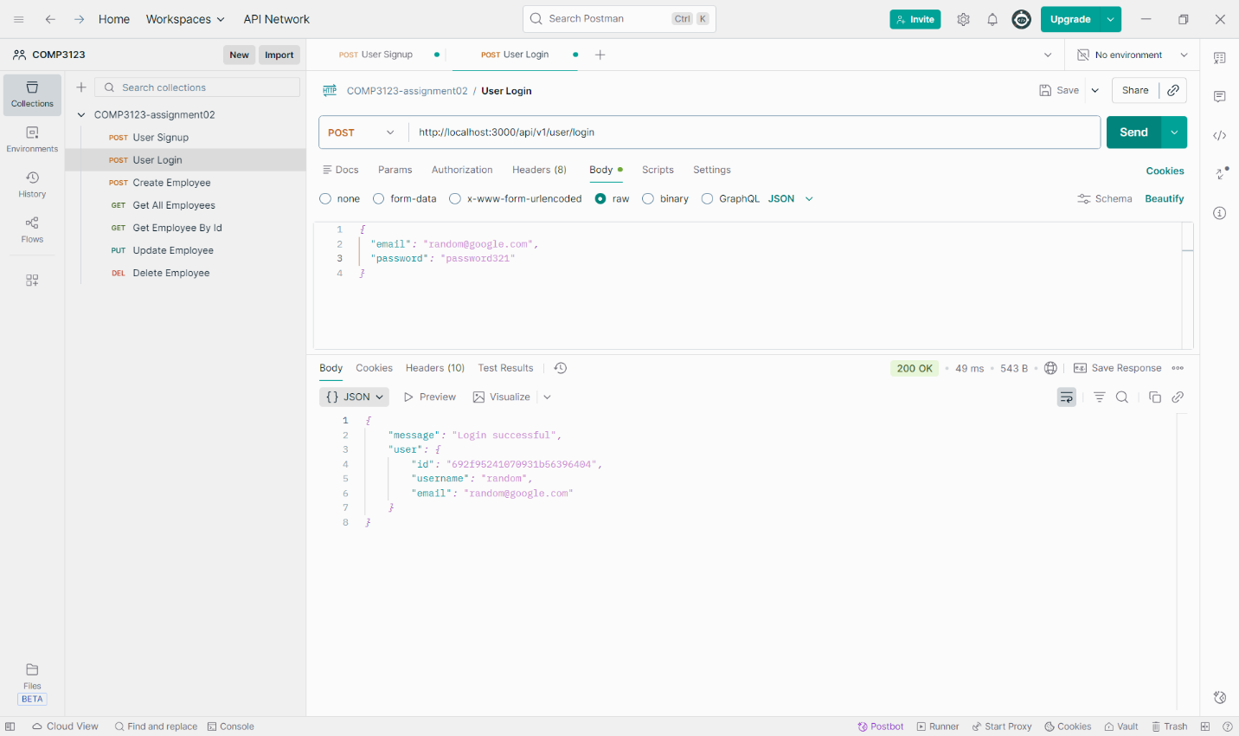
Backend: Login With Wrong Password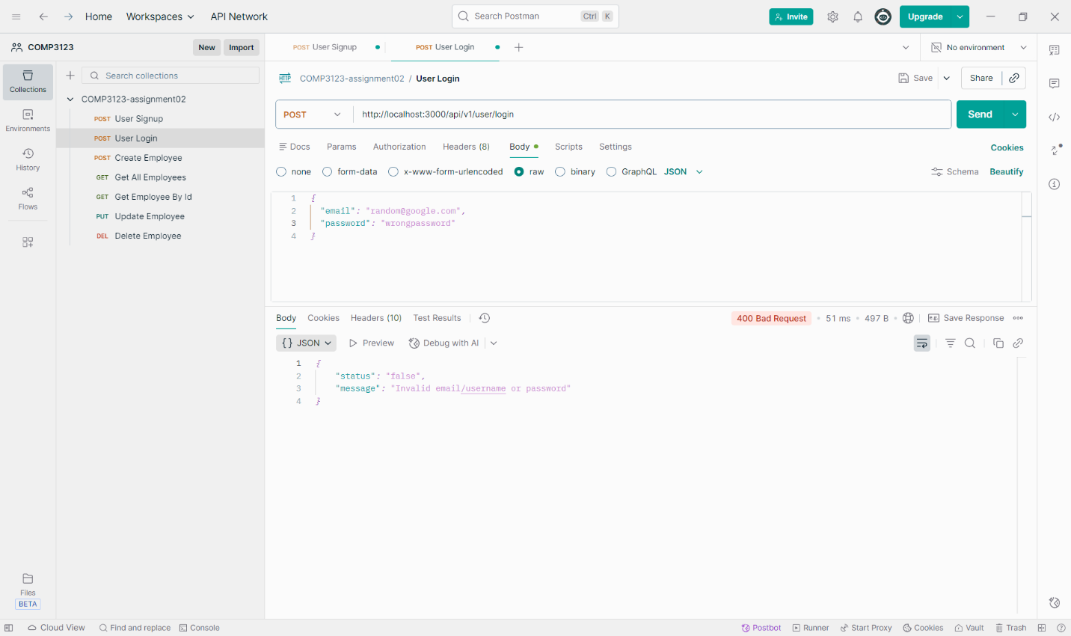

Backend: Create Employee
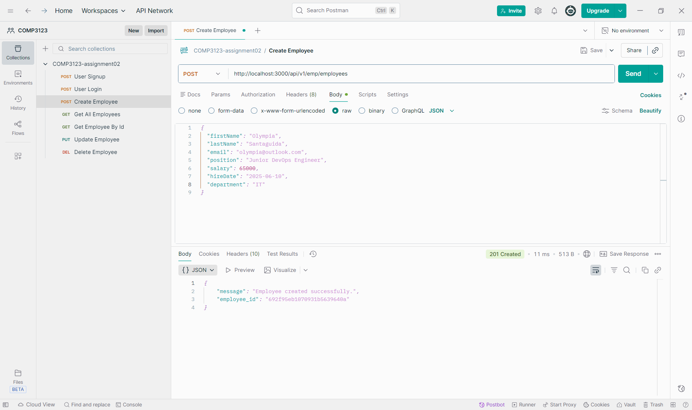
Backend: Get All Employees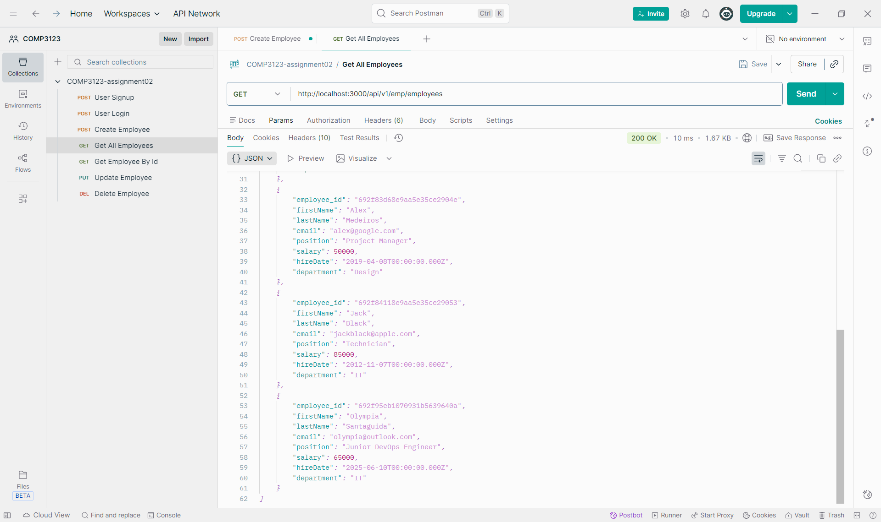
Backend: Update Employee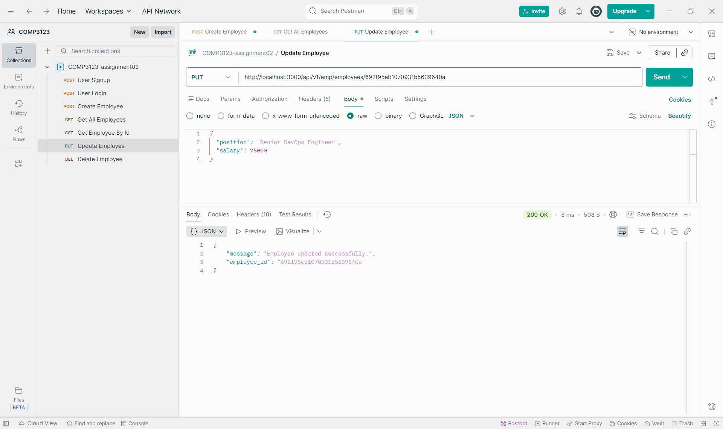
Backend: Get Employee By ID (with Updated Employee)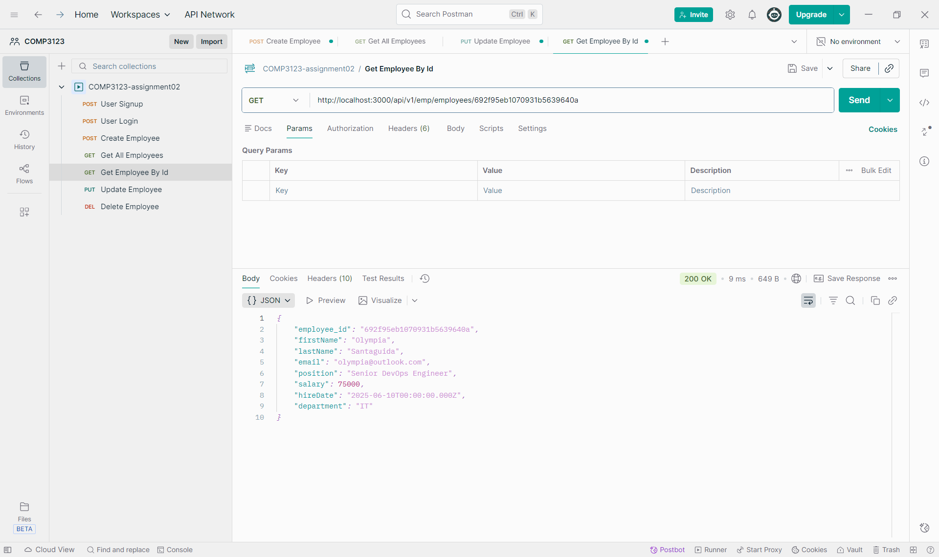
Backend: Delete Employee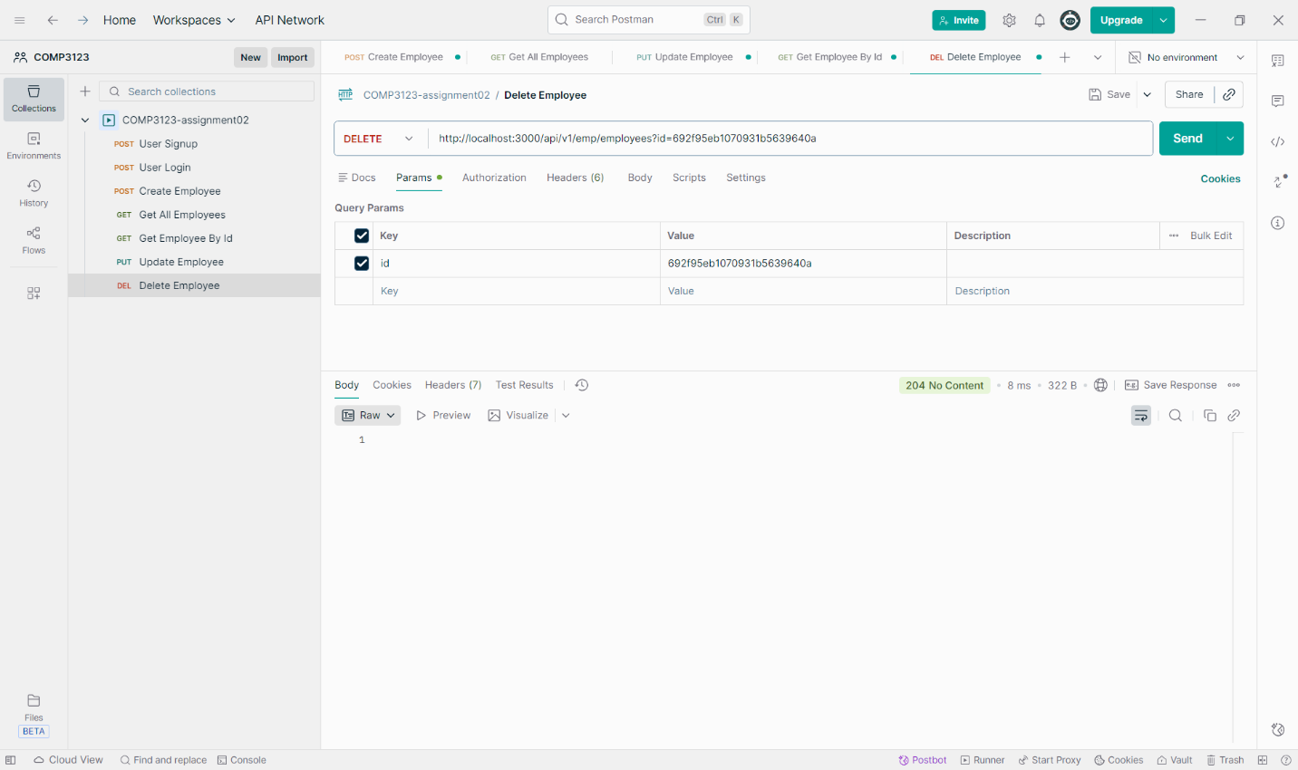
Backend: Get Employee By ID (with Deleted Employee)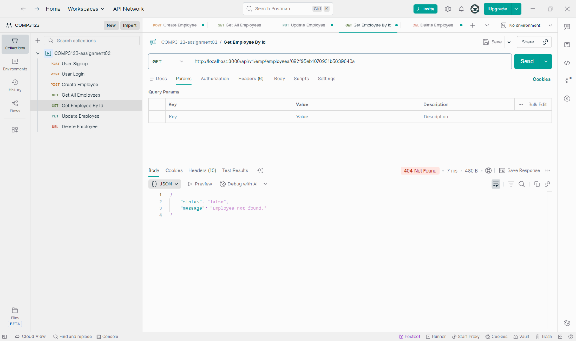
Backend: Get Employee by ID (with Active Employee) 