Measurement of Elastic Constants Using Ultrasound: Theory

Introduction
Ultrasound uses very high frequency sound, higher than 20 kHz (the limit of human hearing), to determine material characteristics of interest such as the presence of cracks or voids, porosity, part thickness and weld penetration. In this experiment, you will measure the speed of sound in several solids including steel, aluminum, brass, and fused quartz and then calculate the Young’s modulus and Poisson’s ratio for these materials.

Stress Waves in Solids
Consider a body, which experiences a disturbance on the surface. The propagation of the disturbance through the body follows the wave equation,
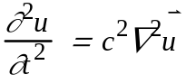 (1)
where (x,y,z,t) is the displacement vector which describes the change in position of any point in the body at position (x,y,z) at time t and c is the speed of sound, which depends on the material. In fluids such as air, sound travels as a pressure wave. However, solids support both normal stress and shear stress. This means that two types of waves, longitudinal and shear, may propagate through a solid. Longitudinal and shear waves are shown schematically in Figure 1. For longitudinal waves, the motion of the particles is parallel to the direction of propagation; for shear waves, the motion of particles is perpendicular to the direction of wave propagation. The wavelength, λ=c/f, is indicated in Figure 1, where f is the wave frequency.
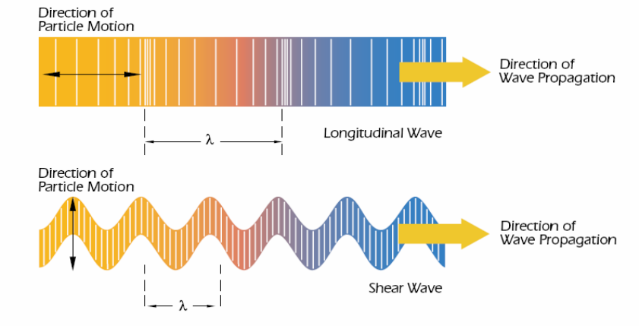
Figure 1: Types of waves in bulk solid: (a) longitudinal waves, (b) shear waves [4]
It may be shown that the speed of sound of longitudinal and shear waves is given by:
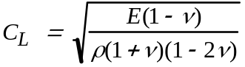 (2)
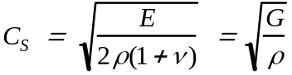 (3)
where E is Young’s modulus (or the modulus of elasticity), ν is Poisson’s ratio, ρ is the density, and G is the shear modulus. Solving these equations for E and ν gives:
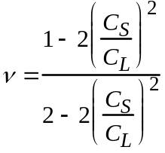 (4)
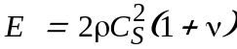 (5)
Thus, given measurements of ρ, C_{L}, and C_{S}, it is possible to determine E and ν. A table of the nominal density of the specimen materials is given in Table 1.
Table 1: Nominal density of four specimen materials
 | Steel | Aluminum | Brass | Fused Quartz
Density -ρ (g/cm³) | 7.85 ± 0.05 | 2.80 ± 0.05 | 8.50 ± 0.05 | 2.2 ± 0.05

Pulse-Echo Method
In the pulse-echo ultrasonic testing technique, an ultrasound transducer generates an ultrasonic pulse and receives its ‘echo’. Using the piezoelectric effect, a short, high voltage electric pulse (less than 20 Ns in duration, 100-200 V in amplitude) excites a piezoelectric crystal, to generate an ultrasound pulse at the surface of the specimen. It travels through the specimen and reflects off the opposite face. The transducer then “listens” to the reflected echoes as the ultrasound pulse keeps bouncing off the opposite faces of the specimen, attenuating with time.
Figure 2 shows a train of echoes from multiple round-trips through the specimen. The time between any two echoes is the length of time required for the pulse to travel through the specimen and back to the transducer. The attenuation (amplitude decay) is exponentially with time.
The speed of sound in the solid can be derived from the observed round trip transit time, Δt, and the measured thickness of the specimen, d:
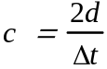 (6)
Values for the speed of sound in a variety of solids range from 1 to 8 km/s. How does this compare to the speed of sound in air?
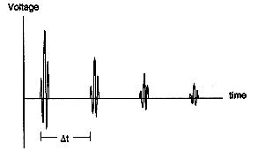
Voltage
Time
Δt
Figure 2: Echoes received from repeated round trips through a specimen

Ultrasonic Transducers
This experiment uses direct contact transducers. Such transducers are generally applicable for minimum thickness of 0.5 mm for metals and 0.125 mm for plastics and where accuracy requirement is not greater than ±0.025 mm.
Figure 3 shows a schematic diagram of an ultrasonic contact transducer. The primary component is the piezoelectric quartz crystal that converts a mechanical pulse into an electrical signal, or conversely, an electrical signal to a mechanical pulse. In the pulse-echo method, the crystal functions in both modes. According to the manner in which the piezoelectric crystal is cut, it vibrates in the thickness direction, producing longitudinal waves, or in the tangential direction producing shear waves. The piezoelectric element is mounted adhesively to a wear plate on one side. On the other side is a lossy backing material, which damps the natural vibration of the piezoelectric crystal to facilitate the production of a pulse of short duration. The pulse has a characteristic bell shaped frequency spectrum with maximum near the natural frequency of the piezoelectric element, which depends on its thickness.
Between the contact transducer and the specimen, a coupling is used. The most common coupling material used for longitudinal waves is glycerin, which is non-toxic and washes off with water. It is more difficult to transmit shear waves across the transducer/specimen interface, so a high viscosity coupling material is more effective.

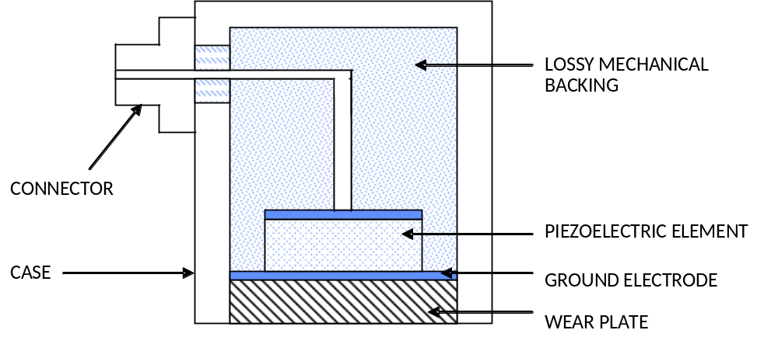
Figure 3: construction of an ultrasonic transducer

Questions
- Calculate the longitudinal and shear wave speeds for each of the materials and estimate your uncertainty.
- What are the wavelengths of 5 MHz shear and longitudinal waves in aluminum?
- Calculate Poisson’s ratio and Young’s modulus of each of the specimen materials. Estimate the measurement uncertainties using propagation of errors. How do your measurements of E and ν compare with published, nominal values?
- Using the measurements taken across the red block specimens, determine the denomination (penny, nickel, etc.) of the coin embedded in each block. How did you determine which coin is in which block? How certain are you of your results? Compare your experimental measurements with measurements of actual coins.

References
- Achenbach, J. D., Wave propagation in Elastic Solids, North-Holland, Amsterdam, 1984.
- Krautkramer, K., Ultrasonic Testing of Materials, Springer-Verlag, New York, 1969.
- Ensminger, D., Ultrasonics: Fundamentals, Technology, Applications, M. Dekker, New York, 1988.
- http://www.olympusndt.com/en/
- Bolz, R. E., Tuve, G., L., Handbook of Tables for Applied Engineering Science, CRC Press, Florida,1984

