Olzhas Zhakhanger – JA363R
Homework 4, Financial Data Analysis

1. Download publicly available daily stock price data (close prices) for minimum 3 months for 3 stocks. Assume that the distribution in case of the daily return values could be approximated with normal distribution. Calculate the probability that the daily stock return is a negative value for that stock that has the highest risk (measured by the standard deviation of the return). (5 points)
I downloaded Data from BSE.hu website of Hungarian stock market for a period starting from 12.06.2025 till 12.11.2025 of three different 3 different stocks: MASTERPLAST, MOL, MTELEKOM. Highest risk was Masterplast, which is 0,01259. MOL was 0,011; Mtelekom was 0,0103. The highest st dev = highest risk. And I also got the mean values as return.
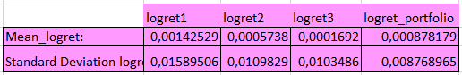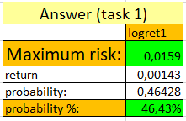
Using norm dist, I got the 46,43% probability.

2. Calculate the smallest possible risk value in case of a portfolio consisting of those two stocks that have smaller risk than the stock with the highest risk in Question 1. (5 points)
Two other stocks with comparatively smaller risk is MOL, MTelekom.
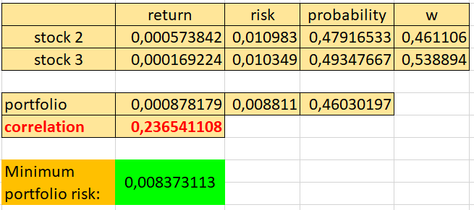
The correlation was 0,236541108; it was calculated between stock 2 and stock 3. And later, the weights are 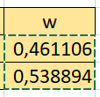 respectively. It was calculated with risks and the correlation.
constraints of Solver to minimize Risk: w2+w3=1, w2>=0, w3>=0. It helped us to adjust them. So the minimum portfolio risk is
0,008373113

3. Calculate coordinates for minimum 5 points in the efficient frontier if the portfolio components may be the three stocks mentioned in Question 1. (10 points)
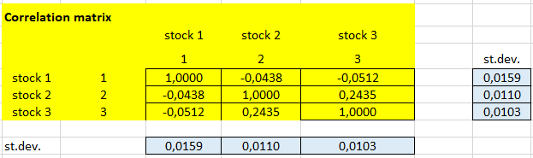
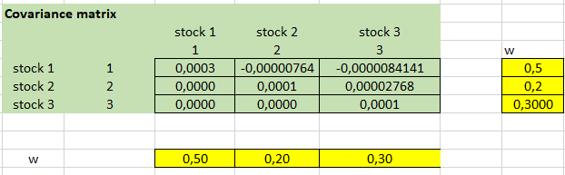
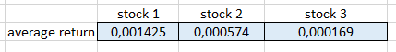
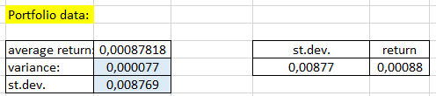

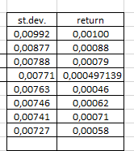
I used 10 cases of w change.
The noticable one was
0,10 | 0,40 | 0,50
Because the values are very close to the graph, and it can be implemented as effective weight. Solver was used to add constraints minimum and maximum, and also comparison constraints to adjust the value of w list.
I would say the most effective ws 1 0 0. Because it enlarged the view, reaching the maxmimum capacity.
At the end we have the minimum-variance portfolio:
- lowest possible risk among all 3-stock combinations
- but also relatively low expected return.
Last task shows that by combining the three stocks in different proportions we can construct a set of optimal portfolios -efficient frontier - which gives the highest possible expected return for each level of risk.

