**Lab Practical #01:**

Study of basic networking commands and IP configuration.

**Practical Assignment #01:**

1. Perform and explain various networking commands listed below:
   1. ipconfig
   2. ping
   3. getmac
   4. systeminfo
   5. traceroute / tracert
   6. netstat
   7. nslookup
   8. hostname
   9. pathping
   10. arp

## ipconfig

### Description:

**Displays all current TCP/IP network configuration values and refreshes Dynamic Host Configuration Protocol (DHCP) and Domain Name System (DNS) settings. Used without parameters, ipconfig displays Internet Protocol version 4 (IPv4) and IPv6 addresses, subnet mask, and default gateway for all adapters.**

|  |  |  |
| --- | --- | --- |
| No. | Option | Description |
| 1 | ipconfig/all | Displays the full TCP/IP configuration for all adapters. Adapters can represent physical interfaces, such as installed network adapters, or logical interfaces, such as dial-up connections. |
| 2 | ipconfig/displaydns | Displays the contents of the DNS client resolver cache, which includes both entries preloaded from the local Hosts file and any recently obtained resource records for name queries resolved by the computer. The DNS Client service uses this information to resolve frequently queried names quickly, before querying its configured DNS servers. |
| 3 | Ipconfig/flushdns | Flushes and resets the contents of the DNS client resolver cache. During DNS troubleshooting, you can use this procedure to discard negative cache entries from the cache, as well as any other entries that have been added dynamically. |

### Implementation:

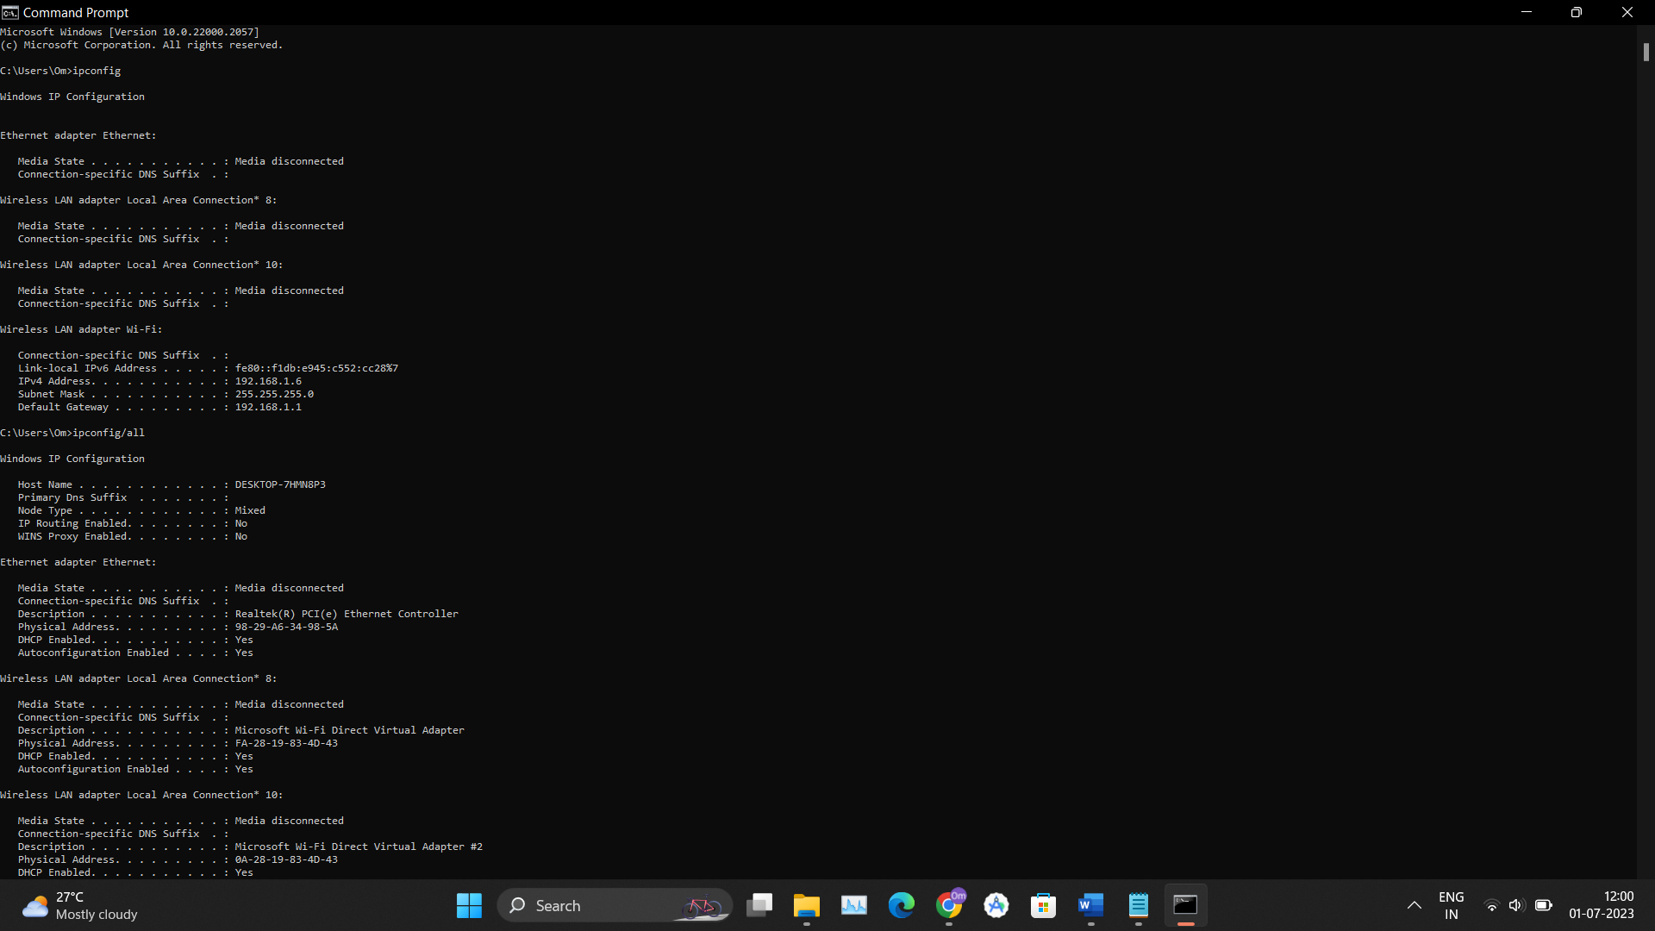

## ping

### Description:

**Verifies IP-level connectivity to another TCP/IP computer by sending Internet Control Message Protocol (ICMP) echo Request messages. The receipt of corresponding echo Reply messages are displayed, along with round-trip times. ping is the primary TCP/IP command used to troubleshoot connectivity, reachability, and name resolution. Used without parameters, this command displays Help content.**

|  |  |  |
| --- | --- | --- |
| No. | Option | Description |
| 1 | ping/t | Specifies ping continue sending echo Request messages to the destination until interrupted. To interrupt and display statistics, press CTRL+ENTER. To interrupt and quit this command, press CTRL+C. |
| 2 | ping/a | Specifies reverse name resolution be performed on the destination IP address. If this is successful, ping displays the corresponding host name. |
| 3 | ping/R | Specifies the round-trip path is traced (available on IPv6 only). |

### Implementation:

## getmac

### Description:

**Returns the media access control (MAC) address and list of network protocols associated with each address for all network cards in each computer, either locally or across a network. This command is particularly useful either when you want to enter the MAC address into a network analyzer, or when you need to know what protocols are currently in use on each network adapter on a computer.**

|  |  |  |
| --- | --- | --- |
| No. | Option | Description |
| 1 | getmac/s | Specifies the name or IP address of a remote computer (do not use backslashes). The default is the local computer. |
| 2 | getmac/p | Specifies the password of the user account that is specified in the /u parameter. |
| 3 | getmac/v | Specifies that the output display verbose information. |

### Implementation:

## 4. systeminfo

### Description:

**Displays detailed configuration information about a computer and its operating system, including operating system configuration, security information, product ID, and hardware properties (such as RAM, disk space, and network cards).**

|  |  |  |
| --- | --- | --- |
| No. | Option | Description |
| 1 | Systeminfo/s | Specifies the name or IP address of a remote computer (do not use backslashes). The default is the local computer. |
| 2 | Systeminfo/p | Specifies the password of the user account that is specified in the /u parameter. |
| 3 | Systeminfo/nh | Suppresses column headers in the output. Valid when the /fo parameter is set to TABLE or CSV. |

### Implementation:

## 4. traceroute/tracert

### Description:

**This command determines the path by sending the first echo Request message with a TTL of 1 and incrementing the TTL by 1 on each subsequent transmission until the target responds or the maximum number of hops is reached. The maximum number of hops is 30 by default and can be specified using the /h parameter.**

|  |  |  |
| --- | --- | --- |
| No. | Option | Description |
| 1 | tracert/d | Stops attempts to resolve the IP addresses of intermediate routers to their names. This can speed up the return of results. |
| 2 | tracert/h | Specifies the maximum number of hops in the path to search for the target (destination). The default is 30 hops. |
| 3 | tracert/S | Specifies the source address to use in the echo Request messages. Use this parameter only when tracing IPv6 addresses. |

### Implementation:

## netstat

### Description:

**Displays active TCP connections, ports on which the computer is listening, Ethernet statistics, the IP routing table, IPv4 statistics (for the IP, ICMP, TCP, and UDP protocols), and IPv6 statistics (for the IPv6, ICMPv6, TCP over IPv6, and UDP over IPv6 protocols). Used without parameters, this command displays active TCP connections.**

|  |  |  |
| --- | --- | --- |
| No. | Option | Description |
| 1 | netstat/a | Displays all active TCP connections and the TCP and UDP ports on which the computer is listening. |
| 2 | netstat/e | Displays Ethernet statistics, such as the number of bytes and packets sent and received. This parameter can be combined with -s. |
| 3 | netstat/n | Displays active TCP connections, however, addresses and port numbers are expressed numerically and no attempt is made to determine names. |

### Implementation:

## nslookup

### Description:

**Displays information that you can use to diagnose Domain Name System (DNS) infrastructure. Before using this tool, you should be familiar with how DNS works. The nslookup command-line tool is available only if you have installed the TCP/IP protocol.**

|  |  |  |
| --- | --- | --- |
| No. | Option | Description |
| 1 | nslookup exit | Exits the nslookup command-line tool. |
| 2 | nslookup finger | Connects with the finger server on the current computer. |
| 3 | nslookup Is | Lists information for a DNS domain. |

### Implementation:

## hostname

### Description:

**Displays the host name portion of the full computer name of the computer.**

|  |  |  |
| --- | --- | --- |
| No. | Option | Description |
| 1 | hostname/? | Displays help at the command prompt. |
| 2 |  |  |
| 3 |  |  |

### Implementation:

## pathping

### Description:

**Provides information about network latency and network loss at intermediate hops between a source and destination. This command sends multiple echo Request messages to each router between a source and destination, over a period of time, and then computes results based on the packets returned from each router. Because this command displays the degree of packet loss at any given router or link, you can determine which routers or subnets might be having network problems. Used without parameters, this command displays help.**

|  |  |  |
| --- | --- | --- |
| No. | Option | Description |
| 1 | pathping/n | Prevents pathping from attempting to resolve the IP addresses of intermediate routers to their names. This might expedite the display of pathping results. |
| 2 | pathping/h | Specifies the maximum number of hops in the path to search for the target (destination). The default is 30 hops. |
| 3 | pathping/i | Specifies the source address. |

### Implementation:

## arp

### Description:

**Displays and modifies entries in the Address Resolution Protocol (ARP) cache. The ARP cache contains one or more tables that are used to store IP addresses and their resolved Ethernet or Token Ring physical addresses. There is a separate table for each Ethernet or Token Ring network adapter installed on your computer. Used without parameters, arp displays help information.**

|  |  |  |
| --- | --- | --- |
| No. | Option | Description |
| 1 | arp/a | Displays current arp cache tables for all interfaces. The /n parameter is case-sensitive. To display the arp cache entry for a specific IP address, use arp /a with the inetaddr parameter, where inetaddr is an IP address. If inetaddr is not specified, the first applicable interface is used. To display the arp cache table for a specific interface, use the /n ifaceaddr parameter in conjunction with the /a parameter where inetaddr is the IP address assigned to the interface. |
| 2 | arp/g | Identical to /a. |
| 3 | arp/s | Adds a static entry to the arp cache that resolves the IP address inetaddr to the physical address etheraddr. To add a static arp cache entry to the table for a specific interface, use the ifaceaddr parameter where ifaceaddr is an IP address assigned to the interface. |

### Implementation:

