**Lab Practical #02:**

Study of different types of network cables & connectors and practically implement the cross-wired cable and straight through cable using clamping tool.

**Practical Assignment #02:**

1. List various networks cable and connectors. Also, write short description.
2. Give cross-wired cable and straight through cable diagram (Color Code wise).

## List various networks cable and connectors. Also, write short description.

1. **Network Cable Name:** Coaxial cable
   * **Network Cable Type:** Guided
   * **Description**: Coaxial cables have been in use for the last four decades. During these years, based on several factors such as the thickness of the sheath, the metal of the conductor, and the material used in insulation, hundreds of specifications have been created to specify the characteristics of coaxial cables.
   * **Diagram**:

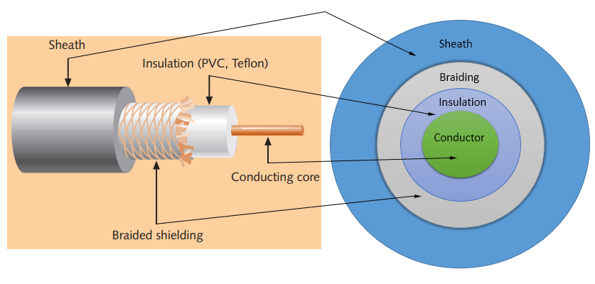

1. **Network Cable Name: Twisted pair cable**
   * **Network Cable Type:** Guided
   * **Description**: The twisted-pair cable was primarily developed for computer networks. This cable is also known as Ethernet cable. Almost all modern LAN computer networks use this cable.
   * This cable consists of color-coded pairs of insulated copper wires. Every two wires are twisted around each other to form pair. Usually, there are four pairs. Each pair has one solid color and one stripped color wire. Solid colors are blue, brown, green, and orange. In stripped color, the solid color is mixed with the white color.
   * Based on how pairs are stripped in the plastic sheath, there are two types of twisted-pair cable; UTP and STP.
   * In the UTP (Unshielded twisted-pair) cable, all pairs are wrapped in a single plastic sheath.
   * In the STP (Shielded twisted-pair) cable, each pair is wrapped with an additional metal shield, then all pairs are wrapped in a single outer plastic sheath.
   * **Diagram**:

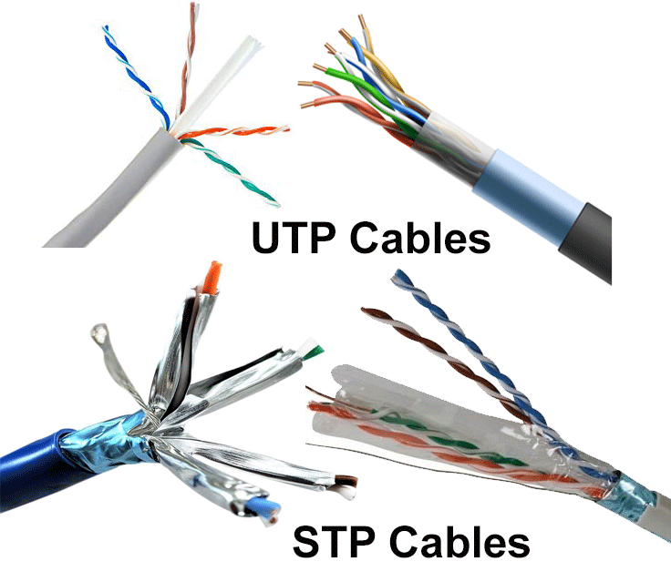

1. **Network Cable Name: Fiber Optic Cable**
   * **Network Cable Type:** Guided
   * **Description**: This cable consists of a core, cladding, buffer, and jacket. The core is made from thin strands of glass or plastic that can carry data over a long distance. The core is wrapped in the cladding; the cladding is wrapped in the buffer, and the buffer is wrapped in the jacket.Core carries the data signals in the form of light.Cladding reflects light back to the core.Buffer protects the light from leaking.The jacket protects the cable from physical damage.
   * **Diagram**: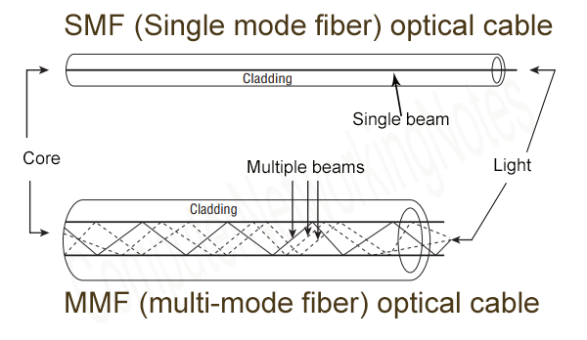
2. **Network Connector Name: Barrel connectors**
   * **Network Cable Type:** Guided
   * **Description**: Barrel connectors are used to join two cables. Barrel connectors are female connectors on both sides. They allow you to extend the length of a cable. If you have two small cables, you can make a long cable by joining them through the barrel connector.Barrel connectors that are used to connect coaxial cables are known as BNC barrel connectors. The following image shows BNC barrel connectors.Barrel connectors that are used to connect STP or UTP cables are known as Ethernet LAN jointers or couplers. The following image shows Ethernet LAN jointers or couplers.
   * **Diagram**:

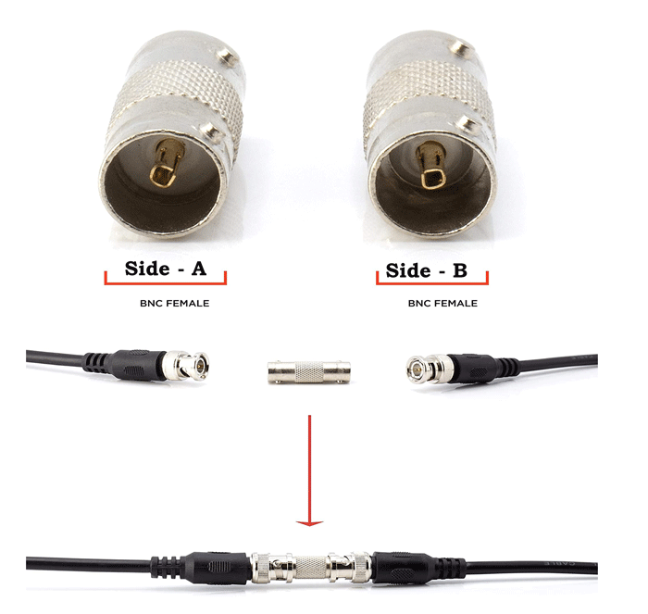

1. **Network Connector Name: RJ-45** 
   * **Network Cable Type:** Guided
   * **Description**: RJ-45 connectors look likes RJ-11 connectors, but they are different. They have 8 pins. They are also bigger in size than RJ-11. RJ-45 connectors are mostly used in computer networks. They are used with STP and UTP cables. Some old Ethernet implementations use only four of the eight pins. Modern Ethernet implementation uses all 8 pins to achieve the fastest data transfer speed.
   * **Diagram**:

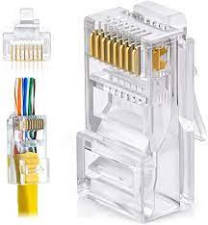

## Give cross-wired cable and straight through cable diagram (Color Code wise).

1. Cross-wired Cable Diagram (Color Code)

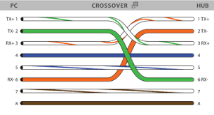

1. Straight Through Cable Diagram (Color Code)

