TRAINING & TECHNICAL MINI PROJECT
Enterprise Student Record and Academic Management Platform
Unit 1: Product Engineering & Design Thinking

Student Name: Omkar Dnyaneshwar Ghorpade
PRN / Roll No.: 2125UDSM1033
Branch / Class: AIDS
Faculty / Trainer: Mr. Karan Gaikwaad Sir

Prepared using the provided Unit-1 Mini Project brief and the provided DevOps Unit-1 Mini Project Guide as the reference structure.

Table of Contents
1. Introduction to Software Product Development
2. Comparative Analysis: Programming vs Software Engineering
3. Root Causes of Software Project Failures
4. Business Understanding: Education & Academic Management
5. Manual Process Challenges vs Automated Solution
6. Introduction to Design Thinking
7. Five Stages of Design Thinking
8. IBM Design Thinking
9. IBM Observe-Reflect-Make Loop
10. Stakeholder Analysis
11. User Personas
12. Requirements Engineering Specification
13. Product Vision, Mission and Success Criteria
14. Minimum Viable Product (MVP)
15. Product Engineering Roadmap
16. Initial System Architecture
17. Project Charter
18. Repository Initialization & Folder Structure
19. Product Discovery Documentation
20. Conclusion
21. Submission Checklist

1. Introduction to Software Product Development
The reference guide explains that modern software products are built using structured engineering frameworks rather than ad-hoc programming. Coding is one execution phase inside a larger lifecycle covering domain analysis, user experience, architecture, database design, testing, automated deployment and continuous monitoring. For this mini project, the same product-engineering approach is applied to academic records and student information management.
The objective is to understand the academic domain first, identify stakeholders and their needs, define requirements, plan the product, and establish a development-ready structure before full implementation.
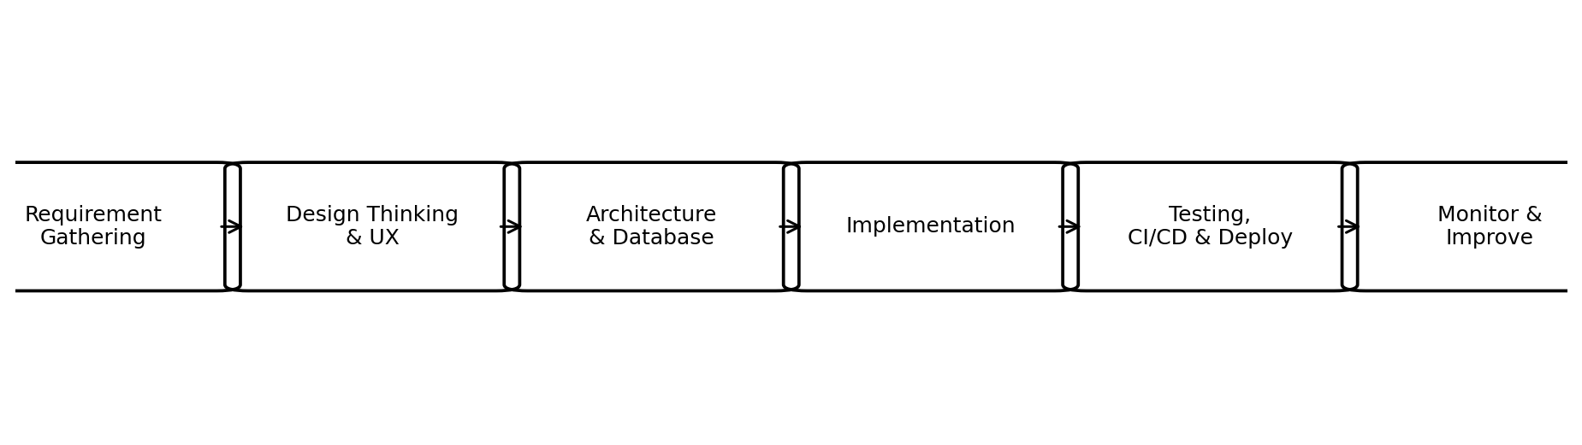
Figure 1: Product engineering lifecycle adapted to the student academic management domain.

2. Comparative Analysis: Programming vs Software Engineering
Dimension | Programming / Coding | Software Product Engineering
Primary Goal | Translate logic and algorithms into executable code. | Build a valuable, scalable, maintainable and user-centered academic system.
Scope | Functions, scripts and individual implementation tasks. | Full lifecycle: requirements, architecture, database, security, testing, deployment and monitoring.
Success Metric | Code compiles and gives expected outputs. | Accurate academic records, good usability, reliability, availability and useful outcomes for users.
Mindset | Technology-centric: How do I implement this function? | Product-centric: What academic problem are we solving and how will users benefit?
Change Handling | Changes are often addressed locally in code. | Requirements and product decisions are continuously refined using feedback.

3. Root Causes of Software Project Failures
- Misaligned requirements: a team may build features that students or academic staff do not need.
- Technology-centric bias: tools may be selected before understanding the academic process.
- Communication silos: students, faculty, administrators and technical teams may interpret needs differently.
- Lack of iterative feedback: usability and workflow issues may be discovered only after substantial development.
- Poor data governance: inconsistent records, duplicate entries and weak validation can reduce trust in academic information.
The project therefore begins with business understanding and Design Thinking rather than immediately starting with implementation.

4. Business Understanding: Education & Academic Management
The target environment is a higher-education institution where student and academic information must be recorded, updated, reviewed and reported. The platform is intended to centralize academic workflows and give each authorized stakeholder a role-appropriate view.

4.1 Core Academic Operations
Academic Operation | Description
Student Admission & Registration | Create and maintain student profiles, program, semester and enrollment information.
Course Registration | Associate students with courses and academic offerings for a semester.
Attendance Management | Record attendance, calculate attendance percentage and provide visibility to students and faculty.
Examination Management | Maintain examination schedules or records and enter authorized marks.
Result Processing | Consolidate approved marks and generate semester/academic results.
Academic Reporting | Generate student reports and administrative summaries.
Administration & Audit | Maintain controlled access, data consistency and traceable updates.

4.2 Business Objectives
- Reduce manual administrative effort.
- Provide a single source of truth for student academic records.
- Reduce calculation and transcription errors.
- Improve the speed of academic report generation.
- Provide secure, role-based access to information.
- Improve transparency for students and academic staff.

5. Manual Process Challenges vs Automated Solution
Manual Bottleneck | Automated Platform Solution | Expected Outcome
Paper files and separate spreadsheets | Centralized relational student database | Faster record retrieval and better consistency
Manual attendance totals | Digital attendance with automatic percentage calculation | Reduced arithmetic and transcription errors
Marks stored in separate sheets | Centralized examination and marks module | Faster result processing and easier verification
Repeated report preparation | Automated academic report generation | Reduced administrative workload
Duplicate student records | Unique identifiers, validation and controlled updates | Improved data integrity
Unclear access to records | Role-based access control | Better confidentiality and governance

5.1 Business Value
A successful platform should reduce unnecessary administrative work while improving the quality and accessibility of academic information. Business value is measured through faster task completion, fewer errors, improved visibility and better user satisfaction.

6. Introduction to Design Thinking
The reference guide defines Design Thinking as an iterative, human-centered problem-solving framework that prioritizes understanding users before technical constraints. In this project, the same approach is used to make sure the solution addresses real student and academic-staff needs.
- Human-centered innovation: design around user behavior and goals.
- Creative problem-solving: explore multiple solution ideas before implementation.
- Iterative prototyping: test low-cost ideas before investing in full development.

7. Applying the Five Stages of Design Thinking
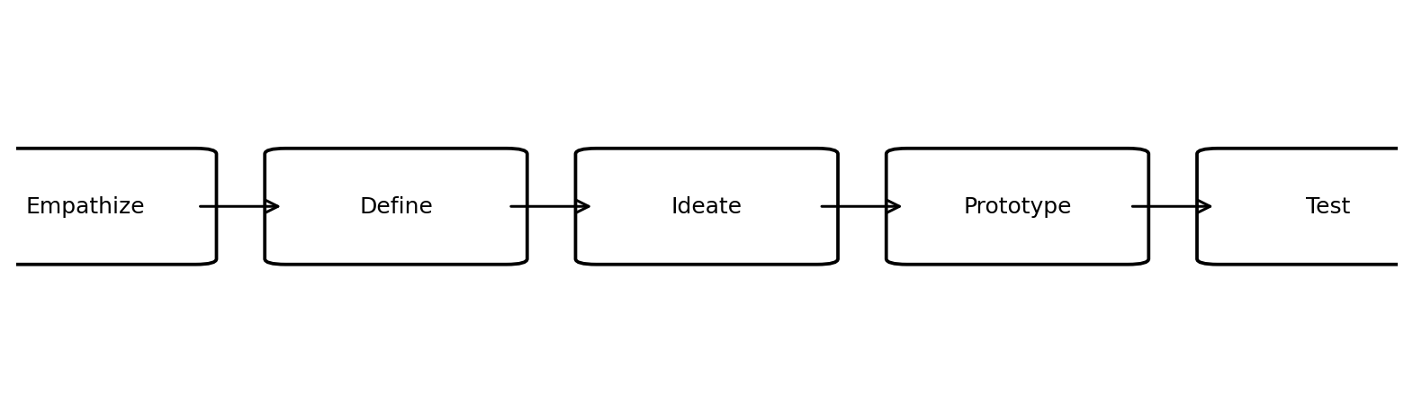
Figure 2: Five-stage Design Thinking cycle.

Stage 1 - Empathize
Study students, faculty members, academic administrators, examination staff and IT support personnel. Capture what they need to accomplish, where delays happen, and what information they currently struggle to access.

Stage 2 - Define
Convert observations into a clear problem statement. The core issue is fragmented academic information and manual workflows that make registration, attendance, examination and reporting slower and more error-prone.

Stage 3 - Ideate
Generate solution ideas such as a centralized student record, course registration workflow, digital attendance, result processing, reports, notifications and role-specific dashboards.

Stage 4 - Prototype
Create low-fidelity screens for login, student dashboard, faculty attendance, marks entry, result view and administrator reporting.

Stage 5 - Test
Validate prototypes with representative users. Observe navigation, clarity of labels, data-entry flow, error handling and whether key academic tasks can be completed efficiently.

8. IBM Design Thinking
The provided guide presents IBM Design Thinking through three core principles. These principles are adapted directly to the academic platform.

8.1 Focus on User Outcomes
The technical goal should be linked to a measurable user outcome. For example, instead of only asking the team to build an attendance database, the outcome can be stated as enabling a student to view current attendance percentage quickly and enabling faculty to record attendance without repetitive calculations.

8.2 Restless Reinvention
The product should be continuously refined from real usage, feedback and observed friction. A release is not the end of the design process; it becomes the next source of learning.

8.3 Diverse Empowered Teams
Effective delivery requires collaboration among academic stakeholders, product/design roles, software developers, QA engineers, database and operations teams.
Principle | Academic Platform Application
Focus on User Outcomes | Measure faster academic task completion, better record accuracy and easier access.
Restless Reinvention | Use feedback and usage observations to improve screens, workflows and reports.
Diverse Empowered Teams | Coordinate students, faculty, administrators, designers, developers, QA and IT support.

9. IBM Observe-Reflect-Make Loop
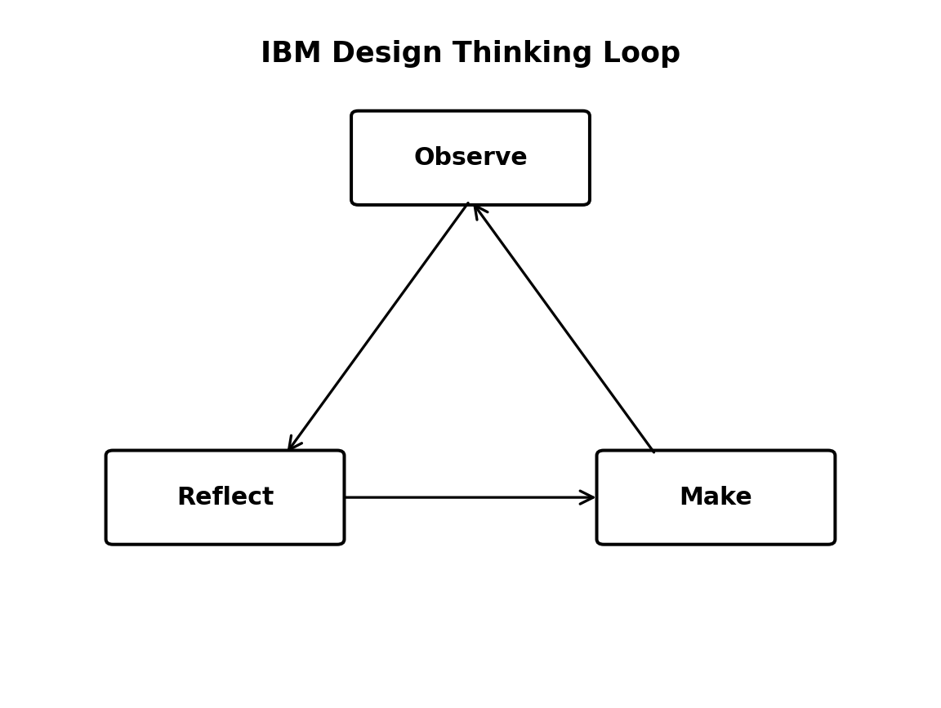
Figure 3: Observe → Reflect → Make loop.
Loop Stage | What the Team Does
Observe | Study user interactions, academic workflows, support requests, errors and operational friction.
Reflect | Analyze observations, compare them with product goals and decide what needs to change.
Make | Design, implement, test and release improvements.

The loop makes the platform iterative: each improvement should create new evidence that informs the next improvement cycle.

10. Stakeholder Analysis
Stakeholder Group | Examples | Interest / Responsibility | Key Expectation
Students | Undergraduate and postgraduate students | Use academic services and view personal records. | Fast access, clarity, privacy and accurate information.
Faculty Members | Course teachers and mentors | Record attendance and marks; review student information. | Simple workflows and reliable records.
Academic Administrators | Department/college academic staff | Manage academic data and generate reports. | Centralized visibility and administrative control.
Examination Cell | Exam and result staff | Manage exam data, marks and result processing. | Accuracy, validation and controlled result publication.
IT Support / DevOps | System and infrastructure staff | Maintain platform availability, backups, security and deployment. | Reliability, maintainability and observability.
Management | Institution leadership | Review academic summaries and business outcomes. | Useful reporting and confidence in data.

11. User Persona Development
Persona | Goals | Responsibilities | Challenges | Expected Feature
Aarav - Student | Register courses, check attendance and results. | Keep personal academic information up to date and track progress. | Scattered information and delayed updates. | Student dashboard and academic record view.
Priya - Faculty | Record attendance and marks efficiently. | Maintain course-related academic information. | Repeated manual calculations and data entry. | Faculty dashboard with attendance and marks modules.
Dr. Sharma - Academic Administrator | Monitor academic status and generate reports. | Manage academic processes and review records. | Manual report preparation and limited real-time visibility. | Admin dashboard and automated reports.

11.1 Persona Needs Summary
- Students need transparency and simple self-service access.
- Faculty need quick and reliable data-entry workflows.
- Administrators need centralized visibility, reporting and controlled access.
- Examination staff need accuracy and auditability for marks and results.
- IT support needs reliable infrastructure and maintainable software.

12. Requirements Engineering Specification

12.1 Functional Requirements Specification (FRS)
ID | Functional Requirement | Description
FR-01 | Authentication & RBAC | Secure login with roles such as Student, Faculty, Academic Administrator and Examination Staff.
FR-02 | Student Registration | Create, update, search and maintain student academic profiles.
FR-03 | Course Registration | Register students for courses and maintain semester-wise enrollment.
FR-04 | Attendance Management | Record attendance and calculate attendance percentage.
FR-05 | Examination & Marks | Enter and manage authorized examination marks.
FR-06 | Result Generation | Generate approved semester/academic results.
FR-07 | Report Generation | Produce student and administrative academic reports.
FR-08 | Notifications | Provide relevant alerts for registration, attendance, examination and result events.
FR-09 | Search & View | Allow authorized users to locate academic records according to their role.
FR-10 | Audit Trail | Maintain traceable records of important updates and administrative actions.

12.2 Non-Functional Requirements Specification (NFRS)
ID | Category | Requirement
NFR-01 | Security | Protect authentication, authorization and data transmission; restrict records using roles.
NFR-02 | Usability | Provide clear, consistent and responsive interfaces for different users.
NFR-03 | Reliability | Maintain data consistency, validation and backup mechanisms.
NFR-04 | Performance | Common searches and record views should complete promptly under expected institutional load.
NFR-05 | Scalability | Architecture should support growth in students, courses, records and concurrent users.
NFR-06 | Maintainability | Use modular code, documentation and automated tests.
NFR-07 | Availability | Support planned backup, recovery and monitoring processes.
NFR-08 | Auditability | Important academic changes should be traceable by authorized administrators.

13. Product Vision, Mission and Success Criteria

13.1 Product Vision Statement
To deliver a modern, centralized and user-friendly Student Record and Academic Management Platform that reduces manual administrative work, improves academic record accuracy, and gives students, faculty and administrators timely access to trusted academic information.

13.2 Mission Statement
To simplify academic record management through secure digital workflows for student registration, course registration, attendance, examinations, results and reporting.

13.3 Business Objectives
- Digitize high-volume academic record workflows.
- Reduce repeated manual data entry and calculations.
- Improve data consistency across departments and academic processes.
- Provide timely academic information to authorized users.
- Enable reliable reporting for students and administrators.

13.4 Success Criteria
Success Area | Indicative Measure
Usability | Users can complete common tasks with clear navigation and minimal confusion.
Accuracy | Validated records reduce manual calculation and duplication errors.
Efficiency | Academic staff spend less time searching and preparing routine reports.
Accessibility | Students can access their authorized information without depending on manual office processes.
Security | Only authorized users can view or update protected academic data.
Reliability | Records remain available and recoverable through backup and operational controls.

14. Minimum Viable Product (MVP)
The MVP is the smallest useful release that supports the highest-priority academic workflows. Non-essential advanced capabilities are intentionally deferred so the team can validate the core product first.
MVP Feature | Why It Is Included | Primary Users
Login & Role-Based Access | Controls access and provides a personalized experience. | All users
Student Registration & Profile | Creates the central academic record. | Students / Admin
Course Registration | Supports semester-wise enrollment. | Students / Admin
Attendance | Provides digital recording and percentage calculation. | Faculty / Students
Marks Management | Captures examination performance. | Faculty / Examination
Result Generation | Transforms approved marks into usable academic results. | Examination / Students
Basic Reports | Provides immediate academic summaries. | Students / Administrators

14.1 Deferred Features
- Advanced analytics and predictive insights
- AI-based recommendations
- External payment integrations
- Large-scale third-party integrations
- Advanced mobile app capabilities
These can be considered after the MVP proves the core workflow and user value.

15. Product Engineering Roadmap
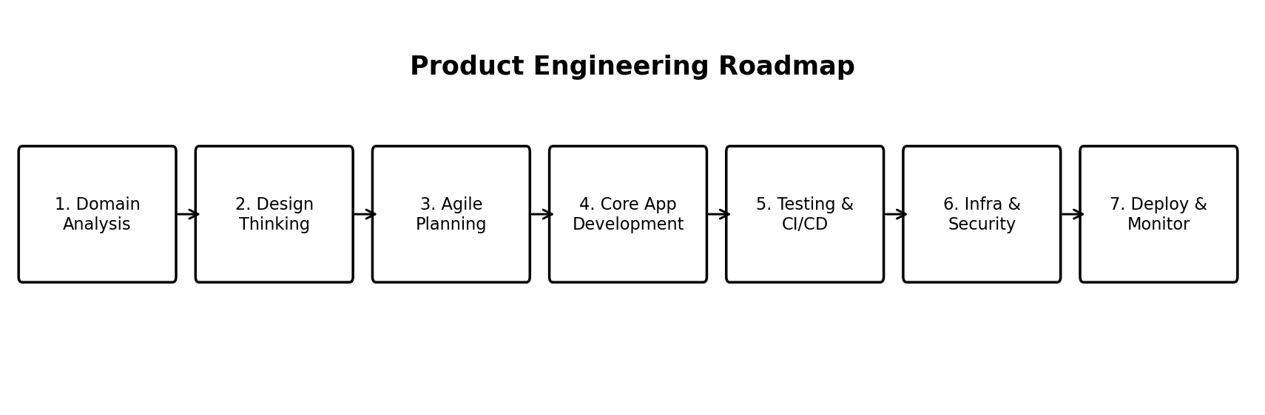
Phase | Detailed Activities | Output
Phase 1 - Domain Analysis | Understand academic workflows, stakeholders, records and pain points. | Business understanding and problem statement.
Phase 2 - Design Thinking | Empathize, define, ideate, prototype and test. | Personas, user journeys and prototype concepts.
Phase 3 - Agile Planning | Create backlog, prioritize MVP stories and define sprint goals. | Product backlog and sprint plan.
Phase 4 - Core Development | Implement frontend, backend and database modules. | Working academic management application.
Phase 5 - Testing & CI/CD | Run unit/integration tests and automate build/deployment steps. | Validated application and CI/CD pipeline.
Phase 6 - Infrastructure & Security | Prepare deployment, backups, access control and operational monitoring. | Secure and maintainable environment.
Phase 7 - Production & Improvement | Deploy, observe usage and refine based on feedback. | Operational platform and continuous improvement loop.

16. Initial System Architecture
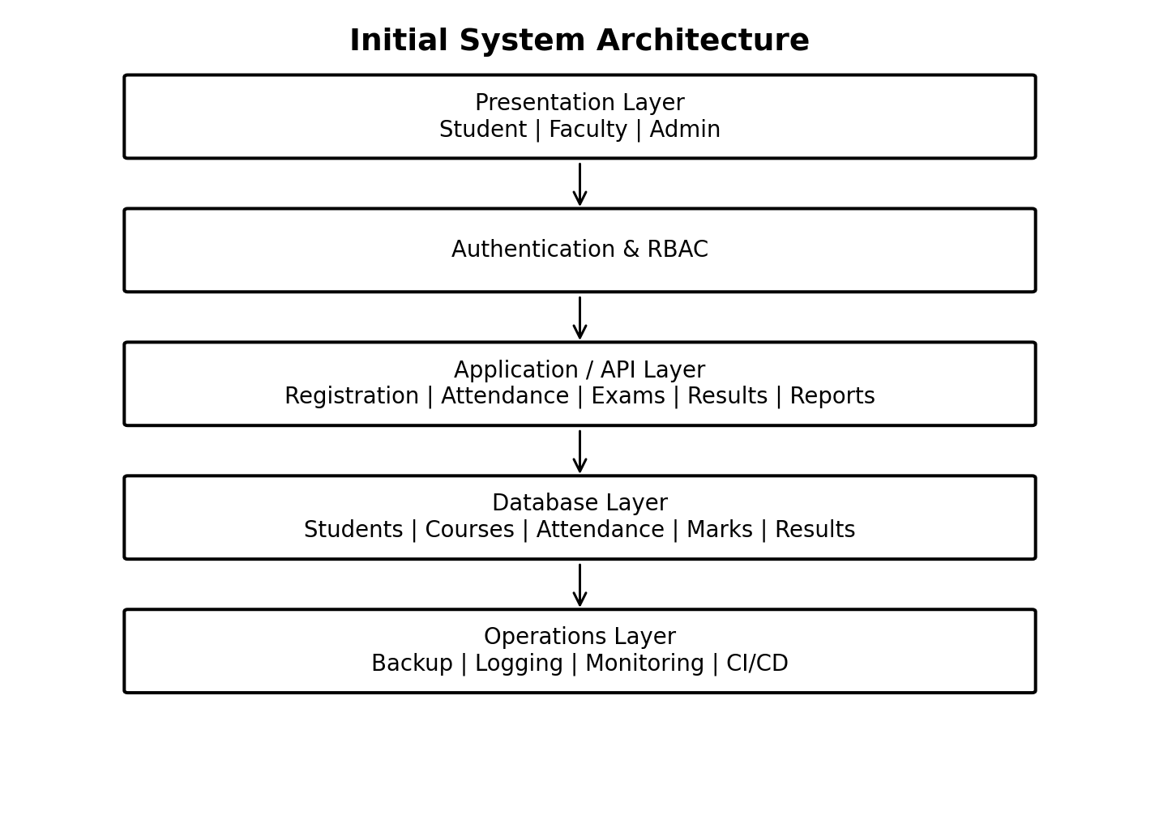

16.1 Architecture Components
Component | Purpose
Presentation Layer | Web interface for students, faculty, administrators and examination staff.
Authentication & RBAC | Verify identity and enforce role-specific permissions.
Application / API Layer | Implements academic business rules and exposes application services.
Database Layer | Stores student, course, attendance, marks, result and user records.
Operations Layer | Supports backup, logging, monitoring, deployment and recovery.

16.2 Main Data Flow
User → Login / RBAC → Authorized Academic Module → Business Validation → Database → Result / Report / Notification. Each stage should enforce appropriate security and validation before data is stored or displayed.

17. Project Charter
Charter Element | Definition
Project Name | Enterprise Student Record and Academic Management Platform
Project Purpose | Centralize student and academic records and digitize important academic workflows.
Problem | Manual or disconnected academic processes create delays, duplicate records, calculation errors and poor visibility.
Primary Users | Students, Faculty, Academic Administrators, Examination Staff and IT Support.
Scope | Student registration, course registration, attendance, examinations, results and reports.
MVP | Login/RBAC, student records, course registration, attendance, marks, results and basic reports.
Deliverables | BRD/business understanding, Design Thinking documentation, IBM Design Thinking/Loop, stakeholder analysis, personas, FRS/NFRS, vision, MVP, roadmap, architecture and repository plan.
Key Risks | Incorrect requirements, data-entry mistakes, security weaknesses, integration complexity and poor adoption.
Risk Response | Early feedback, clear validation, role-based access, testing, backups and iterative releases.
Success | The platform is understandable, secure, accurate, maintainable and useful for its intended academic workflows.

18. Project Repository Initialization & Folder Structure
The reference guide demonstrates a standardized repository hierarchy. The same engineering principle is applied here, with modules renamed for academic management.
student-record-academic-management/
├── .github/ # CI/CD workflows
├── app/ # Application source code
│ ├── modules/ # Students, Courses, Attendance, Exams, Results
│ ├── database/ # Schemas, migrations and models
│ └── tests/ # Unit and integration tests
├── frontend/ # User interface
├── backend/ # APIs and business logic
├── docs/ # BRD, FRS, NFRS, personas, diagrams and reports
├── docker/ # Container configuration
├── deployment/ # Deployment configuration
├── monitoring/ # Logging and monitoring configuration
└── README.md # Project overview and setup

18.1 Git Initialization Plan
- Create the project repository with the standardized folder structure.
- Add README.md and documentation under docs/.
- Create an initial commit for the project skeleton.
- Commit feature work in logical increments using clear commit messages.
- Use the repository as the central location for code, technical documentation and project history.

19. Product Discovery Documentation

19.1 Observe
Observe how students, faculty and academic staff currently complete common tasks: registration, attendance, examination handling, result checking and report preparation.

19.2 Reflect
Organize observations into repeated pain points, user needs, process bottlenecks and high-risk data areas. Decide which problems should be addressed first.

19.3 Make
Create a small prototype or MVP feature, test it with representative users, collect feedback and use the evidence to refine the next iteration.

19.4 Problem Statement
Higher-education institutions need a centralized and secure way to manage student academic information because manual and disconnected processes make it difficult to maintain accurate records, provide timely access and generate consistent reports.

19.5 Proposed Solution Statement
A role-based Student Record and Academic Management Platform will centralize academic records and provide digital workflows for registration, attendance, examinations, results and reporting.

19.6 Product Discovery Outputs
- Business problem and justification.
- Stakeholder map and user personas.
- Functional and non-functional requirements.
- Design Thinking stages and prototype plan.
- IBM Observe-Reflect-Make loop.
- Product vision and MVP scope.
- Roadmap, architecture and repository structure.

20. Conclusion
The Enterprise Student Record and Academic Management Platform demonstrates a complete Unit-1 product-engineering approach. The work starts with business understanding and user needs, follows Design Thinking and IBM Design Thinking, identifies stakeholders and personas, defines functional and non-functional requirements, establishes the product vision and MVP, and then plans the roadmap, architecture and repository structure.
The outcome is a development-ready product plan rather than an isolated coding exercise. This prepares the project for Agile planning, implementation, testing, DevOps automation and later deployment.

21. Submission Checklist
☐ Business Understanding and Business Problem Statement
☐ Design Thinking: Empathize, Define, Ideate, Prototype, Test
☐ IBM Design Thinking principles
☐ IBM Observe → Reflect → Make Loop
☐ Stakeholder Analysis
☐ User Personas
☐ Functional Requirements Specification (FRS)
☐ Non-Functional Requirements Specification (NFRS)
☐ Product Vision and Mission
☐ MVP Definition
☐ Product Engineering Roadmap
☐ Initial System Architecture
☐ Project Charter
☐ Repository Initialization and Folder Structure
☐ Product Discovery Documentation
☐ Flowcharts / diagrams included

