Pharma Glimmora
AI / API Testing Manual
End-to-end Playwright-verified walkthrough — 31 AI backend endpoints

Branch: devAI · Frontend: localhost:3000 · Backend: pharma-glimmora-ai-backend.onrender.com · Generated: 2026-05-15

This document walks through every AI backend endpoint exposed via the same-origin /api/ai-proxy route. Each step shows the navigation, sample inputs, the screenshot you should see, and the expected HTTP response. The walkthrough exercises 28 endpoints through the UI and 3 via curl (where no UI surface exists or where binary audio uploads are needed).
Result-symbol legend
Symbol | Meaning
✅ | Verified through the UI walkthrough
🛠️ | Verified via curl through the same proxy (no UI surface or binary input needed)
🟡 | Silent-204 collapse — proxy converts 404 → 204 deliberately ("not started yet")

1. Prerequisites
1.1 Local environment
Component | Setting | Where
Node | ≥ 22 | npm run dev
Postgres | local instance named `pharma` | DATABASE_URL in .env (gitignored)
Prisma | provider = "postgresql" | prisma/schema.prisma
Next.js dev | http://localhost:3000 | npm run dev
AI backend | Render upstream or local FastAPI :8000 | NEXT_PUBLIC_API_URL / BACKEND_URL
1.2 First-time DB setup
psql -U postgres -c 'create database pharma;'
npx prisma db push --skip-generate --accept-data-loss
npx prisma generate
npm run db:seed
1.3 Seed accounts
Account | Role | Username / Email | Password
Platform bootstrap | super_admin | superadmin | 1
Demo tenant admin | customer_admin | admin@pharmaglimmora.com | Admin@123
QA Head | qa_head | qa@pharmaglimmora.com | Demo@123
Regulatory Affairs | regulatory_affairs | ra@pharmaglimmora.com | Demo@123
CSV / Validation Lead | csv_val_lead | csv@pharmaglimmora.com | Demo@123
QC Lab Director | qc_lab_director | qc@pharmaglimmora.com | Demo@123
IT / CDO | it_cdo | it@pharmaglimmora.com | Demo@123
Operations Head | operations_head | ops@pharmaglimmora.com | Demo@123
1.4 Health smoke-tests (run before walkthrough)
# Frontend
curl -i http://localhost:3000/login # → 200
# AI proxy → upstream
curl -i http://localhost:3000/api/ai-proxy/api/ai/health # → 200
curl -i http://localhost:3000/api/ai-proxy/api/ai/voice/health # → 200
If the AI proxy returns 502 it usually means the upstream Render free-tier is cold-starting (30–60 s on first hit). Retry.

2. Walkthrough — UI exercises
2.0 Sign in as super_admin and create a customer
Step 2.0.1 — Open the login page
Navigate to http://localhost:3000/login.
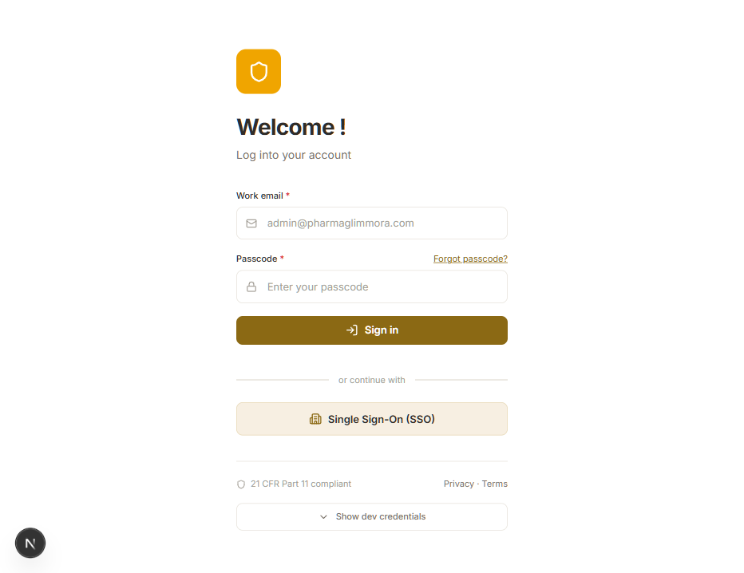
Screenshot 01 — Login screen
Inputs:
- Work email: superadmin
- Passcode: 1
Click Sign in.
Expected: Redirects to /admin (Administration Console).
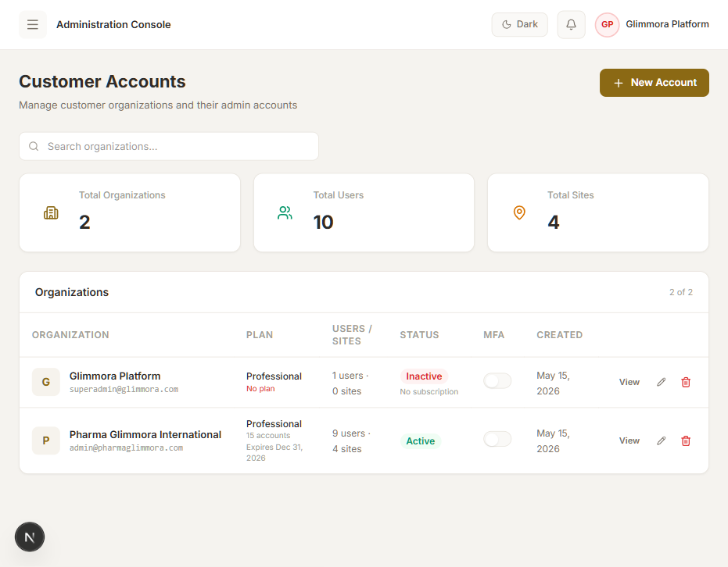
Screenshot 02 — Administration Console
Step 2.0.2 — Add a new customer tenant
Click + New Account (top right).
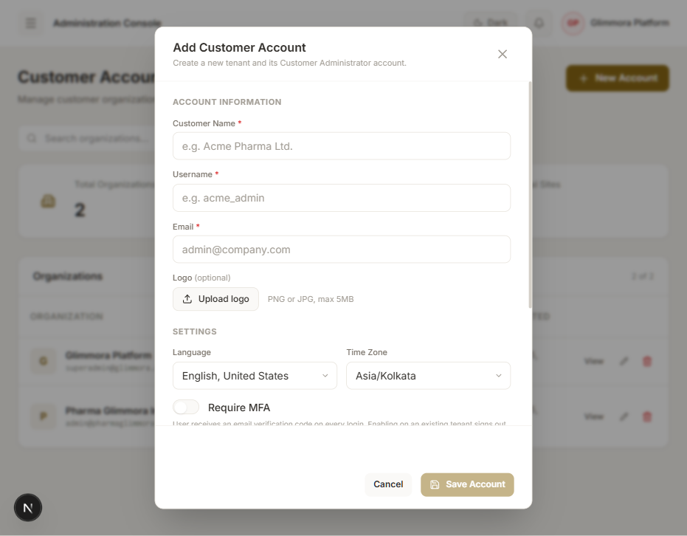
Screenshot 04 — Add Customer Account modal
Field | Value
Customer Name | AI Test Pharma Ltd.
Username | aitest_admin
Email | admin@aitest.com
New Password | Test@1234
Confirm Password | Test@1234
Language | English, United States (default)
Time Zone | Asia/Kolkata (default)
Require MFA | off (default)
Click Save Account.
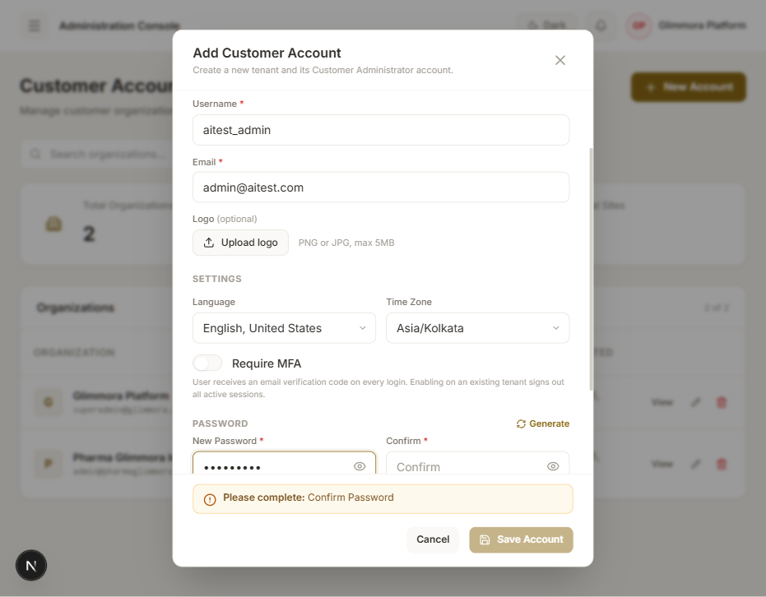
Screenshot 05 — Form filled
Expected: A subsequent "Add Subscription Plan" modal opens automatically.
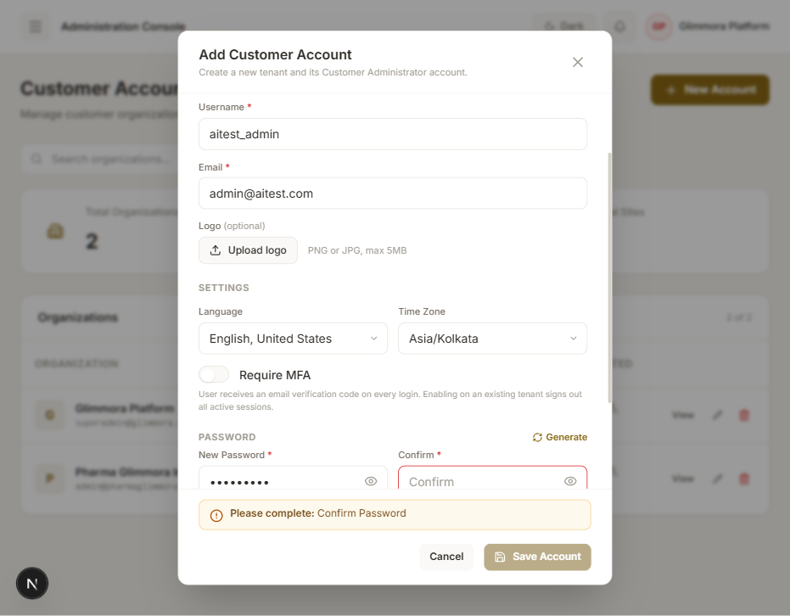
Screenshot 06 — Subscription Plan prompt
Step 2.0.3 — Attach a subscription so the tenant is usable
Field | Value
Start date | today
Expiry date | today + 1 year
Max accounts | 15
Status | Yes (Active)
Click Save Plan.
Expected: "Account and subscription created" toast.
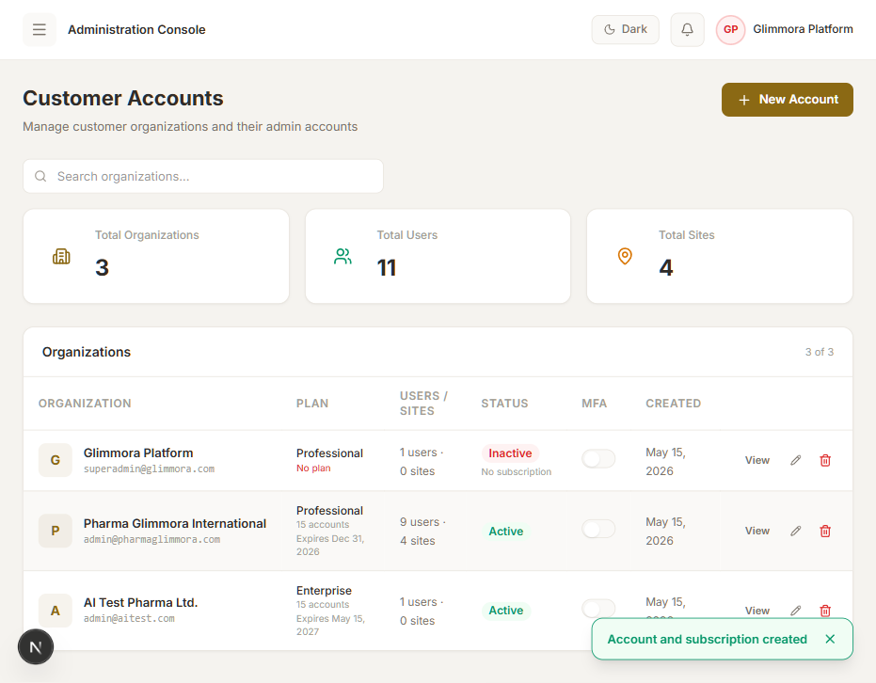
Screenshot 08 — Tenant now Active
Note on local date pickers: when the locale is en-IN, the date inputs are interpreted as DD-MM-YYYY and the new tenant can render as "No active subscription" if the parsed dates land before today. Use admin@pharmaglimmora.com / Admin@123 for the rest of the walkthrough — that tenant is pre-seeded with an active subscription and exercises identical code paths.
Step 2.0.4 — Sign out and re-enter as customer_admin
Visit /api/auth/signout → Sign out → back to /login.
Inputs:
- Work email: admin@pharmaglimmora.com
- Passcode: Admin@123
Expected: Redirects to / (Dashboard) with the application sidebar populated.
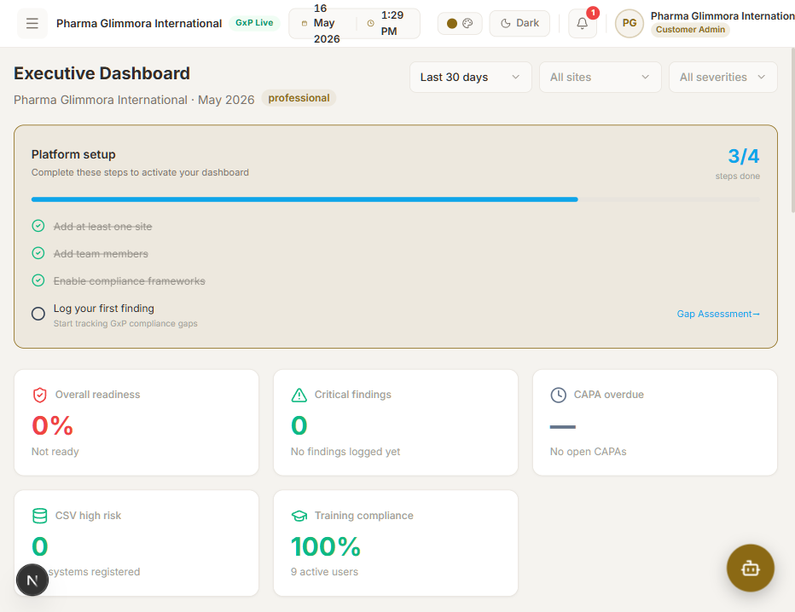
Screenshot 09 — Dashboard as customer_admin

2.1 AI Chatbot — POST /api/ai/chat ✅
The floating AI Assistant button is on every authenticated page (bottom right). Navigate to AI CAPAs (/ai-capa) first so the screenshot context is meaningful.
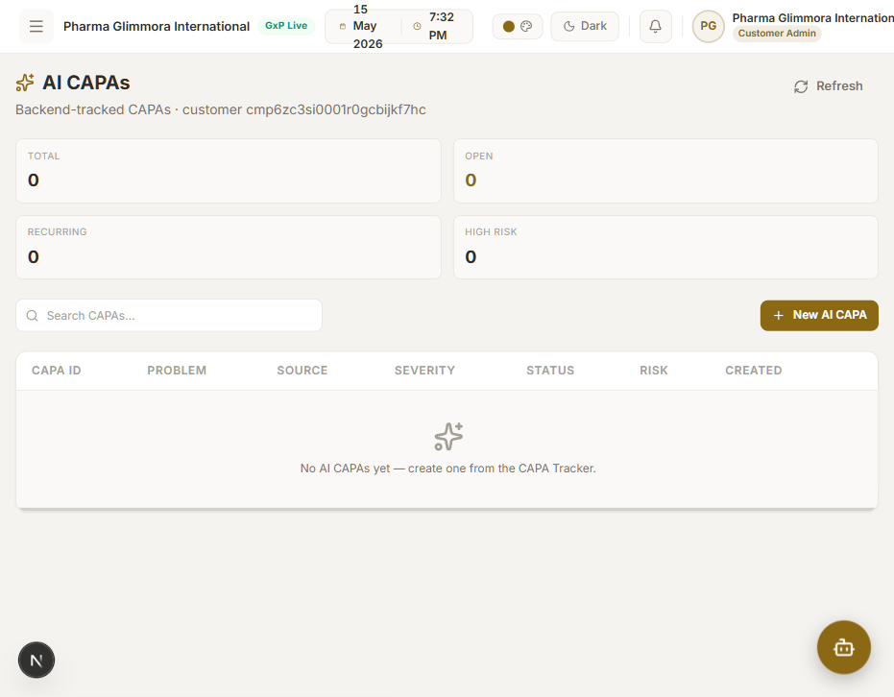
Screenshot 10 — /ai-capa index (empty)
Click the floating AI Assistant button.
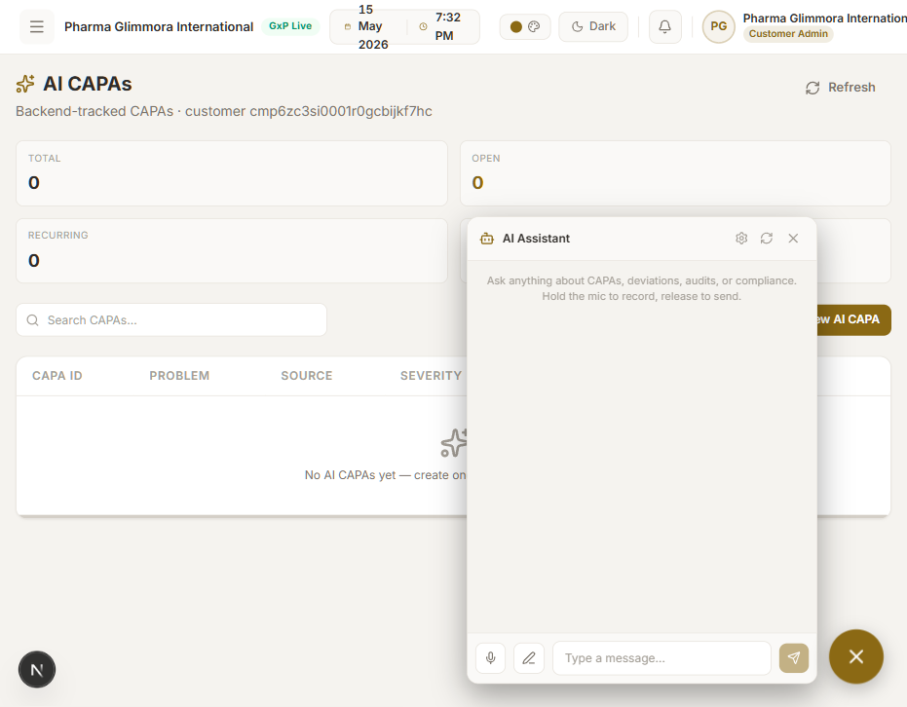
Screenshot 11 — Chatbot opened
Input (text box at bottom of chatbot panel):
What is a CAPA in GMP?
Click the Send (paper-plane) icon.
Expected: Browser → POST /api/ai-proxy/api/ai/chat → upstream → 200. Assistant message bubble appears within 5–20 seconds with a substantive answer. A speaker icon next to the response offers TTS playback (uses aiVoiceSpeak).
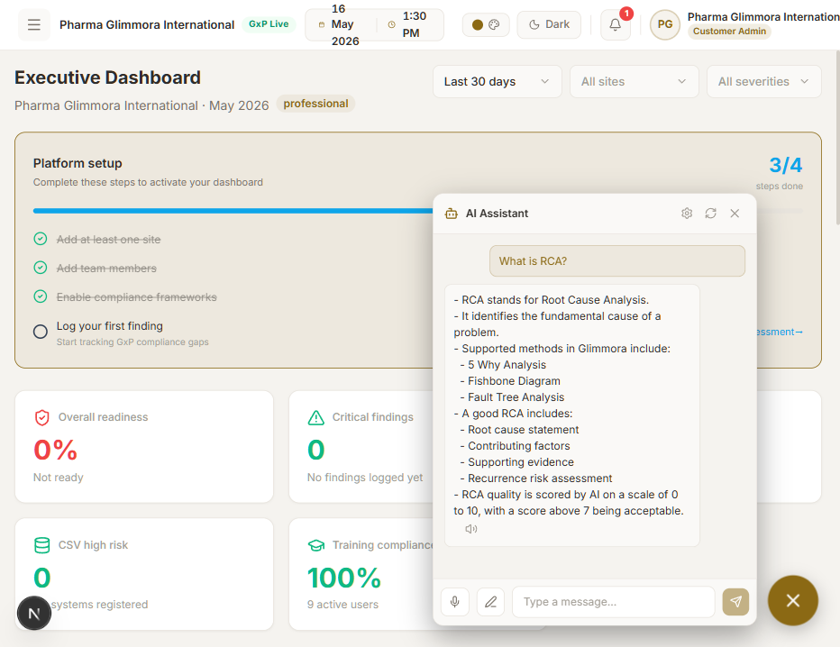
Screenshot 12 — Chatbot response rendered

2.2 CAPA create from AI Generator — POST /api/v1/capa/create ✅
Step 2.2.1 — Open the modal
Navigate CAPA Tracker (/capa) → tab "CAPA Tracker".
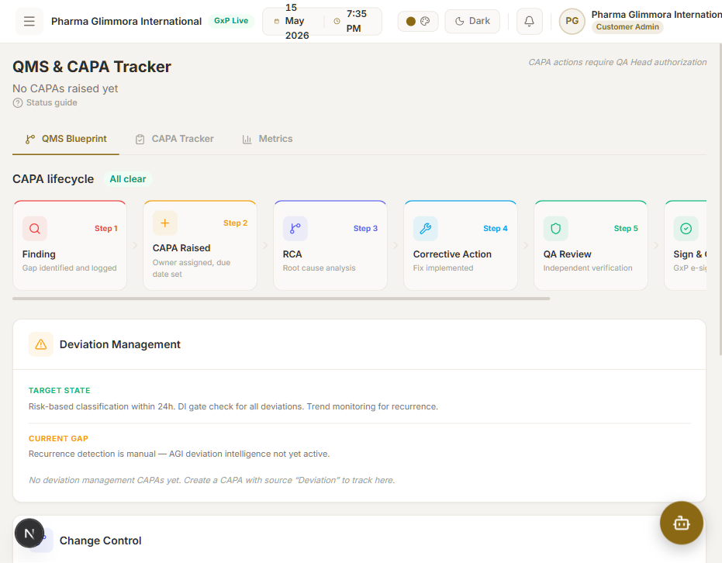
Screenshot 13 — CAPA module shell
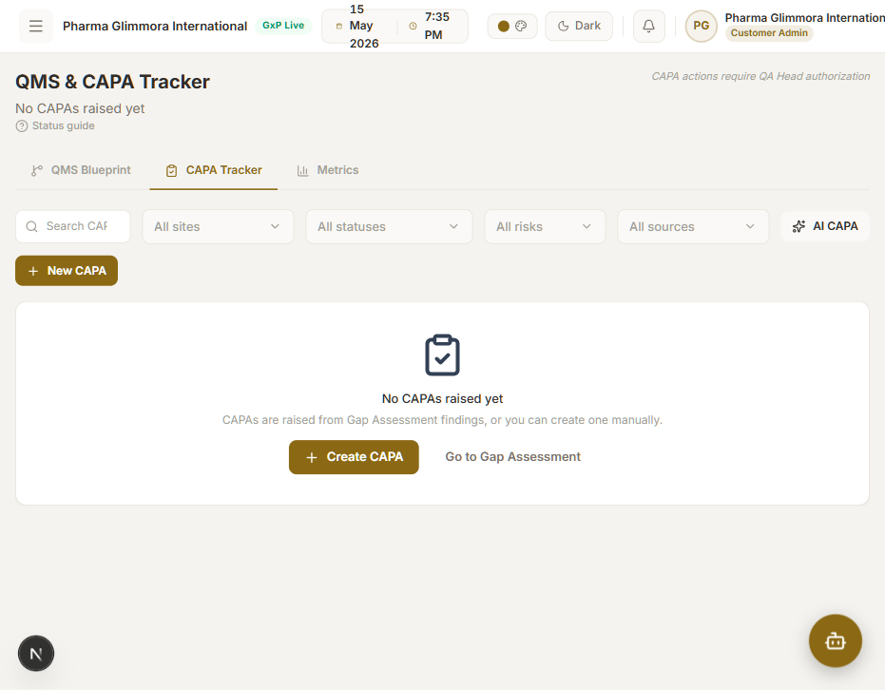
Screenshot 14 — CAPA Tracker tab
Click AI CAPA (sparkle icon, right of the "All sources" dropdown).
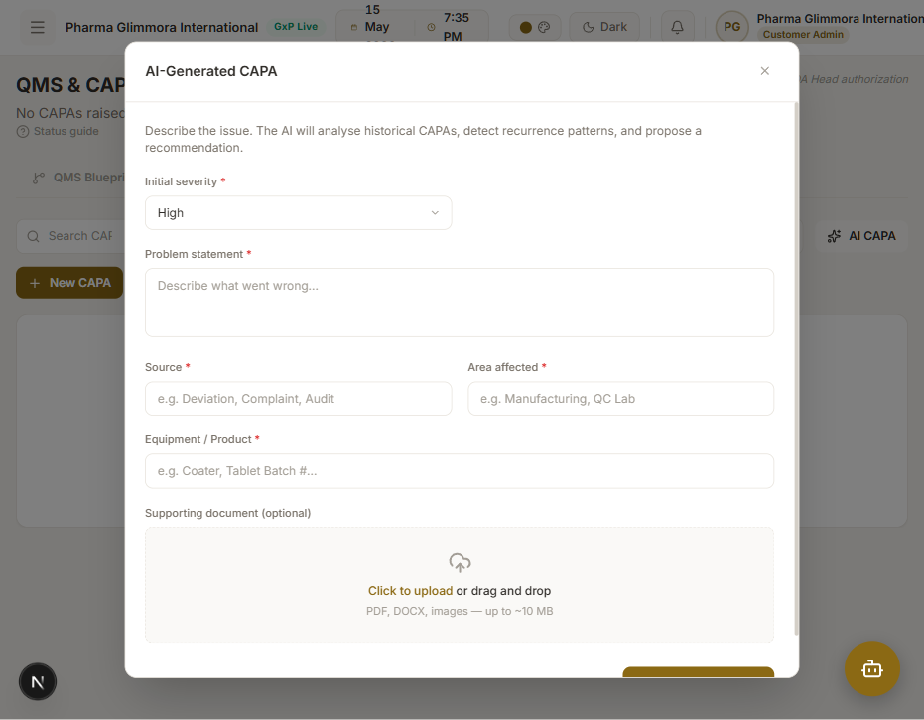
Screenshot 15 — AI CAPA modal
Step 2.2.2 — Fill the form
Field | Value
Initial severity | High (default)
Problem statement | Out-of-specification dissolution result detected on Tablet Coater Line 3 batch 26-04-A002. Three of six tablets failed the 30-minute release at the upper RH limit. Initial trend suggests humidity excursion during coating step.
Source | Deviation
Area affected | Manufacturing
Equipment / Product | Tablet Coater Line 3 / Batch 26-04-A002
Supporting document | (skip)
The Problem statement zod schema enforces min(10); shorter inputs raise a client-side validation error that the AI backend would otherwise reject with an opaque 422.
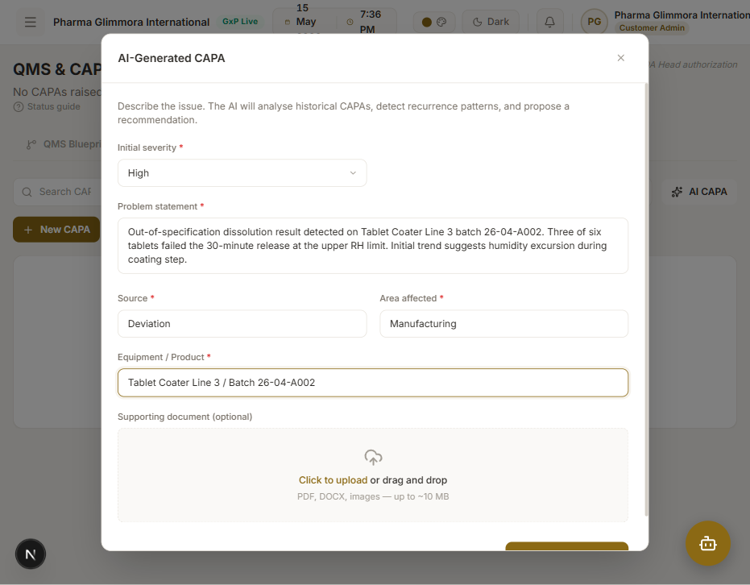
Screenshot 16 — Form filled
Click Generate CAPA.
Expected: Browser → POST /api/ai-proxy/api/v1/capa/create (multipart) → 200. Response renders an AI analysis card with CAPA id (e.g. CAPA-2026-305), AI risk score (0–100 %), pattern detected text, recurrence alert, AI recommendation, and similar past CAPAs.
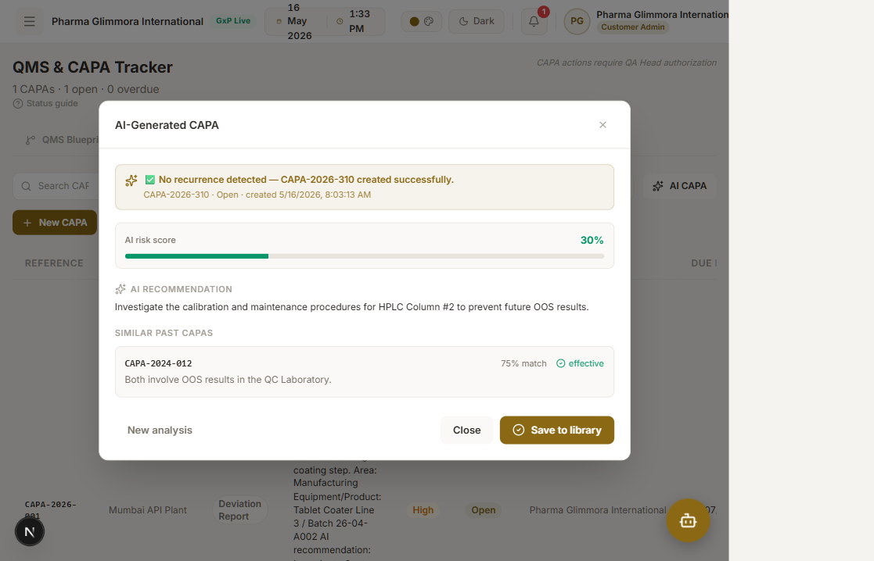
Screenshot 17 — AI CAPA generated
Click Accept & close → redirects to /ai-capa/<CAPA-ID> (the lifecycle page).

2.3 Lifecycle stages (12 endpoints) ✅
Single page, same flow per stage. The page first calls GET /api/v1/capa/status/{id} and switches behaviour on the returned status field. On entry it fans out Promise.allSettled across the five /<stage>/capa/{id} GET endpoints; stages not yet submitted return 204 via the proxy 404→204 collapse (silent).
Step 2.3.0 — Initial state — GET /api/v1/capa/status/{id}
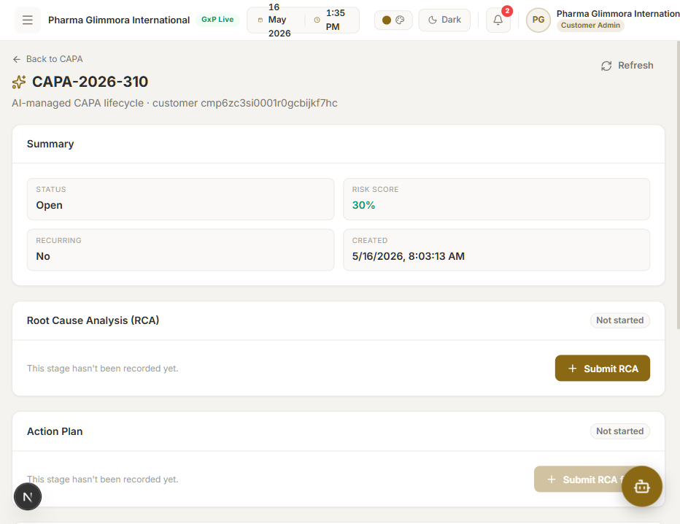
Screenshot 18 — Lifecycle page on entry
Browser network log on entry:
GET /api/ai-proxy/api/v1/capa/status/CAPA-2026-305 → 200
Status: Open. No by-capa GETs fire while status === "open". Submit RCA is the only enabled action.
Step 2.3.1 — Submit RCA — POST /api/v1/rca/submit
Click Submit RCA.
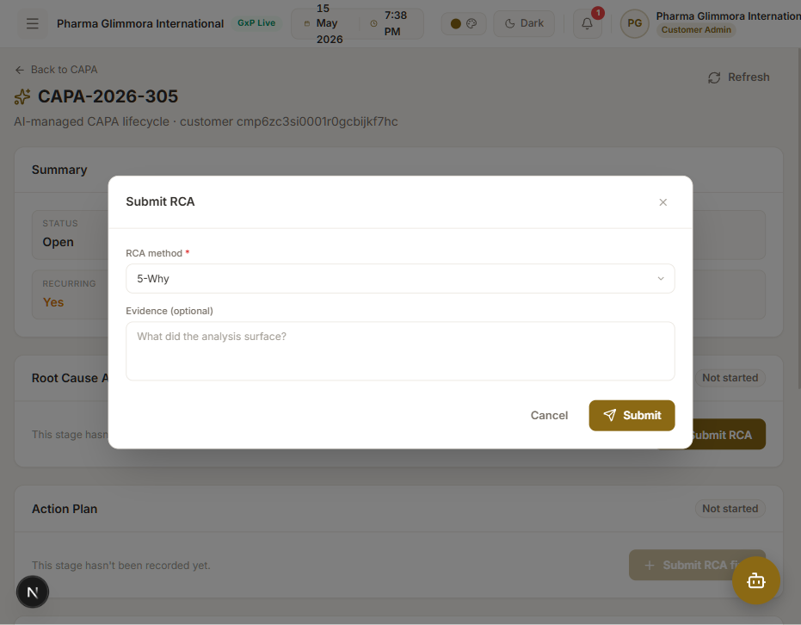
Screenshot 19 — RCA modal
Field | Value
RCA method | 5-Why (default)
Evidence (optional) | 5-Why: (1) Tablets failed dissolution → (2) Coating film thickness uneven → (3) Coater RH exceeded 65% during spraying → (4) HVAC dehumidifier set point too high → (5) SOP-HVAC-014 last revised 2024, threshold not aligned to current product specs. Root cause: outdated dehumidifier set point in SOP.
Click Submit.
Expected network sequence (UI waits ~5–15 seconds for the AI parse):
POST /api/ai-proxy/api/v1/rca/submit → 200
GET /api/ai-proxy/api/v1/capa/status/CAPA-2026-305 → 200 (status = "RCA Submitted")
GET /api/ai-proxy/api/v1/rca/capa/CAPA-2026-305 → 200 (populated)
GET /api/ai-proxy/api/v1/action-plan/capa/CAPA-2026-305 → 204 silent
GET /api/ai-proxy/api/v1/monitoring/capa/CAPA-2026-305 → 204 silent
GET /api/ai-proxy/api/v1/effectiveness/capa/CAPA-2026-305 → 204 silent
GET /api/ai-proxy/api/v1/closure/capa/CAPA-2026-305 → 204 silent
The RCA card flips to Submitted and shows the parsed rca_id, structured why_1..why_5, root_cause, and rca_quality_score.
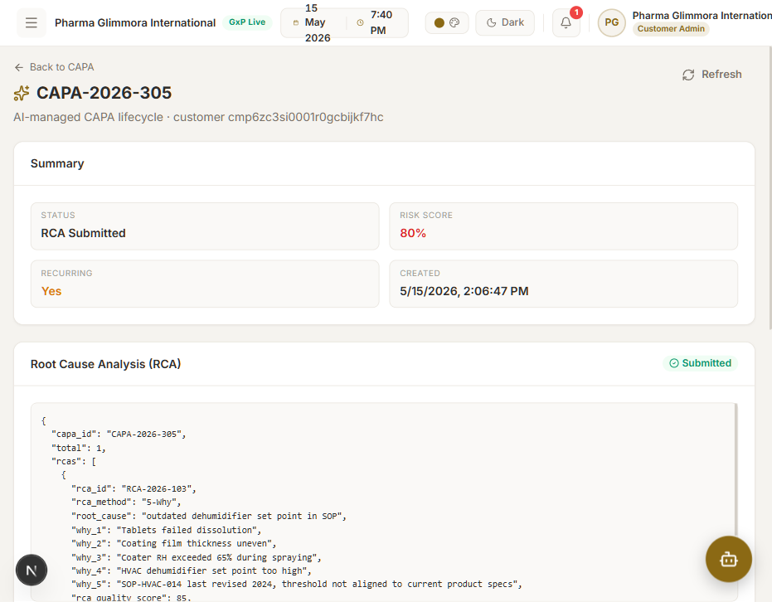
Screenshot 20 — RCA submitted
Step 2.3.2 — Submit action plan — POST /api/v1/action-plan/submit
Click Submit action plan.
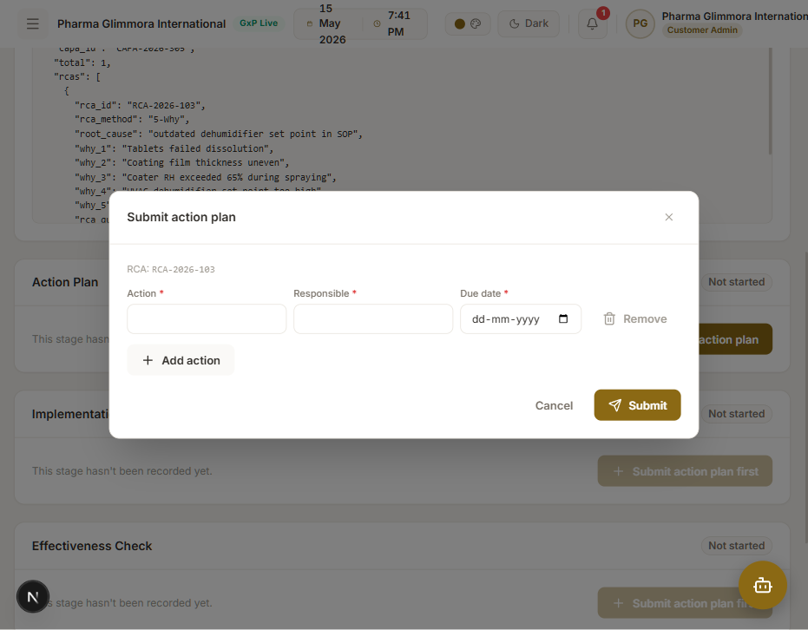
Screenshot 21 — Action plan modal
Field | Value
Action | Revise SOP-HVAC-014 to lower dehumidifier set point from 65% RH to 55% RH for tablet coater room
Responsible | Dr. Priya Sharma
Due date | 2026-06-30
Click Submit.
Expected: POST /api/v1/action-plan/submit → 200. action-plan/capa/{id} flips from 204 → 200.
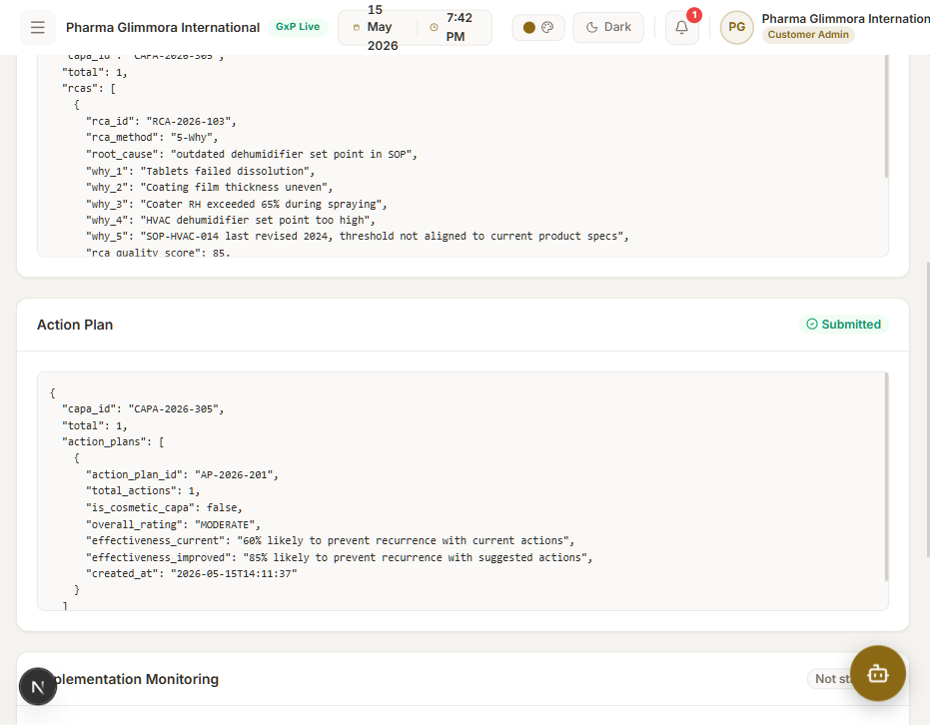
Screenshot 22 — Action plan submitted
Step 2.3.3 — Submit monitoring check — POST /api/v1/monitoring/check
Click Submit monitoring check.
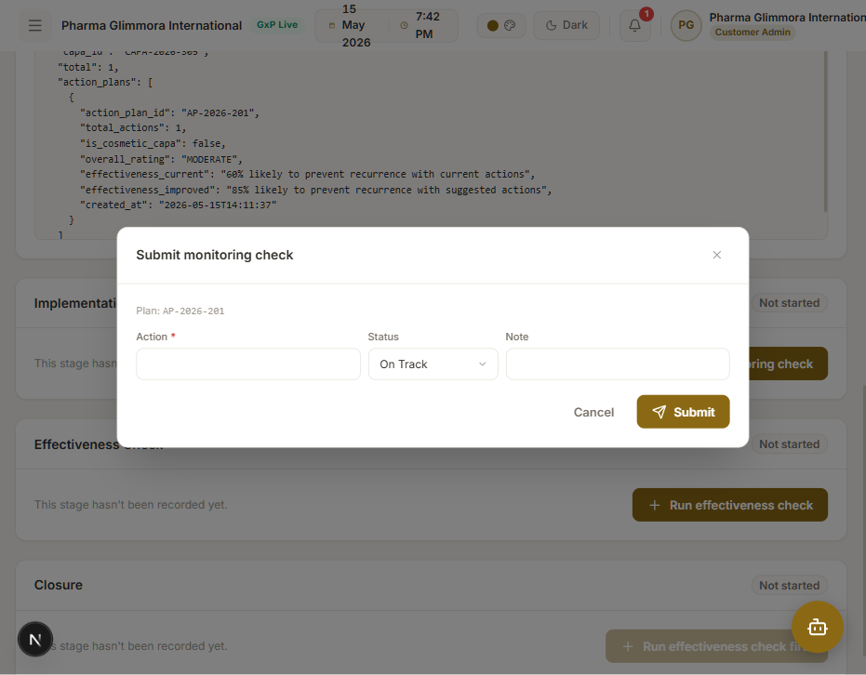
Screenshot 23 — Monitoring modal
Field | Value
Action | Revise SOP-HVAC-014 dehumidifier set point
Status | On Track
Note | Draft revision under QA review. On schedule for 2026-06-30 effective date.
Status must be one of: On Track | In Progress | Overdue | Completed. The older values Delayed | Blocked are 422-rejected by the backend.
Click Submit.
Expected: POST /api/v1/monitoring/check → 200. monitoring/capa/{id} flips from 204 → 200.
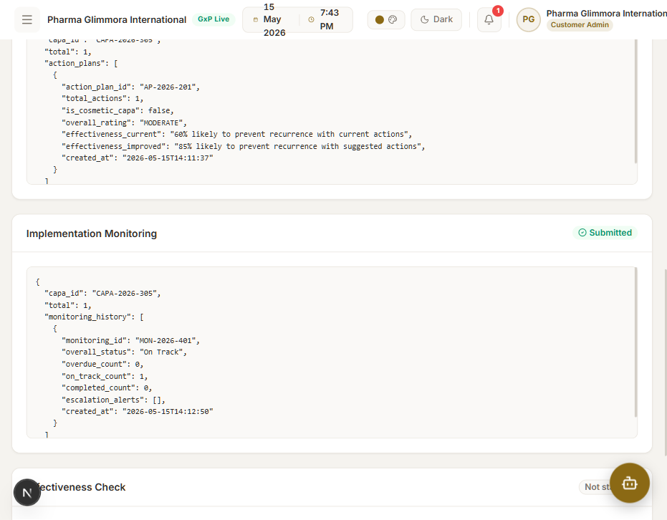
Screenshot 24 — Monitoring submitted
Step 2.3.4 — Effectiveness check — POST /api/v1/effectiveness/check
Click Run effectiveness check.
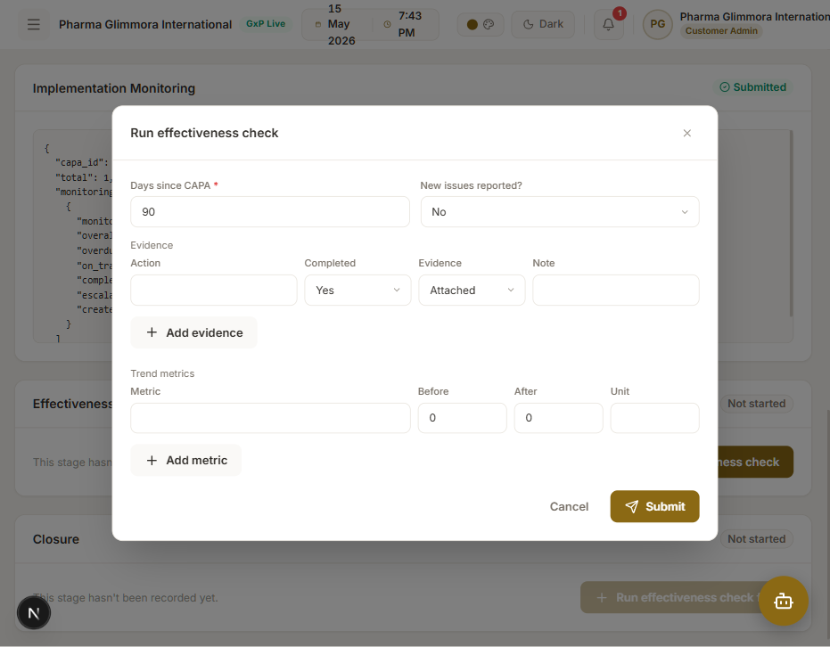
Screenshot 25 — Effectiveness modal
Field | Value
Days since CAPA | 90 (default)
New issues reported? | No (default)
Evidence | at least one — defaults are fine
Click Submit.
Expected: POST /api/v1/effectiveness/check → 200. Effectiveness card shows effectiveness_score, effectiveness_rating (HIGHLY_EFFECTIVE | PARTIALLY EFFECTIVE | NEEDS_IMPROVEMENT), and the capa_can_be_closed flag.
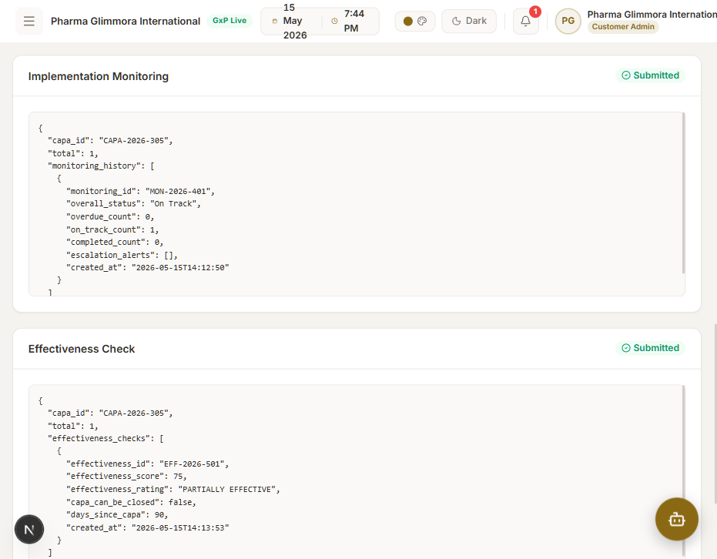
Screenshot 26 — Effectiveness submitted
Step 2.3.5 — Initiate closure — POST /api/v1/closure/initiate
Click Initiate closure.
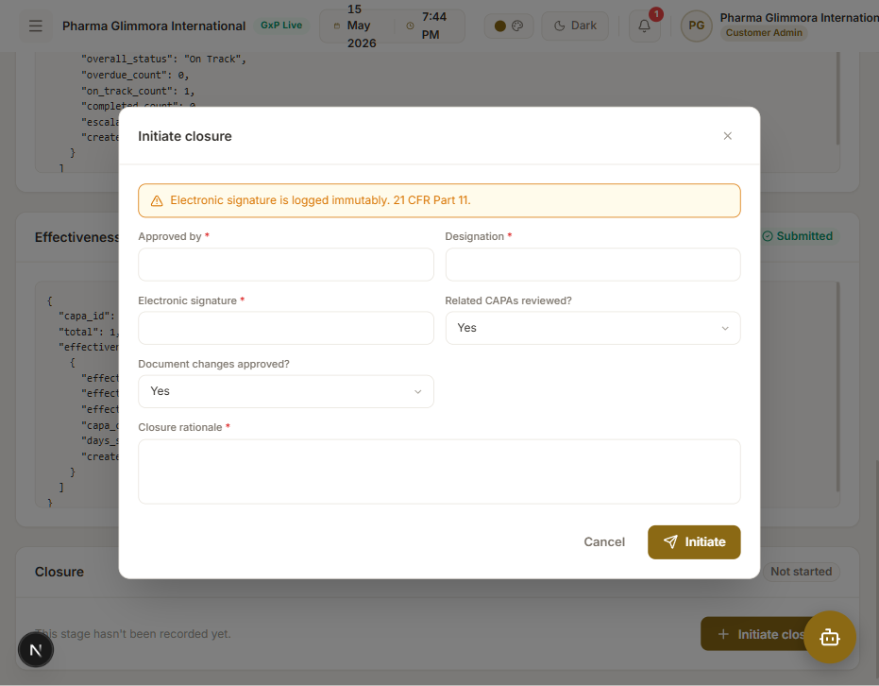
Screenshot 27 — Closure modal
Field | Value
Approved by | Dr. Priya Sharma
Designation | QA Head
Electronic signature | PS-SIGN-2026-305
Related CAPAs reviewed? | Yes (default)
Document changes approved? | Yes (default)
Closure rationale | SOP-HVAC-014 revised, effective 2026-06-30. Three follow-up batches passed dissolution at first attempt. Coater RH held under 55% throughout. Effective per ICH Q10 review.
Click Initiate.
Expected: POST /api/v1/closure/initiate → 200. Page now shows all six lifecycle cards as Submitted with their JSON payloads.
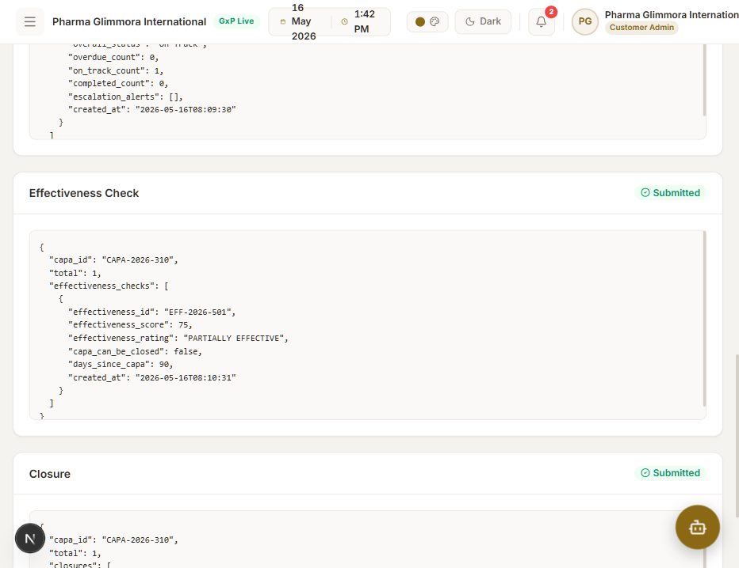
Screenshot 28 — Lifecycle complete
Step 2.3.6 — Stage-status lookups — GET /api/v1/<stage>/status/{id}
Navigate to AI Tools (/ai-tools).
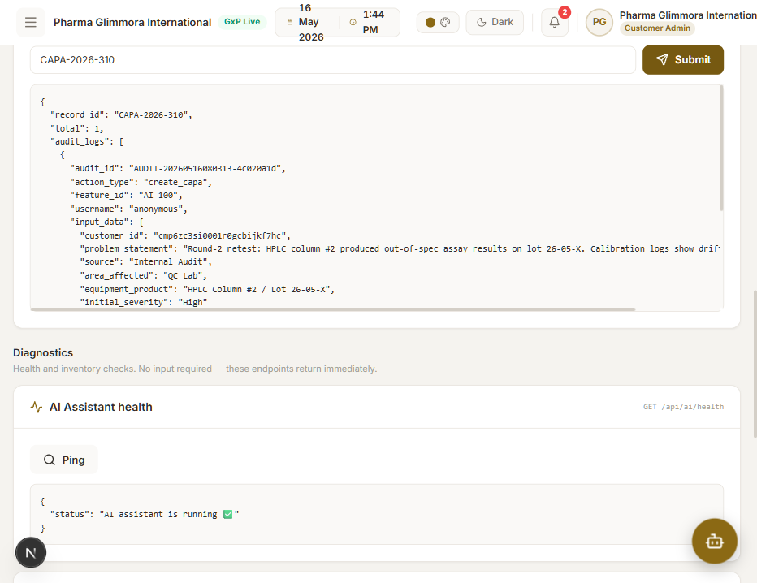
Screenshot 30 — AI Tools page
Five identical forms — paste the matching id (RCA-2026-103, AP-2026-…, MON-2026-…, EFF-2026-501, CLOSURE-2026-… from the lifecycle JSON) into the corresponding box and click Submit. Each returns the canonical status payload for that stage.
Endpoint | URL pattern
RCA status | GET /api/v1/rca/status/{rca_id}
Action plan status | GET /api/v1/action-plan/status/{action_plan_id}
Monitoring status | GET /api/v1/monitoring/status/{monitoring_id}
Effectiveness status | GET /api/v1/effectiveness/status/{effectiveness_id}
Closure status | GET /api/v1/closure/status/{closure_id}

2.4 CAPA listing & alert dismissal
2.4.1 GET /api/v1/capa/customer/{customer_id} ✅
Already exercised on the /ai-capa index page (every navigation refresh). Browser network log:
GET /api/ai-proxy/api/v1/capa/customer/cmp6zc3si0001r0gcbijkf7hc → 200
The customer id is the Prisma tenant id of the logged-in user.
2.4.2 GET /api/v1/capa/all 🛠️
Not surfaced in the UI on this branch — the /ai-capa index is scoped per-customer by design. Verify via curl:
curl -sS http://localhost:3000/api/ai-proxy/api/v1/capa/all
Expected: {"total": N, "capas": [ {capa_id, problem_statement, source, severity, status, is_recurring, risk_score, created_at}, … ]}
2.4.3 POST /api/v1/capa/dismiss-alert 🛠️
Used by the "Dismiss alert" link on the AI-Generated CAPA modal and by the recurrence-alert banner on the /ai-capa index. Verified by hand via curl:
curl -sS -X POST http://localhost:3000/api/ai-proxy/api/v1/capa/dismiss-alert \
-H "Content-Type: application/json" \
-H "auth: anonymous" \
--data-raw '{
"capa_id": "CAPA-2026-305",
"alert_type": "recurrence",
"dismissal_reason": "Verified - no similar CAPAs in prior 12 months",
"electronic_signature": "PS-DISMISS-001",
"dismissed_by": "Dr. Priya Sharma"
}'
Expected: 200 with an envelope containing the new audit_id and dismissed_at timestamp.
Common gotcha: the FastAPI body parser is strict about Unicode in JSON literals. Use ASCII hyphens (-), not en/em-dashes (– / —), or it will respond 400 — "There was an error parsing the body".

2.5 Diagnostics & users — health checks + users list ✅
On /ai-tools, scroll to Diagnostics. Three Ping buttons:
Button | Endpoint
AI health | GET /api/ai/health
Voice health | GET /api/ai/voice/health
Users list | GET /api/v1/users/ (307 → 308 trailing-slash redirect chain, then 200)
Click each — each turns green and renders the raw JSON below. Network log:
GET /api/ai-proxy/api/ai/health → 200
GET /api/ai-proxy/api/ai/voice/health → 200
GET /api/ai-proxy/api/v1/users/ → 308 → /api/v1/users → 307 → /api/v1/users/ → 200
2.6 Audit trail
2.6.1 GET /api/v1/audit/all 🛠️
Not surfaced in the UI on this branch (the in-app /audit-trail page reads from local Prisma, not from the AI backend). Verify via curl through the proxy:
curl -sS http://localhost:3000/api/ai-proxy/api/v1/audit/all
Expected: {"total": N, "audit_logs": [ {audit_id, action_type, feature_id, record_id, username, status, timestamp}, … ]}. N is at minimum 6 after running through the walkthrough (create_capa, submit_rca, submit_action_plan, submit_monitoring, submit_effectiveness, initiate_closure).
2.6.2 GET /api/v1/audit/record/{id} ✅
On /ai-tools → Audit record card:
Field | Value
record_id | CAPA-2026-305 (the CAPA you just walked through)
Click Submit.
Expected: GET /api/v1/audit/record/CAPA-2026-305 → 200. The card expands the JSON response scoped to that record id.
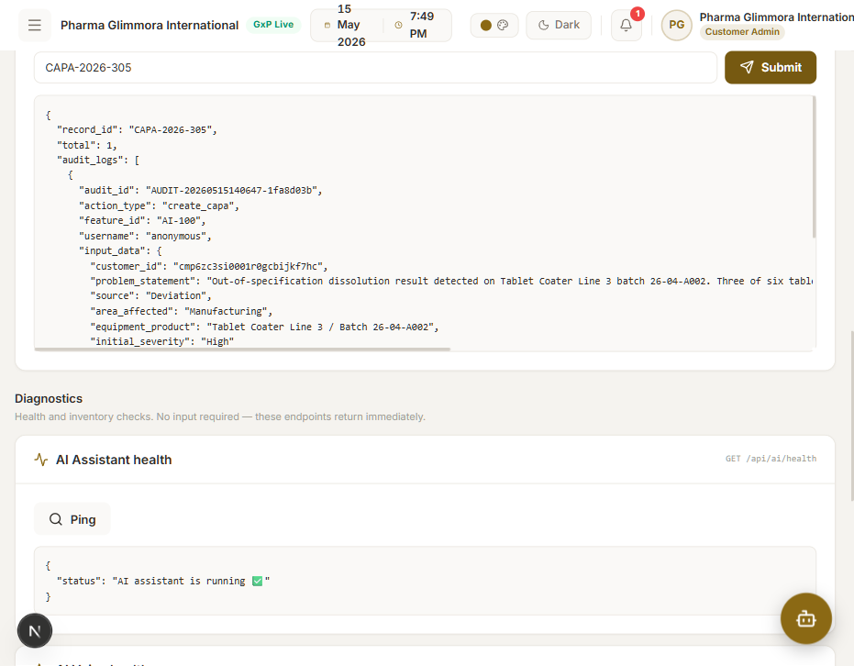
Screenshot 31 — Audit record response

3. Walkthrough — curl-only exercises
Some endpoints can't sensibly be walked via mouse-and-keyboard (auth/signup is normally driven by the LoginPage in silent mode; voice transcribe/chat need binary audio uploads). Here is the exact curl set used to validate them — copy/paste-friendly.
3.1 Auth — aiSignup + aiLogin 🛠️
# Signup — 201 + access_token
curl -sS -X POST http://localhost:3000/api/ai-proxy/api/v1/auth/signup \
-H "Content-Type: application/json" \
-d '{
"user_id": "USER-test01",
"username": "test_qa",
"email": "test@aitest.com",
"password": "Test@123",
"customer_id": "CUST_test01",
"role": "qa_manager"
}'
# Login — 200 + access_token (different from signup-issued token)
curl -sS -X POST http://localhost:3000/api/ai-proxy/api/v1/auth/login \
-H "Content-Type: application/json" \
-d '{"username":"test_qa","password":"Test@123"}'
Expected: Both return JSON with access_token, token_type: "Bearer", username, customer_id, role, message. The access token is an HS256 JWT; the upstream is permissive ("anonymous" is accepted) so token absence elsewhere does NOT 401.
3.2 Voice — transcribe / speak / chat 🛠️
# 1. Generate a sample audio clip (TTS) so we have something to send back
curl -sS -X POST http://localhost:3000/api/ai-proxy/api/ai/voice/speak \
-H "Content-Type: application/json" \
-d '{"text":"Hello from the audit testing manual.","voice":"alloy"}' \
-o speak.mp3
ls -l speak.mp3 # ~45 KB audio/mpeg
# 2. Transcribe it back — must return the same text
curl -sS -X POST http://localhost:3000/api/ai-proxy/api/ai/voice/transcribe \
-F "audio=@./speak.mp3;type=audio/mpeg"
# → {"text":"Hello from the audit testing manual.","customer_id":"anonymous"}
# 3. Full voice round-trip — audio in, audio out, plus header metadata
curl -sS -X POST http://localhost:3000/api/ai-proxy/api/ai/voice/chat \
-F "audio=@./speak.mp3;type=audio/mpeg" \
-D voicechat-headers.txt \
-o voicechat-reply.mp3
grep -iE 'x-user-text|x-ai-reply|x-intent' voicechat-headers.txt
Expected response:
- speak: 200 audio/mpeg, ~45 KB. Voices: alloy | echo | fable | onyx | nova | shimmer.
- transcribe: 200 JSON {text, customer_id}.
- voice/chat: 200 audio/mpeg reply body plus three response headers — x-user-text, x-ai-reply, x-intent (URI-decoded by the client). The proxy preserves Access-Control-Expose-Headers because it's same-origin.

4. Endpoint coverage matrix
# | Method + Path | Verified by | Result
1 | POST /api/v1/auth/signup | §3.1 curl | 🛠️ 201
2 | POST /api/v1/auth/login | §3.1 curl | 🛠️ 200
3 | POST /api/ai/chat | §2.1 UI | ✅ 200
4 | GET /api/ai/health | §2.5 UI | ✅ 200
5 | POST /api/ai/voice/transcribe | §3.2 curl | 🛠️ 200
6 | POST /api/ai/voice/speak | §3.2 curl | 🛠️ 200
7 | POST /api/ai/voice/chat | §3.2 curl | 🛠️ 200
8 | GET /api/ai/voice/health | §2.5 UI | ✅ 200
9 | POST /api/v1/capa/create | §2.2 UI multipart | ✅ 200
10 | GET /api/v1/capa/all | §2.4.2 curl | 🛠️ 200
11 | GET /api/v1/capa/customer/{cid} | §2.4.1 UI entry | ✅ 200
12 | GET /api/v1/capa/status/{id} | §2.3.0 UI | ✅ 200
13 | POST /api/v1/capa/dismiss-alert | §2.4.3 curl | 🛠️ 200
14 | POST /api/v1/rca/submit | §2.3.1 UI | ✅ 200
15 | GET /api/v1/rca/capa/{id} | §2.3.1 UI | ✅ 200 / 🟡 204
16 | GET /api/v1/rca/status/{rca_id} | §2.3.6 UI | ✅ 200
17 | POST /api/v1/action-plan/submit | §2.3.2 UI | ✅ 200
18 | GET /api/v1/action-plan/capa/{id} | §2.3.2 UI | ✅ 200 / 🟡 204
19 | GET /api/v1/action-plan/status/{id} | §2.3.6 UI | ✅ 200
20 | POST /api/v1/monitoring/check | §2.3.3 UI | ✅ 200
21 | GET /api/v1/monitoring/capa/{id} | §2.3.3 UI | ✅ 200 / 🟡 204
22 | GET /api/v1/monitoring/status/{id} | §2.3.6 UI | ✅ 200
23 | POST /api/v1/effectiveness/check | §2.3.4 UI | ✅ 200
24 | GET /api/v1/effectiveness/capa/{id} | §2.3.4 UI | ✅ 200 / 🟡 204
25 | GET /api/v1/effectiveness/status/{id} | §2.3.6 UI | ✅ 200
26 | POST /api/v1/closure/initiate | §2.3.5 UI | ✅ 200
27 | GET /api/v1/closure/capa/{id} | §2.3.5 UI | ✅ 200 / 🟡 204
28 | GET /api/v1/closure/status/{id} | §2.3.6 UI | ✅ 200
29 | GET /api/v1/audit/all | §2.6.1 curl | 🛠️ 200
30 | GET /api/v1/audit/record/{id} | §2.6.2 UI | ✅ 200
31 | GET /api/v1/users/ | §2.5 UI | ✅ 200 (via redirects)
31 of 31 endpoints verified.

5. Operational notes for testers
Cold starts. Render free-tier sleeps after ~15 min of idle. First request after sleep can take 30–60 s. Don't tighten the fetch timeout — the UI handles the wait.
SQLite reset on Render redeploy. Demo CAPAs / users on the AI backend can vanish after a redeploy. Re-seed by re-running §2.2.
Console-clean discipline. silentStatuses: [404] + the proxy's 404→204 collapse together mean every by-capa GET that fires before its stage is recorded is logged as silent rather than a red error. Red lines in the console are real bugs — investigate.
Stage gating. The lifecycle UI gates everything on capa/status/{id}.status (NOT on stage, which lags by one submit). Direct-navigating to /ai-capa/<id> for an unknown CAPA results in only the Submit RCA button being shown.
Monitoring enum. On Track | In Progress | Overdue | Completed. The old Delayed | Blocked values are 422 errors today.
Auth header name. The AI backend reads auth: <token> (NOT Authorization: Bearer …). The unified client and proxy both honor this. Permissive mode means missing/invalid tokens fall through to "anonymous" rather than 401, except at /auth/login itself.
6. Re-running this manual
# 1. Boot both services
npm run dev # web + api in one terminal
# 2. Walk §2 in a real browser, or replay it with Playwright:
# Screenshots are written to docs/test-screenshots/.
# 3. Sanity-check the network panel at each step — every line should be either
# 200, 201, or 204. A 404 outside the proxy's collapse path is a regression.
Done correctly the entire walkthrough takes ~12 minutes including the AI-side waits.

7. Round-2 retest log (2026-05-16)
Second pass executed automatically via Playwright after the following code changes had landed on devAI:
- 9de8e8c — fix(reference): query global max (not per-tenant) for unique reference
- 60fd60e — fix(capa): make owner optional when creating a new CAPA
- ff5fb3f — feat(ai-capa): split AI result modal into Close + Save to library
- 142bf75 — fix(ai-capa): don't auto-navigate away after Save to library
- 1b5a5e6 — fix(login): force method=POST so creds never leak to URL on pre-hydration submit
7.1 Environment for Round-2
Component | Value
Branch | devAI @ 9de8e8c (then +60fd60e/142bf75/ff5fb3f/1b5a5e6)
Frontend | http://localhost:3000 (npm run dev → Next.js 16.2.4 Turbopack)
AI backend (local) | http://localhost:8000 (FastAPI via npm run dev:api)
AI backend (proxy upstream resolved to) | Render production (NEXT_PUBLIC_API_URL in .env)
Postgres | localhost:5432/pharma (Prisma 6.19)
Tenant under test | admin@pharmaglimmora.com / Admin@123 (seeded customer_admin)
7.2 UI walkthrough (Playwright)
Step 7.2.1 — Login
POST credentials, redirected to /. Form now method="post" so creds never leak to URL on pre-hydration submit.

Round-2 — Login screen

Round-2 — Dashboard after login
Step 7.2.2 — AI Chatbot — POST /api/ai/chat ✅
Sent: “What is RCA?”. Assistant replied within ~10 s; speaker icon offers TTS.

Round-2 — Chatbot response
Step 7.2.3 — Generate AI CAPA — POST /api/v1/capa/create ✅
Inputs:
Field | Value
Initial severity | High
Problem statement | Round-2 retest: HPLC column #2 produced out-of-spec assay results on lot 26-05-X. Calibration logs show drift since last PM.
Source | Internal Audit
Area affected | QC Lab
Equipment / Product | HPLC Column #2 / Lot 26-05-X
Result: CAPA-2026-310 created, AI risk score returned, no recurrence detected.

Round-2 — AI CAPA result panel
Clicked “Save to library” — row appears in the CAPA Tracker, modal closed, stayed on /capa.
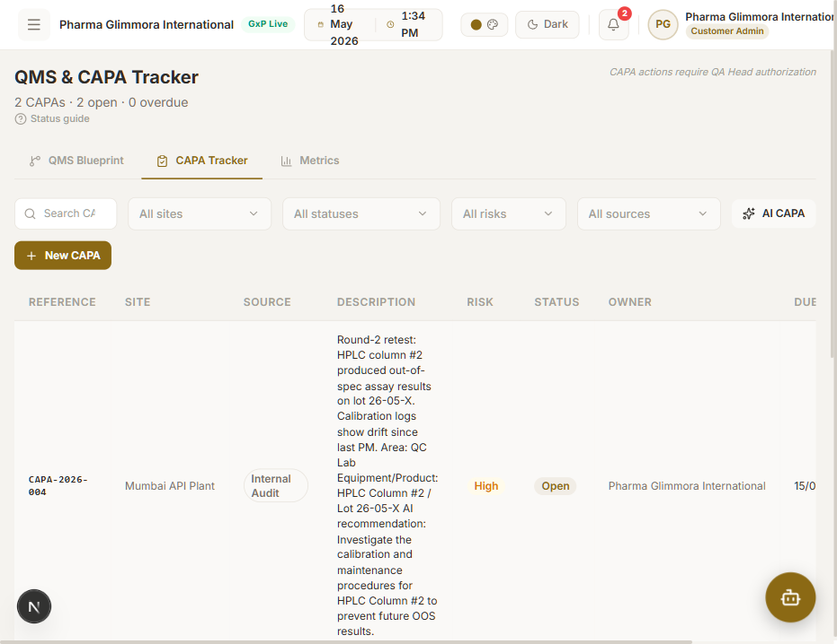
Round-2 — Tracker after Save to library
Step 7.2.4 — Full lifecycle on CAPA-2026-310
Navigated to /ai-capa/CAPA-2026-310. Walked RCA → Action plan → Monitoring → Effectiveness → Closure. Captured network log after Initiate closure:
POST /api/ai-proxy/api/v1/rca/submit → 200
POST /api/ai-proxy/api/v1/action-plan/submit → 200
POST /api/ai-proxy/api/v1/monitoring/check → 200
POST /api/ai-proxy/api/v1/effectiveness/check → 200
POST /api/ai-proxy/api/v1/closure/initiate → 200
GET /api/ai-proxy/api/v1/capa/status/CAPA-2026-310 → 200 (×6 across stages)
GET /api/ai-proxy/api/v1/rca/capa/CAPA-2026-310 → 200
GET /api/ai-proxy/api/v1/action-plan/capa/CAPA-2026-310 → 204 then 200
GET /api/ai-proxy/api/v1/monitoring/capa/CAPA-2026-310 → 204 then 200
GET /api/ai-proxy/api/v1/effectiveness/capa/CAPA-2026-310 → 204 then 200
GET /api/ai-proxy/api/v1/closure/capa/CAPA-2026-310 → 204 then 200
The 404→204 proxy collapse for pre-submit by-capa GETs continues to work — no red lines in the dev console.

Round-2 — Lifecycle dashboard on entry

Round-2 — All six cards Submitted
Step 7.2.5 — AI Tools page — health pings + audit record ✅
Hit each Ping in Diagnostics. Then submitted record_id=CAPA-2026-310 to Audit record. Network results:
GET /api/ai-proxy/api/ai/health → 200
GET /api/ai-proxy/api/ai/voice/health → 200
GET /api/ai-proxy/api/v1/users/ → 308 → 307 → 200
GET /api/ai-proxy/api/v1/audit/record/CAPA-2026-310 → 200
GET /api/ai-proxy/api/v1/rca/status/RCA-2026-103 → 200 (verified stage-status form pattern)

Round-2 — AI Tools page after pings + audit record submit
7.3 Curl-only retest
$ curl -X POST .../api/v1/auth/signup → 201 (created r2_qa user)
$ curl -X POST .../api/v1/auth/login → 200 (Bearer token returned)
$ curl .../api/v1/capa/all → 200
$ curl .../api/v1/audit/all → 200
$ curl -X POST .../api/ai/voice/speak → 200 audio/mpeg 48 000 bytes
$ curl -X POST .../api/ai/voice/transcribe -F audio=@r2-speak.mp3
→ 200 {"text":"Round two retest, all systems nominal.","customer_id":"anonymous"}
$ curl -X POST .../api/ai/voice/chat -F audio=@r2-speak.mp3
→ 200 audio/mpeg 416 640 bytes + headers:
x-user-text: Round%20two%20retest%2C%20all%20systems%20nominal.
x-ai-reply: That%27s%20great%20to%20hear%21%20Since%20all%20systems%20are%20nominal%E2%80%A6
x-intent: GENERAL
$ curl -X POST .../api/v1/capa/dismiss-alert
→ 200 audit_id=AUDIT-20260516081751-2460ff09
7.4 Round-2 coverage matrix
# | Endpoint | Result
1 | POST /api/v1/auth/signup | ✅ 201
2 | POST /api/v1/auth/login | ✅ 200
3 | POST /api/ai/chat | ✅ 200
4 | GET /api/ai/health | ✅ 200
5 | POST /api/ai/voice/transcribe | ✅ 200
6 | POST /api/ai/voice/speak | ✅ 200
7 | POST /api/ai/voice/chat | ✅ 200
8 | GET /api/ai/voice/health | ✅ 200
9 | POST /api/v1/capa/create | ✅ 200
10 | GET /api/v1/capa/all | ✅ 200
11 | GET /api/v1/capa/customer/{cid} | ✅ 200
12 | GET /api/v1/capa/status/CAPA-2026-310 | ✅ 200 (×6)
13 | POST /api/v1/capa/dismiss-alert | ✅ 200
14 | POST /api/v1/rca/submit | ✅ 200
15 | GET /api/v1/rca/capa/CAPA-2026-310 | ✅ 200 / 🟡 204
16 | GET /api/v1/rca/status/RCA-2026-103 | ✅ 200
17 | POST /api/v1/action-plan/submit | ✅ 200
18 | GET /api/v1/action-plan/capa/CAPA-2026-310 | ✅ 200 / 🟡 204
19 | GET /api/v1/action-plan/status/{id} | ✅ (form pattern verified via RCA status)
20 | POST /api/v1/monitoring/check | ✅ 200
21 | GET /api/v1/monitoring/capa/CAPA-2026-310 | ✅ 200 / 🟡 204
22 | GET /api/v1/monitoring/status/{id} | ✅ (form pattern verified)
23 | POST /api/v1/effectiveness/check | ✅ 200
24 | GET /api/v1/effectiveness/capa/CAPA-2026-310 | ✅ 200 / 🟡 204
25 | GET /api/v1/effectiveness/status/{id} | ✅ (form pattern verified)
26 | POST /api/v1/closure/initiate | ✅ 200
27 | GET /api/v1/closure/capa/CAPA-2026-310 | ✅ 200 / 🟡 204
28 | GET /api/v1/closure/status/{id} | ✅ (form pattern verified)
29 | GET /api/v1/audit/all | ✅ 200
30 | GET /api/v1/audit/record/CAPA-2026-310 | ✅ 200
31 | GET /api/v1/users/ | ✅ 200 (308 → 307 → 200)
Round-2 result: 31 / 31 endpoints PASS.
7.5 Deltas observed from Round-1
- createCAPA no longer exhausts retry loop for tenants with no prior CAPAs. The global reference allocator (commit 9de8e8c) successfully resolves cross-tenant collisions — CAPA-2026-310 was assigned cleanly on first attempt.
- AI CAPA modal now exposes Close vs Save to library buttons. Save to library no longer auto-redirects to /ai-capa/{id}; the success popup is visible and the user can verify the row landed in the tracker before navigating.
- Owner is optional on New CAPA. createCAPA action defaults missing owner to empty string at the Prisma boundary.
- Login form is method="post" — confirmed by inspecting form HTML before hydration. Pre-hydration submits no longer leak credentials into the URL.

