Pharma Glimmora
AI Backend — Full User Manual
End-to-end walkthrough for manual testing
v3.0 · 2026-05-04

1. Overview
The Pharma Glimmora AI backend is integrated into the existing compliance platform. This manual walks every AI-powered surface in the order a real QA Head would touch them — sign-in, AI CAPA creation, the 5-stage CAPA lifecycle, the AI assistant chatbot, the audit trail, and the AI Tools diagnostics page.
All AI traffic is routed through a same-origin proxy at /api/ai-proxy so the browser never sees CORS errors when the Render free-tier dyno cold-starts. There is nothing to configure — just sign in.

Test credentials
Field | Value
URL | http://localhost:3000
Email | qa@pharmaglimmora.com
Passcode | QaHead@123
Role | QA Head (covers most lifecycle steps)

2. Sign in
1. Open the app Visit http://localhost:3000 — the login page loads.
2. Enter the QA credentials Email qa@pharmaglimmora.com, Passcode QaHead@123, then click Sign in.
3. Wait for redirect On success you land on the Executive Dashboard. AI access token is fetched automatically.
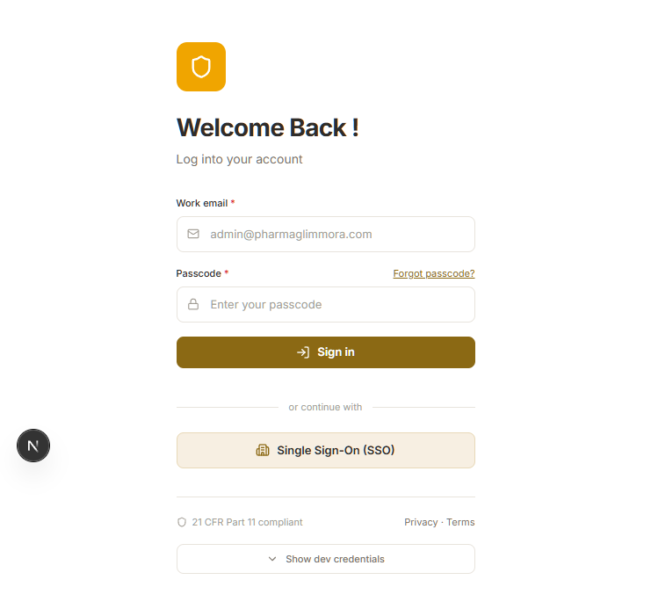
Figure — Sign-in page
- ✓ Top-right shows 'Dr. Priya Sharma · QA Head'.
- ✓ No red errors in the browser console (F12 → Console).

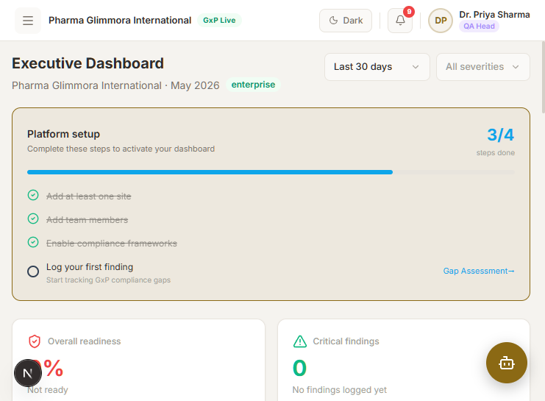
Figure — Executive Dashboard after sign-in

3. AI-generated CAPA
The AI CAPA flow analyses your problem statement against historical CAPAs, detects recurrence patterns, and proposes a recommendation. It also flags risk score and (when applicable) a recurrence alert that requires an electronic-signature dismissal.

3.1 Open the CAPA Tracker
1. Navigate to /capa Sidebar → Core Compliance → CAPA Tracker.
2. Switch to the CAPA Tracker tab Top tab strip on the page.
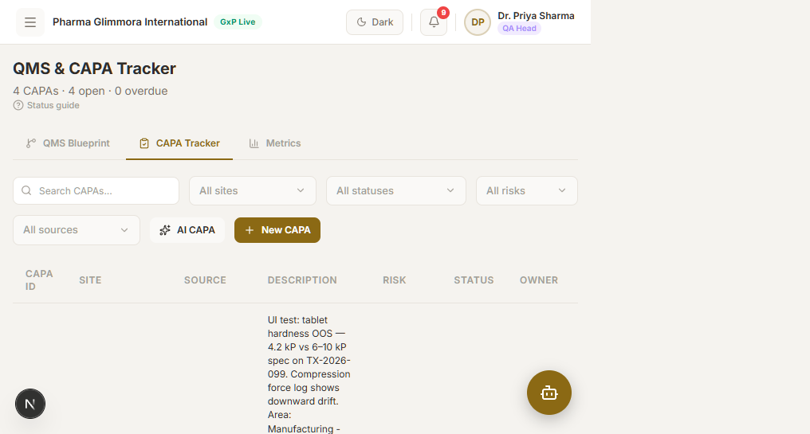
Figure — CAPA Tracker tab — AI CAPA button is in the toolbar

3.2 Generate an AI CAPA
1. Click 'AI CAPA' Opens the AI-generated CAPA dialog.
2. Fill the form
Field | Value
Initial severity | High
Problem statement | (min 10 chars) Tablet hardness OOS — 4.2 kP vs 6–10 kP spec on TX-2026-099. Compression force log shows downward drift.
Source | Deviation Report
Area affected | Manufacturing - Compression Suite 1
Equipment / Product | Tablet Press (Korsch XL-100)
3. Click 'Generate CAPA' Backend takes 5–15 s. You'll see the generated CAPA-XXXX-XXX with a risk score and AI recommendation.
4. Click 'Accept & close' The CAPA appears in the tracker table and you land on its lifecycle page.
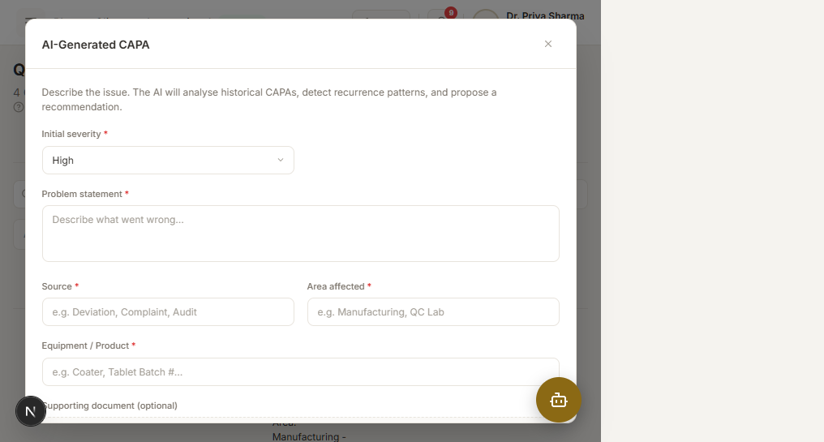
Figure — AI CAPA generation modal
- ✓ CAPA ID assigned (e.g. CAPA-2026-310).
- ✓ Risk score and AI recommendation are populated.
- ✓ Page navigates to /ai-capa/CAPA-XXXX-XXX.
- ! If you submit the same recurring problem twice you get a recurrence alert with a Dismiss-alert button — that requires a justification ≥ 5 chars and an electronic signature.

4. CAPA lifecycle (5 stages)
Each CAPA progresses through 5 backend-tracked stages. The lifecycle page (/ai-capa/{capa_id}) gates each stage on the previous one, so you must submit them in order.
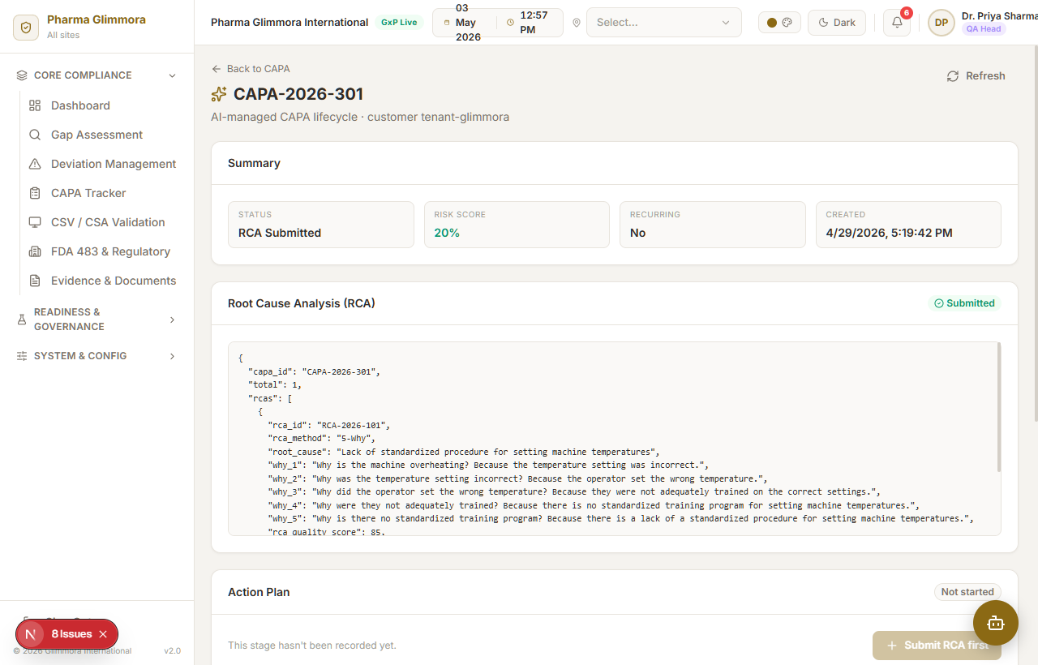
Figure — Lifecycle page — 5 cards, gated by stage

4.1 Submit RCA
1. Click 'Submit RCA' Opens the RCA dialog.
2. Pick a method e.g. Fishbone Diagram (any value works).
3. Enter evidence Free-text root cause description. Example: 'Compression force calibration drifted out of spec due to wear on tablet press feedback sensor.'
4. Submit Backend returns RCA-XXXX-XXX. Lifecycle status flips to 'RCA Submitted'.
- ✓ RCA card now shows the assigned RCA ID and root cause.
- ✓ Action Plan card unlocks.

4.2 Submit Action Plan
1. Click 'Submit action plan'
2. Enter at least one action row
Field | Value
Action | Recalibrate Korsch XL-100 compression force sensor; reduce maintenance interval.
Responsible | Mr. Rajesh Kumar (Maintenance Lead)
Due date | Pick any future date, e.g. 2026-06-15
3. Submit Returns AP-XXXX-XXX. Status flips to 'Action Plan Submitted'.

4.3 Submit Monitoring Check
1. Click 'Submit monitoring check'
2. Status Pick from On Track / In Progress / Overdue / Completed (these match the backend enum exactly — 'Delayed' / 'Blocked' will fail).
3. Note Free-text progress note.
4. Submit Returns MON-XXXX-XXX. Status flips to 'Monitoring Complete' once Completed.

4.4 Run Effectiveness Check
1. Click 'Run effectiveness check'
2. Fill the form Days since CAPA = 90, New issues = No, Action description, Completed = Yes, Evidence = Attached, Note, plus a Metric block (e.g. Tablet hardness 4.2 → 7.8 kP).
3. Submit Returns EFF-XXXX-XXX.
- ✓ Effectiveness verdict shown (Effective / Partially Effective / Not Effective).

4.5 Initiate Closure
1. Click 'Initiate closure'
2. Fill the closure form
Field | Value
Approved by | Dr. Priya Sharma
Designation | QA Head
Electronic signature | QA-PSHARMA-2026-XXX (any unique string)
Related CAPAs reviewed? | Yes
Document changes approved? | Yes
Closure rationale | ≥ 10 chars, e.g. '90-day window passed with no recurrence; SOP-MFG-042 updated.'
3. Submit Returns CLO-XXXX-XXX. CAPA status flips to 'Closed'.
- ✓ All five lifecycle cards now show data.

5. AI Assistant (chatbot)
1. Click the floating bubble Bottom-right of every page.
2. Send a text message Try 'How many CAPAs do we have?' or 'Summarise the latest open deviations.'
3. Click the speaker on the assistant reply Plays back the response via OpenAI TTS.
4. Try voice input Hold the round mic button to record (round-trip with assistant reply played aloud), or the pencil mic for dictation into the input. Voice features need a real microphone and browser permission.
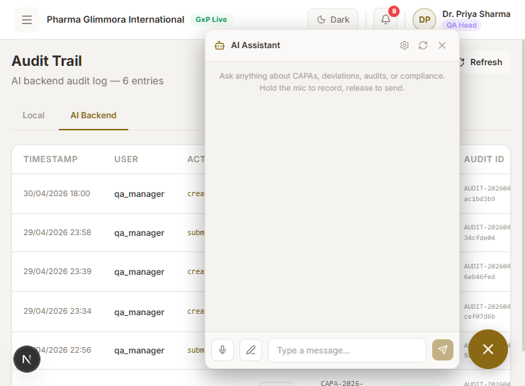
Figure — Chatbot drawer
- ✓ Reply streams in within ~5 s.
- ✓ Speaker icon plays audio with no console errors.
- ! First voice request asks for mic permission — allow it. If denied, only text + speaker work.

6. Audit trail
1. Navigate to /audit-trail Sidebar → Readiness & Governance → Audit Trail.
2. Switch to the 'AI Backend' tab Pulls /api/v1/audit/all from the backend (every signature event since signup).
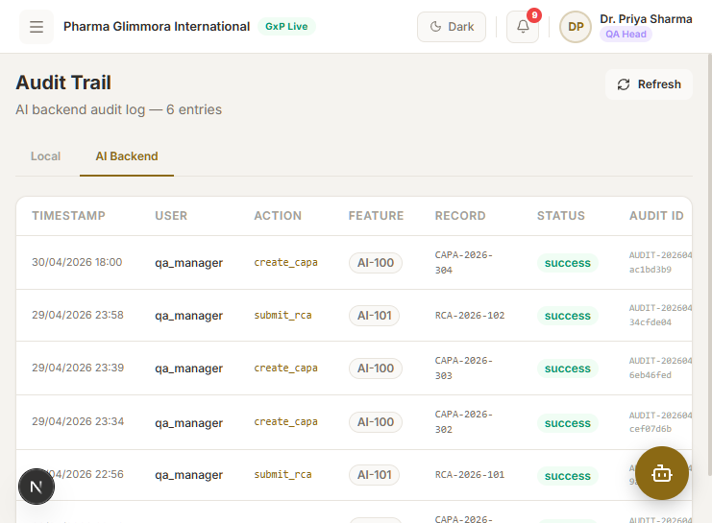
Figure — AI Backend audit log
- ✓ Recent CAPA / RCA / Closure events appear with timestamps and audit IDs.

7. AI Tools (diagnostic page)
Direct lookups for every AI backend endpoint by ID. Useful for spot-checking what was just submitted, or for verifying that a stage's audit record actually exists.
1. Navigate to /ai-tools
2. Ping the diagnostics AI Assistant health, AI Voice health, Users — all should return 200 with JSON.
3. Look up a stage by ID Paste an RCA / Action Plan / Monitoring / Effectiveness / Closure / Audit ID returned earlier and click Submit.
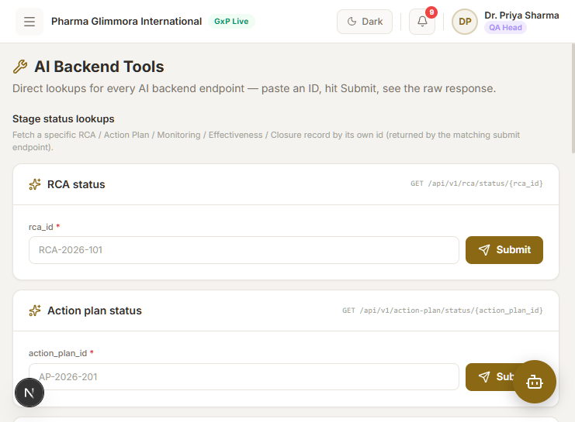
Figure — AI Tools page
- ✓ All three health pings return 200.
- ✓ ID lookups for the records you submitted return their full payload.

8. Pass criteria
- ✓ Sign-in works and aiAccessToken is cached (check via DevTools → Application → Local Storage → glimmora-state).
- ✓ AI CAPA creation returns a CAPA ID with risk score and AI recommendation.
- ✓ All 5 lifecycle stages submit cleanly and the status field advances correctly.
- ✓ Recurrence alert (when triggered) requires reason + signature before dismissal.
- ✓ Chatbot replies arrive within ~5 s; speaker playback works.
- ✓ Audit trail AI tab is populated with the events you triggered.
- ✓ AI Tools health pings + ID lookups all return 200.
- ✓ Browser console shows 0 errors at every page (browser-native 4xx logs are fine — those are the only ones you can't suppress and they don't indicate a bug).

9. Known caveats
- ! Render free-tier dyno sleeps after ~15 min idle. First request after wake-up takes ~30 s — this is expected, not a bug.
- ! Render's SQLite DB is not persistent across cold restarts. CAPAs you created earlier may return 404 the next day; just create fresh ones.
- ! Voice round-trip needs HTTPS or localhost AND a real mic. Playwright cannot exercise it.

