Pharma Glimmora
AI Backend — Quick Smoke Test
Shortest happy-path manual test (~10 min)
v3.0 · 2026-05-04

Test credentials
Field | Value
URL | http://localhost:3000
Email | qa@pharmaglimmora.com
Passcode | QaHead@123
Role | QA Head (covers most lifecycle steps)

Goal
Confirm that login + AI CAPA creation + the full 5-stage lifecycle + chatbot all work end-to-end against the deployed backend. ~10 minutes start to finish.

Steps
1. Sign in http://localhost:3000 → email/passcode above → Sign in.
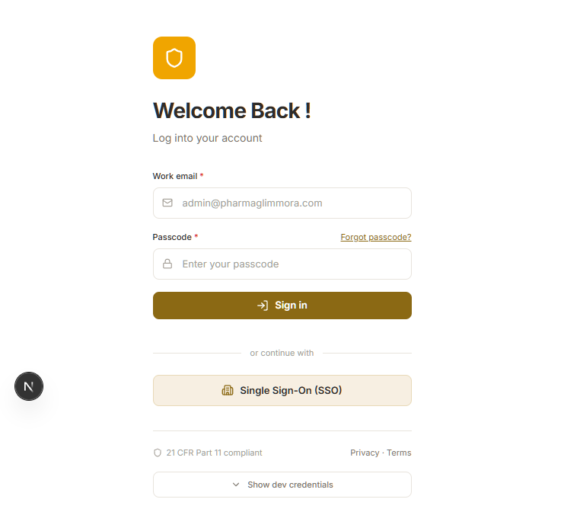
Figure — Login page
- ✓ Top-right shows 'Dr. Priya Sharma · QA Head'.
2. Open CAPA Tracker Sidebar → CAPA Tracker → click the 'CAPA Tracker' tab.
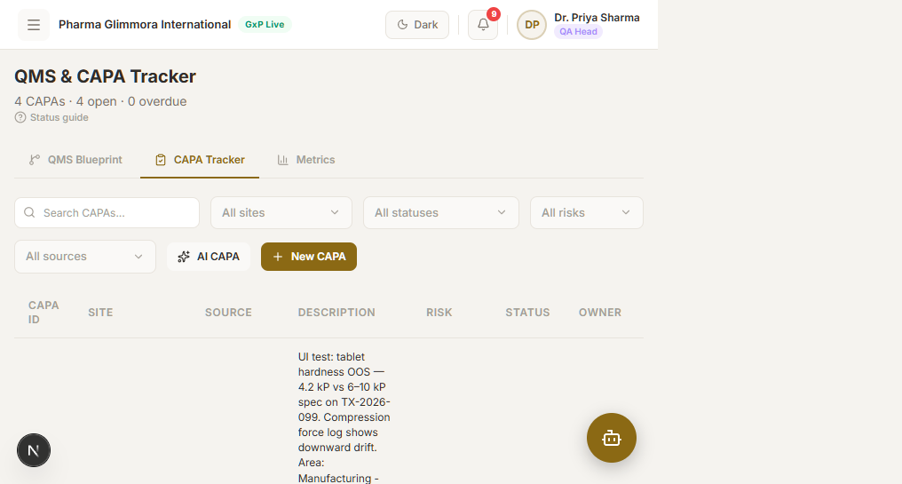
Figure — CAPA Tracker tab
3. Generate an AI CAPA Click 'AI CAPA'. Fill: severity High; problem '≥ 10 chars'; source / area / equipment any short text. Click Generate CAPA.
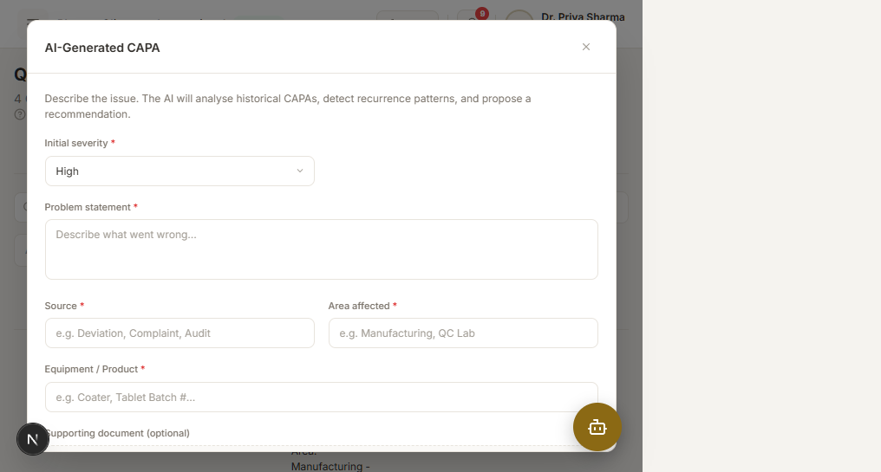
Figure — AI CAPA modal
- ✓ After 5–15 s a CAPA-XXXX-XXX appears with risk score + AI recommendation.
4. Accept & open lifecycle Click 'Accept & close'. You land on /ai-capa/CAPA-XXXX-XXX.
5. Submit RCA Click 'Submit RCA'. Method = Fishbone, evidence = any sentence. Submit.
- ✓ RCA card populates; Action Plan unlocks.
6. Submit Action Plan Click 'Submit action plan'. Action / Responsible / Due date — any values. Submit.
7. Monitoring check Click 'Submit monitoring check'. Status MUST be one of: On Track / In Progress / Overdue / Completed. Submit.
- ! Do not pick anything outside that 4-value enum — backend will return 422.
8. Effectiveness Click 'Run effectiveness check'. Days = 90, New issues = No, Completed = Yes, Evidence = Attached, plus any metric block. Submit.
9. Closure Click 'Initiate closure'. Approved by / Designation / Signature / both Yes / rationale ≥ 10 chars. Submit.
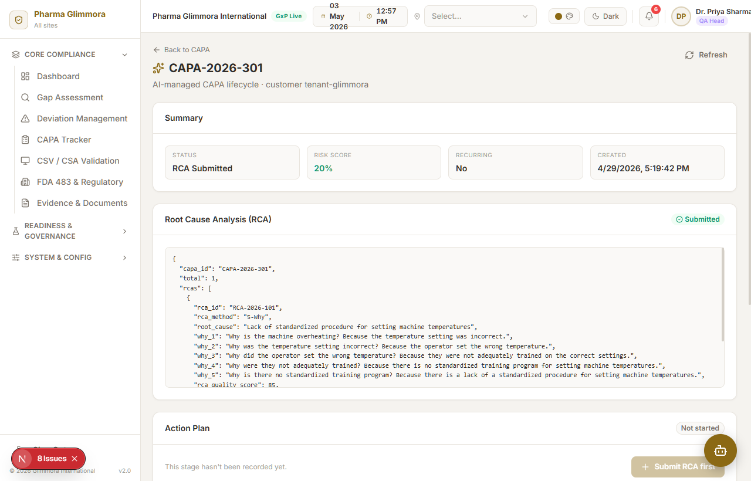
Figure — Lifecycle page after all 5 stages
- ✓ All 5 cards show submitted data; CAPA status = Closed.
10. Chatbot Click the floating bubble (bottom-right). Type 'How many CAPAs do we have?' and send. Click the speaker icon on the reply.
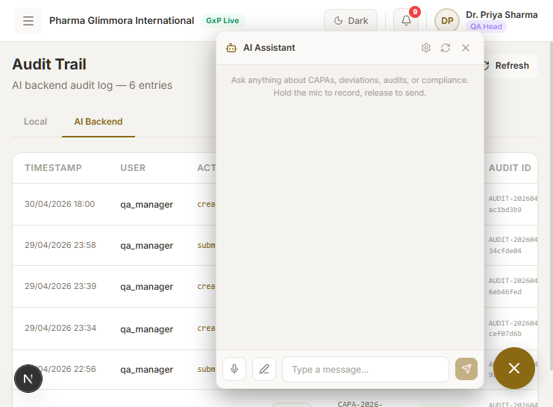
Figure — Chatbot drawer
- ✓ Reply arrives in ~5 s. Speaker plays audio.

Pass / Fail
- ✓ Every step above completed without a red error toast in the UI.
- ✓ Browser console (F12 → Console) shows 0 JavaScript errors. (Browser-native 'Failed to load resource' 404 lines are not bugs — ignore them.)
- ✓ Audit trail at /audit-trail → AI Backend tab shows your events with timestamps.
- ! If the very first request hangs ~30 s — that's Render's free-tier waking up. Wait, then retry once.

