**1.Garlic:**

used to reduce the risk of [**heart disease**](https://www.betterhealth.vic.gov.au/health/conditionsandtreatments/heart-disease-risk-factors) by lowering levels of blood fats and [**cholesterol**](https://www.betterhealth.vic.gov.au/health/conditionsandtreatments/cholesterol) (a type of blood fat). The antibiotic and antiviral properties of garlic mean that it is also used to fight [**colds**](https://www.betterhealth.vic.gov.au/health/conditionsandtreatments/colds), [**sinusitis**](https://www.betterhealth.vic.gov.au/health/conditionsandtreatments/sinusitis) and other respiratory infections.

Garlic (Allium sativum) is an herb related to onion, leeks, and chives. It is commonly used for conditions related to the [heart](http://www.webmd.com/heart/picture-of-the-heart) and [blood](http://www.webmd.com/heart/anatomy-picture-of-blood) system.  
  
Garlic produces a chemical called allicin. This is what seems to make garlic work for certain conditions. Allicin also makes garlic smell. Some products are made "odorless" by aging the garlic, but this process can also change the effects of garlic.  
  
People commonly use garlic for high blood pressure, high levels of cholesterol or other fats in the blood, and hardening of the [arteries](http://www.webmd.com/heart/picture-of-the-arteries). It is also used for the common cold, [osteoarthritis](http://www.webmd.com/osteoarthritis/guide/osteoarthritis-basics), and many other conditions, but there is no good scientific evidence to support these uses.

A painful uterine disorder ([endometriosis](http://www.webmd.com/women/endometriosis/endometriosis-causes-symptoms-treatment)). Taking garlic powder tablets by [mouth](http://www.webmd.com/oral-health/ss/slideshow-mouth-problems) daily for 3 months seems to improve pain in people with this condition.

Hardening of the arteries ([atherosclerosis](http://www.webmd.com/heart-disease/what-is-atherosclerosis)). Taking garlic powder by [mouth](http://www.webmd.com/oral-health/rm-quiz-mouth-myths), alone or with other ingredients, seems to help slow hardening of the arteries.

Diabetes. Taking garlic powder by mouth seems to reduce pre-meal [blood sugar levels](http://www.webmd.com/diabetes/guide/normal-blood-sugar-levels-chart-adults) by a small amount in people with or without diabetes. It seems to work best if it is taken for at least 3 months. It's unclear if garlic reduces post-meal blood sugar levels or [HbA1c levels](http://www.webmd.com/diabetes/guide/glycated-hemoglobin-test-hba1c).

High levels of cholesterol or other fats ([lipids](http://www.webmd.com/cholesterol-management/guide/tests-for-high-cholesterol-lipid-panel)) in the blood ([hyperlipidemia](http://www.webmd.com/cholesterol-management/hyperlipidemia-overview)).

Taking garlic by mouth daily for at least 8 weeks might reduce [total cholesterol](http://www.webmd.com/cholesterol-management/ss/slideshow-lowering-cholesterol) and low-density lipoprotein ([LDL](http://www.webmd.com/heart-disease/ldl-cholesterol-the-bad-cholesterol), "bad" cholesterol) in people with high [cholesterol levels](http://www.webmd.com/cholesterol-management/guide/understanding-numbers). But any benefit is probably small. And taking garlic doesn't help increase high-density lipoprotein (HDL, "good" cholesterol) or lower levels of other blood fats called [triglycerides](http://www.webmd.com/cholesterol-management/lowering-triglyceride-levels).

High blood pressure. Taking garlic by mouth seems to reduce systolic blood pressure (the top number) by about 7-9 mmHg and [diastolic blood pressure](http://www.webmd.com/hypertension-high-blood-pressure/guide/diastolic-and-systolic-blood-pressure-know-your-numbers) (the bottom number) by about 4-6 mmHg in people with high blood pressure.

Build up of [fat](http://www.webmd.com/diet/features/good-fat-bad-fat) in the [liver](http://www.webmd.com/digestive-disorders/picture-of-the-liver) in people who drink little or no alcohol (nonalcoholic [fatty liver disease](http://www.webmd.com/hepatitis/fatty-liver-disease) or NAFLD). Taking garlic powder by mouth seems to help to improve liver health in people with NAFLD. People who eat more garlic also seem to be less likely to be diagnosed with NAFLD.

A serious gum infection ([periodontitis](http://www.webmd.com/oral-health/guide/gingivitis-periodontal-disease)). Taking aged garlic extract by mouth twice daily for 18 months can help improve gum health in people who have mild or moderate periodontitis.

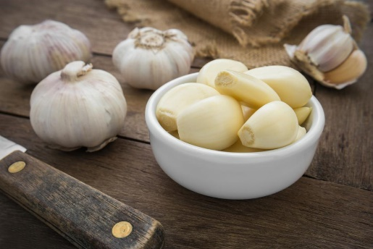

**2.** **Ginger:**

many studies have shown ginger to be useful in treating nausea, including [**motion sickness**](https://www.betterhealth.vic.gov.au/health/healthyliving/motion-sickness) and [**morning sickness**](https://www.betterhealth.vic.gov.au/health/healthyliving/pregnancy-morning-sickness).

Nausea and vomiting caused by drugs used to treat [HIV](https://www.webmd.com/hiv-aids/understanding-aids-hiv-basics)/AIDS (antiretroviral-induced nausea and vomiting). Taking ginger by [mouth](https://www.webmd.com/oral-health/ss/slideshow-mouth-problems) daily, 30 minutes before each dose of antiretroviral treatment for 14 days, reduces the risk of nausea and vomiting in patients receiving [HIV treatment](https://www.webmd.com/hiv-aids/understanding-aids-hiv-treatment).

[Menstrual cramps](https://www.webmd.com/women/ss/slideshow-get-rid-of-cramps) (dysmenorrhea). Taking ginger by [mouth](https://www.webmd.com/oral-health/rm-quiz-mouth-myths) during the first 3-4 days of a [menstrual cycle](https://teens.webmd.com/all-about-menstruation) somewhat reduces painful menstrual periods. It seems to work about as well as some pain [medications](https://www.webmd.com/drugs/index-drugs.aspx), like [ibuprofen](https://www.webmd.com/drugs/2/drug-5166/ibuprofen+oral/details), [mefenamic acid](https://www.webmd.com/drugs/2/drug-11586/mefenamic+acid+oral/details), or Novafen. Taking ginger along with medicines such as mefenamic acid also seems to be helpful.

Osteoarthritis. Taking ginger by mouth can slightly reduce pain in some people with osteoarthritis. But applying ginger gel or oil to the [knee](https://www.webmd.com/pain-management/knee-pain/picture-of-the-knee) doesn't seem to help.

[Morning sickness](https://www.webmd.com/baby/guide/Managing-morning-sickness). Taking ginger by mouth seems to reduce nausea and vomiting in some people during pregnancy. But it might work slower or not as well as some drugs used for nausea.

Muscle soreness caused by [exercise](https://www.webmd.com/fitness-exercise/ss/slideshow-7-most-effective-exercises). Taking ginger by mouth doesn't reduce or prevent [muscle pain](https://www.webmd.com/pain-management/guide/myofascial-pain-syndrome) from exercise.

[Motion sickness](https://www.webmd.com/cold-and-flu/ear-infection/motion-sickness). Taking ginger by mouth up to 4 hours before travel doesn't prevent motion sickness.

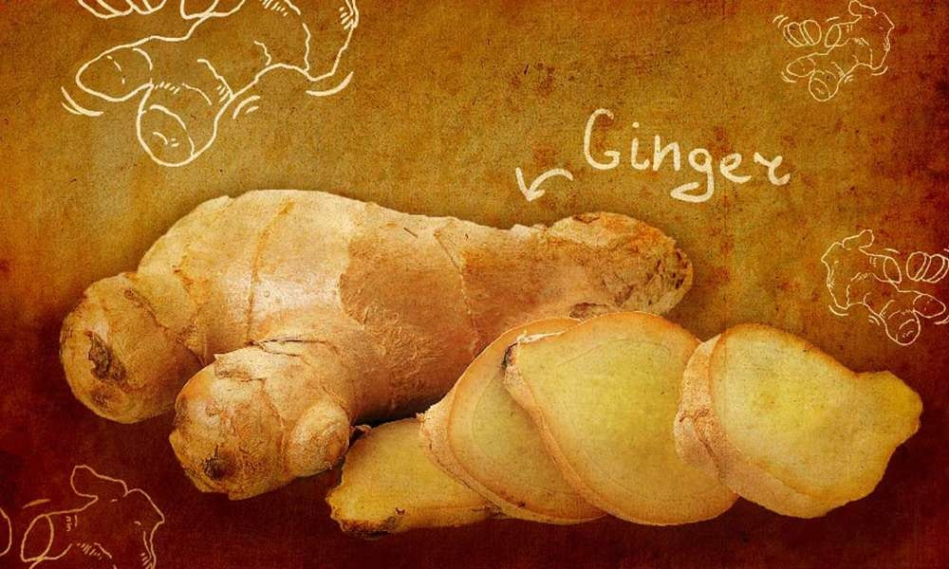

**3. Tulsi:**

There are four types of tulsi mentioned in ayurvedic texts ie Rama, Krishna, Vana & Kapoor Tulsi.

For over the centuries Tulsi (the queen of herbs) has been known for its remarkable healing properties.

* Tulsi is taken as herbal tea.
* The oil extracted from the Karpoora Tulsi is mostly used in the herbal toiletry. Its oil is also used against insects and bacteria.
* The Rama Tulsi is an effective remedy for Severe acute Respiratory Syndrome. Juice of its leaves gives relief in cold, fever, bronchitis and cough.
* Tulsi oil is also used as an ear drop.
* Tulsi helps in curing malaria.
* It is very effective against indigestion, headache, hysteria, insomnia, and cholera.
* The fresh leaves of Tulsi are taken by millions of people every day.
* Many people wear Tulsi beads, which is said to have certain physical and medicinal properties.
* Mint has been used in traditional medicine to treat a variety of ailments for many years. Unfortunately, there aren't many human studies documenting the impact mint has on the body apart from digestion support and irritable bowel syndrome relief. With time, research could confirm that mint is useful in treating a wider variety of illnesses.

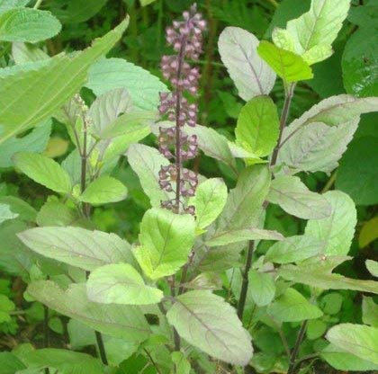

**4. Aloe Vera**

The aloe vera grows only under the sun with well-drained dry or moist soil. Although the plant tastes like a turd, it’s still edible. The sap from aloe vera is extremely useful to speed up the healing & reducing the risk of infections for :

* wounds
* cuts
* burns
* reducing inflammation

Apart from its external use on the skin, aloe vera is also taken internally in the treatment of :

* ulcerative colitis (drinking aloe vera juice)
* chronic constipation
* poor appetite
* digestive problems

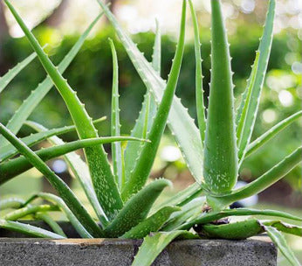

**5. Gotu Kola**

The [gotu kola](https://nurserylive.com/products/brahmi-gotu-kola-centella-asiatica-plant" \o "Gotu Kola) acts on various phases of connective tissue development and stimulates healing of :

* ulcers
* skin injuries
* decreasing capillary fragility
* stimulation of the lipids and protein necessary for healthy skin
* Leaves are thought to maintain youthfulness.
* Crushed leaves are poulticed to treat open sores.

The gotu kola can also be used to :

* treat leprosy
* revitalize the brain and nervous system
* increase attention span and concentration
* treat venous insufficiency

[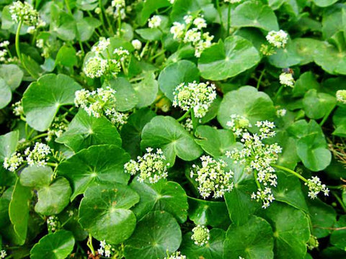](https://nurserylive.com/products/brahmi-gotu-kola-centella-asiatica-plant)

**6. Calendula**

It grows in almost any type of soil condition. It has no problem with nutritionally poor, very acidic or very alkaline soils, just as long as it’s moist. Well known as a remedy for skin problems, the deep-orange flowered pot marigold variety is applied externally to :

* bites
* stings
* sprains
* wounds
* sore eyes
* varicose veins
* Internally it is used to treat fevers and chronic infections.
* The tea of the petals tones up circulation and, taken regularly, eases varicose veins.
* Applying the crushed stems of the pot marigold to corns and warts will soon have them easily removable.

[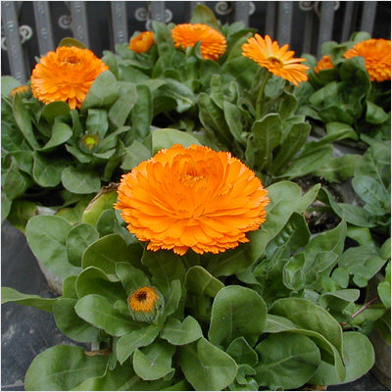](https://nurserylive.com/collections/all/products/omx-calendula-bon-bon-yellow-seeds)

**7. Basil**

You must have used basil lot many times in food but have you ever tried it to heal flatulence? It has the power to treat:

* Cuts
* Lack of appetite
* Stomach gas
* scrapes

[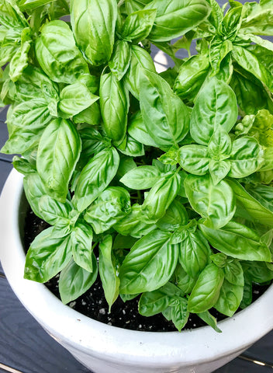](https://nurserylive.com/collections/all/products/basil-genovese-green-seeds)

**8. Thyme**

It is mostly known for its strong antiseptic nature. It is wonderful when it comes to the treatment of:

* Congestion
* Stomach gas
* Coughs

[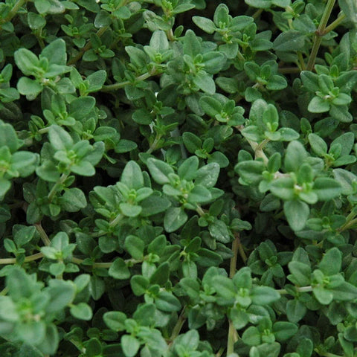](https://nurserylive.com/collections/all/products/omx-thyme-seeds)

### 9. Rosemary

[Rosemary](https://nurserylive.com/collections/all/products/omx-rosemary-seeds)is the great reviver. This perennial woody herb stimulates energy and optimism and sharpens memory and concentration by bringing more oxygen to your brain, according to UMMC. It’s a wonderfully stimulating alternative to caffeine when you need that second wind!

A row of these long-lived and drought-tolerant plants makes a beautiful, bee-friendly, evergreen hedge. You may only need one plant in your garden, as a little bit goes a long way.

[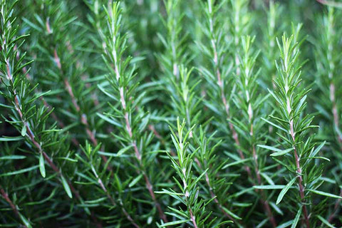](https://nurserylive.com/collections/all/products/rosemary-plant)

### 10. Lavender

Long recognized for its sweet perfume, [lavender also boasts medical benefits](https://nurserylive.com/collections/all/products/cuphea-hyssopifolia-lavender-plant) as a nervine and mild antidepressant. UMMC suggests adding it to your bath to alleviate stress, tension, and insomnia. It's also used in creams to treat sunburns and acne.

Woody lavender plants prefer hot, sunny, and dry environments. The fresh flowers are tasty in small doses when added to salads, honey, butter, lemonade, and even shortbread cookies. If you’re crafty, try sewing up an herbal heating pad or eye pillow with the fragrant dried flowers.

[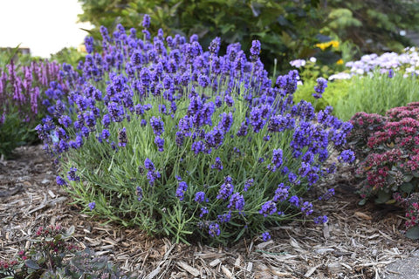](https://nurserylive.com/collections/all/products/omx-lavender-seeds)

### 11. German Chamomile

Delicate, apple-scented [chamomile](https://nurserylive.com/collections/all/products/omx-german-chamomile-seeds)demonstrates that mildness does not mean ineffectiveness. Primarily grown for its small, yellow-bellied flowers, NCCAM reports that chamomile is one of the best children’s herbs for treating colic, nervous stress, infections, and stomach disorders.

[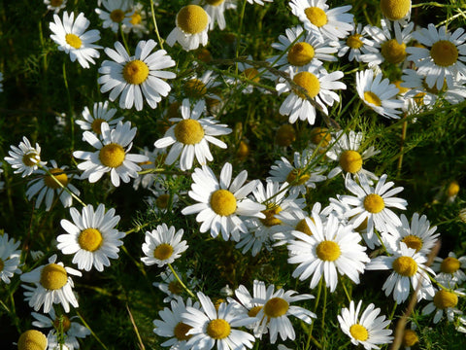](https://nurserylive.com/collections/all/products/omx-german-chamomile-seeds)

**12.**[**Methi**](https://nurserylive.com/collections/all/products/omx-methi-kasturi-fenugreek-seeds)**(Fenugreek)**

Fenugreek seeds are nourishing and taken to :

* encourage weight gain (take note, anorexics)
* inhibit cancer of the liver
* lower blood cholesterol levels
* treat inflammation and ulcers of the stomach and intestines
* drain off sweat ducts
* for body building
* for late onset diabetes
* poor digestion
* insufficient lactation
* painful menstruation
* labor pains
* freshen bad breath
* restore a dull sense of taste

[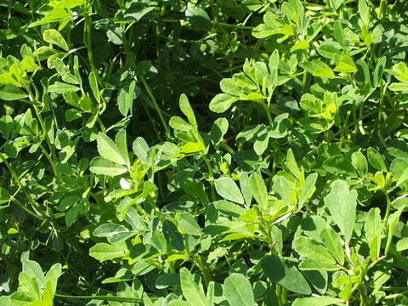](https://nurserylive.com/collections/all/products/omx-methi-kasturi-fenugreek-seeds)

**13. Sage**

Salvia, the Latin name for [sage](https://nurserylive.com/collections/all/products/omx-sage-seeds), means ‘to heal’. Internally, the sage is used for :

* indigestion
* flatulence
* liver complaints
* excessive lactation
* excessive perspiration
* excessive salivation
* anxiety
* depression
* female sterility
* menopausal problems

On the other hand, it is used externally for :

* insect bites
* skin infections
* throat infections
* mouth infections
* gum infections
* skin infections
* vaginal discharge

[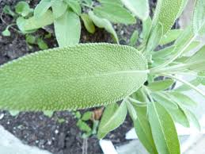](https://nurserylive.com/collections/all/products/clary-sage-plant)

**14. Peppermint**

[Peppermint](https://nurserylive.com/collections/all/products/omx-peppermint-seeds)is sometimes regarded as ‘the world’s oldest medicine’, with archaeological evidence placing its use at least as far back as ten thousand years ago. Pepeprmint are naturally high in manganese, vitamin A and vitamin C. Crushed leaves rubbed on the skin help soothe and relax the muscles. Infused peppermint leaves are used to :

* reduce irritable bower syndrome
* against upset stomachs
* inhibit bacterial growth
* treat fevers
* flatulence
* spastic colon

[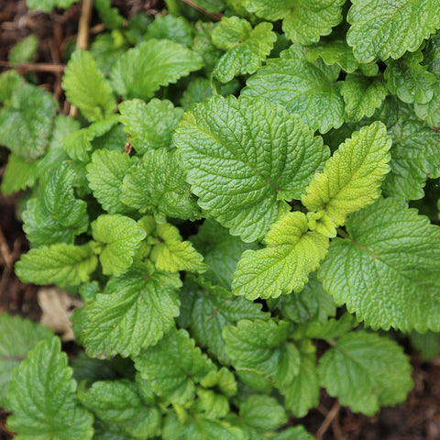](https://nurserylive.com/collections/all/products/omx-peppermint-seeds)

**15. Lemon Balm**

The reason the plant is called [lemon balm](https://nurserylive.com/collections/all/products/lemon-balm-plant) is because of the lemon minty scent of the leaves. The flowers, which appear during the summer, are full of nectar. The crushed leaves, when rubbed on the skin, are used as :

* mosquito repellent
* herpes
* sores
* gout
* insect bites

Infusion of the leaves with water are known to treat :

* colds
* fevers
* indigestion due to nervous tension
* digestive upsets in children
* hyperthyroidism
* depression
* mild insomnia
* headaches

[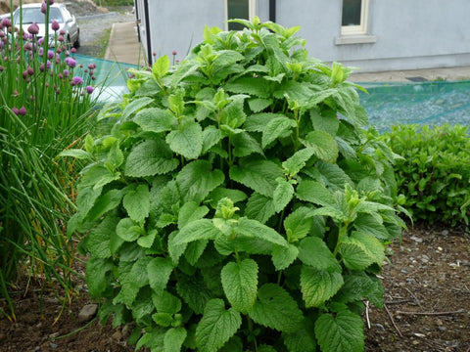](https://nurserylive.com/collections/all/products/lemon-balm-plant)

**16. Globe Artichoke**

A bitter tasting plant that requires a lot of sun, the cardoon has become important as a medicinal herb in recent years following the discovery of cynarin. The cardoon leaves, best harvested before flowering, helps to :

* improve liver and gall bladder function
* stimulate the secretion of digestive juices
* lower blood cholesterol levels
* treat chronic liver and gall bladder diseases
* jaundice
* hepatitis
* asteriosclerosis
* early stages of late-onset diabetes

[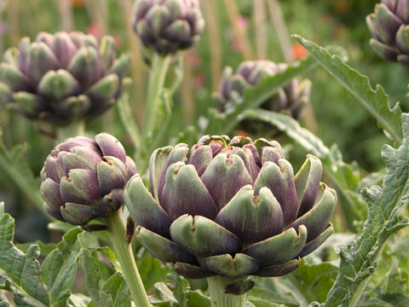](https://nurserylive.com/collections/all/products/omx-artichoke-green-globe-seeds)

**17. Ashwangandha**

[Ashwagandha](https://nurserylive.com/collections/all/products/ashwagandha-plant)is best known for stress Reduction, Neural Protection, and a Lot More from an Ancient Herb

The benefits of ashwagandha are many; in addition to promoting fertility, aiding in wound care, and boosting the immune system, some other benefits are:

* Diuretic, Sleep aid
* Galactogogue
* Anti-epileptic
* Anti-tumor, Pain relief
* Eye health
* Heart tonic
* Lowers cholesterol & Regulates blood sugar
* Reduces depression and anxiety, Combats stress
* Fights cognitive decline due to brain cell degeneration

[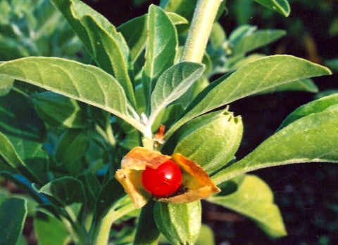](https://nurserylive.com/collections/all/products/ashwagandha-plant)

**18. Lemon Grass**

[Lemongrass](https://nurserylive.com/products/omx-lemon-grass-seeds)has been reported to have innumerable therapeutic and other health benefits.

* alleviate certain respiratory conditions including laryngitis and sore throats
* anti-pyretic property which reduces high fevers.
* useful for all types of pain including abdominal pain, headaches, joint pains, muscle pains, digestive tract spasms, muscle cramps, stomachache and others
* lemongrass inhibits bacteria and yeast growth.
* beneficial for nervous and stress-related conditions.

[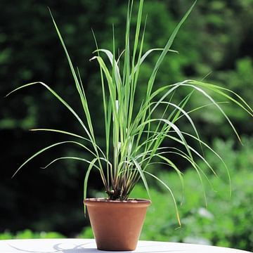](https://nurserylive.com/collections/all/products/lemonn-grass-plant)

**19. Bryophyllum, Panfuti**

Bryophyllum calycinum, Bryophyllum pinnatum, also known as the Air Plant, Life Plant, Miracle Leaf, Goethe Plant and the Katakataka (Filipino)) is a succulent plant native to Madagascar.

* The leaf or its juice is taken for diabetes.
* Leaf paste application stops bleeding and heals wounds.
* The burnt leaf (mashi) made in to paste with coconut oil cures burn.
* To prevent septic to cuts from sharp instruments, 15 leaves with four pepper corns roasted, powdered and mixed in cow ghee is applied.
* Leaf paste boiled in oil cures sciatica and rhematic pains.
* One leaf eaten raw with one pepper corn first thing every morning for 3 to 7 days cures urinary stones.
* The leaves can be used raw for making chutneys or tamblis.

[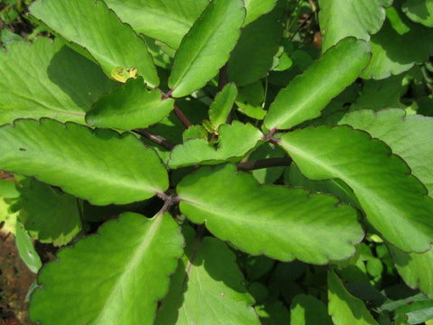](https://nurserylive.com/collections/all/products/bryophyllum-panfuti-plant)

**20. Rui**

RUVA, Purple ( Ekke, Rui,arka ) Calotropis gigantea

* The leaves and flowers of both the varieties are used for pooja of Shiva, Hanuman and Devi.
* Leaves of both varieties are used for fomentation to paining joints.
* Fomentation of leaves after application of castor oil relieves stomach pain of infants.

[](https://nurserylive.com/collections/all/products/mandar-rui-plant)

### 21. Costus

Costus igneus, commonly known as insulin plant in India, belongs to the family Costaceae. Consumption of the leaves are believed to lower blood glucose levels, and diabetics who consumed the leaves of this plant did report a fall in their blood glucose levels.

The fresh leaves of this plant is chewed two times daily for 1 week after 1 week, 1 leaf should be chewed twice a day this dosage should be continued for 1 month. It is said that this treatment is effective in bringing blood sugar levels under control in diabetes patients.

[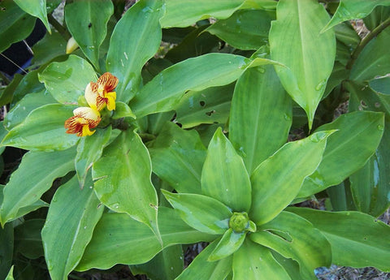](https://nurserylive.com/collections/all/products/costus-malortieanus-plant)

### 22. Khus

It has anti-inflammatory and antiseptic effects that provide relief from inflammations in circulatory system and nervous system. Khus khus is used to create a tonic bath, which is the reason why it is often included in high quality soaps.

It is a boon for individuals suffering from rheumatism, arthritis, gout, muscular aches, dryness and cracking of skin etc.

The oil obtained from khus khus has sedative effect and aids in the treatment of emotional outbursts, such as anger, anxiety, epileptic and hysteric attacks, restlessness, nervousness, etc.

[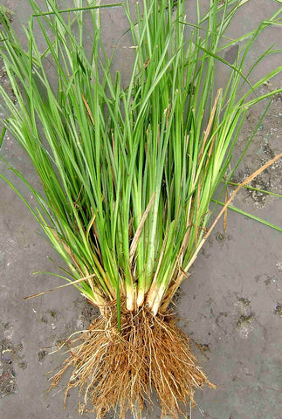](https://nurserylive.com/collections/all/products/khus-vetiver-plant)

**23. Vitex Negundo**

Commonly known as the five-leaved chaste tree, is a large aromatic shrub with quadrangular, densely whitish, tomentose branchlets.

Key therapeutic benefits:

* Because of its anti-inflammatory, antibacterial and antifungal properties, the plant is useful in treating sores and skin infections.
* Five-Leaved Chaste Tree relieves muscle aches and joint pains.
* The herb is effective in treating vaginal discharge.

[[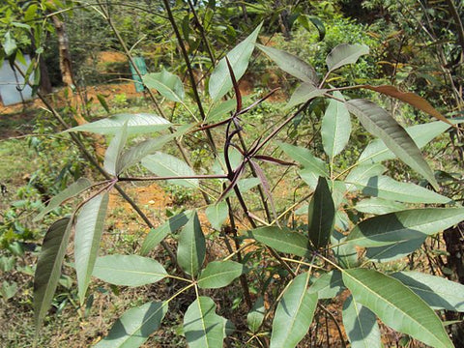](https://nurserylive.com/collections/all/products/vitex-negundo-nirgundi-seeds-seeds)Buy](https://nurserylive.com/collections/all/products/vitex-negundo-nirgundi-seeds-seeds)

**24. Sagargota, Bonduc nut**

Sagargota, Bonduc nut, Fever nut, physic nut is used as anti diabetic & anti-malarial drug

Medicinal Uses :

* Root : In dysentery and diabetes
* Leaves : Emmenagogue
* Seed : Abortifacient used as anti-malarial drug and also tonic

[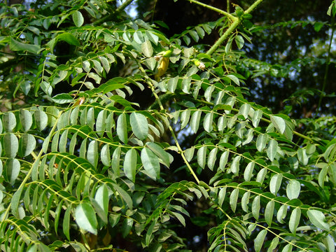](https://nurserylive.com/collections/all/products/sagargota-plant)

### 25. Stevia

With its steviol glycoside extracts having up to 300 times the sweetness of sugar,stevia has garnered attention with the rise in demand for low-carbohydrate, low-sugar food alternatives.

Because stevia has a negligible effect on blood glucose, it is attractive as a natural sweetener to people on carbohydrate-controlled diets.

[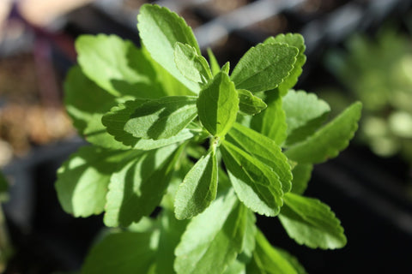](https://nurserylive.com/collections/all/products/stevia-plant-stevia-rebaudiana-plant)

**26. Marsh Mallow**

The plant of which marshmallows were once made of. The root is taken internally to treat :

* inflammations and irritations of the urinary and respiratory mucus membranes
* counter excess stomach acid
* peptic ulceration
* gastritis

Externally, the root is applied to :

* bruises, sprains
* aching muscles
* insect bites
* skin inflammations, splinters
* The leaves are very edible, unlike the aloe vera. They can be added to salads, boiled, or fried. It is known to help out in the area of cystitis and frequent urination.

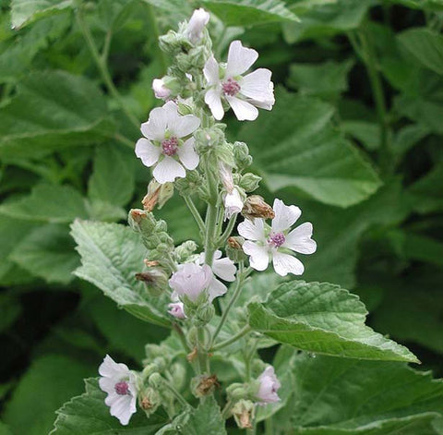

**27. Great Burdock**

It requires moist soil and can grow shadeless. The great burdock is the pretty famous in the area of detoxification in both Chinese and Western herbal medicine. The root is is used to treat ‘toxic overload’ that result in throat infections and skin diseases like :

* boils, rashes, burns, bruises
* herpes, eczema, acne
* impetigo, ringworm, bites
* The leaves and seeds can be crushed to poultice it to bruises, burns, ulcers and sores

[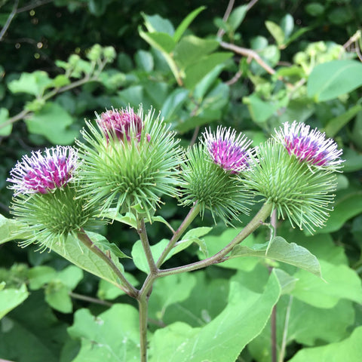](https://nurserylive.com/collections/plants)

### 28. Camomile

With a sweet, crisp, fruity and herbaceous fragrance, has long been used medicinally as a remedy for problems regarding the digestive system.

It has a soothing and calming effect in the area of aromatherapy, used to end stress and aid in sleep.

The entire herb is used to treat common aches like toothache, earache, shoulder pain and neuralgia.

[](https://nurserylive.com/collections/plants)

**29. Chinese Yum**

A type of yam that can be eaten raw, the chinese yam can be easily grown, succeeding in fertile, well drained soil in a sunny position. It is sweet and soothing to the stomach, spleen and has a tonic effect on the lungs and kidneys. It is used internally to treat :

* tiredness, weight loss, loss of appetite, poor digestion, chronic diarrhea
* asthma, dry coughs, uncontrollable urination, diabetes, emotional instability

Externally, it is applied to  ulcers, boils, abscesses

* The leaf, on the other hand, is used to treat snakebites and scorpion stings.

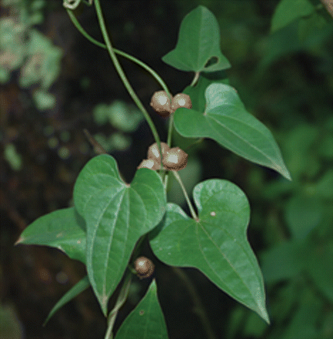

### 30. Echinacea

One of the world’s most important medicinal herbs, the echinacea has the capacity to raise the body’s resistance to bacterial and viral infections by stimulating the immune system. It also has antibiotic properties that helps relieve allergies. Basically, the roots are beneficial in the treatment of sores, wounds and burns.

It was once used by the Native Americans as an application for insect bites, stings and snakebites. The echinacea grows on any well drained soil, as long as it gets sunlight.

[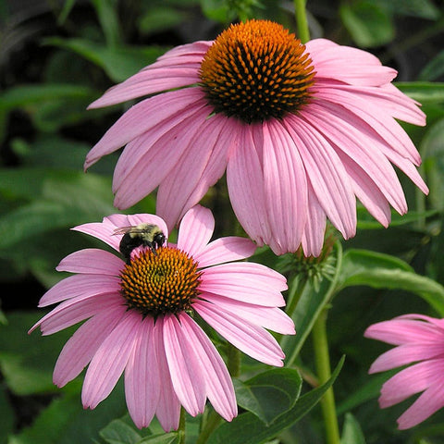](https://nurserylive.com/collections/plants)

**31. Siberian Ginseng**

The siberian ginseng has a wide range of health benefits, mostly as a powerful tonic herb that maintains good health. Its medicinal properties are used for :

* menopausal problems, geriatric debility, physical and mental stress
* treat bone marrow suppression caused by chemotherapy or radiation
* hypercholesterolemia and neurasthenia with headache
* insomnia, poor appetite, increasing endurance, memory improvement
* anti-inflammatory purposes
* immunogenic purposes
* chemoprotective purposes
* radiological protection

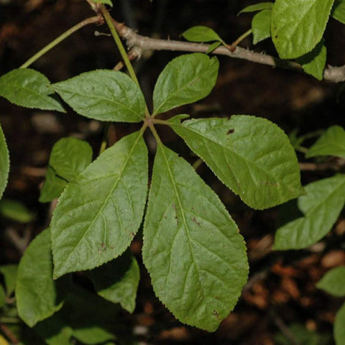

**32. The Great Yellow Gentian**

The great yellow gentian root is a bitter herb used to treat digestive disorders and states of exhaustion from chronic diseases. It stimulates the liver, gal bladder, and digestive system, strengthening the overall human body. Internally, it is taken to treat :

* liver complaints
* indigestion
* gastric infections
* anorexia

[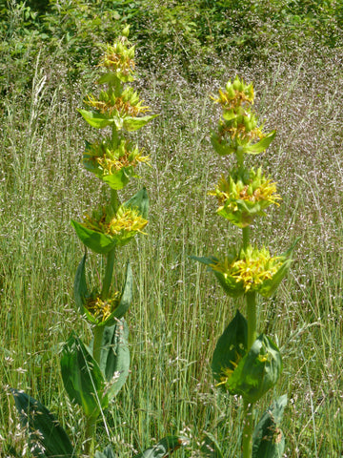](https://nurserylive.com/collections/plants)

### 33. Sea Buckthorn

The sea-buckthorn has been used throughout the centuries in China to relieve cough, aid digestion, invigorate blood circulation and alleviate pain. The branches and leaves are used in Mongolia to treat gastrointestinal distress in humans and animals.

The bark and leaves are used for treating diarrhea, gastrointestinal, dermatological disorders and topical compressions for rheumatoid arthritis. Even the flowers are used as skin softeners.

The berries, on the other hand, are used together with other medications for pulmonary, gastrointestinal, cardiac, blood and metabolic disorders. Fresh sea buckthorn berry juice is known to be taken in the event of colds,  fever,  exhaustion,  stomach ulcers,  cancer, metabolic disorders, liver diseases, inflammation, peptic ulcer, gastritis,  eczema, canker sores, general ulcerative disorders, keratitis, trachoma

[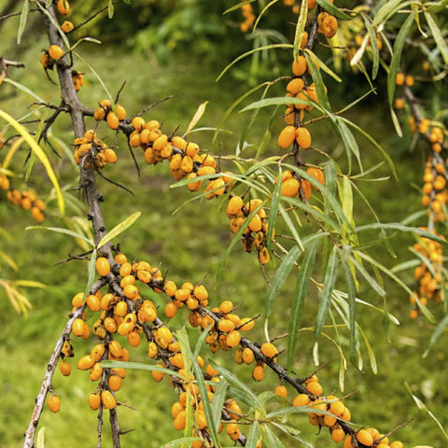](https://nurserylive.com/collections/plants)

### 34. Tea Tree

Even the aborigines have been using the tea tree leaves for medicinal purposes, like chewing on young leaves to relieve headaches. The paperbark itself is extremely useful to them as it serves to line coolamons when used as cradles, as a bandage, like a sleeping mat, as material for building humpies, as an aluminum foil, as a disposable raincoat and for tamping holes in canoes.

The leaves and twigs, eventually made into tea tree oil, is anti-fungal, antibacterial, antiseptic and deserves a place in every household medicine box. Tea tree oil can be used to treat: cystitis, glandular fever, chronic fatigue syndrome, thrush, vaginal infections, acne, athlete’s foot, verrucae, warts, insect bites, cold sores, nits, minor burns

[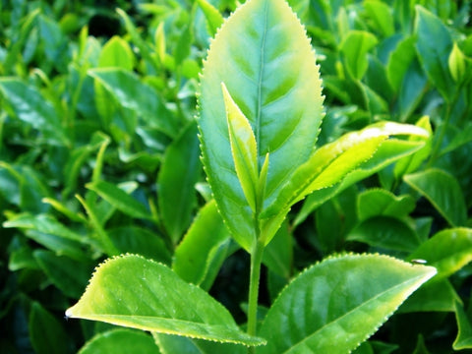](https://nurserylive.com/collections/plants)