Introduction
Between 2015 and 2019, Boston’s 311 system processed approximately 1.2 million non-emergency service requests covering a wide range of urban services, including infrastructure maintenance, noise complaints, and waste management. For city administrators operating under limited resources, understanding where and when service demand occurs - and what drives faster resolution is critical for efficient operations and citizen satisfaction.
Most existing analyses rely on total request volume to guide resource allocation. However, this approach ignores population size, obscuring meaningful differences in service demand across neighborhoods. Two neighborhoods may generate the same number of requests but face vastly different service pressures when population is considered. To address this limitation, this study integrates 311 request data with U.S. Census population estimates to compute service request rates per 1,000 residents, enabling a more equitable and informative comparison across Boston neighborhoods.
In addition to spatial patterns, we examine temporal trends to identify whether service demand follows predictable seasonal cycles that could support proactive staffing and resource planning. Finally, we develop predictive models to improve operational decision-making: a logistic regression model to predict whether a request will be resolved within 24 hours, and a LASSO regression model to estimate resolution time while identifying key drivers of service delays.
Analysis
We used Boston 311 service request data (2015–2019) with 1.2 million cases and neighborhood-level population data from the U.S. Census. After removing cases with missing or invalid dates and extreme outliers, 943,079 cases remained. Population data were aligned to 311 neighborhoods, enabling calculation of per-capita request rates. Key temporal features and historical averages were created for predictive modeling, including a binary indicator for requests resolved within 24 hours.
Year-by-Year System Performance Overview
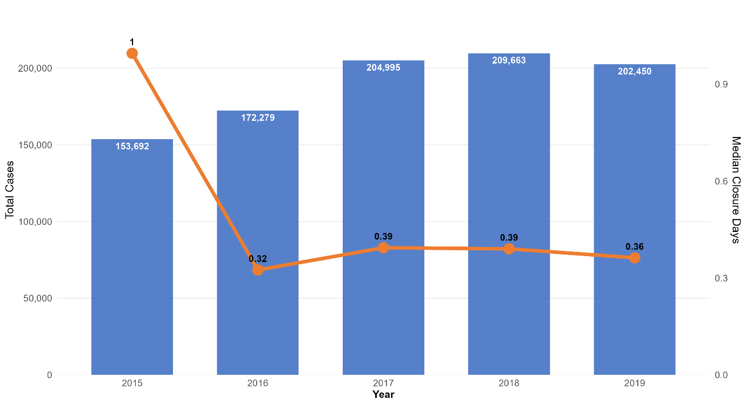
The graph illustrates the citywide performance trajectory over the five-year period. Total service request volume increased steadily from 153,692 cases in 2015 to a peak of 209,663 cases in 2018, representing a 36% growth. In 2019, volume declined slightly to 202,450 cases, suggesting either stabilization in usage or improvements in issue prevention. This upward trend through 2018 likely reflects increased public engagement with the 311 system, improved accessibility, or heightened awareness of city services.
More notable than the growth in volume is the substantial improvement in resolution speed. Median closure time declined sharply from 1.0 day in 2015 to 0.32 days in 2016, a 68% reduction. After this initial improvement, median closure times remained relatively stable, fluctuating between 0.36 and 0.39 days from 2017 through 2019. The magnitude and timing of the 2015–2016 reduction suggest the implementation of significant operational changes, such as process standardization, staffing adjustments, or technology enhancements.
Importantly, these trends indicate that increased demand did not come at the expense of service quality. Despite handling substantially more cases than in 2015, the system consistently resolved requests faster than its original baseline. This pattern suggests that Boston’s 311 system successfully expanded capacity or improved efficiency during the study period, enabling it to absorb higher workloads while maintaining improved response times.

Neighborhood Demand:
Figure 1: Total Service Requests by Neighborhood
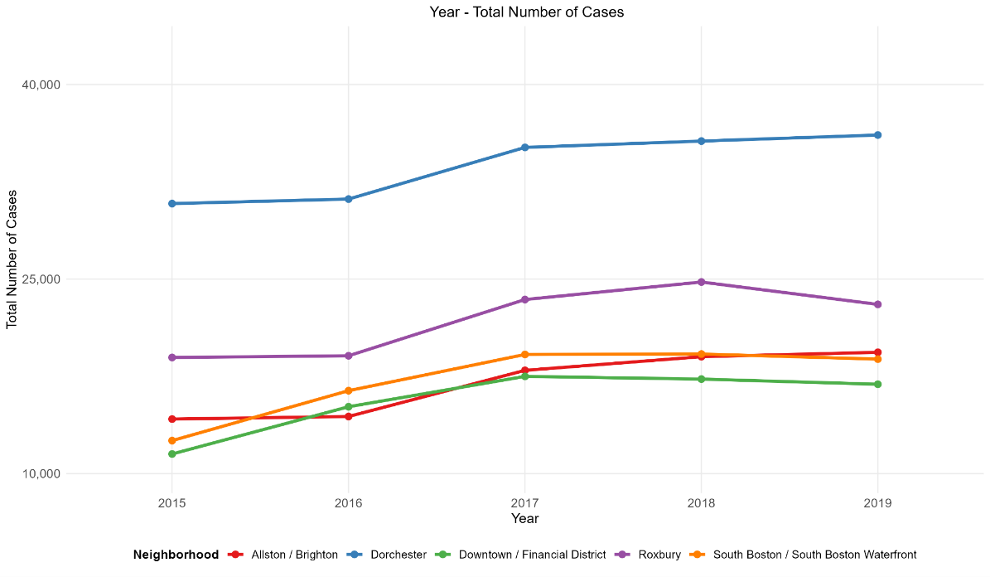
This line chart shows annual service request counts for the five highest-volume neighborhoods. Dorchester leads with 30,000–35,000 requests per year, followed by Roxbury, South Boston/South Boston Waterfront, Allston/Brighton, and Downtown / Financial District, which handles only 3,000–4,000 requests annually. The chart highlights absolute volume differences between neighborhoods.
Figure 2: Service Request Rate per 1,000 Residents by Neighborhood (2015–2019)

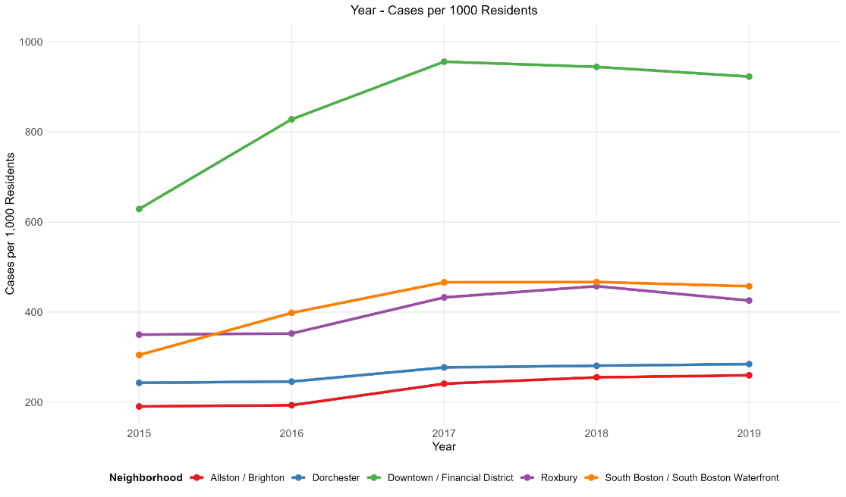
This line chart shows population-adjusted service request rates. Although Dorchester has high total case counts, its large population and area spread these requests, resulting in moderate per-capita intensity (190–285 per 1,000 residents). In contrast, Downtown / Financial District, with far fewer residents, exhibits much higher per-capita rates (629–956 per 1,000 residents), indicating concentrated service demand that requires focused resources despite its smaller size.

Seasonal Demand Patterns
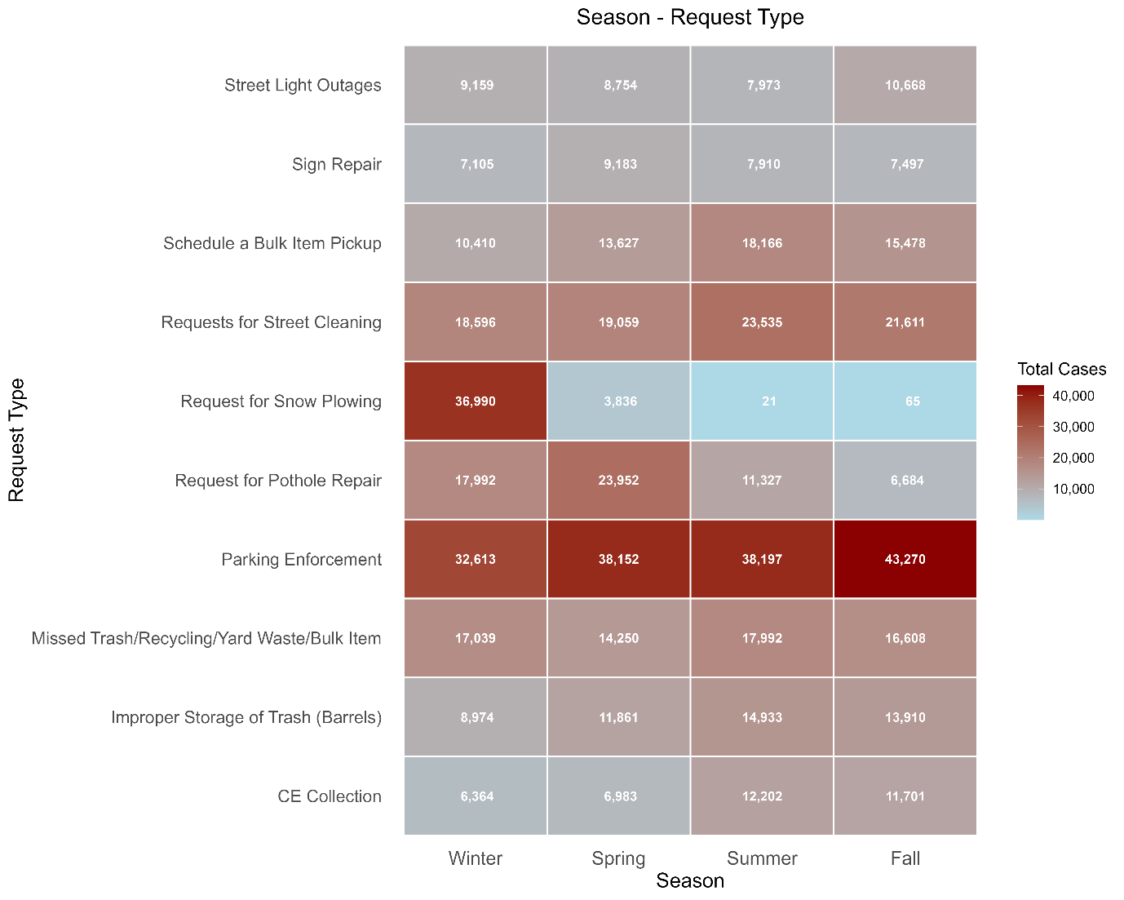

Figure 3: Service Request type by Season
The ten most common request types show distinct seasonal patterns that remain stable across all five years, allowing the city to anticipate demand spikes and allocate resources in advance. The heatmap highlights clear clustering: snow plowing occurs almost entirely in winter (36,990 cases), pothole repair peaks in spring (23,952 cases), parking enforcement remains high year-round but peaks in fall, and street cleaning rises moderately in summer and fall.
These patterns reflect expected seasonal effects—winter weather, spring thaw, and summer-fall maintenance cycles. The predictability supports proactive staffing, seasonal hiring, and contractor planning, avoiding the inefficiencies of uniform staffing throughout the year. The five-year consistency confirms these trends are structural and reliable for operational planning.
Department Performance Relationships
Figure 4: Department Performance Correlation Matrix
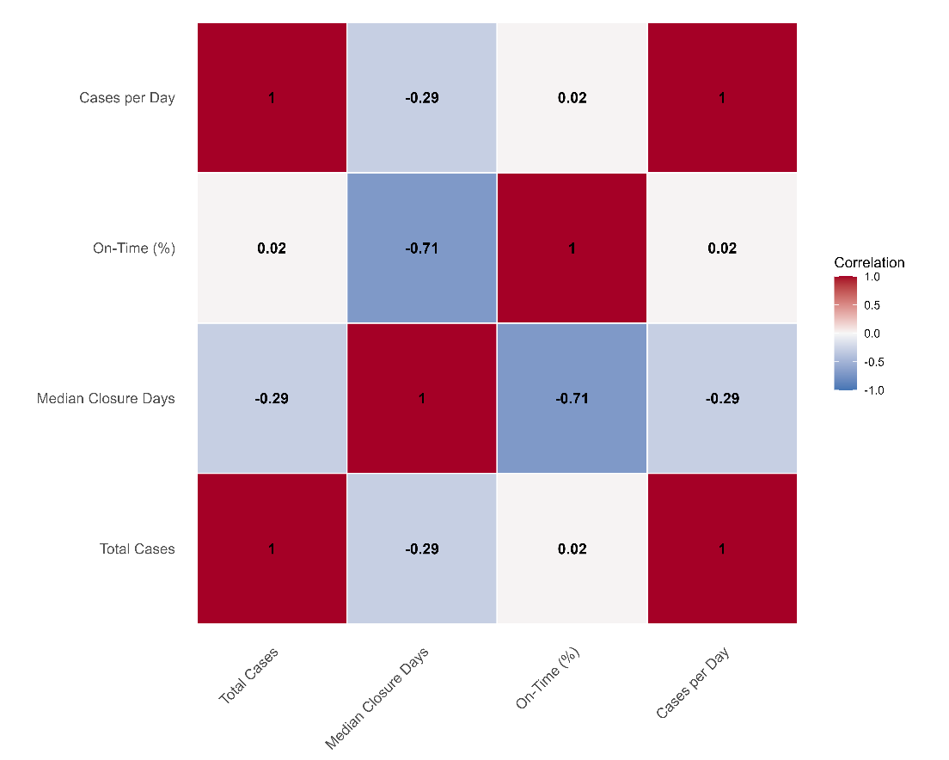
Correlation analysis across ten departments handling at least 500 cases reveals how workload relates to service quality. Figure 4: Department Performance Correlation Matrix shows relationships among Total Cases, Median Closure Days, On-Time %, and Cases per Day.
Three key insights emerge:
- Workload vs. speed: Total cases negatively correlate with median closure days (-0.29), meaning high-volume departments actually resolve cases faster. For example, BTDT processed 221,060 cases with a 0.14-day median, while BWSC handled 4,092 cases with 3.22 days.
- Speed vs. quality: Median closure days strongly negatively correlate with on-time performance (-0.71). Departments that take longer to close cases systematically miss SLA targets—there is no speed-quality tradeoff.
- Workload vs. quality: Total cases and cases per day show near-zero correlation with on-time percentage (0.02), indicating that busy departments do not sacrifice quality.
These findings suggest that operational efficiency, rather than workload, drives department performance. Underperformance stems from process inefficiencies, not volume, while high-performing departments show that large caseloads can be handled quickly without compromising quality.
Logistic Regression: Predicting 24-Hour Resolution
Logistic regression models were developed to predict whether a service request would close within 24 hours—a key indicator of rapid service. In the cleaned dataset of 943,079 cases, 615,785 (65.3%) closed within a day, while 327,294 (34.7%) took longer. This moderate class imbalance is acceptable for logistic regression without additional sampling or weighting.
Table 1: Logistic Regression table
 | Dependent variable:
 | 24-Hour Resolution (< 24 hours = 1)
 | Temporal Only  (1) | Add Department  (2) | Add Request Type  (3) | Full Model  (4)
Constant | 0.123 (0.008) | 0.348 (0.017) | 3.182 (0.036) | 2.426 (0.085)
Odds Ratio (Constant) | 1.13 | 1.417 | 24.106 | 11.314
Test Accuracy | 0.665 | 0.685 | 0.762 | 0.79
Weekend | Yes | Yes | Yes | Yes
Season | Yes | Yes | Yes | Yes
Year | Yes | Yes | Yes | Yes
Department | No | Yes | Yes | Yes
Request Type | No | No | Yes | Yes
Neighbourhood | No | No | No | Yes
Source | No | No | No | Yes
Observations | 647,835 | 647,835 | 647,835 | 647,835
Log Likelihood | -409,464.200 | -392,059.100 | -311,535.100 | -300,611.100
Akaike Inf. Crit. | 818,946.500 | 784,146.200 | 623,118.300 | 601,290.300
Note: | 'Yes' indicates the variable category is included.
Model Comparison
Four logistic regression models were built with progressively larger predictor sets to assess the contribution of different variable categories. Model 1 included only temporal predictors—year, season, and weekend indicator—and achieved a baseline test accuracy of 66.5%, indicating that timing alone provides limited insight into resolution speed. Model 2 added department identifiers, separating the five highest-volume departments and grouping the rest as “Other,” improving accuracy to 68.5%. This shows that departmental differences matter, but their contribution is modest.
Incorporating request type classifications in Model 3 produced the largest gain, raising accuracy to 76.2%. This confirms that the nature of the request is the strongest determinant of closure speed, as some requests are simple to resolve while others require extensive investigation or legal processes. The full Model 4 added submission source and neighborhood identifiers, achieving 79.0% test accuracy on 277,644 held-out cases. The Akaike Information Criterion decreased steadily from 818,947 (Model 1) to 601,290 (Model 4), demonstrating that each added variable genuinely improved predictive power rather than overfitting.
Overall, the model comparison highlights a clear hierarchy of predictor importance. Request type provides the largest marginal improvement in both accuracy and AIC, followed by department efficiency, while temporal factors contribute minimally beyond basic weekday and seasonal patterns. Neighborhood and submission source offer modest refinement. These results suggest that operational improvements will be most effective when focused on efficiently handling inherently slow request types, rather than attempting to influence when or how citizens submit requests.
Table 2: Model 4 Classification Performance Metrics
Accuracy | Precision | Recall | F1_Score
78.96% | 80.52% | 89.40% | 0.8473

Description: The table summarizes the detailed performance characteristics on test data. These metrics indicate strong predictive performance, with the model accurately identifying fast-resolution cases while maintaining a good balance between precision and recall. Precision of 80.52% indicates that when the model predicts fast resolution, this prediction proves correct four out of five times. Recall of 89.40% means the model successfully identifies nearly nine out of ten cases that actually do close within 24 hours. The F1-score of 0.847 balances these metrics, confirming strong overall classification performance.
Table 3: Model 4 Confusion matrix
 | Actual: ≥24hrs | Actual: <24hrs
Predicted: <24hrs | 39199 | 162052
Predicted: ≥24hrs | 57176 | 19217

Description: The confusion matrix shows 57,176 true negatives (correctly identified slow cases), 162,052 true positives (correctly identified fast cases), 39,199 false positives (predicted fast but actually slow), and 19,217 false negatives (predicted slow but actually fast). From an operational perspective, the model shows a slight conservative bias, producing more false positives (39,199) than false negatives (19,217). In other words, it more often predicts slow resolution for cases that actually close quickly. For citizen communication, this bias is advantageous: setting conservative expectations reduces the risk of overpromising 24-hour resolution and allows the city to pleasantly exceed expectations, maintaining trust and satisfaction.
Figure 5: ROC Curve for 24-Hour Resolution Prediction
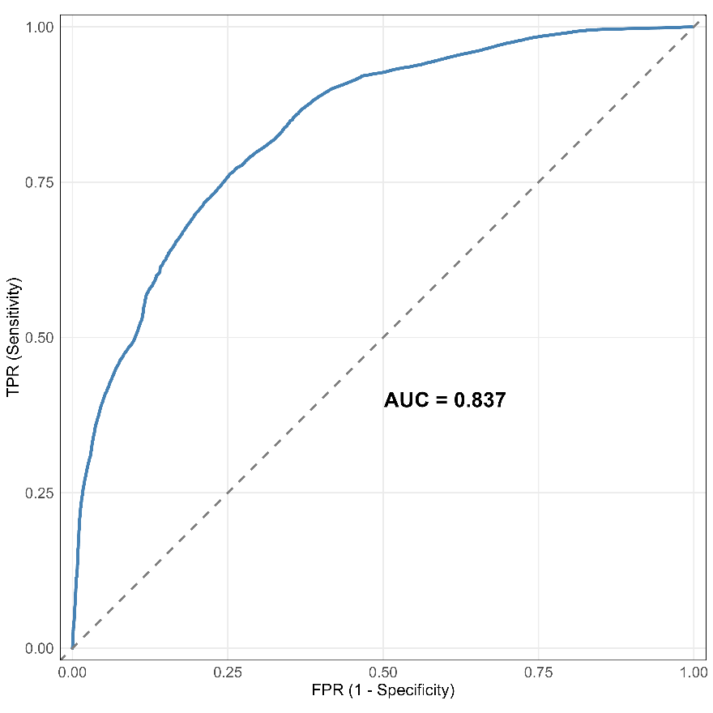
The graph visualizes the model's discrimination capability across all possible classification thresholds. An AUC of 0.837 means that if we randomly select one case that actually closed quickly and one that closed slowly, the model correctly assigns higher probability to the fast case 83.7% of the time. This substantially exceeds random guessing performance (AUC = 0.50), demonstrating the model captures genuine predictive relationships rather than noise.
The progressive model comparison highlights the relative importance of predictor categories. Request type provides the largest improvement in both AIC and accuracy, showing that the nature of the request is the main determinant of closure speed. Department efficiency matters but explains less variance, while temporal factors contribute minimally beyond basic weekday and seasonal patterns. Neighborhood and submission source offer modest refinement. This hierarchy suggests that operational improvements will be most effective when focused on handling inherently slow request types rather than attempting to change when or how requests are submitted.
LASSO Regression: Predicting Closure Time and Identifying Key Drivers
The model included eight predictors: five temporal features (hour, day, week, month, and year) and three historical performance features (average closure time by neighborhood, department, and request type). The 943,079 cases were split 70/30 into training (660,155) and testing (282,924) sets.
Figure 6: LASSO Cross-Validation Curve
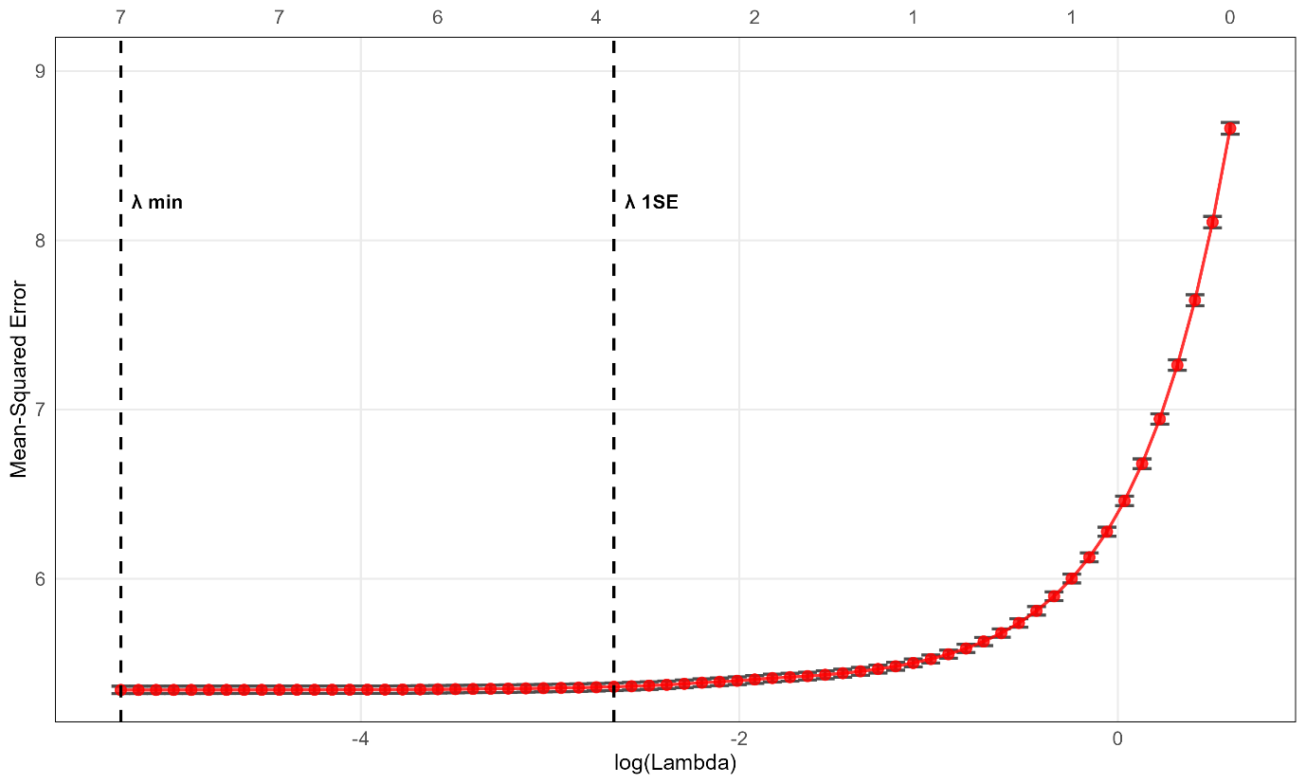
The curve shows how prediction error changes as we increase the penalty (lambda) on model complexity. At the far right (high lambda), the penalty is so strong that all features are eliminated and error is highest (~8.5). Moving left (decreasing lambda), features are added back one by one and error drops dramatically. The optimal lambda-min at 0.00516 selects 7 out of 8 features with MSE of 5.34. Lambda-1SE at 0.07 selects just 4 features with slightly higher error, representing a more conservative, simpler model.
The tiny error bars reflect cross-validation variance below 1%, which is exceptionally low. This stability comes from our massive training set of 660,000 cases—the model produces consistent predictions regardless of which data partition is used. This means the lambda selection is highly reliable and the model will generalize well to new service requests.
Table 4: LASSO vs OLS Model Comparison
Model | Predictors | R^2 | RMSE | MAE
OLS Regression | 8 | 0.3861 | 2.3124 | 1.4132
LASSO Regression | 7 | 0.3861 | 2.3126 | 1.4131

The final LASSO model, fitted using the lambda that minimizes cross-validation error, was compared to ordinary least squares (OLS) regression on the same eight predictors. OLS achieved R² = 0.386, RMSE = 2.31 days, and MAE = 1.41 days on the test set. LASSO eliminated one predictor entirely (Month) while delivering nearly identical performance, achieving the same R², RMSE, and MAE. This demonstrates that LASSO produces a more parsimonious model with 12.5% fewer parameters, simplifying implementation, explanation, and reducing overfitting risk.
An R² of 0.386 indicates the model explains 38.6% of the variance in closure time—a meaningful result for a complex urban system with nearly one million requests, where unmeasured factors such as case complexity, personnel availability, weather, and multi-agency coordination introduce unavoidable variability. The RMSE of 2.31 days and MAE of 1.41 days show that predictions are typically within ±2.3 days of actual closure, which is reasonable given the dataset’s median closure of 0.5 days and mean of 1.8 days. This level of precision provides practical guidance for workforce scheduling, citizen communication, and resource allocation decisions, offering actionable insights even with inherent uncertainty.
Figure 7: Feature Selection: OLS vs LASSO Coefficients
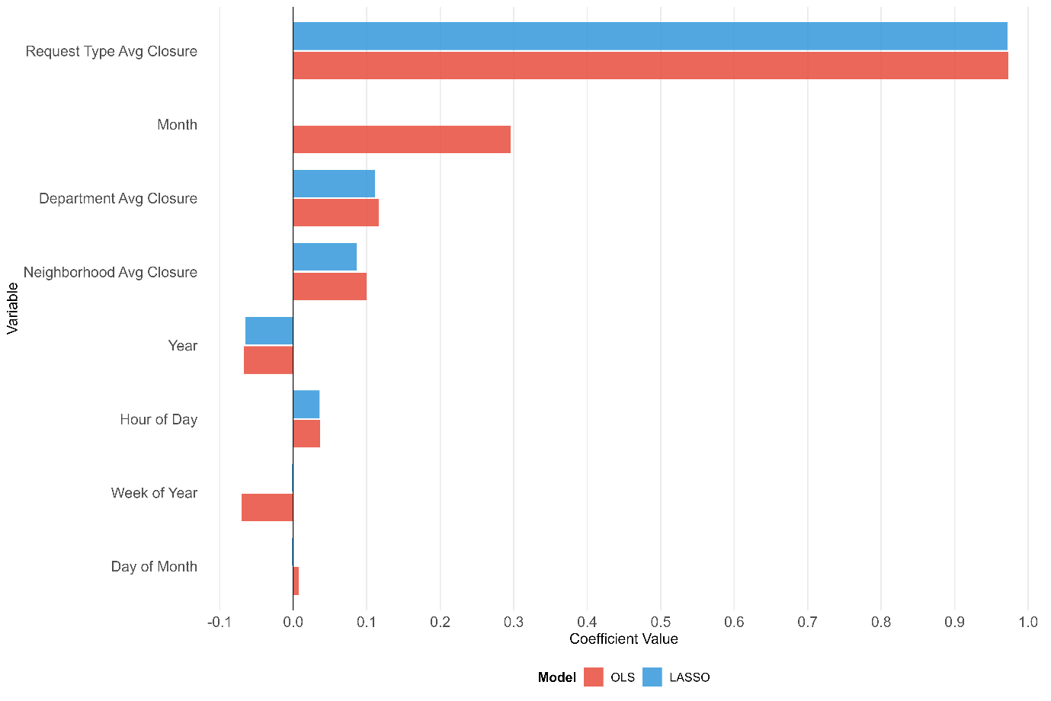

A grouped horizontal bar chart compares OLS and LASSO coefficients for the eight predictor variables. Request type average closure dominates both models, with coefficients near 0.97, making it by far the strongest predictor: a request matching a historically slower type adds nearly one day to predicted closure time. Month, which had a substantial OLS coefficient (~0.30), is completely eliminated by LASSO, demonstrating its lack of predictive value once other features are included. Week of year is nearly eliminated as well, while department and neighborhood average closure retain moderate coefficients (~0.11 and ~0.09), indicating some influence. The remaining temporal features—year, hour, and day of month—have minimal impact in both models.
This chart illustrates LASSO’s feature selection and highlights the key insight: historical performance metrics dominate temporal features. The type of request, the responsible department, and its location predict closure time far better than submission timing, showing that operational factors—not when a request is submitted—drive resolution speed.

The LASSO model's ability to maintain OLS-equivalent performance while using one fewer predictor demonstrates the value of regularization for practical deployment. Simpler models are easier to implement in production systems, require fewer real-time data inputs, reduce computational burden, and are more transparent to stakeholders who must understand and trust the predictions. The automated feature selection provides statistical confirmation of which variables matter, removing subjective judgment from the model specification process.
Conclusion
The analysis of 1.2 million Boston 311 service requests from 2015-2019 demonstrates that effective system management requires population-adjusted metrics, seasonal forecasting, and predictive modeling rather than reliance on raw case volume. Spatial analysis shows that fair resource allocation must distinguish between neighborhoods needing capacity for scale (e.g., Dorchester) and those requiring specialized resources for intensity (e.g., Downtown), which generates service requests at rates three times higher per capita despite lower absolute volume. Seasonal trends reveal predictable demand cycles, enabling proactive staffing instead of reactive scrambling.
Department performance analysis challenges assumptions about workload constraints. High-volume departments resolve cases faster (r = -0.29), and closure time strongly aligns with on-time performance (r = -0.71), confirming that operational efficiency—not workload—drives performance. Workload shows no correlation with quality, highlighting the value of process improvement over simply adding staff.
Predictive modeling supports data-driven operations. Logistic regression predicts 24-hour resolution with 79% accuracy (AUC = 0.837), while LASSO regression explains 39% of closure time variance (RMSE = 2.31 days) and identifies historical request type performance as the dominant predictor (coefficient = 0.97). Both models demonstrate stable cross-validation results, suitable for operational deployment.
Based on these findings, we recommend four key interventions:
- Dual-metric resource allocation: consider both total volume and per-capita rates to assign resources efficiently across neighborhoods.
- Automated case triage: use the logistic model to route predicted slow cases to priority queues.
- Process improvement: benchmark underperforming departments against high-performing, high-volume departments to enhance operational efficiency.
- Seasonal staffing: adjust personnel and contractor capacity according to predictable demand cycles.
This integrated framework - combining population adjustment, predictive modeling, and correlation-based diagnostics - can transform Boston 311 from reactive response to data-driven optimization, ensuring resource allocation reflects the true complexity of the urban service system.

