**Name-** Om Raut

**Designation-** Devops Engineer

**DevOps Task 2 – Docker Basics**

**Objective**

* Create a Dockerfile for a Node.js application.
* Build and run the container locally.
* Push the Docker image to DockerHub.

**Steps Performed**

**1. Created Project Directory**

mkdir C:\GTaterix\Devops-task\docker-node-app cd C:\GTaterix\Devops-task\docker-node-app

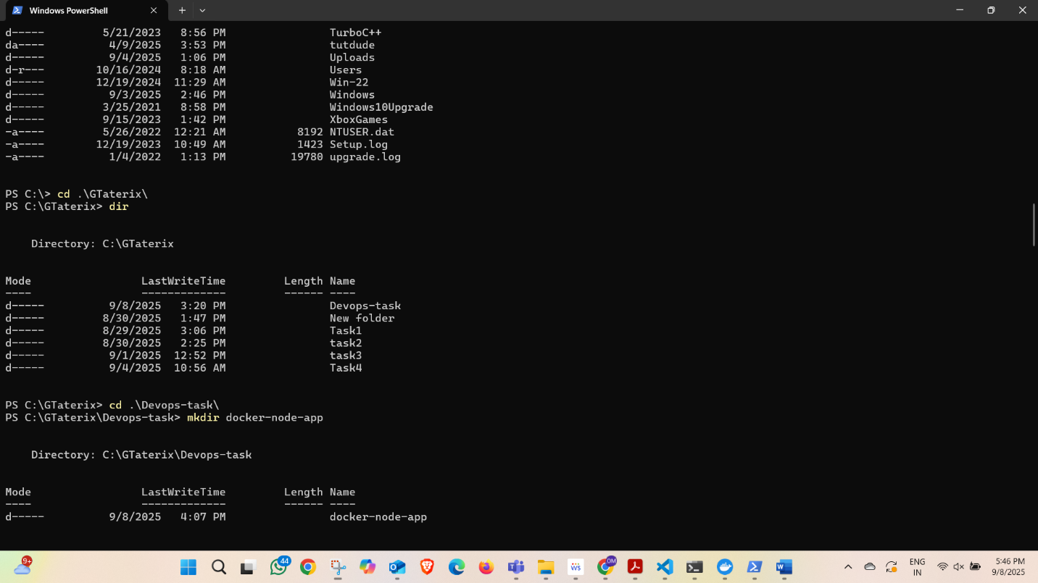

**2. Created Application Files**

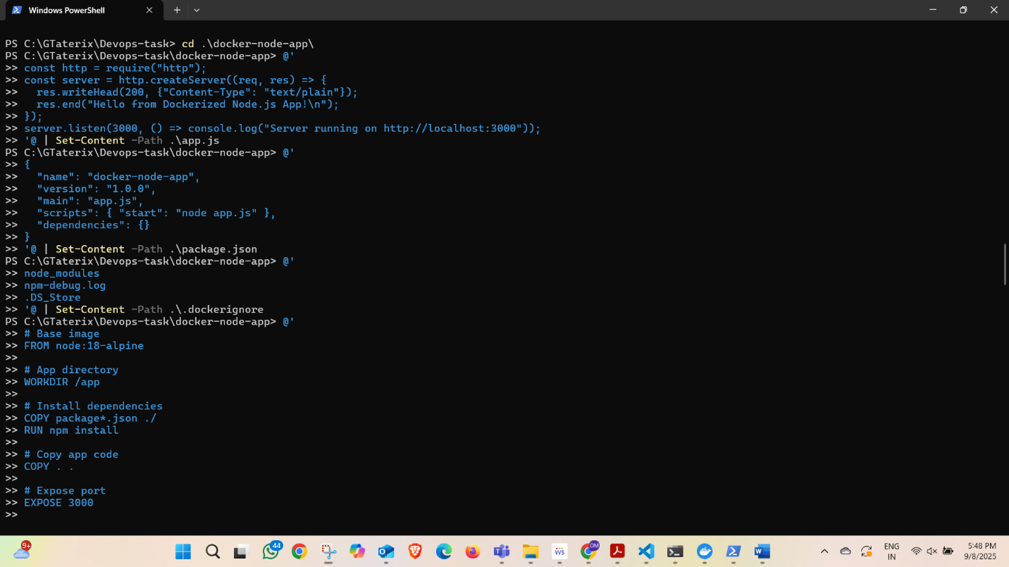

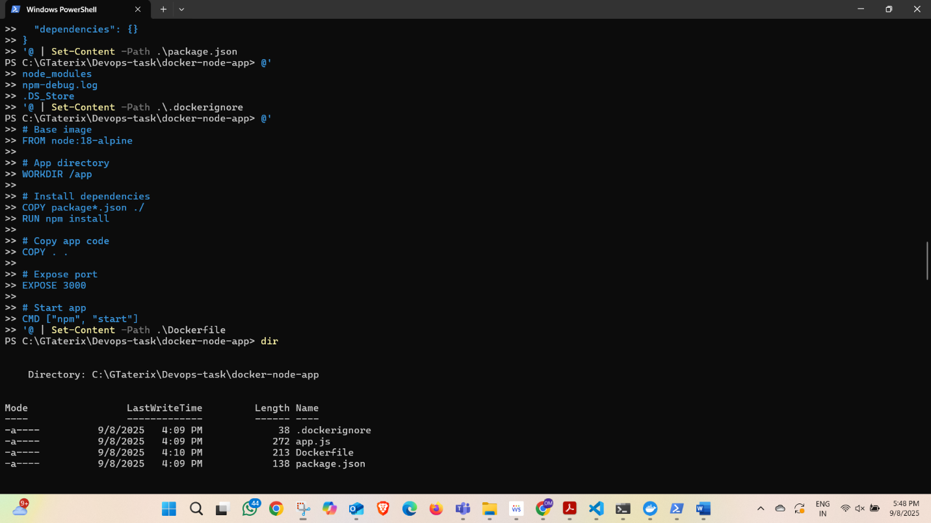

**3. Built Docker Image**

docker build -t om0508/node-docker-app:v1 .

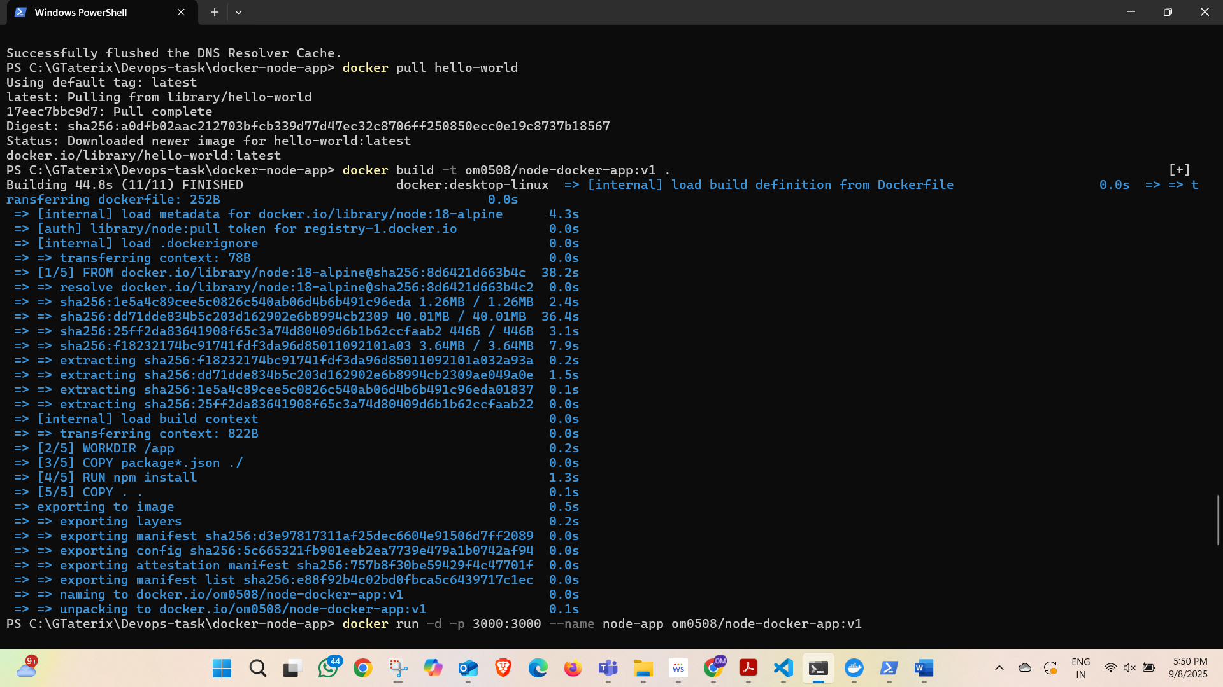

**4. Ran Docker Container**

docker run -d -p 3000:3000 --name node-app om0508/node-docker-app:v1

* Open browser: http://localhost:3000 → Shows message:

Hello from Dockerized Node.js App!

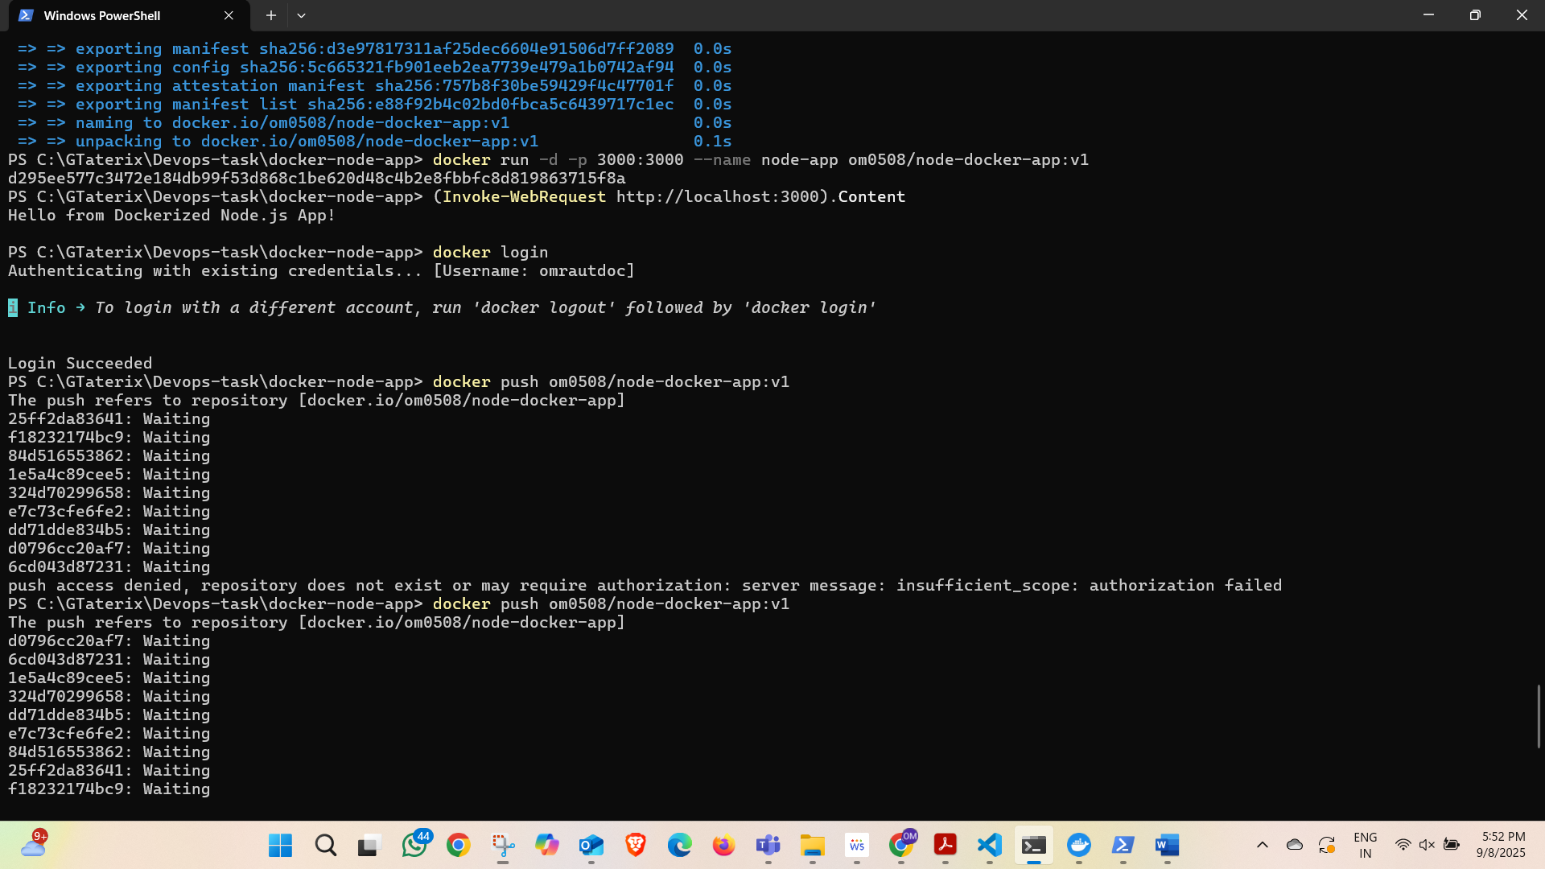

**5. Tagged Docker Image for DockerHub**

docker tag om0508/node-docker-app:v1 omrautdoc/node-docker-app:v1

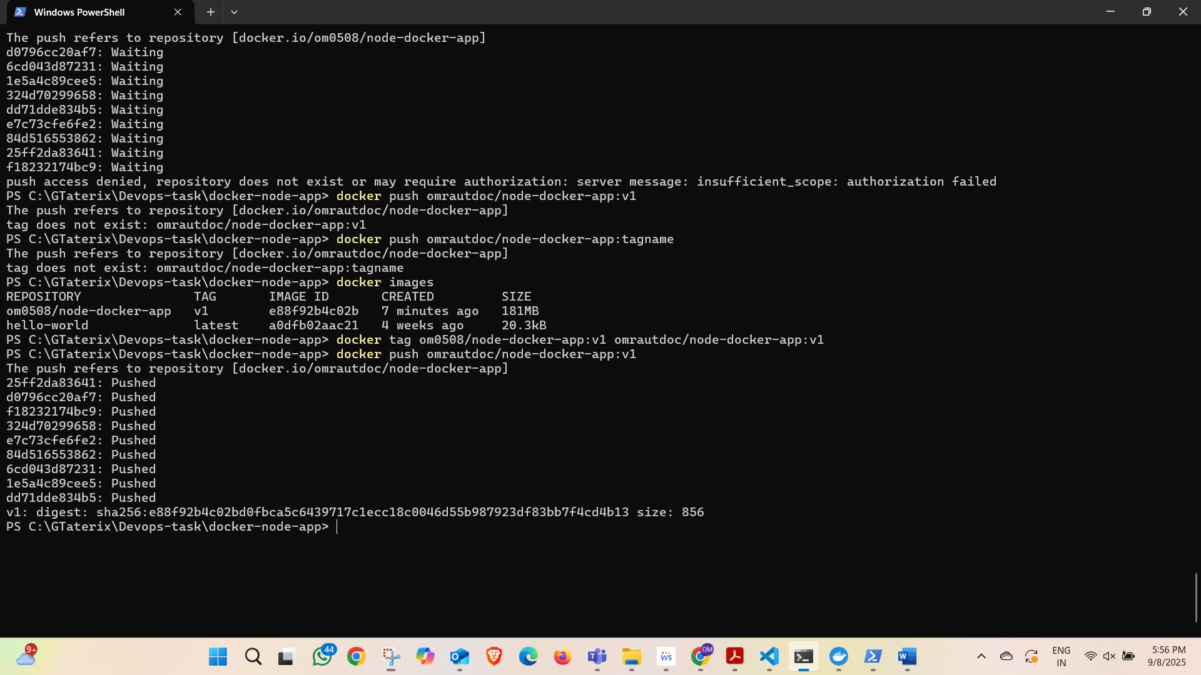

**6. Pushed Docker Image to DockerHub**

docker login docker push omrautdoc/node-docker-app:v1

* DockerHub Repo: <https://hub.docker.com/r/omrautdoc/node-docker-app>

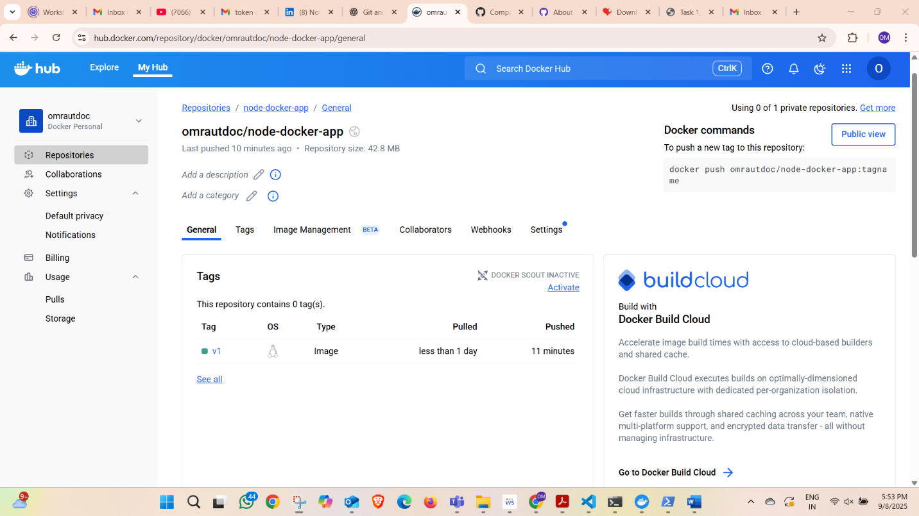

**Conclusion**

* Successfully created a Node.js application and Dockerized it.
* Built and ran the Docker container locally.
* Pushed the Docker image to DockerHub for remote access.