Vellum Scanned Demo
A synthetic mixed-layout fixture for OCR testing
This document is a deliberately mixed-layout sample used to test the OCR conversion path of Vellum. It contains one-column body text, a multi-column section, two tables, and embedded figures. The document was first typeset as a normal text-based PDF; every page was then rasterized at 200 DPI and the resulting bitmap was re-embedded as the only content of each page after going through a scanner-style degradation pipeline (slight skew, blur, sensor noise, grayscale, JPEG compression). The end result has no extractable text layer at all, which mirrors what a flatbed scanner would _~ produce when scanning a printed copy.
Item | a Quantity | Unit price — | | Subtotal
Notebook, A5 | 12 | 3.50 | 42.00
Pen, blue | — 48 | 0.80 | — | 38.40
Stapler | 4 | 12.00 | 48.00
Paper, A4 ream - | | 6 | 4.25 | 25.50

-Multi-column section

Lorem ipsum dolor sit amet, consectetur adipiscing elit. Sed do eiusmod tempor incididunt ut labore et dolore magna aliqua. Ut enim ad minim veniam, quis - nostrud exercitation ullamco laboris nisi ut aliquip ex ea commodo consequat. Duis aute irure dolor in reprehenderit in voluptate velit esse cillum dolore eu fugiat nulla pariatur.
Excepteur sint occaecat cupidatat non proident, sunt in culpa qui officia deserunt mollit anim id est laborum. Curabitur pretium tincidunt lacus, at hendrerit nulla feugiat eu. Vivamus ac leo pretium, faucibus dui in, elementum nisl.
Sed ut perspiciatis unde omnis iste natus error sit voluptatem accusantium doloremque laudantium, totam rem aperiam, eaque ipsa quae ab illo inventore veritatis et quasi architecto beatae vitae dicta sunt explicabo.
Nemo enim ipsam voluptatem quia voluptas sit aspernatur aut odit aut fugit, sed quia consequuntur magni dolores eos qui ratione voluptatem sequi nesciunt. Neque porro quisquam est qui dolorem ipsum quia dolor sit amet, consectetur, adipisci velit.

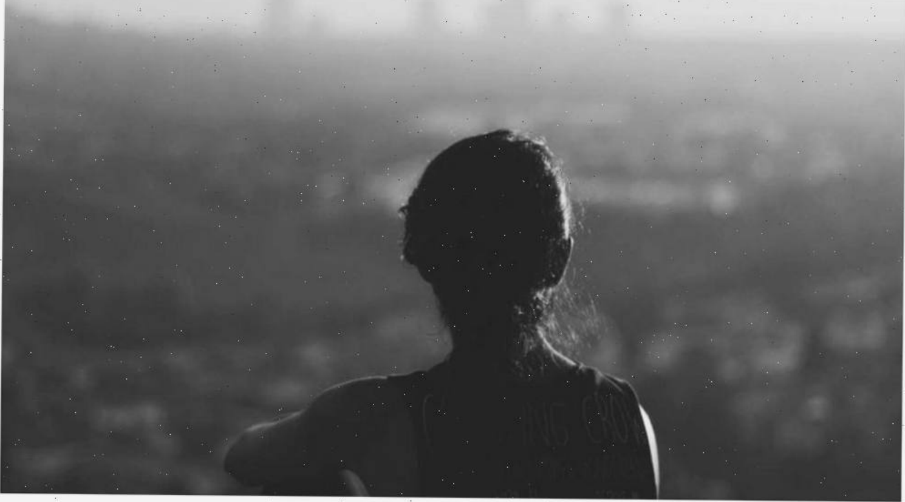
Figure 1 - Ascenic placeholder image fetched from picsum.photos.

Figures and summary
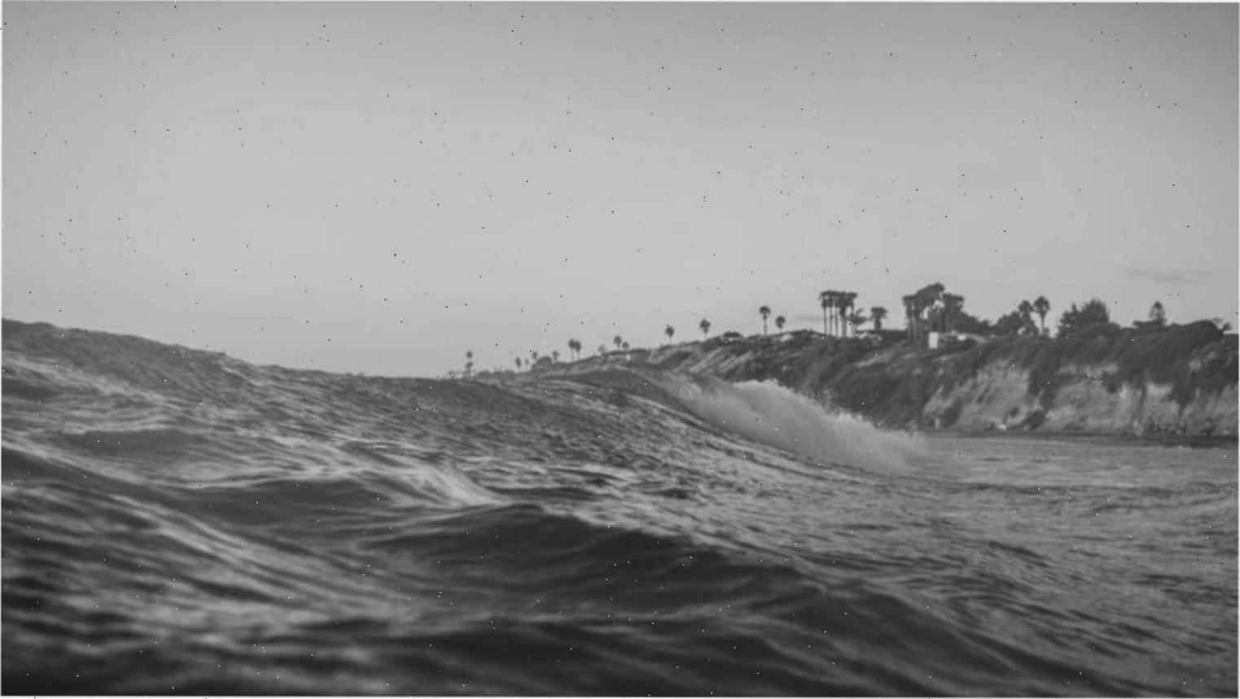
Figure 2 - Another scenic placeholder image fetched from picsum.photos.
Section _ | | Status 7 | Last updated
Introduction | Done | 2026-04-08
Two-column body | Done | 2026-04-08
Figures . - | -|Done’ - | 2026-04-08
Summary Oo | In progress | 2026-04-08
This concludes the Vellum scanned demo fixture. The original PDF (before scanning) had three — pages with mixed layouts, two tables, two figures, and both single- and multi-column body text. After. the rasterization and scanner-degradation step that produces the final PDF, every text glyph has been baked into a slightly noisy bitmap and the only way to recover the content is via OCR.

