CSUA22186: Lab Practice – II

OPERATING SYSTEM LABORATORY

Scheme: Practical: 6 Hours/Week
Examination Scheme: CE: 50 Marks Practical/Oral: 50 Marks
Prerequisites: Computer Fundamentals

Course Objectives:
- To have students understand the principles in the design and implementation of
Operating systems software
- To understand various operating system algorithms for resource management.

Course Outcomes:
- Comprehend the knowledge of operating systems software
- Apply the operating systems algorithms for tasks like scheduling, process management etc.

CSUA22186: Lab Practice – II

OPERATING SYSTEM LABORATORY

Class: SE (Comp) Semester: 2 Academic Year:2019-20

Sr. No. | Assignment Name
1 | Study the Basic Linux commands
2 | write a program to implement an address book with the options given below: a) create address book b) view address book c) Insert Record d) Delete a record e) Modify a record f) Exit
3 | Process control system calls: The demonstration of fork, execve and wait system calls along with zombie and orphan states.
4 | Write a program to show the demonstration of Scheduling Algorithms: 1) FCFS 2) SJF 3) Priority Scheduling
5 | Thread management using pthread library. Implement matrix multiplication using multithreading. Application should have pthread_create, pthread_join, pthread_exit. In the program, every thread must return the value and must be collected in pthread_join in the main function. Final sum of row column multiplication must be done by main thread (main function).
6 | Thread synchronization using counting semaphores and mutual exclusion using mutex. Application to demonstrate producer-consumer problem with counting semaphores and mutex.
7 | Case Study: XV6  Linux Kernel configuration, compilation and rebooting from the newly compiled kernel.

Lab Coordinator:

Dr. Sachin R Sakhare Dr. Kirti H Wanjale

All the assignments should be conducted on Latest version of Open-Source Operating Systems, tools and Multi-core CPU supporting Virtualization and Multi-Threading.

Links for Laboratory Assignments

- https://www.cse.iitb.ac.in/~mythili/os/
- http://homes.cs.washington.edu/~tom/nachos/
- http://web.cecs.pdx.edu/~walpole/class/cse513/project/syscall.html
- http://web.cecs.pdx.edu/~walpole/class/cse513/project/syscall.html

ASSIGNMENT NUMBER:

AIM: TO

OBJECTIVE:

THEORY:

PROGRAM: { PRINTOUT OF PROGRAM }

OUTPUT: { RUN PROGRAM AND THEN TAKE PRINTOUT}

CONCLUSION: HENCE WE STUDIED

ASSIGNMENT NUMBER: 1

AIM: To study the basic commands in the linux.

Unix/Linux Command Reference

File Commands
1. ls Directory listing
2. ls -al Formatted listing with hidden files
3. ls -lt Sorting the Formatted listing by time modification
4. cd dir Change directory to dir
5. cd Change to home directory
6. pwd Show current working directory
7. mkdir dir Creating a directory dir
8. cat > file Places the standard input into the file
9. more file Output the contents of the file
10. head file Output the first 10 lines of the file
11. tail file Output the last 10 lines of the file
12. tail -f file Output the contents of file as it grows, starting with the last 10 lines
13. touch file Create or update file
14. rm file Deleting the file
15. rm -r dir Deleting the directory
16. rm -f file Force to remove the file
17. rm -rf dir Force to remove the directory dir
18. cp file1 file2 Copy the contents of file1 to file2
19. cp -r dir1 dir2 Copy dir1 to dir2;create dir2 if not present
20. mv file1 file2 Rename or move file1 to file2,if file2 is an existing directory
21. ln -s file link Create symbolic link link to file

Process management
1. ps To display the currently working processes
2. top Display all running process
3. kill pid Kill the process with given pid
4. killall proc Kill all the process named proc
5. pkill pattern Will kill all processes matching the pattern
6. bg List stopped or background jobs,resume a stopped job in the background
7. fg Brings the most recent job to foreground
8. fg n Brings job n to the foreground

File permission
1. chmod octal file Change the permission of file to octal,which can
be found separately for user,group,world by
adding,
• 4-read(r)
• 2-write(w)
• 1-execute(x)

Searching
1. grep pattern file Search for pattern in file
2. grep -r pattern dir Search recursively for pattern in dir
3. command | grep pattern Search pattern in the output of a command
4. locate file Find all instances of file
5. find . -name filename Searches in the current directory (represented by a period) and below it,
for files and directories with names starting with filename
6. pgrep pattern Searches for all the named processes , that matches with the pattern and, by
default, returns their ID

System Info
1. date Show the current date and time
2. cal Show this month's calender
3. uptime Show current uptime
4. w Display who is on line
5. whoami Who you are logged in as
6. finger user Display information about user
7. uname -a Show kernel information
8. cat /proc/cpuinfo Cpu information
9. cat proc/meminfo Memory information
10. man command Show the manual for command
11. df Show the disk usage
12. du Show directory space usage
13. free Show memory and swap usage
14. whereis app Show possible locations of app
15. which app Show which applications will be run by default

Compression
1. tar cf file.tar file Create tar named file.tar containing file
2. tar xf file.tar Extract the files from file.tar
3. tar czf file.tar.gz files Create a tar with Gzip compression
4. tar xzf file.tar.gz Extract a tar using Gzip
5. tar cjf file.tar.bz2 Create tar with Bzip2 compression
6. tar xjf file.tar.bz2 Extract a tar using Bzip2
7. gzip file Compresses file and renames it to file.gz
8. gzip -d file.gz Decompresses file.gz back to file

Network
1. ping host Ping host and output results
2. whois domain Get whois information for domains
3. dig domain Get DNS information for domain
4. dig -x host Reverse lookup host
5. wget file Download file
6. wget -c file Continue a stopped download

Shortcuts
1. ctrl+c Halts the current command
2. ctrl+z Stops the current command, resume with fg in the foreground or bg in the background
3. ctrl+d Logout the current session, similar to exit
4. ctrl+w Erases one word in the current line
5. ctrl+u Erases the whole line
6. ctrl+r Type to bring up a recent command
7. !! Repeats the last command
8. exit Logout the current session

Assignment No: - 2

AIM: Creating Address Book using Shell Script

Theory :

SHELL:
A Shell provides you with an interface to the Unix system. It gathers input from you and executes programs based on that input. When a program finishes executing, it displays that program's output.

Shell is an environment in which we can run our commands, programs, and shell scripts. There are different flavors of a shell, just as there are different flavors of operating systems. Each flavor of shell has its own set of recognized commands and functions.
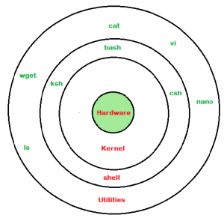

SHELL TYPES:
BASH (Bourne Again Shell): It is most widely used shell in Linux systems. It is used as default login shell in Linux systems and in macOS. It can also be installed on Windows OS.

CSH (C Shell): The C shell’s syntax and usage are very similar to the C programming language.

KSH (Korn SHell) – The Korn Shell also was the base for the POSIX Shell standard specifications etc.

Code: (Must be indented and include comments)

#!/bin/bash

echo "1. Create Addressbook"
echo "2. View Addressbook"
echo "3. Insert Record"
echo "4. Delete Record"
echo "5. Modify Record"
echo "6. Exit"
echo "Select action you want to perform:"
read opt

# variables
FILE=book.txt

case "$opt" in
# Creating Addressbook
1)

RUN=1

while [[ RUN -ne 0 ]]; do
echo "Enter Name to be inserted:"
read NAME
echo "Enter Number to be inserted:"
read NUMBER

echo "$NAME $NUMBER" >> $FILE;

echo "Do u want to keep inserting?"
echo "0: no, 1: yes"
read RUN

done

;;

# View Addressbook
2)
if [[ -f "$FILE" ]]; then
echo ""
echo "*************** Addressbook ***************"
cat "$FILE"

else
echo "$FILE doesn't exist"
fi
;;

# Insert Record
3)
echo "Enter Name to be inserted:"
read NAME
echo "Enter Number to be inserted:"
read NUMBER

echo "$NAME $NUMBER" >> $FILE;

;;

# Delete Record
4)
echo "Enter Name to be Deleted:"
read NAME

# outputs everything but line with $NAME
grep -vi “$NAME” “$FILE” > temp.txt;
rm $FILE
mv temp.txt book.txt
;;

# Modify
5)
echo "Enter Name to be Deleted:"
read NAME

echo "Enter new Name:"
read NEW_NAME

echo "Enter new number:"
read NEW_NUMBER

sed -i "s/^.*$NAME.*$/$NEW_NAME $NEW_NUMBER/" $FILE
;;

*)
echo "Byee"
;;
esac

Output:
1) Create Addressbook
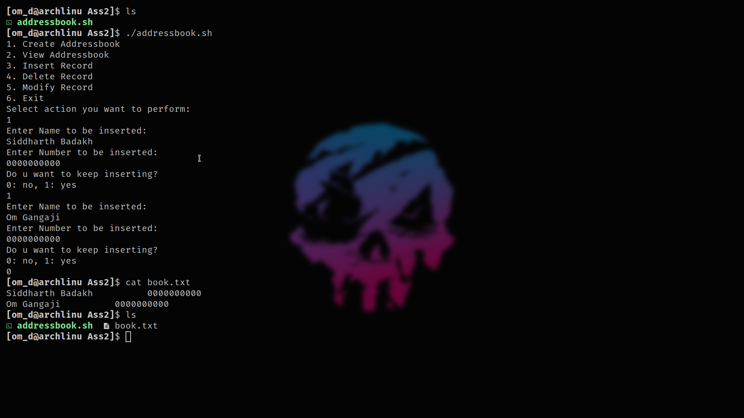
- View Addressbook
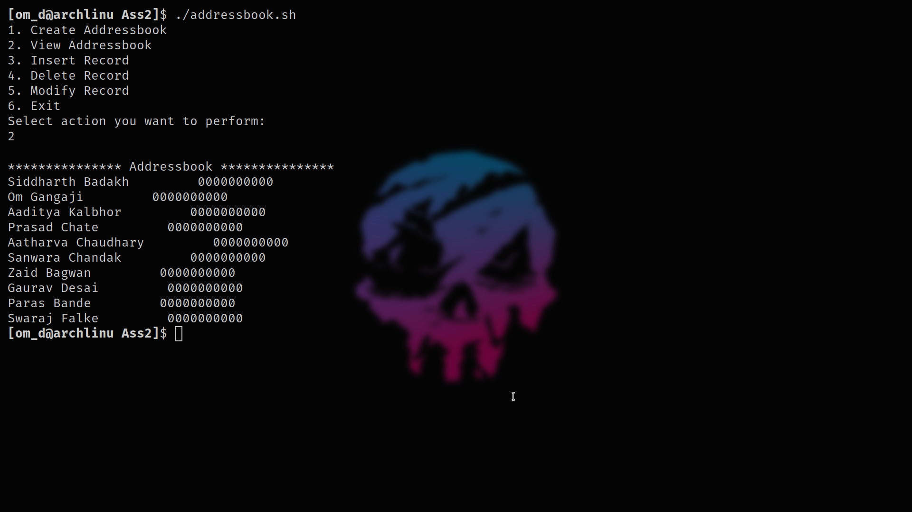
- Insert Record
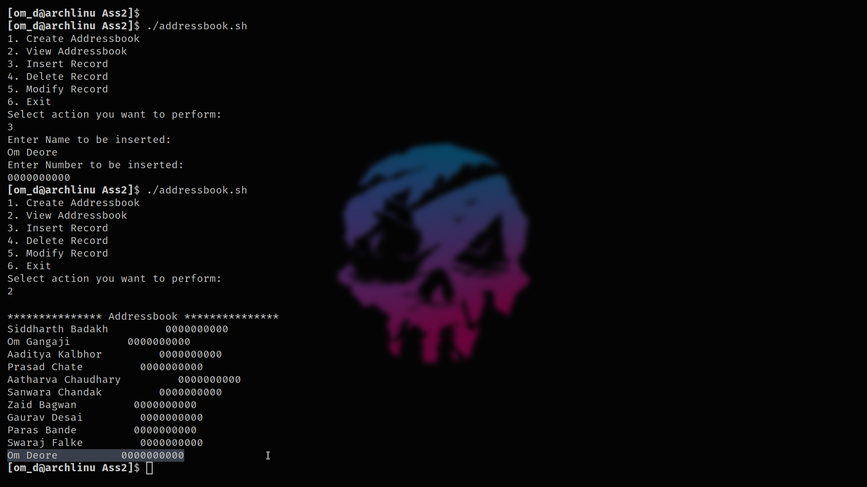
    - Delete Record
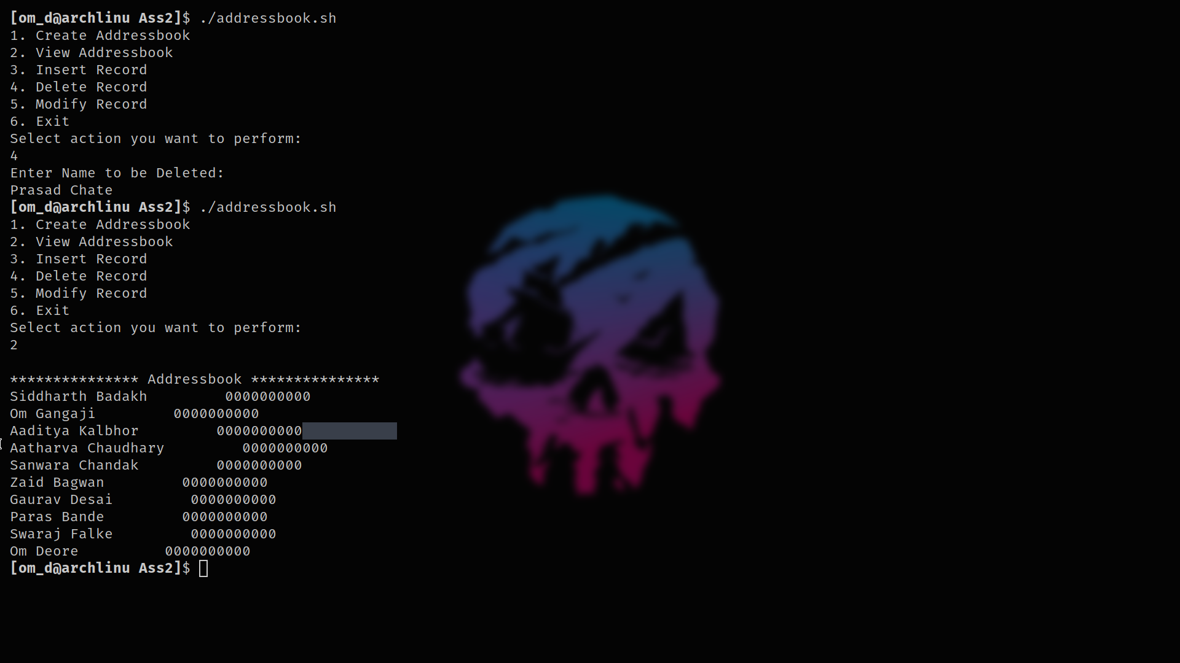

    - Modify Record
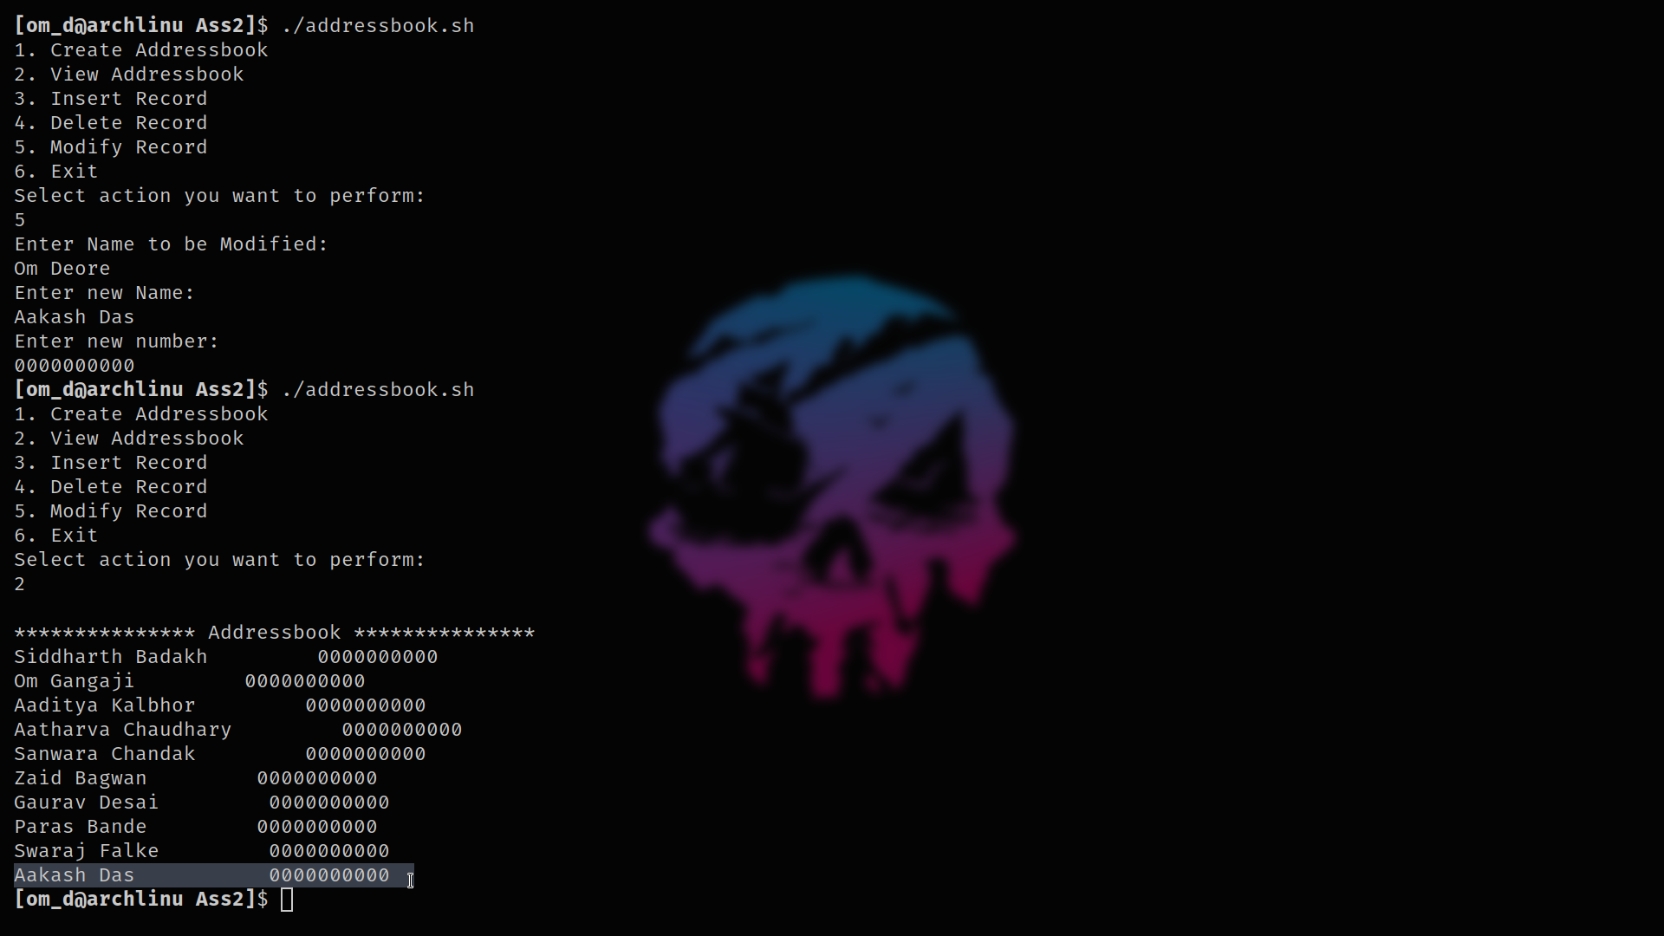

Assignment No: - 3

AIM: Implement following programs to exhibit UNIX Process Control "Program where parent process sorts
array elements in ascending order and child process sorts array elements in descending order.
Show the demonstration of wait() and zombie process"

Theory:
Student should write
- What is Process ,
- How to create a new process,
- Fork()
- Exec()
- Orphan processes
- zombie Process

Code: (Must be indented and include comments)

Program
/*The program (parent process) reads an array from the user.
It sorts it in descending order.
The child process created by parent process sorts it ascending order
*/
#include<stdlib.h>
#include<stdio.h>
int main()
{
int cpid;
int temp,a[100],n,i,j;
printf("\nEnter number of elements : ");
scanf("%d",&n);
printf("Enter elements\n");
for(i=0;i<n;i++){
scanf("%d",&a[i]);
}
printf("\n");
cpid=fork(); /*Creating child process using fork() system call */
if(cpid<0)
{
printf("Cannot create a new process\n");
exit(0);
}
if(cpid != 0)
{
/*fork returns processid of newly created process.
Therefore, the value of integer variable cpid in parent process is the process id of child process.
This block (if block) is executed only by the parent because the value of cpid is zero in child process. We use the value of variable cpid to decide which process (parent or child) should execute which part of code*/
printf("\nThis is parent with id: %d\n",getpid());
/* The UNIX system call getpid() return the process id of process being executed.*/
for(i=0;i<n;i++){
for(j=0;j<n-1;j++){
if(a[j]<a[j+1]){
temp = a[j];
a[j] = a[j+1];
a[j+1] = temp;
}
}
}
printf("Parent sorted the array in descending order\n");
}else
{
/*This block (else block) is executed only by the child process because value of cpid is zero only for child process.*/
printf("\nThis is child with id: %d \n",getpid());
for(i=0;i<n;i++){
for(j=0;j<n-1;j++){
if(a[j]>a[j+1]){
temp = a[j];
a[j] = a[j+1];
a[j+1] = temp;
}
}
}
printf("Child sorted the array in ascending order\n");
}
/*The following part of code is executed by both the processes because it is not restricted using the value of cpid.*/
for(i=0;i<n;i++){
printf("%d\n",a[i]);
}
return 0;
}

Output: screen-shots

Assignment No: - 4

AIM: Write a program to show the demonstration of Scheduling Algorithms: 1) FCFS 2) SJF 3) Round Robin
TC=3 ms

Theory:
Student should write
- What is scheduling
- Scheduling Criteria
- Scheduling terminologies and formule
- Scheduling algorithms

Code: (Must be indented and include comments)

Output: screen-shots

Assignment No: - 5

AIM: Thread management using pthread library. Implement matrix multiplication using multithreading. Application should have pthread_create, pthread_join, pthread_exit. In the program, every thread must return the value and must be collected in pthread_join in the main function. Final sum of row column multiplication must be done by main thread (main function).

Theory:
Student should write
- What is Threading
- Difference between Threads and Process
- Pthreads() etc

Code: (Must be indented and include comments)

Output: screen-shots

Assignment No 7 :- Self Study Assignment

Assignment Name:- Case Study and Comparison of XV6 and Linux Operating system. Points of study will be Kernel
configuration, compilation and rebooting from the newly compiled kernel, Scheduling
policies, Memory Management Policies, Interposes communication etc.

