Cross-Region Multi-Account AWS DNS Mesh
Architecture Research Note | Centralized private DNS resolution, public delegation automation, and multi-account Route 53 governance
Author : Om Shree | Cloud Engineer | Global Platform Capabilities, FICO

Scope | AWS Organizations, Route 53 Resolver, private hosted zones, public hosted zones, Terraform, Lambda
Primary objective | Centralize DNS control while preserving regional resolution locality and account-level workload autonomy
Confidentiality note | All identifiers in this document are generalized. Account IDs, internal URLs, customer names, and environment-specific names have been removed.

Abstract
This document describes a DNS mesh architecture for a distributed AWS organization where private DNS zones, resolver endpoints, resolver rules, logs, and delegation automation are centralized without forcing all workloads into a single account or region. The design separates private DNS resolution from public DNS delegation: private zones are made globally reachable through VPC associations and Route 53 Resolver rules, while public subdomain delegation is reconciled by a scheduled Lambda workflow that maintains NS records in parent zones.
The result is a DNS control plane that behaves as a shared infrastructure primitive: workloads remain distributed, DNS policy remains centralized, and region/account expansion does not require a redesign of the name-resolution model.

1. Problem Statement
In a multi-account, multi-region AWS estate, DNS becomes a hidden coupling point. Application teams create records in different accounts, private zones are associated with region-bound VPCs, resolver rules are regional resources, and operational logs scatter across accounts. Without a coherent control plane, teams eventually accumulate manual delegations, inconsistent resolver rules, orphaned public NS records, and incident response paths that depend on tribal knowledge.
The architecture addresses this by treating DNS as an organizational substrate rather than an account-local utility. The central network hub owns DNS governance. Workload accounts consume resolution capability and, where delegated, contribute records through controlled automation.

2. Design Objectives
Objective | Architectural implication
Centralized DNS management | Private hosted zones, public hosted zone delegation, resolver rules, logging, and security controls are owned from hub accounts.
Regional resilience | Each participating region receives local inbound and outbound resolver endpoints across multiple Availability Zones.
Cross-region private resolution | Every DNS VPC is associated with every private hosted zone, enabling any regional resolver entry point to resolve the complete private namespace.
Multi-account access | Resolver rules are shared through AWS RAM / organization-level sharing so workload accounts can resolve central zones without owning the zones.
Infrastructure as Code | The steady-state topology is modeled in Terraform; Lambda is reserved for reconciliation where Route 53 state must be discovered and converged.
Auditability | Resolver query logs and VPC flow logs land in centralized storage with predictable prefixes and retention policy.
Failure containment | Resolver endpoint failure, AZ loss, regional dependency, and stale delegation state are handled independently.

3. Core Architecture
The mesh is built from four control-plane objects: DNS VPCs, Route 53 private hosted zones, Route 53 Resolver endpoints, and resolver rules. The private hosted zone remains a global Route 53 object, but the resolution path enters through VPC-bound resolver endpoints. The key design move is to associate all participating DNS VPCs with all private hosted zones, then publish resolver rules in each region that target local or regional resolver endpoint IPs.
Component | Role in the mesh
Central network hub account | Owns DNS VPCs, resolver endpoints, private hosted zones, public hosted zones where applicable, logging buckets, and DNS automation.
DNS VPC per region | Provides the VPC association surface required by private hosted zones and hosts resolver endpoint ENIs.
Inbound resolver endpoint | Allows workloads and connected networks to send DNS queries into the Route 53 private namespace.
Outbound resolver endpoint | Allows Route 53 Resolver forwarding rules to target other resolver endpoints or hybrid DNS systems.
Resolver rule | Maps a domain suffix to one or more endpoint IPs and is shared with workload accounts.
Private hosted zone association mesh | Associates each PHZ with each regional DNS VPC, removing the need to reason about PHZ “home region” during resolution.
Public delegation reconciler | Maintains NS records across public parent/child hosted zones where DNS protocol delegation is required.

3.1 Private Hosted Zone Behavior
A Route 53 private hosted zone requires at least one VPC association, but the zone is not solved by normal public DNS delegation. Private hosted zone records are visible only through Route 53 Resolver in associated VPCs. In practice, the NS record set exists because hosted zones require one, but private resolution is governed by VPC association and resolver reachability rather than internet-facing delegation.
This distinction is the foundation of the mesh. Instead of building a fragile delegation tree for private zones, the architecture expands the association graph. Every DNS VPC becomes a valid entry point into every private zone.

3.2 Regional Endpoint Pattern
- Create a DNS VPC in each participating region.
- Allocate at least two private subnets across distinct Availability Zones.
- Create an inbound resolver endpoint with IPs in those subnets.
- Create an outbound resolver endpoint using the same subnet/AZ redundancy pattern.
- Create resolver rules for the private domain suffixes and target the regional endpoint IPs.
- Share resolver rules with workload accounts through organization-level sharing.
- Associate every private hosted zone with every regional DNS VPC.

3.3 Resolution Flow
A workload VPC does not need to own the private hosted zone. It only needs access to the shared resolver rule and a network path to the resolver endpoint. Query handling follows a deterministic path:
Step | Resolution action
1 | A workload queries a name under a private domain suffix.
2 | The shared resolver rule matches the suffix and forwards the query to configured endpoint IPs.
3 | The regional resolver endpoint enters the central DNS VPC.
4 | Route 53 Resolver evaluates PHZ associations attached to that VPC.
5 | Because every DNS VPC is associated with every PHZ, the resolver can answer records across the complete private namespace.
6 | Query and network telemetry are written to centralized logging destinations.

4. Mesh Invariant
The important invariant is simple: for N regions and M private hosted zones, each regional DNS VPC must be associated with each private hosted zone. The steady-state association graph is therefore N x M. This is intentionally explicit. It avoids implicit region ownership assumptions and ensures that any regional resolver ingress can resolve any private zone.
Invariant | Why it matters
Every PHZ has all DNS VPC associations | Any resolver entry point can resolve the full namespace.
Every region has redundant endpoint IPs | AZ failure does not remove regional DNS ingress.
Resolver rules are created per region | Route 53 Resolver rules are regional resources and must be represented in each region where workloads consume them.
Logging is centralized | Incident reconstruction does not require account-by-account log discovery.
No manual DNS state | Terraform and reconciler states define the source of truth.

5. Public Hosted Zone Delegation
Public hosted zones are different from private hosted zones. Public DNS delegation is real protocol-level delegation: when a child public hosted zone exists, the parent zone must contain an NS record delegating the child name to the child zone name servers. Without that NS record, the child zone exists inside Route 53 but is not discoverable through public DNS recursion.
This architecture therefore uses a Lambda-based reconciliation loop for public hosted zone delegation. The reconciler scans permitted accounts, discovers public hosted zones under a configured root domain, builds a parent-child hierarchy, compares expected NS delegations against current parent-zone records, and converges the records with create/update/delete changes.
Private DNS | Public DNS
Resolution is controlled by VPC association and Route 53 Resolver reachability. | Resolution is controlled by DNS delegation from parent zone to child zone name servers.
All participating DNS VPCs are associated with every PHZ. | Parent zones must contain correct NS records for child zones.
No meaningful public delegation chain exists for private hosted zones. | Delegation chain is required for internet DNS resolvers to discover child zones.
Terraform represents topology. | Lambda reconciles discovered hosted-zone state into parent NS records.

5.1 Delegation Reconciler Algorithm
- Discover current zones. Assume read/write roles in the configured DNS accounts and list public hosted zones matching the approved root suffix.
- Build the hierarchy. For each discovered zone, compute its immediate parent by removing the leftmost label and verifying that the parent remains under the approved root domain.
- Read existing delegations. For each parent hosted zone, list NS records below the parent apex and exclude the parent apex NS record itself.
- Converge desired state. Create missing NS records, update records whose name servers drifted, and delete orphaned records only after every configured account scan succeeds.
- Protect critical names. Refuse deletion for explicitly protected domains such as the root domain and fixed public entry points.
- Throttle intentionally. Use adaptive retry, exponential backoff, jitter, and inter-account delays to stay inside Route 53 API limits during multi-level reconciliation.

5.2 Sanitized Python Excerpt
The implementation below is intentionally reduced to the core reconciliation logic. Identifiers are generalized and account IDs are represented as placeholders.
class Route53NSReconciler:
def __init__(self):
self.root_domain = "example.com"
self.accounts = {
"prod": {"role_arn": "arn:aws:iam::<account-id>:role/Route53DelegationRole"},
"dev": {"role_arn": "arn:aws:iam::<account-id>:role/Route53DelegationRole"},
}
self.protected_domains = [self.root_domain, f"www.{self.root_domain}"]

def get_parent_domain(self, domain: str) -> str | None:
if domain == self.root_domain:
return None
parent = ".".join(domain.split(".")[1:])
if parent == self.root_domain or parent.endswith(f".{self.root_domain}"):
return parent
return None

def build_delegation_hierarchy(self, zones: list[dict]) -> dict[str, list[dict]]:
zone_names = {zone["name"] for zone in zones}
zone_names.add(self.root_domain)
delegation_map = {}
for zone in zones:
parent = self.get_parent_domain(zone["name"])
if parent and parent in zone_names:
delegation_map.setdefault(parent, []).append(zone)
return delegation_map

def update_ns_delegation_in_parent(self, route53, parent_zone_id, child_domain, nameservers):
return route53.change_resource_record_sets(
HostedZoneId=parent_zone_id,
ChangeBatch={
"Comment": f"Reconcile NS delegation for {child_domain}",
"Changes": [{
"Action": "UPSERT",
"ResourceRecordSet": {
"Name": f"{child_domain}.",
"Type": "NS",
"TTL": 300,
"ResourceRecords": [{"Value": ns.rstrip(".")} for ns in nameservers],
},
}],
},
)

5.3 Safety Properties
Safety property | Implementation behavior
Account scan gate | Deletion is skipped if any configured account scan fails, preventing false orphan detection during partial outages.
Protected names | The reconciler refuses destructive action for configured protected domains.
Idempotent writes | NS records are compared before mutation; unchanged records are left untouched.
Drift repair | Changed child hosted zone name servers are reconciled through UPSERT.
Rate-limit tolerance | Route 53 calls use adaptive retry, exponential backoff, jitter, and deliberate progress throttling.
Observable result summary | Each invocation reports created, updated, deleted, unchanged, protected, error, API call count, and duration totals.

5.4 Terraform Deployment Shape
The Lambda deployment is small by design: an execution role, STS assume-role permission into DNS accounts, CloudWatch logging, a packaged Python artifact, and an EventBridge schedule for reconciliation.
resource "aws_iam_role" "delegation_reconciler" {
name = "dns-delegation-reconciler-role"

assume_role_policy = jsonencode({
Version = "2012-10-17"
Statement = [{
Effect = "Allow"
Action = "sts:AssumeRole"
Principal = { Service = "lambda.amazonaws.com" }
}]
})
}

resource "aws_iam_role_policy" "delegation_reconciler" {
role = aws_iam_role.delegation_reconciler.id

policy = jsonencode({
Version = "2012-10-17"
Statement = [
{
Effect = "Allow"
Action = ["logs:CreateLogGroup", "logs:CreateLogStream", "logs:PutLogEvents"]
Resource = "arn:aws:logs:*:*:*"
},
{
Effect = "Allow"
Action = ["sts:AssumeRole"]
Resource = ["arn:aws:iam::<account-id>:role/Route53DelegationRole"]
}
]
})
}

resource "aws_lambda_function" "delegation_reconciler" {
function_name = "dns-delegation-reconciler"
role = aws_iam_role.delegation_reconciler.arn
handler = "index.lambda_handler"
runtime = "python3.11"
timeout = 600
memory_size = 256

environment {
variables = {
ROOT_DOMAIN = "example.com"
}
}
}

resource "aws_cloudwatch_event_rule" "scheduled_reconciliation" {
schedule_expression = "cron(0 2 * * ? *)"
}

6. Security and Governance Model
The security model intentionally centralizes authority while limiting blast radius. Workload accounts consume shared resolver rules and delegated DNS capabilities, but do not independently own the authoritative DNS control plane. Public delegation mutation is performed through explicit roles, not ambient credentials.
Control | Design choice
IAM boundary | Lambda assumes narrowly scoped delegation roles in approved DNS accounts.
Resolver endpoint ingress | Security groups restrict inbound DNS access to approved networks, workload CIDRs, VPN ranges, or cloud WAN attachments.
Resolver endpoint egress | Egress remains permissive only where resolver forwarding requires it; otherwise it is constrained by network policy.
Central logs | Resolver query logs and VPC flow logs are written to central storage.
Change traceability | Terraform changes and Lambda reconciliation summaries provide two separate audit trails: topology intent and discovered-state convergence.
Deletion protection | Critical apex and entry-point delegations are protected in code.

7. Observability
DNS systems fail quietly unless instrumented. The mesh therefore collects both query-level and network-level telemetry. Query logs answer what was resolved. Flow logs answer whether the network path to resolver endpoints was reachable. Lambda logs answer whether public delegation state is converging.
Signal | Purpose
Route 53 Resolver query logs | Debug missing records, NXDOMAIN responses, unexpected suffix matches, and workload resolution behavior.
VPC flow logs | Validate traffic from workload networks to resolver endpoint ENIs and detect blocked paths.
CloudWatch Lambda logs | Track reconciliation counts, API throttling, account scan status, and safety aborts.
EventBridge invocation history | Confirm scheduled convergence is running.
Route 53 change IDs | Trace public hosted zone mutations during delegation updates.

8. Failure Analysis
Failure mode | Expected behavior | Mitigation
Single resolver endpoint IP failure | Queries retry against alternate endpoint IPs. | Use at least two endpoint IPs across separate AZs.
AZ failure | Regional resolution remains available through surviving endpoint ENI. | Distribute resolver endpoints across AZs.
Region-local resolver outage | Affected region may fail while other regional entry points continue to operate. | Deploy DNS VPCs and rules in all participating regions.
Partial account scan failure | Public delegation deletion is skipped. | Abort destructive reconciliation when account inventory is incomplete.
Route 53 throttling | Reconciliation slows but does not immediately fail. | Adaptive retry, jitter, and deliberate delays.
Orphaned public NS records | Reconciler removes records only after complete successful inventory. | Protected-domain list plus account scan gate.
Incorrect PHZ association set | Some regional entry points cannot resolve all private zones. | Treat N x M association matrix as a monitored invariant.

9. Operational Runbook

9.1 Adding a New Region
- Create the regional DNS VPC and subnets across at least two Availability Zones.
- Create inbound and outbound Route 53 Resolver endpoints.
- Create resolver rules for all private DNS suffixes in the region.
- Associate the new DNS VPC with every existing private hosted zone.
- Share resolver rules with workload accounts that need regional resolution.
- Enable query logs and VPC flow logs for the new region.
- Validate resolution from at least one workload VPC in that region.

9.2 Adding a New Private Hosted Zone
- Create the private hosted zone in the central DNS account.
- Associate the zone with every regional DNS VPC in the mesh.
- Create or update records through the approved IaC workflow.
- Validate resolution from two distinct regions to confirm the association matrix is complete.

9.3 Adding a New Public Child Zone
- Create the child public hosted zone in an approved account.
- Allow the scheduled reconciler to discover the zone and its assigned name servers.
- Confirm that the parent hosted zone receives or updates the child NS delegation record.
- Verify public DNS discovery using a resolver outside the organization network.

10. Design Trade-offs
Trade-off | Decision
Explicit N x M associations | Accepts configuration size in exchange for predictable resolution from every regional entry point.
Centralized DNS authority | Reduces workload-account autonomy but improves governance, auditability, and operational consistency.
Scheduled reconciliation | Accepts bounded convergence delay for public delegation instead of relying on synchronous event completeness.
Regional resolver rules | Requires repeated rule representation because resolver rules are regional resources.
Sanitized public documentation | Removes production identifiers while preserving architecture mechanics.

11. Conclusion
The DNS mesh converts DNS from a collection of regional/account-local resolver objects into a coherent platform primitive. Private resolution is handled by a complete association mesh between private hosted zones and regional DNS VPCs. Public delegation is handled separately through a reconciliation loop that respects the DNS protocol requirement for parent-zone NS records.
The architecture is intentionally boring in the right places: regional endpoint redundancy, centralized logs, Terraform-defined topology, Lambda-based state convergence, and explicit safety gates around destructive DNS changes. That is the point. DNS should not be clever during an incident; it should be explainable, observable, and recoverable.

Appendix A. Sanitized Original Architecture Diagram
This appendix preserves the original architecture sketch after sanitization. Account IDs, URLs, customer names, and unique environment identifiers have been removed or generalized.
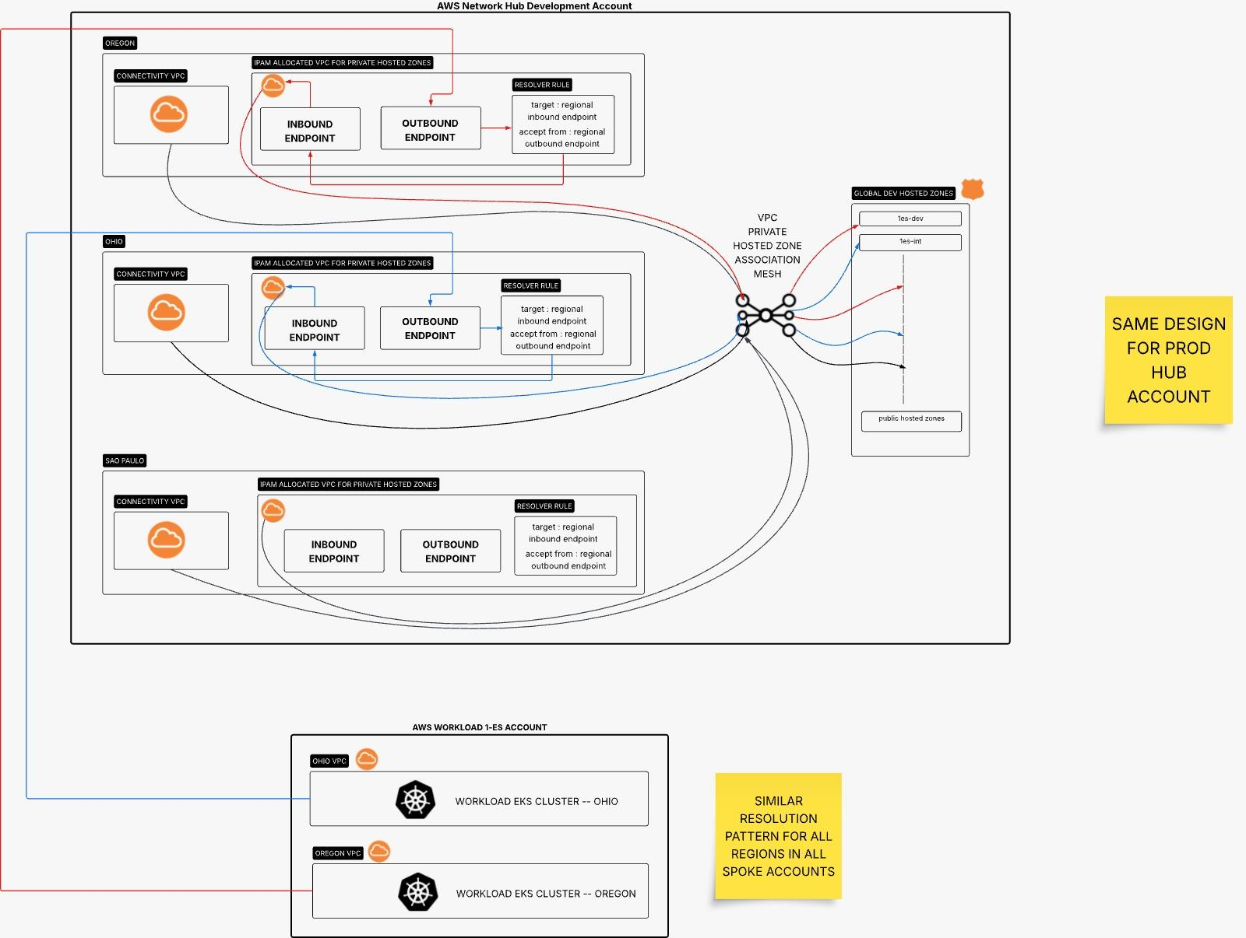
Figure A1. Sanitized original DNS mesh architecture sketch.

References
- AWS Route 53 Developer Guide: Simplify DNS management in a multi-account environment with Route53

