Project 1

<Tic Tac Toe>

<Find the ball>

CIS-17A 42448

Name: Oscar Mayorga

Date: 5/30/2016

Introduction

Title: Tic Tac Toe and Find the ball

The Project has two simple games implemented in order to meet the requirement for the Project #1. You can navigate the program’s menu system using numbers.

The first game is “Find the ball from 5 cups”, the game presents the player five cups, which are identical, from which the player chooses one hoping that that cup holds the ball. The player has to enter a number between one and five guessing which one the ball may be under. A quick example is; if the player enter “1” the game will output the five cups and reveled which one had the ball, if the player guessed then it will tell the player that he/she won, and save the number of wins as the player keeps playing.

The second game is the popular game “Tic Tac Toe”. The game will give the player a square looking figure, the player will choose a number between one and nine to play the game. The player will play against a simple easy computer, the first getting 3 rows of X’s or O’s wins.

Summary

Project size: about 490 lines

The number of variables: about 21 variables

The number of method: 13 functions.

The project includes all the concepts required for the project which we learned from the book and from the power point. It took time getting use to using the structures with arrays inside of it. The most difficult part of coding this project was the de-allocation of memory from different types of arrays, such as array of structures and pointers in structures. I believe I have done the de- allocating correctly but I can’t seem to find any way of checking if any memory is leaking.

Building the game was not that difficult and the game was perfect for using a set of arrays in different types of ways.

Description

The creation of the games was to implement the concepts learned in class. The game utilizes structures with arrays to be used as a storage area to leave information and take information to functions to help process in an organized way.

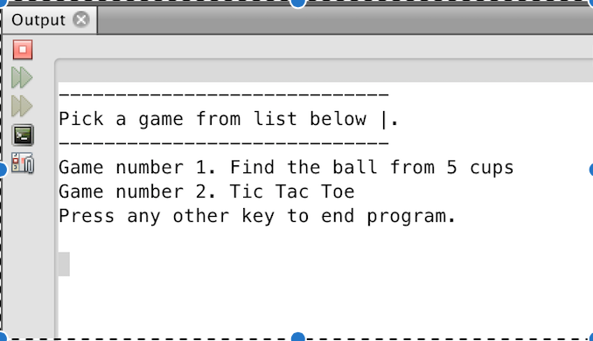

Input / Output

The entire program is navigated from a menu type system.

For Example, to pick a game the player will see a menu as shown in the figure above, the for example, if the player wants to choose game number two which is “Tic Tac Toe”, the player will have to enter the number 2. Similarly if the player wants to choose the “Find the Ball from five cups” game.

PseudoCode

*Initialize*

*Do While loop until game =0 Display Menu If input equals 1 then go to first game*

*Do while until game is finished*

*Create the cups*

*Display the cups*

*Put a ball into one of the cups randomly*

*Asks the player to choose a cup to find the ball*

*Input the answer*

*Win or Lose*

*Ask to play again Input*

*-----*

*If input equals 2 then go to second game*

*Do while game is over*

*Create a tic tac toe display*

*Randomly choose one of the arrays for computer*

*Ask the player to input in a box*

*Input Win or Lose*

*Ask if want to play again*

*Input*

*If input equals 3 then go exit*

**Flow Chart**

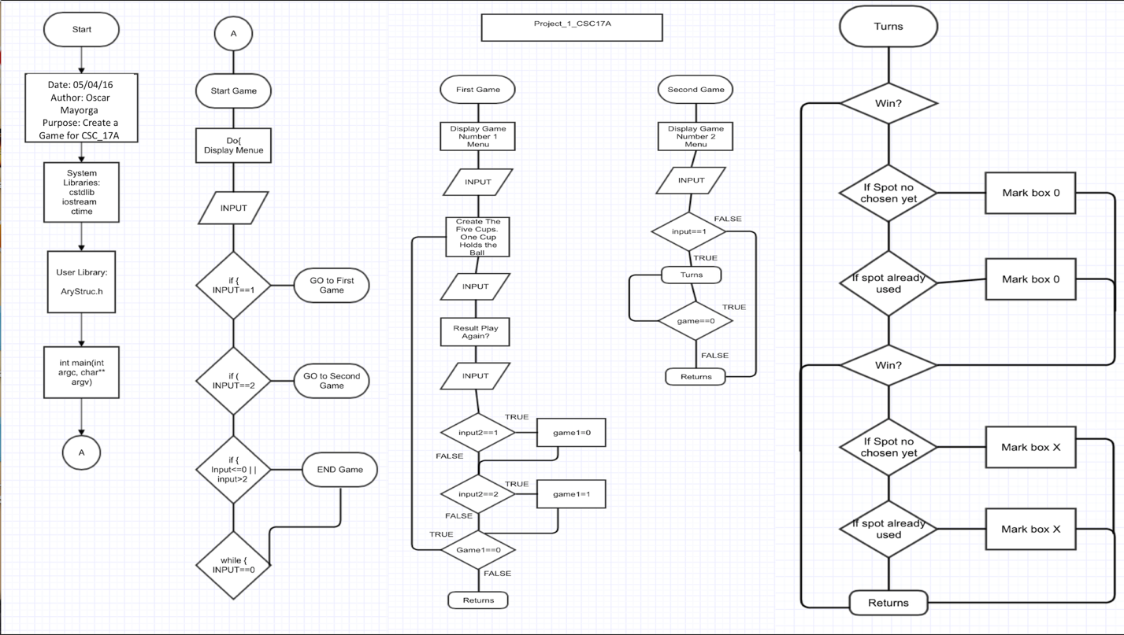

**Program**

/*

* File: main.cpp

* Author: Oscar

* Created on April 6, 2016, 3:24 PM

* CSC-17A - Project 1

*/

//System Libraries

#include <iostream>

#include <cstdlib>

#include <ctime>

//User libraries

#include "AryStruc.h"

using namespace std;

//Structures

//Game 2

struct checkga{

int *box;

};

//Function Prototypes

//Game 1

void game1(int &);

void fillAry(Array *,int);

void prntAry(Array *);

void dstry(Array *);

void effecta();

void effectb(Array *);

void random(Array *);

void result(Array *,int &);

//Game 2

void game2(int &);

void display(Array2 *);

void turns(checkga &,Array2 *,int &);

void win(Array2 *,int &);

void tie(Array2 *,int &);

//Execution Begins Here

int main(int argc, char** argv) {

//Declare variables

int input,start=0;

//Continue the loop until player exits

do{

//Menu

cout<<"-----------------------------"<<endl;

cout<<"Pick a game from list below |."<<endl;

cout<<"-----------------------------"<<endl;

cout<<"Game number 1. Find the ball from 5 cups"<<endl;

cout<<"Game number 2. Tic Tac Toe"<<endl;

cout<<"Press any other key to end program."<<endl;

cout<<endl;

cin>>input;

if(input==1)game1(start);

if(input==2)game2(start);

if(input<=0||input>2)start=1;

}while(start==0);

return 0;

}

void tie(Array2 *a,int &game){

int count =0;

for(int i=0;i<9;i++){

if(a[i].store==88||a[i].store==79){

count++;

}

}

if(count==9)game=1;

//cout<<"Tied"<<endl;

}

void win(Array2 *a,int &game){

//Person

//Straight Line Horizontal

if(a[0].store==88&&a[1].store==88&&a[2].store==88){

cout<<"You Win"<<endl;

game=1;

}

if(a[3].store==88&&a[4].store==88&&a[5].store==88){

cout<<"You Win"<<endl;

game=1;

}

if(a[6].store==88&&a[7].store==88&&a[8].store==88){

cout<<"You Win"<<endl;

game=1;

}

//Straight Line Vertical

if(a[0].store==88&&a[3].store==88&&a[6].store==88){

cout<<"You Win"<<endl;

game=1;

}

if(a[1].store==88&&a[4].store==88&&a[7].store==88){

cout<<"You Win"<<endl;

game=1;

}

if(a[2].store==88&&a[5].store==88&&a[8].store==88){

cout<<"You Win"<<endl;

game=1;

}

//Cross

if(a[0].store==88&&a[4].store==88&&a[8].store==88){

cout<<"You Win"<<endl;

game=1;

}

if(a[2].store==88&&a[4].store==88&&a[6].store==88){

cout<<"You Win"<<endl;

game=1;

}

//Computer

//Straight Line Horizontal

if(a[0].store==79&&a[1].store==79&&a[2].store==79){

cout<<"You Lose"<<endl;

game=1;

}

if(a[3].store==79&&a[4].store==79&&a[5].store==79){

cout<<"You Lose"<<endl;

game=1;

}

if(a[6].store==79&&a[7].store==79&&a[8].store==79){

cout<<"You Lose"<<endl;

game=1;

}

//Straight Line Vertical

if(a[0].store==79&&a[3].store==79&&a[6].store==79){

cout<<"You Lose"<<endl;

game=1;

}

if(a[1].store==79&&a[4].store==79&&a[7].store==79){

cout<<"You Lose"<<endl;

game=1;

}

if(a[2].store==79&&a[5].store==79&&a[8].store==79){

cout<<"You Lose"<<endl;

game=1;

}

//Cross

if(a[0].store==79&&a[4].store==79&&a[8].store==79){

cout<<"You Lose"<<endl;

game=1;

}

if(a[2].store==79&&a[4].store==79&&a[6].store==79){

cout<<"You Lose"<<endl;

game=1;

}

}

void display(Array2 *a){

cout<<"____________"<<endl;

cout<<"["<<a[0].store<<" ]["<<a[1].store<<" ]["<<a[2].store<<" ]"<<endl;

cout<<"["<<a[3].store<<" ]["<<a[4].store<<" ]["<<a[5].store<<" ]"<<endl;

cout<<"["<<a[6].store<<" ]["<<a[7].store<<" ]["<<a[8].store<<" ]"<<endl;

cout<<"------------"<<endl;

}

void turns(checkga &chec,Array2 *b,int &game){

//Declare variables

int input2,a1,a2;

if(game==0){

//Computer

cout<<"Computer's Turn"<<endl;

a1=rand()%9+1;

if(chec.box[a1-1]==0){

b[a1-1].store=79;

chec.box[a1-1]=1;

}

else if(chec.box[a1-1]==1){

do{

a2=rand()%9+1;

}while(chec.box[a2-1]==1);

b[a2-1].store=79;

chec.box[a2-1]=1;

}

win(b,game);

tie(b,game);

}

display(b);

if(game==0){

//Person

cout<<"Person's Turn"<<endl;

cout<<"Enter Choice 1~9"<<endl;

cin>>input2;

if(chec.box[input2-1]==0){

b[input2-1].store=88;

chec.box[input2-1]=1;

}

else if(chec.box[input2-1]==1){

do{

cout<<" Re-Enter Choice 1~9"<<endl;

cin>>input2;

}while(chec.box[input2-1]==1);

b[input2-1].store=88;

chec.box[input2-1]=1;

}

win(b,game);

tie(b,game);

}

}

void game2(int &start){

//Set timer seed

srand(static_cast<unsigned int>(time(0)));

//Declare variables

const int SIZE=9;

int input,game=0;

//Check if box is filled

checkga check;

check.box=new int [SIZE];

//Array of structures to use to fill X or O

Array2 *point=new Array2[SIZE];

for(int i=0;i<SIZE;i++){

check.box[i]=0;

}

for(int i=0;i<SIZE;i++){

point[i].store=0;

}

cout<<"------------"<<endl;

cout<<"Tic Tac Toe"<<endl;

cout<<"------------"<<endl;

cout<<"Enter 1 to Start Game."<<endl;

cout<<"enter 2 to Exit the game."<<endl;

cin>>input;

if(input==1){

cout<<"Computer goes first"<<endl;

do{

turns(check,point,game);

}while(game==0);

};

//Un-allocated

delete []point;

delete []check.box;

}

void result(Array *a,int &count){

//Declare variable

int choose;

cout<<"Which cup has the ball?"<<endl;

cout<<"Input the number between 1 to 5"<<endl;

cout<<"1. First Cup"<<endl;

cout<<"2. Second Cup"<<endl;

cout<<"3. Third Cup"<<endl;

cout<<"4. Forth Cup"<<endl;

cout<<"5. Fifth Cup"<<endl;

cin>>choose;

cout<<"Your choice was "<<choose<<endl;

if(choose==1){

if(a->cup[0]==1){

cout<<"You were right!"<<endl;

count++;

}

else{

cout<<"Wrong choice!"<<endl;

}

}

if(choose==2){

if(a->cup[1]==1){

cout<<"You were right!"<<endl;

count++;

}

else{

cout<<"Wrong choice!"<<endl;

}

}

if(choose==3){

if(a->cup[2]==1){

cout<<"You were right!"<<endl;

count++;

}

else{

cout<<"Wrong choice!"<<endl;

}

}

if(choose==4){

if(a->cup[3]==1){

cout<<"You were right!"<<endl;

count++;

}

else{

cout<<"Wrong choice!"<<endl;

}

}

if(choose==5){

if(a->cup[4]==1){

cout<<"You were right!"<<endl;

count++;

}

else{

cout<<"Wrong choice!"<<endl;

}

}

}

void random(Array *a){

//Set timer seed

srand(static_cast<unsigned int>(time(0)));

//Declare variables

int random;

random=rand()%5+1;

if(random==1)a->cup[0]=1;

if(random==2)a->cup[1]=1;

if(random==3)a->cup[2]=1;

if(random==4)a->cup[3]=1;

if(random==5)a->cup[4]=1;

}

void effectb(Array *a){

if(a->cup[0]==1){

cout<<" .-~~-."<<" .-~~-."<<" .-~~-."<<" .-~~-."<<" .-~~-."<<endl;

cout<<",|`-__-'|"<<" ,|`-__-'|"<<" ,|`-__-'|"<<" ,|`-__-'|"<<" ,|`-__-'|"<<endl;

cout<<"|| BALL |"<<" || ? |"<<" || ? |"<<" || ? |"<<" || ? |"<<endl;;

cout<<"`| |"<<" `| |"<<" `| |"<<" `| |"<<" `| |"<<endl;

cout<<" `-__-'"<<" `-__-'"<<" `-__-'"<<" `-__-'"<<" `-__-'"<<endl;

}

if(a->cup[1]==1){

cout<<" .-~~-."<<" .-~~-."<<" .-~~-."<<" .-~~-."<<" .-~~-."<<endl;

cout<<",|`-__-'|"<<" ,|`-__-'|"<<" ,|`-__-'|"<<" ,|`-__-'|"<<" ,|`-__-'|"<<endl;

cout<<"|| ? |"<<" || BALL |"<<" || ? |"<<" || ? |"<<" || ? |"<<endl;;

cout<<"`| |"<<" `| |"<<" `| |"<<" `| |"<<" `| |"<<endl;

cout<<" `-__-'"<<" `-__-'"<<" `-__-'"<<" `-__-'"<<" `-__-'"<<endl;

}

if(a->cup[2]==1){

cout<<" .-~~-."<<" .-~~-."<<" .-~~-."<<" .-~~-."<<" .-~~-."<<endl;

cout<<",|`-__-'|"<<" ,|`-__-'|"<<" ,|`-__-'|"<<" ,|`-__-'|"<<" ,|`-__-'|"<<endl;

cout<<"|| ? |"<<" || ? |"<<" || BALL |"<<" || ? |"<<" || ? |"<<endl;;

cout<<"`| |"<<" `| |"<<" `| |"<<" `| |"<<" `| |"<<endl;

cout<<" `-__-'"<<" `-__-'"<<" `-__-'"<<" `-__-'"<<" `-__-'"<<endl;

}

if(a->cup[3]==1){

cout<<" .-~~-."<<" .-~~-."<<" .-~~-."<<" .-~~-."<<" .-~~-."<<endl;

cout<<",|`-__-'|"<<" ,|`-__-'|"<<" ,|`-__-'|"<<" ,|`-__-'|"<<" ,|`-__-'|"<<endl;

cout<<"|| ? |"<<" || ? |"<<" || ? |"<<" || BALL |"<<" || ? |"<<endl;;

cout<<"`| |"<<" `| |"<<" `| |"<<" `| |"<<" `| |"<<endl;

cout<<" `-__-'"<<" `-__-'"<<" `-__-'"<<" `-__-'"<<" `-__-'"<<endl;

}

if(a->cup[4]==1){

cout<<" .-~~-."<<" .-~~-."<<" .-~~-."<<" .-~~-."<<" .-~~-."<<endl;

cout<<",|`-__-'|"<<" ,|`-__-'|"<<" ,|`-__-'|"<<" ,|`-__-'|"<<" ,|`-__-'|"<<endl;

cout<<"|| ? |"<<" || ? |"<<" || ? |"<<" || ? |"<<" || BALL |"<<endl;;

cout<<"`| |"<<" `| |"<<" `| |"<<" `| |"<<" `| |"<<endl;

cout<<" `-__-'"<<" `-__-'"<<" `-__-'"<<" `-__-'"<<" `-__-'"<<endl;

}

}

void effecta(){

//Cup with effects

cout<<" .-~~-."<<" .-~~-."<<" .-~~-."<<" .-~~-."<<" .-~~-."<<endl;

cout<<",|`-__-'|"<<" ,|`-__-'|"<<" ,|`-__-'|"<<" ,|`-__-'|"<<" ,|`-__-'|"<<endl;

cout<<"|| ? |"<<" || ? |"<<" || ? |"<<" || ? |"<<" || ? |"<<endl;;

cout<<"`| |"<<" `| |"<<" `| |"<<" `| |"<<" `| |"<<endl;

cout<<" `-__-'"<<" `-__-'"<<" `-__-'"<<" `-__-'"<<" `-__-'"<<endl;

}

void dstry(Array *a){

delete []a->cup;

}

void prntAry(Array *a){

//Print the cup and its contents

for(int i=0;i<a->size;i++){

cout<<a->cup[i]<<" ";

}

cout<<endl;

}

void fillAry(Array *a,int n){

//Declare size in array structure

a->size=n;

//Allocate memory

a->cup=new int [a->size];

//Fill the array with 0's

for(int i=0;i<a->size;i++){

a->cup[i]=0;

}

}

void game1(int &start){

//Declare variables

int size=5,game1=0,input1,input2,count=0;

//Display Game 1 Menu

cout<<"------------------------------------"<<endl;

cout<<"Try to find which cup holds the ball"<<endl;

cout<<"------------------------------------"<<endl;

cout<<"Enter 1 to Start Game."<<endl;

cout<<"Enter 2 to Exit the Game."<<endl;

cin>>input1;

if(input1==1){

do{

Array cup;

//Fill the cup

fillAry(&cup,size);

//Display the cups

effecta();

//Put a ball in one of the cups

random(&cup);

//prntAry(&cup);//To check

result(&cup,count);

effectb(&cup);

//De-allocate

dstry(&cup);

//Give options to keep playing

cout<<"~Current Record~"<<endl;

cout<<"You currently have "<<count<<" wins."<<endl;

cout<<endl;

cout<<"Do you want to try again?"<<endl;

cout<<"Enter 1 if Yes."<<endl;

cout<<"Enter 2 if you want to Exit."<<endl;

cin>>input2;

if(input2==1)game1=0;

if(input2==2)game1=1;

}while(game1==0);

};

}

**AryStruc.h**

#ifndef ARYSTRUC_H

#define ARYSTRUC_H

//Game 1

struct Array{

int *cup;

int size;

};

//Game 2

struct Array2{

char store;

};

#endif /* ARYSTRUC_H */