Task-03: Local Store E-commerce Platform

Create an e-commerce website for a local store in your area, enabling customers to browse and purchase products online. The platform should feature product listings with images, descriptions, prices, and a shopping cart functionality.

Optional Features: Order tracking, user reviews, customer support, sort & filters for products.

Technology Stack
- Frontend: HTML, CSS, JavaScript, Bootstrap
- Backend: Node.js, Express.js
- Database: MongoDB
- Authentication: JWT, bcrypt
- Tools: VS Code, Postman, Git/GitHub

OUTPUT:

🔹 STEP 1: Create Project Folder
Create a folder named:local-store-ecommerce
🔹 STEP 2: Initialize Node.js Project
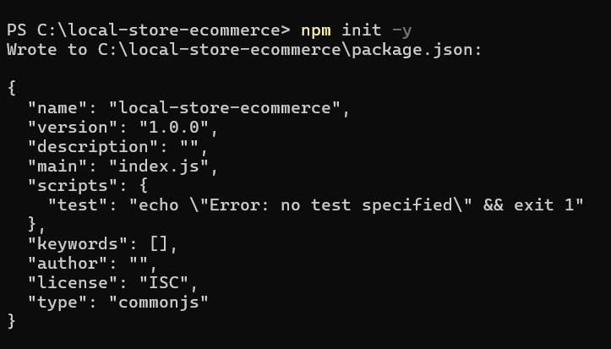
🔹 STEP 3: Install Required Packages
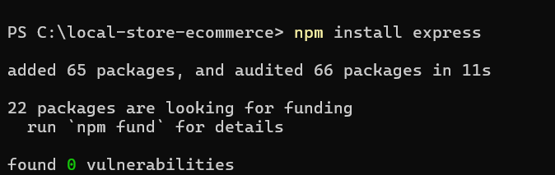

🔹 STEP 4: Create server.js
const express = require('express');
const path = require('path');

const app = express();
const PORT = 3000;

// Serve static files
app.use(express.static(path.join(__dirname, 'public')));

// Home route
app.get('/', (req, res) => {
res.sendFile(path.join(__dirname, 'public', 'index.html'));
});

app.listen(PORT, () => {
console.log(`Server running at http://localhost:${PORT}`);
});

STEP 5: Create index.html
Inside public → index.html
<!DOCTYPE html>
<html>
<head>
<title>Local Store</title>
<link rel="stylesheet" href="css/style.css">
</head>
<body>

<h1>🛒 Local Store E-commerce</h1>

<div class="product">
<img src="https://via.placeholder.com/150">
<h3>Rice Bag</h3>
<p>Price: ₹500</p>
<button onclick="addToCart()">Add to Cart</button>
</div>

<script src="js/script.js"></script>
</body>
</html>

STEP 6: Create CSS (style.css)
Inside public/css/style.css
body {
font-family: Arial;
text-align: center;
}

.product {
border: 1px solid #ccc;
width: 200px;
margin: auto;
padding: 10px;
}

🔹 STEP 7: Create JavaScript (script.js)
function addToCart() {
alert("Product added to cart 🛒");
}

🔹 STEP 9: Run the Project
In terminal:
