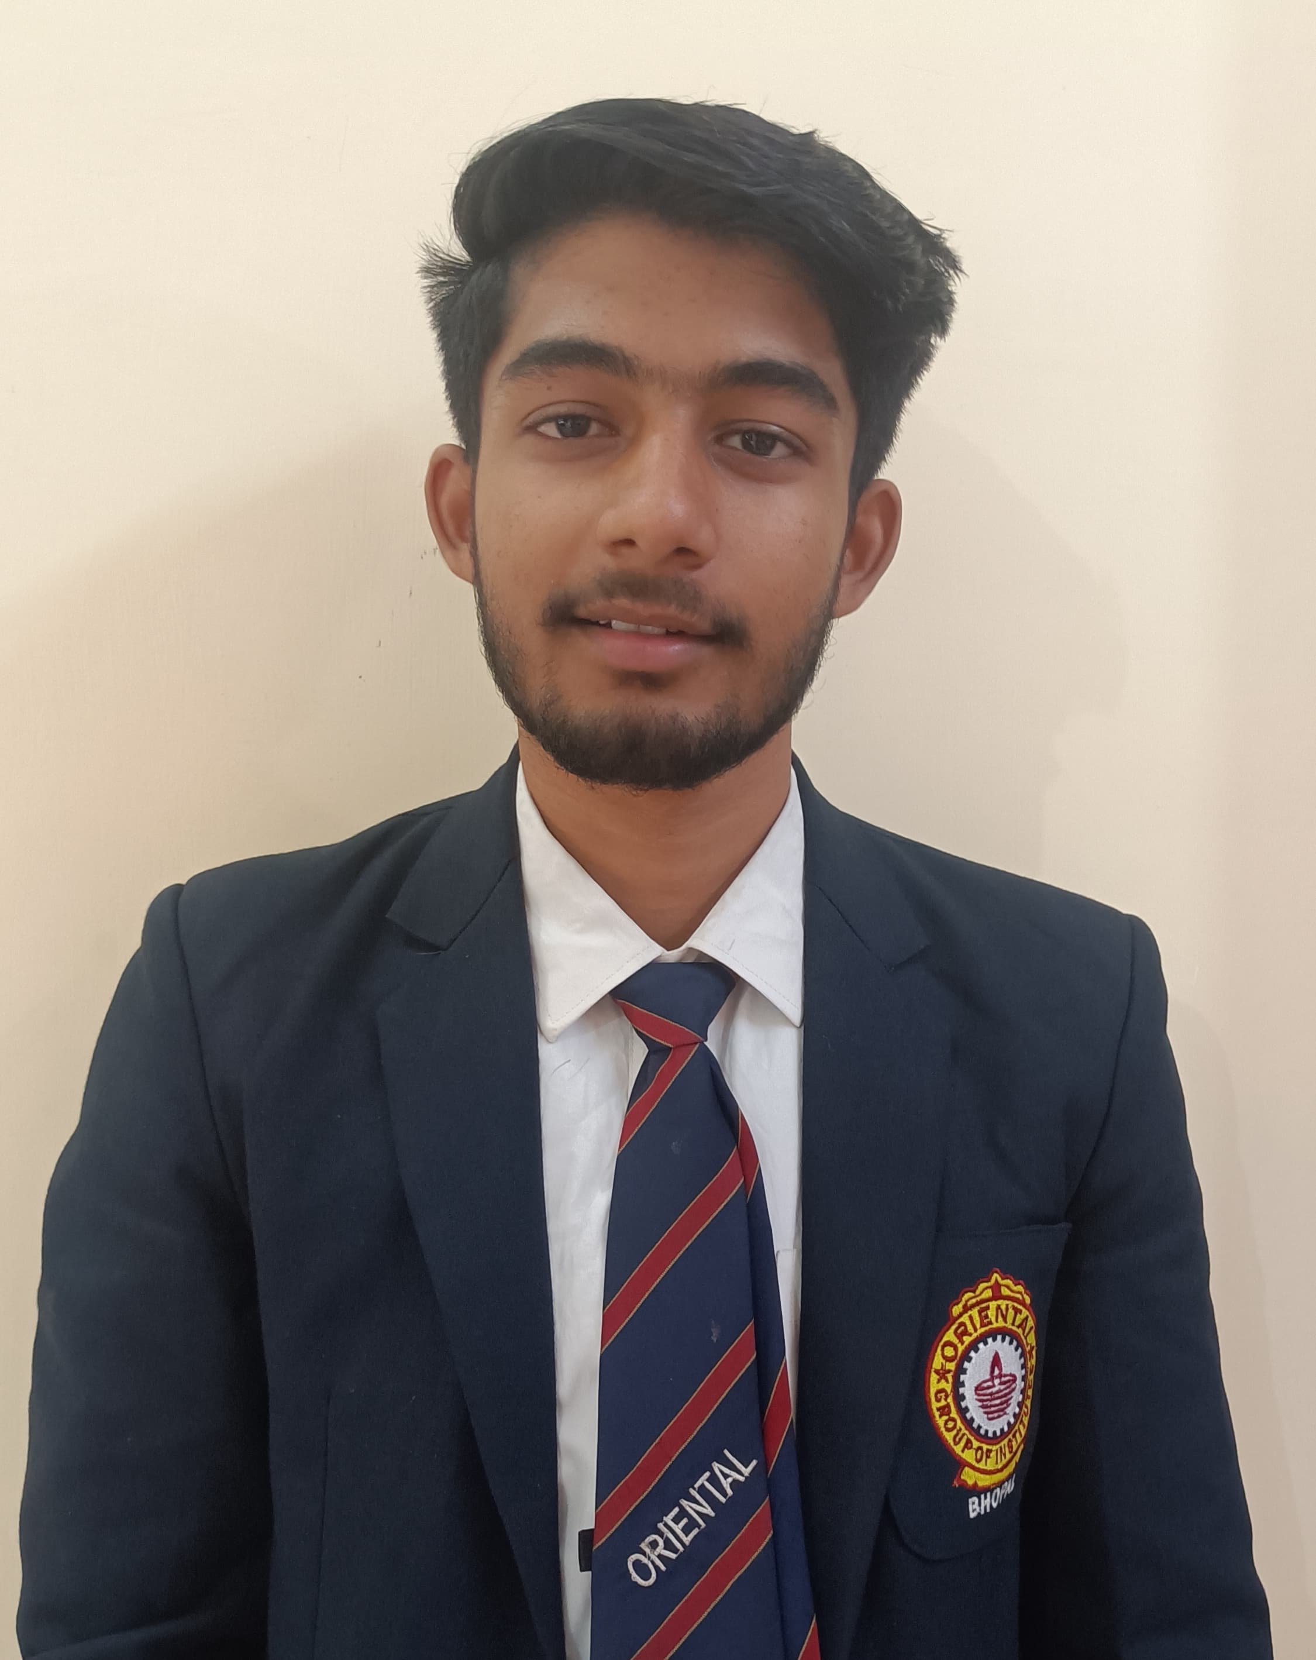OM KARMAKAR

Front-End Developer|📍Bhopal, Madhya Pradesh | 📧 omkarmakar423@gmail.com| Phone- 08101884148

# OBJECTIVE

Passionate and detail-oriented Front-End Developer with foundational skills in HTML, CSS, and JavaScript. Excited to contribute to innovative projects and learn advanced development techniques. Seeking an entry-level position to leverage my technical knowledge and continue growing in a collaborative environment.

# SKILLS

- Web Development: HTML5, CSS3, JavaScript (ES6+)  
- Version Control: Git, GitHub  
- Responsive Design: Media Queries, Flexbox, Grid  
- Tools: Visual Studio Code, Chrome DevTools, Figma (UI/UX design)

# PROJECTS

1. Portfolio Website  
*A personal portfolio to showcase my skills and projects*  
- Designed and developed a responsive portfolio website using HTML and CSS.  
- Deployed the website on GitHub Pages.  
- GitHub Repo | Live Demo

2. Simple Calculator App  
*A simple web application to do calculations*  
- Developed a calculator using vanilla JavaScript.  
  
- Practiced DOM manipulation and local storage.  
- GitHub Repo | Live Demo

3. Responsive Travelling site Landing Page  
*A one-page landing site for a Travelling site*  
- Used Flexbox to create a fully responsive layout.  
- GitHub Repo | Live Demo

# EDUCATION

Bachelor of Technology (B.Tech) in Computer Science  
Oriental Institute of Science and Technoloigy, Bhopal, MP  
Year of Graduation: 2026

# SOFT SKILLS

- Problem-solving  
- Attention to detail  
- Team collaboration  
- Adaptability  
- Eager to learn

# ACTIVITIES & INTERESTS

- Contributing to open-source projects on GitHub.  
- Learning React.js through online courses and tutorials.  
- Designing wireframes and mockups in Figma.