**Course**: High Performance Computing Lab

**PRN**: 22510034

**Name**: Om Kulkarni

**Batch**: B2

**Title:** Introduction to OpenMP

**Problem Statement 1:**

Demonstrate Installation and Running OpenMP code in C.

For linux ubuntu 22.04.5 LTS   
To install essential build tools

Sudo apt install build-essential

It’ll install gcc

Created a file named as:

open_a1_p1.c

Source Code:

#include <stdio.h>

#include <omp.h>

int main(void)

{

#pragma omp parallel

{

printf("Hello, world.\n");

}

return 0;

}

Create a .exe output file with the below command:   
gcc -fopenmp open_a1_p1.c -o open_a1_p1

Execute the file as:

./open_a1_p1

Output:

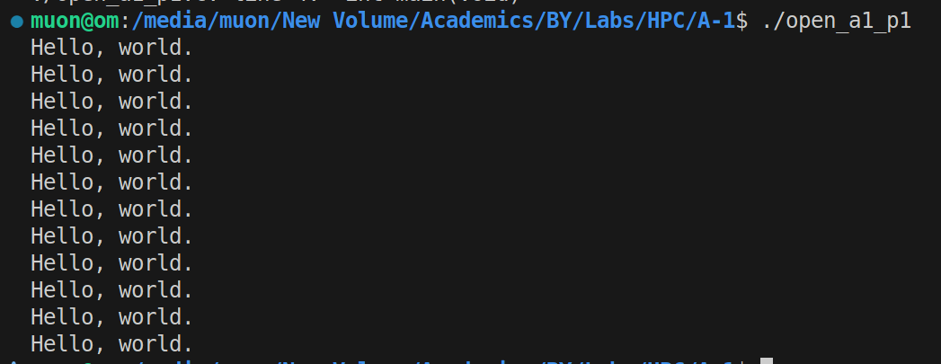

**Problem Statement 2:**

Print ‘Hello, World’ in Sequential and Parallel in OpenMP

Source Code:

#include <stdio.h>

#include <omp.h>

int main() {

int num_threads;

// taking user input for number of threads

printf("Enter the number of threads to use: ");

scanf("%d", &num_threads);

printf("\n--- Sequential Execution ---\n");

// using single thread for loop based

for (int i = 0; i < num_threads; i++) {

printf("Hello, World from sequential loop, iteration %d\n", i);

}

printf("\n--- Parallel Execution ---\n");

// setting the number ff threads

omp_set_num_threads(num_threads);

// initializing threads

#pragma omp parallel

{

// fetch the thread id

int thread_id = omp_get_thread_num();

printf("Hello, World from thread %d\n", thread_id);

}

return 0;

}

Output: 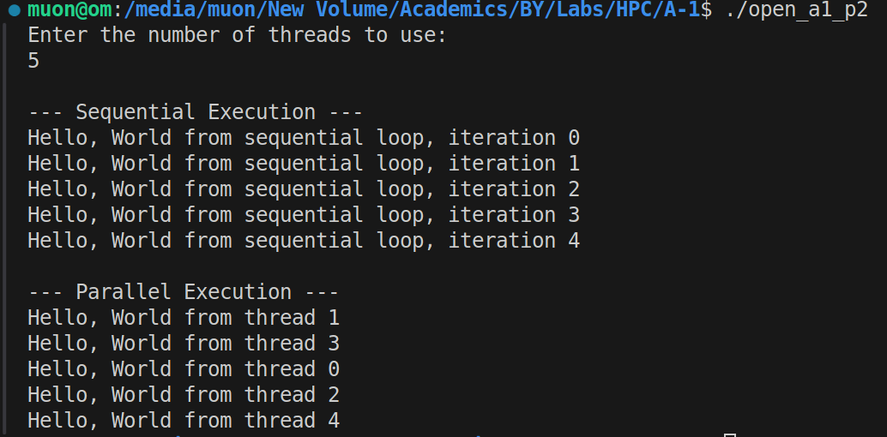

**Problem Statement 3:**

Calculate theoretical FLOPS of your system on which you are running

the above codes.

On linux ubuntu lscpu command gives the status for the cpu with respect to running of above two codes

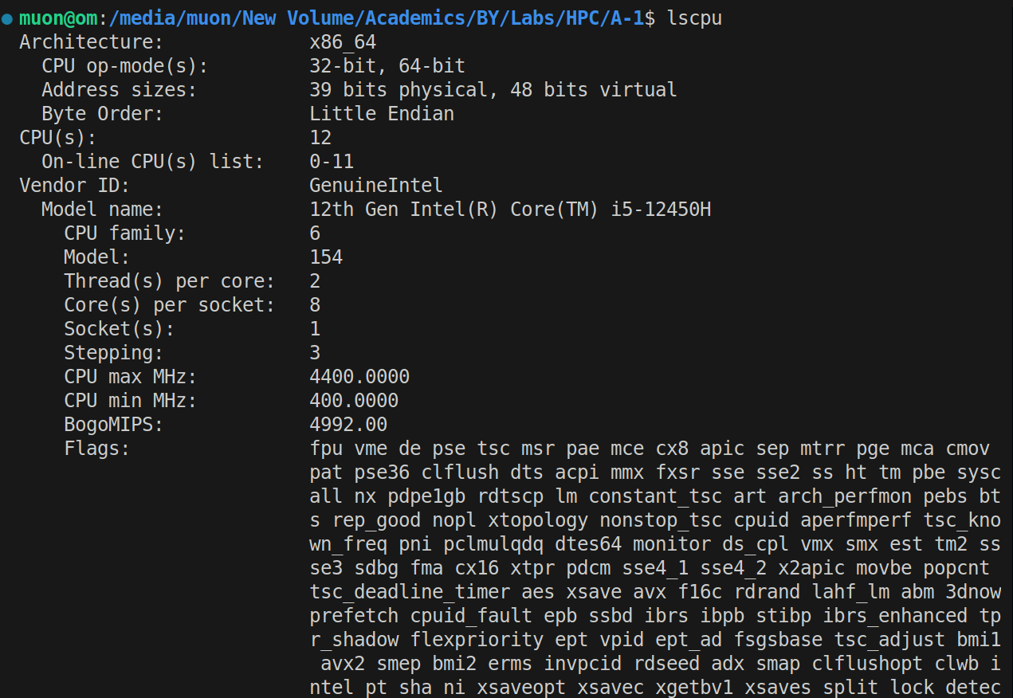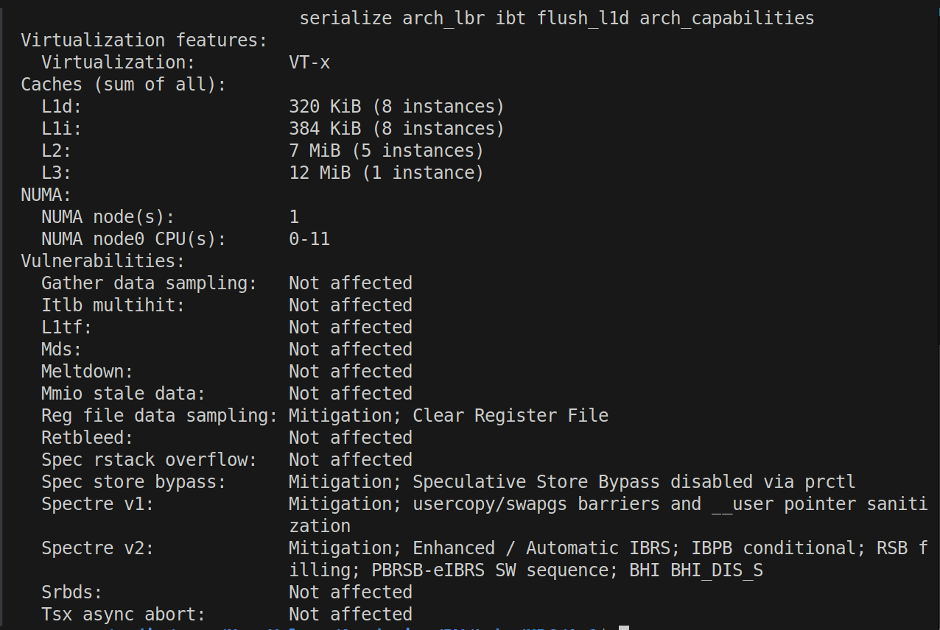

Analysis of the above output:

Information regarding the device:

- Model Name: `12th Gen Intel(R) Core(TM) i5-12450H`

- CPU(s): `12`: Total Number of Logical Threads

- Core(s) per socket:`8`: Total Number of Physical Cores

- Thread(s) per core: `2`: Hyperthreading being active

- CPU max MHz: `4400.0000` MHz: Maximum boost clock

Intel Core i5-12450H has two types of cores:  
Performance-cores (P-cores): Maximum speed: 4

Efficient-cores (E-cores): Power efficiency: 4

P-core Max Turbo Frequency: 4.4 GHz.

E-core Max Turbo Frequency: 3.3 GHz.

Peak FLOPS Calculation:

Total FLOPS=(FLOPSP-cores​)+(FLOPSE-cores​)

Single Precision Performance:

Total SP GFLOPS= (4×4.4 GHz×16) + (4×3.3 GHz×16)

= 281.6+211.2=492.8 GFLOPS

Double Precision Performance:

​Total DP GFLOPS = (4×4.4 GHz×8) +(4×3.3 GHz×8)

=140.8+105.6=246.4 GFLOPS

Github Link: <https://github.com/om7057/22510034-HPC_Lab.git>