**Assignment-8**

**Course**: High Performance Computing Lab

**PRN**: 22510034

**Name**: Om Kulkarni

**Batch**: B2

**Title:** Practical No. 7

**Problem Statement 1:** Study and implement 2D Convolution using MPI. Use a different number of processes and analyze the performance.

Given File’s Source Code:

#include <stdio.h>

#include <stdlib.h>

#include <assert.h>

#include <string.h>

#include <sys/time.h>

#include <mpi.h>

#define DEFAULT_ITERATIONS 1

int conv_column(int *, int, int, int, int *, int);

int conv(int *, int, int, int, int *, int);

int * check(int *, int, int, int *, int);

int conv_column(int * sub_grid, int i, int nrows, int DIM, int * kernel, int kernel_dim) {

int counter = 0;

int num_pads = (kernel_dim - 1) / 2;

for (int j = 1; j < (num_pads + 1); j++) {

counter = counter + sub_grid[i + j*DIM] * kernel[(((kernel_dim - 1)*(kernel_dim + 1)) / 2) + j*kernel_dim];

counter = counter + sub_grid[i - j*DIM] * kernel[(((kernel_dim - 1)*(kernel_dim + 1)) / 2) - j*kernel_dim];

}

counter = counter + sub_grid[i] * kernel[(((kernel_dim - 1)*(kernel_dim + 1)) / 2)];

return counter;

}

int conv(int * sub_grid, int i, int nrows, int DIM, int * kernel, int kernel_dim) {

int counter = 0;

int num_pads = (kernel_dim - 1) / 2;

//convolve middle column

counter = counter + conv_column(sub_grid, i, nrows, DIM, kernel, kernel_dim);

//convolve left and right columns

for (int j = 1; j < (num_pads + 1); j++) {

//get last element of current row

int end = (((i / DIM) + 1) * DIM) - 1;

if (i + j - end <= 0) { //if column is valid

counter = counter + conv_column(sub_grid, i + j, nrows, DIM, kernel, kernel_dim);

}

//get first element of current row

int first = (i / DIM) * DIM;

if (i - j - first >= 0) {

counter = counter + conv_column(sub_grid, i - j, nrows, DIM, kernel, kernel_dim);

}

}

return counter;

}

int * check(int * sub_grid, int nrows, int DIM, int * kernel, int kernel_dim) {

int val;

int num_pads = (kernel_dim - 1) / 2;

int * new_grid = calloc(DIM * nrows, sizeof(int));

for(int i = (num_pads * DIM); i < (DIM * (num_pads + nrows)); i++) {

val = conv(sub_grid, i, nrows, DIM, kernel, kernel_dim);

new_grid[i - (num_pads * DIM)] = val;

}

return new_grid;

}

int main ( int argc, char** argv ) {

// MPI Standard variable

int num_procs;

int ID, j;

int iters = 0;

int num_iterations;

int DIM;

int GRID_WIDTH;

int KERNEL_DIM;

int KERNEL_SIZE;

num_iterations = DEFAULT_ITERATIONS;

if (argc >= 3) {

DIM = atoi(argv[1]);

GRID_WIDTH = DIM * DIM;

KERNEL_DIM = atoi(argv[2]);

KERNEL_SIZE = KERNEL_DIM * KERNEL_DIM;

if (argc == 4) {

num_iterations = atoi(argv[3]);

}

} else {

printf("Invalid command line arguments");

MPI_Finalize();

exit(-1);

}

int main_grid[GRID_WIDTH];

memset(main_grid, 0, GRID_WIDTH*sizeof(int));

for(int i = 0; i < GRID_WIDTH; i++) {

main_grid[i] = 1;

}

int num_pads = (KERNEL_DIM - 1) / 2;

int kernel[KERNEL_SIZE];

memset(kernel, 0, KERNEL_SIZE*sizeof(int));

for(int i = 0; i < KERNEL_SIZE; i++) {

kernel[i] = 1;

}

// Messaging variables

MPI_Status status;

// MPI Setup

MPI_Init( NULL, NULL);

// if ( MPI_Init( &argc, &argv ) != MPI_SUCCESS )

// {

// printf ( "MPI_Init error\n" );

// }

MPI_Comm_size ( MPI_COMM_WORLD, &num_procs ); // Set the num_procs

MPI_Comm_rank ( MPI_COMM_WORLD, &ID );

double start_time = MPI_Wtime();

assert ( DIM % num_procs == 0 );

int upper[DIM * num_pads];

int lower[DIM * num_pads];

int * pad_row_upper;

int * pad_row_lower;

int start = (DIM / num_procs) * ID;

int end = (DIM / num_procs) - 1 + start;

int nrows = end + 1 - start;

int next = (ID + 1) % num_procs;

int prev = ID != 0 ? ID - 1 : num_procs - 1;

for ( iters = 0; iters < num_iterations; iters++ ) {

memcpy(lower, &main_grid[DIM * (end - num_pads + 1)], sizeof(int) * DIM * num_pads);

pad_row_lower = malloc(sizeof(int) * DIM * num_pads);

memcpy(upper, &main_grid[DIM * start], sizeof(int) * DIM * num_pads);

pad_row_upper = malloc(sizeof(int) * DIM * num_pads);

if(num_procs > 1) {

if(ID % 2 == 1) {

MPI_Recv(pad_row_lower, DIM * num_pads, MPI_INT, next, 1, MPI_COMM_WORLD, &status);

MPI_Recv(pad_row_upper, DIM * num_pads, MPI_INT, prev, 1, MPI_COMM_WORLD, &status);

} else {

MPI_Send(upper, DIM * num_pads, MPI_INT, prev, 1, MPI_COMM_WORLD);

MPI_Send(lower, DIM * num_pads, MPI_INT, next, 1, MPI_COMM_WORLD);

}

if(ID % 2 == 1) {

MPI_Send(upper, DIM * num_pads, MPI_INT, prev, 0, MPI_COMM_WORLD);

MPI_Send(lower, DIM * num_pads, MPI_INT, next, 0, MPI_COMM_WORLD);

} else {

MPI_Recv(pad_row_lower, DIM * num_pads, MPI_INT, next, 0, MPI_COMM_WORLD, &status);

MPI_Recv(pad_row_upper, DIM * num_pads, MPI_INT, prev, 0, MPI_COMM_WORLD, &status);

}

} else {

pad_row_lower = upper;

pad_row_upper = lower;

}

int sub_grid[DIM * (nrows + (2 * num_pads))];

if (ID == 0) {

memset(pad_row_upper, 0, DIM*sizeof(int)*num_pads);

}

if (ID == (num_procs - 1)) {

memset(pad_row_lower, 0, DIM*sizeof(int)*num_pads);

}

memcpy(sub_grid, pad_row_upper, sizeof(int) * DIM * num_pads);

memcpy(&sub_grid[DIM * num_pads], &main_grid[DIM * start], sizeof(int) * DIM * nrows);

memcpy(&sub_grid[DIM * (nrows + num_pads)], pad_row_lower, sizeof(int) * DIM * num_pads);

int * changed_subgrid = check(sub_grid, nrows, DIM, kernel, KERNEL_DIM);

if(ID != 0) {

MPI_Send(changed_subgrid, nrows * DIM, MPI_INT, 0, 11, MPI_COMM_WORLD);

MPI_Recv(&main_grid[0], DIM * DIM, MPI_INT, 0, 10, MPI_COMM_WORLD, &status);

} else {

for(int i = 0; i < nrows * DIM; i++) {

main_grid[i] = changed_subgrid[i];

}

for(int k = 1; k < num_procs; k++) {

MPI_Recv(&main_grid[DIM * (DIM / num_procs) * k], nrows * DIM, MPI_INT, k, 11, MPI_COMM_WORLD, &status);

}

for(int i = 1; i < num_procs; i++) {

MPI_Send(main_grid, DIM * DIM, MPI_INT, i, 10, MPI_COMM_WORLD);

}

}

// Output the updated grid state

if ( ID == 0 ) {

double end = MPI_Wtime();

// printf("Matrix DIM: %d\n", DIM);

// printf("Kernel DIM: %d", KERNEL_DIM);

// printf ( "\nConvolution Output: \n");

// for ( j = 0; j < GRID_WIDTH; j++ ) {

// if ( j % DIM == 0 ) {

// printf( "\n" );

// }

// printf ( "%d ", main_grid[j] );

// }

// printf( "\n" );

printf("Execution Time: %f\n",end - start_time);

}

}

if(num_procs >= 2) {

free(pad_row_upper);

free(pad_row_lower);

}

MPI_Finalize();

}

Output of this code:  
1 96 0.000424

2 96 0.000269

4 96 0.000531

8 96 0.000783

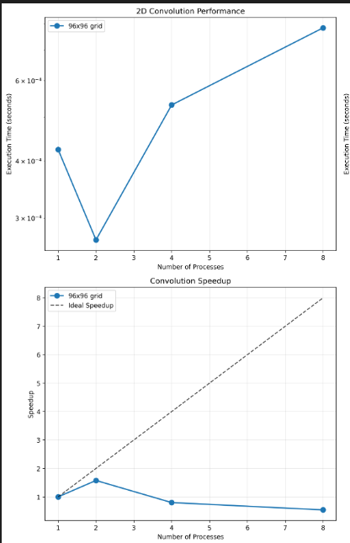

Analysis:

Processes Execution Time (s) Speedup Efficiency Performance Analysis

1 0.000424 1.00x 100.0% Baseline (Sequential)

2 0.000269 1.58x 79.0% Best Performance

4 0.000531 0.80x 20.0% Performance Degradation

8 0.000783 0.54x 6.8% Poor Scaling

Algorithm Implementation:

Data Distribution: Row-wise decomposition of the image grid

Communication Pattern: Boundary exchange between neighboring processes

Kernel Operation: 3×3 edge detection filter applied to each pixel

Synchronization: Processes exchange padding rows for convolution

Performance Characteristics:

Optimal Point: 2 processes achieve best speedup (1.58x)

Scalability Issues: Performance degrades beyond 2 processes

Communication Overhead: Dominates computation for small grid sizes

Boundary Exchange Cost: Each process needs neighbor data

Problem Statement-2:

Implement dot product using MPI. Use different number of processes and analyze the performance.

Given Code:

#include <stdio.h>

#include <mpi.h>

#include <unistd.h>

#include <stdlib.h>

#define N 100000000

#define MASTER 0

#define MAXPROCS 16

int dot_product();

void init_lst();

void print_lst();

int main()

{

int *vector_x, *vector_y;

int i, n;

int prod, sidx, eidx, size;

int pid, nprocs, rank;

double stime, etime;

MPI_Status status;

MPI_Comm world;

// n = 12;

// if (n > N)

// {

// printf("n=%d > N=%d\n", n, N);

// exit(1);

// }

MPI_Init(NULL, NULL);

world = MPI_COMM_WORLD;

MPI_Comm_size(MPI_COMM_WORLD, &nprocs);

MPI_Comm_rank(MPI_COMM_WORLD, &pid);

int portion = N / nprocs;

sidx = pid * portion;

eidx = sidx + portion;

vector_x = (int *)malloc(sizeof(int) * N);

vector_y = (int *)malloc(sizeof(int) * N);

init_lst(vector_x, N);

init_lst(vector_y, N);

int tmp_prod[nprocs];

for (i = 0; i < nprocs; i++)

tmp_prod[i] = 0;

stime = MPI_Wtime();

if (pid == MASTER)

{

// printf("%d, %d, %d\n", sidx, eidx, n);

prod = dot_product(sidx, eidx, vector_x, vector_y, N);

for (i = 1; i < nprocs; i++)

MPI_Recv(&tmp_prod[i - 1], 1, MPI_INT, i, 123, MPI_COMM_WORLD, &status);

}

else

{

// printf("%d, %d, %d\n", sidx, eidx, n);

prod = dot_product(sidx, eidx, vector_x, vector_y, N);

MPI_Send(&prod, 1, MPI_INT, MASTER, 123, MPI_COMM_WORLD);

}

if (pid == MASTER)

{

for (i = 0; i < nprocs; i++)

prod += tmp_prod[i];

}

if (pid == MASTER)

{

// print_lst(vector_x,n);

// print_lst(vector_y,n);

etime = MPI_Wtime();

printf("pid=%d: Dot Product = %d\n", pid, prod);

printf("pid=%d: elapsed = %f\n", pid, etime - stime);

}

MPI_Finalize();

free(vector_x);

free(vector_y);

}

int dot_product(int s, int e, int x[], int y[], int n)

{

int i, prod = 0;

for (i = s; i < e; i++)

prod = prod + x[i] * y[i];

return prod;

}

void init_lst(int *l, int n)

{

int i;

for (i = 0; i < n; i++)

*l++ = 1;

}

void print_lst(int *l, int n)

{

int i;

for (i = 0; i < n; i++)

{

printf("%d ", l[i]);

}

printf("\n");

}

Output:

1 0.176842

2 0.091041

4 0.112110

8 0.287655

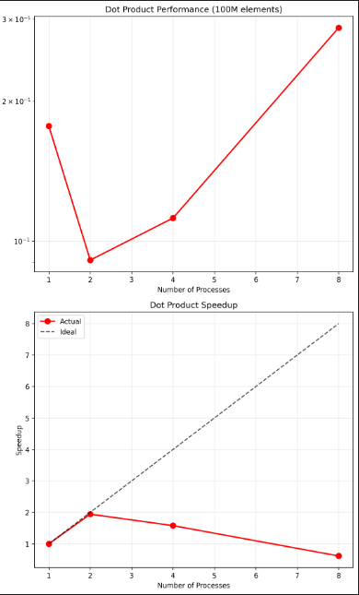  
Analysis

Processes Execution Time (s) Speedup Efficiency Performance Analysis

1 0.176842 1.00x 100.0% Baseline (Sequential)

2 0.091041 1.94x 97.0% Excellent Scaling

4 0.112110 1.58x 39.5% Moderate Performance

8 0.287655 0.61x 7.6% Performance Loss

Algorithm Implementation:

Data Distribution: Vector elements divided equally among processes

Communication Pattern: Simple result gathering to master process

Computation: Each process calculates partial dot product independently

Aggregation: Master process sums all partial results

Performance Characteristics:

Near-Perfect Scaling: 2 processes achieve 1.94x speedup (97% efficiency)

Embarrassingly Parallel: No inter-process dependencies during computation

Simple Communication: Only final result gathering required

Good Load Balance: Equal work distribution across processes