**Assignment - 1**

Name : Om Kulkarni Date : 19/01/25

Class : TY CSE

PRN : 22510034 Batch : T-3

* 1. Download / get setup CD of Server & Client (Win/Linux).

Server :

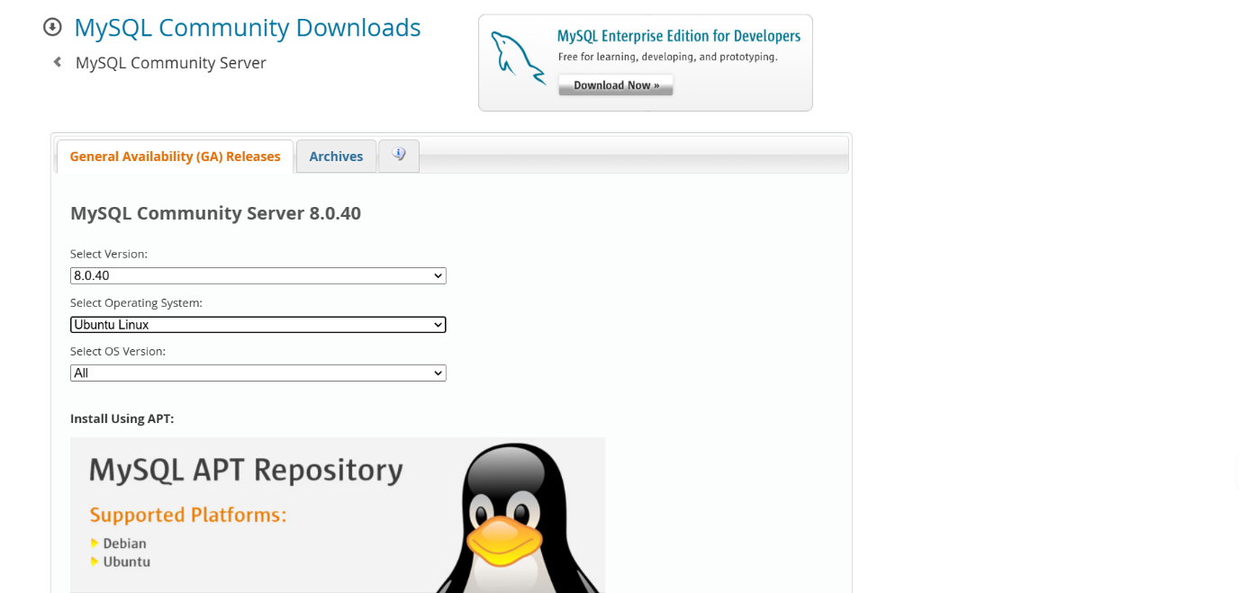

Client : mysql workbench

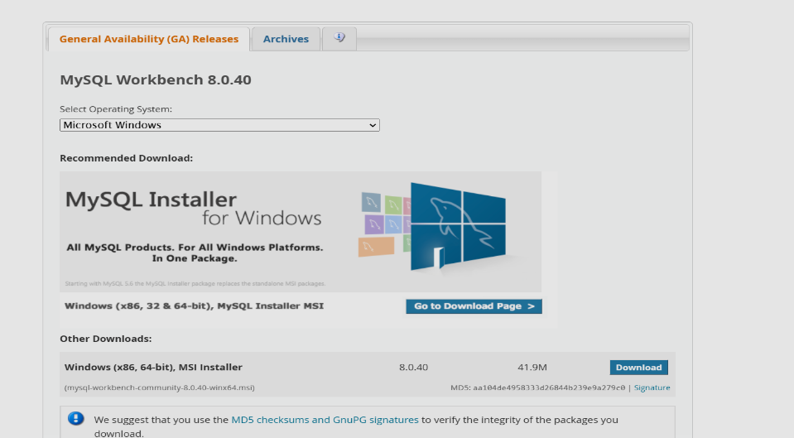

* 1. Read and follow the prerequisite for installation and accordingly set the system.

**System Requirements**:

* **Windows**:

OS: Windows 10 or later.

RAM: At least 1GB (2GB recommended).

Disk Space: Minimum 1GB.

* **Linux**:

Kernel: 2.6.32 or higher.

Required libraries and dependencies installed (libaio, glibc, etc.).

**User Privileges**:

* Ensure you have administrator/root privileges on the system.

**Firewall**:

* Allow MySQL default port **3306** in the firewall settings.

**Backup**:

* If upgrading or reinstalling, back up the existing MySQL data directory (/var/lib/mysql for Linux or the data folder in the installation directory for Windows).
  1. If server already installed, uninstall it.
  2. 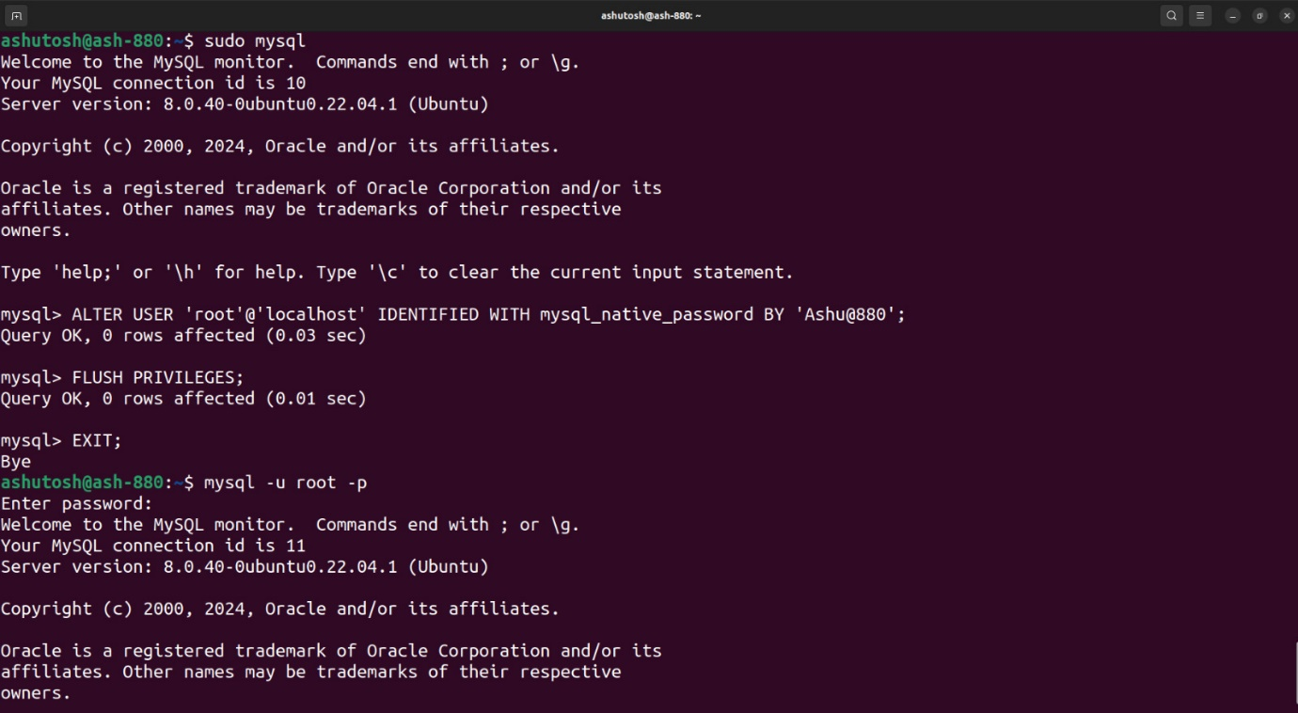Install MySQL Server on one machine.
  3. Install Client (MySQL Workbench) on another machine.

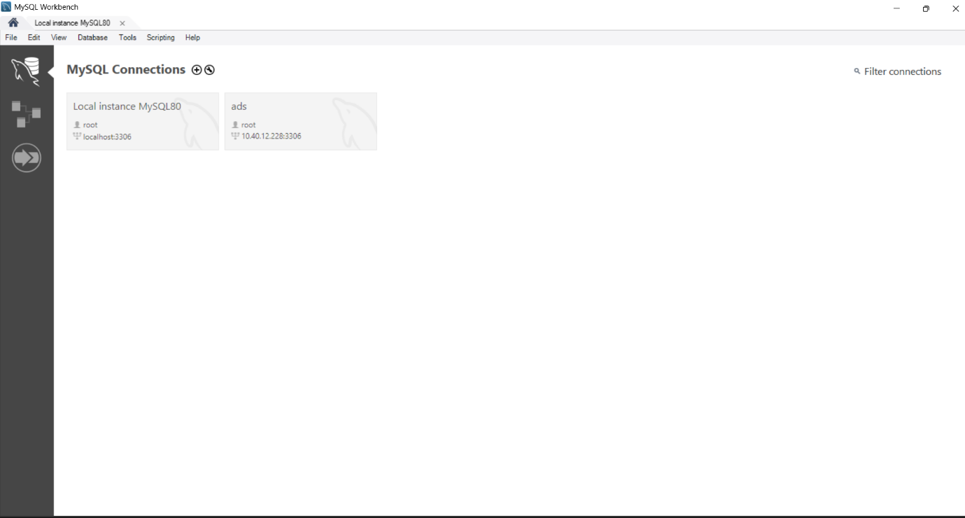

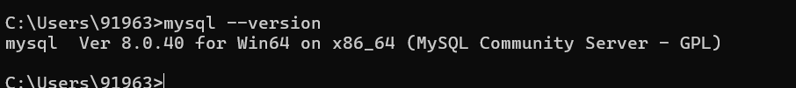

* 1. Check the connectivity from Web client and SQL command line. (Note use the demo/example schema)

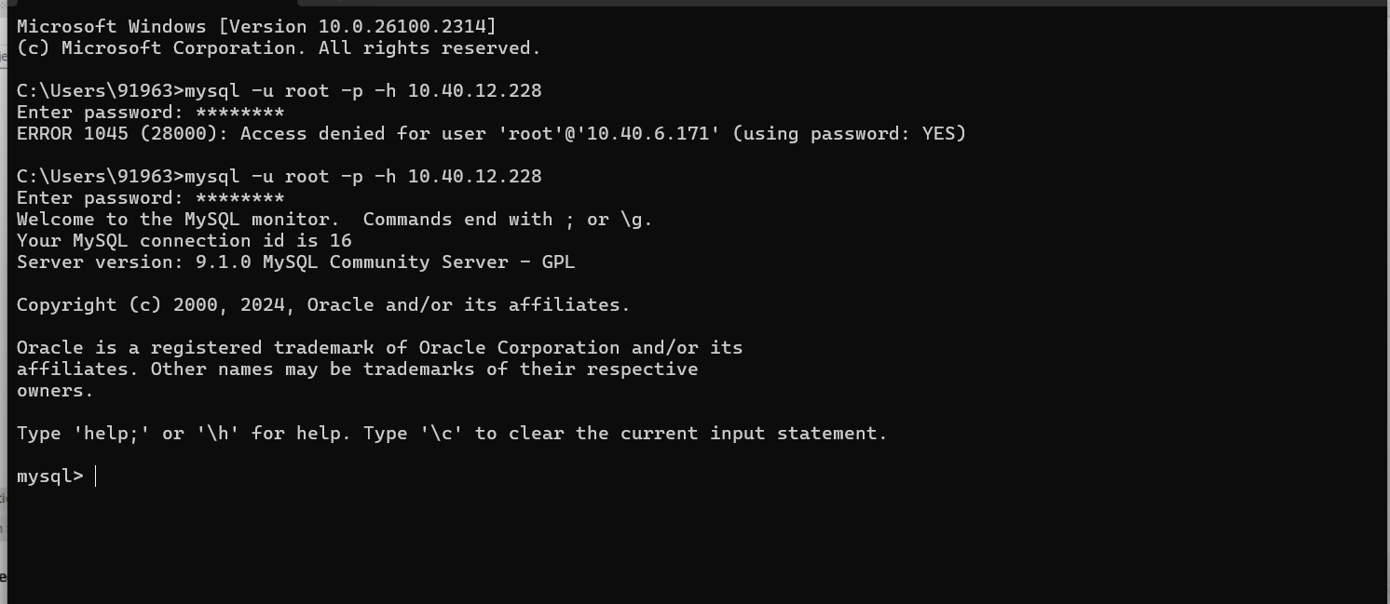

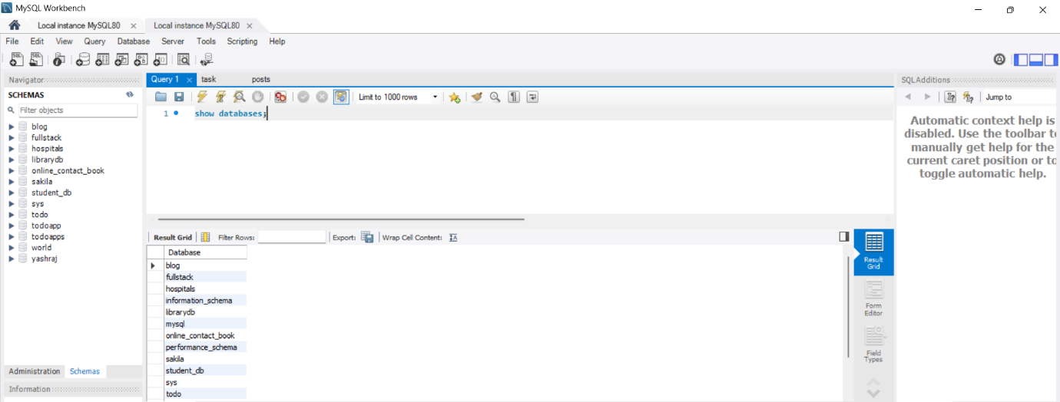

* 1. Create new user by your PRN e.g. 22511234.

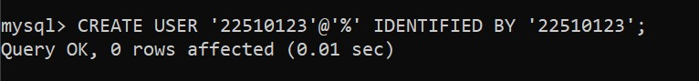



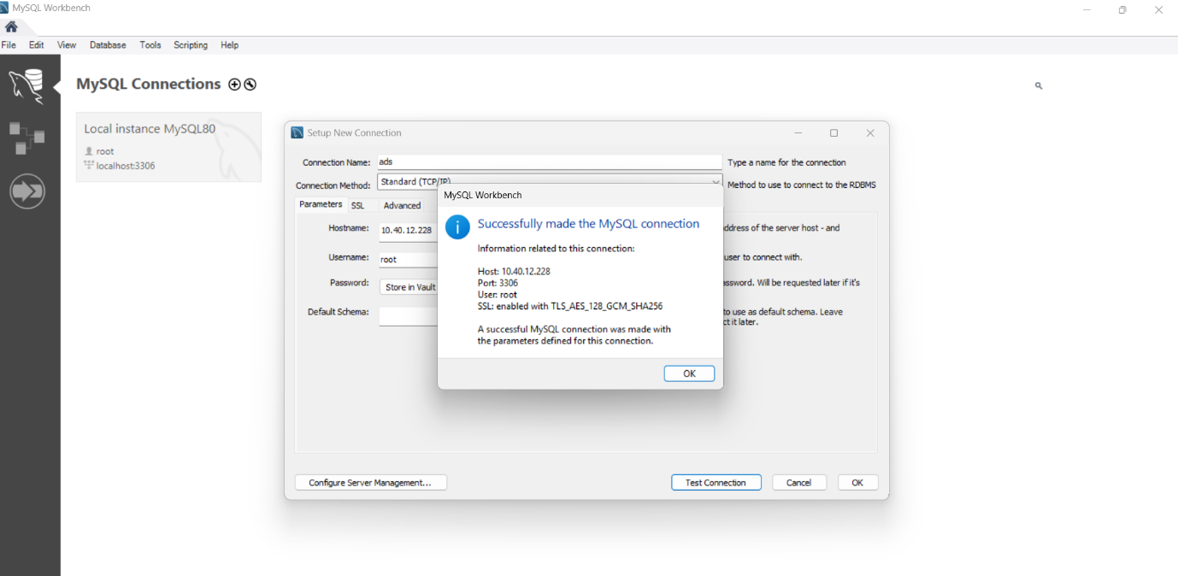

* 1. Create sample database, create sample tables in newly created database



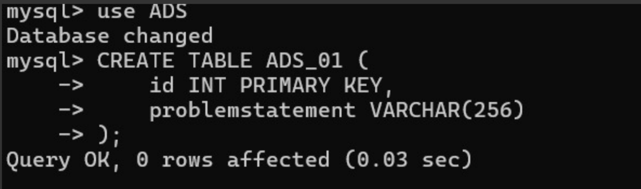

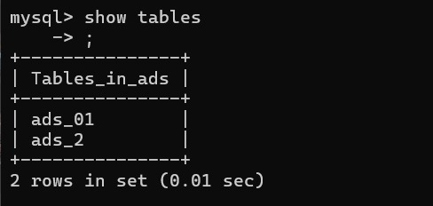

* 1. Repeat the step 6 for this new database.

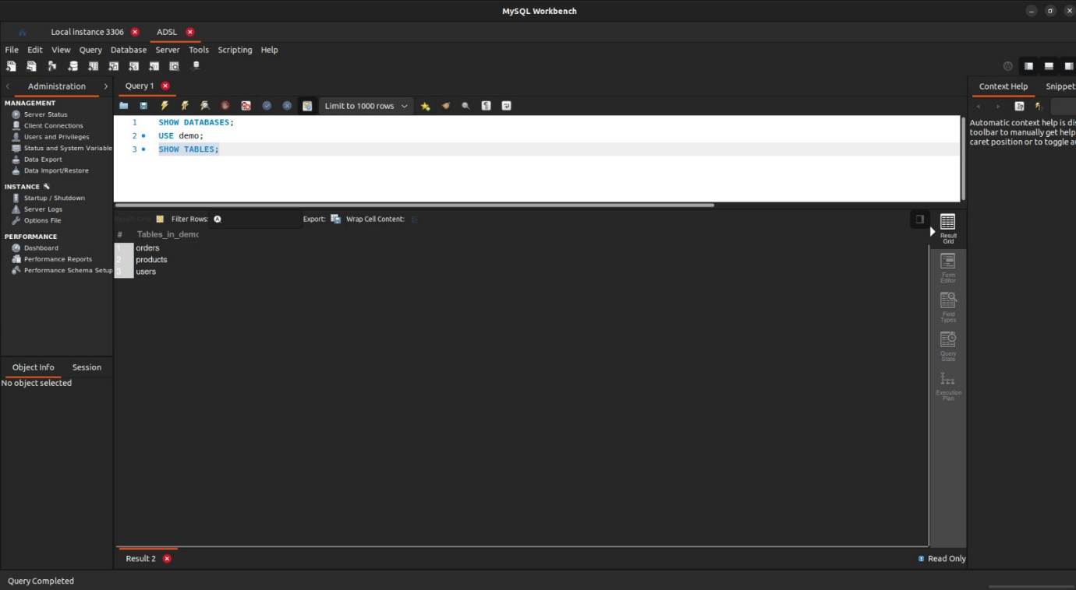

* 1. Demonstrate the DML on new tables.

