**Assignment – 6**

Name : Om Kulkarni Date : 21/02/25

Class : TY CSE

PRN : 22510034 Batch : T-3

A comprehensive report on data warehouse for a customer order processing system in a company.

**Introduction**

### **Objective:**

The objective of this project is to **design and implement a Data Warehouse** for a customer order processing system in a company. The data warehouse enables **OLAP (Online Analytical Processing)** operations such as roll-up, drill-down, slicing, and dicing to analyze business performance effectively.

### **Scope:**

* Stores, customers, and order details are managed efficiently.
* Users can perform OLAP queries for **sales analysis, stock tracking, and customer behavior insights**.

**Business Requirement**

The enterprise has multiple stores in different cities.

Customers place orders either **walk-in** or **mail-order**.

The warehouse will store customer, order, store, and item details.

Users will perform OLAP queries for sales analysis, stock tracking, and customer insights.

**3. Functional Specification**

**Input**: Operational databases (Customer, Stores, Items, Orders).

**Output**: OLAP reports for sales, inventory, customer behavior, and stor

**4. Data Warehouse Design :**

The Star Schema was implemented with:

Fact Table: Fact_Order (Measures: Ordered_price, Quantity_ordered).

Dimension Tables: Dim_Customer, Dim_Store, Dim_Item, Dim_Time.

Supporting Tables: Stores, Stored_Items, Headquarters.

**SQL Queries :   
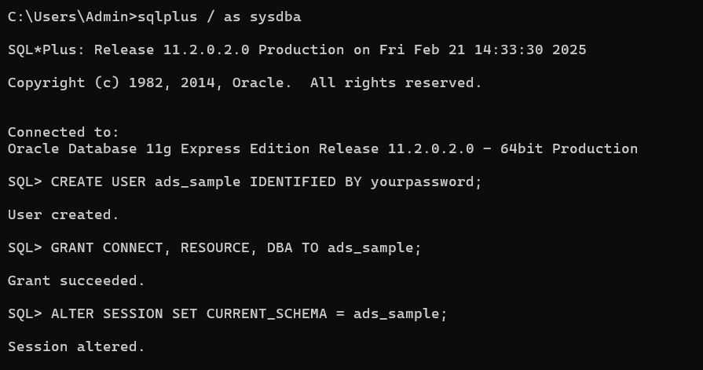**

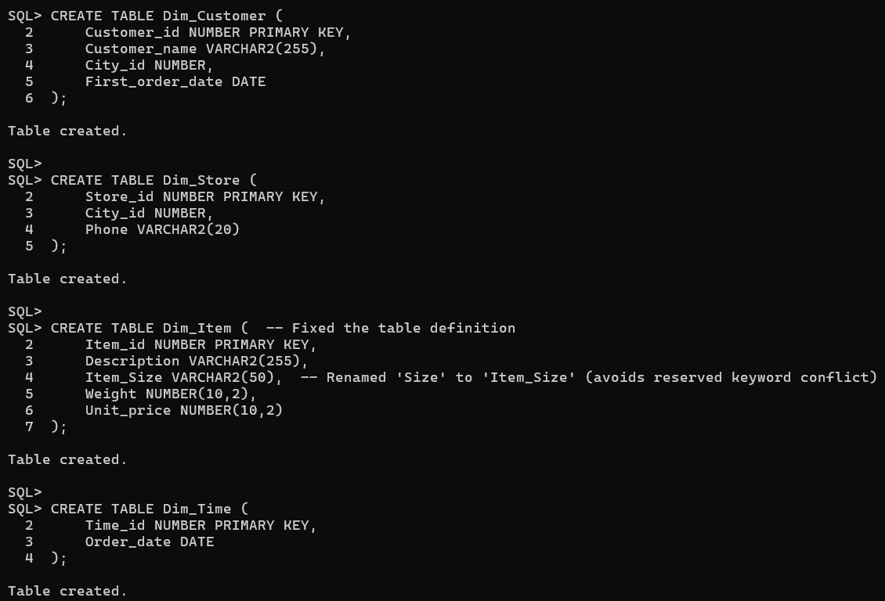

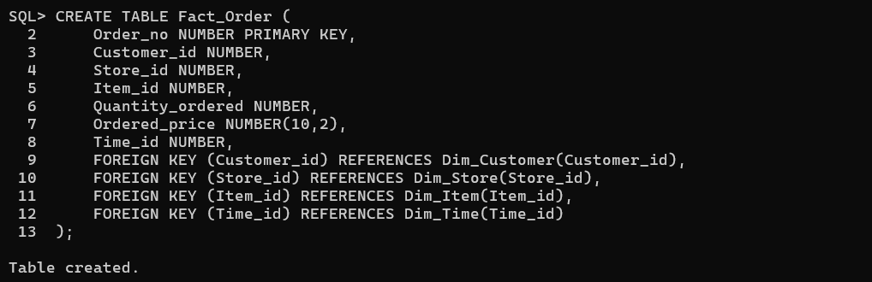

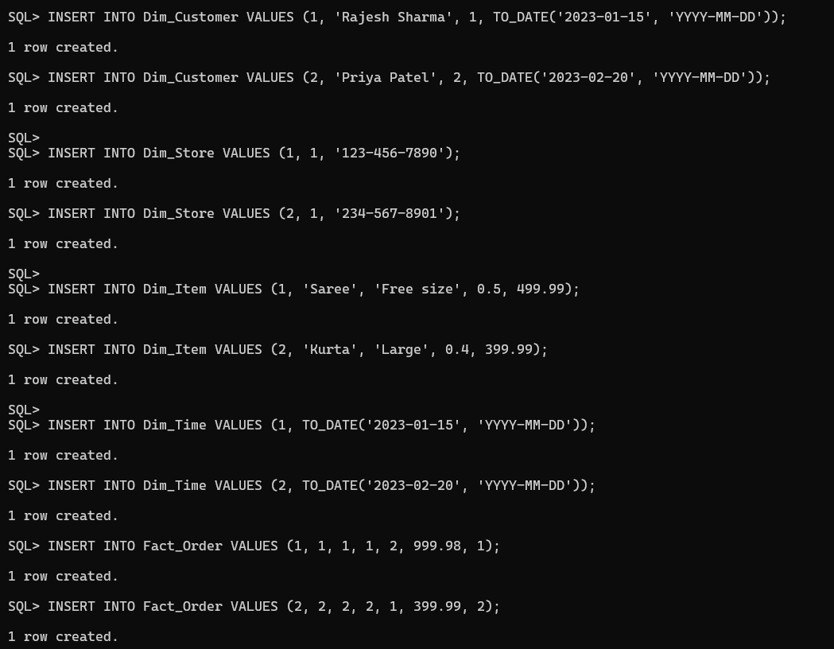

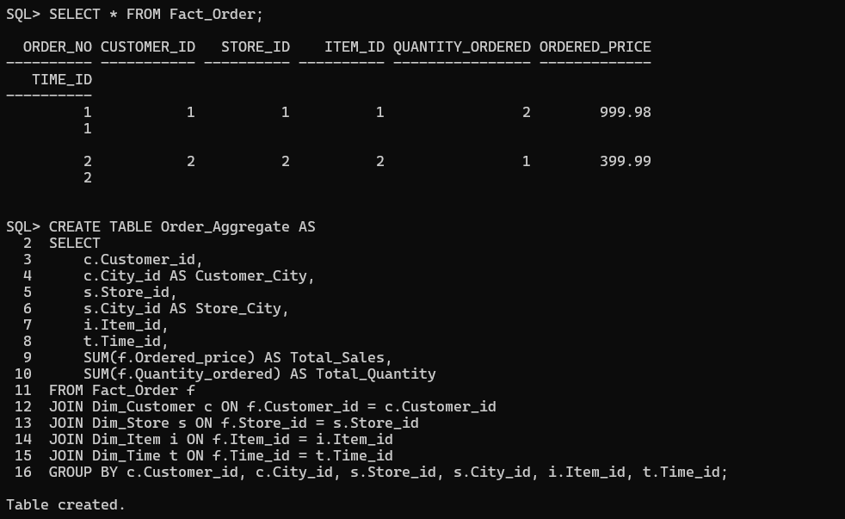

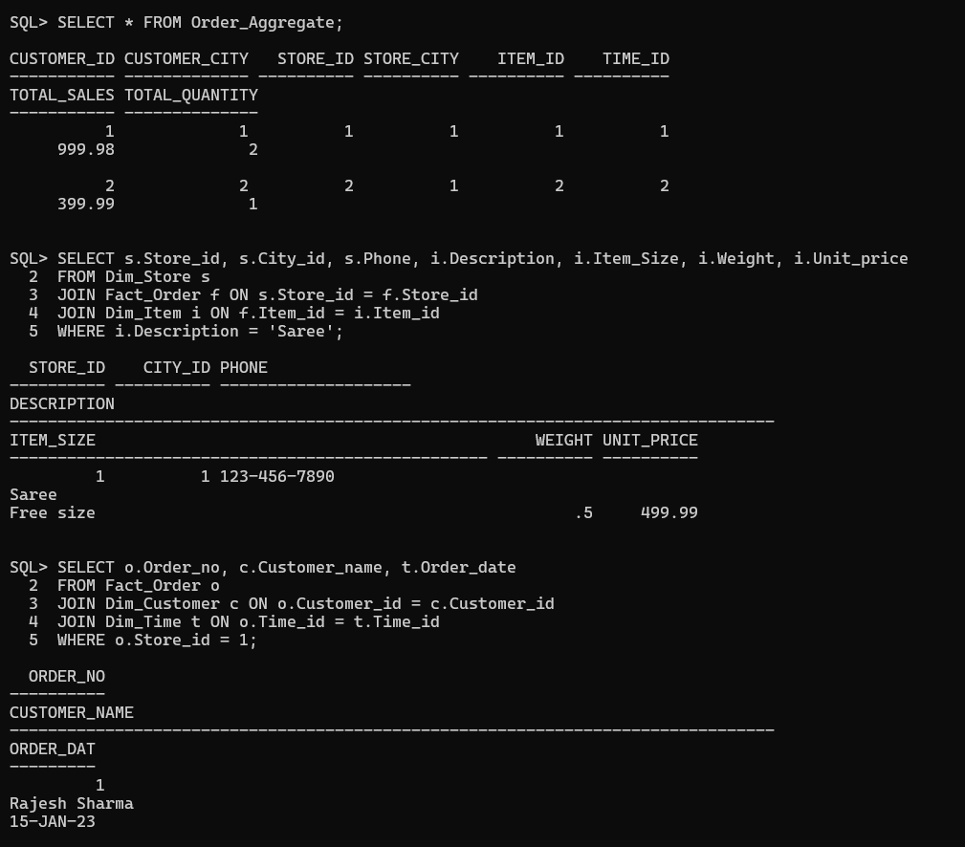

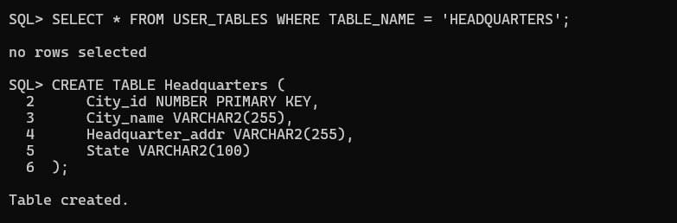

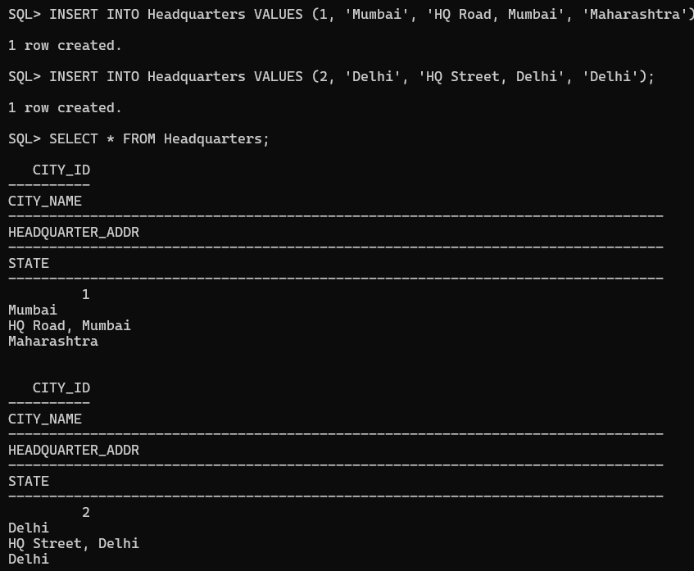

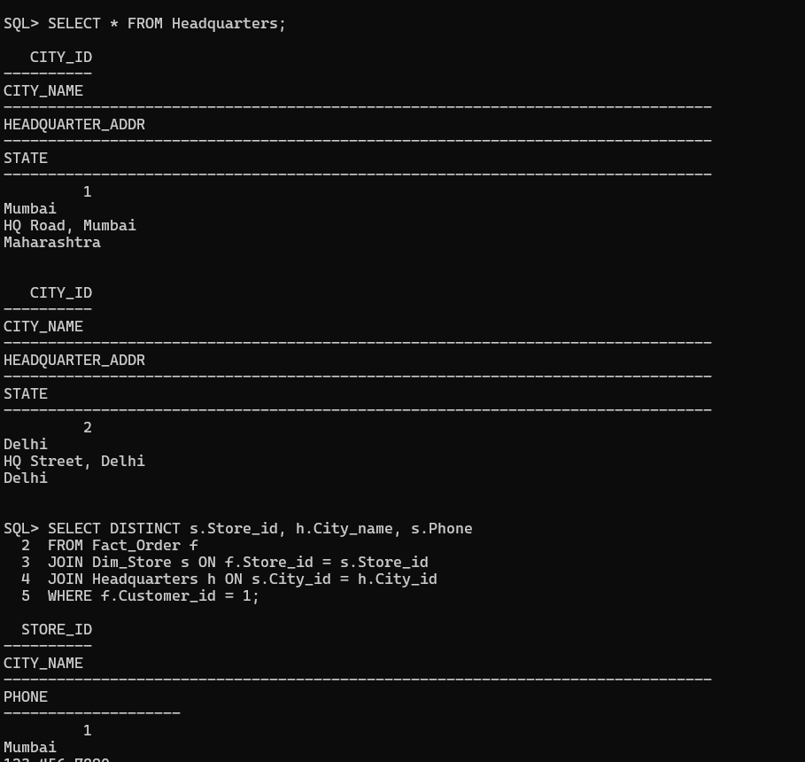

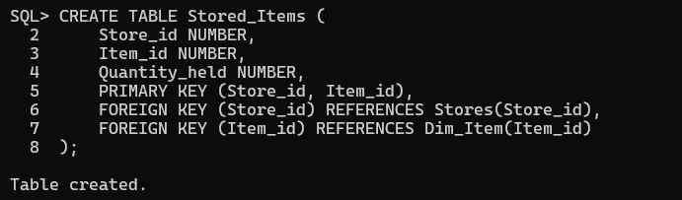

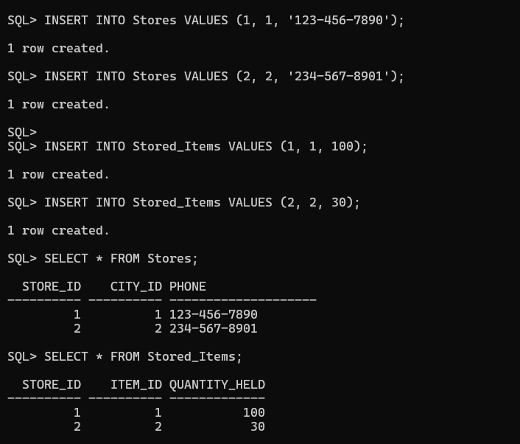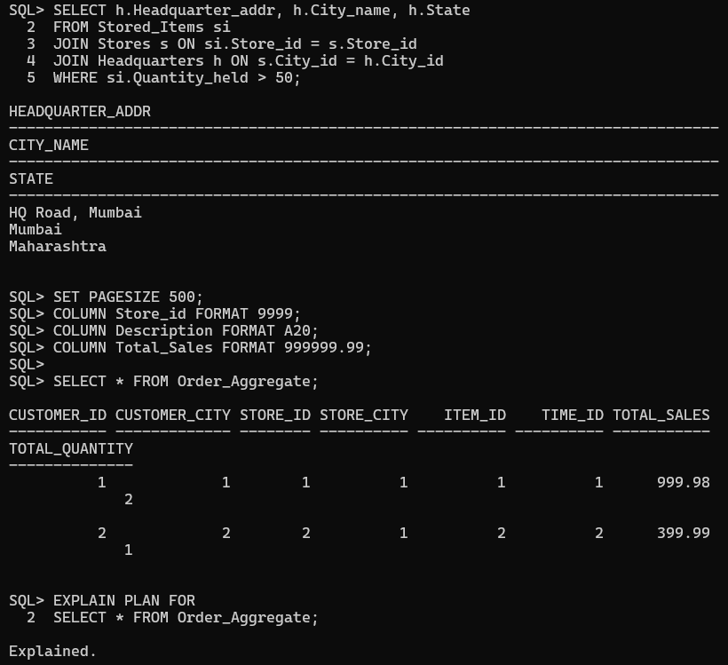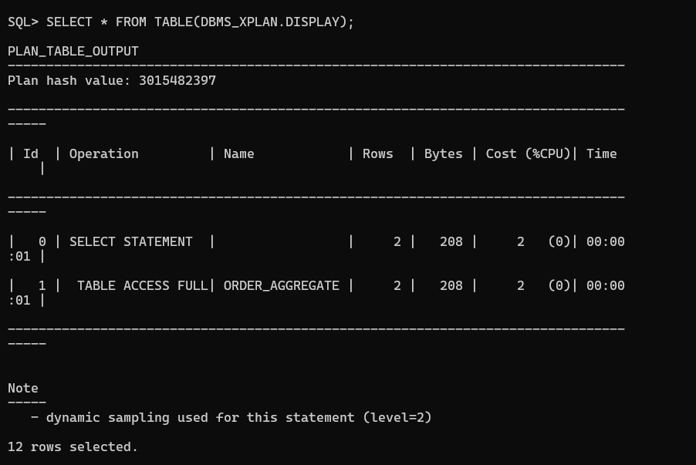

**6. Observations and Analysis :   
Roll-up :** Total sales per customer, store, item.

**Drill-down :** Detailed orders for a specific store or item.

**Slice :** Find customers who ordered specific products.

**Dice :** Compare stock levels across multiple cities.