**Assignment – 7**

Name : Om Kulkarni Date : 26/02/25

Class : TY CSE

PRN : 22510034 Batch : T-3

Steps to install mongo DB :   
1) Go to this link :

<https://www.mongodb.com/try/download/shell>

Download .msi file and after that click for installation

2) Go to mongoDB / Server / 8.0 / bin

Copy that path and give to the system environment variables

3)Open cmd and check for mongosh --version

If it confirms then run the command mongosh to get started.

Basic CRUD operations using mongoDB :

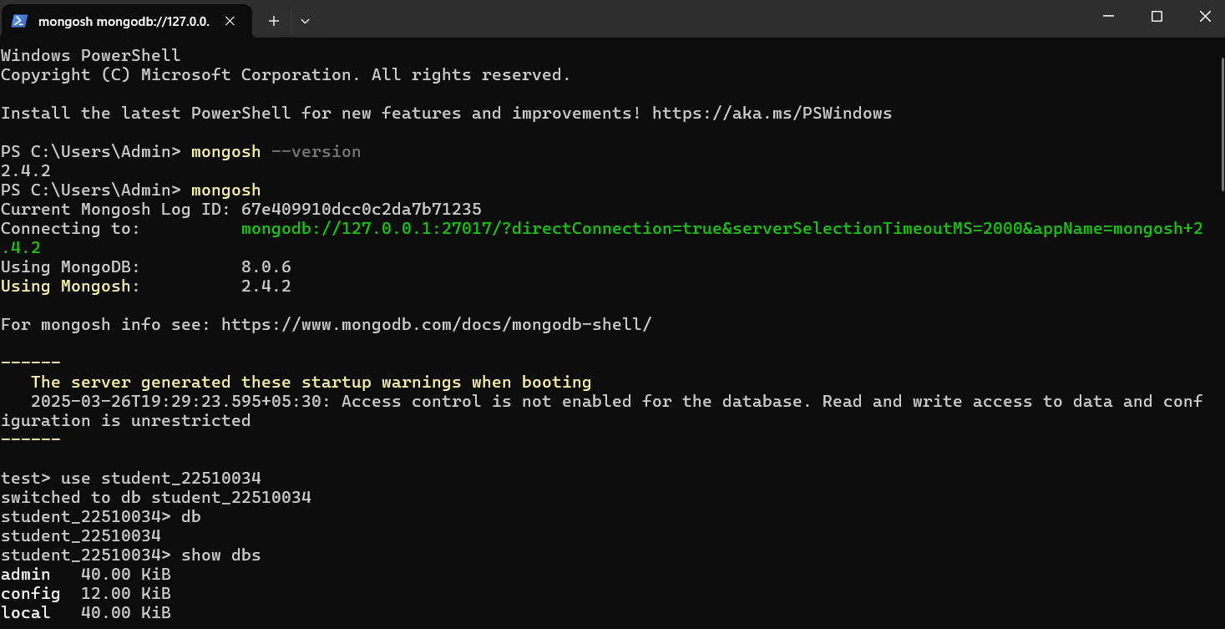

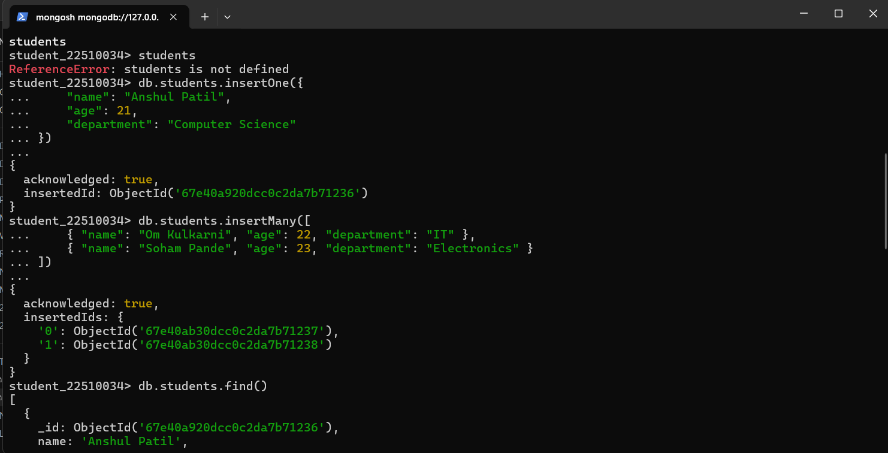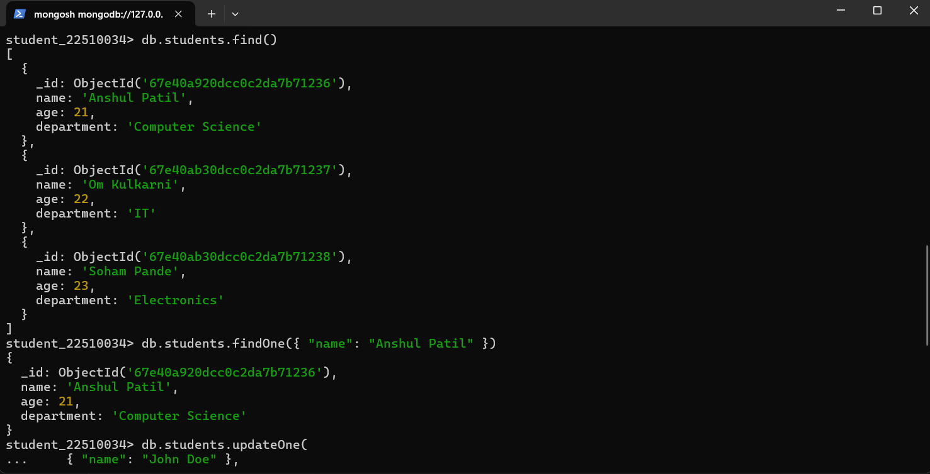

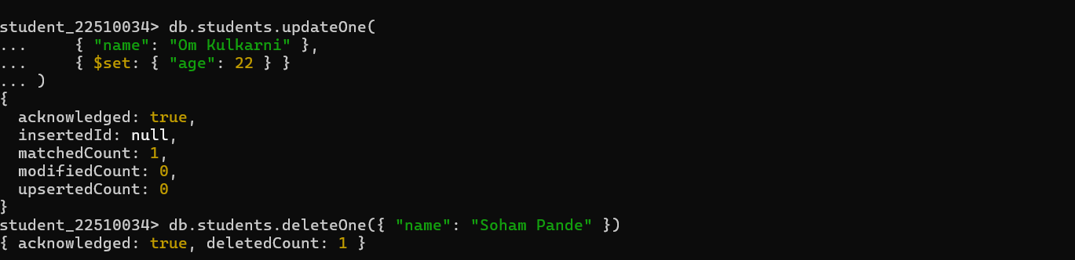

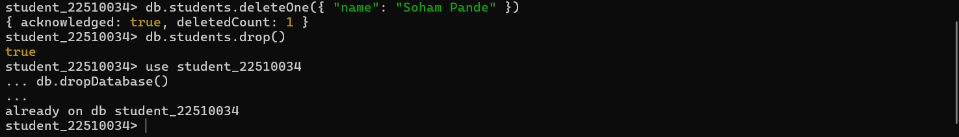

Frontend :

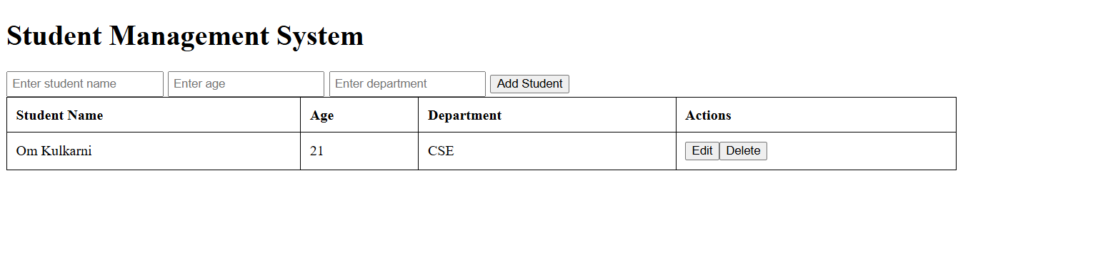

Connected MongoDB :

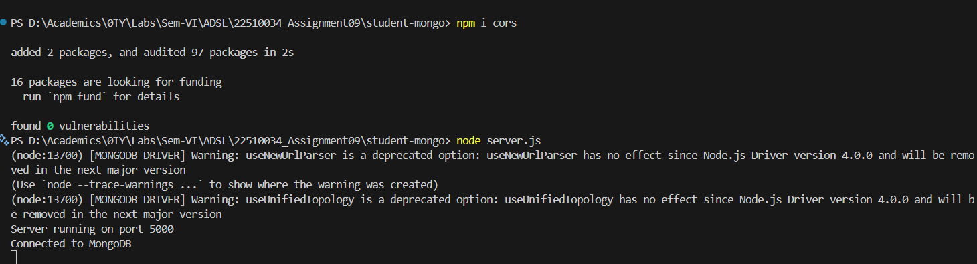

And I’ve performed operations on mongoDB and it was verified that data was created in the shell.